同济大学计算机系

数字逻辑课程实验报告



学 号 1652228
姓 名 王哲源
专 业 计算机
授课老师 张冬冬

- 实验内容
使用Verilog HDL 语言实现RAM 以及寄存器堆的设计和仿真
- 硬件逻辑图
包含16个寄存器的寄存器堆
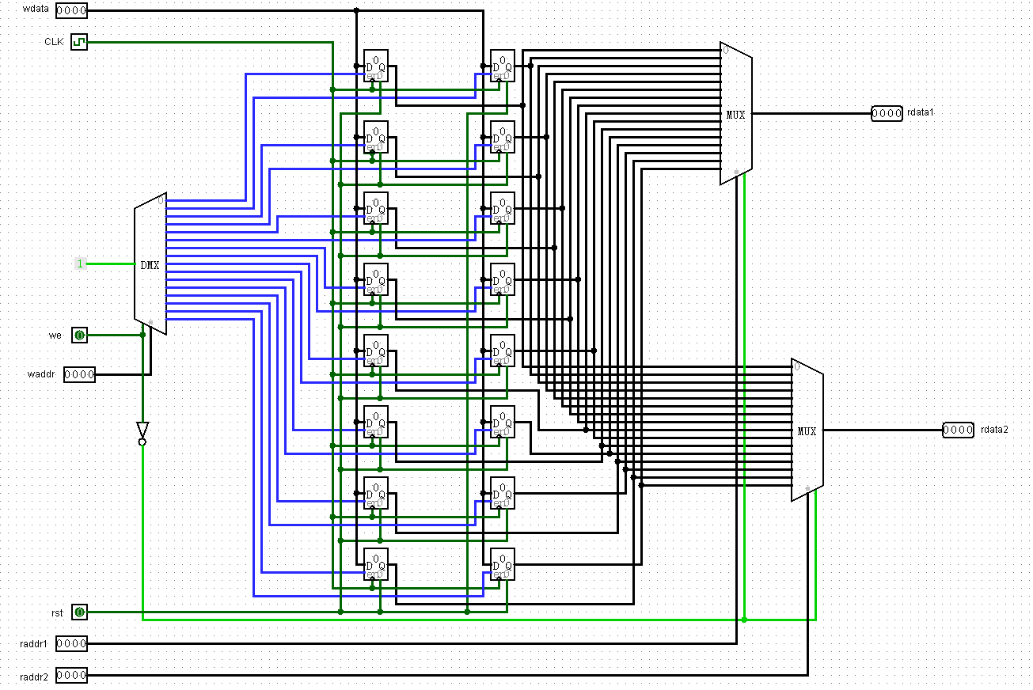
- 模块建模
- 双线输入输出ram
根据wena模块控制是使用data_in的输入还是输出到data_out上
module ram(
input clk,
input ena,
input wena,
input [4:0] addr,
input [31:0] data_in,
output [31:0] data_out
);

reg [31:0] temp[31:0];
assign data_out = (ena == 1 && wena == 0) ? temp[addr] : {32{1'bz}};
always @(posedge clk)
if(ena == 1 && wena == 1)
temp[addr] = data_in;
endmodule
- 单线输入输出ram
根据wena信号选择使用data输入或输出数据
module ram2(
input clk,
input ena,
input wena,
input [4:0] addr,
inout [31:0] data
);

reg [31:0] temp[31:0];
assign data = (ena == 1 && wena == 0) ? temp[addr] : {32{1'bz}};
always @(posedge clk)
if(ena == 1 && wena == 1)
temp[addr] = data;
endmodule
- 寄存器堆
  - 顶层模块，实例化寄存器堆
module Regfiles(
input clk,
input rst,
input we,
input [4:0] raddr1,
input [4:0] raddr2,
input [4:0] waddr,
input [31:0] wdata,
output [31:0] rdata1,
output [31:0] rdata2
);
wire [31:0] encode_waddr;
wire [31:0] temp_data[31:0];

decoder Decoder(.iData(waddr),.iEna(we),.oData(encode_waddr));

pcreg Reg0(.clk(~clk), .rst(rst), .ena(encode_waddr[0]), .data_in(wdata), .data_out(temp_data[0]));
pcreg Reg1(.clk(~clk), .rst(rst), .ena(encode_waddr[1]), .data_in(wdata), .data_out(temp_data[1]));
pcreg Reg2(.clk(~clk), .rst(rst), .ena(encode_waddr[2]), .data_in(wdata), .data_out(temp_data[2]));
pcreg Reg3(.clk(~clk), .rst(rst), .ena(encode_waddr[3]), .data_in(wdata), .data_out(temp_data[3]));
pcreg Reg4(.clk(~clk), .rst(rst), .ena(encode_waddr[4]), .data_in(wdata), .data_out(temp_data[4]));
pcreg Reg5(.clk(~clk), .rst(rst), .ena(encode_waddr[5]), .data_in(wdata), .data_out(temp_data[5]));
pcreg Reg6(.clk(~clk), .rst(rst), .ena(encode_waddr[6]), .data_in(wdata), .data_out(temp_data[6]));
pcreg Reg7(.clk(~clk), .rst(rst), .ena(encode_waddr[7]), .data_in(wdata), .data_out(temp_data[7]));
pcreg Reg8(.clk(~clk), .rst(rst), .ena(encode_waddr[8]), .data_in(wdata), .data_out(temp_data[8]));
pcreg Reg9(.clk(~clk), .rst(rst), .ena(encode_waddr[9]), .data_in(wdata), .data_out(temp_data[9]));
pcreg Reg10(.clk(~clk), .rst(rst), .ena(encode_waddr[10]), .data_in(wdata), .data_out(temp_data[10]));
pcreg Reg11(.clk(~clk), .rst(rst), .ena(encode_waddr[11]), .data_in(wdata), .data_out(temp_data[11]));
pcreg Reg12(.clk(~clk), .rst(rst), .ena(encode_waddr[12]), .data_in(wdata), .data_out(temp_data[12]));
pcreg Reg13(.clk(~clk), .rst(rst), .ena(encode_waddr[13]), .data_in(wdata), .data_out(temp_data[13]));
pcreg Reg14(.clk(~clk), .rst(rst), .ena(encode_waddr[14]), .data_in(wdata), .data_out(temp_data[14]));
pcreg Reg15(.clk(~clk), .rst(rst), .ena(encode_waddr[15]), .data_in(wdata), .data_out(temp_data[15]));
pcreg Reg16(.clk(~clk), .rst(rst), .ena(encode_waddr[16]), .data_in(wdata), .data_out(temp_data[16]));
pcreg Reg17(.clk(~clk), .rst(rst), .ena(encode_waddr[17]), .data_in(wdata), .data_out(temp_data[17]));
pcreg Reg18(.clk(~clk), .rst(rst), .ena(encode_waddr[18]), .data_in(wdata), .data_out(temp_data[18]));
pcreg Reg19(.clk(~clk), .rst(rst), .ena(encode_waddr[19]), .data_in(wdata), .data_out(temp_data[19]));
pcreg Reg20(.clk(~clk), .rst(rst), .ena(encode_waddr[20]), .data_in(wdata), .data_out(temp_data[20]));
pcreg Reg21(.clk(~clk), .rst(rst), .ena(encode_waddr[21]), .data_in(wdata), .data_out(temp_data[21]));
pcreg Reg22(.clk(~clk), .rst(rst), .ena(encode_waddr[22]), .data_in(wdata), .data_out(temp_data[22]));
pcreg Reg23(.clk(~clk), .rst(rst), .ena(encode_waddr[23]), .data_in(wdata), .data_out(temp_data[23]));
pcreg Reg24(.clk(~clk), .rst(rst), .ena(encode_waddr[24]), .data_in(wdata), .data_out(temp_data[24]));
pcreg Reg25(.clk(~clk), .rst(rst), .ena(encode_waddr[25]), .data_in(wdata), .data_out(temp_data[25]));
pcreg Reg26(.clk(~clk), .rst(rst), .ena(encode_waddr[26]), .data_in(wdata), .data_out(temp_data[26]));
pcreg Reg27(.clk(~clk), .rst(rst), .ena(encode_waddr[27]), .data_in(wdata), .data_out(temp_data[27]));
pcreg Reg28(.clk(~clk), .rst(rst), .ena(encode_waddr[28]), .data_in(wdata), .data_out(temp_data[28]));
pcreg Reg29(.clk(~clk), .rst(rst), .ena(encode_waddr[29]), .data_in(wdata), .data_out(temp_data[29]));
pcreg Reg30(.clk(~clk), .rst(rst), .ena(encode_waddr[30]), .data_in(wdata), .data_out(temp_data[30]));
pcreg Reg31(.clk(~clk), .rst(rst), .ena(encode_waddr[31]), .data_in(wdata), .data_out(temp_data[31]));

selector Rdata1(.iC0(temp_data[0]), .iC1(temp_data[1]), .iC2(temp_data[2]), .iC3(temp_data[3]),
.iC4(temp_data[4]), .iC5(temp_data[5]), .iC6(temp_data[6]), .iC7(temp_data[7]),
.iC8(temp_data[8]), .iC9(temp_data[9]), .iC10(temp_data[10]), .iC11(temp_data[11]),
.iC12(temp_data[12]), .iC13(temp_data[13]), .iC14(temp_data[14]), .iC15(temp_data[15]),
.iC16(temp_data[16]), .iC17(temp_data[17]), .iC18(temp_data[18]), .iC19(temp_data[19]),
.iC20(temp_data[20]), .iC21(temp_data[21]), .iC22(temp_data[22]), .iC23(temp_data[23]),
.iC24(temp_data[24]), .iC25(temp_data[25]), .iC26(temp_data[26]), .iC27(temp_data[27]),
.iC28(temp_data[28]), .iC29(temp_data[29]), .iC30(temp_data[30]), .iC31(temp_data[31]),
.iS(raddr1), .iEna(~we), .oZ(rdata1));
selector Rdata2(.iC0(temp_data[0]), .iC1(temp_data[1]), .iC2(temp_data[2]), .iC3(temp_data[3]),
.iC4(temp_data[4]), .iC5(temp_data[5]), .iC6(temp_data[6]), .iC7(temp_data[7]),
.iC8(temp_data[8]), .iC9(temp_data[9]), .iC10(temp_data[10]), .iC11(temp_data[11]),
.iC12(temp_data[12]), .iC13(temp_data[13]), .iC14(temp_data[14]), .iC15(temp_data[15]),
.iC16(temp_data[16]), .iC17(temp_data[17]), .iC18(temp_data[18]), .iC19(temp_data[19]),
.iC20(temp_data[20]), .iC21(temp_data[21]), .iC22(temp_data[22]), .iC23(temp_data[23]),
.iC24(temp_data[24]), .iC25(temp_data[25]), .iC26(temp_data[26]), .iC27(temp_data[27]),
.iC28(temp_data[28]), .iC29(temp_data[29]), .iC30(temp_data[30]), .iC31(temp_data[31]),
.iS(raddr2), .iEna(~we), .oZ(rdata2));
endmodule
  - 译码器，将输入的寄存器编号译为32个寄存器对应的01序列
module decoder(
input [4:0] iData,
input iEna,
output reg [31:0] oData
);

always @(*)
begin
oData = {32{1'b0}};
if(iEna == 1)
oData[iData] = 1'b1;
end
endmodule
  - 32位寄存器模块
module pcreg(
input clk,
input rst,
input ena,
input [31:0] data_in,
output reg [31:0] data_out
);

wire [31:0] data_tmp;
Asynchronous_D_FF b0(.CLK(clk), .D(data_in[0]), .RST_n(~rst), .Q1(data_tmp[0]));
Asynchronous_D_FF b1(.CLK(clk), .D(data_in[1]), .RST_n(~rst), .Q1(data_tmp[1]));
Asynchronous_D_FF b2(.CLK(clk), .D(data_in[2]), .RST_n(~rst), .Q1(data_tmp[2]));
Asynchronous_D_FF b3(.CLK(clk), .D(data_in[3]), .RST_n(~rst), .Q1(data_tmp[3]));
Asynchronous_D_FF b4(.CLK(clk), .D(data_in[4]), .RST_n(~rst), .Q1(data_tmp[4]));
Asynchronous_D_FF b5(.CLK(clk), .D(data_in[5]), .RST_n(~rst), .Q1(data_tmp[5]));
Asynchronous_D_FF b6(.CLK(clk), .D(data_in[6]), .RST_n(~rst), .Q1(data_tmp[6]));
Asynchronous_D_FF b7(.CLK(clk), .D(data_in[7]), .RST_n(~rst), .Q1(data_tmp[7]));
Asynchronous_D_FF b8(.CLK(clk), .D(data_in[8]), .RST_n(~rst), .Q1(data_tmp[8]));
Asynchronous_D_FF b9(.CLK(clk), .D(data_in[9]), .RST_n(~rst), .Q1(data_tmp[9]));
Asynchronous_D_FF b10(.CLK(clk), .D(data_in[10]), .RST_n(~rst), .Q1(data_tmp[10]));
Asynchronous_D_FF b11(.CLK(clk), .D(data_in[11]), .RST_n(~rst), .Q1(data_tmp[11]));
Asynchronous_D_FF b12(.CLK(clk), .D(data_in[12]), .RST_n(~rst), .Q1(data_tmp[12]));
Asynchronous_D_FF b13(.CLK(clk), .D(data_in[13]), .RST_n(~rst), .Q1(data_tmp[13]));
Asynchronous_D_FF b14(.CLK(clk), .D(data_in[14]), .RST_n(~rst), .Q1(data_tmp[14]));
Asynchronous_D_FF b15(.CLK(clk), .D(data_in[15]), .RST_n(~rst), .Q1(data_tmp[15]));
Asynchronous_D_FF b16(.CLK(clk), .D(data_in[16]), .RST_n(~rst), .Q1(data_tmp[16]));
Asynchronous_D_FF b17(.CLK(clk), .D(data_in[17]), .RST_n(~rst), .Q1(data_tmp[17]));
Asynchronous_D_FF b18(.CLK(clk), .D(data_in[18]), .RST_n(~rst), .Q1(data_tmp[18]));
Asynchronous_D_FF b19(.CLK(clk), .D(data_in[19]), .RST_n(~rst), .Q1(data_tmp[19]));
Asynchronous_D_FF b20(.CLK(clk), .D(data_in[20]), .RST_n(~rst), .Q1(data_tmp[20]));
Asynchronous_D_FF b21(.CLK(clk), .D(data_in[21]), .RST_n(~rst), .Q1(data_tmp[21]));
Asynchronous_D_FF b22(.CLK(clk), .D(data_in[22]), .RST_n(~rst), .Q1(data_tmp[22]));
Asynchronous_D_FF b23(.CLK(clk), .D(data_in[23]), .RST_n(~rst), .Q1(data_tmp[23]));
Asynchronous_D_FF b24(.CLK(clk), .D(data_in[24]), .RST_n(~rst), .Q1(data_tmp[24]));
Asynchronous_D_FF b25(.CLK(clk), .D(data_in[25]), .RST_n(~rst), .Q1(data_tmp[25]));
Asynchronous_D_FF b26(.CLK(clk), .D(data_in[26]), .RST_n(~rst), .Q1(data_tmp[26]));
Asynchronous_D_FF b27(.CLK(clk), .D(data_in[27]), .RST_n(~rst), .Q1(data_tmp[27]));
Asynchronous_D_FF b28(.CLK(clk), .D(data_in[28]), .RST_n(~rst), .Q1(data_tmp[28]));
Asynchronous_D_FF b29(.CLK(clk), .D(data_in[29]), .RST_n(~rst), .Q1(data_tmp[29]));
Asynchronous_D_FF b30(.CLK(clk), .D(data_in[30]), .RST_n(~rst), .Q1(data_tmp[30]));
Asynchronous_D_FF b31(.CLK(clk), .D(data_in[31]), .RST_n(~rst), .Q1(data_tmp[31]));

always @(*)
if(rst == 1 && (ena == 1 || ena == 0))
data_out = 0;
else if(rst == 0 && ena == 1)
data_out = data_tmp;
else if(rst == 0 && ena == 0)
;
else
data_out = {32{1'bx}};
endmodule
  - 异步复位D触发器，为寄存器中每一位的存储系统
module Asynchronous_D_FF(
input CLK,
input D,
input RST_n,
output reg Q1,
output reg Q2
);

always @(posedge CLK or negedge RST_n)
if(RST_n == 0)
{Q1, Q2} = 2'b01;
else if(RST_n == 1)
case(D)
0: {Q1, Q2} = 2'b01;
1: {Q1, Q2} = 2'b10;
default: {Q1, Q2} = 2'bxx;
endcase
else
{Q1, Q2} = 2'bxx;
endmodule
  - 32位选择器，根据所要求的地址信息从32个寄存器中选取对应的值输出
module selector(
input [31:0] iC0,
input [31:0] iC1,
input [31:0] iC2,
input [31:0] iC3,
input [31:0] iC4,
input [31:0] iC5,
input [31:0] iC6,
input [31:0] iC7,
input [31:0] iC8,
input [31:0] iC9,
input [31:0] iC10,
input [31:0] iC11,
input [31:0] iC12,
input [31:0] iC13,
input [31:0] iC14,
input [31:0] iC15,
input [31:0] iC16,
input [31:0] iC17,
input [31:0] iC18,
input [31:0] iC19,
input [31:0] iC20,
input [31:0] iC21,
input [31:0] iC22,
input [31:0] iC23,
input [31:0] iC24,
input [31:0] iC25,
input [31:0] iC26,
input [31:0] iC27,
input [31:0] iC28,
input [31:0] iC29,
input [31:0] iC30,
input [31:0] iC31,
input [4:0] iS,
input iEna,
output reg [31:0] oZ
);

always @(*)
begin
if(iEna == 1)
case(iS)
5'b00000: oZ = iC0;
5'b00001: oZ = iC1;
5'b00010: oZ = iC2;
5'b00011: oZ = iC3;
5'b00100: oZ = iC4;
5'b00101: oZ = iC5;
5'b00110: oZ = iC6;
5'b00111: oZ = iC7;
5'b01000: oZ = iC8;
5'b01001: oZ = iC9;
5'b01010: oZ = iC10;
5'b01011: oZ = iC11;
5'b01100: oZ = iC12;
5'b01101: oZ = iC13;
5'b01110: oZ = iC14;
5'b01111: oZ = iC15;
5'b10000: oZ = iC16;
5'b10001: oZ = iC17;
5'b10010: oZ = iC18;
5'b10011: oZ = iC19;
5'b10100: oZ = iC20;
5'b10101: oZ = iC21;
5'b10110: oZ = iC22;
5'b10111: oZ = iC23;
5'b11000: oZ = iC24;
5'b11001: oZ = iC25;
5'b11010: oZ = iC26;
5'b11011: oZ = iC27;
5'b11100: oZ = iC28;
5'b11101: oZ = iC29;
5'b11110: oZ = iC30;
5'b11111: oZ = iC31;
default: oZ = {32{1'bz}};
endcase
else
oZ = {32{1'bz}};
end
endmodule
- 测试模块建模
- 双线输入输出ram
`timescale 1ns / 1ps
module ram_tb
#(
parameter data_route = "E:/vivado_project/project_8/project_8.srcs/sim_1/new/data.txt"
);
reg clk, ena, wena;
reg [4:0] addr;
reg [5:0] i;
reg [31:0] data_reset[31:0];
reg [31:0] data_in;
wire [31:0] data_out;

ram uut(.clk(clk), .ena(ena), .wena(wena),
.addr(addr), .data_in(data_in),
.data_out(data_out));

initial
$readmemb(data_route, data_reset);
initial
clk = 1;

always #10 clk = ~clk;
initial
begin
ena <= 0; wena <= 1;
#23 ena <= 1;
for (i = 0; i < 32; i = i + 1)
begin
addr <= i[4:0]; data_in <= data_reset[i[4:0]];
#20 ;
end

wena <= 0;
#11 addr = 5'b10101;
#22 addr = 5'b01011;
#110 ena = 0;
end
endmodule
- 单线输入输出ram
`timescale 1ns / 1ps
module ram2_tb
#(
parameter data_route = "E:/vivado_project/project_8/project_8.srcs/sim_1/new/data.txt"
);
reg clk, ena, wena;
reg [4:0] addr;
reg [5:0] i;
reg [31:0] data_reset[31:0];
reg [31:0] data_in;
wire [31:0] data_out;
wire [31:0] data;

ram2 uut(.clk(clk), .ena(ena), .wena(wena),
.addr(addr),
.data(data));

assign data = (wena == 1) ? data_in : {32{1'bz}};
assign data_out = (wena == 0) ? data : {32{1'bz}};

initial
$readmemb(data_route, data_reset);
initial
clk = 1;

always #10 clk = ~clk;
initial
begin
ena <= 0; wena <= 1;
#23 ena <= 1;
for (i = 0; i < 32; i = i + 1)
begin
addr <= i[4:0]; data_in <= data_reset[i[4:0]];
#20 ;
end

wena <= 0;
#11 addr = 5'b10101;
#22 addr = 5'b01011;
#110 ena = 0;
end
endmodule
- 寄存器堆
`timescale 1ns / 1ps
module Regfiles_tb
#(
parameter data_route = "E:/vivado_project/project_8/project_8.srcs/sim_1/new/data.txt"
);
reg clk, rst, we;
reg [4:0] raddr1, raddr2, waddr;
reg [5:0] i;
reg [31:0] data_reset[31:0];
reg [31:0] wdata;
wire [31:0] rdata1, rdata2;

Regfiles uut(.clk(clk), .rst(rst), .we(we),
.raddr1(raddr1), .raddr2(raddr2), .waddr(waddr),
.wdata(wdata), .rdata1(rdata1), .rdata2(rdata2));

initial
$readmemb(data_route, data_reset);
initial
clk = 1;
always #10 clk = ~clk;
initial
begin
rst <= 1; we <= 1;
#5
rst <= 0; we <= 0;
raddr1 <= 5'b10101; raddr2 <= 5'b01010;
#10
we = 1;
for (i = 0; i < 32; i = i + 1)
begin
waddr <= i[4:0]; wdata <= data_reset[i[4:0]];
#20 ;
end

#27 we <= 0;
#50 rst <= 1; raddr1 <= 5'b10000; raddr2 <= 5'b00001;
end
endmodule
- 实验结果
- 双线输入输出ram
  - modelsim波形仿真图
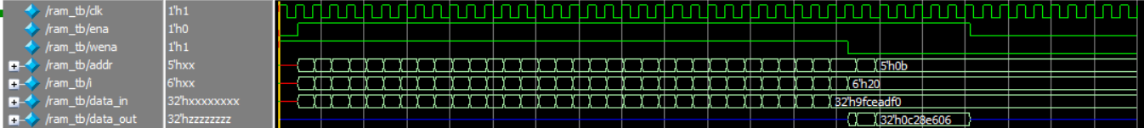
- 单线输入输出ram
  - modelsim波形仿真图
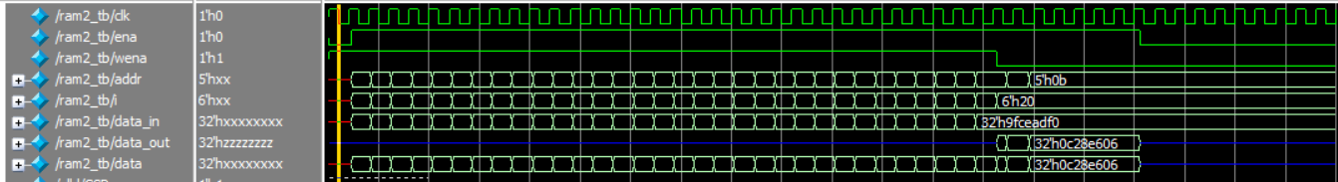
- 寄存器堆
  - logisim模拟电路图
赋值：
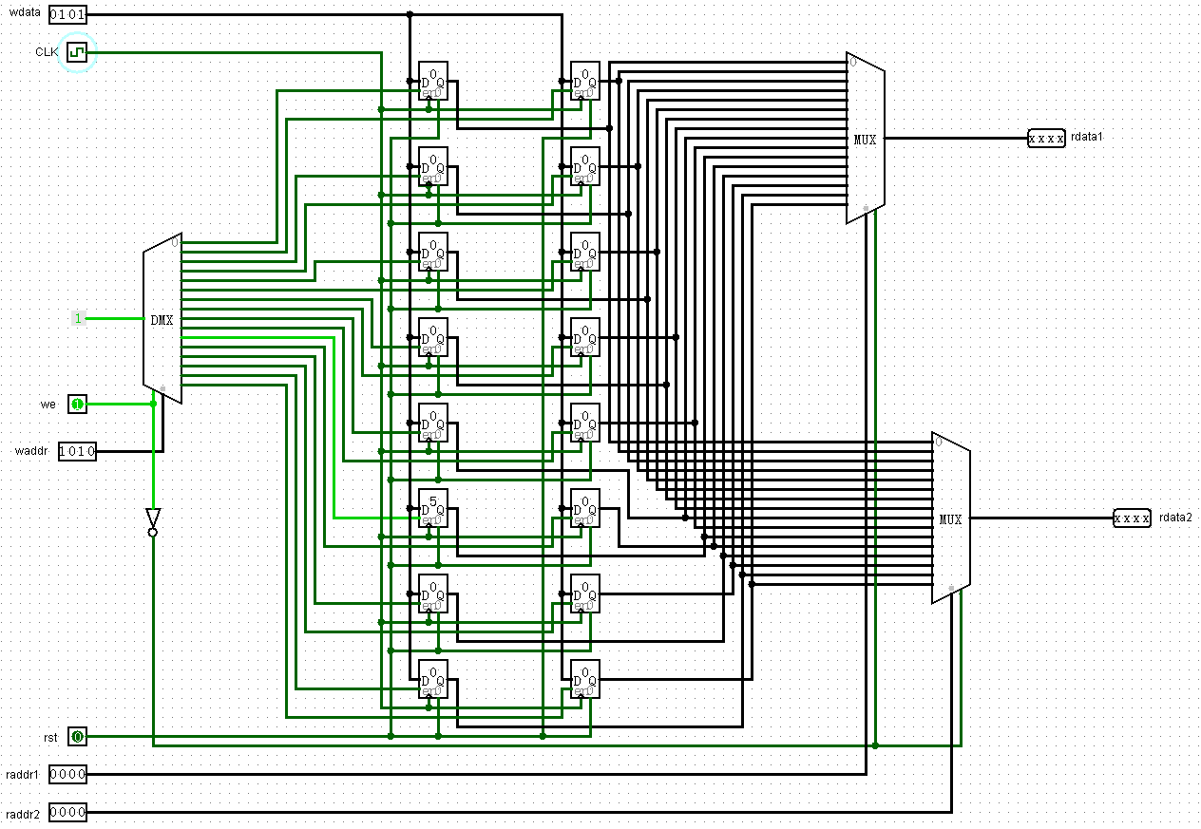
取值：
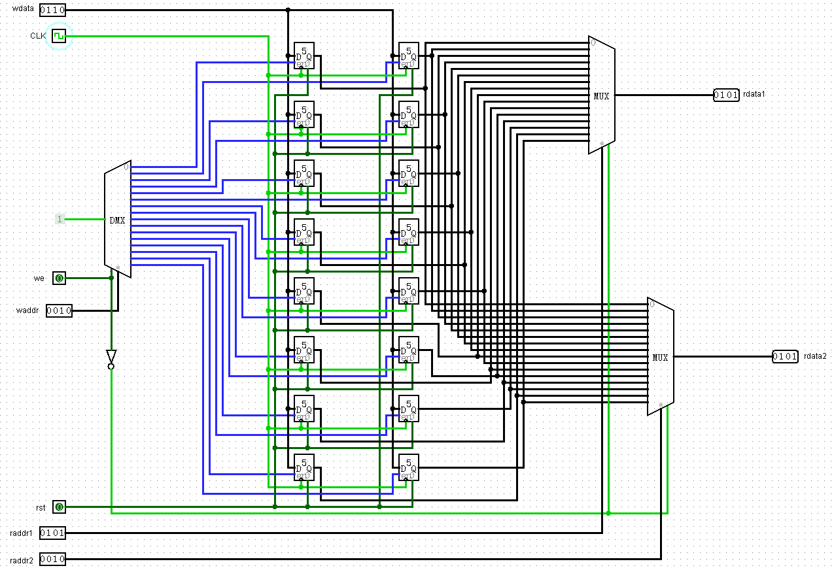
清零：
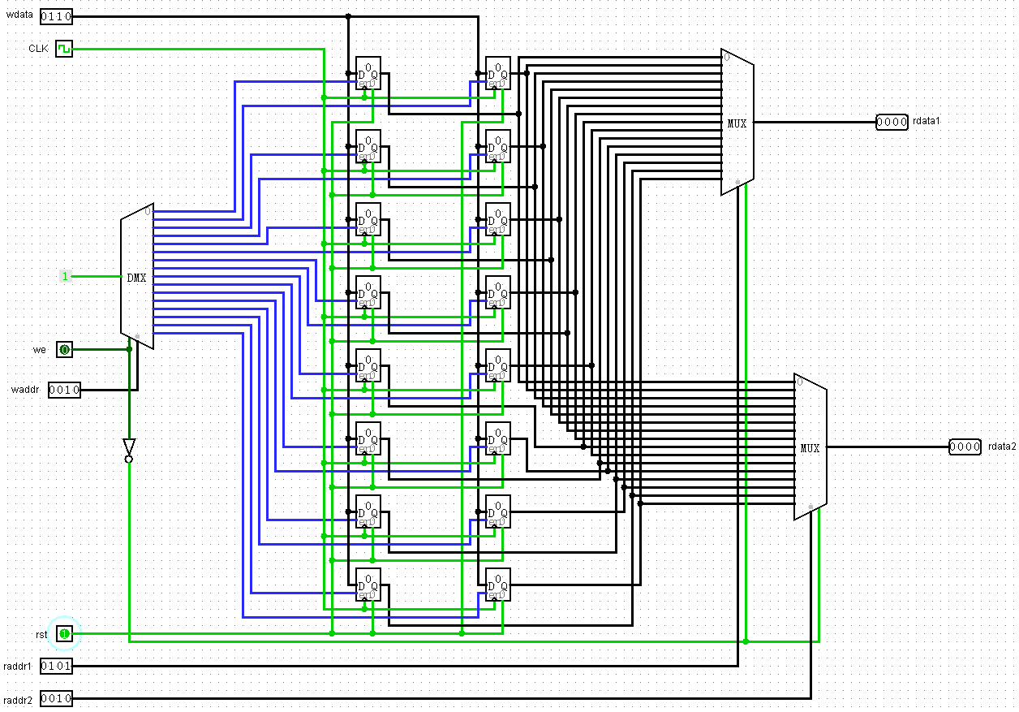
  - modelsim波形仿真图
