**COMP 3123 – Full Stack Development – Lab 1**

* JavaScript Refresher Exercises

**Developer Note:**

* Answer any 4 of the JavaScript exercises below
* Try to solve the problems without using search engines or stack overflow for the solutions.

**Exercise 1:**

***Write a JavaScript program to capitalize the first letter of each word of a given string.***

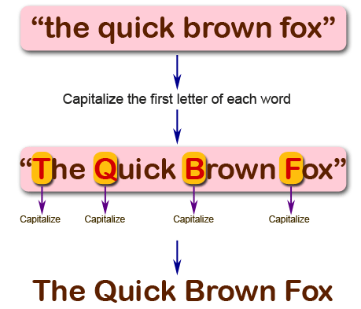

<script>

function capitalizeFirstLetter(inputString) {

const words = inputString.split(" ");

const storeWords = [];

for (const word of words) {

if (word.length === 0) {

storeWords.push(word);

} else {

const capLetter = word.charAt(0).toUpperCase();

const restLetters = word.slice(1);

storeWords.push(capLetter + restLetters);

}

}

return storeWords.join(' ');

}

const test = capitalizeFirstLetter("hello there");

console.log(test);

</script>

**Exercise 2:**

***Write a JavaScript program to find the largest of three given integers.***

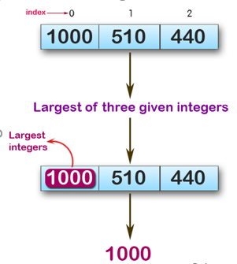

console.log(max (1,0,1));

console.log(max (0,-10,-20));

console.log(max (1000,510,440));

**Sample Output:**

1  
0  
100

<script>

function max(firstNum, secondNum, thirdNum) {

if (firstNum >= secondNum && firstNum >= thirdNum) {

return firstNum;

} else if (secondNum >= firstNum && secondNum >= thirdNum) {

return secondNum;

} else {

return thirdNum;

}

}

console.log(max(5,-2,30));

</script>

**Exercise 3:**

*Write a JavaScript program to move last three character to the start of a given string. The string length must be greater or equal to three****.***

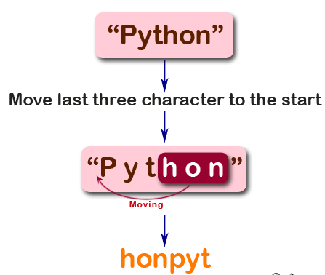

console.log(right("Python"));

console.log(right("JavaScript"));

console.log(right("Hi"));

**Sample Output:**

honPyt  
iptJavaScr  
Hi

<script>

function right(inputString) {

const restWords = inputString.slice(0, -3);

const lastThree = inputString.slice(-3);

const switchWord = lastThree + restWords;

return switchWord;

}

console.log(right("Python"));

</script>

**Exercise 4:**

*Write a JavaScript program to find the types of a given angle.*

Types of angles:  
• Acute angle: An angle between 0 and 90 degrees.  
• Right angle: An 90 degree angle.  
• Obtuse angle: An angle between 90 and 180 degrees.  
• Straight angle: A 180 degree angle.

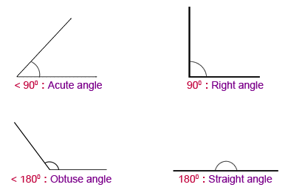

console.log(angle_Type(47))

console.log(angle_Type(90))

console.log(angle_Type(145))

console.log(angle_Type(180))

**Sample Output:**

Acute angle  
Right angle  
Obtuse angle  
Straight angle

<script>

function angleType(angle) {

if (angle >= 0 && angle < 90) {

return "Acute angle";

} else if (angle == 90) {

return "Right angle";

} else if (angle > 90 && angle < 180) {

return "Obtuse angle";

} else if (angle == 180) {

return "Straight angle";

} else {

return "Invalid angle";

}

}

console.log(angleType(90));

</script>

**Exercise 5:**

*Write a JavaScript program to find the maximum possible sum of some of its k consecutive numbers (numbers that follow each other in order.) of a given array of positive integers.*

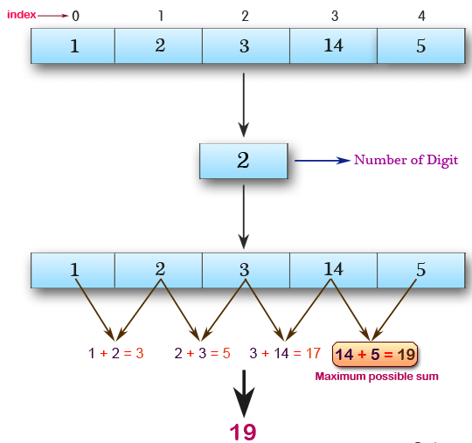

console.log(array_max_sum([1, 2, 3, 14, 5], 2))

console.log(array_max_sum([2, 3, 5, 1, 6], 3))

console.log(array_max_sum([9, 3, 5, 1, 7], 2))

**Sample Output:**

19  
12  
12