# kjlnaeerv (awekncv) Sonobuoy Report

### Tue Jul 24 2018

Navy surplus sonobuoys (type-NA) were deployed from the survey vessel during awekncv; this report includes deployments conducted between Aug 08 2014 and Dec 08 2014 on the vessel(s) *asdcxc*. Sonobuoys were programmed to allow for best performance (Table 1). Sonobuoy signals were received via shipboard antenna cabled to a Winradio sonobuoy receiver (model WR-G39WSBE). Recordings were digitized at a 48 kHz sampling rate with a PAM_20140808_041739.wav and recorded to hard drive using Pamguard software (Pamguard version xxxx, Gillespie et al. 2008).

Detection and localization of calls used the Pamguard DIFAR module (Miller et al. 2014); sonobuoys were calibrated following methods developed by Miller et al. (2014). Calibrations consisted of [x] number of samples, with each sample consisting of [x] s clips with a minimum interval of [x] s between clips. Classification settings were customized for calibration on vessel noise and for analysis of specific call types (Table 2).

A total of 182 sonobuoys were deployed at 91 locations throughout the study area (Fig. 1). (Table 1). Deployments included 91 sonobuoy stations and 0 sonobuoys deployed opportunistically in the presence of sighted cetaceans (Table 1). Acoustic detections included species name bma, bmb, and bp (Table 2, Figure 2).

**Literature**

Gillespie, D., Gordon, J., McHugh, R., McLaren, D., Mellinger, D. K., Redmond, P., Thode, A., Trinder, P., and Deng, X.Y. 2008. PAMGUARD: Semiautomated, open source software for realtime acoustic detection and localisation of cetaceans, Proc. Inst. Acoustics.

Miller, Brian S., D. Gillespie, G. Weatherup, S. Calderan, and M. C. Double. 2014. Software for the localization of baleen whale calls using DIFAR sonobuoys: PAMGuard DIFAR. Report to the International Whaling Commission SC/65b/SH06. 7pp.

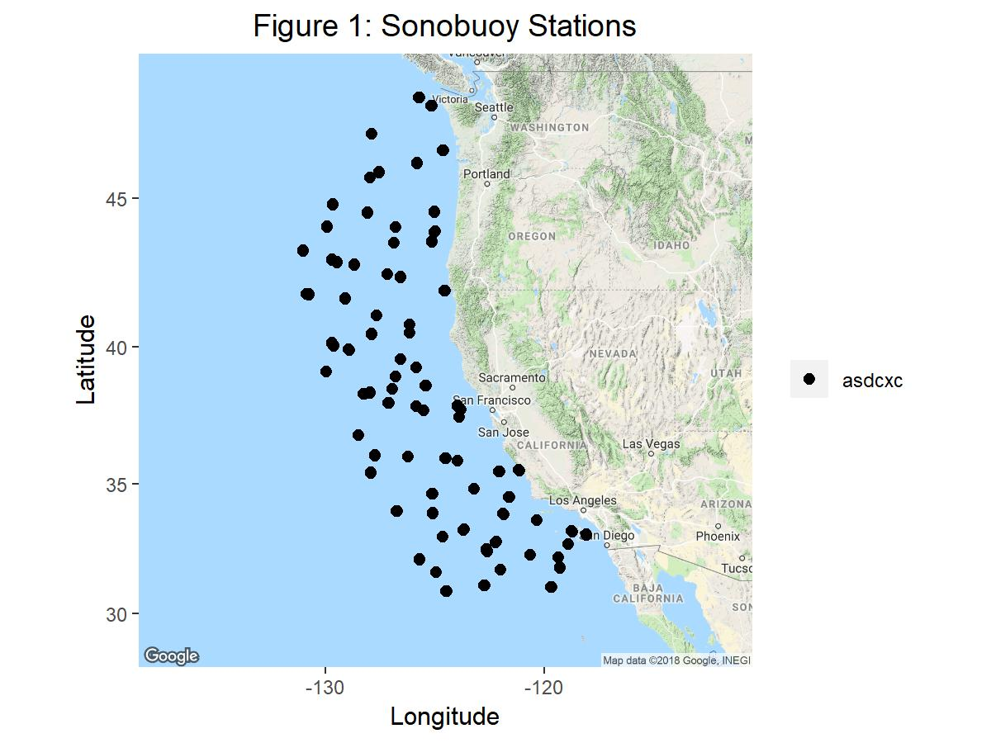

Figure 1: Map of Sonobuoy Stations during the awekncv survey for vessel(s) *asdcxc* (Black)

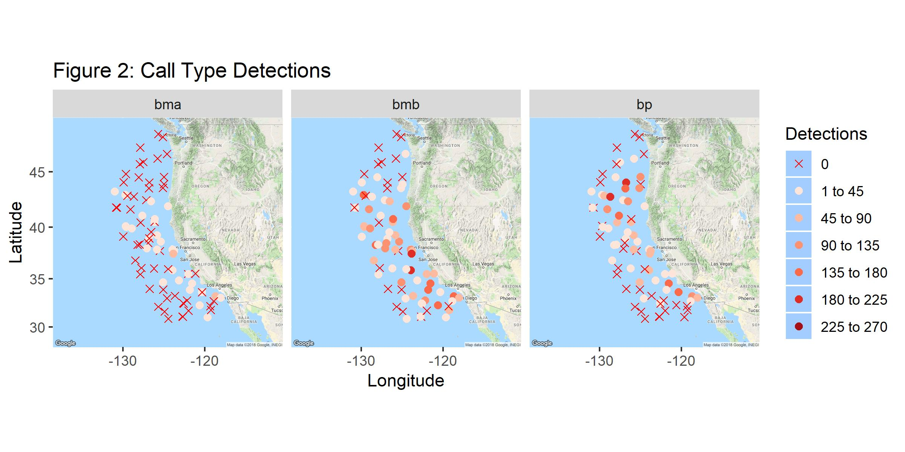

Figure 2: Acoustic detection of call types attributed to species [x]

##### 

Table 2: description and title here  
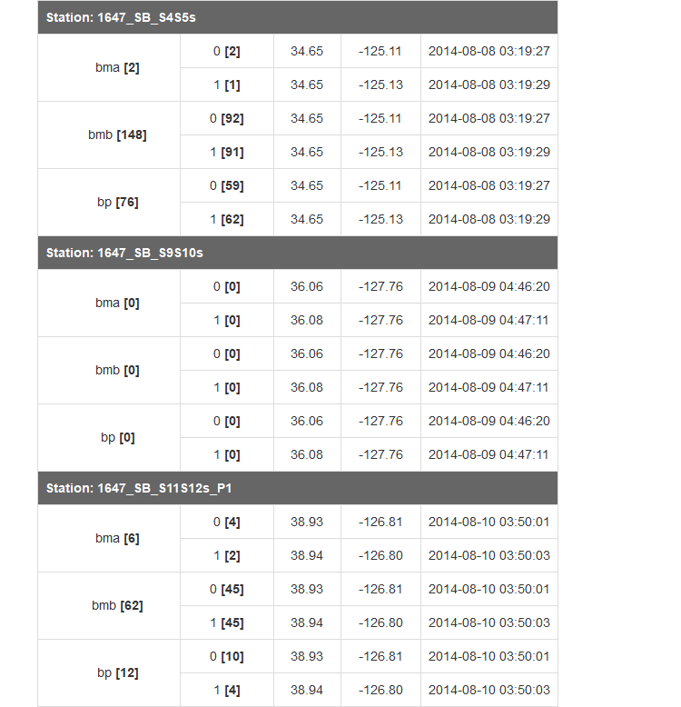

##### 

Table 2 (cont.)  
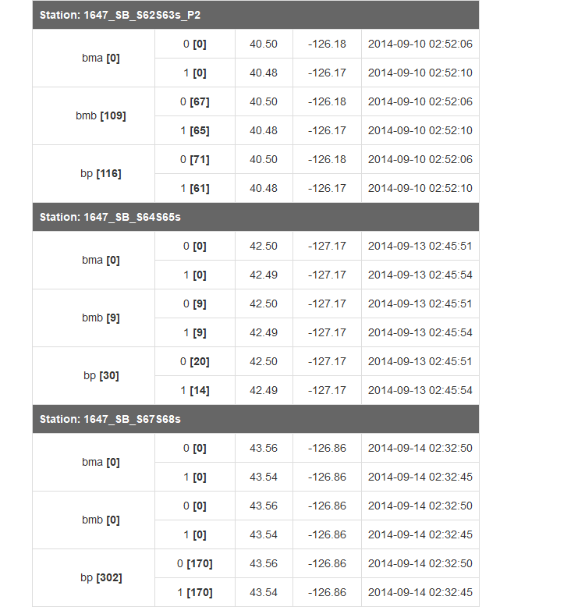

##### 

Table 2 (cont.)  
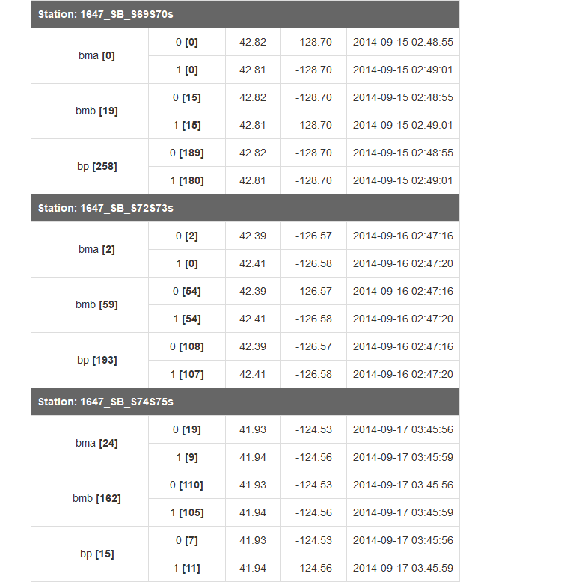

##### 

Table 2 (cont.)  
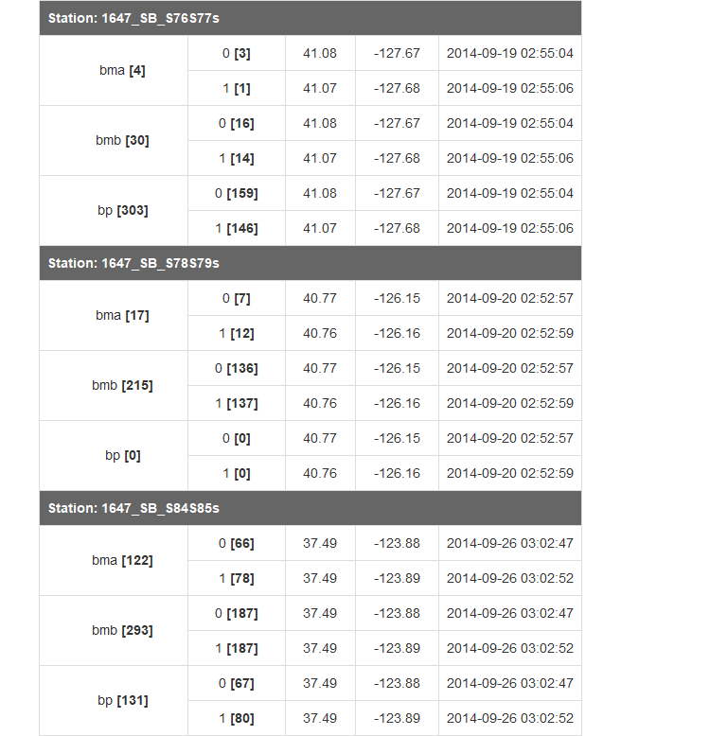

##### 

Table 2 (cont.)  
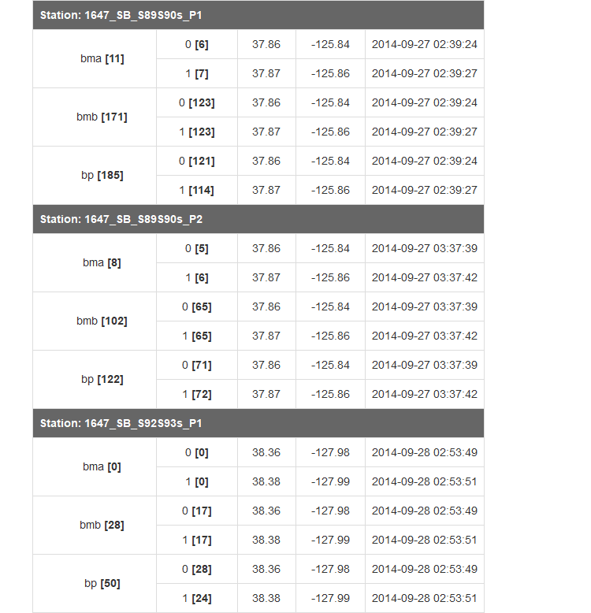

##### 

Table 2 (cont.)  
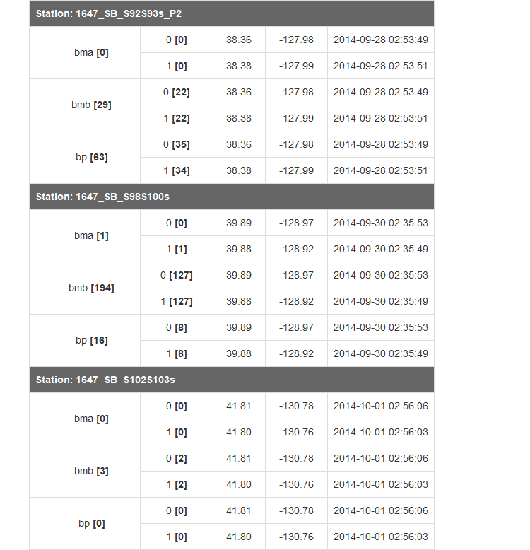

##### 

Table 2 (cont.)  
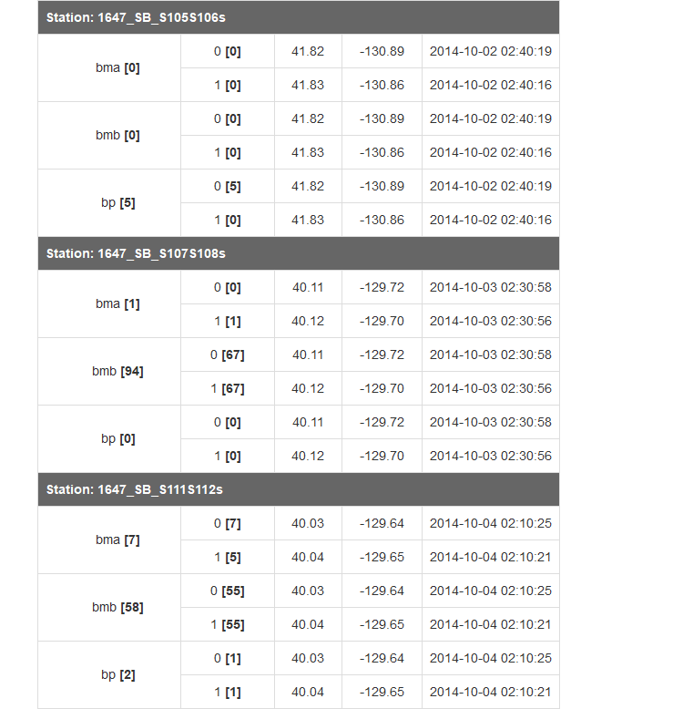

##### 

Table 2 (cont.)  
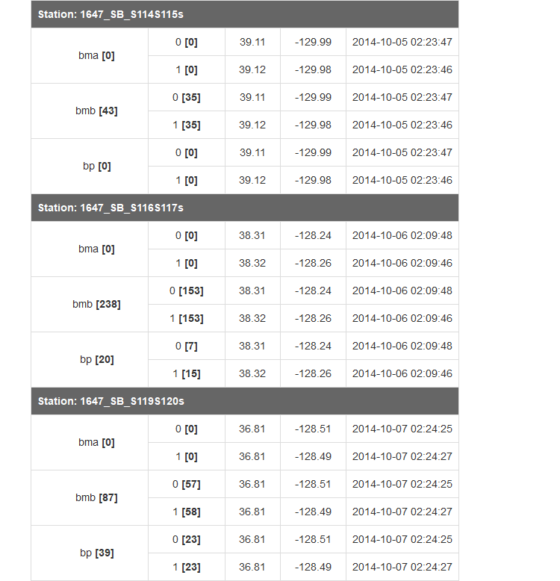

##### 

Table 2 (cont.)  
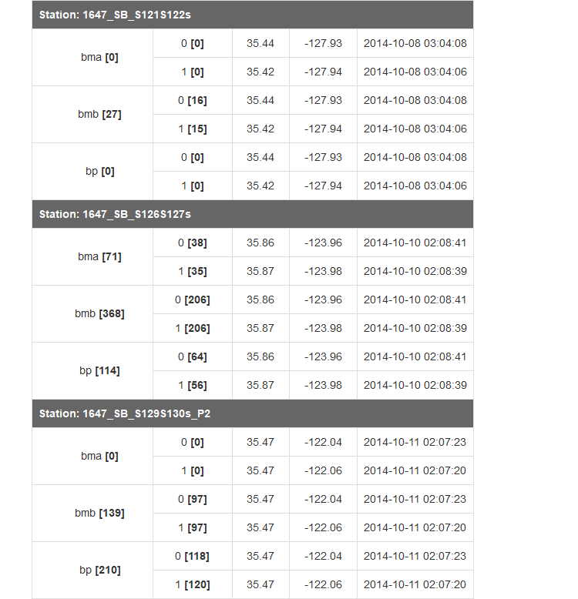

##### 

Table 2 (cont.)  
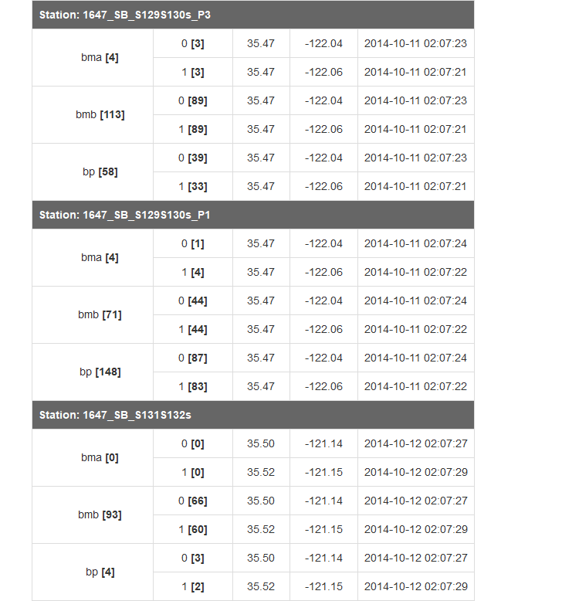

##### 

Table 2 (cont.)  
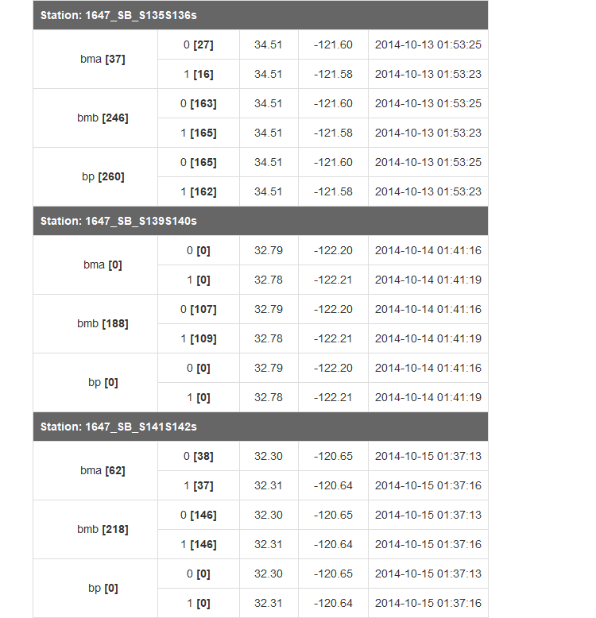

##### 

Table 2 (cont.)  
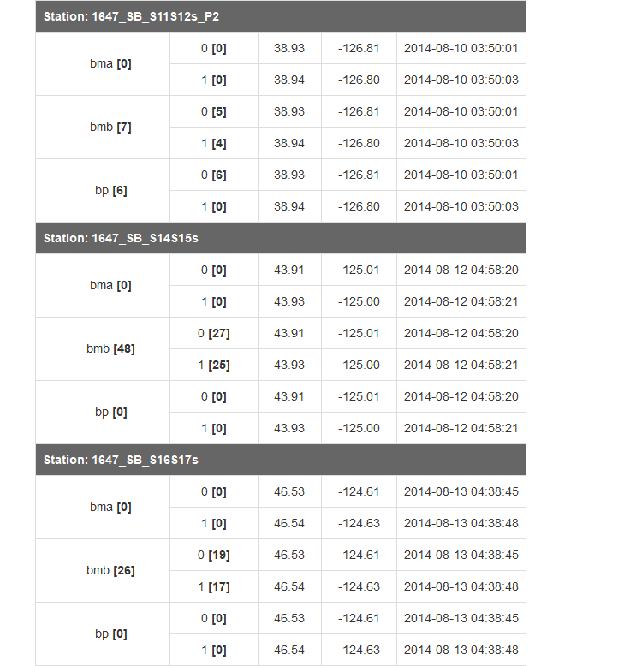

##### 

Table 2 (cont.)  
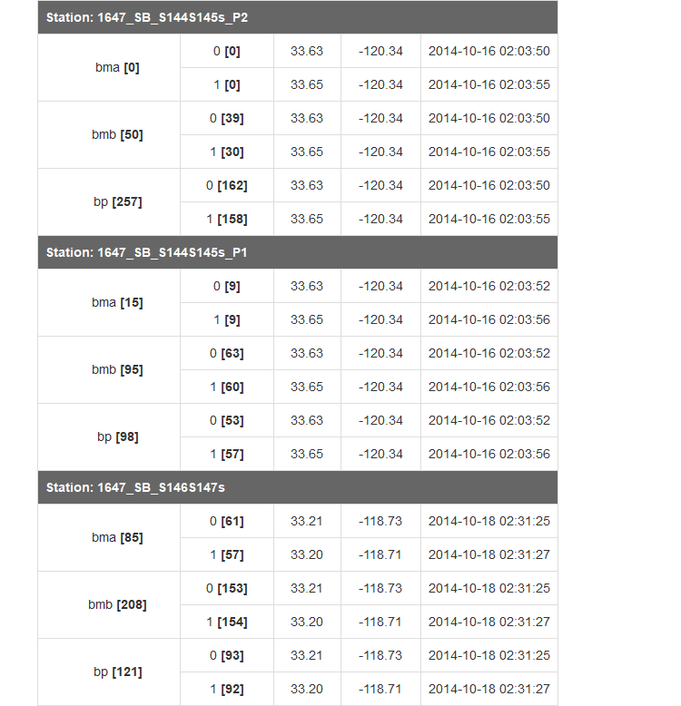

##### 

Table 2 (cont.)  
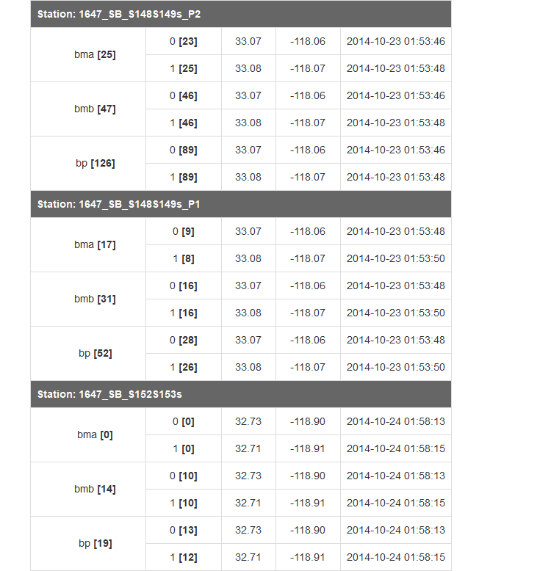

##### 

Table 2 (cont.)  
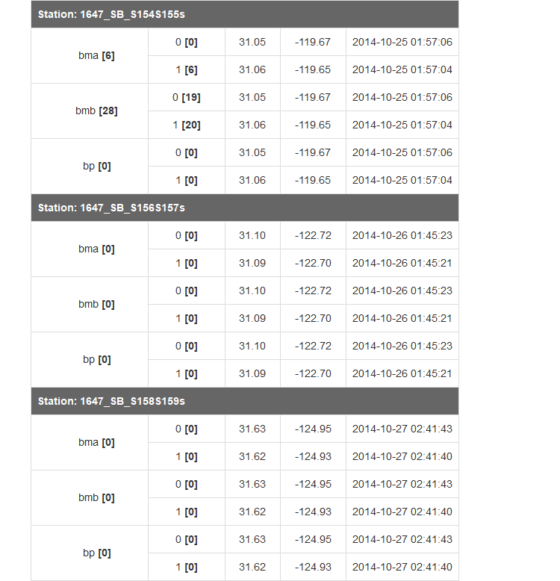

##### 

Table 2 (cont.)  
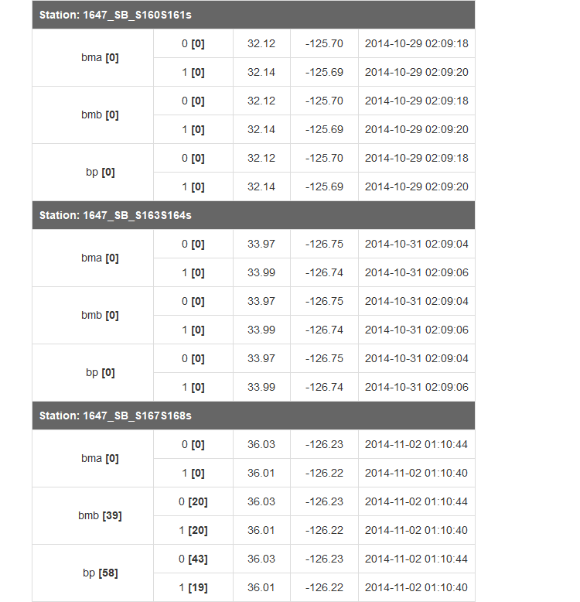

##### 

Table 2 (cont.)  
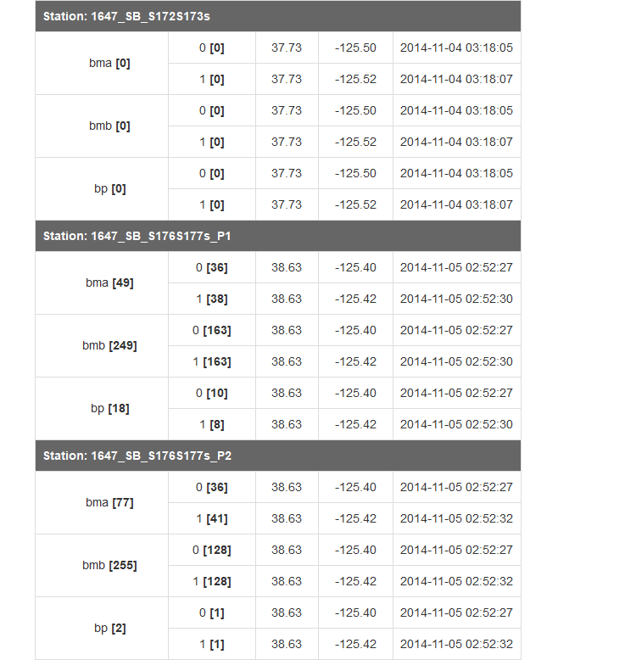

##### 

Table 2 (cont.)  
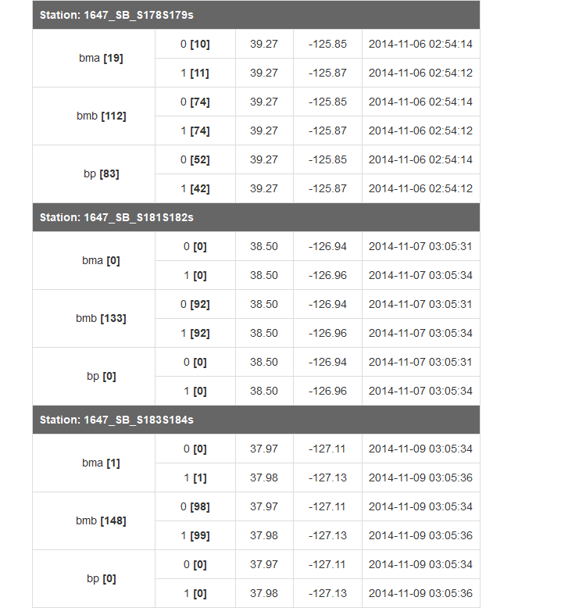

##### 

Table 2 (cont.)  
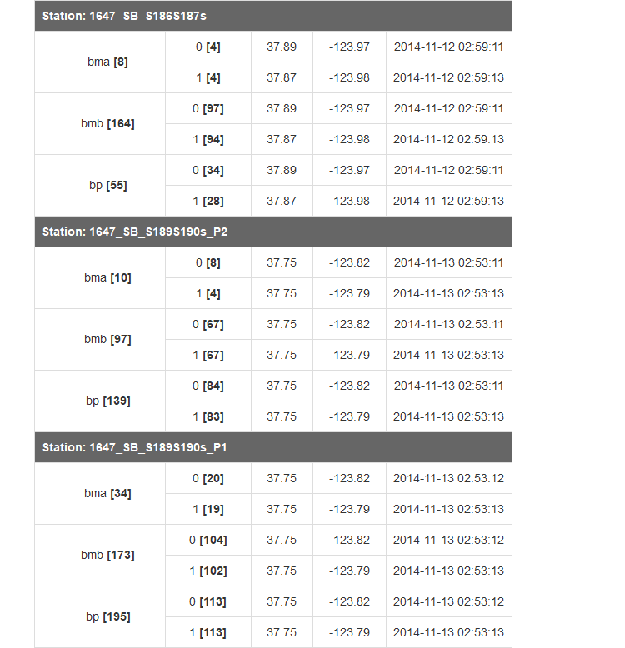

##### 

Table 2 (cont.)  
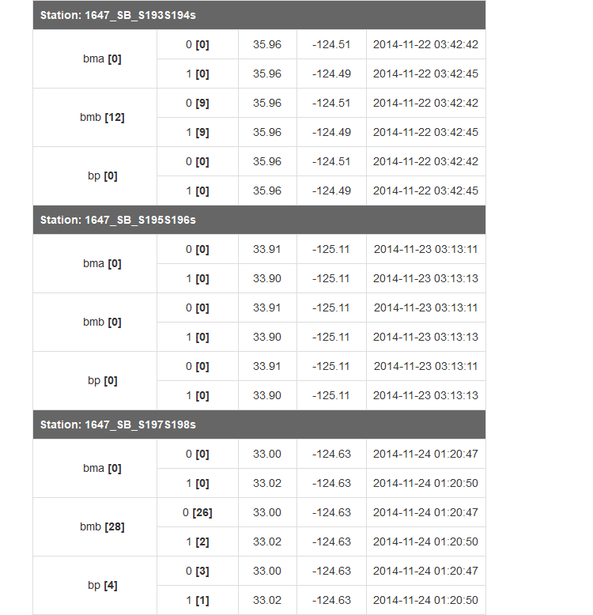

##### 

Table 2 (cont.)  
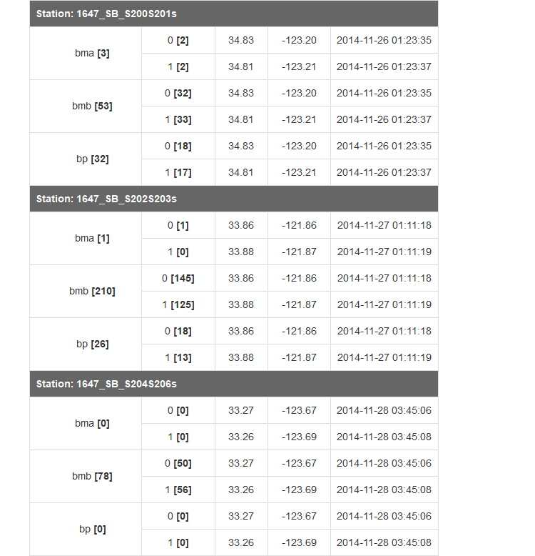

##### 

Table 2 (cont.)  
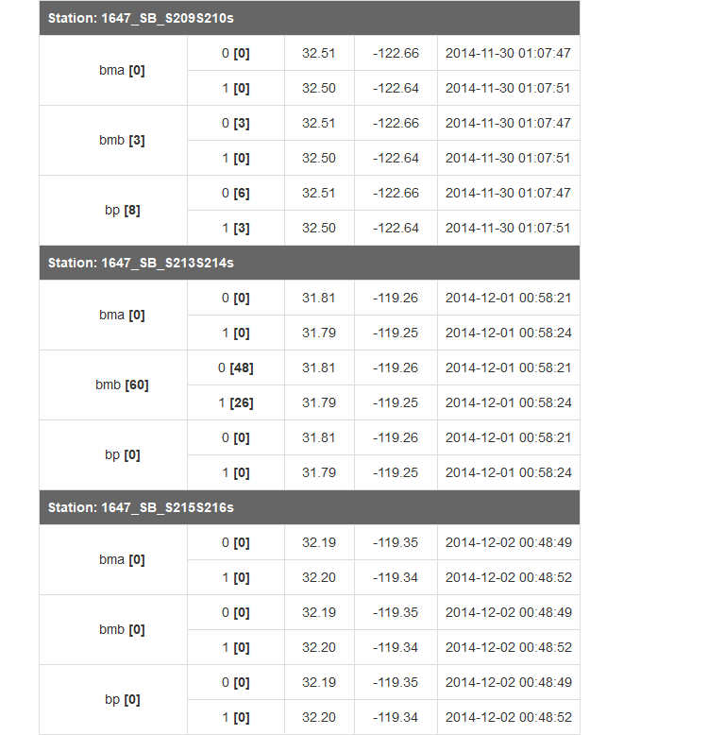

##### 

Table 2 (cont.)  
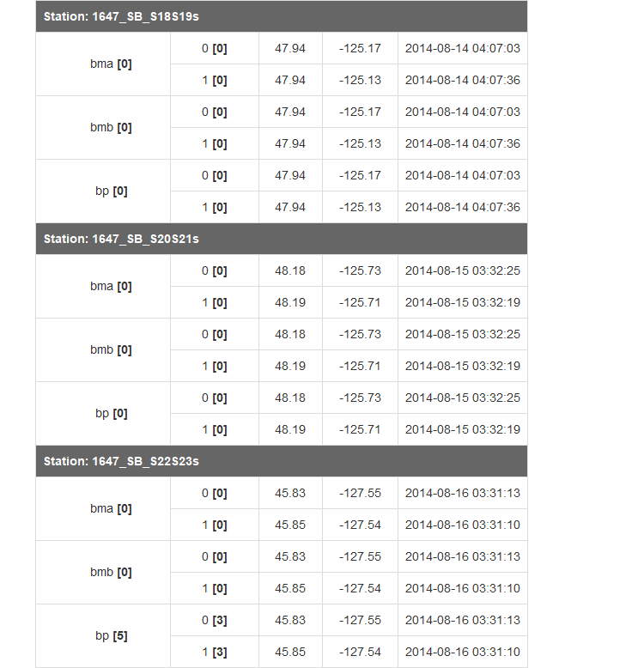

##### 

Table 2 (cont.)  
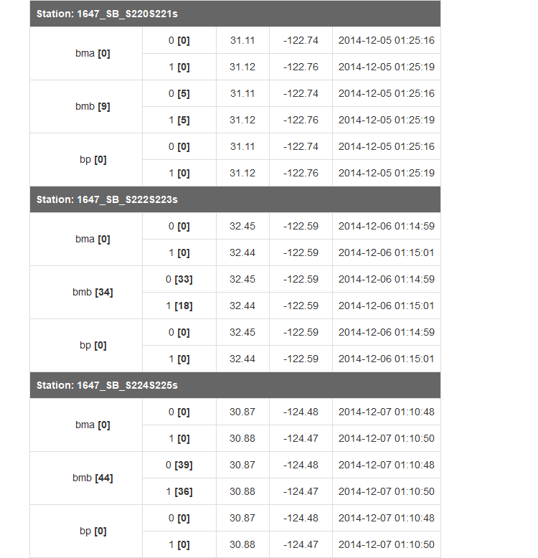

##### 

Table 2 (cont.)  
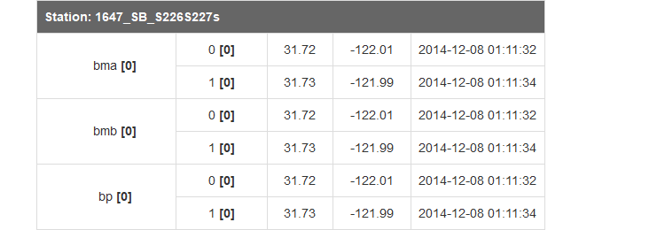

##### 

Table 2 (cont.)  
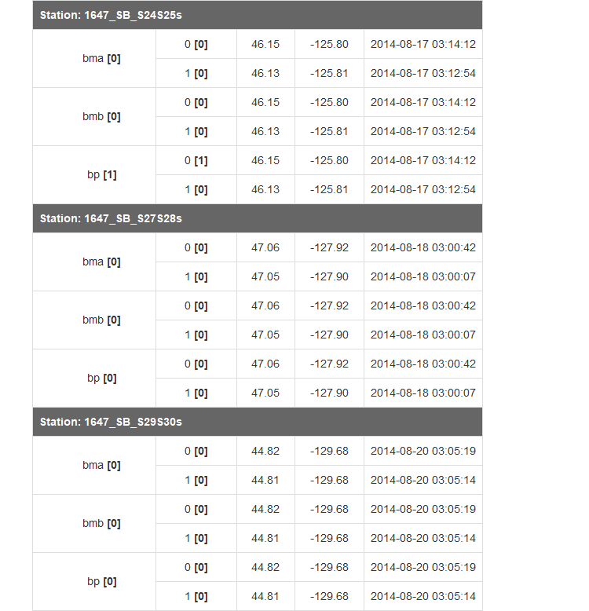

##### 

Table 2 (cont.)  
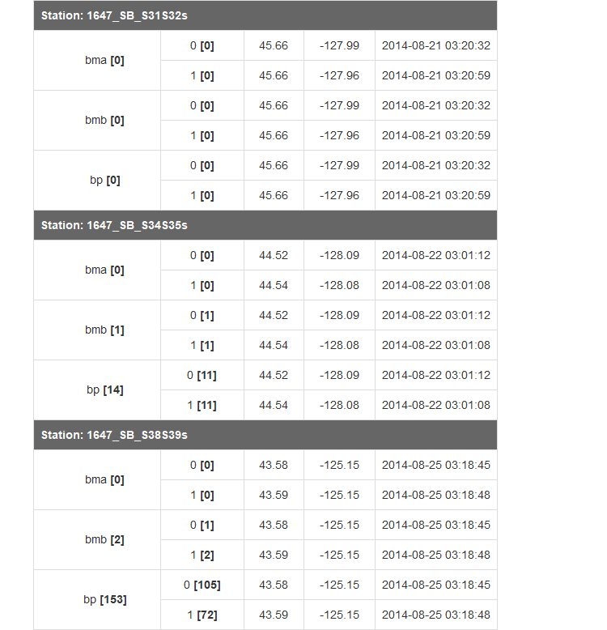

##### 

Table 2 (cont.)  
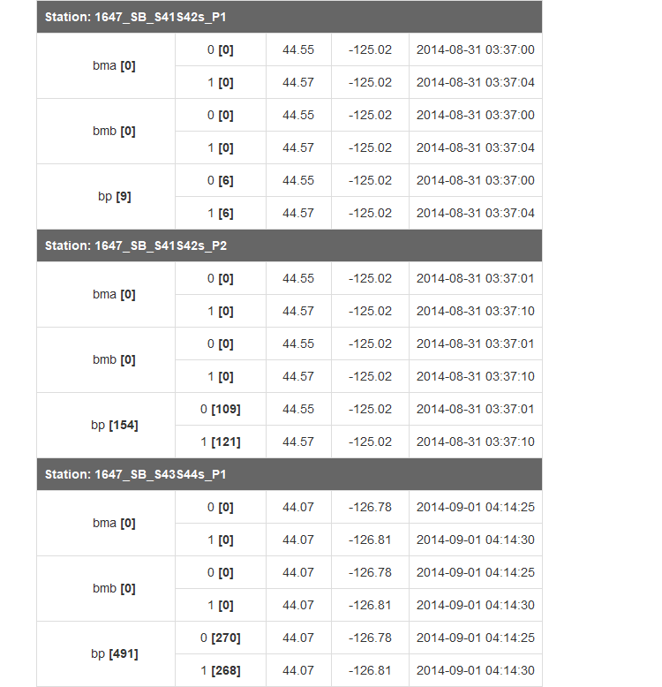

##### 

Table 2 (cont.)  
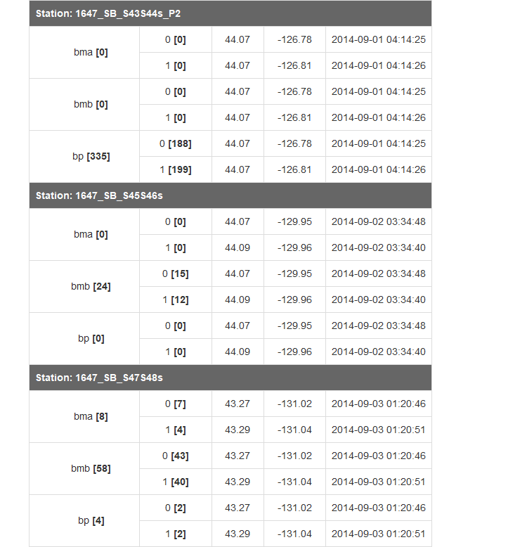

##### 

Table 2 (cont.)  
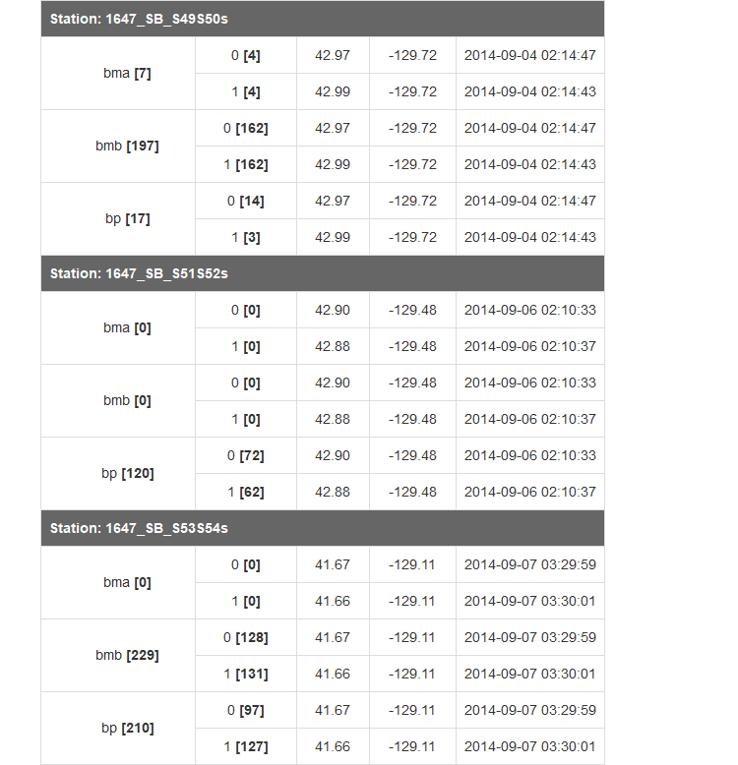

##### 

Table 2 (cont.)  
