Swing Point Alternatives Integration and Comparison
This report compares percentage reversal and volatility-scaled ATR reversal with traditional TA. The alternatives produce fewer swings with longer confirmation delays. Both run correctly through the shared application, but neither improves aggregate profit and loss under the base-cost assumptions.

Integration with the existing application
The supplied main already contains all three alternative swing algorithms and the SwingMethod interface. This addition reuses PercentageReversalMethod and ATRReversalMethod, then connects them to a focused Steps 1–6 comparison. It adds a command, editable settings, paired results, diagnostic plots and integration tests.
Step 1 loads the same prices. Step 2 selects one swing detector. All methods then share Step 3 candidate construction and validation, Step 4 breakout confirmation, and Steps 5–6 trade execution and accounting. Only the swing method and its attributes change. Prominence remains available in the application but is outside this two-alternative experiment.

How the three methods identify swings
Traditional TA uses strict Close extrema with two completed bars on each side. A pivot becomes available two bars after its occurrence.
Percentage reversal confirms a running extreme after a 5% move in the opposite direction. For example, a running high of 100 is confirmed when Close reaches 95 or below. Confirmation delay varies with the subsequent prices.
ATR reversal requires an opposite move of two times the 14-bar Wilder Average True Range. ATR measures recent price-range volatility. Its value is frozen at the candidate extreme and refreshed only by a new extreme. A final unconfirmed extreme is excluded.

Test design and profit and loss
The test uses 25,180 daily records for 20 stocks. The data span February 2013 to February 2018. Four separate test blocks cover 2014, 2015, 2016 and January 2017 to 7 February 2018. Earlier history provides warm-up; each stock starts each block flat with 10,000 units.
Positions hold one share, long or short. Entry is at the next Open after confirmation. The stop is two signal-time ATR(14) units away; the target is twice that risk distance. Occupied signals are skipped. Trendline tolerance is 0.5%; break confirmation requires two closes. Parameters were fixed, without fitting to these results.
Method | Zero costs | Base costs | Stress costs
Traditional TA | 234.39 | -61.62 | -1,049.01
Percentage | -75.14 | -227.31 | -480.89
ATR reversal | -144.62 | -317.65 | -749.02
Table 1. Total net marked P/L in input price units across independently reset blocks. These are sums, not compounded returns.
Base costs apply 5 basis points of adverse slippage per fill, a 0.10 fee per order and 3% annual short borrowing. Stress costs use 10 basis points, 0.50 and 6%. One basis point is 0.01%. Zero costs exclude all three charges.
Net marked P/L adds realized P/L from closed trades and unrealized P/L from open positions, after incurred costs. Open positions remain marked at the final Close; no hypothetical exit fee is charged. Under base costs, one-share buy and hold produces +2,267.94 using the same stocks and test blocks.

Swing differences and validation
Method | Swings | Mean delay | Trades
Traditional TA | 5,748 | 2.00 | 885
Percentage | 635 | 10.17 | 274
ATR reversal | 1,149 | 6.14 | 452
Table 2. Confirmed swings, event-weighted delay in observed bars, and filled trades under base costs. Counts cover 80 stock-period blocks per method.
A swing is counted when it becomes confirmed, even if its pivot lies in warm-up. Delay is the number of observed bars between pivot and confirmation. The alternatives suppress small reversals but wait longer for evidence. Fewer swings also mean different trendline anchors and breakout signals; the later-stage rules themselves are identical.
Median detector times were Traditional TA 1.488 ms, Percentage 0.223 ms, ATR reversal 0.583 ms. Each case uses the median of three replays; these figures summarize 80 cases per method. Timing excludes loading, Steps 3–6, exports and charts. It measures this implementation on this machine, not universal algorithm speed.

Validation and limits
All 156 tests pass, including nine new comparison tests. The 720 backtests pass independent Decimal accounting checks over 185,940 equity records. The largest error is below 0.00000001 units. All 720 swing-prefix checks and 12 trade-prefix checks pass. Corresponding P/L results exactly match the earlier backtesting run.
This previously used dataset is not an untouched holdout. Daily bars cannot resolve every intraday price path. Dividends and interest are excluded. One-share sizing leaves most capital idle, making account drawdowns small.

Interpretation and use
Traditional TA has the smallest aggregate loss at base costs. Percentage reversal beats TA in 46 of 80 individual base-cost blocks, but its larger losing blocks make its total worse. Both alternatives lose less than TA under stress costs, where lower trading frequency helps; all three still lose money.
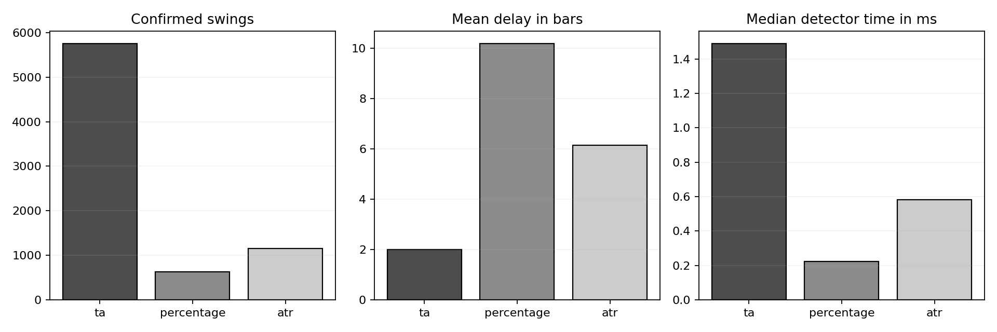
Figure 1. Differences in swing frequency, confirmation delay and detector runtime. Full price and trendline comparisons are included with the exported results.
The implementation works as specified. This experiment does not establish that either alternative is a more profitable replacement for TA. Keep the alternatives available for controlled parameter comparisons, then evaluate any selected settings on newer data that were not used for selection.

Run the comparison
After applying the backtesting and swing-comparison additions, activate the existing Python environment in swingpoints_project and run:
python compare_swing_methods.py --output swing_method_results/my_run
Edit methods[].attributes in swing_comparison_plan.json to change thresholds. The existing GUI selects swing methods; the command above runs the full trade comparison. Exported CSV tables and validation JSON files document the results.

