Backtesting Implementation and Results
  - Financial Technical Analysis application
The application completed 960 historical simulations and passed the numerical checks. However, all four swing methods had negative total net profit/loss under the base-cost assumptions. The implementation is suitable for further research; these results do not support a claim that the current trading rules are profitable.

Data and compatibility
We used Cam Nugent’s S&P 500 stock dataset on Kaggle, published under CC0. Its download script identifies IEX as the upstream provider. The source contains 619,040 rows for 505 symbols. We selected 20 stocks before calculating strategy returns, giving 25,180 daily observations from 8 February 2013 to 7 February 2018. [1]
The sample includes AAPL, MSFT, AMZN, GOOGL, JPM, BAC, XOM, CVX, JNJ, PFE, PG, KO, WMT, HD, GE, BA, CAT, MMM, DIS and VZ. Each has 1,259 records. The adapter separates symbols, renames date to timestamp, and preserves Open, High, Low, Close and Volume. All selected rows passed the existing price loader; no prices were filled in or interpolated.

Chronological experiment
The test blocks are 2014, 2015, 2016, and January 2017 to 7 February 2018. Earlier records provide warm-up history; the first block has 226 prior bars. Each block starts flat with 10,000 units of capital per stock, or 200,000 across 20 separate accounts. Positions and profits do not carry between blocks.
The matrix is 20 stocks × 4 methods × 4 blocks × 3 cost cases. Parameters were fixed before the run. No optimization or random train/test split was used. Cost cases share the same market history, so the 960 simulations are not 960 independent samples.

Trading rules and profit calculation
The runner reuses the application’s swing detection, candidate trendline validation and Step 4 breakout events. TA uses a two-bar window; percentage reversal uses 5%; ATR reversal uses ATR(14) × 2; prominence uses radius 5, prominence 3% and spacing 3. Every method uses Close-based trendlines with 0.5% tolerance and a 20-swing lookback.
A break must survive two consecutive closes. The five-bar false-break window remains active, but a later failure cannot erase an earlier trade. Only confirmations inside the test block can enter. Entries fill at the next observed Open, a standard event-driven convention that avoids using an already observed Close as an executable price. [2]
The engine trades one share at a time per stock and permits both long and short positions. Average True Range (ATR) measures recent price ranges including gaps. ATR(14) at confirmation fixes the stop distance at 2 ATR; the profit target is twice this distance. Stops and targets stay fixed. EMA filtering and false-break/opposite-signal exits are off.
$P_{net} = dq(P_{exit} − P_{entry}) − F − B$
Here d is +1 for a long position and −1 for a short; q is the number of shares; entry and exit prices include modelled slippage. F is the sum of entry and exit fees, and B is accrued short-borrow cost. Slippage is not deducted again.
$E_{final} = E_{initial} + P_{realized} + P_{open}$
E denotes account equity. Realized P/L belongs to closed trades. Open P/L values remaining positions at the last Close, including costs already incurred. No final sale or extra exit fee is invented. Account return is net P/L divided by initial equity, multiplied by 100.
Buy-and-hold buys the same one share per stock at the first test Open, pays the same entry costs and marks the last Close. Cash earns zero. Dividends, taxes and interest on idle cash are excluded; reported P/L is simulated, price-only profit rather than live realized earnings.

Results across stocks and periods
Table 1 gives net marked P/L at base costs, in the input’s US-equity price units. Each cell aggregates 20 separately funded stock accounts. Positive values are gains and negative values are losses.
Test block | TA | Percentage | ATR | Prominence | Buy and hold
2014 | -131.57 | 29.17 | -74.15 | 20.88 | -3.06
2015 | -293.77 | 29.13 | 42.32 | -37.02 | 555.45
2016 | 220.98 | -163.76 | -227.23 | -265.16 | 322.48
2017 to Feb 2018 | 142.74 | -121.84 | -58.59 | 15.69 | 1,393.07
Block sum | -61.62 | -227.31 | -317.65 | -265.60 | 2,267.94
Table 1. Base costs are 5 basis points of adverse market-fill slippage, 0.10 per order and 3% annual short borrow. One basis point is 0.01%. The block sum adds independent experiments; it is not a compounded account return.
Traditional TA lost 131.57 in 2014 and 293.77 in 2015, then gained 220.98 in 2016 and 142.74 in the final block. Its combined net P/L is −61.62, comprising −55.49 realized P/L and −6.14 from open positions at the four cutoffs. These components are rounded separately.
TA produced 885 entries and 822 closed trades, with 293 winners: a 35.64% win rate. Its profit factor is 0.98, meaning positive closed net P/L was smaller than the absolute total of negative closed net P/L. A reasonable win rate alone therefore does not establish profitability.
All four methods have negative base-cost sums and trail the same-quantity buy-and-hold sum of 2,267.94. Percentage reversal and prominence beat buy-and-hold in the 2014 block, but neither sustained that advantage. Across the 320 base-cost stock/method/block runs, 117 were positive and 19 made no trades.

Transaction costs and interpretation
Method | Zero costs | Base costs | Stress costs
Traditional TA | 234.39 | -61.62 | -1,049.01
Percentage | -75.14 | -227.31 | -480.89
ATR reversal | -144.62 | -317.65 | -749.02
Prominence | -106.94 | -265.60 | -497.98
Table 2. Net P/L summed across independent blocks. Stress costs use 10 basis points of market-fill slippage, 0.50 per order and 6% annual borrow. These are sensitivity assumptions, not historical broker quotations.
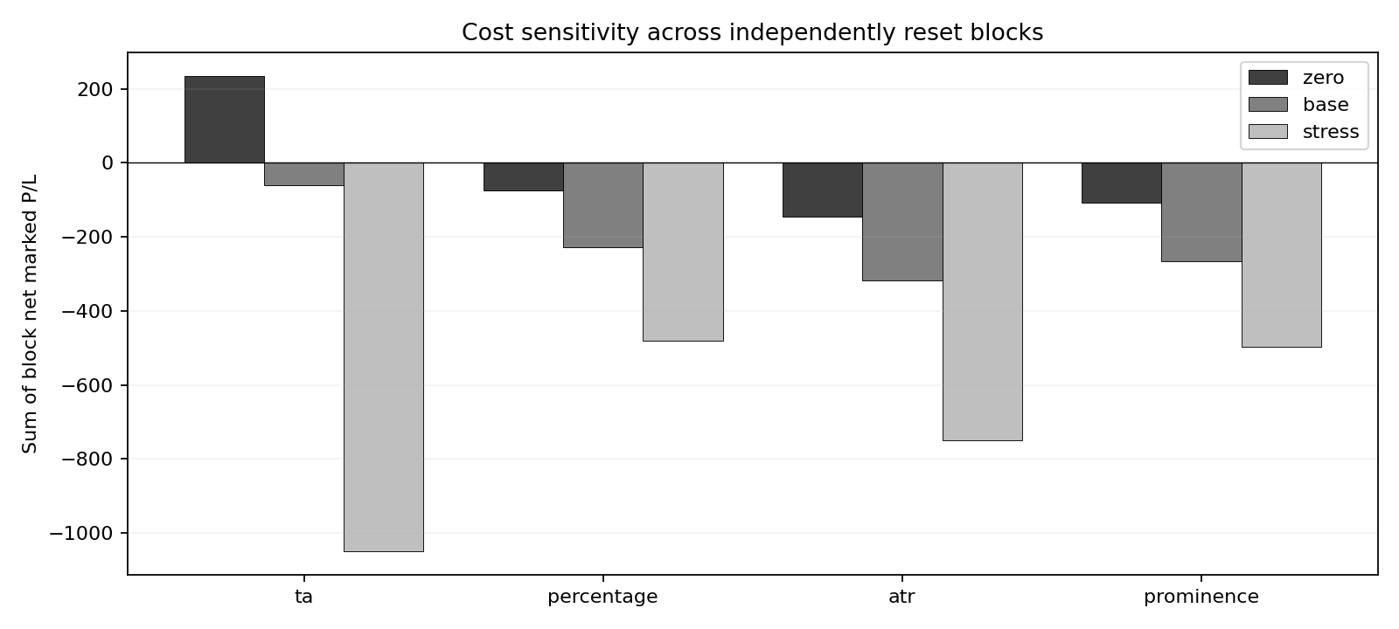
Figure 1. Costs remove TA’s small gross advantage. All methods are negative at both base and stress costs.
Borrow uses entry notional and elapsed days divided by 365. Costs can change subsequent trades, so scenario differences are not simply fees deducted from identical trades.
Drawdown measures a fall from peak closing equity. TA’s largest base-cost block drawdown is 0.168%. One-share sizing leaves most of the 200,000 capital idle, while higher-priced shares create larger exposures. A fully invested version could have substantially larger drawdowns.

Validation and conclusion
All 147 automated tests passed, including 34 added tests. Independent Decimal arithmetic reconstructed 247,920 closing-equity values across all 960 runs and 5,519 filled trades. The largest discrepancy was below 0.000000000003 price units. Sixteen AAPL midpoint replays across the four methods and four blocks preserved earlier confirmed events and equity.
One audited example is AAPL’s first TA short in 2014. It confirmed on 3 January, entered on 6 January at 76.74011075 and stopped on 15 January at 79.40027952. One share lost 2.66016877 before costs. Fees of 0.20 and nine days of borrow costing 0.05676666 give net P/L of −2.91693543, or −2.92 when rounded. The ledger retains full precision.
Daily bars do not reveal the order of intraday prices. The engine takes the stop first when both stop and target occur within a bar; three base-cost TA exits used this rule. Opening gaps are handled separately. These assumptions, short availability and real execution spreads still require validation.
The data are an old, selected S&P snapshot rather than a point-in-time universe. Survivorship bias, uncertain adjustment conventions and omitted dividends limit the economic conclusions. The sample also ends before modern market regimes and tests daily, not intraday, settings. Backtested performance remains hypothetical. [3]
The code is ready for continued testing, but the current rules have not demonstrated a profitable edge after costs. Further work should use newer data with explicit corporate-action treatment and a fresh evaluation period. Any parameter changes should be chosen on earlier data and assessed once on that reserved period.

Sources accessed 15 October 2026
[1] Cam Nugent. S&P 500 stock data. Kaggle. CC0.
[2] Backtrader. Order Management and Execution.
[3] SEC. Investor Bulletin Performance Claims.

