# **Tutorial 2**

#### Exercice 1 : A cosine wave

1. Let’s consider the signal $x\left(t\right)=5cos\left(628*t\right)$.
   1. Calculate the period in second [s]
   2. Calculate the frequency in Hertz [Hz]
   3. Calculate the angular frequency in radian-per-second [rad/s]
   4. What is the magnitude of this cosine?
   5. What is the phase of this cosine?
2. Let’s consider the above signal sampled with the sampling frequency $F_{s}=1kHz$ over 10 seconds
   1. What is the resulting length $N$ of this signal? (i.e. how many samples?)
   2. Construct the time axis $t$ (from 0 to 10s)
   3. Plot the signal in the time domain (i.e. $x$ versus $t$)
   4. Inspect the time domain signal to measure the period of the signal (use close-ups to investigate closely the signal). Is it the same as the once calculated in a)?
3. Frequency domain analysis
   1. What is the frequency resolution $Δf$ of the signal?
   2. Define a function “discrete_Fourrier_Transform()”, that takes as an input a signal and the sampling frequency, and returns as output its discrete Fourier transform $X_{k}$ and the frequency axis $f$.

**Remarks:**

* Do not use Python built-in functions.
* $X_{k}$ is defined for $k=0,1…N-1$ from a numerical point of view
* Each $k$ correspond to the frequency $f_{k}=k.Δf$, so the resulting frequency axis: $f=0,Δf,2.Δf,…,\left(N-1\right)Δf$
* The discrete Fourier transform is described as follow:

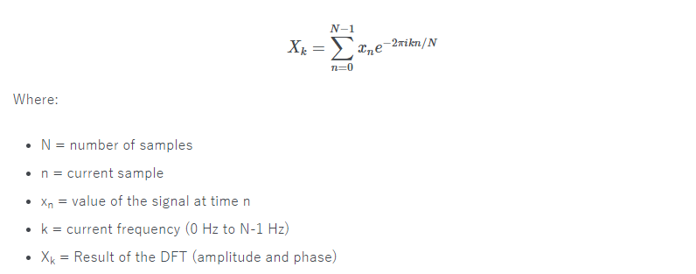

* 1. Sketch the real part and imaginary part of $X_{k}$ in two different plots with respect to the frequency axis $f$. Comment the result (the position of the harmonics, their amplitude, etc.).
  2. Compute the normalized spectrum.
  3. Normalize the spectrum by dividing $X_{k}$ by the signal length. Comment the amplitude of the peaks

1. Fast Fourrier Tansform using python
   1. Use the built-in fast Fourrier Transform to compute $X_{k}$
   2. Plot the real part and imaginary part of $X_{k}$ in two different plots with respect to the frequency axis $f$. Comment the result (the position of the harmonics, their amplitude, etc.). Compare with the results obtained in c).
   3. Compute the normalized spectrum. Compare with the results obtained in c).
   4. Normalize the spectrum by dividing $X_{k}$ by the signal length. Comment the amplitude of the peaks. Compare with the results obtained in c).
2. A noisy signal: Now add a white Gaussian noise $n\left(t\right)$ to the signal: $x\left(t\right)=5cos\left(628*t\right)+n\left(t\right)$. The standard deviation of the noise is $σ_{n}=6$
   1. Plot the time domain signal.
   2. Plot the normalized spectrum of the signal. Comment.
   3. Explain why it is enough to plot half the spectrum (also called one-sided spectrum)

#### Exercice 2 : Fourier Analysis of periodic signals

Let's consider the signal:

$$y\left(t\right)=\sum_{k}{g\left(t-0.02*k\right)+w\left(t\right)}$$

* $g\left(t\right)$ is a centered Gaussian function with standart $σ_{g}=0.002$:
$$g\left(t\right)=e^{-\frac{t^{2}}{2*{\left(σ_{g}\right)}^{2}}}$$

* $w\left(t\right)$ is a white Gaussian noise with a standard deviation $σ_{w}=0.1$

In the following, we will construct the above signal with a sampling frequency $F_{s}=2kHz$ over 10s.

1. Plot the time signal with and without noise. What is the period? Deduce the frequency of the signal.
2. Plot the (normalized) spectrum of the noisy signal using the built-in FFT function. Comment.
3. Now we are going to add a periodic modulation $\sin\left(2π*0.1*t\right)$ to the original model, i.e.:
$$z\left(t\right)=\left(1+\sin\left(2π*3*t\right)\right)\sum_{k}{g\left(t-0.02*k\right)+w\left(t\right)}$$

4. What is the frequency of the modulation signal
5. Repeat the question a) and (b). Comment where the modulations appear in the spectrum