There are three files in total(not including this one):

template.mlapp; SuperApp.exe; AwsomeApp.exe

1. Try open “template.mlapp”

This, I guess, would fail. Let me know if you can open this.

If it happens to open, you should see something like this

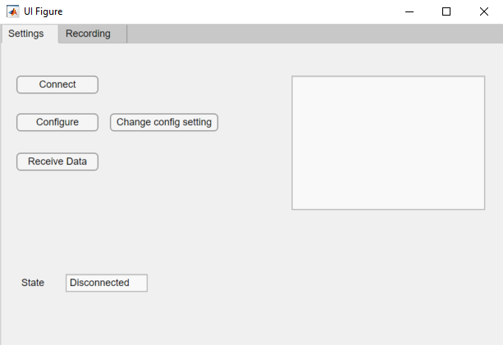

My guess for a fail would be asking you to select a program to open the file.

1. Install “SuperApp.exe”
   * 1. It will ask you for installation folder twice.

I suggest you to remember both path(they can be the same one), because you need to delete the whole folder to “uninstall”. XD

The first one is the actually app itself.

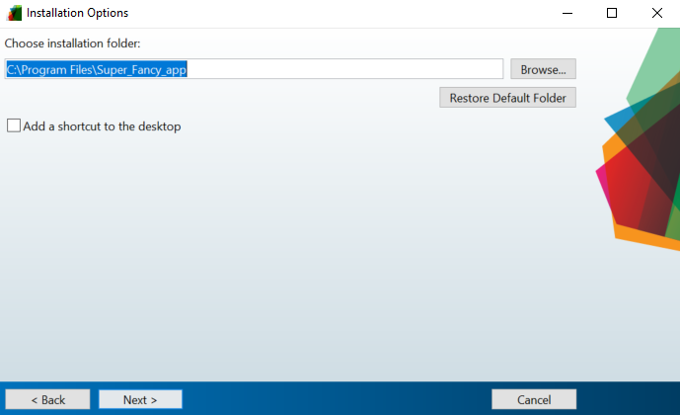

The second one is “MATLAB runtime”.

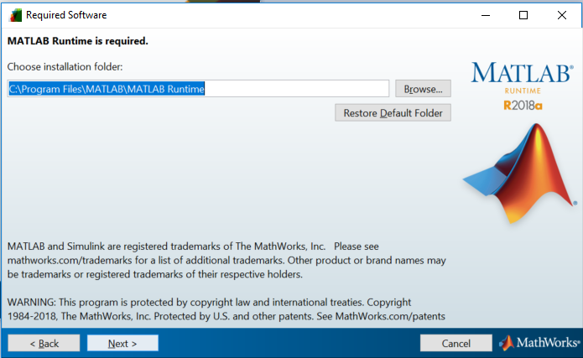

* + 1. It is normal for installation to take more than 20 mins.
    2. Let me know if you can install this file, and run this program installed. A sign of success would be seeing something like the first image in this document, you can play with the buttons and it gives you some response in the state field at the bottom, the text field on the right and the buttons themselves.
    3. And do NOT delete any file in this step before completing step 3 with “AwsomeApp.exe”

1. Try to install “Awsome.exe”

Let me know if this time still need to install the “MATLAB runtime”.

If you see the following line, it means the “AwsomeApp.exe” still need to install “MATLAB runtime”. And you can cancel the installation.

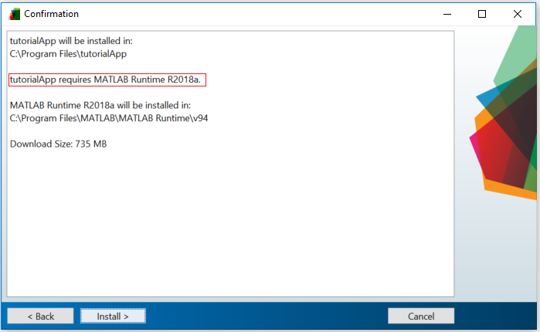

If you do not see that line, click “install” and check how long it takes to install. If less than 20, it means “Awsome.exe” does not need to install “MATLAB runtime” again. If over, I don’t know then XD, but you can cancel the installation.

And that’s it ~ Thank you~