Dementia MRI Training and Benchmark Results
Arman Kazi | STS manuscript Results | October 18 2026
Six MobileNetV3-Large training runs achieved 99.32% to 99.89% accuracy on the complete 5,450-image test split. The runs comprise two conditions with three seeds each and are archived as the October 11 Round 1 study. The full-test replay is descriptive and post hoc; the 1,058-image matched comparison retains its prespecified primary role. These image-level results do not establish patient-independent or clinical performance.

Training and validation selection
Stage-only learned the four supplied image labels; multitask added a separate AD/control auxiliary head with a shared backbone. Both conditions used seeds 20261011, 20261012 and 20261013, completing 305 epochs in total. All six runs stopped under the 15-epoch patience rule before the 100-epoch cap. Checkpoints were selected by validation negative log-likelihood with a required improvement greater than 0.0001. The validation-only preference was stage-only, represented by seed 20261012 at epoch 37; no test result was used to change this preference.
Table 1. Completed training and validation-selected checkpoints.
Run | Condition | Seed | Completed | Selected | Val NLL
C1 | Stage only | 20261011 | 38 | 23 | 0.037472
C2 | Multitask | 20261011 | 43 | 28 | 0.051601
C3 | Stage only | 20261012 | 52 | 37 | 0.034771
C4 | Multitask | 20261012 | 74 | 59 | 0.045311
C5 | Stage only | 20261013 | 54 | 39 | 0.036942
C6 | Multitask | 20261013 | 44 | 29 | 0.054033

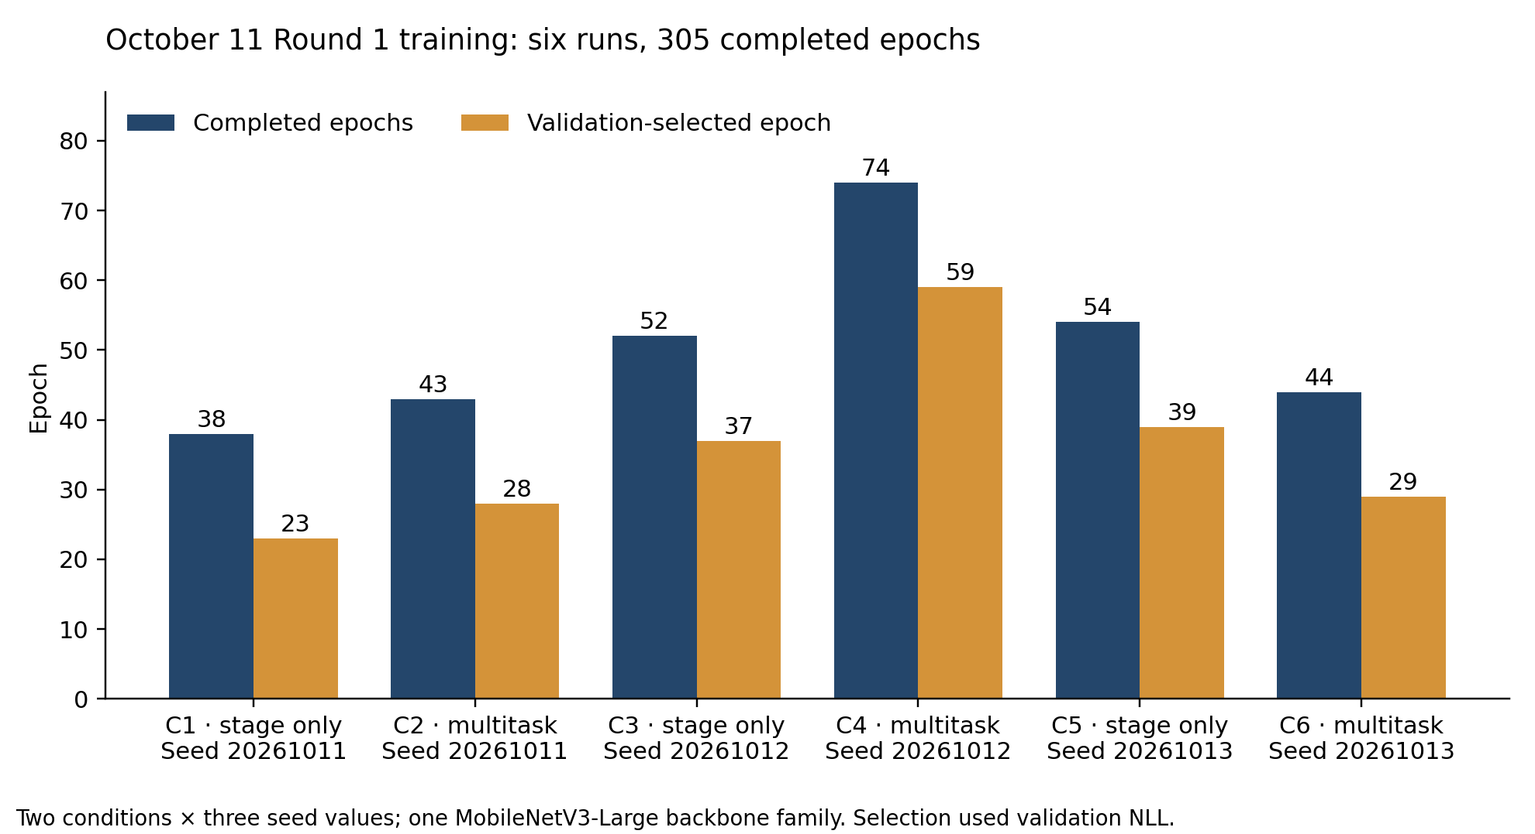
Figure 1. Actual completed epochs and selected checkpoint epochs for the six runs. These are two conditions across three seeds, not six architectures. C1 to C6 correspond to Table 1.

Complete test split of 5450 images
The legacy collection contained 44,000 upstream-augmented JPEG images. Group-based exclusions removed 1,863 rows connected to the historical 100-image benchmark and 14,959 rows in mixed-label similarity groups, leaving 27,178 images: 19,023 training, 2,705 validation and 5,450 test. The exclusions do not establish that the supplied labels were wrong. Exact-pixel and identical-dHash connected groups were kept within one split; patient and original augmentation-family identities remain unavailable.
The complete test split contained 1,342 MildDemented, 1,538 ModerateDemented, 1,324 NonDemented and 1,246 VeryMildDemented images. Table 2 was recomputed from each frozen checkpoint’s saved full-test prediction CSV and checked against the archived replay metrics. No retraining, checkpoint reselection or new inference was used to recompute these historical results.
Table 2. Complete test split performance for all six selected checkpoints.
Model | Correct / n | Errors | Acc % | BA % | F1 %
Stage 11 | 5,438/5,450 | 12 | 99.78 | 99.77 | 99.77
Multitask 11 | 5,413/5,450 | 37 | 99.32 | 99.27 | 99.29
Stage 12 | 5,443/5,450 | 7 | 99.87 | 99.87 | 99.87
Multitask 12 | 5,435/5,450 | 15 | 99.72 | 99.71 | 99.71
Stage 13 | 5,444/5,450 | 6 | 99.89 | 99.88 | 99.88
Multitask 13 | 5,428/5,450 | 22 | 99.60 | 99.58 | 99.58

Acc denotes accuracy; BA is the mean recall across the four supplied classes; F1 is macro-averaged F1. Model suffixes 11, 12 and 13 denote the final two digits of the full seeds in Table 1. Stage-only accuracies were 99.78%, 99.87% and 99.89%; multitask accuracies were 99.32%, 99.72% and 99.60%. Across all six models, balanced accuracy ranged from 99.27% to 99.88% and macro F1 from 99.29% to 99.88%.
The validation-preferred representative, Stage 12, correctly classified 5,443/5,450 images, with 99.87% accuracy, 99.87% balanced accuracy and 99.87% macro F1. Stage 13 had one fewer observed error, but this post-hoc test difference does not replace the validation-selected representative.

Relationship to the matched comparison
The replay protocol explicitly identifies the full 5,450-image evaluation as a post-hoc supplement that contains the primary 1,058-image subset. It therefore supplies a broader descriptive assessment of the six new checkpoints, not an additional independent cohort. Under the old baseline split, these 5,450 images comprise 3,860 training, 532 validation and 1,058 test rows; a baseline comparison on all 5,450 would mix previously seen and held-out images.
The historical full-test replay did not provide paired uncertainty estimates for this complete cohort. Table 2 therefore reports point estimates only. Detailed per-class counts and all confusion matrices accompany the reproducible analysis in the repository.

Matched comparison and sensitivity analysis
The prespecified matched comparison used the same 1,058 exact image rows for the old baseline and all six new checkpoints, representing 966 prepared similarity groups. Of those images, 302 had a similarity-group mate in old training or validation. Excluding those groups yielded the prespecified 756-image sensitivity subset in 733 groups. The smaller subset changes sample composition and does not establish patient independence.
Table 3. Correct classifications and accuracy on the matched and historical benchmarks.
Model | Matched 1058 | Sensitivity 756 | Reused 100
Old baseline | 1057/1058 (99.91%) | 755/756 (99.87%) | 100/100 (100.00%)
Stage 11 | 1055/1058 (99.72%) | 753/756 (99.60%) | 99/100 (99.00%)
Multitask 11 | 1054/1058 (99.62%) | 752/756 (99.47%) | 100/100 (100.00%)
Stage 12 | 1057/1058 (99.91%) | 755/756 (99.87%) | 100/100 (100.00%)
Multitask 12 | 1056/1058 (99.81%) | 754/756 (99.74%) | 99/100 (99.00%)
Stage 13 | 1057/1058 (99.91%) | 755/756 (99.87%) | 100/100 (100.00%)
Multitask 13 | 1055/1058 (99.72%) | 754/756 (99.74%) | 99/100 (99.00%)
Stage ensemble | 1058/1058 (100.00%) | 756/756 (100.00%) | 100/100 (100.00%)
Multitask ensemble | 1056/1058 (99.81%) | 754/756 (99.74%) | 100/100 (100.00%)

Individual-model accuracy ranged from 99.62% to 99.91% in the matched comparison and 99.47% to 99.87% in the sensitivity analysis. The stage-only ensemble averaged the three frozen probability vectors uniformly and achieved 1,058/1,058 and 756/756 correct classifications. The multitask stage ensemble achieved 1,056/1,058 and 754/756. Ensemble membership, weights and thresholds were not fitted to these test results.
The frozen analysis used 2,000 paired percentile bootstrap resamples of similarity groups. For the validation-preferred Stage 12 model versus the baseline, the matched accuracy difference was 0.00 percentage points (95% interval -0.29 to +0.28); the sensitivity difference was 0.00 (-0.40 to +0.40). These estimates do not demonstrate a performance improvement. Intervals are exploratory, unadjusted for multiplicity and conditional on the available images and grouping; they exclude uncertainty from training and source selection.

Reused historical benchmark
The old baseline, Stage 12, Stage 13, Multitask 11 and both ensembles correctly classified all 100 historical benchmark images; the other three single checkpoints scored 99/100. Of these 100 images, 66 match old training rows, nine old validation rows and 25 old test rows. This is reused descriptive evidence. Perfect observed accuracy and degenerate bootstrap intervals do not imply population certainty or clinical superiority.

Benchmark comparison and original figures
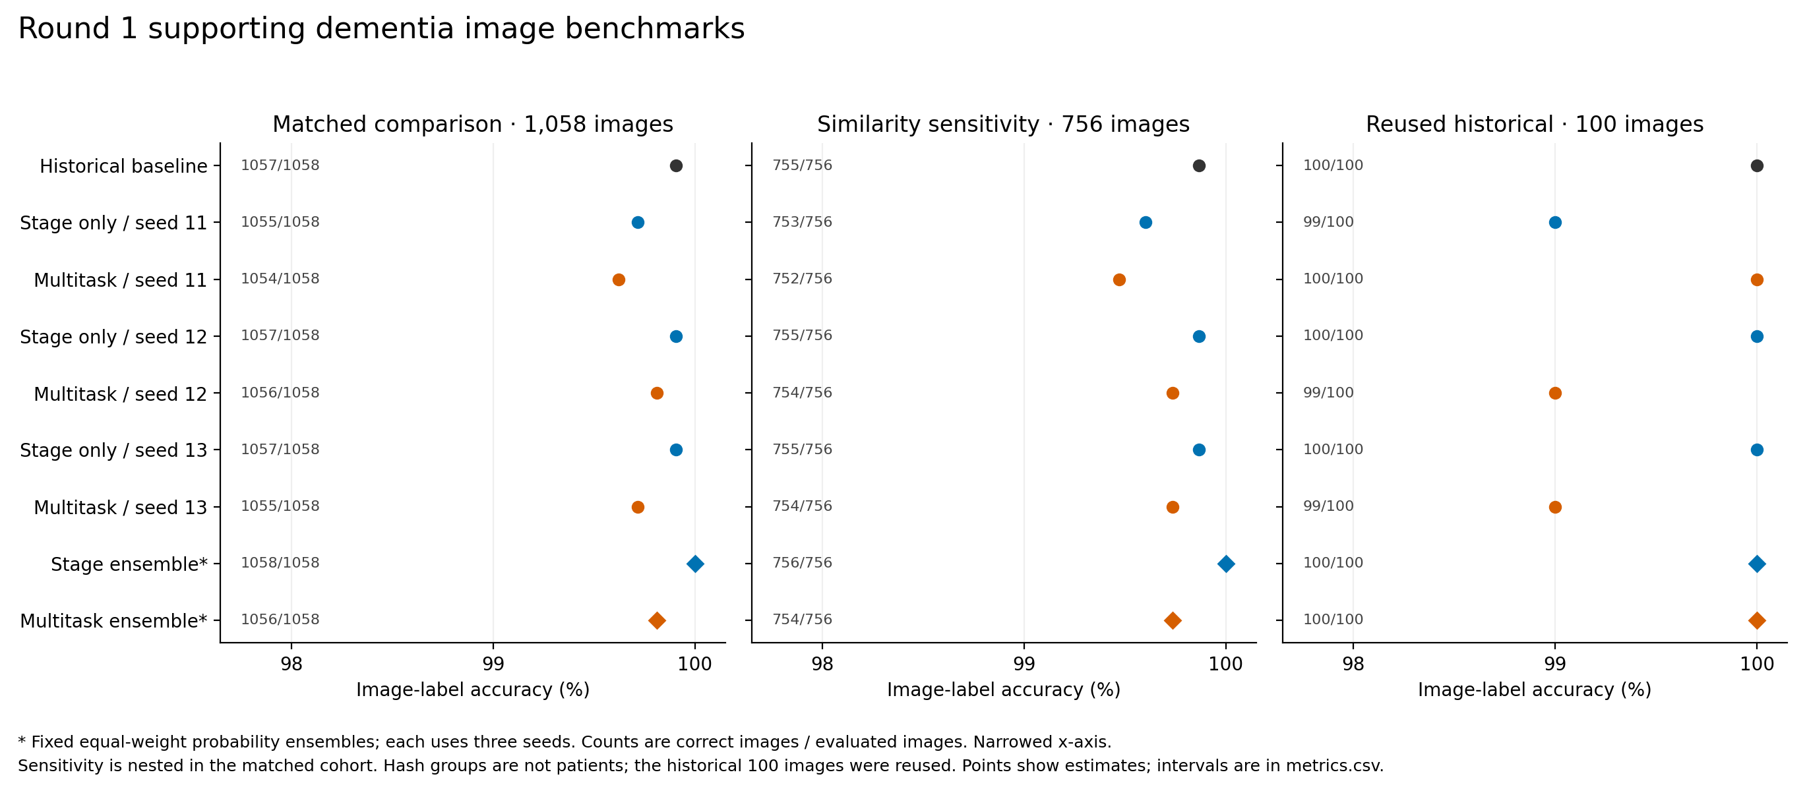
Figure 2. Accuracy for the exact-row matched comparison, its similarity-exclusion subset and the reused historical benchmark. The sensitivity subset overlaps the matched cohort, and the historical images are reused. The narrowed horizontal scale makes small differences visible; Table 3 gives the counts and denominators.

Interpretation
The results show high agreement with four supplied image labels within this legacy dataset. Upstream augmentation, unknown patient identities and unverified augmentation-family relationships limit generalization claims. The four labels are not a validated mapping to clinical CDR stages. Similarity exclusion cannot remove unknown relationships or prove that every image was equally unseen by the old and new models. Clinical AD/control results require separate endpoints and participant-level evidence; they are not inferred from these four-class percentages.
The earlier specialist histories are separate from the six October 11 runs summarized here. The 305-epoch total must not be attributed to six architectures, to 18 runs, or to the older specialist checkpoint. The manuscript emphasizes the six-run development study and complete test split while retaining the original primary-versus-supplementary analysis roles.

Source records and original GitHub figures
Training histories and completed Methods
Frozen validation selection and analysis protocol
Full-test replay protocol and cohort role
Original full-test confusion matrices
Original six-run loss curves
Original paired accuracy intervals
Original two-condition architecture figure
Complete matched statistics and historical benchmark

