Some Thoughts on Solar/Lunar
Aircraft Transit Capture

A Position Paper

Flymoon Project · February 2026

1. Introduction
Flymoon is an automated system for detecting and recording aircraft transits of the Sun and Moon. After several weeks of operation without capturing a confirmed transit, it is worth examining the underlying statistics and geometry to understand what probability of success is realistic, and what strategies genuinely improve it. This paper sets out the physics of transit corridors, quantifies the Poisson waiting times involved, compares aircraft transits with the more familiar ISS/Hubble transit case, evaluates the theoretical benefit of a mobile observer, and concludes with practical recommendations.

2. The Transit Corridor — Geometry
For a given aircraft and a given observer, a transit occurs when the aircraft's angular position (as seen by the observer) falls within the Sun's or Moon's disk. Both bodies subtend approximately 0.5° of arc (31 arcminutes). Because the Sun and Moon are millions of kilometres distant, any aircraft at cruise altitude is effectively in the foreground; the transit geometry is therefore purely angular.
The set of all ground positions from which a particular aircraft appears to transit the Sun defines a narrow strip — the transit corridor. Its width is:
W = 2 × sin(θ☉/2) × R_slant ≈ θ☉ × R_slant
where θ☉ = 0.00873 rad (0.5°) is the Sun's angular diameter and R_slant is the slant range from the observer to the aircraft. Table 1 gives corridor widths and transit durations for typical aircraft geometries.

Table 1 — Transit Corridor Width and Duration vs. Aircraft Distance
Horiz. distance | Slant range | Corridor width | Transit duration | Notes
0 km (overhead) | 10 km | 87 m | 0.3 s | Extreme parallax; impractical
25 km | 26.9 km | 235 m | 0.9 s | Very narrow corridor
50 km | 51.0 km | 445 m | 1.8 s
100 km | 100.5 km | 877 m | 3.5 s | Typical geometry
150 km | 150.3 km | 1,312 m | 5.2 s
200 km | 200.2 km | 1,748 m | 7.0 s | Visible at lower elevations
300 km | 300.2 km | 2,619 m | 10.5 s | Long transit — easiest to record

Figure 1 — Corridor width and transit duration as a function of aircraft horizontal distance.
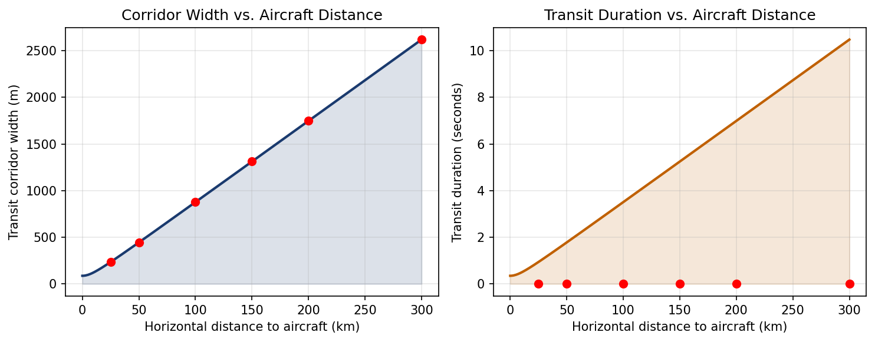

3. Waiting Time — Poisson Statistics
Transit events at a fixed location are well-modelled as a Poisson process: each event is independent, and the average rate λ is approximately constant over timescales of weeks. Published estimates from experienced solar transit photographers suggest 5–30 events per year from a fixed location in busy airspace. The probability of observing exactly zero events in an observation window of t days is:
P(0 events) = e^(−λt)

Table 2 — Probability of Zero Transits at a Fixed Location
Rate (per year) | 1 week | 2 weeks | 1 month | Days to 50% probability
5/yr | 91% | 83% | 66% | 51 days
10/yr | 83% | 68% | 44% | 25 days
15/yr | 75% | 56% | 29% | 17 days
20/yr | 68% | 46% | 19% | 13 days
30/yr | 56% | 32% | 8% | 8 days
At the mid-range estimate of 15 events/year, there is a 56% chance of seeing no transits in any given two-week window. After six weeks the cumulative probability of having seen at least one exceeds 85%. Observing zero transits in the first two weeks of operation is entirely consistent with the statistics.
Figure 2 — Survival function: probability that no transit has yet been observed.
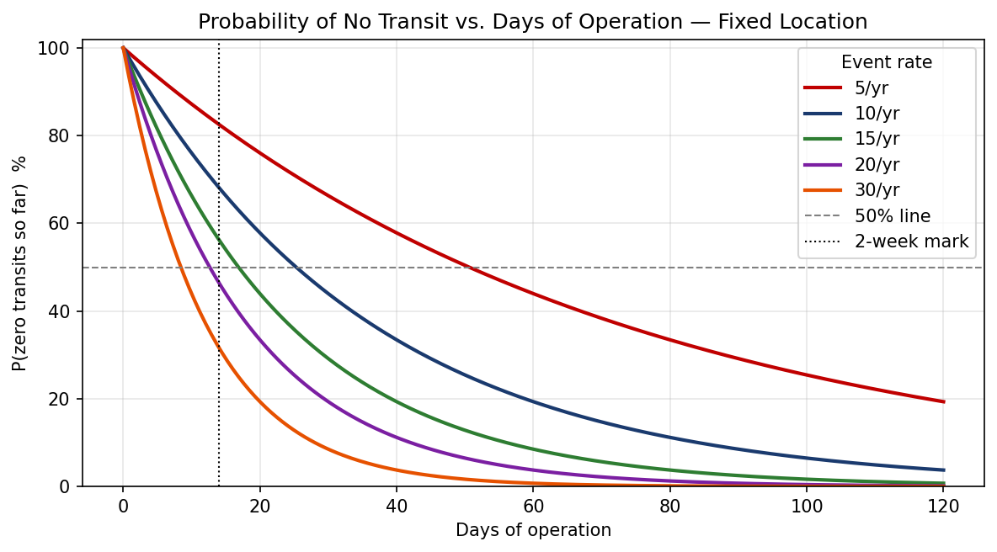

4. Aircraft vs. ISS/Hubble — A Critical Comparison
Experienced observers often draw an analogy between aircraft transits and ISS/Hubble transits. The analogy is instructive but breaks down in one critical dimension: predictability.

Table 3 — Aircraft Transit vs. ISS Transit Comparison
Property | Aircraft Transit | ISS / Hubble Transit
Transit duration | 0.3 – 10.5 seconds | 0.5 – 1.5 seconds
Corridor width at 100 km | ~877 m | ~4,000 m (ISS altitude 400 km)
Position predictable? | No — filed flight plans ±5–20 km | Yes — orbital mechanics to <10 m
Timing predictable? | No — departure delays ±minutes | Yes — TLE accurate to <1 second
Advance notice | Minutes (live ADS-B only) | Days to weeks
Corridor chaseable? | No — uncertainty >> corridor | Yes — routinely done
Capture strategy | Fixed automated station | Drive to GPS coordinate
Event rate (fixed point) | ~10–30 per year | ~5–10 per year (ISS only)
Automation value | Essential — transit lasts <2 s | Helpful but manual capture possible
The position uncertainty of a commercial aircraft (±5–20 km from its filed flight plan) is 6–23 times larger than the transit corridor width at 100 km range (877 m). Chasing an aircraft transit corridor requires positioning to within ~440 m of the centreline with less than a minute's notice — which is not feasible. This is categorically different from ISS chasing, where Heavens-Above.com and Transit Finder provide corridor centrelines accurate to within metres, days in advance.

5. The Mobile Observer — Theory vs. Practice
A natural question is whether moving the observer within, say, a 50 km radius improves the capture probability. The geometric answer is yes — dramatically so. The practical answer is no, for the reasons established in Section 4.

Table 4 — Theoretical Mobility Gain (50 km radius)
Aircraft distance | Corridor width | Fixed target area | Theoretical gain (50 km radius)
25 km | 235 m | 43,363 m² | 181,120×
50 km | 445 m | 155,510 m² | 50,505×
100 km | 877 m | 604,096 m² | 13,001×
150 km | 1312 m | 1,351,740 m² | 5,810×
200 km | 1748 m | 2,398,441 m² | 3,275×
300 km | 2619 m | 5,389,015 m² | 1,457×
The gains are enormous in theory (thousands to hundreds of thousands of times). However, realising this gain requires knowing, in advance, which 500 m strip within the 50 km circle the corridor will pass through. As shown in Section 4, this knowledge is unavailable for aircraft. The theoretical gain is therefore inaccessible. A fixed automated station is not a compromise — it is the correct strategy.
Figure 3 — Theoretical mobility gain is large but inaccessible in practice.
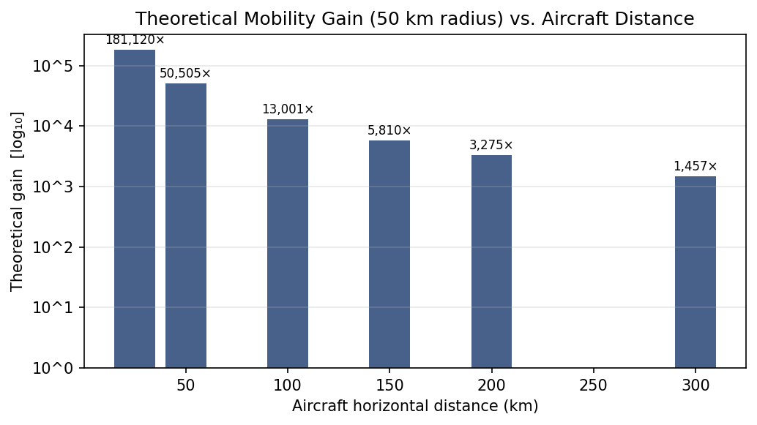

6. The Position Uncertainty Problem
Filed IFR flight plans specify a sequence of waypoints. Actual flight paths deviate from filed plans for several reasons:
- ATC re-routing due to traffic separation (common, typically ±5–15 km laterally)
- Weather avoidance (occasional, can be ±50 km or more)
- Wind-optimal routing adjusted in real time (±2–10 km)
- Departure delay propagating to a different Sun position (±1–4° per 4 min delay)
For a transit to be captured, the aircraft must be within the corridor at the moment the Sun is in the right direction. The combined position+timing uncertainty must be smaller than the corridor width. Table 5 compares these quantities.

Table 5 — Position Uncertainty vs. Corridor Width
Error source | Typical magnitude | Corridor width at 100 km
ATC lateral re-route | 5,000 – 15,000 m
Weather avoidance | Up to 50,000 m
Wind optimisation | 2,000 – 10,000 m
4-min departure delay | ≈ 1° Sun shift = 2× disk diameter
Transit corridor (100 km) | — reference — | 877 m
Ratio (ATC / corridor) | 6× – 17× | Must be <1 to chase
Figure 4 — Position uncertainties (log scale) dwarf the transit corridor width.
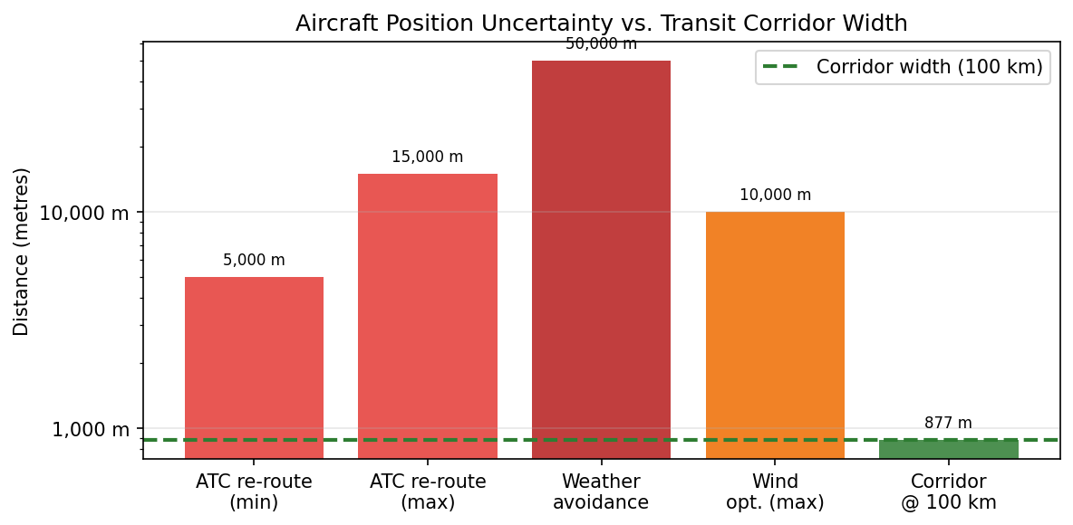

7. Expected Capture Frequency — Fixed Station
Given a well-sited, reliably operating automated station, what is the expected wait for a first capture? Modelling transits as a Poisson process with rate λ, the expected waiting time to first event is 1/λ. Table 6 gives the expected first-capture dates from a notional start date of 7 February 2026.

Table 6 — Expected First Capture Date (from 7 Feb 2026)
Rate (per year) | Expected wait | 50% probability by | 90% probability by
5/yr | 73 days (Apr 21) | 51 days (Mar 29) | 168 days (Jul 25)
10/yr | 36 days (Mar 15) | 25 days (Mar 04) | 84 days (May 02)
15/yr | 24 days (Mar 03) | 17 days (Feb 23) | 56 days (Apr 04)
20/yr | 18 days (Feb 25) | 13 days (Feb 19) | 42 days (Mar 21)
30/yr | 12 days (Feb 19) | 8 days (Feb 15) | 28 days (Mar 07)
At the mid estimate of 15/yr, there is a 50% chance of a first capture by approximately late March 2026, and a 90% chance by late June 2026. Absence of a capture after two weeks is well within the normal range.
Figure 5 — Cumulative probability of first capture. The 14-day mark is still early.
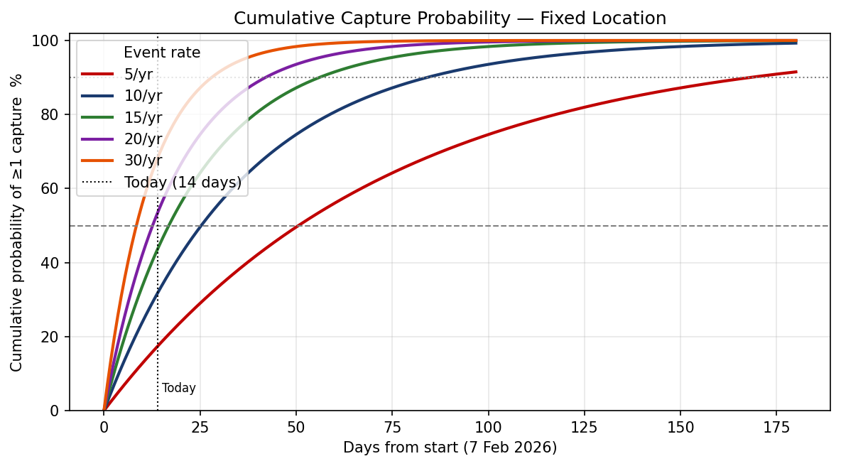

8. Validating the System Before a Real Transit Occurs
A critical question for any automated capture system is: how do we know it will work when a transit actually occurs? The following validation ladder addresses each link in the detection and recording chain.

Table 7 — Validation Ladder
Step | Method | What it validates | Status
1 | Inject synthetic flight at 0.1° from Sun, run check_transit() | Angular separation maths | Doable now
2 | Cross-check HIGH predictions against transitfinder.com | Detection pipeline agreement | Ongoing
3 | Trigger recording via simulator; verify .mp4 file | Capture chain end-to-end | Done (Feb 7 & 20)
4 | Continuous solar camera (1 fps) for one day; compare to HIGH events | False positive / miss rate | Recommended
5 | Compare predicted vs. actual position for HIGH events using ADS-B replay | 15-min prediction accuracy | Doable
6 | Real capture | Full system confirmation | Pending — expected weeks to months

9. Recommendations
- Keep the fixed automated station running. This is the correct strategy for aircraft transits. The event will occur; automation ensures it is not missed.
- Run the end-to-end recording dry-run. Point the scope at the Sun, trigger an artificial HIGH event via the built-in simulator, and verify the .mp4 file is valid and correctly timestamped. This closes the most important unknown.
- Add a near-miss log. Record all HIGH-probability events with their angular separations even when no recording occurs. Over time this reveals which sky directions and times of day produce the most corridor activity.
- Cross-validate predictions with transitfinder.com. When transitfinder.com predicts a near-miss for the region, check whether Flymoon also raises a HIGH or MEDIUM alert. Agreement between two independent systems is strong validation of the detection pipeline.
- Consider site optimisation. A one-time analysis of the near-miss log (once sufficient data exists) may reveal that relocating the scope 1–3 km in a specific direction would significantly increase corridor intercept frequency.
- Set realistic expectations. At 15 events/year, the 90th percentile waiting time is approximately 140 days from the start of operation. The system is working correctly. Patience is part of the methodology.

10. Conclusion
Aircraft solar and lunar transits are rare, brief, geometrically constrained events. The corridor width of a few hundred metres to ~2 km, combined with the irreducible position uncertainty of commercial aircraft, makes corridor-chasing infeasible — unlike ISS transits, which are fully predictable from orbital mechanics.
A fixed automated station is therefore not merely convenient but is the only practical capture strategy. Poisson statistics show that two weeks without a capture is entirely normal; the expected first-capture time at a busy location is one to three months.
The Flymoon system addresses the key engineering challenges correctly: sub-second detection latency, pre-buffered recording, automated telescope control, and continuous unattended operation. The outstanding validation task is a full end-to-end recording dry-run to confirm the telescope capture chain before a real transit occurs.

