1. Assure that regional language is set to English (United State)

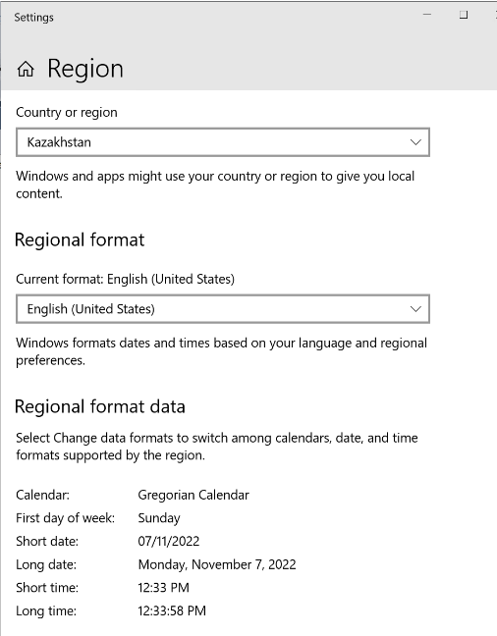

1. Change Language for non-Unicode programs to Russian
   1. Run Power Shell with elevated permissions

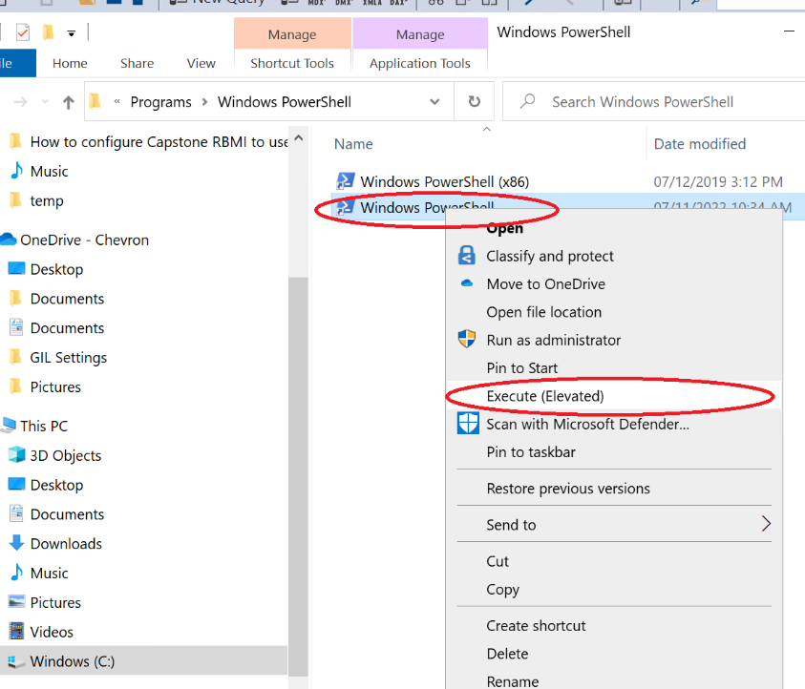

* 1. Exec command: Set-WinSystemLocale -SystemLocale ru-RU
  2. Restart virtual mashine
  3. Assure that language is changed

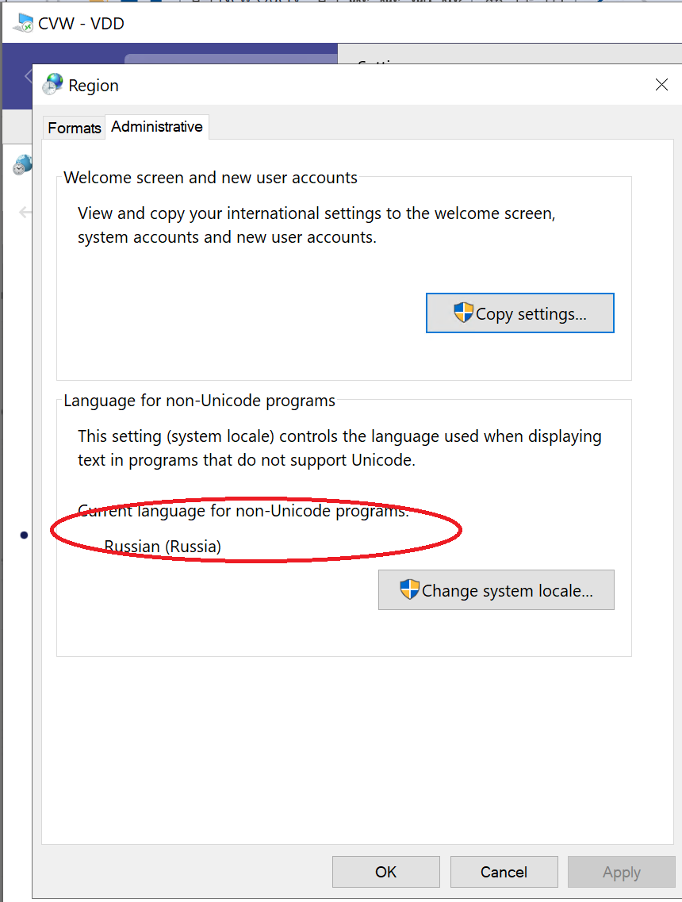

1. Install Capstone (if not installed)
2. Import reg file form email I send.
3. Run Capstone with your CAI and pass form email