**Department of Computer Science**

|  |  |
| --- | --- |
| **STUDENT NAME** | **Taimoor Manzoor** |
| **STUDENT ID** | **Sp20-bscs-0021** |
| **SECTION** | **Am** |
| **ASSIGNMENT NO.** | **1** |
| **DUE DATE** | **4/11/2021** |
| **SUBMITTED ON** | **4/11/2021** |

**Task 1:**

**Find the highest number in an array.**

**Answer:**



**Task 2:**

**Find the Average of the elements in an Array.**

**Answer:**



**Task 3:**

**Find the number of unique values in an array.**

**arr[] = {1,1,3,4,3,5,6,3,4,7}  
output = {1,3,4,5,6,7}**

**Answer:**

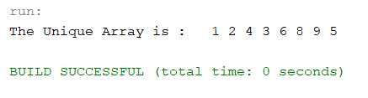

**Task 4:**

**Arrange the elements of Array-1 in ascending order in Array-2.**

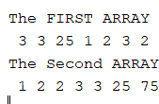

**Answer:**

**Task 5:**

**You are hired as a developer in Medical firm and your first task is to  
detect black spots in X-Rays images. You will be given X-Ray image in a  
form of 2D Array that consist of 5 rows and 5 columns. Your job is to count  
the number of black spots in that array. A black spot is consist of a 2x2 array  
with all ‘0’ elements.**

**Answer:**

