**Department of Computer Science**

|  |  |
| --- | --- |
| **STUDENT NAME** | **Taimoor Manzoor** |
| **STUDENT ID** | **SP20-BSCS-0021** |
| **SECTION** | **AM** |
| **ASSIGNMENT NO.** | **2** |
| **DUE DATE** | **3/19/2021** |
| **SUBMITTED ON** | **3/18/2021** |

**Question 1/Task 1:**

**Create an Array List of strings. Then input a string from user and return the index  
of that string. If string is not found then return "String not found!".**

**Answer:**

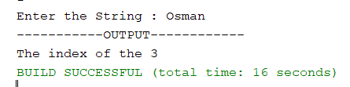

**Question 2/Task 2:**

**Sort the given array based on the number of occurrences of a value.  
Implement this using Array List.  
  
array = {3,5,2,5,3,6,8,6,5,3,5,2,6,5,3}  
output = {8,2,6,3,5}**

**Answer:**

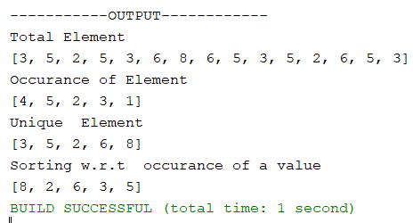

**Question 3/Task 3:**

**Consider a Food Panda Rider has to deliver 5 orders at different locations.  
All locations have a single route from the restaurant. You will be given two arrays,   
one of them consist of locations name and other contains distances in KM of those  
locations from restaurant respectively.  
  
You need to find the most optimize route and delivery sequence to help rider.  
  
Input Sample:  
Location Array: A, E, D, B, C  
Distance Array: 13, 21, 8, 10, 4  
  
Output Sample:  
Optimize Route: C, D, B, A, E**

**Answer:**

