DATABASE MANAGEMENT SYSTEM (DBMS)

PROJECT TITLE:

INVENTORY MANAGEMENT SYSTEM

CONTRIBUTOR NAMES:

ANAS ALI KHAN (SP20-BSCS-0015)

TAIMOOR MANZOOR (SP20-BSCS-00021)

HASAN AHMED (SP20-BSCS-0028)

* **PROBLEM STATEMENT:**

In inventory systems, demand is usually uncertain, and the lead-time can also vary. To avoid shortages, managers often maintain a safety stock. In such situations, it is not clear what order quantities and reorder points will minimize expected total inventory cost.

A food management database system is an app that allows the chief to search order, order history, track every purchase detail that the customer has done.

* **ERD DIAGRAM:**

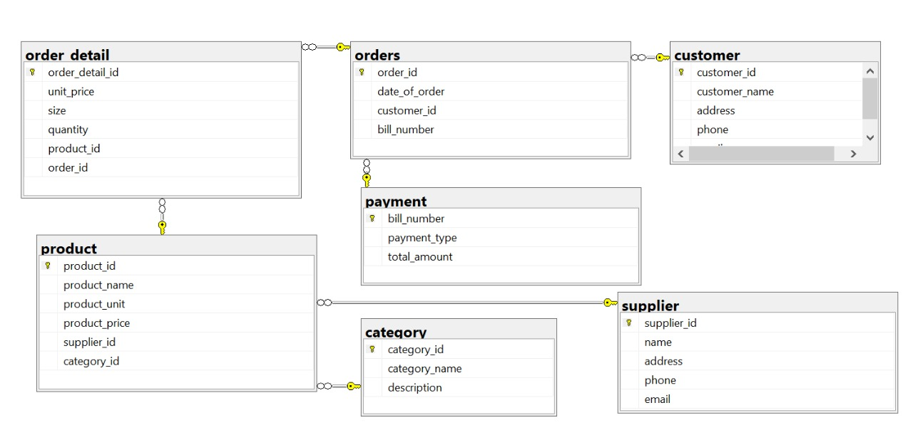

* **Database Functionalities:**

**Tables:**

1. customer
2. orders
3. order detail
4. product
5. category
6. supplier
7. payment

**VIEWS:**

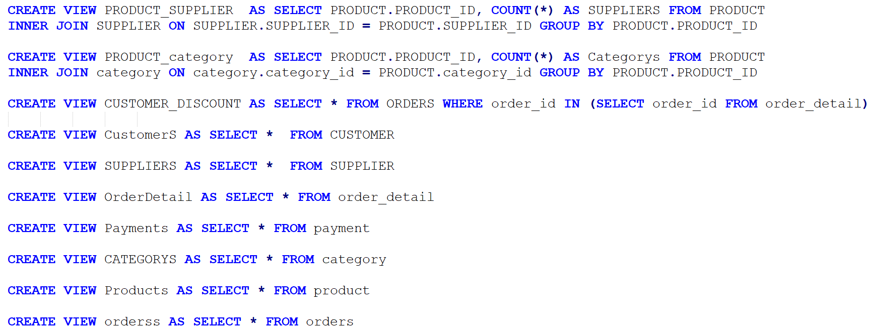

**Procedures:**

1. CUSTOM_FILTER (It search for the customer by comparing it’s ID).
2. CUSTOMER_VIEW (It will display all the customers detail).
3. CUSTOMER_INSERT (It adds a new customer).
4. CUSTOMER_UPDATE (It modifies the customers information).
5. CUSTOMER_DELETE (It’ll delete customer record).
6. SUPPLIER_FILTER, VIEWS, DML.
7. CATEGORY_ FILTER, VIEWS, DML.
8. PAYMENT_ FILTER, VIEWS, DML.
9. ORDERS_ FILTER, VIEWS, DML.
10. PRODUCTS_ FILTER, VIEWS, DML.
11. ORDERDETAIL_ FILTER, VIEWS, DML.

Note: All the functions work the same with all the other Tables.

**Triggers:**

1. HISTORY_PRODUCT (Whenever a person performs a DML Function, it will perform that operation and the date on which it’s done).
2. CHECK_DATE (It checks whether the order date is valid or not).

**Functions:**

1. RECORD_DATE (Returns the count of total order in that day).

* **NUMBER OF FORMS:**

1. **Login Form**
2. **Home Form**
3. **Product Form**
4. **Product Category Form**
5. **Order Form**
6. **Order Detail Form**
7. **Payment Form**
8. **Customer Form**
9. **Supplier Form**

* **SCREENSHOT & DESCRIPTION OF FORMS:**

**Description: Login page for all the users i.e (admin)**

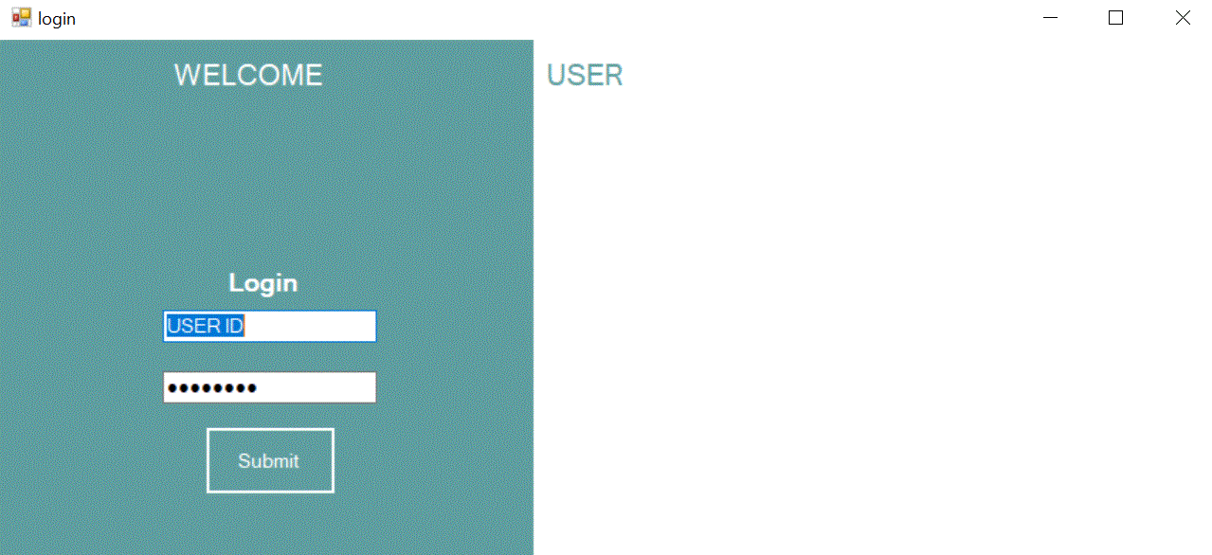

**Description: Home page to search the history related to the Order.**

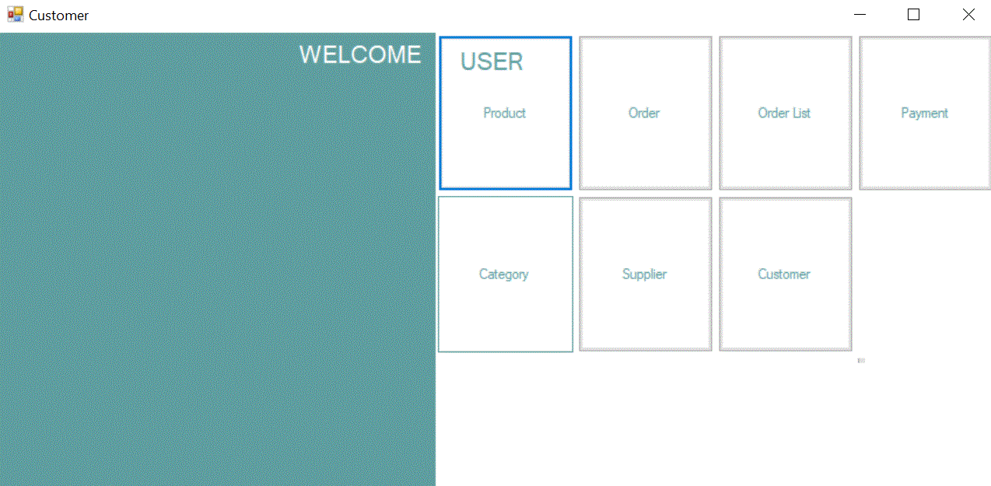

**Description: Product page to show the product details and to perform DML Functions.**

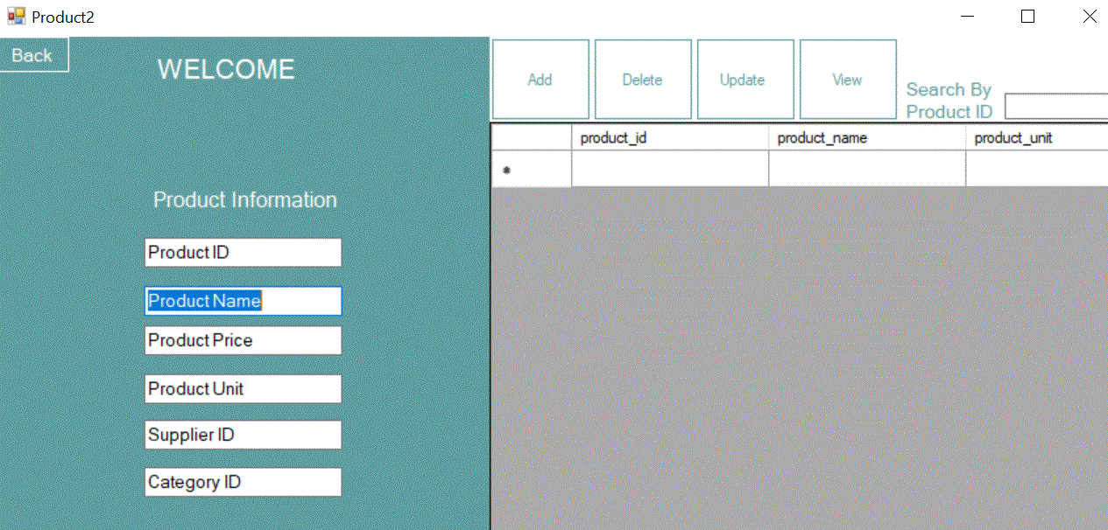

**Description: Product Category page shows different category of each item, and you can perform DML functions here as well.**

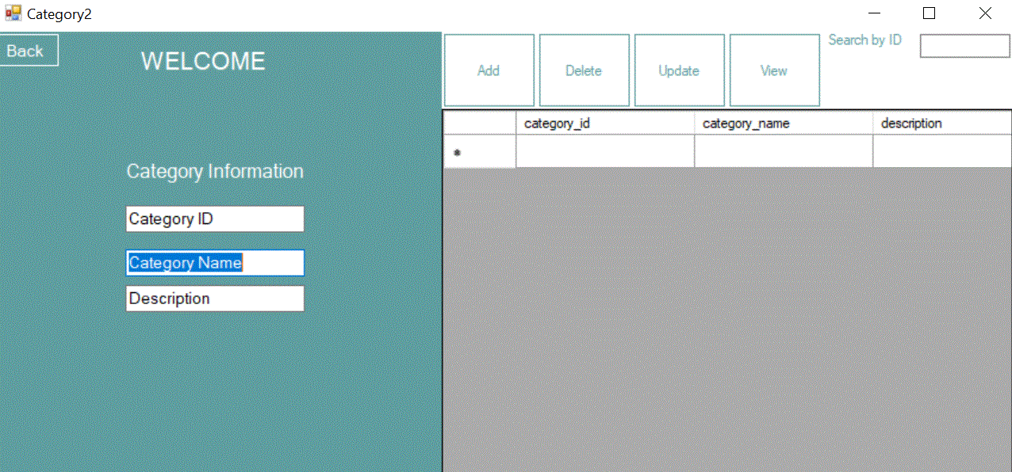

**Description: Order page will display all the orders placed and you can modify them as per your need.**

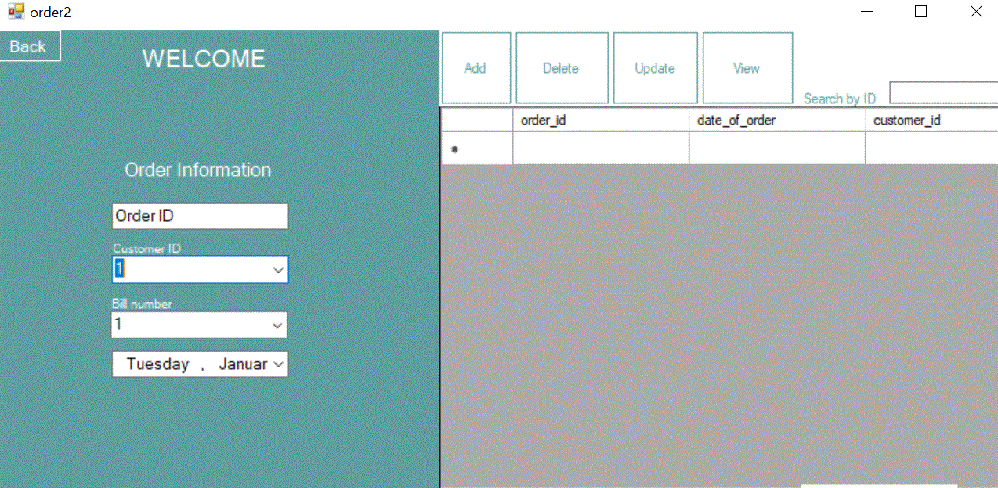

**Description: Order Detail page will illustrate all the orders placed and you can modify them as per your need.**

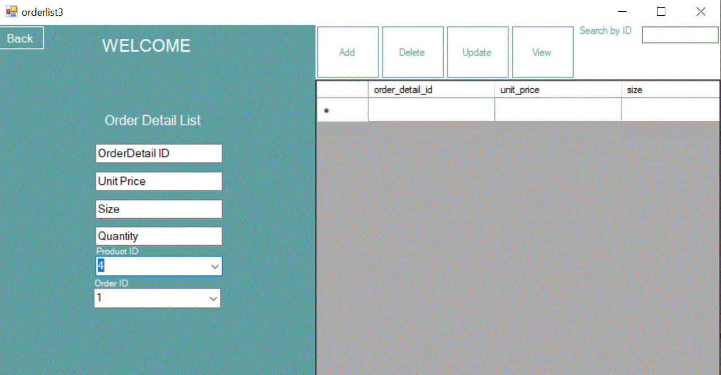

**Description: Payment page will store all the orders payment and you can perform DML Functions.**

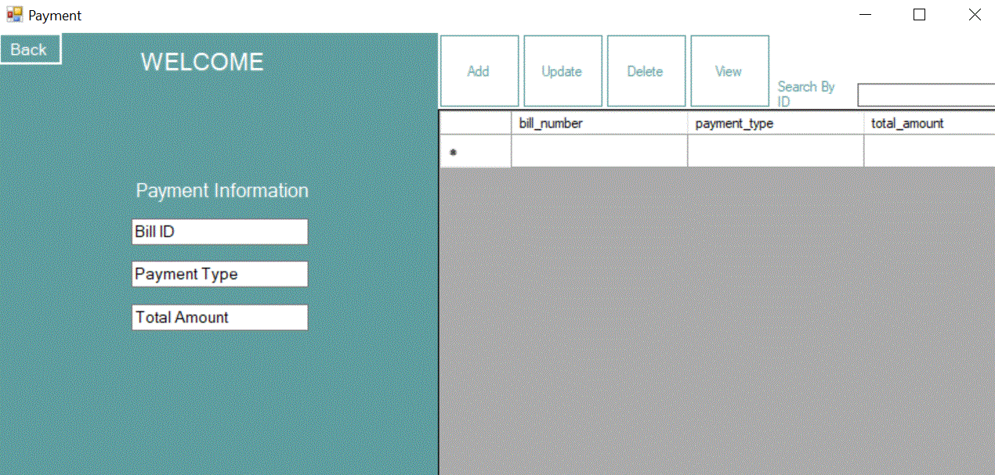

**Description: Customer page will display the customer Information.**

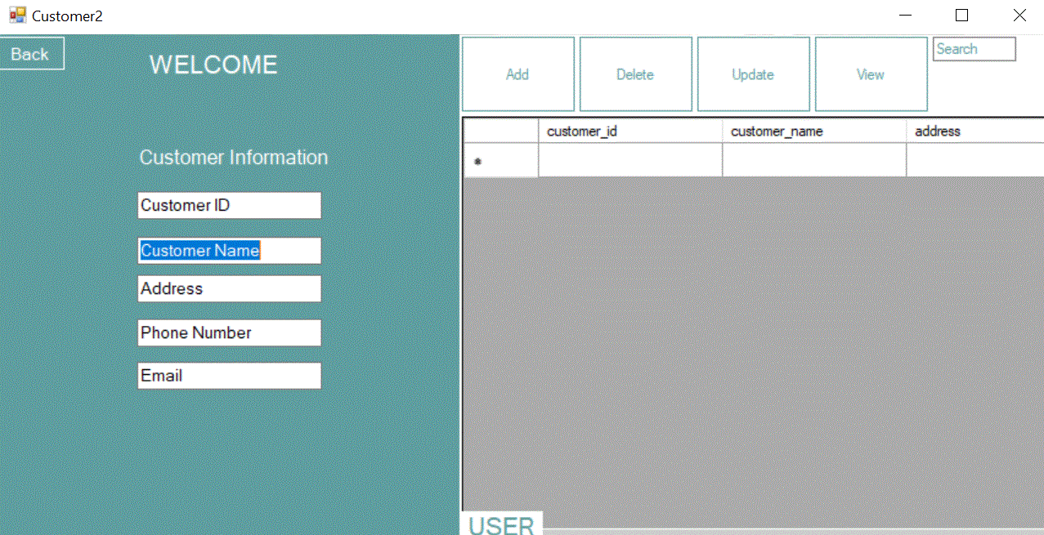

**Description: Supplier page will display the detail about the supplier.**

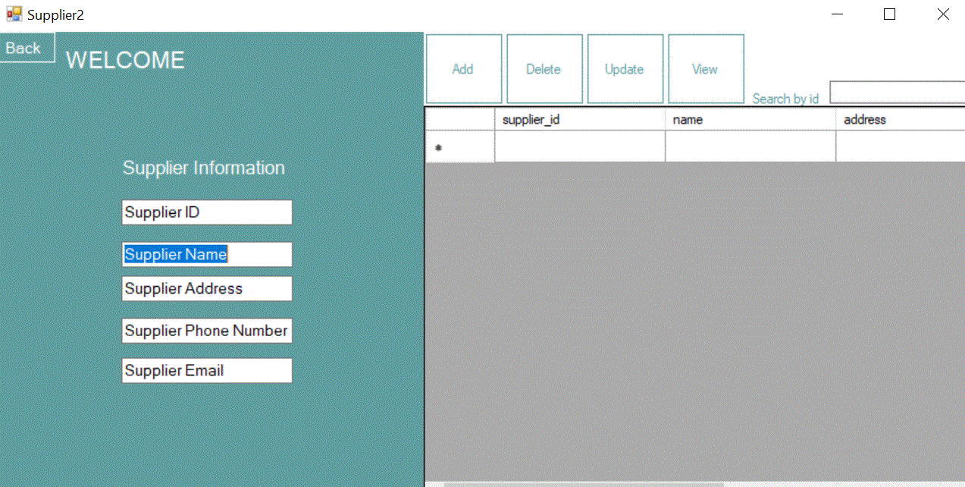

**THE END**