**Department of Computer Science**

|  |  |
| --- | --- |
| **STUDENT NAME** | **Taimoor Manzoor** |
| **STUDENT ID** | **SP20-BSCS-0021** |
| **SECTION** | **AM** |
| **ASSIGNMENT NO.** | **4** |
| **DUE DATE** | **6-11-2020** |
| **SUBMITTED ON** | **29-10-2020** |

**Question 1/Task 1:**

**Create a class named 'Student' having two variables 'name' and 'roll_no' respectively. Assign the value of roll_no as '101' and that of name as "Ahmed" by creating an object of the class Student. Print the values in the main/test/driver class.**

**Answer:**

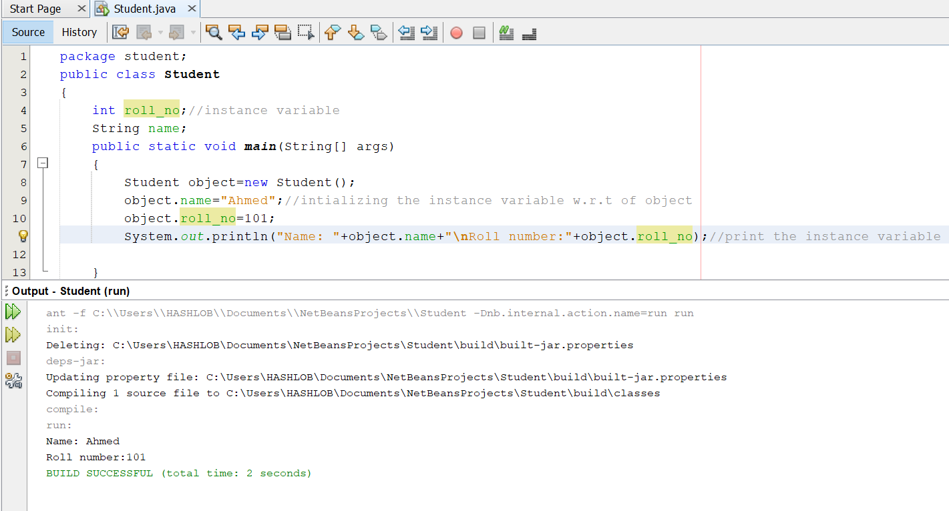

**Question 2/Task 2:**

Modify the above program that assigns and print the roll number, age and address of two students having names "**Ali**" and "**Ahad**" respectively by creating two objects of class **'Student'**. **Answer:**

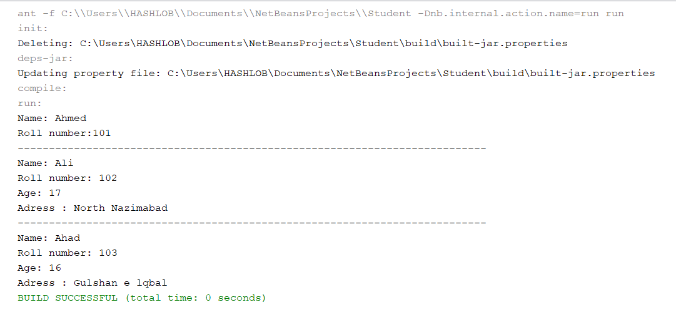

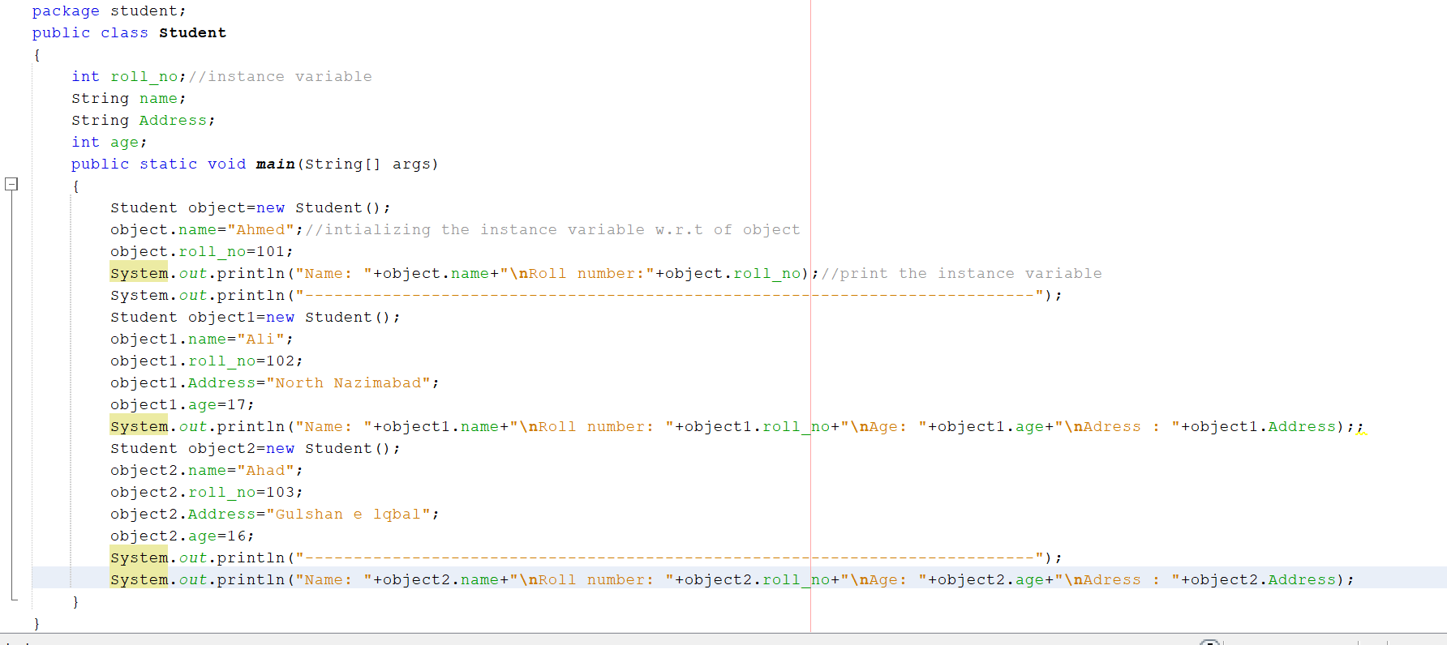

**Question 3/Task 3:**

Write a program to print the area of a rectangle by creating a class named **'Area'** having two methods. First method named as **'setValues ()'** that takes length and breadth of rectangle as parameters and the second method named as **'getArea ()'** that returns the area of the rectangle. Length and breadth of rectangle should be entered through keyboard.

Answer:

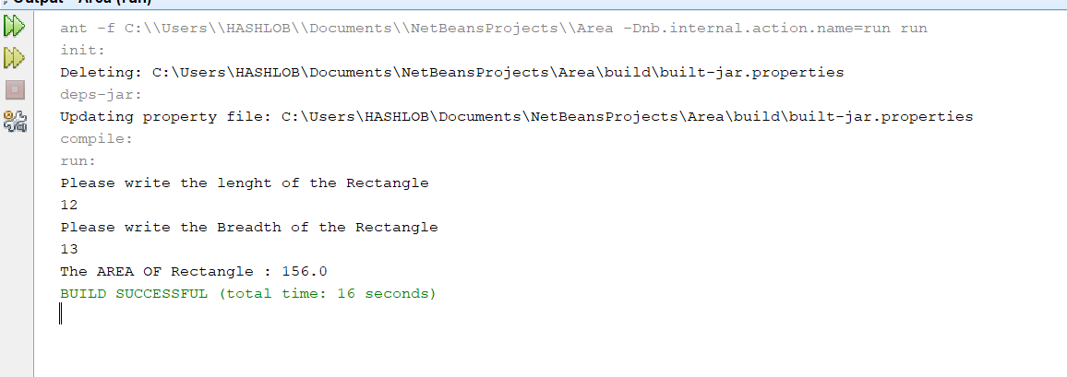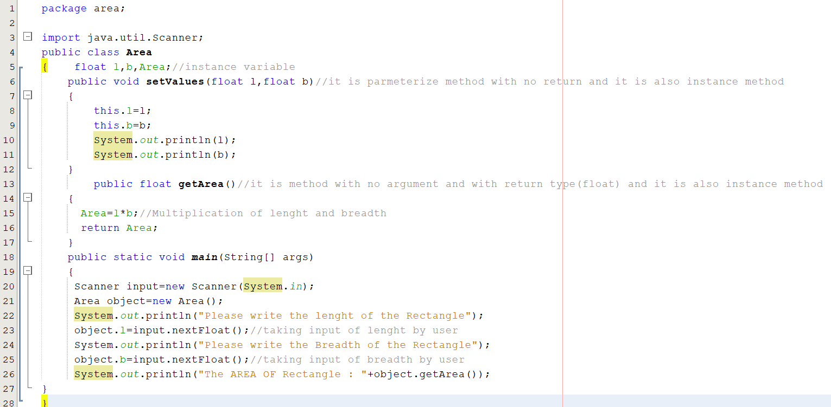

**Question 4/Task 4:**

Create a class named **'Average'** having a method **calculateAverage ()** that calculates the average of three numbers entered by user and print the average.

**Answer:**

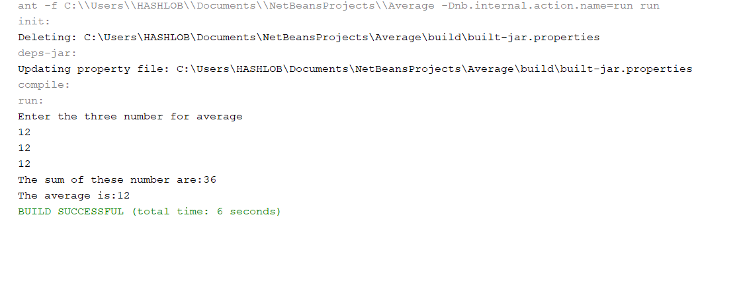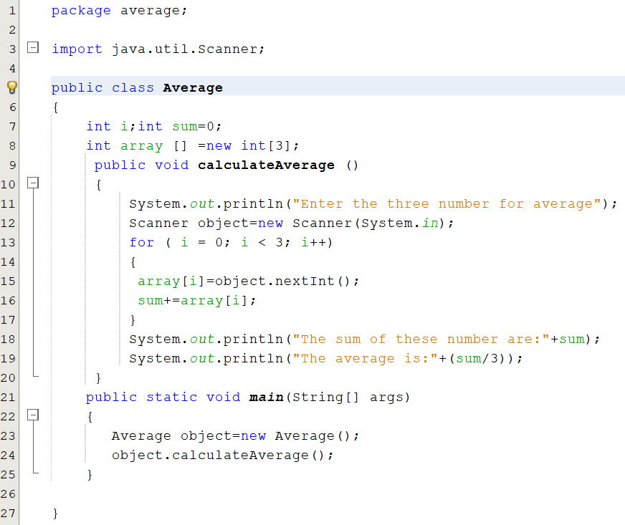

**Question 5/Task 5:**

### Create a class named 'Employee' having the following two instance methods. a. getInfo() b. printInfo() The getInfo() method takes the information about employee’s name, year of joining, salary and city as parameter. The printInfo() method prints all the information. Your main/driver/test class should print information of three employees. The output should be as follows: Name        Year of joining     Salary     City Ahmed            1998                 85000 Karachi Ali                 2002                95500 Islamabad Sara                 1991                 80000 Hyderabad

### Answer:

**Question 6/Task 6:**

Write a java program that creates an **'Employee'** class having the following methods:

* **'getInfo ()**' this method takes the salary, number of hours of work per day of employee as parameter.
* **'addBonus ()'** this method adds **$15** to the salary of the employee if it is less than $600.
* **'addWork ()'** this method adds **$10** to the salary of employee if the number of hours of work per day is more than 8 hours.

Print the final salary of the employee.

