Documentation

1.1 Background and Necessity for the Web Application Traveling, whether for business or leisure, often involves managing multiple expenses. These expenses can quickly accumulate, leading to the necessity for meticulous tracking to stay within budget. Many travelers, however, struggle with maintaining an organized record of their expenditures, leading to overspending, loss of receipts, and difficulty in reimbursement claims. Traditional methods of tracking expenses, such as manual entry in spreadsheets or keeping physical receipts, are cumbersome and prone to errors. With the rise of digital transformation, there is a growing demand for automated solutions that simplify expense management. The proliferation of smartphones and easy Internet access provide an excellent opportunity to develop a Web application that addresses these challenges effectively. 1.2 Proposed Solution To make it easier for users, a Web application titled ExpenseVoyage is to be developed. This Web application will enable users to register, and thereafter facilitate efficient and user-friendly tracking of travel expenses and more. The application will cater to individual travelers as well as groups ensuring seamless and collaborative expense tracking. © Aptech Limited 1.3 Purpose of this Document The purpose of this document is to present a detailed description of ExpenseVoyage Web application. This document will explain the purpose and features of the application, the interfaces of the application, what the application will do, and so on. This document is intended for both stakeholders and developers of the system. 1.4 Scope of Project This will be a Web application to be used by individuals. The ExpenseVoyage Web application aims to provide a comprehensive and user-friendly solution for travelers to manage and track their travel expenses

1.5 Constraints The development of the ExpenseVoyage Web application must adhere to several constraints to ensure its successful implementation and operation. Technically, the application must be compatible with major Web browsers and responsive across various devices. You may encounter constraints related to data storage, data synchronization, and backup procedures. The usage of various images, and videos may be subject to licensing agreements and copyright restrictions. It is important to understand and comply with these constraints to avoid legal issues. © Aptech Limited 1.6 Functional Requirements The Web application will be designed with a set of forms/pages with menus representing choice of activities to be performed.

Following are the functional requirements of the application: For Users: 1) Home Page and Dashboard

1. Personalized Welcome Message

• It will display an attractive visual and menus for various operations including basic functionality such as Registration and Login. After users are logged in, they will be able to access various menus.

• The home page must display a personalized welcome message with the user’s name on logging in.

b) Current/Upcoming Trip Overview   
• The home page must show an overview of current or upcoming trips including destination, dates, key itinerary items, and remaining budget.

c) Recent Activities

• Display a list of recent activities including logged expenses and itinerary updates. © Aptech Limited

2) User Management

a) User Registration and Login

• Users must be able to register using their email address and password.

• Provide password recovery and reset functionalities. b) User Profile Management

• Users must be able to create and edit their profile including personal information, preferred currency, and travel preferences.

• Users must be able to upload a profile picture.

3) Trip Planning

a) Create and Manage Trips

• Users must be able to create a new trip by specifying the destination, start date, and end date.

• Users must be able to edit and delete existing trips. • Users must be able to view a list of all their trips.

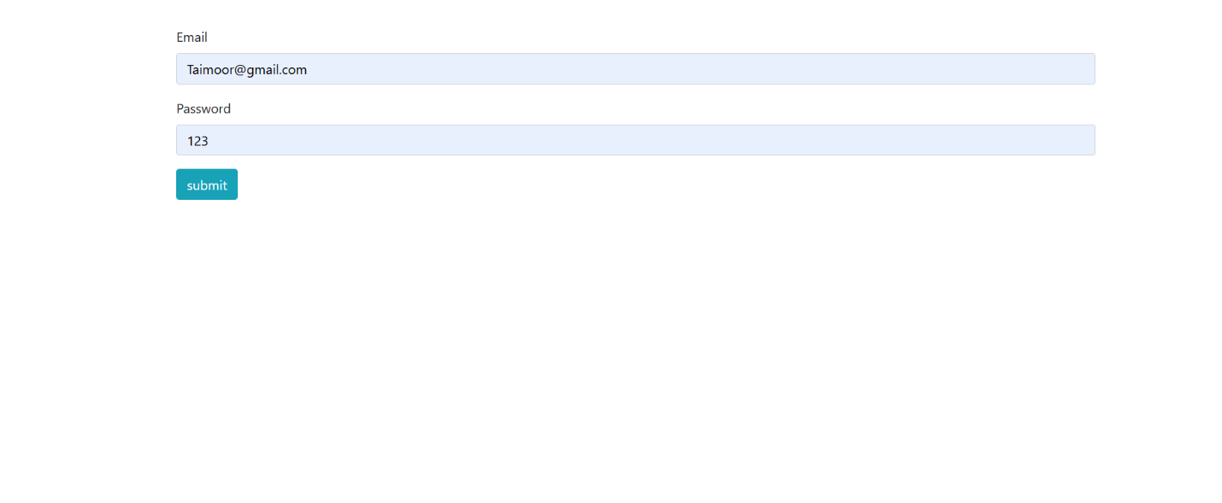

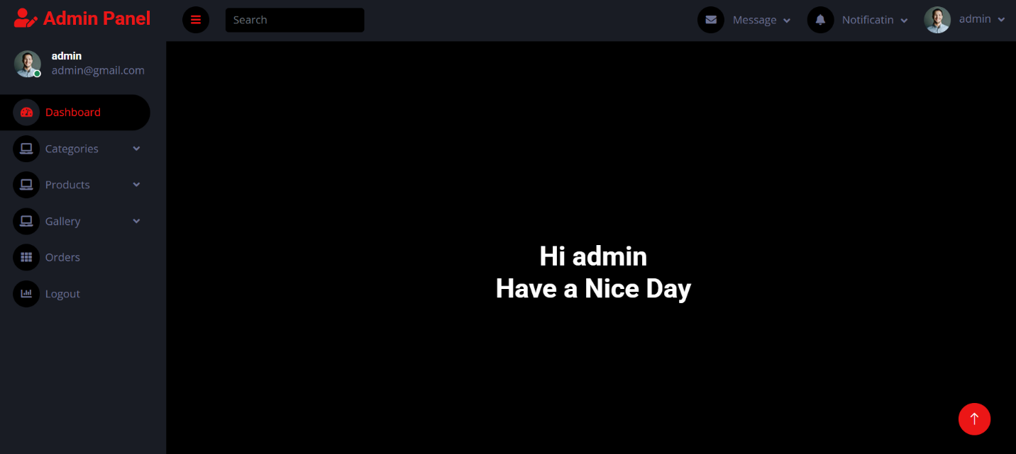

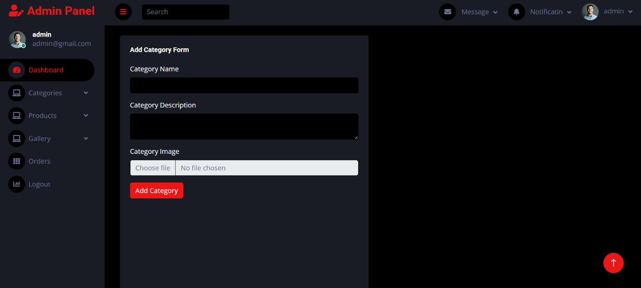

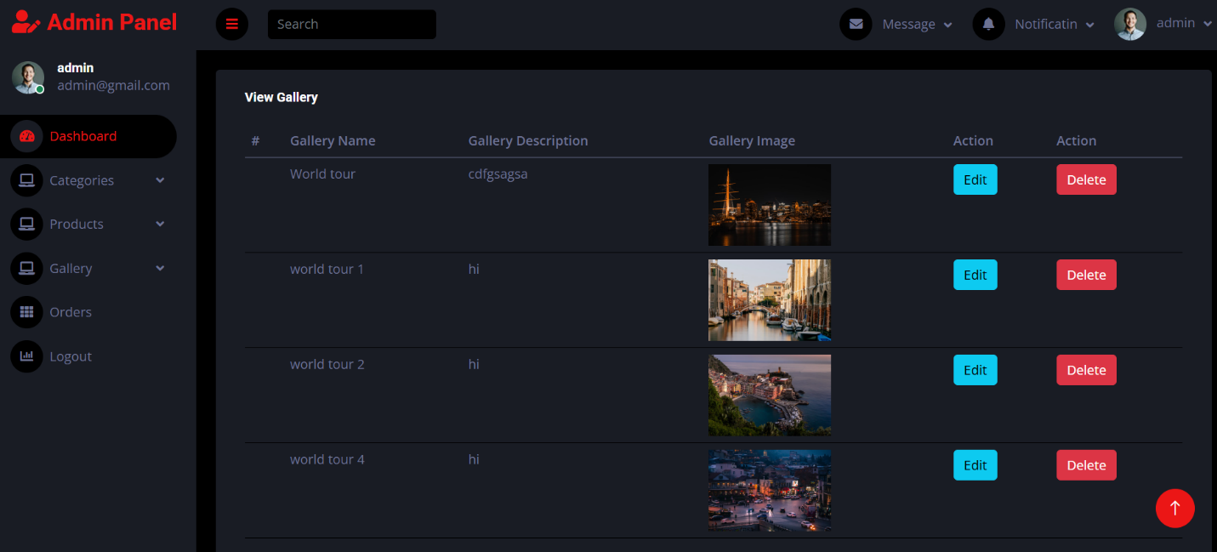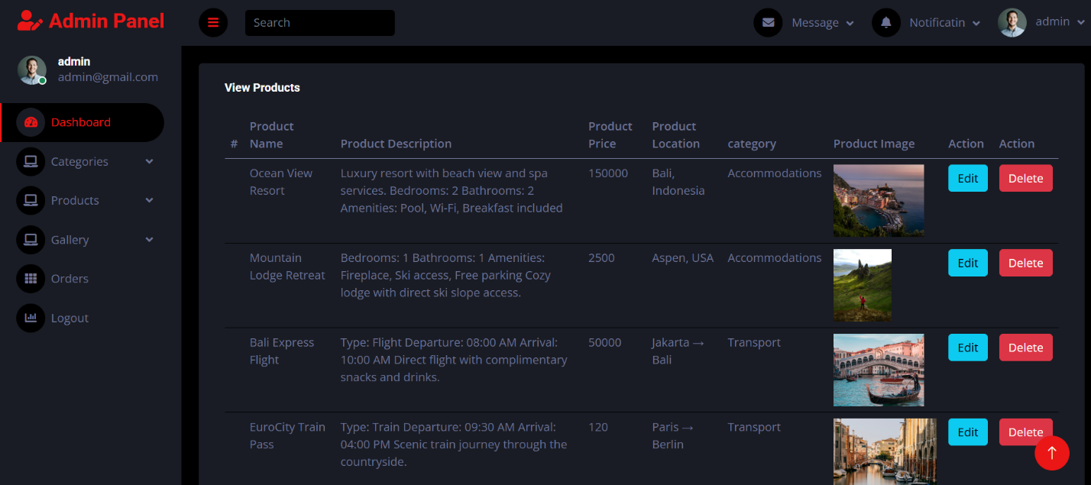

1. Itinerary Management

• Users must be able to add, edit, and delete itinerary items including flights, accommodations, and activities. • Itinerary items must be categorizable (for example, transport, lodging, and activities).

4) Expense Tracking

a) Real-Time Expense Logging

• Users must be able to log expenses manually, specifying the amount, category, date, and notes.

• Users must be able to edit and delete logged expenses. b) Budget Management

• Users must be able to set an overall budget for each trip.

• Users must be able to set category-specific budgets (for example, accommodation, food, and transport).

• The application must provide real-time tracking of expenses against the set budget.

• Users must receive alerts when they are approaching or exceeding their budget.

1. Currency Conversion
2. • The application must support multiple currencies [at least four, including USD $, Euro €, GBP £, and your Local Currency] and provide exchange rates.
3. • Expenses must be convertible to the user’s preferred currency. © Aptech Limited Note: Boilerplate or readymade HTML template can be used, provided it is only for design aspect and not for implementing application functionality. 5) Reports a) Expense Reports • Generate detailed expense reports summarizing expenses by category and trip. 6) Notifications and Reminders a) Reminders • Send daily notifications to log expenses. • Provide reminders for upcoming itinerary items. b) Alerts • Send budget alerts to notify users when they are approaching or exceeding their spending limits. For Admin • Login: It will allow Admin to login to the Web Application. • Add/Modify/Delete: It will allow Admin to perform these operations - Add and Manage destinations. - Add and Manage tours/trips with their itinerary. - Add Currency and exchange rates. Common to both Admin and Users • Search/Filter: These options enable search orfilterfor a particulartrip/tour or destination and so on based on specific criteria. • Sort: This option enables sorting of data based on specific criteria. • About Us: Description of services offered by the Web application. • Image Gallery: Gallery showcasing various locations. • Contact Us: A form to accept user queries with fields for name, email, contact number, and message. Implement GPS functionality as appropriate.