Array

1. **OBJECTIVES:**

* Define and describe arrays
* List and explain the types of arrays
* Explain the Array class

1. **EXERCISES**
   1. Using single-dimentional array.

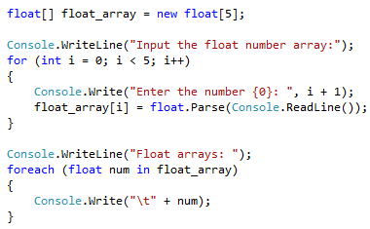

Run the program

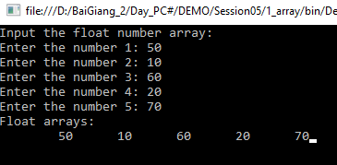

* 1. Using rectangular array

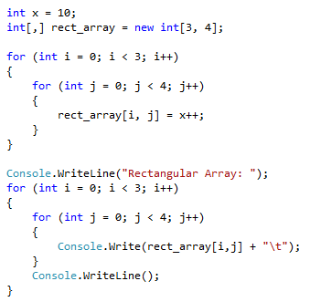

Run the program:

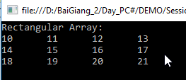

* 1. Using Jagged Array

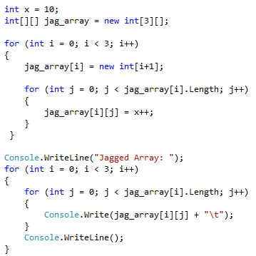

Run the program:

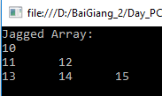

* 1. Create a program to define an integer array.
* Allow user enter data for elements of the array
* Display the array
* Display the average of the array.
* Allow user enter an integer number x. How many times does the number x appear in the array?
* Replace the number x in the above question by 100.
* Display the prime numbers in the array.
* Sort the array in descending.
* Enter a new array
* Find the elements that appears in two arrays.
* Find the elements that appears in the first array but without in the second array.
* Merge the second array into the first array.