Networking & Connectivity Troubleshooting Lab
  - Illustrated project documentation | Cisco Packet Tracer

Project summary
Designed a simulated two-department office network using a Cisco 2911 router, Cisco 2960 switch, and four PCs. Configured VLAN segmentation, static IPv4 addressing, 802.1Q trunking, and router-on-a-stick routing. Introduced and corrected two common faults: an incorrect default gateway and a misassigned switch VLAN.

Network plan
Department | VLAN | PC addresses | Gateway
IT Support | 10 | 192.168.10.10 / .11 | 192.168.10.1
HR | 20 | 192.168.20.10 / .11 | 192.168.20.1

Evidence index
01 Network Topology
02 VLAN Configuration
03 PC IP Configuration
04 Switch Trunk Configuration
05 Router Subinterfaces
06 VLAN 10 Connectivity Test
07 Inter-VLAN Connectivity Test
08 Troubleshooting: Failed Ping
09 Connectivity Restored After Gateway Fix
10 Troubleshooting: Incorrect VLAN
11 VLAN Assignment Corrected
12 Connectivity Restored After VLAN Fix
Screenshots document the lab as captured. Descriptions summarize the intended setup and testing procedures; refer to the images for exact observed command output.

01 Network Topology
Purpose and evidence: The office network topology includes one router, one switch, and four end-user computers organized into two departments.
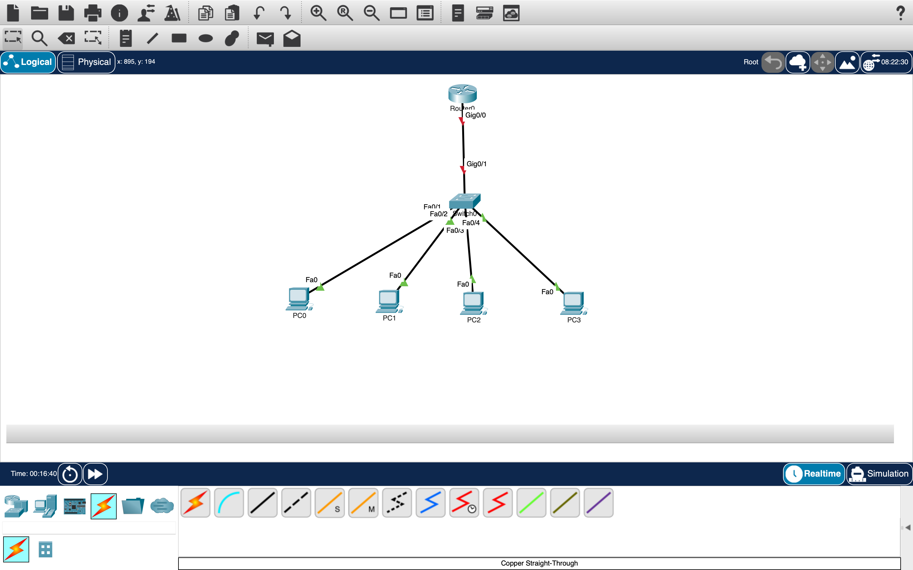
01-network-topology.png
Skill demonstrated: Network design and device connectivity.

02 VLAN Configuration
Purpose and evidence: The switch separates IT Support (VLAN 10) and HR (VLAN 20) into distinct logical networks.
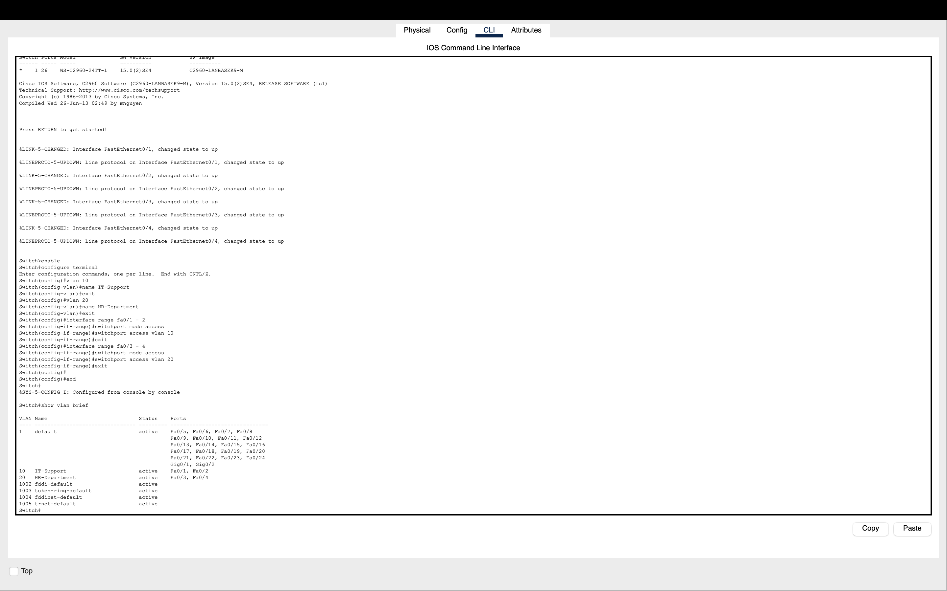
02-vlan-configuration.png
Skill demonstrated: VLAN creation and access-port assignment.

03 PC IP Configuration
Purpose and evidence: End devices use static IPv4 addresses, subnet masks, and default gateways corresponding to their assigned department.
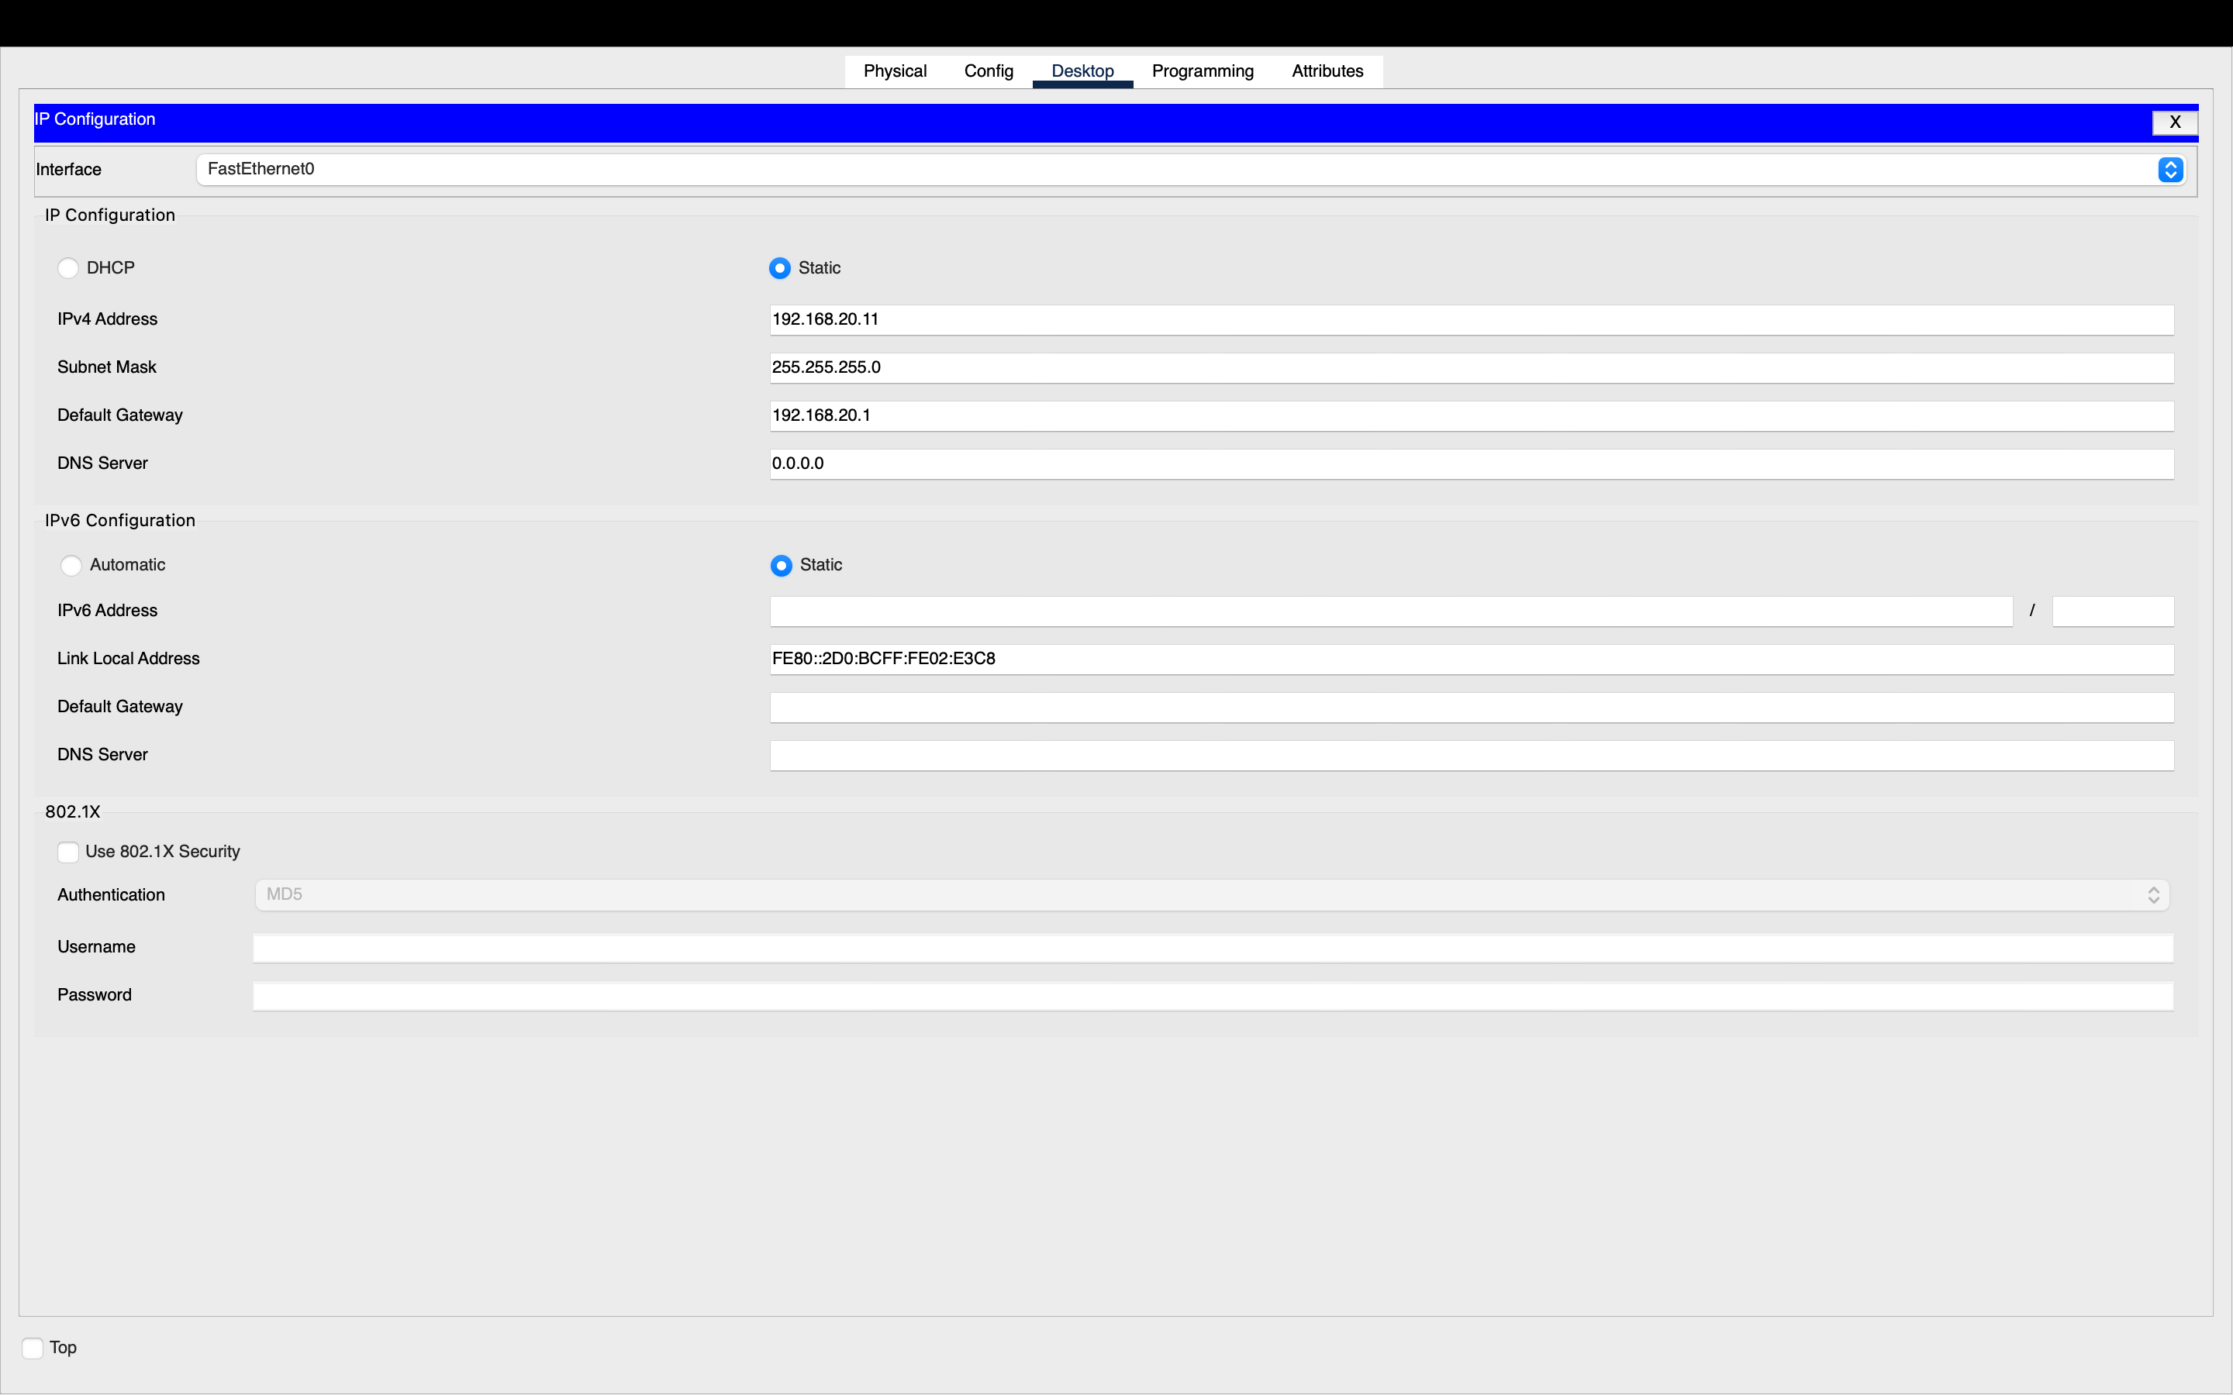
03-pc-ip-configuration.png
Skill demonstrated: IPv4 host addressing and default gateway configuration.

04 Switch Trunk Configuration
Purpose and evidence: The switch uplink uses an 802.1Q trunk to carry traffic for VLANs 10 and 20 toward the router.
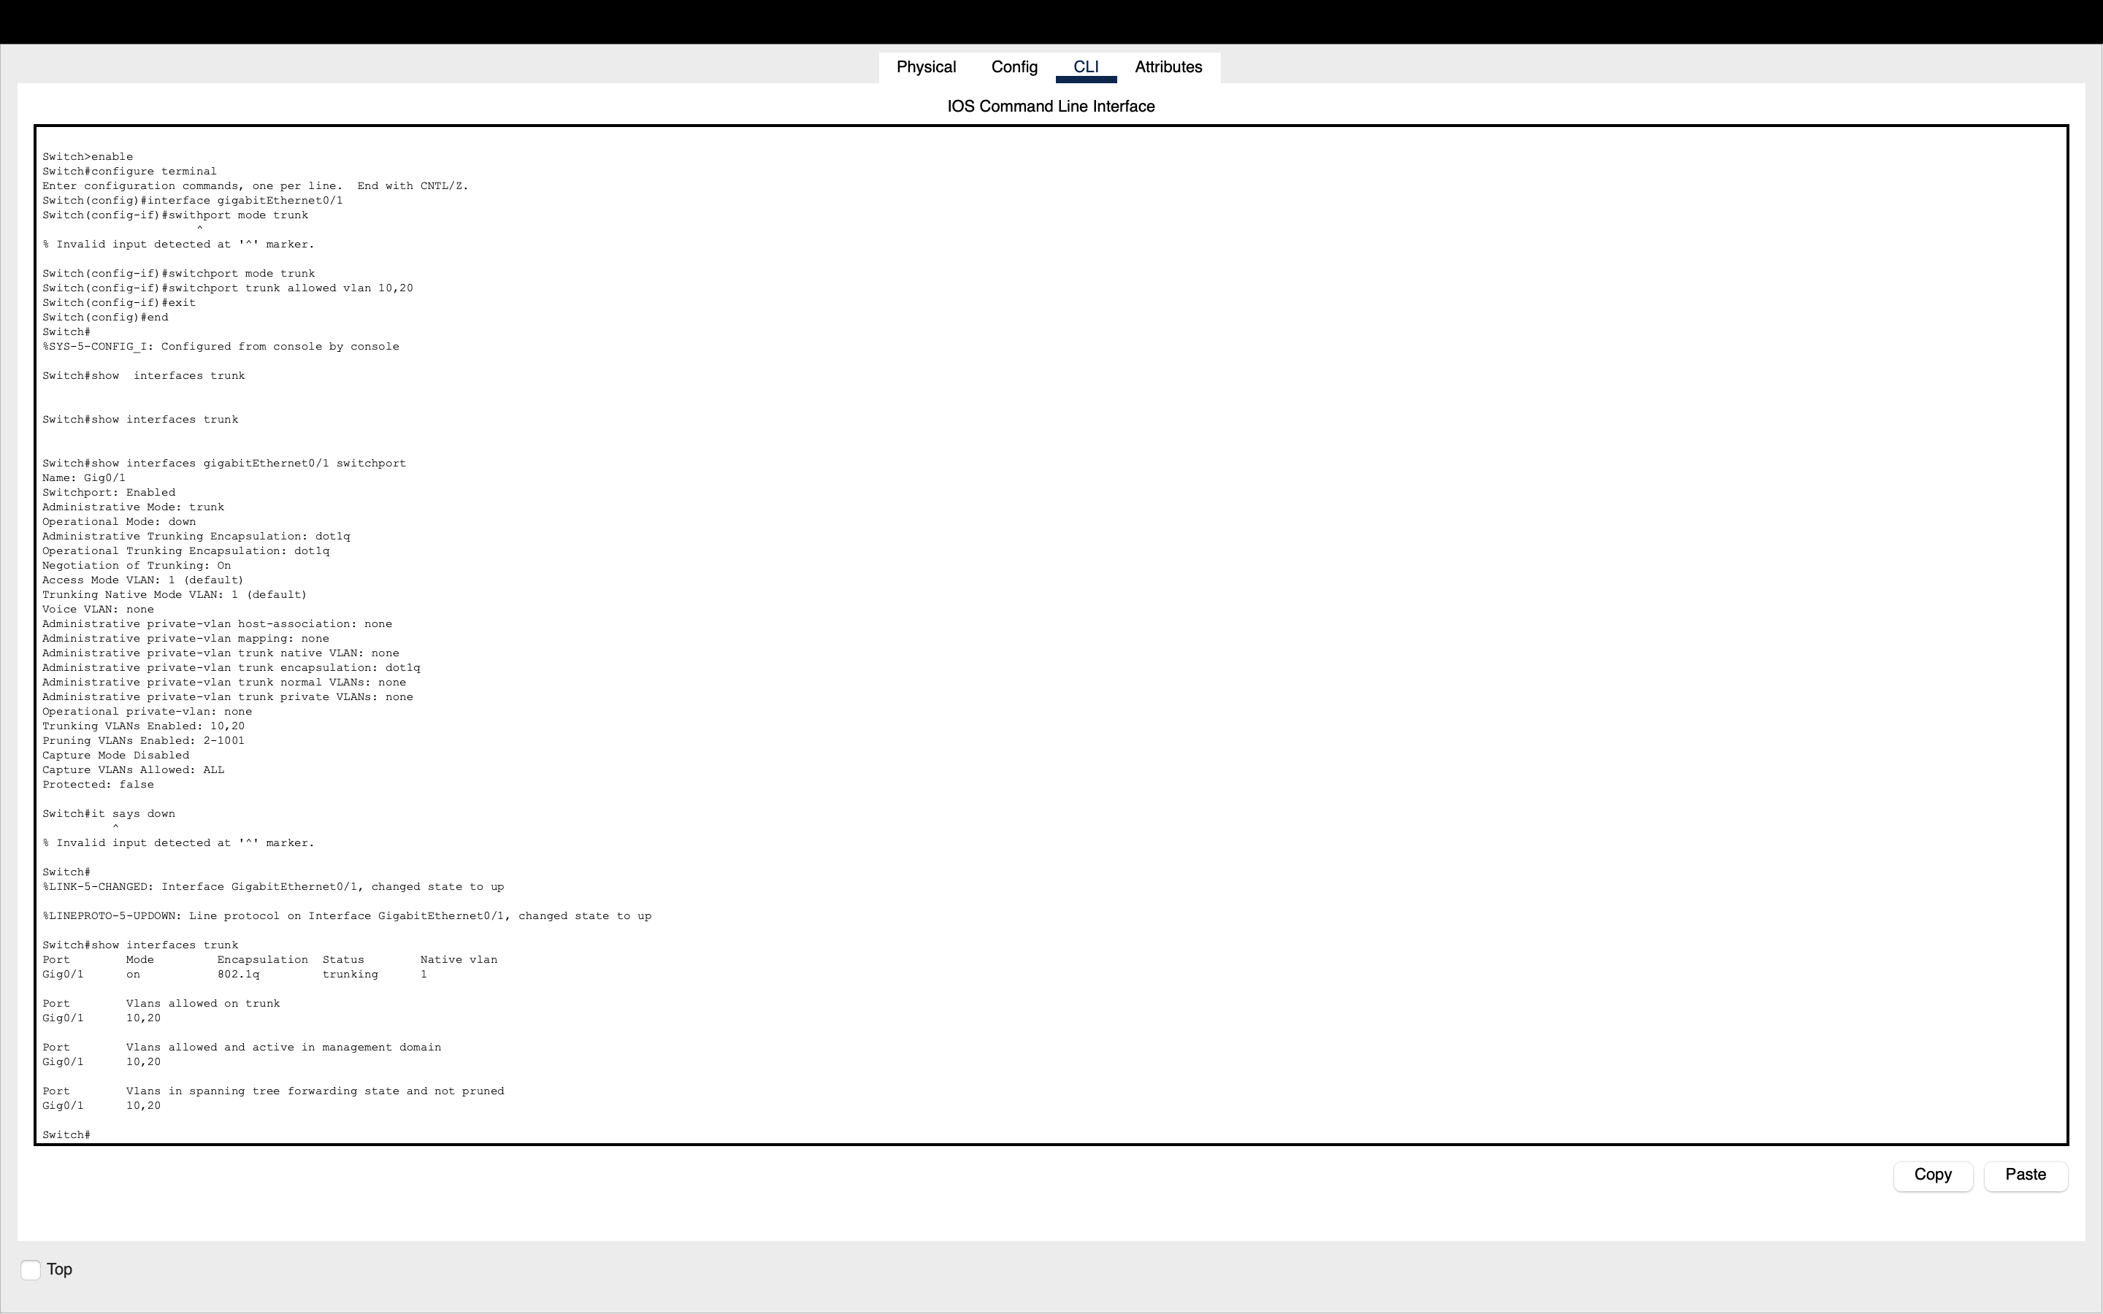
04-switch-trunk-configuration.png
Skill demonstrated: Trunk verification and VLAN transport.

05 Router Subinterfaces
Purpose and evidence: Router-on-a-Stick uses subinterfaces for VLAN 10 (192.168.10.1) and VLAN 20 (192.168.20.1).
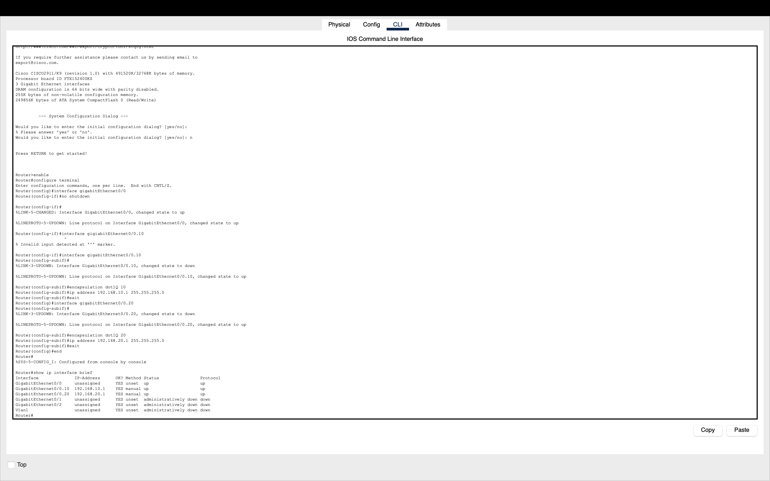
05-router-subinterfaces.png
Skill demonstrated: 802.1Q encapsulation and inter-VLAN routing configuration.

06 VLAN 10 Connectivity Test
Purpose and evidence: A ping from PC0 to PC1 tests connectivity between two hosts assigned to the IT Support VLAN.
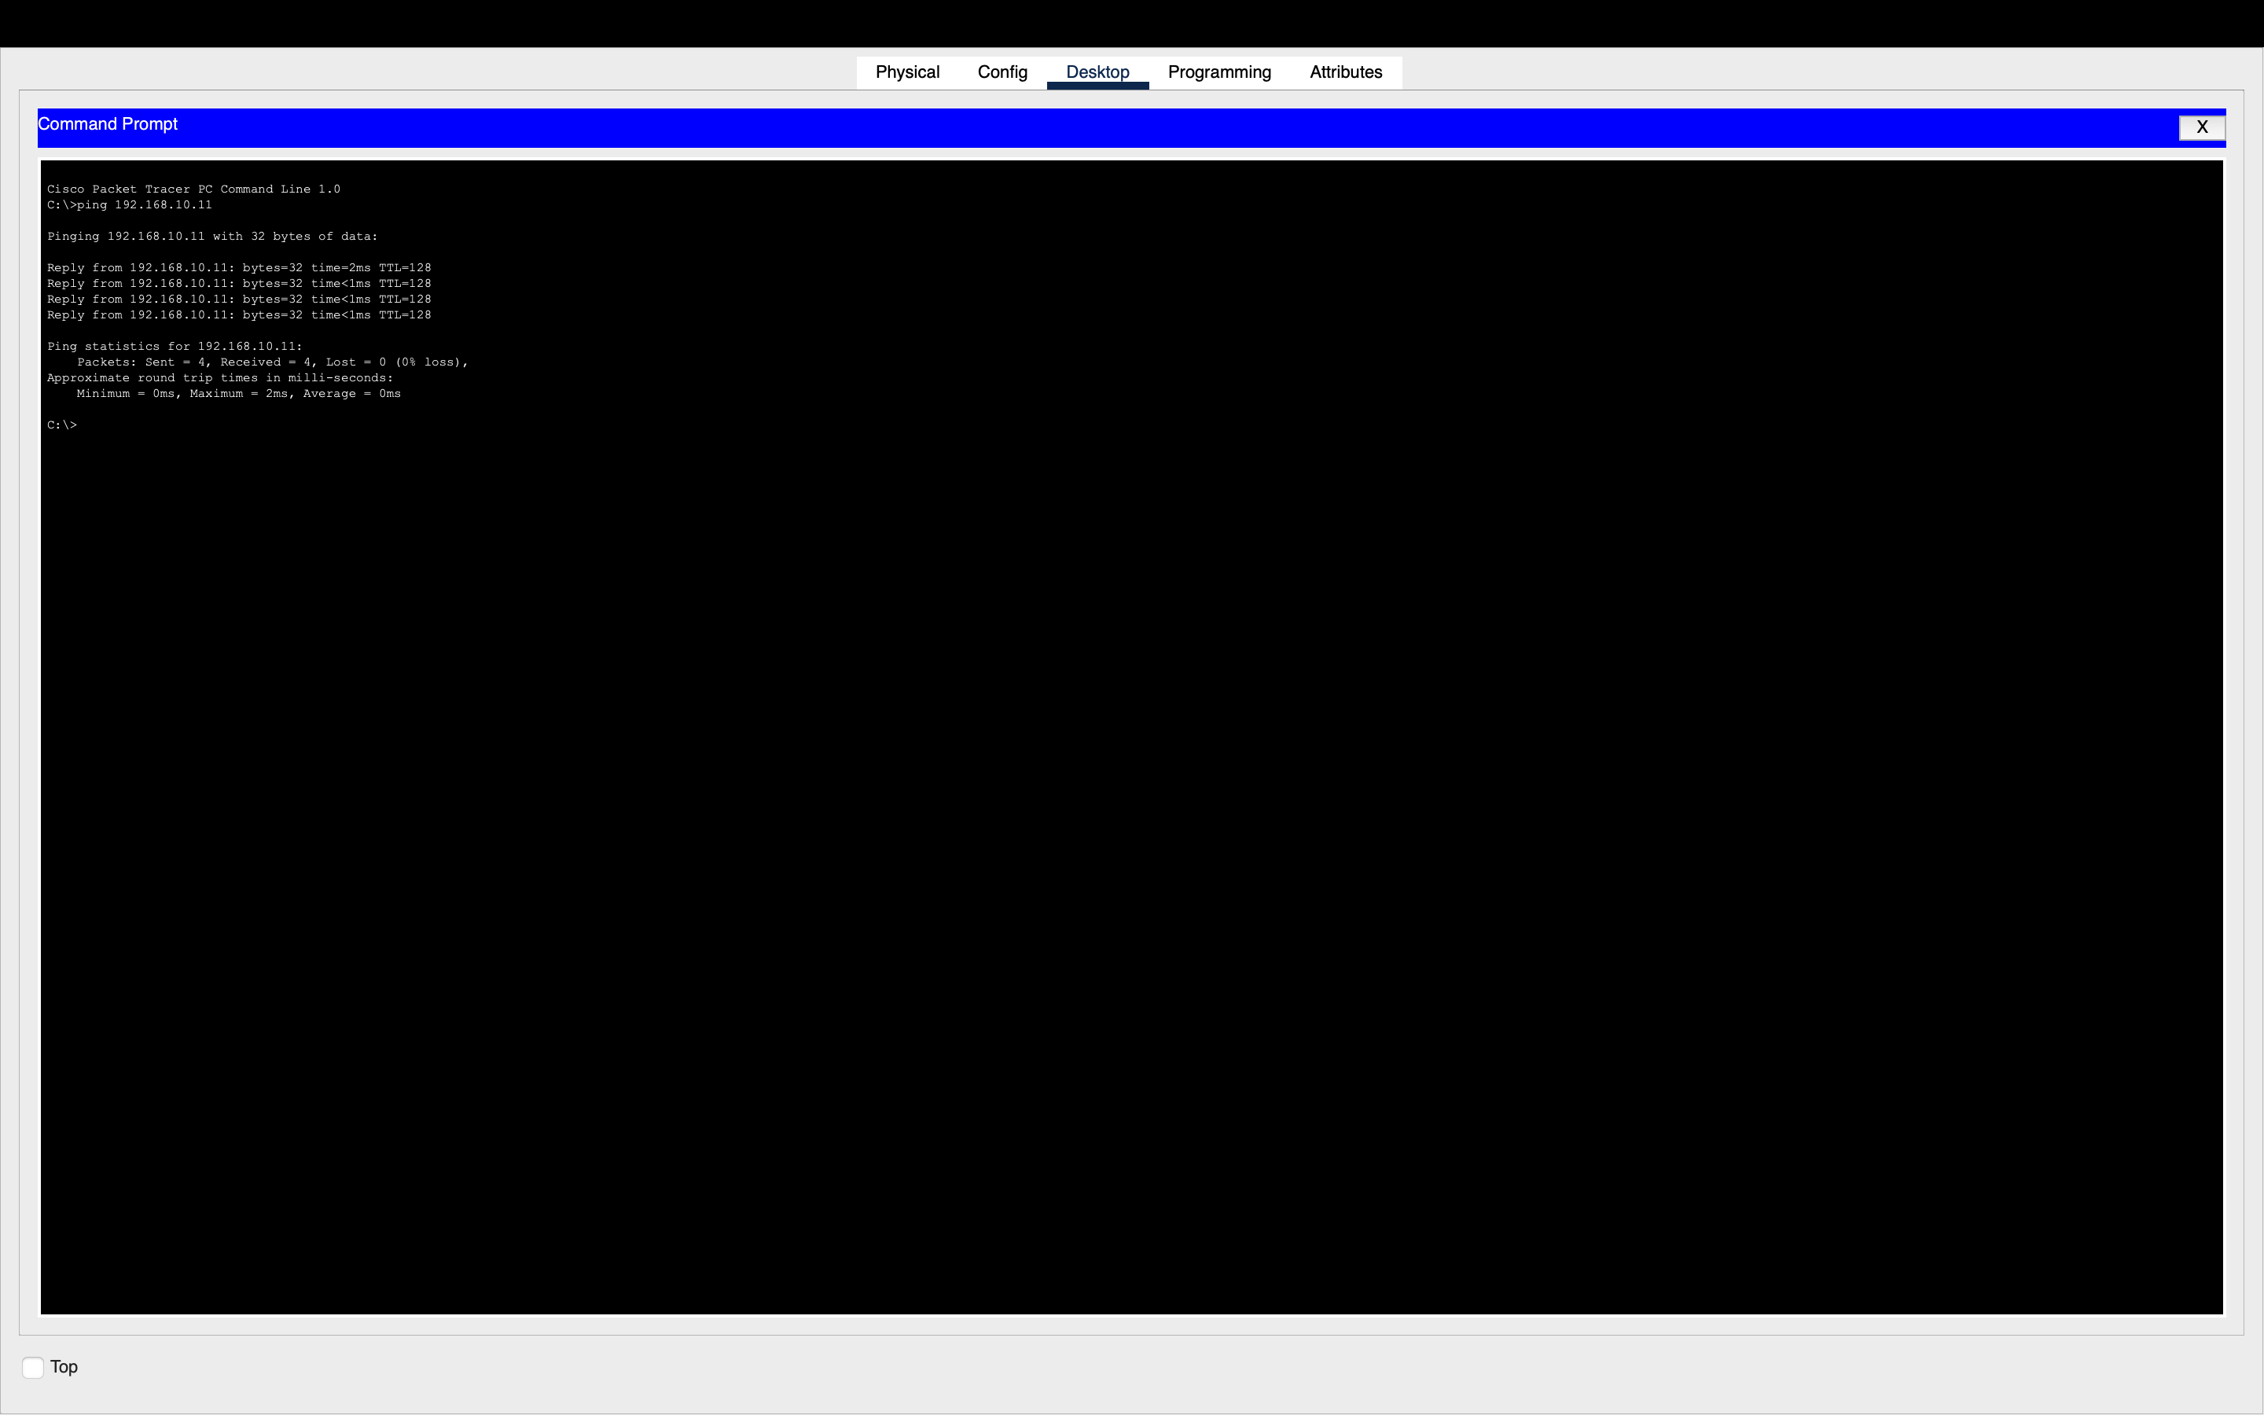
06-vlan10-connectivity-test.png
Skill demonstrated: Basic ICMP testing and same-VLAN reachability.

07 Inter-VLAN Connectivity Test
Purpose and evidence: A ping from the IT network to an HR host tests communication through the router between separate VLANs.
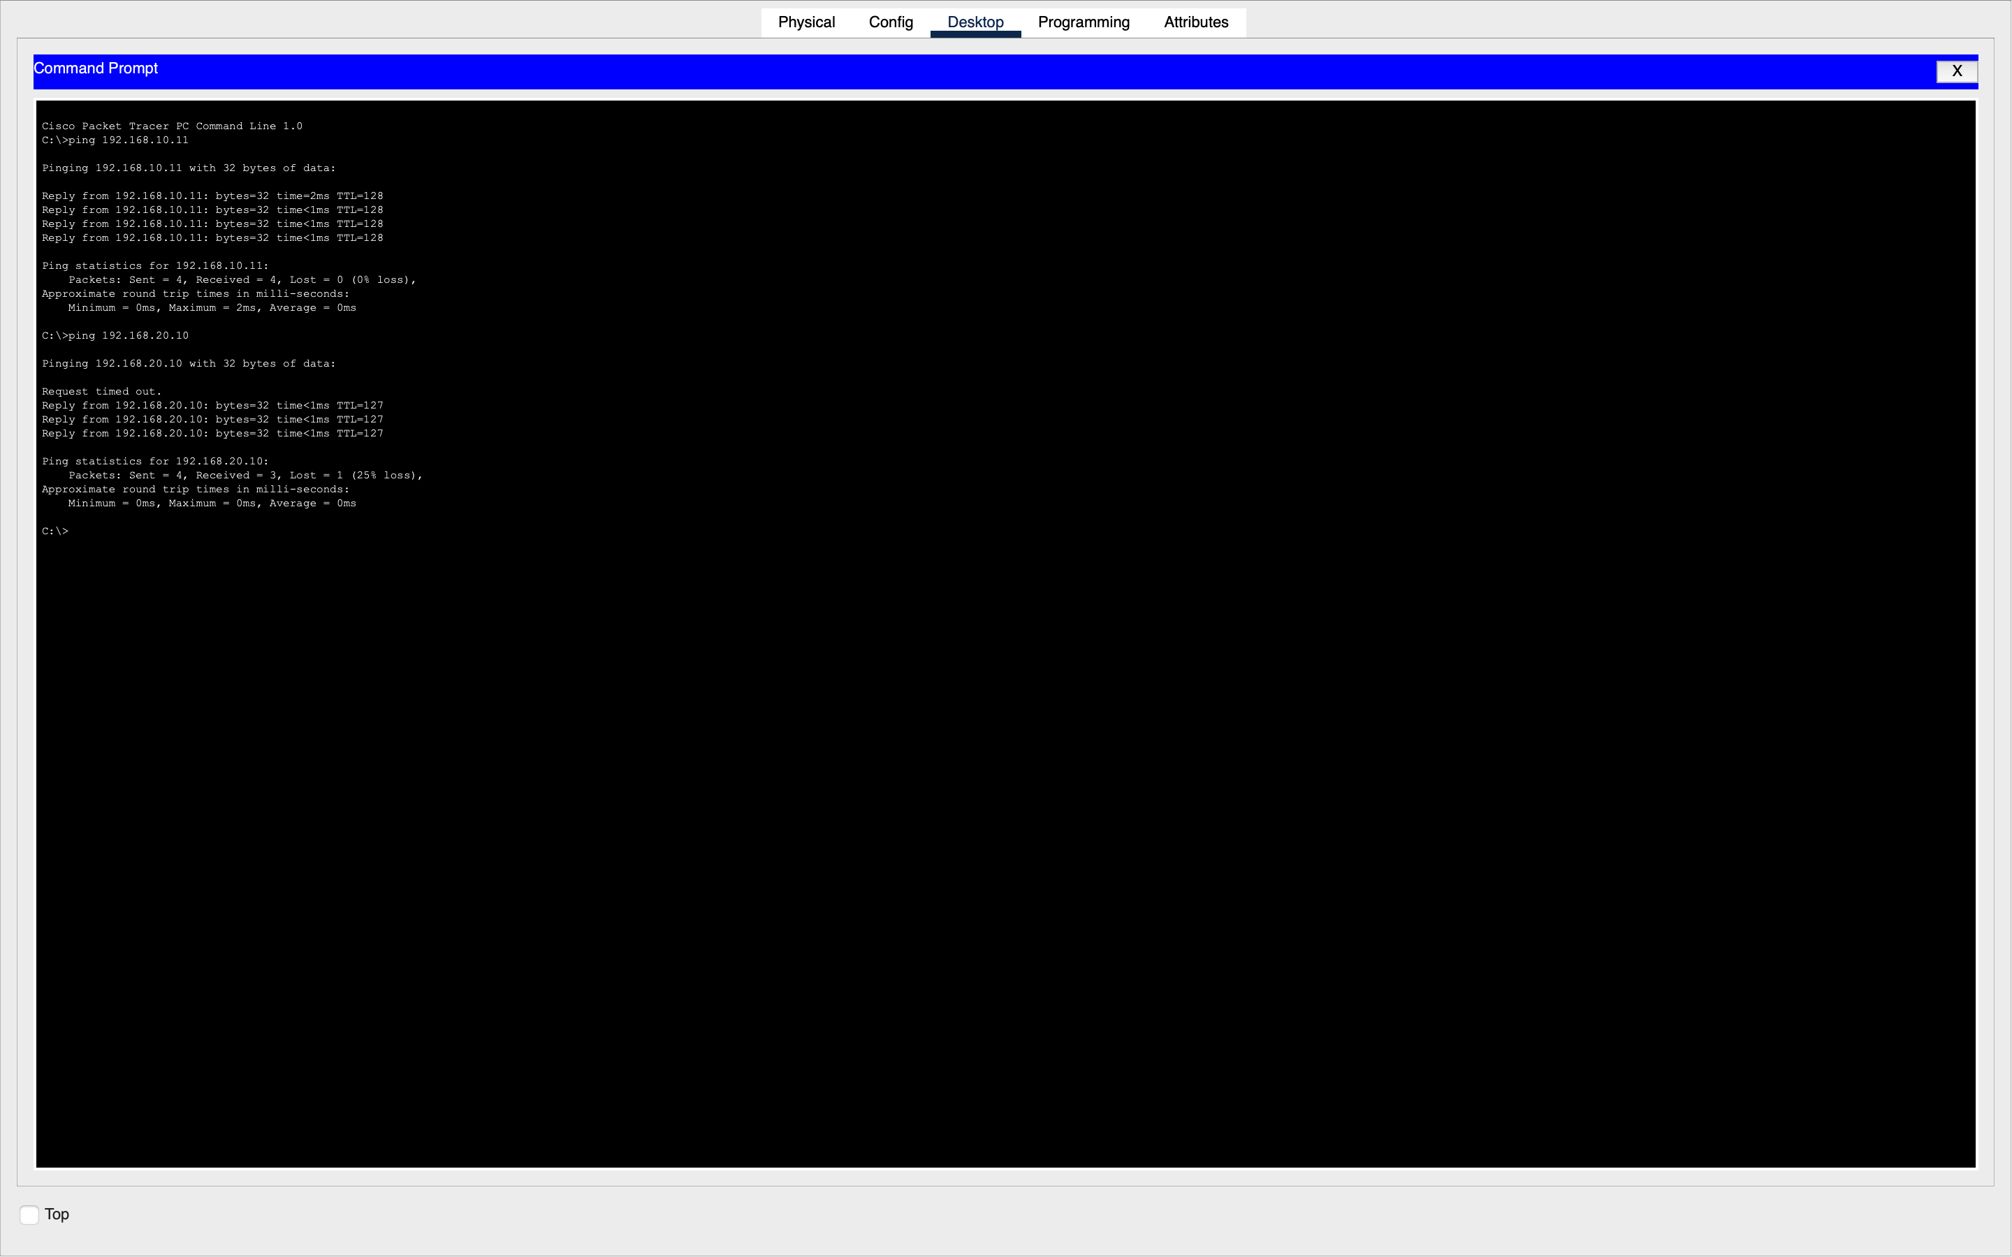
07-inter-vlan-connectivity.png
Skill demonstrated: Inter-VLAN reachability validation.

08 Troubleshooting: Failed Ping
Purpose and evidence: The HR computer was intentionally configured with an incorrect default gateway (192.168.20.254) to reproduce a connectivity problem.
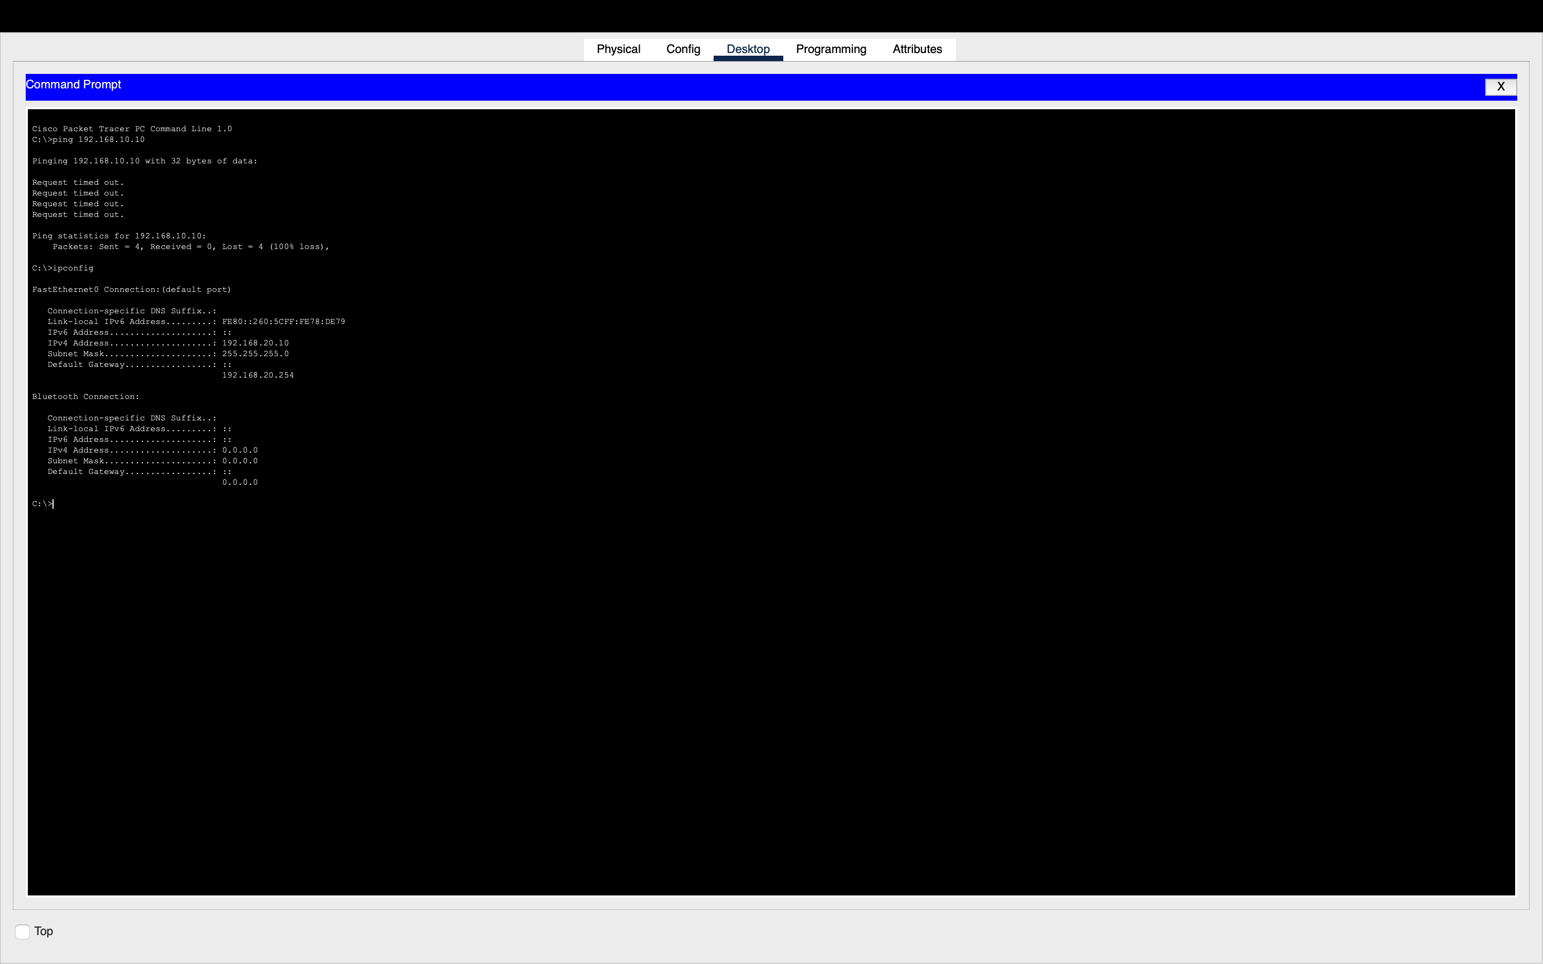
08-network-troubleshooting-failed-ping.png
Skill demonstrated: Reproducing and diagnosing an IPv4 gateway fault.
Troubleshooting method: identify the symptom, inspect relevant host or switch configuration, correct the misconfiguration, and verify connectivity.

09 Connectivity Restored After Gateway Fix
Purpose and evidence: The HR computer’s default gateway was restored to 192.168.20.1, and connectivity was retested.
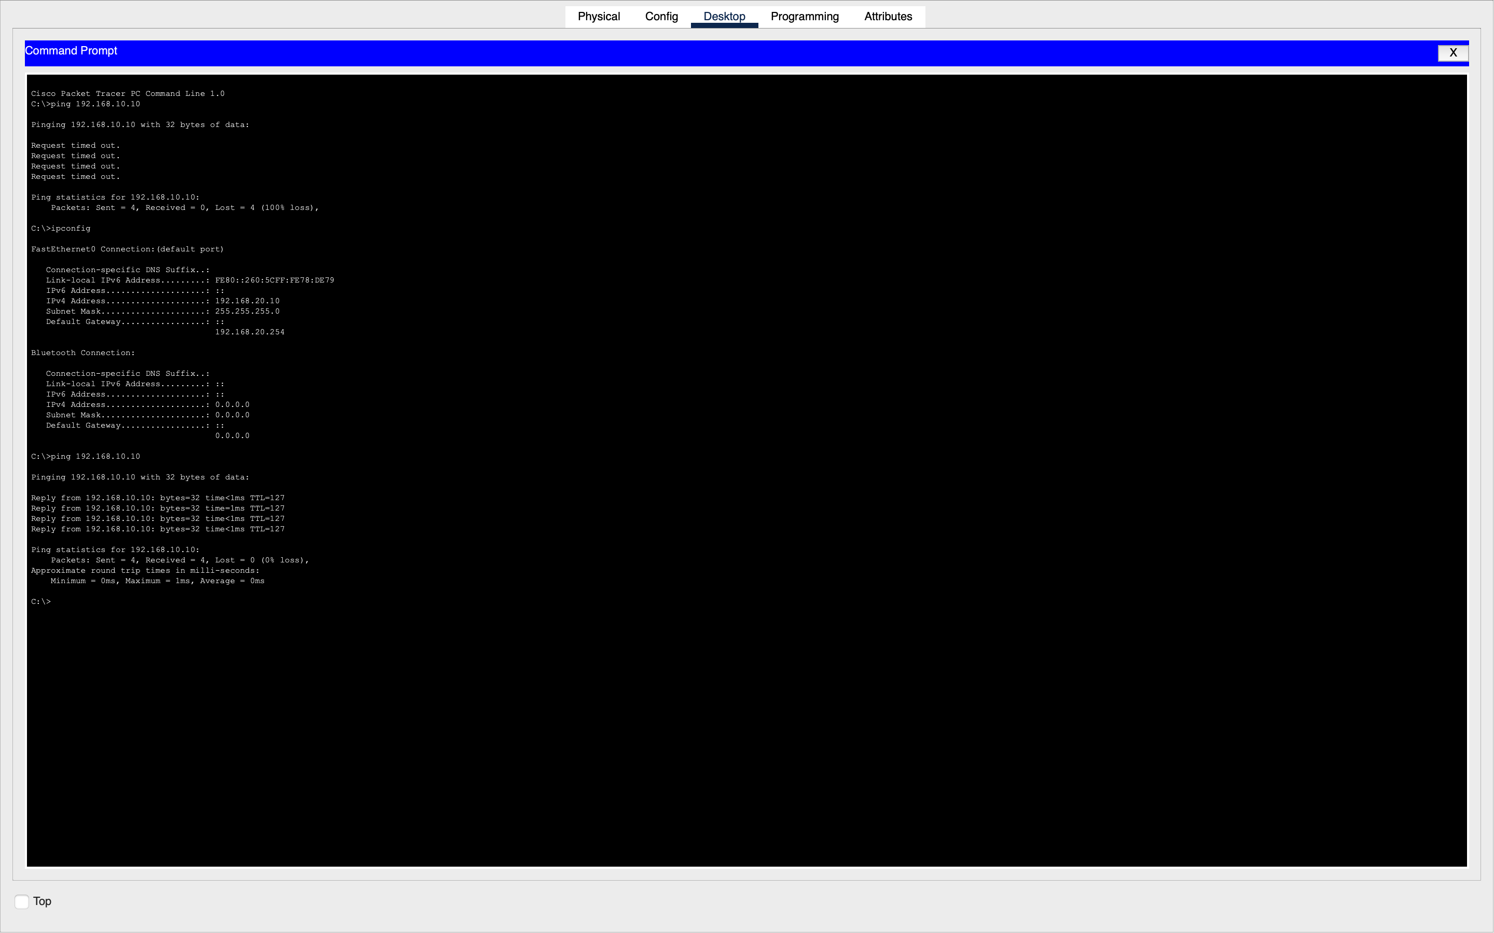
09-network-connectivity-restored.png
Skill demonstrated: Corrective action and post-fix verification.

10 Troubleshooting: Incorrect VLAN
Purpose and evidence: The switch port serving PC1 (Fa0/2) was intentionally moved to VLAN 20 even though PC1 uses a VLAN 10 IP address.
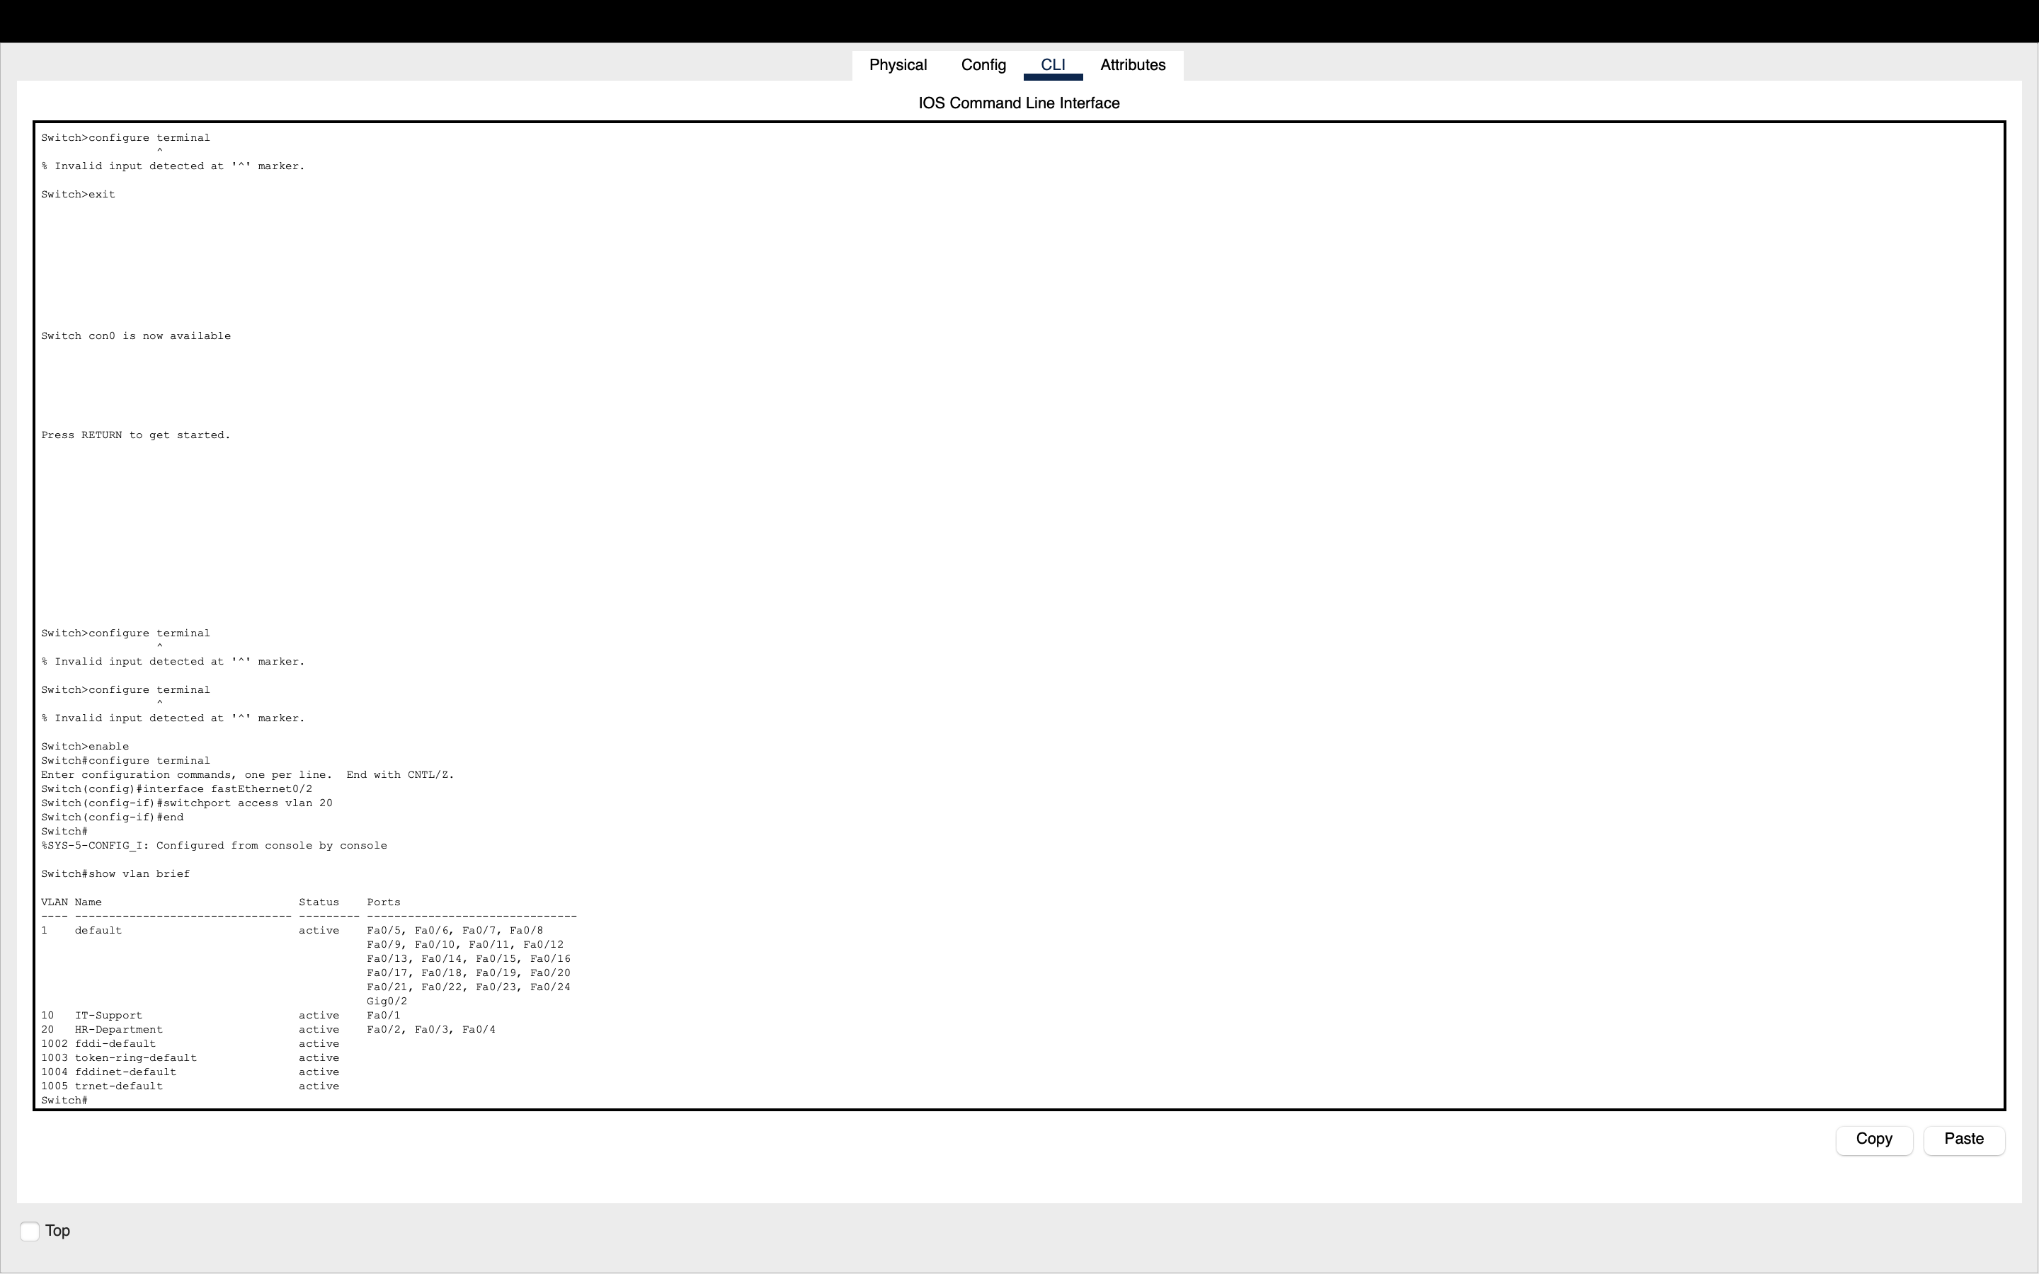
10-vlan-misconfiguration.png
Skill demonstrated: Diagnosing access-port VLAN mismatches using show vlan brief.
Troubleshooting method: identify the symptom, inspect relevant host or switch configuration, correct the misconfiguration, and verify connectivity.

11 VLAN Assignment Corrected
Purpose and evidence: The switch port Fa0/2 was returned to VLAN 10, restoring the intended IT Support port membership.
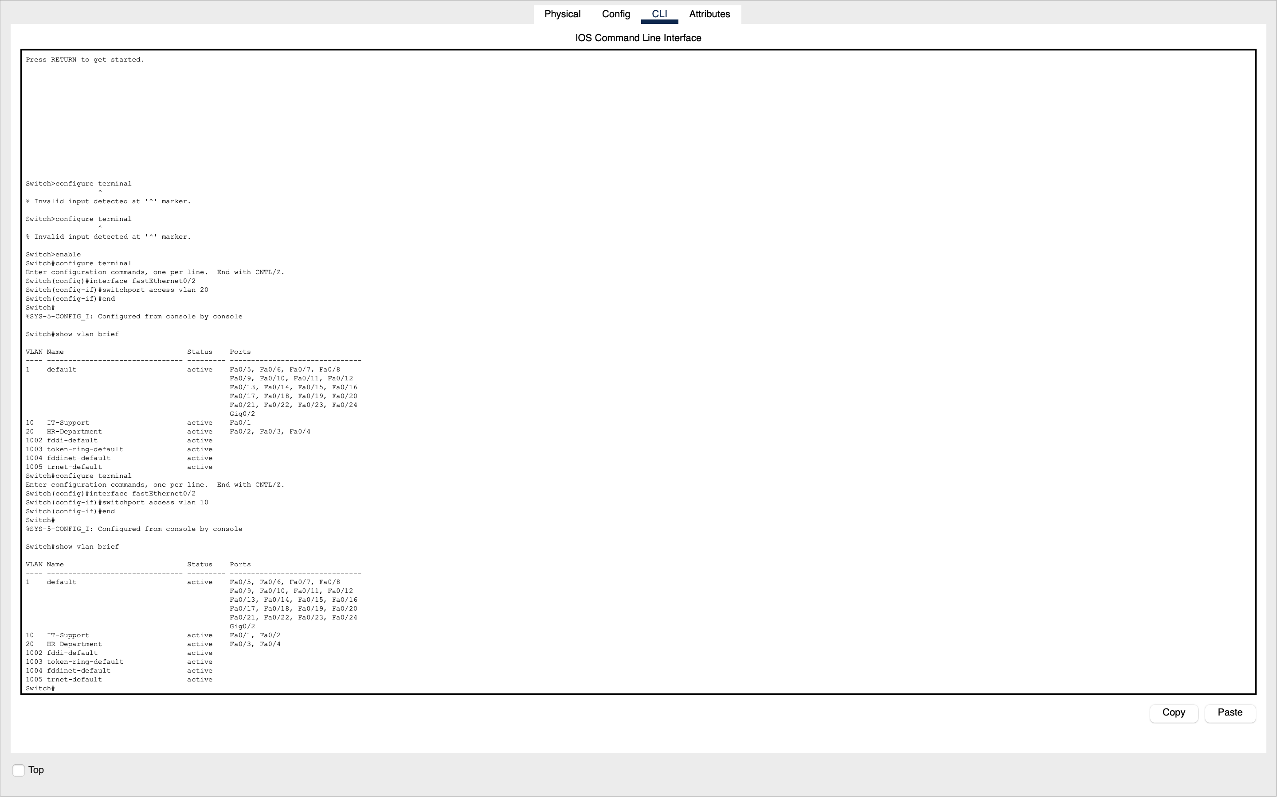
11-vlan-misconfiguration-fixed.png
Skill demonstrated: Switch configuration remediation and validation.

12 Connectivity Restored After VLAN Fix
Purpose and evidence: PC0 pinged PC1 after the VLAN correction to validate same-VLAN connectivity.
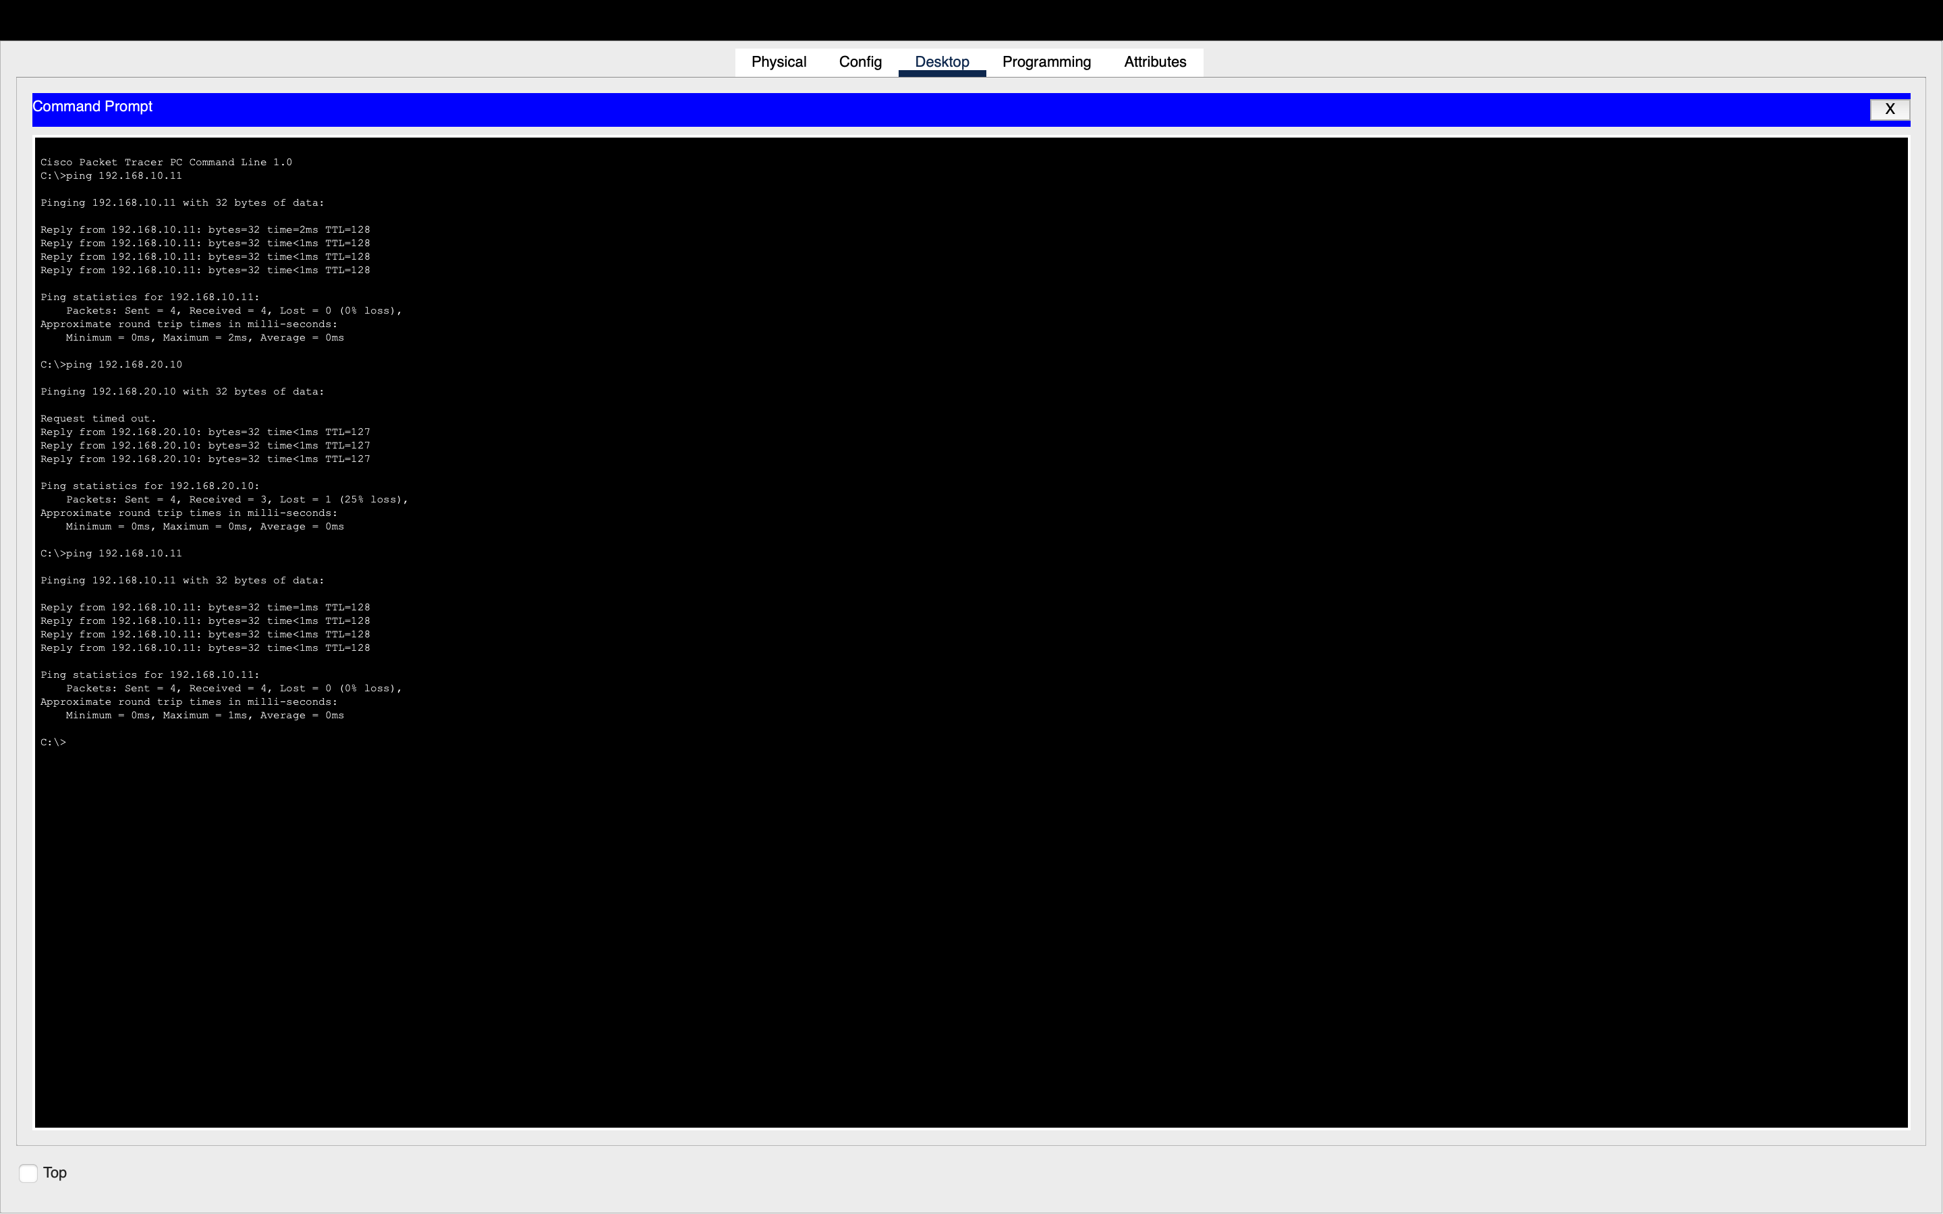
12-vlan-connectivity-restored.png
Skill demonstrated: End-to-end testing following a switch configuration fix.

