Samba Active Directory & User Management Lab
Project 3 | IT Support Portfolio Lab
Debian 13 ARM64 • UTM • Samba Active Directory Domain Controller

Project Summary
Built an Active Directory-compatible domain controller in a Debian virtual machine and performed common IT support administration tasks: onboarding test users, resetting passwords, enabling and disabling accounts, creating security groups, verifying group membership, and checking directory database consistency.
Environment: macOS / Apple Silicon host; UTM virtualization; Debian 13 ARM64; Samba AD DC; hostname dc01; domain corp.example.test; NetBIOS domain CORP. All employee identities are fictional.
Scope: This is a Samba AD-compatible lab, not Microsoft Windows Server or the Active Directory Users and Computers graphical console. Group membership does not itself assign file permissions.

Evidence Index
Screenshot | Evidence
01 | Domain Controller Service Status
02 | Domain Controller and Domain Identification
03 | Initial Domain User Listing
04 | Help Desk Password Reset
05 | Account Disable for Offboarding
06 | Account Reactivation
07 | IT-Support Security Group Creation
08 | IT-Support Group Membership
09 | Multiple Employee Accounts
10 | HR Department Group Membership
11 | Directory Database Consistency Check

Screenshot 01 — Domain Controller Service Status
Task and observation: Verified that the samba-ad-dc service was enabled and actively running using systemctl status samba-ad-dc.
Skill demonstrated: Service availability and Linux service administration.
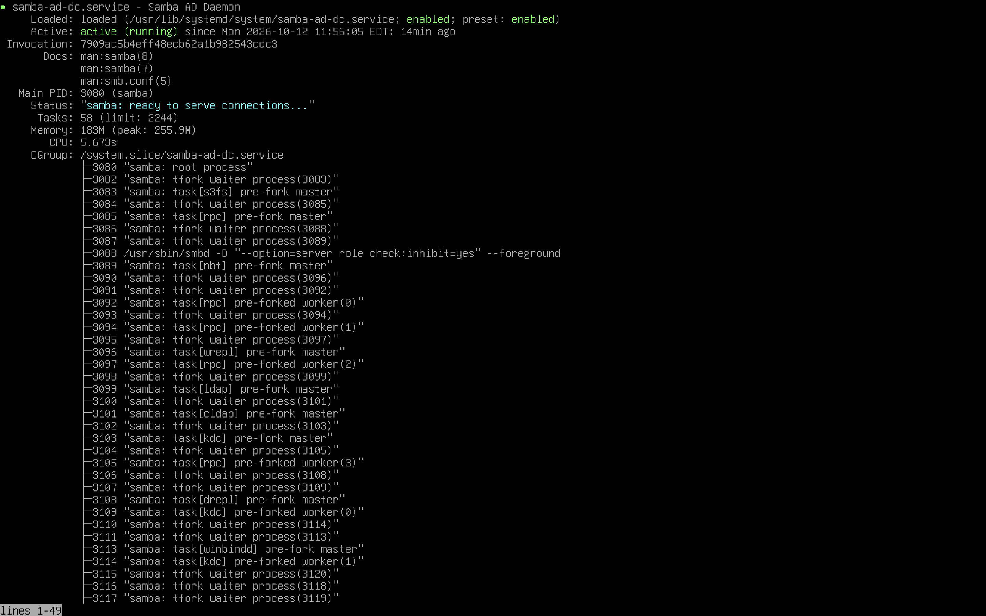
Evidence file: screenshots/01-domain-controller-running.png

Screenshot 02 — Domain Controller and Domain Identification
Task and observation: Queried the local domain controller with samba-tool domain info 127.0.0.1 to identify the CORP domain and dc01 server.
Skill demonstrated: Directory environment verification and domain identification.
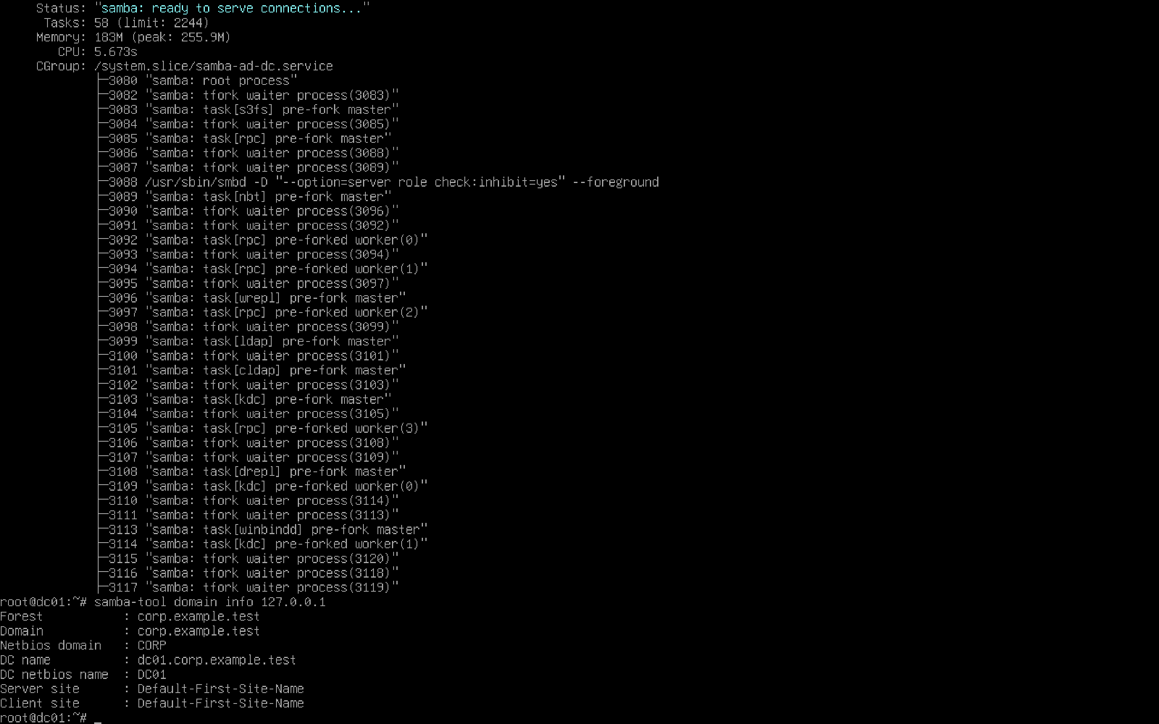
Evidence file: screenshots/02-active-directory-domain-info.png

Screenshot 03 — Initial Domain User Listing
Task and observation: Used samba-tool user list to inspect built-in domain accounts and confirm the fictional jsmith user account.
Skill demonstrated: Account provisioning validation.
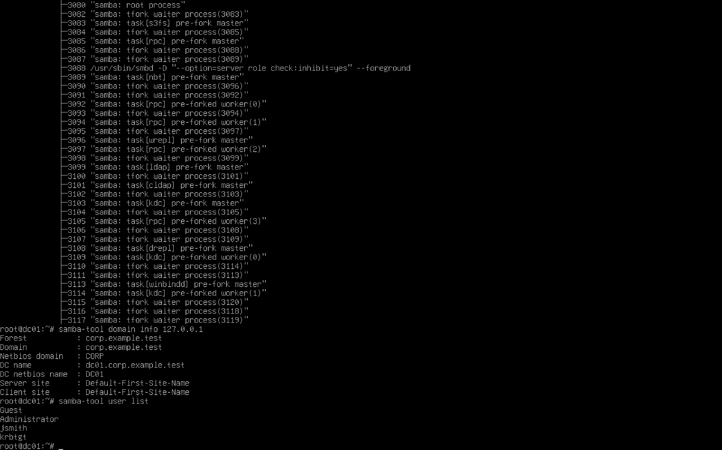
Evidence file: screenshots/03-active-directory-users.png

Screenshot 04 — Help Desk Password Reset
Task and observation: Used samba-tool user setpassword jsmith and followed the password confirmation prompts. Password values are not included in the report.
Skill demonstrated: Password reset workflow for user support.
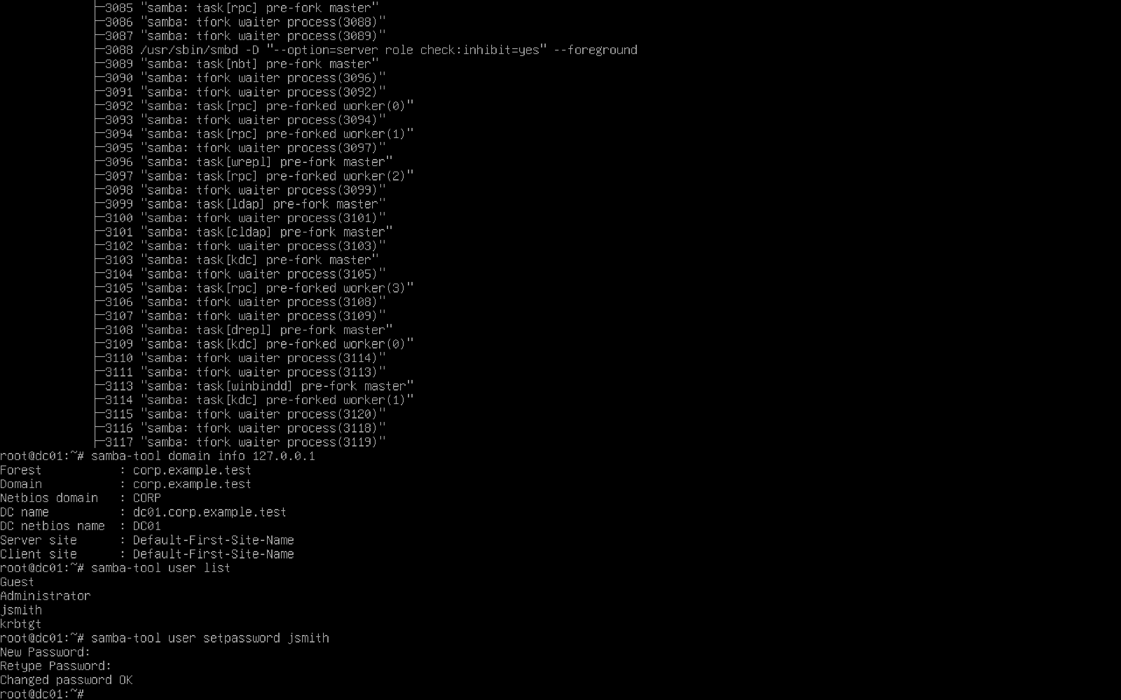
Evidence file: screenshots/04-active-directory-password-reset.png

Screenshot 05 — Account Disable for Offboarding
Task and observation: Disabled jsmith and inspected the directory account attributes. The userAccountControl value 514 is consistent with a disabled typical user account.
Skill demonstrated: Offboarding and access restriction.
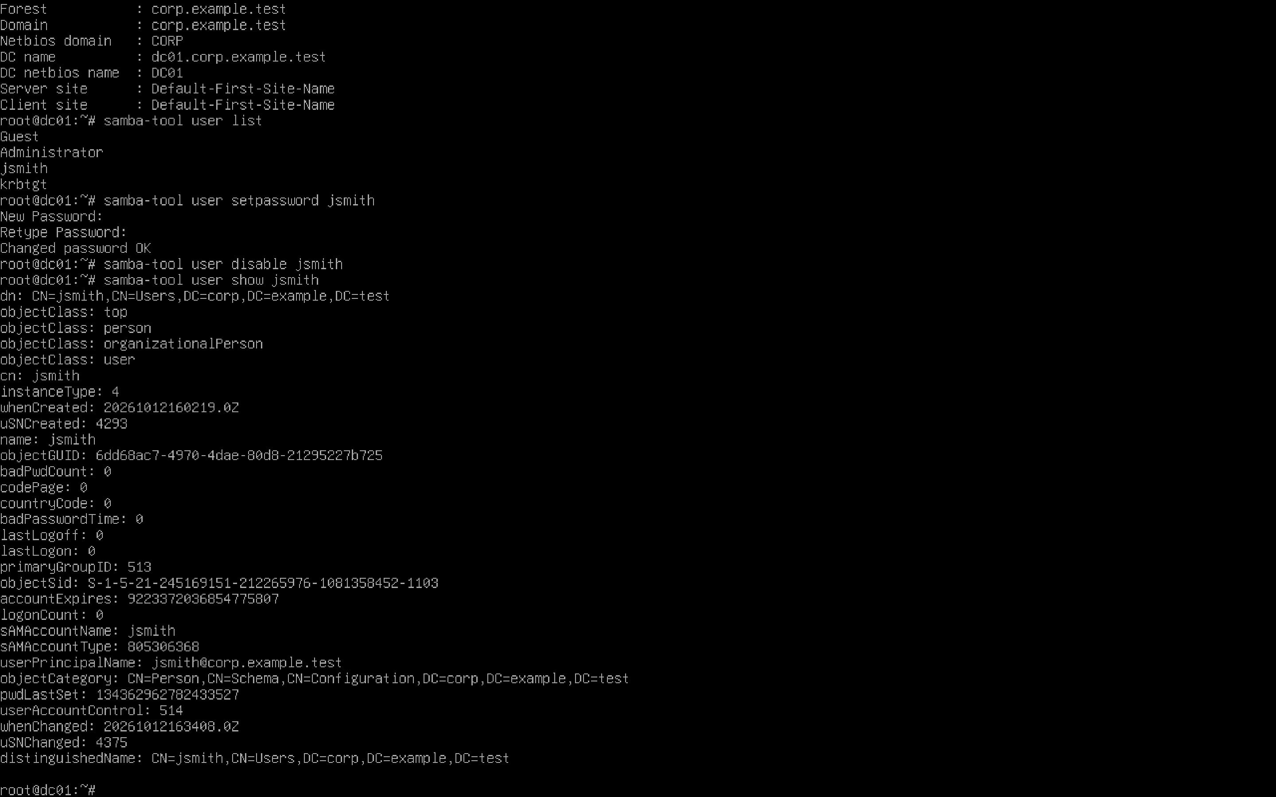
Evidence file: screenshots/05-disabled-user-account.png

Screenshot 06 — Account Reactivation
Task and observation: Re-enabled jsmith and checked account attributes. The expected userAccountControl value for a typical enabled user is 512.
Skill demonstrated: Account restoration and state verification.
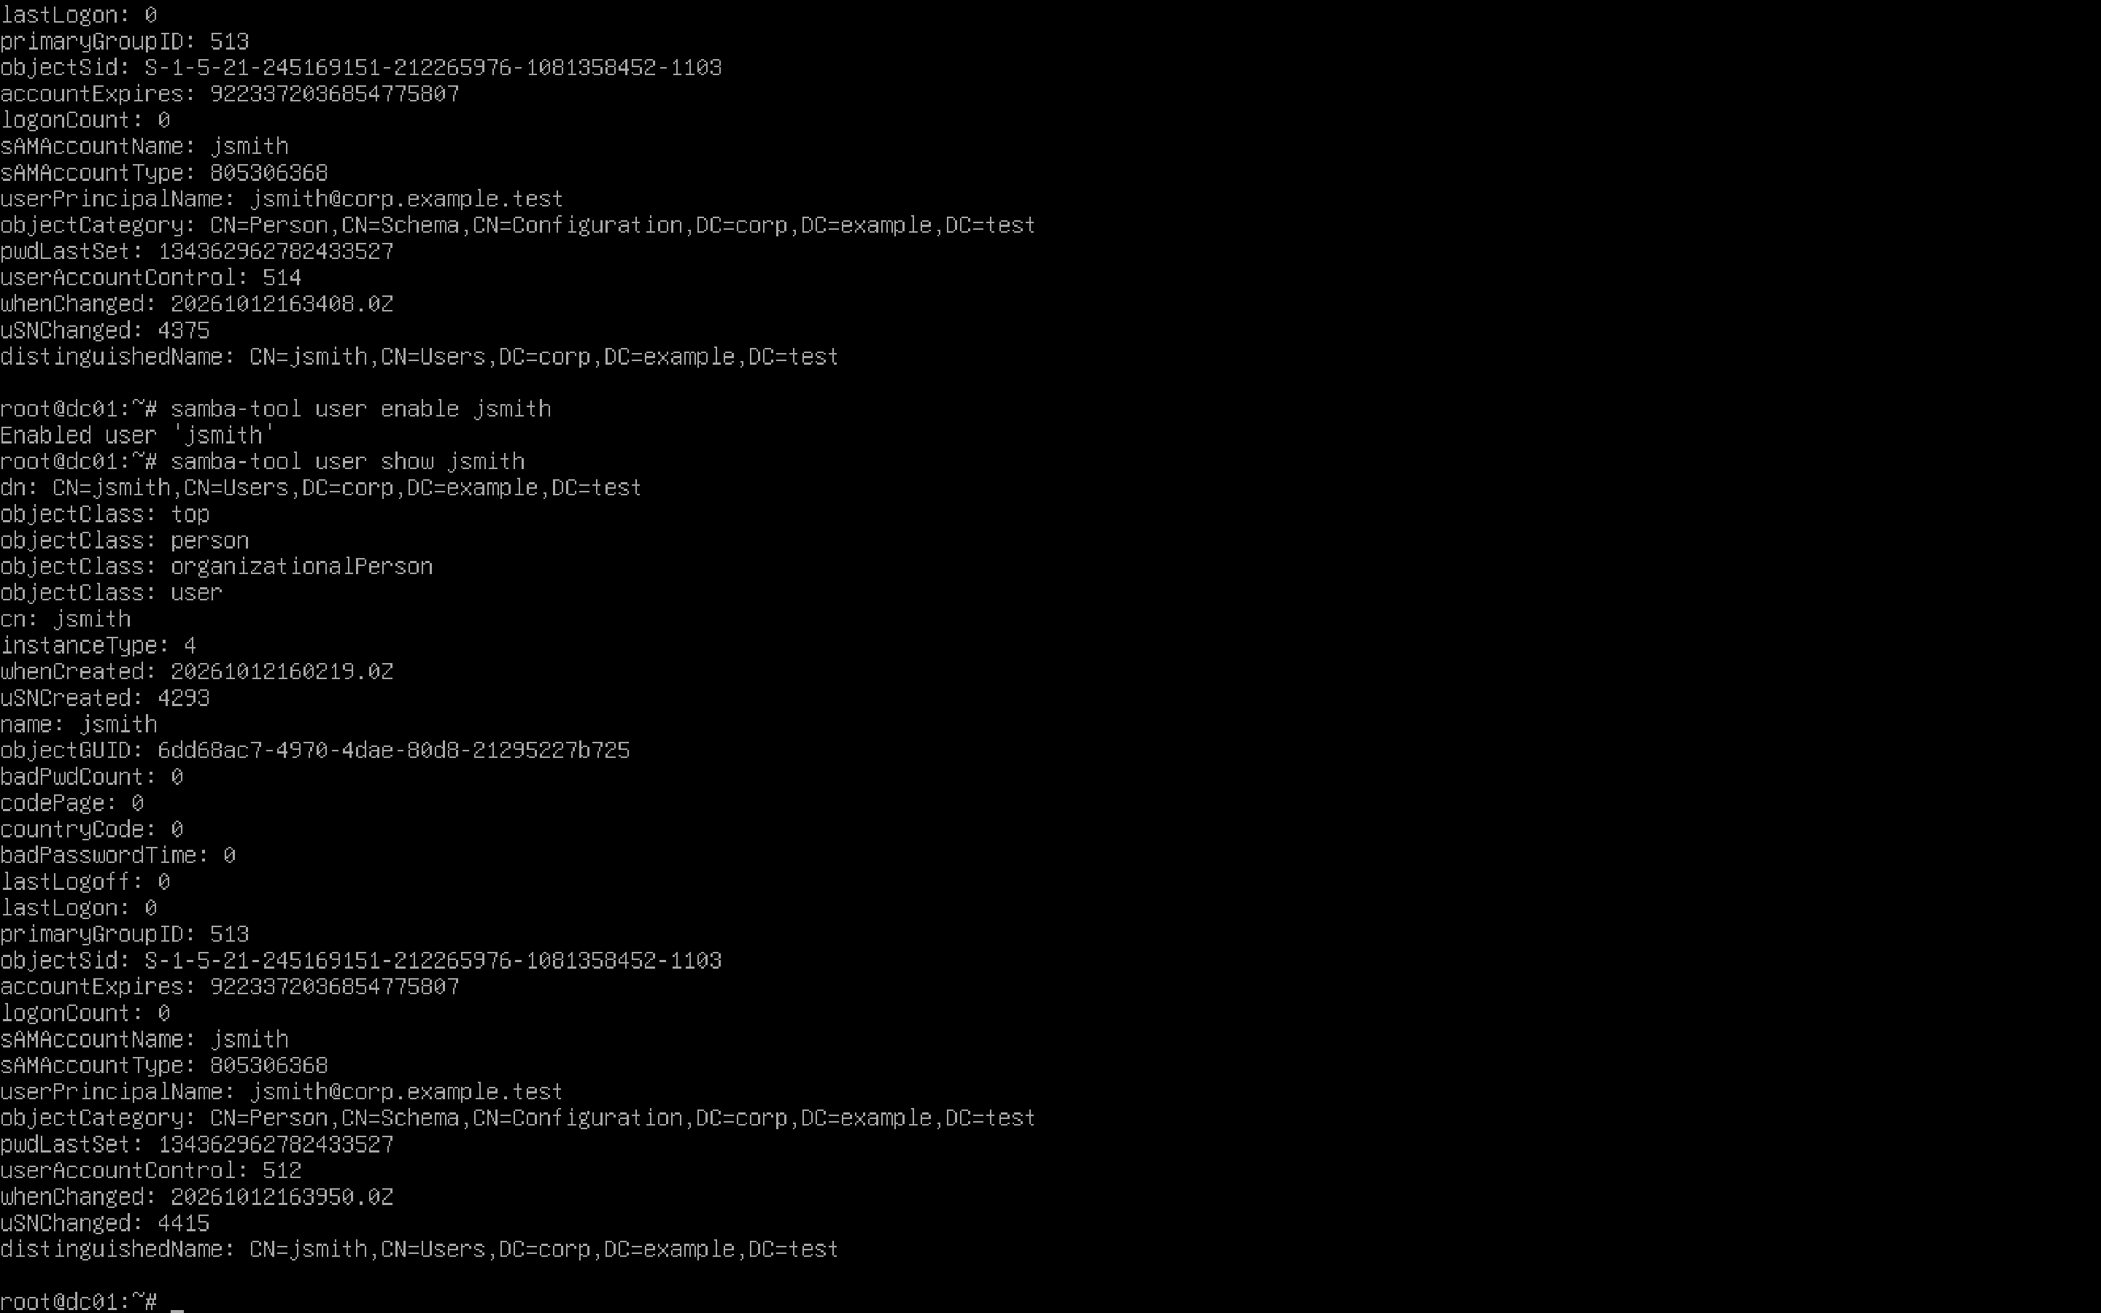
Evidence file: screenshots/06-enabled-user-account.png

Screenshot 07 — IT-Support Security Group Creation
Task and observation: Created the IT-Support security group using samba-tool group add.
Skill demonstrated: Departmental identity organization.
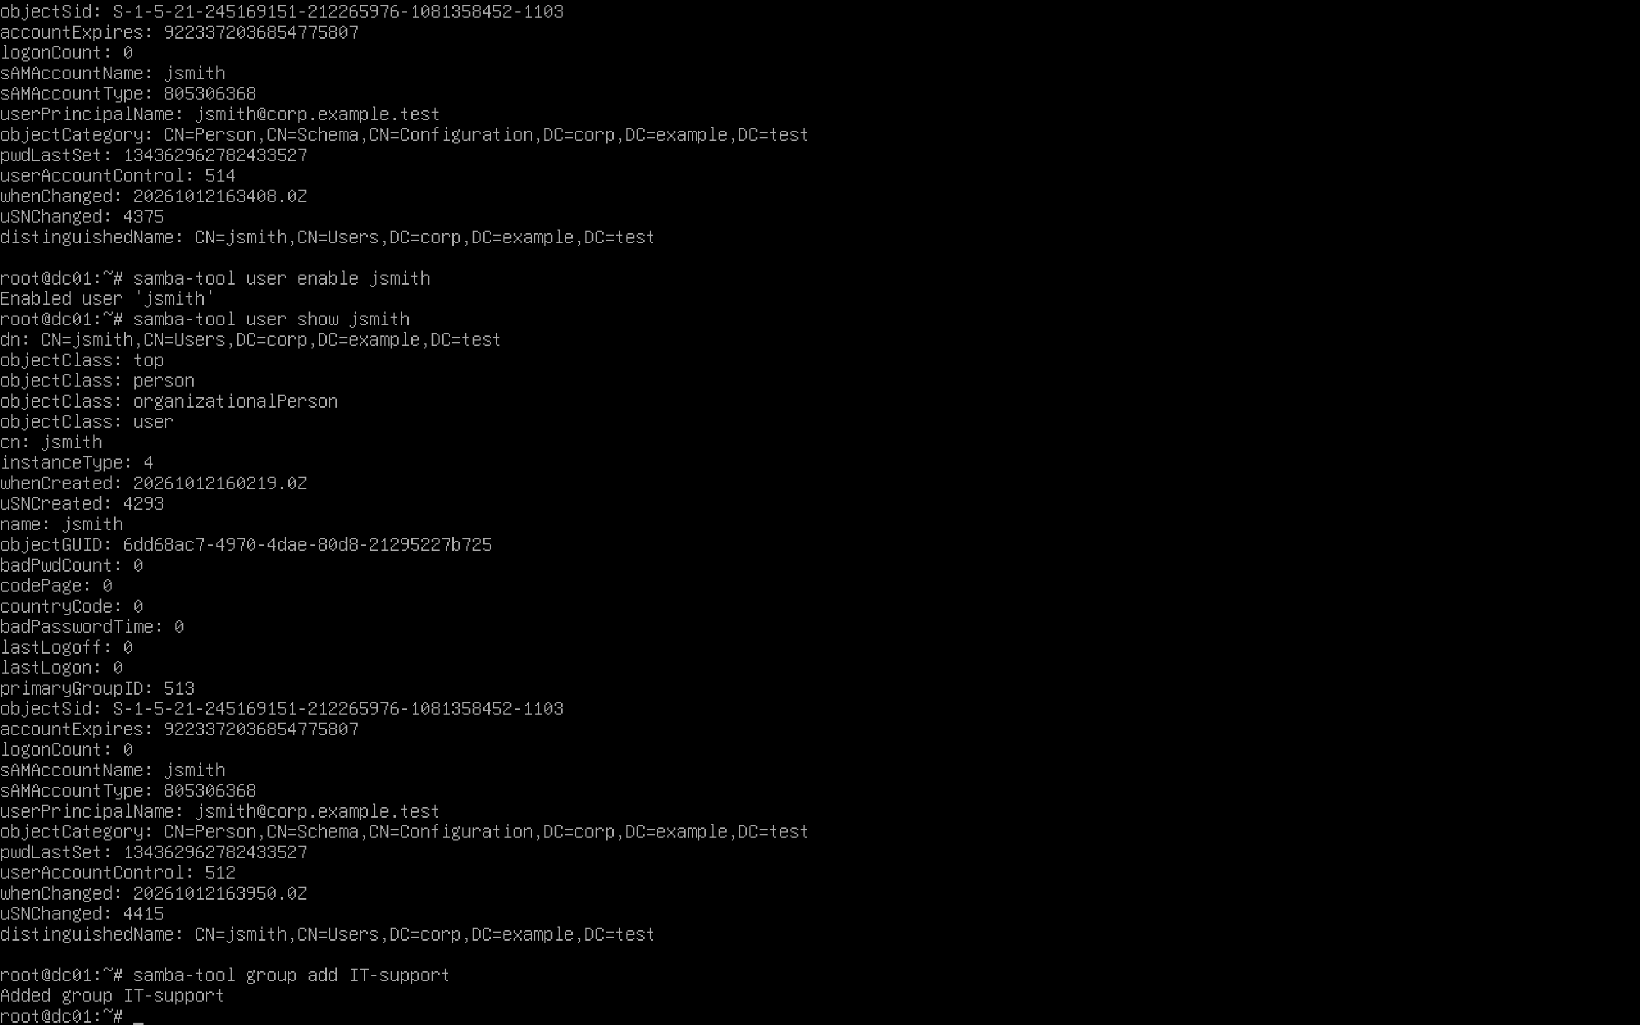
Evidence file: screenshots/07-security-group-created.png

Screenshot 08 — IT-Support Group Membership
Task and observation: Added jsmith to IT-Support and listed group members to validate the assignment.
Skill demonstrated: Group membership administration.
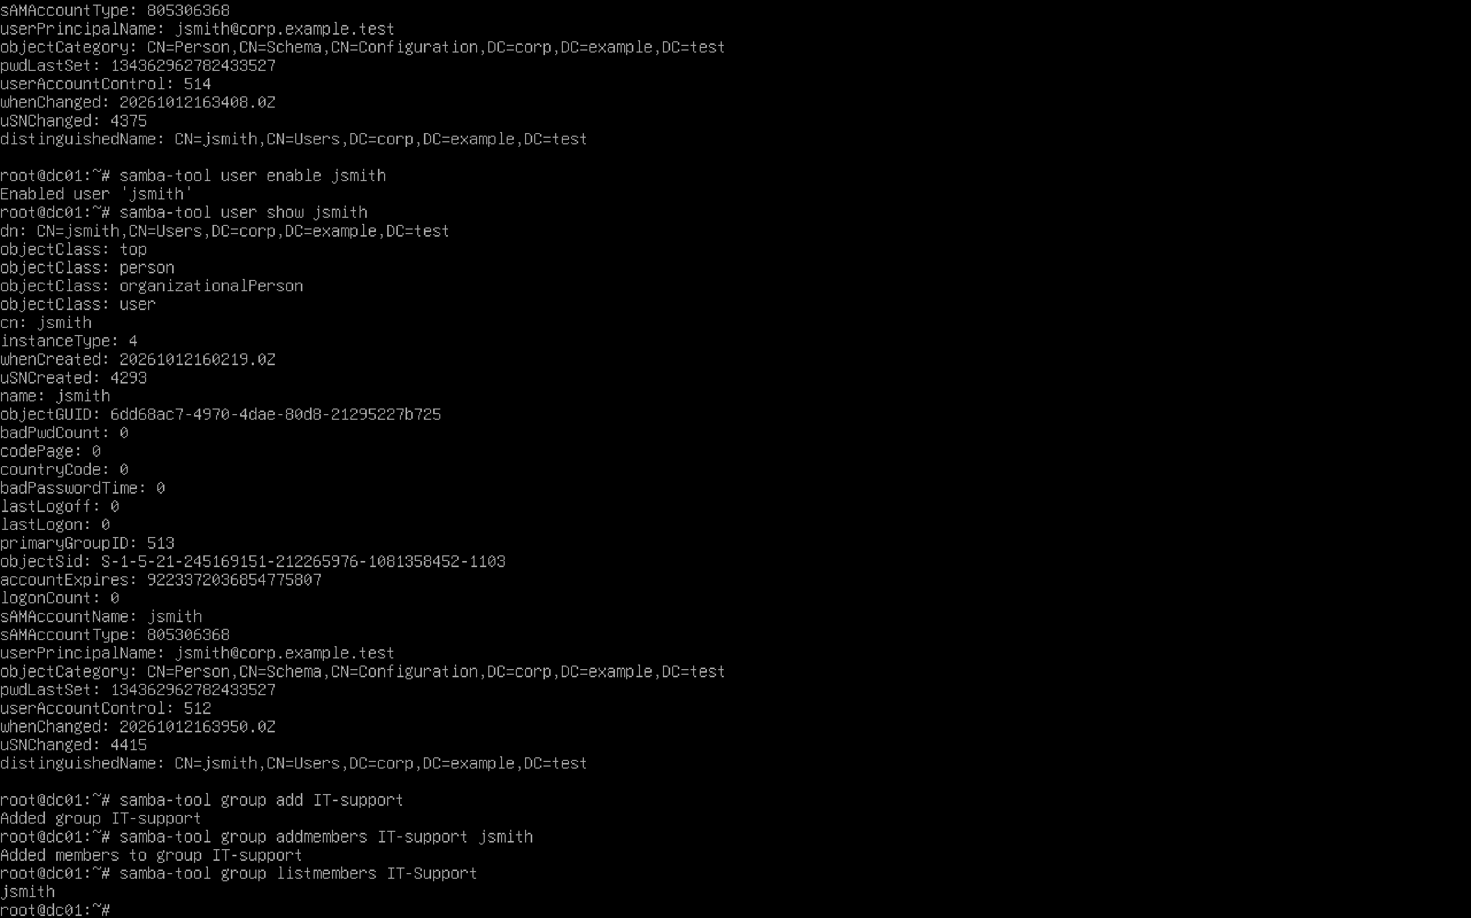
Evidence file: screenshots/08-security-group-membership.png

Screenshot 09 — Multiple Employee Accounts
Task and observation: Created the fictional sjohnson account and used samba-tool user list to confirm both employees exist.
Skill demonstrated: New-hire onboarding and account inventory.
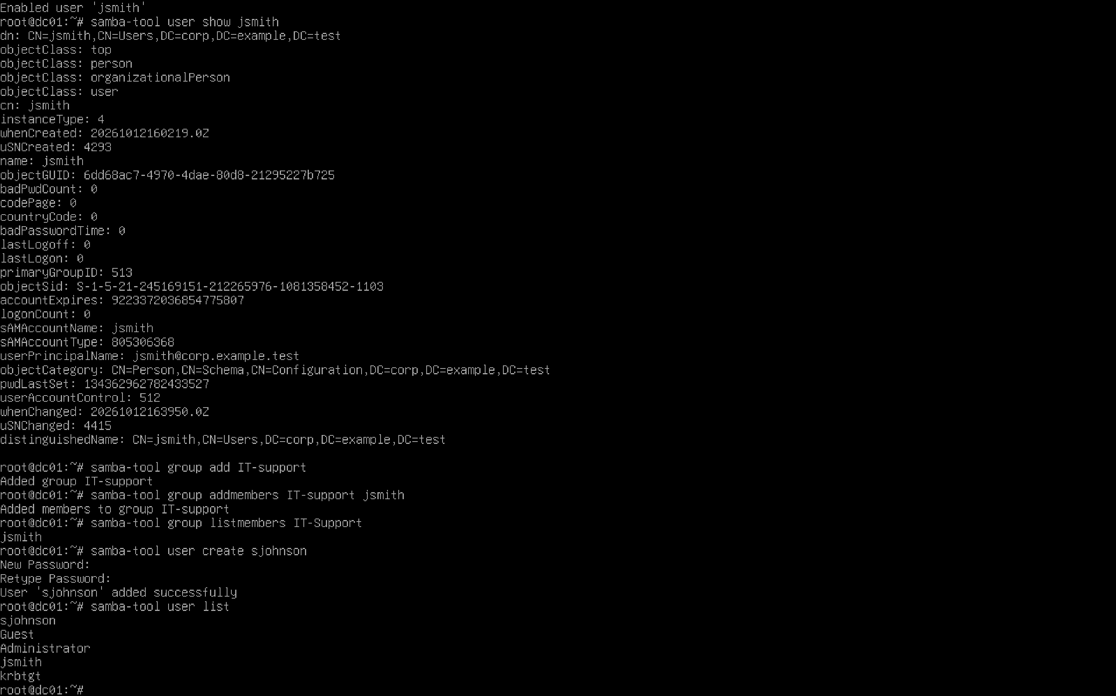
Evidence file: screenshots/09-multiple-ad-users.png

Screenshot 10 — HR Department Group Membership
Task and observation: Created HR-Department, assigned sjohnson, and queried the group membership.
Skill demonstrated: Role-aligned group assignment and verification.
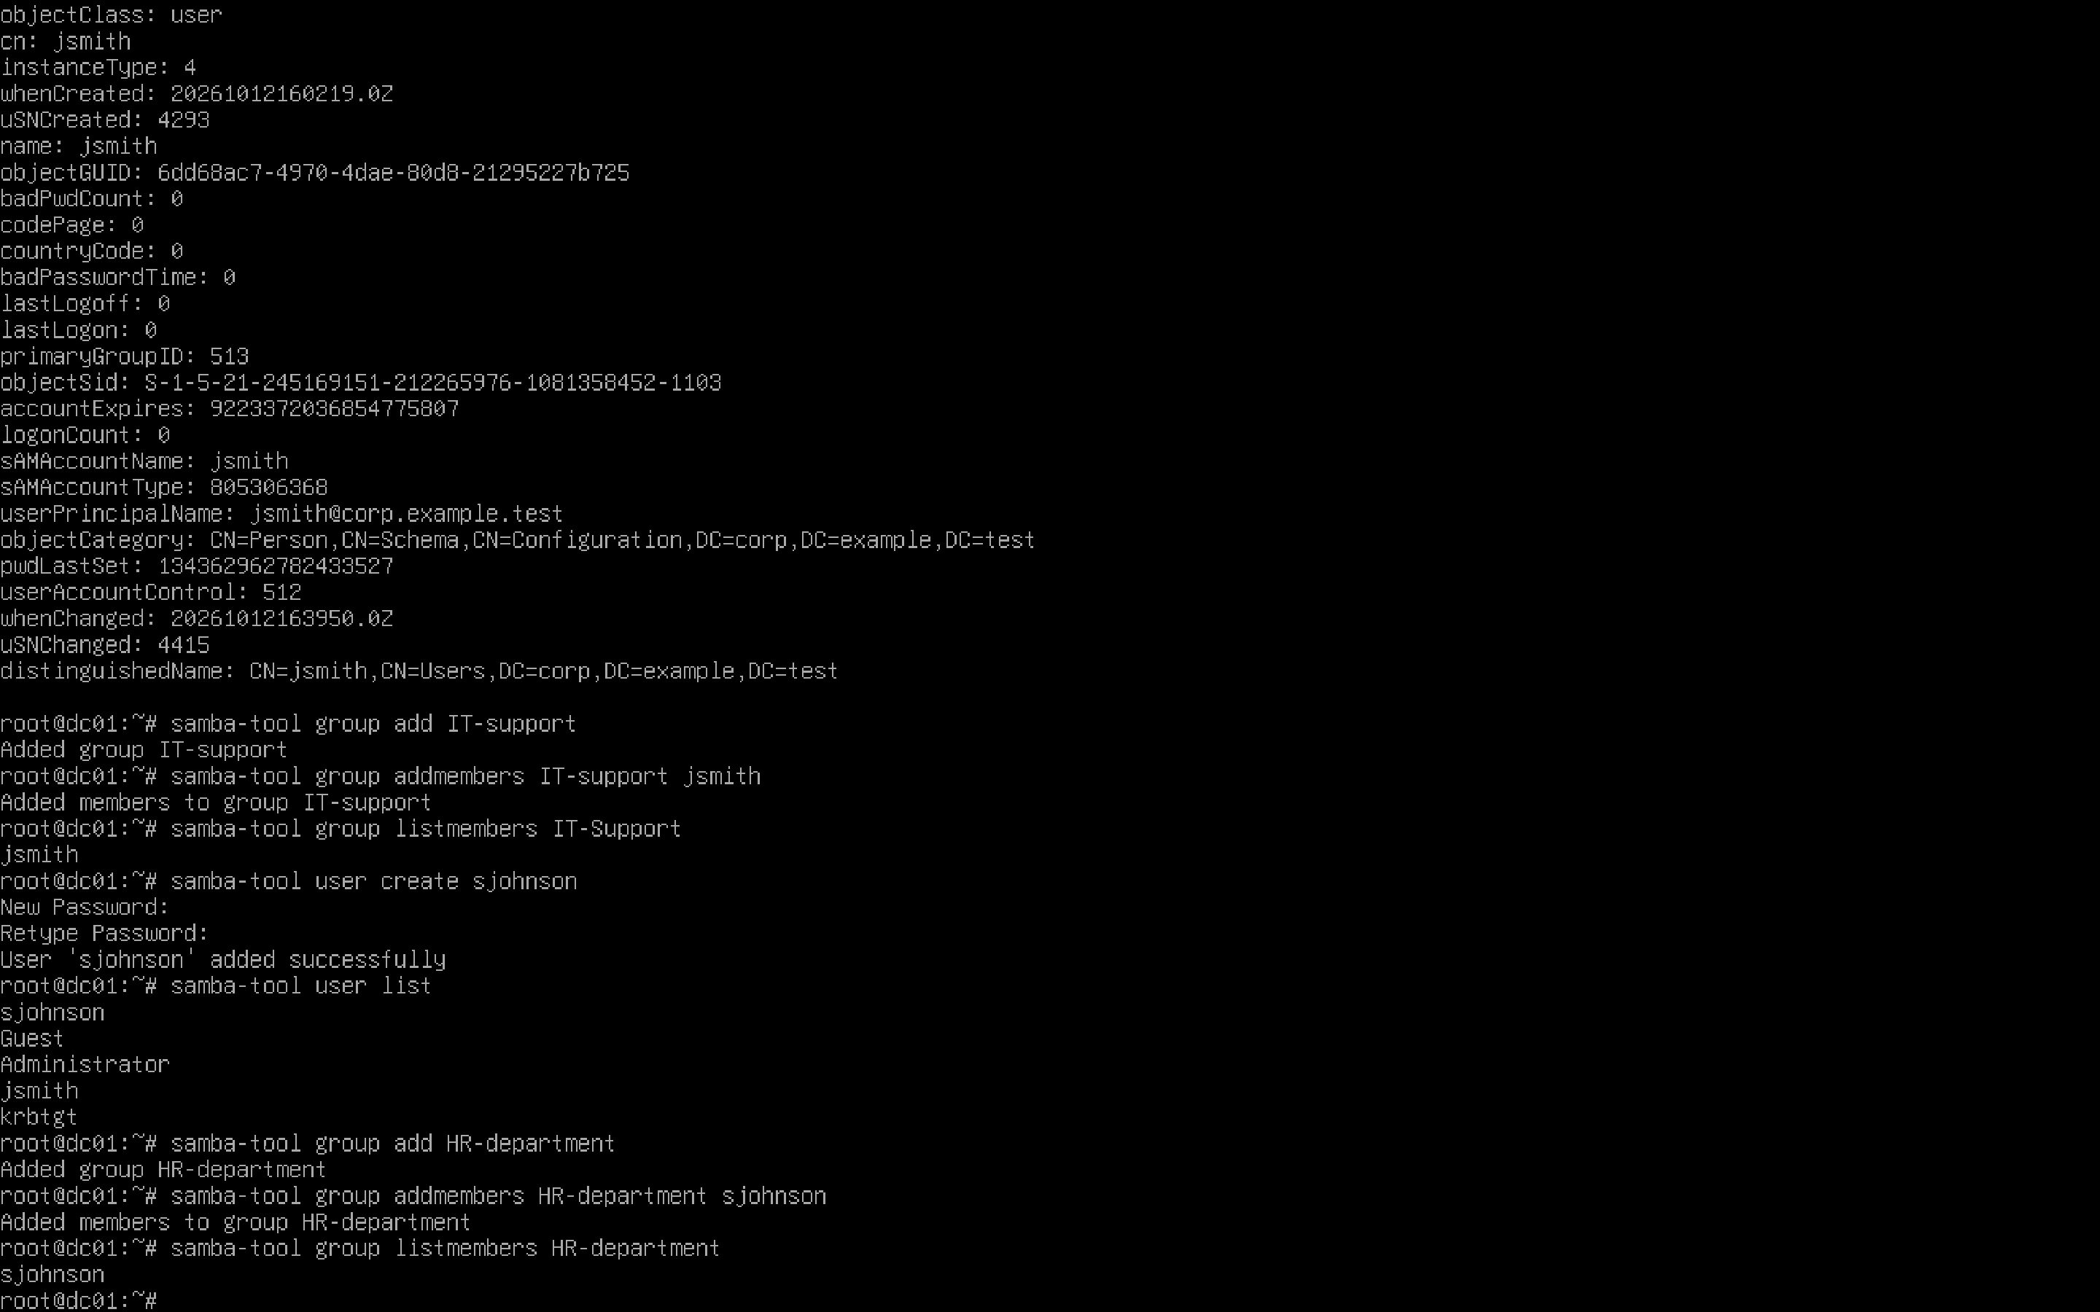
Evidence file: screenshots/10-hr-security-group-membership.png

Screenshot 11 — Directory Database Consistency Check
Task and observation: Ran samba-tool dbcheck to examine directory object consistency. This check does not substitute for complete DNS, Kerberos, or client logon tests.
Skill demonstrated: Directory verification and troubleshooting.
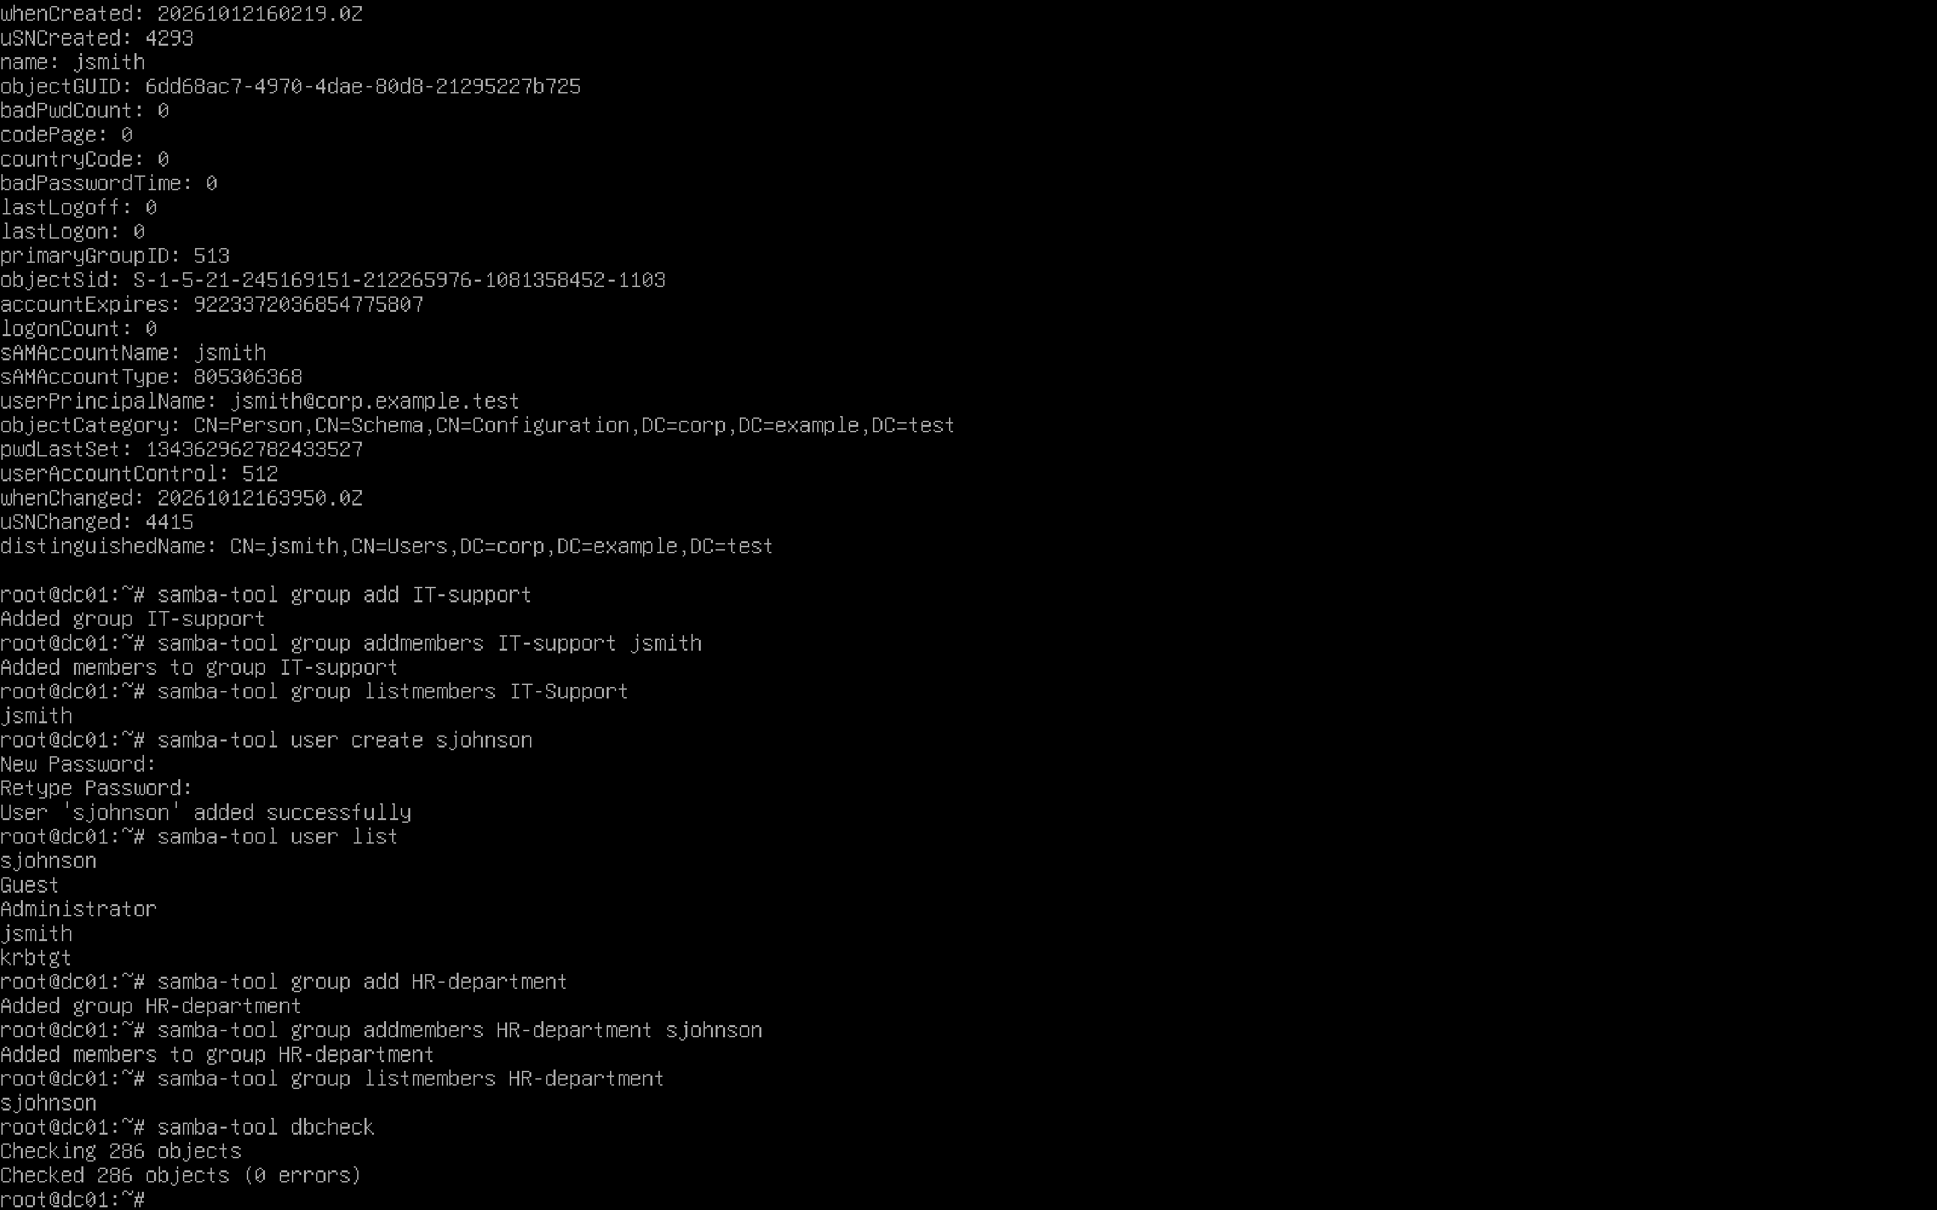
Evidence file: screenshots/11-active-directory-database-check.png

