Exercise 02 | Network Connectivity
  - SERVICENOW IT HELP DESK TICKETING LAB

Exercise overview
Incident: INC0010006
Scenario: Simulated employee unable to access websites or company network resources.
Lab outcome: Resolved for training purposes.
Environment: ServiceNow Personal Developer Instance (PDI) — simulated incidents

Objective
Practice structured incident intake, investigation documentation, incident lifecycle updates, and appropriate resolution or escalation decisions.

Evidence and activity walkthrough

1. Incident creation
Recorded the reported network issue with urgency and customer-visible symptoms.
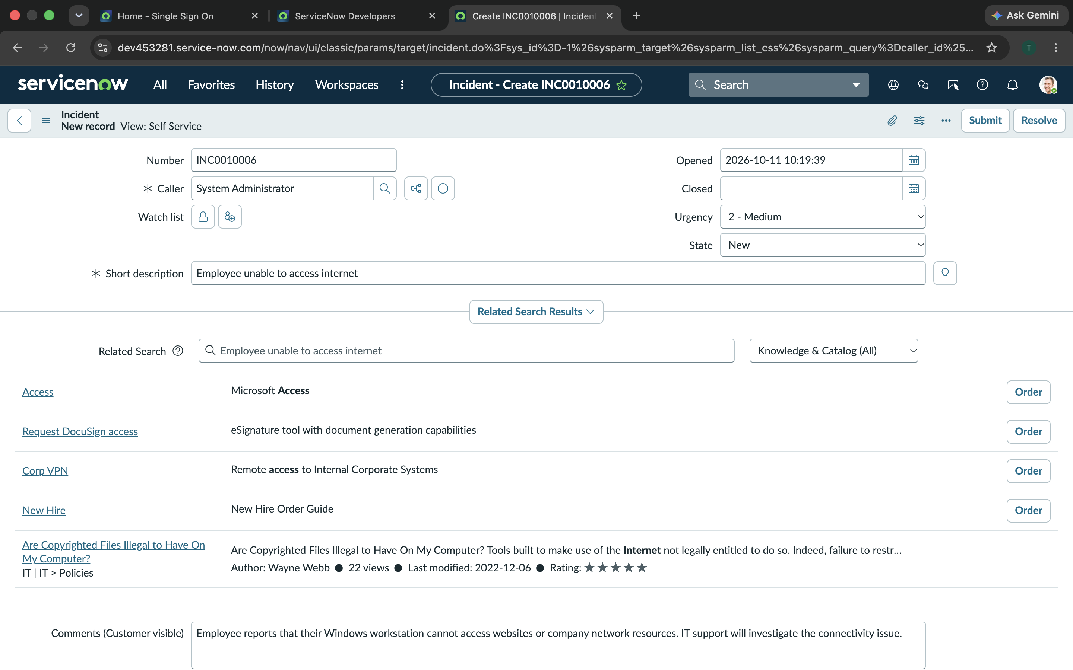
Figure 1. 06-Network-Issue-Incident-Creation.png

2. Investigation started
Moved the incident to In Progress.
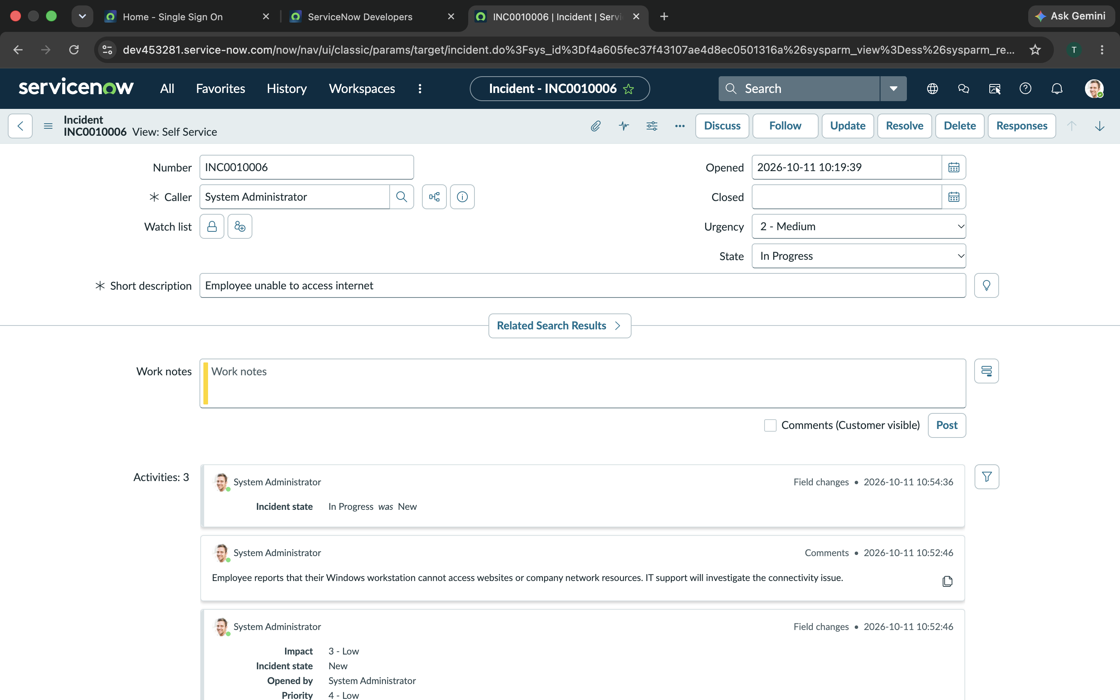
Figure 2. 07-Network-Issue-In-Progress.png

3. Network diagnostics work notes
Documented proposed checks: ipconfig /all, APIPA, loopback and gateway pings, external IP connectivity, and nslookup for DNS.
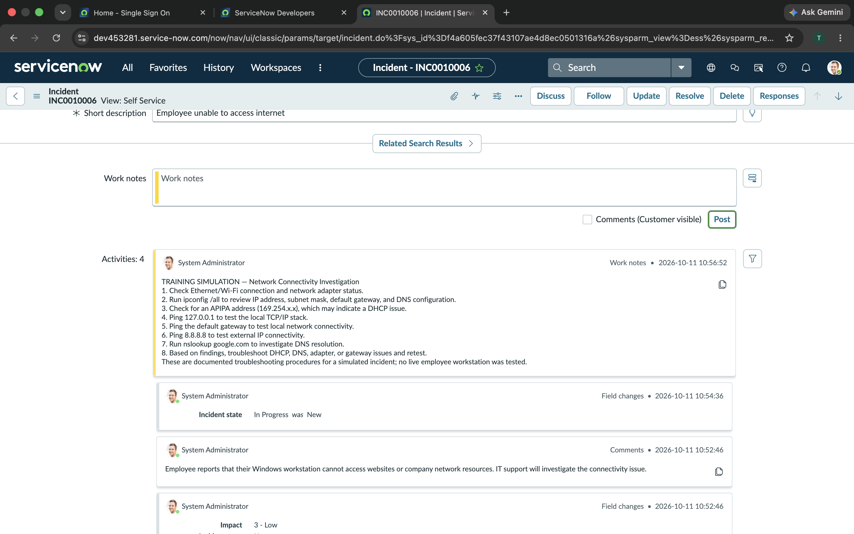
Figure 3. 08-Network-Issue-Troubleshooting.png

4. Resolution documentation
Recorded the simulated diagnostic workflow and resolution notes without claiming actual workstation repairs.
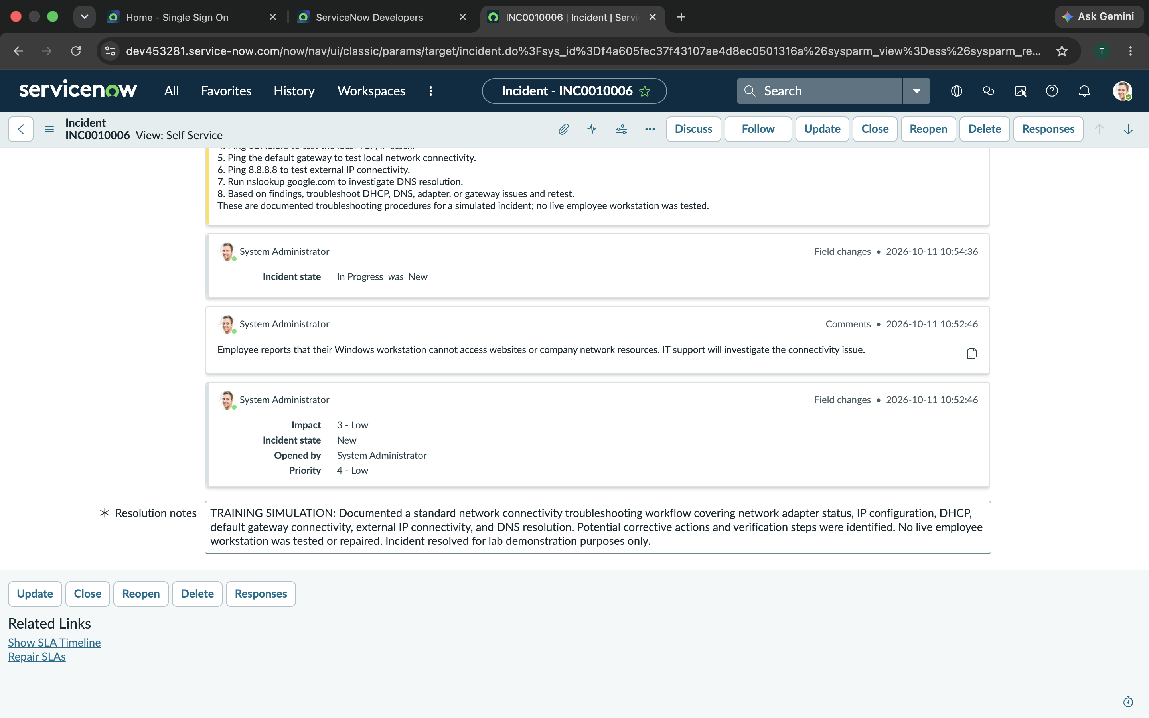
Figure 4. 09-Network-Issue-Resolution.png

Skills demonstrated
IP configuration; DHCP and DNS triage; layered network troubleshooting; work notes.

Training and verification note
This is a simulated ServiceNow incident management exercise. Troubleshooting notes describe planned or hypothetical steps, not verified tests or repairs performed on real employee systems. For the outage scenario, escalation was documented as a plan rather than an actual production escalation.

