Exercise 05 | Widespread Network Outage
  - SERVICENOW IT HELP DESK TICKETING LAB

Exercise overview
Incident: INC0010010
Scenario: Simulated department-wide loss of access to network resources and internal applications.
Lab outcome: Left In Progress with simulated escalation plan; restoration not verified.
Environment: ServiceNow Personal Developer Instance (PDI) — simulated incidents

Objective
Practice structured incident intake, investigation documentation, incident lifecycle updates, and appropriate resolution or escalation decisions.

Evidence and activity walkthrough

1. Incident creation
Recorded the widespread service impact and customer-visible outage report.
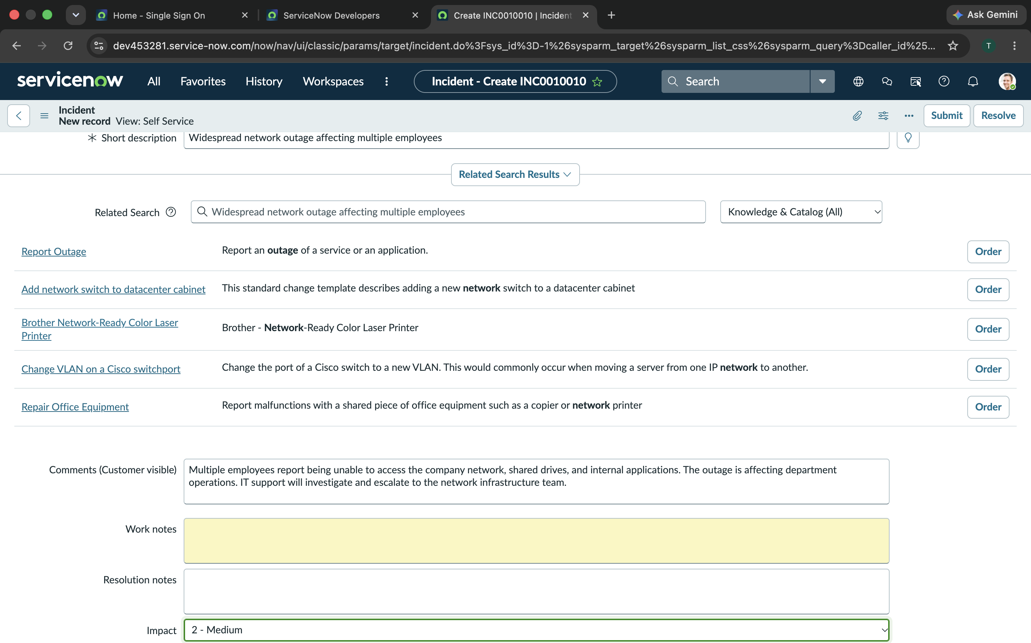
Figure 1. 17-Service-Outage-Incident-Creation.png

2. Priority and status
Set Impact to 2 – Medium and Urgency to 1 – High; ServiceNow displayed Priority 2 – High. Set state In Progress.
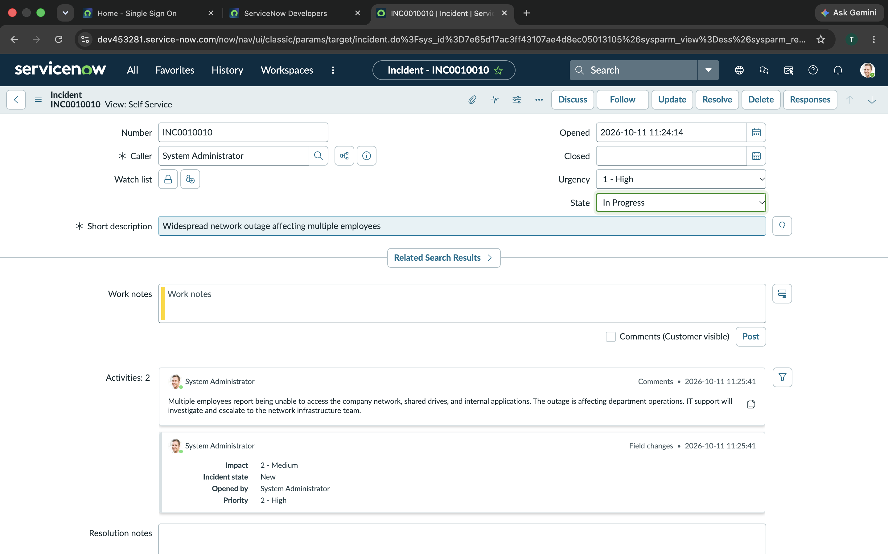
Figure 2. 18-Service-Outage-In-Progress.png

3. Outage investigation notes
Documented scope assessment, network infrastructure checks, service dependencies, stakeholder updates, and verification criteria.
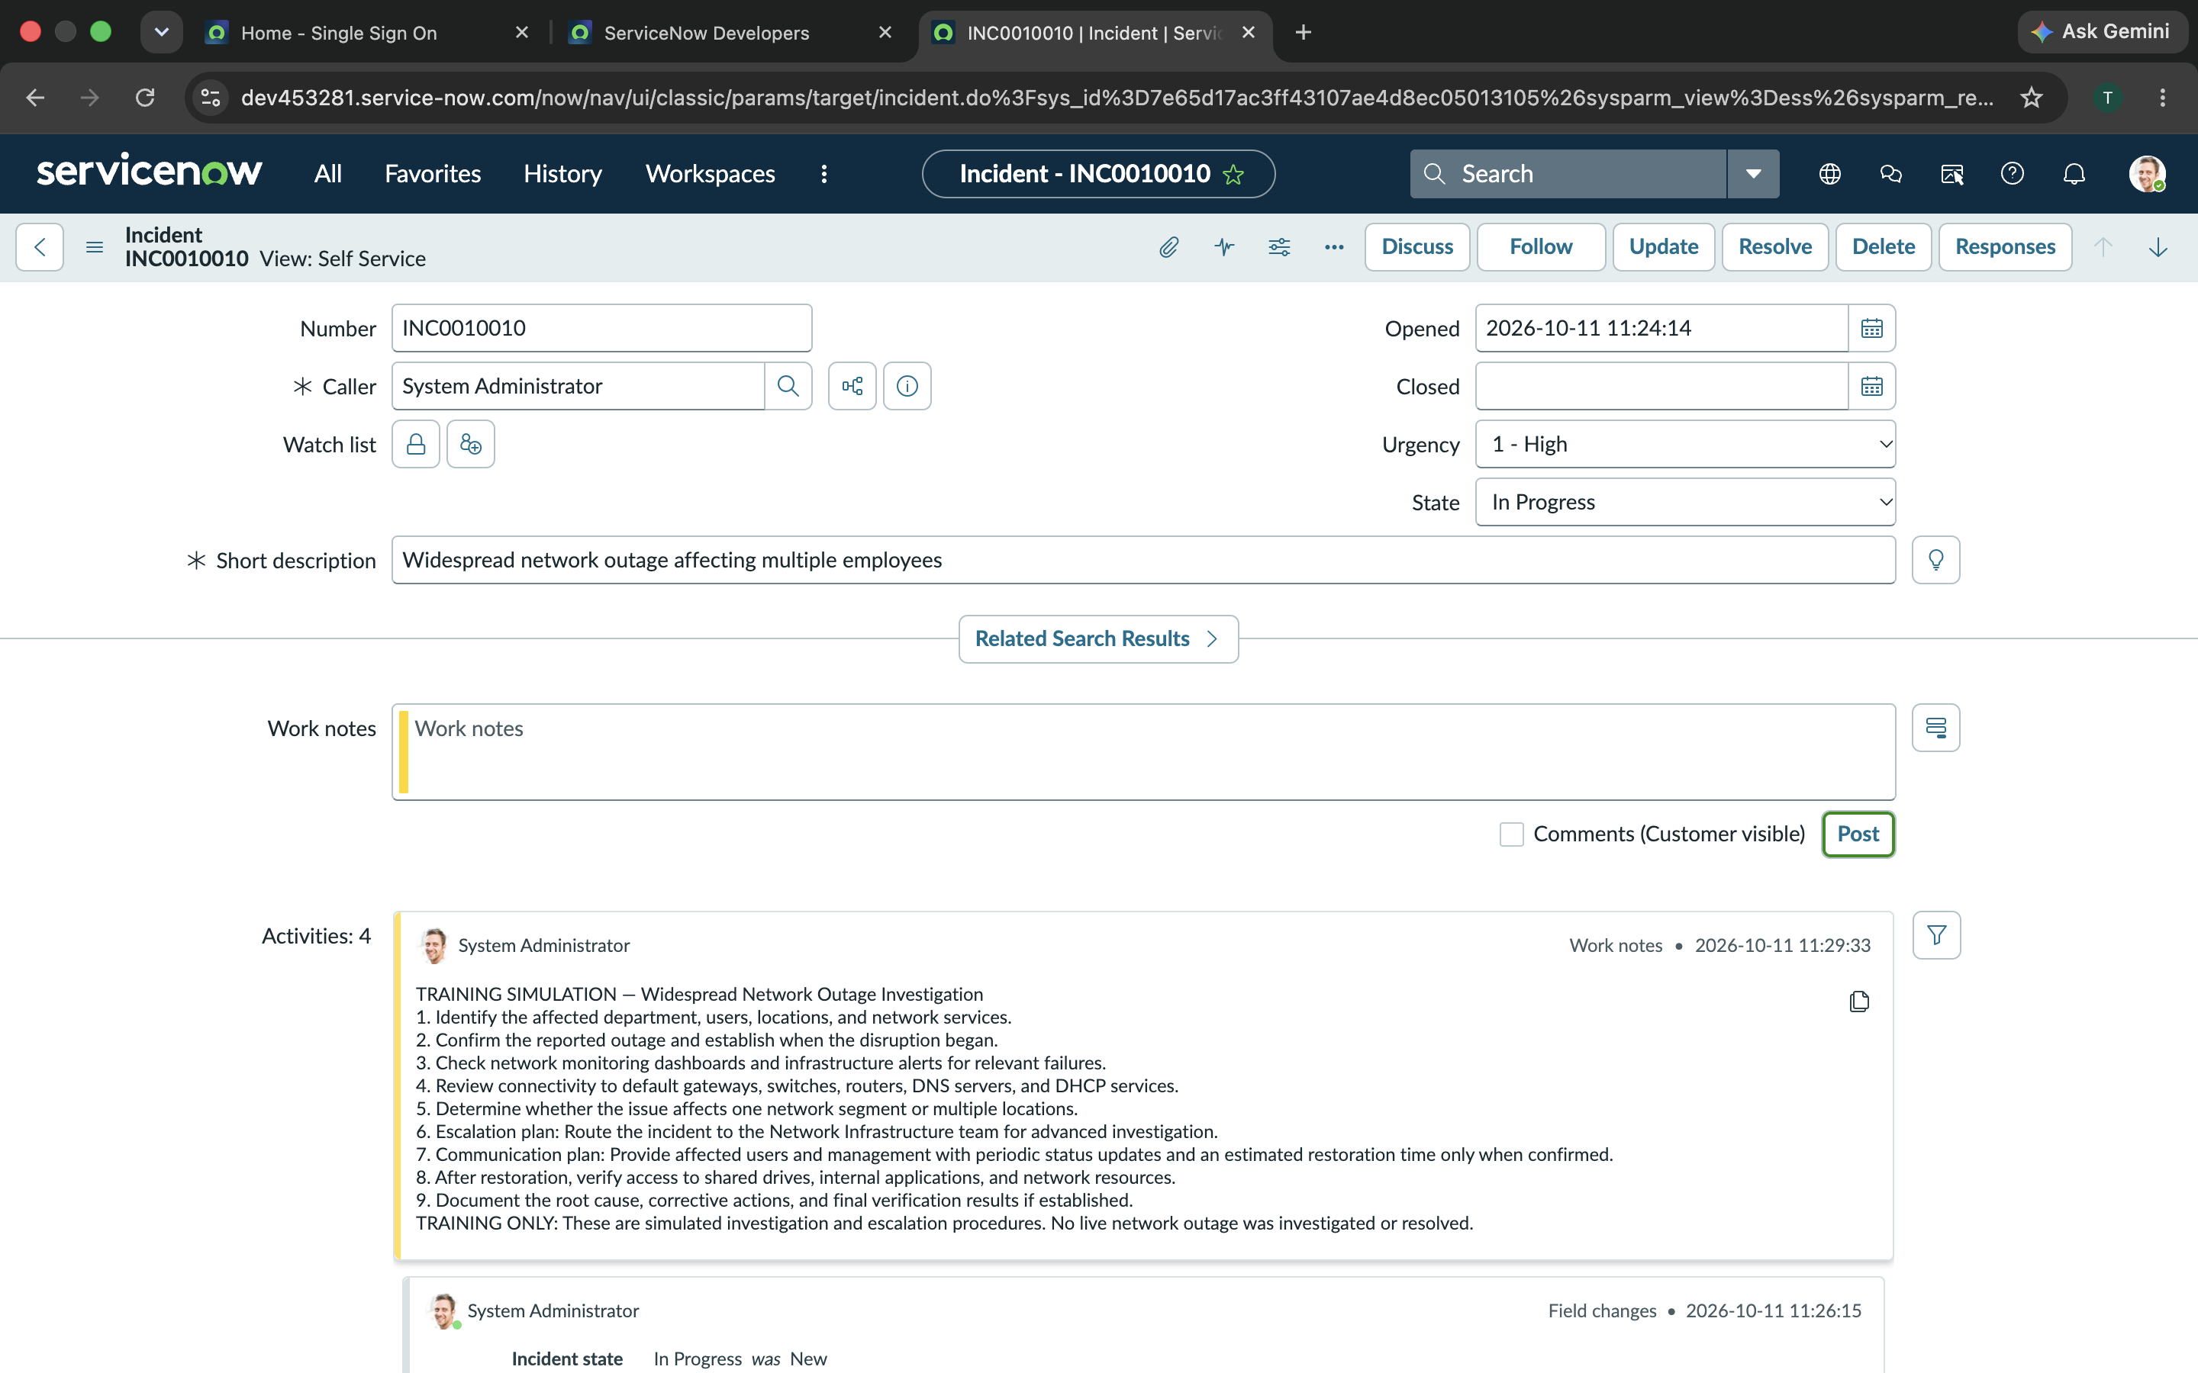
Figure 3. 19-Service-Outage-Troubleshooting.png

4. Escalation notes
Documented the proposed Network Infrastructure Team escalation and communications plan; kept incident open pending verified restoration.
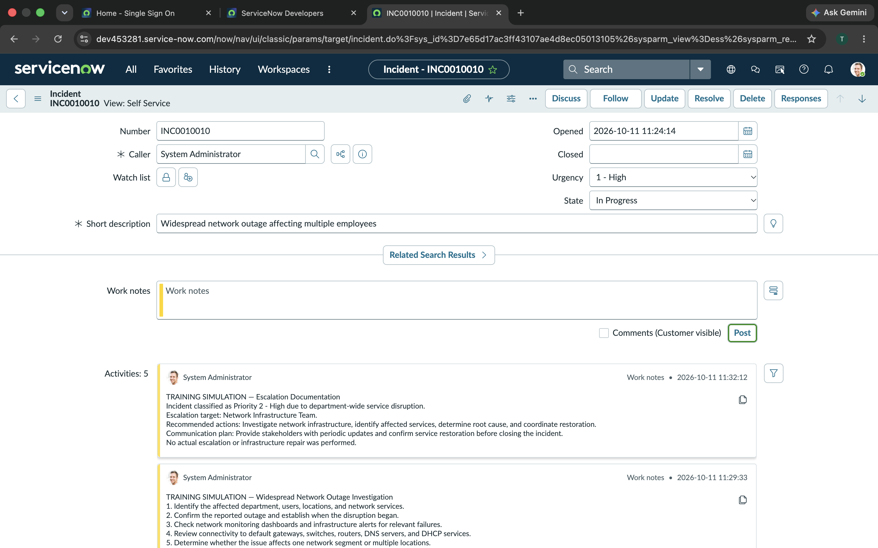
Figure 4. 20-Service-Outage-Escalation.png

Skills demonstrated
Impact and urgency assessment; incident prioritization; infrastructure escalation; stakeholder communications.

Training and verification note
This is a simulated ServiceNow incident management exercise. Troubleshooting notes describe planned or hypothetical steps, not verified tests or repairs performed on real employee systems. For the outage scenario, escalation was documented as a plan rather than an actual production escalation.

