Exercise 04 | Printer Troubleshooting
  - SERVICENOW IT HELP DESK TICKETING LAB

Exercise overview
Incident: INC0010008
Scenario: Simulated employee unable to print; documents stuck in the print queue.
Lab outcome: Resolved for training purposes.
Environment: ServiceNow Personal Developer Instance (PDI) — simulated incidents

Objective
Practice structured incident intake, investigation documentation, incident lifecycle updates, and appropriate resolution or escalation decisions.

Evidence and activity walkthrough

1. Incident creation
Created the printer support incident with symptoms and urgency.
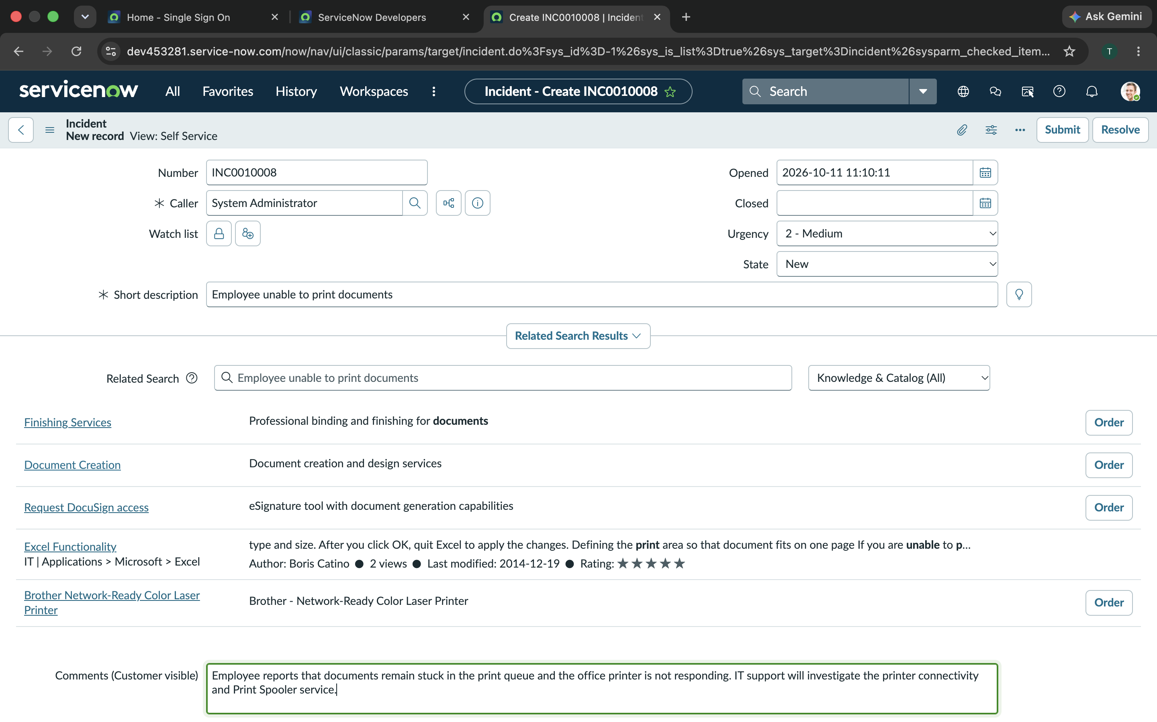
Figure 1. 13-Printer-Issue-Incident-Creation.png

2. Investigation started
Changed the state to In Progress.
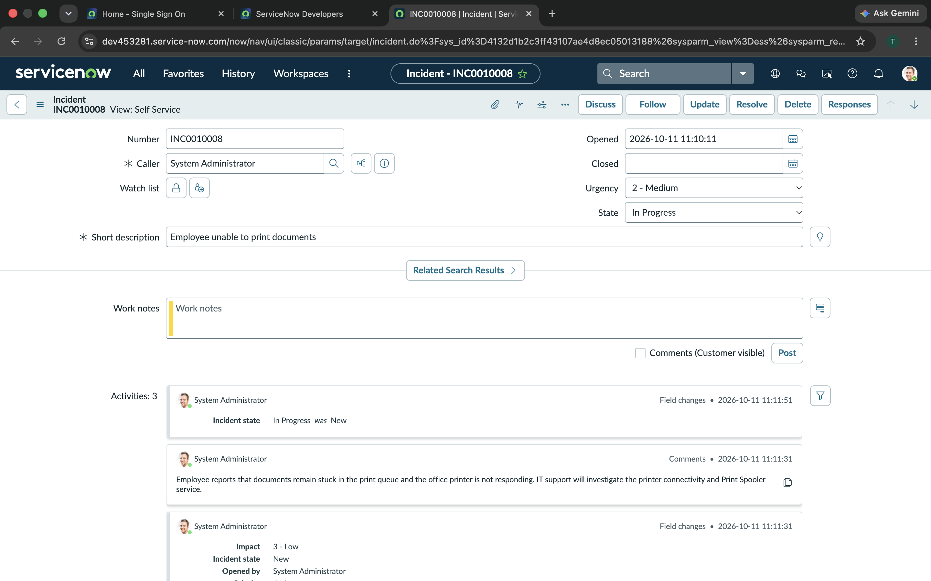
Figure 2. 14-Printer-Issue-In-Progress.png

3. Printer troubleshooting work notes
Documented proposed checks: printer status, offline state, print queue, Print Spooler via services.msc, network reachability, drivers and test page.
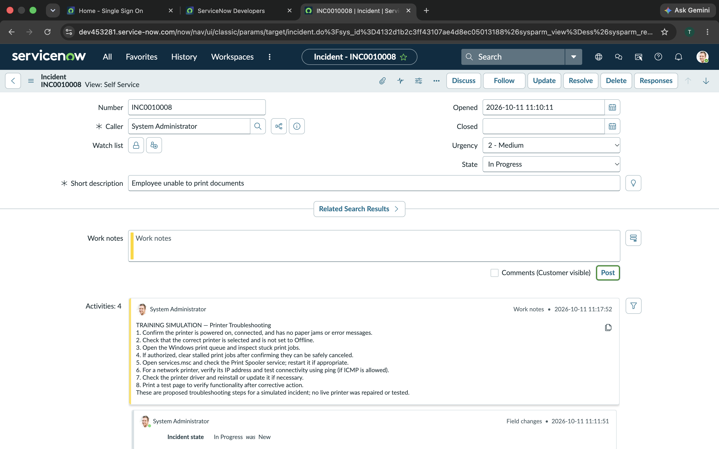
Figure 3. 15-Printer-Issue-Troubleshooting.png

4. Resolution documentation
Captured simulated resolution notes without claiming that a physical printer was repaired.
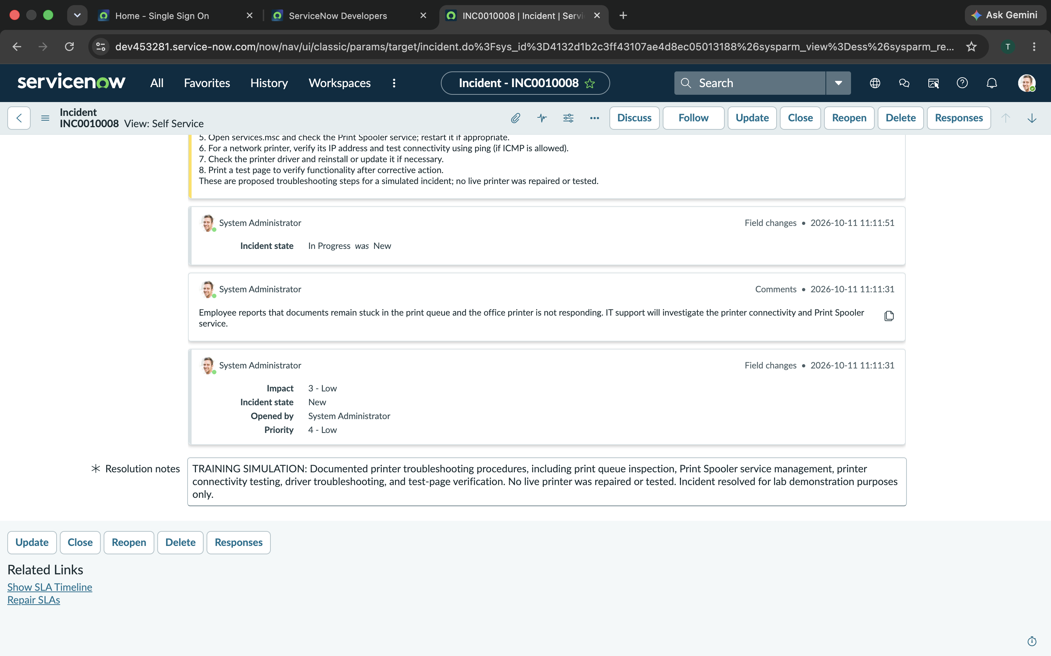
Figure 4. 16-Printer-Issue-Resolution.png

Skills demonstrated
Windows print services; print queue troubleshooting; printer network and driver diagnostics.

Training and verification note
This is a simulated ServiceNow incident management exercise. Troubleshooting notes describe planned or hypothetical steps, not verified tests or repairs performed on real employee systems. For the outage scenario, escalation was documented as a plan rather than an actual production escalation.

