Exercise 03 | Outlook Application Crash
  - SERVICENOW IT HELP DESK TICKETING LAB

Exercise overview
Incident: INC0010007
Scenario: Simulated Microsoft Outlook crashing at startup on an employee workstation.
Lab outcome: Resolution workflow documented for training.
Environment: ServiceNow Personal Developer Instance (PDI) — simulated incidents

Objective
Practice structured incident intake, investigation documentation, incident lifecycle updates, and appropriate resolution or escalation decisions.

Evidence and activity walkthrough

1. Incident creation
Logged the reported Outlook crash and customer-visible description.
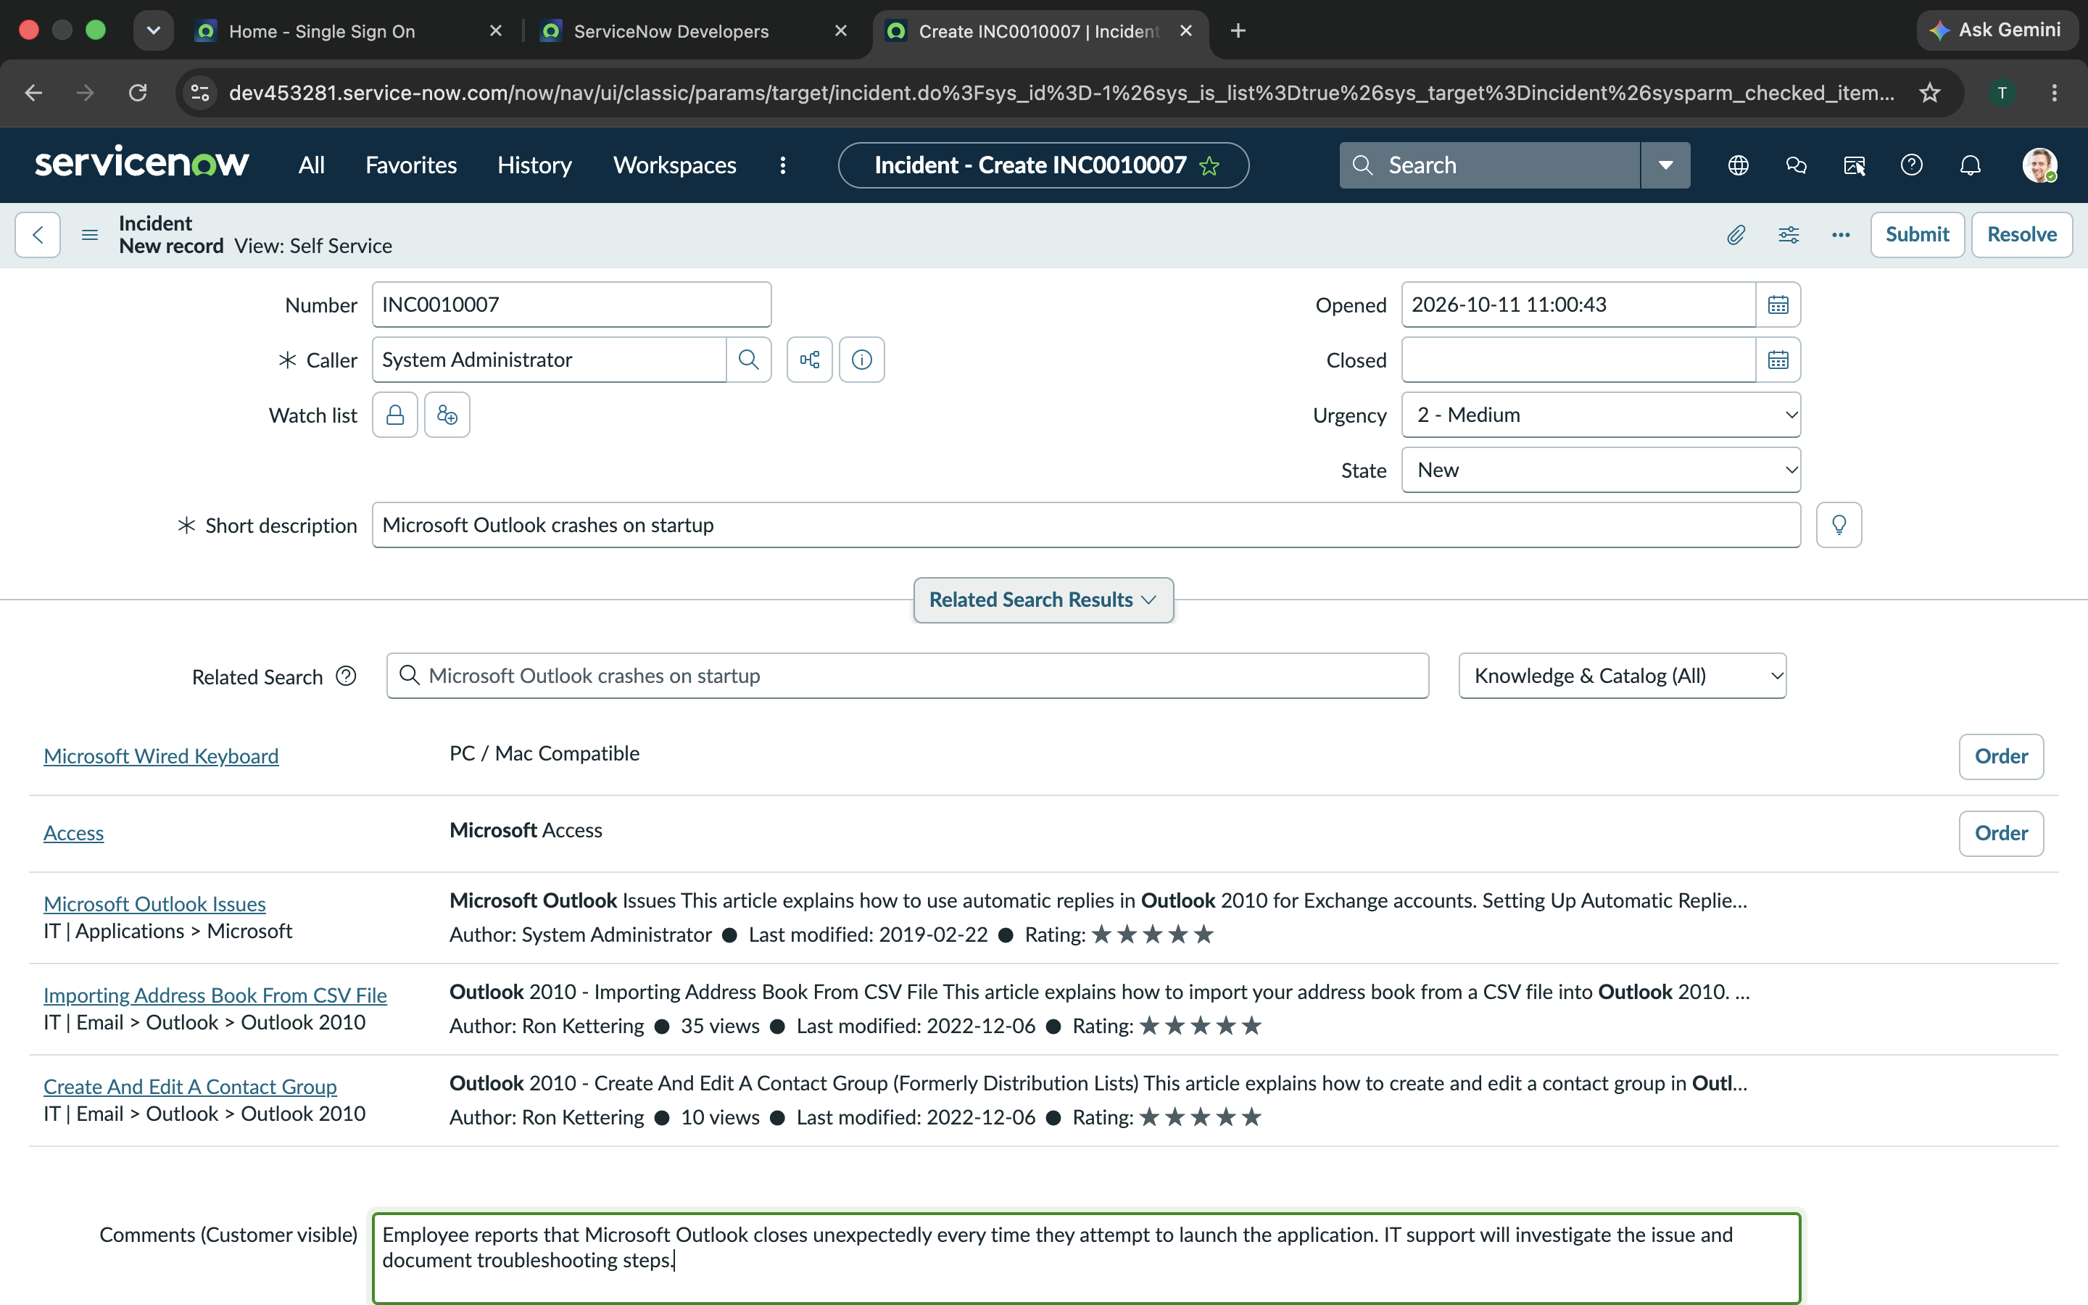
Figure 1. 10-Application-Crash-Incident-Creation.png

2. Application troubleshooting work notes
Documented proposed checks: Event Viewer Application log, classic Outlook Safe Mode, COM add-ins, Office updates and Quick Repair, and Outlook profile isolation.
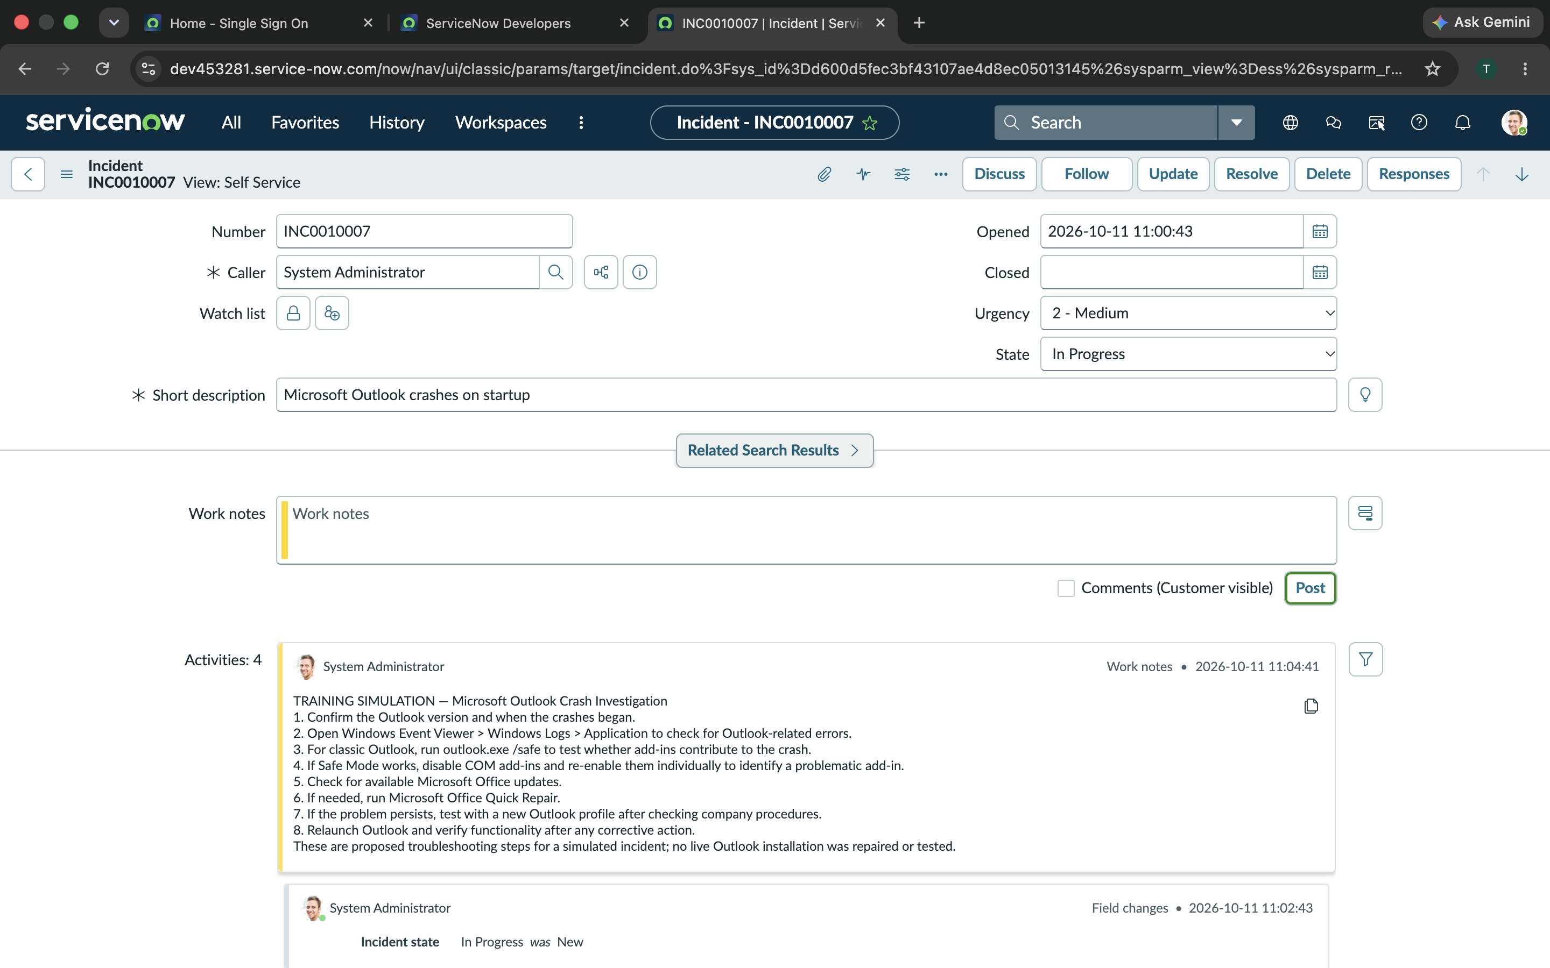
Figure 2. 11-Application-Crash-Troubleshooting.png

3. Resolution documentation
Captured the training resolution notes for the Outlook troubleshooting workflow.
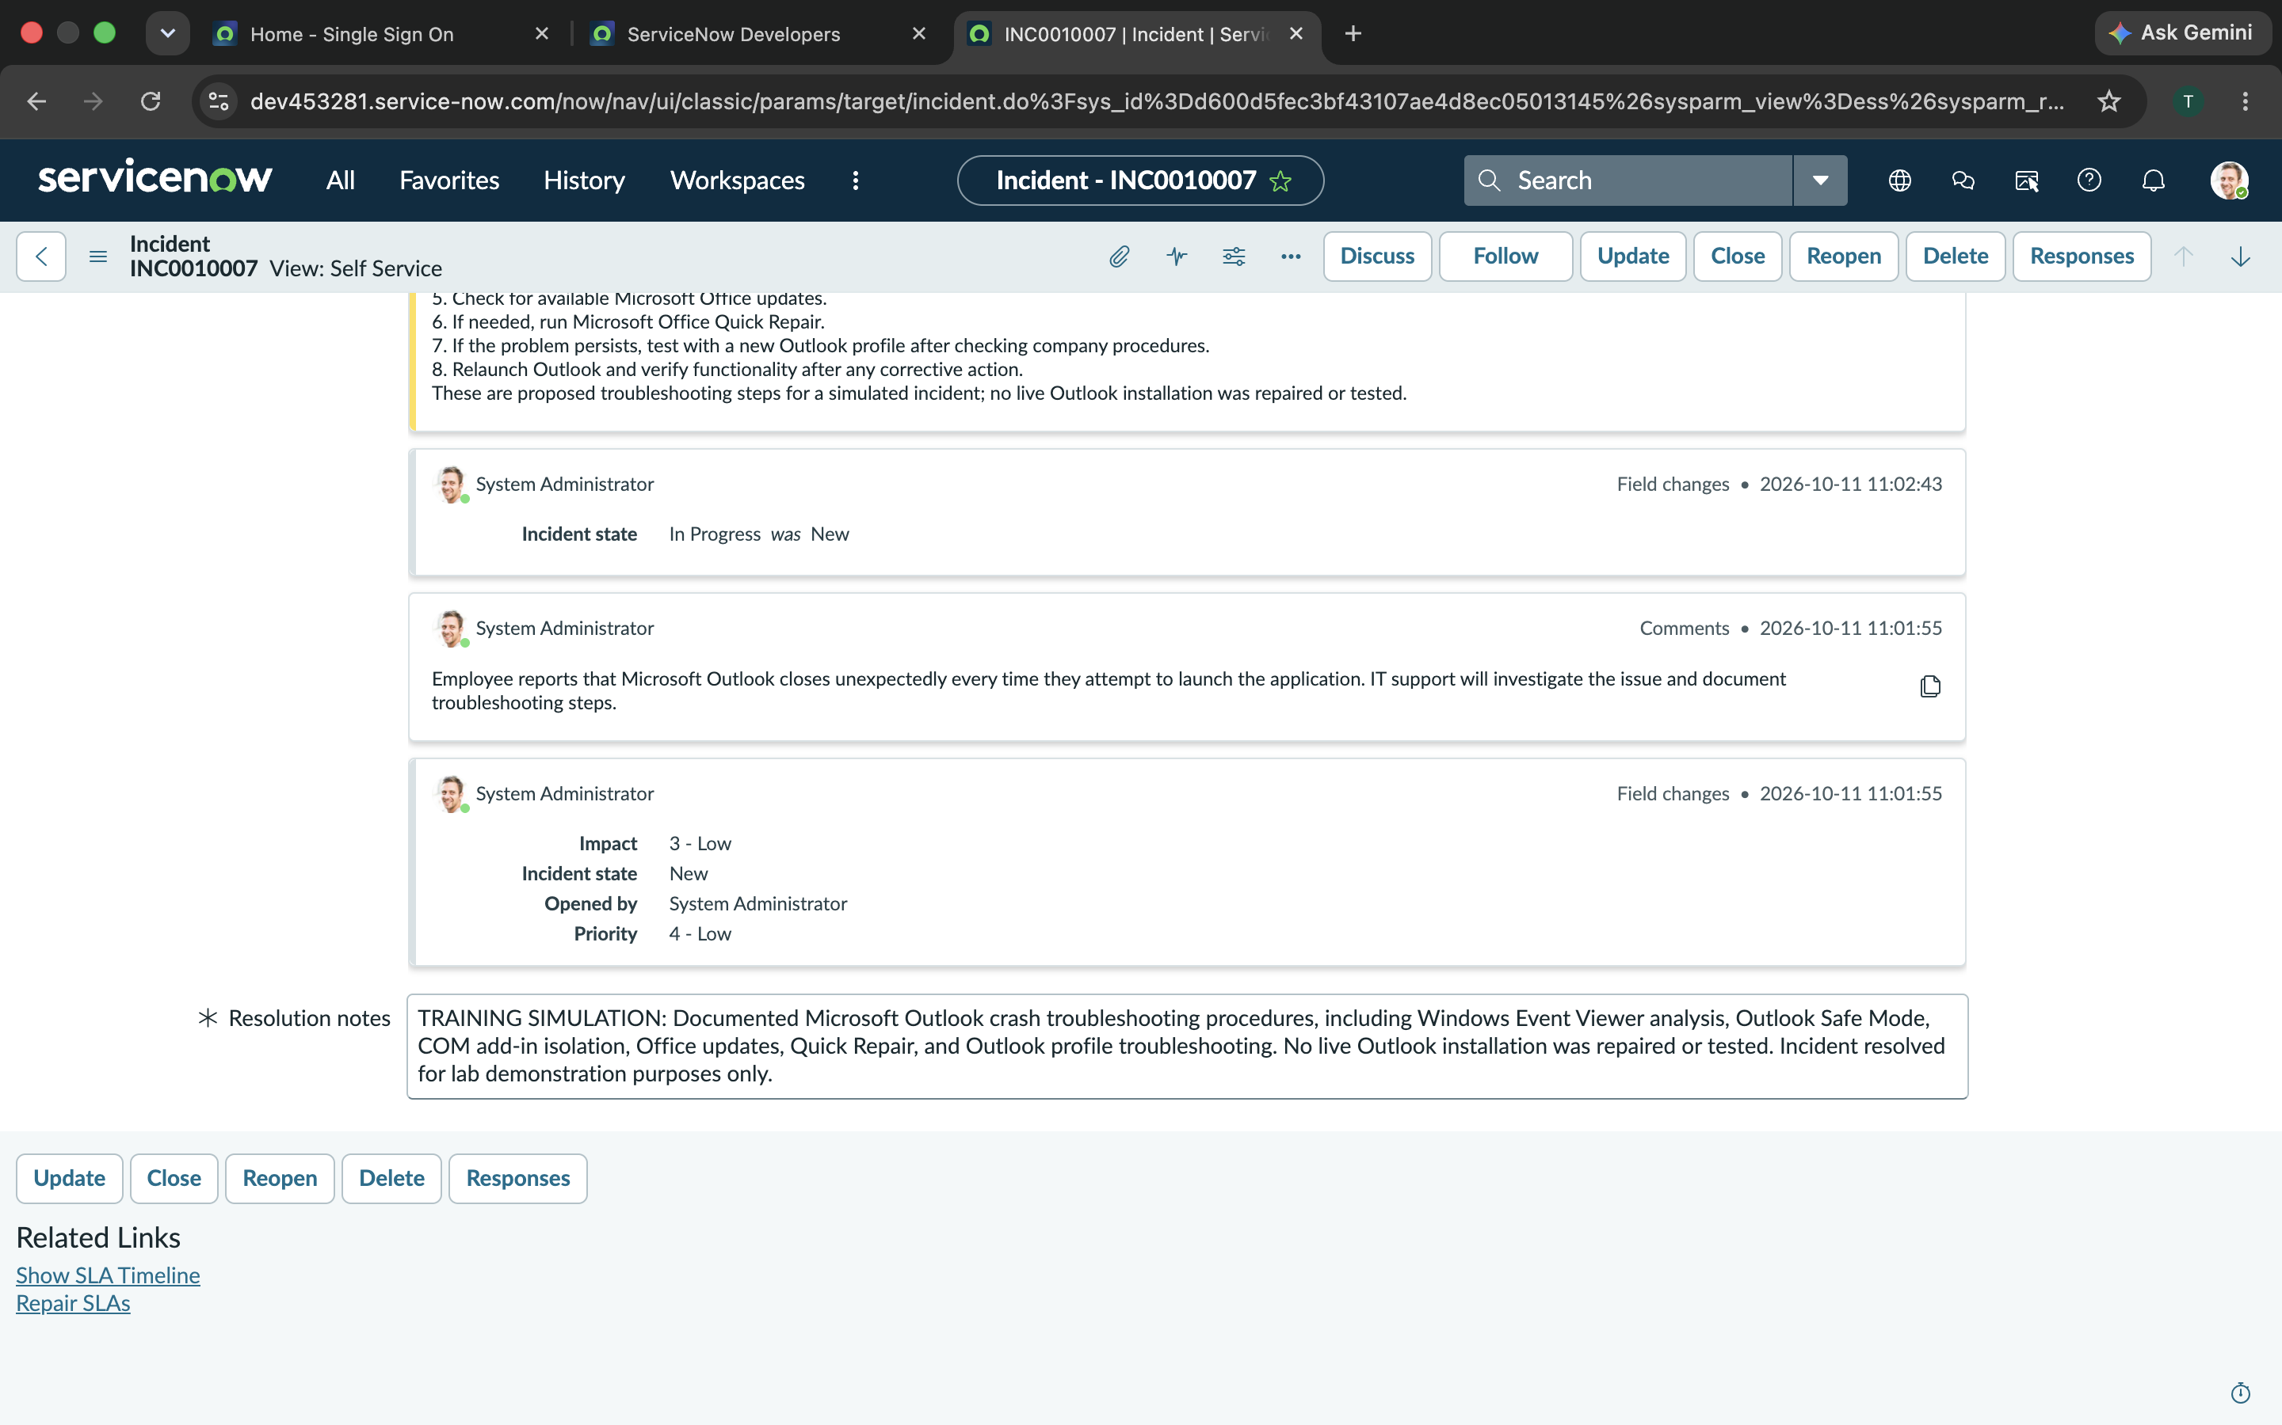
Figure 3. 12-Application-Crash-Resolution.png

Skills demonstrated
Application log analysis; safe-mode isolation; software repair planning; incident documentation.

Training and verification note
This is a simulated ServiceNow incident management exercise. Troubleshooting notes describe planned or hypothetical steps, not verified tests or repairs performed on real employee systems. For the outage scenario, escalation was documented as a plan rather than an actual production escalation.

