Exercise 01 | Account Lockout
  - SERVICENOW IT HELP DESK TICKETING LAB

Exercise overview
Incident: INC0010003
Scenario: Simulated employee unable to sign in because an account may be locked.
Lab outcome: Resolved for training purposes.
Environment: ServiceNow Personal Developer Instance (PDI) — simulated incidents

Objective
Practice structured incident intake, investigation documentation, incident lifecycle updates, and appropriate resolution or escalation decisions.

Evidence and activity walkthrough

1. Incident creation
Created a new incident for a reported Windows sign-in failure and recorded a customer-visible issue summary.
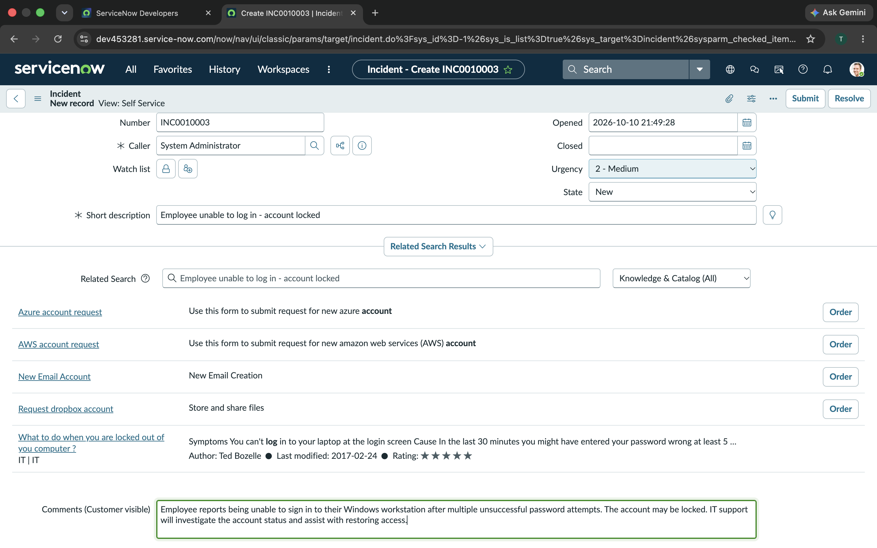
Figure 1. Account lockout Incident-1.png

2. Saved incident details
Reviewed the saved incident record, caller, urgency and description.
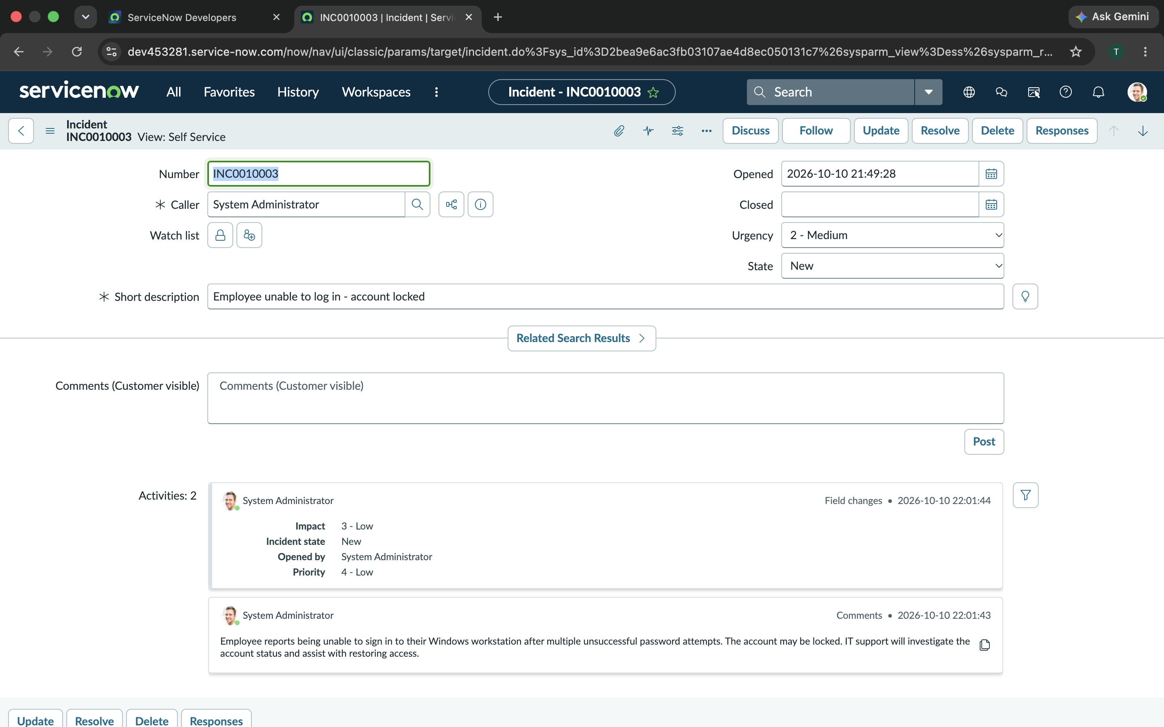
Figure 2. 02-Account-Lockout-Ticket-Details.png

3. Investigation started
Changed the incident state from New to In Progress to represent technician ownership.
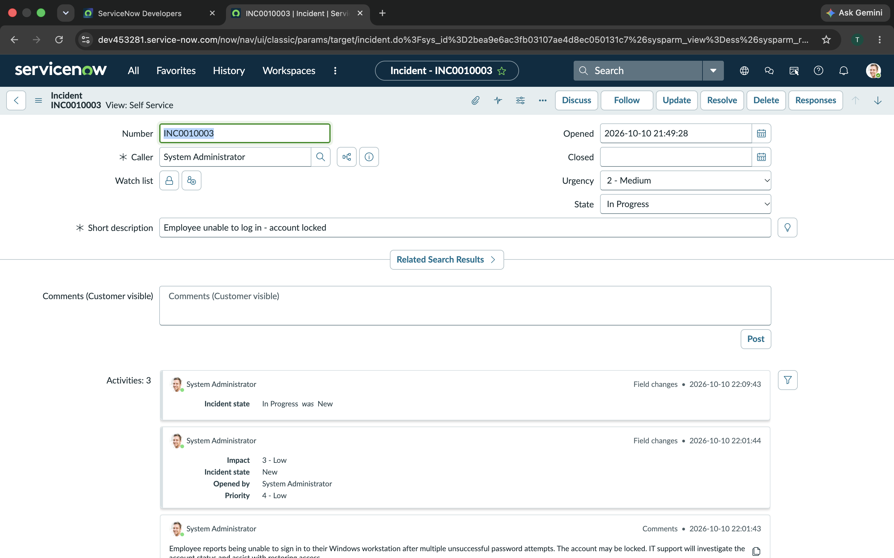
Figure 3. 03-Account-Lockout-In-Progress.png

4. Internal work notes
Documented a simulated workflow: verify identity, check Active Directory lockout status, review failed sign-ins, consider authorized unlock or password reset, and verify sign-in.
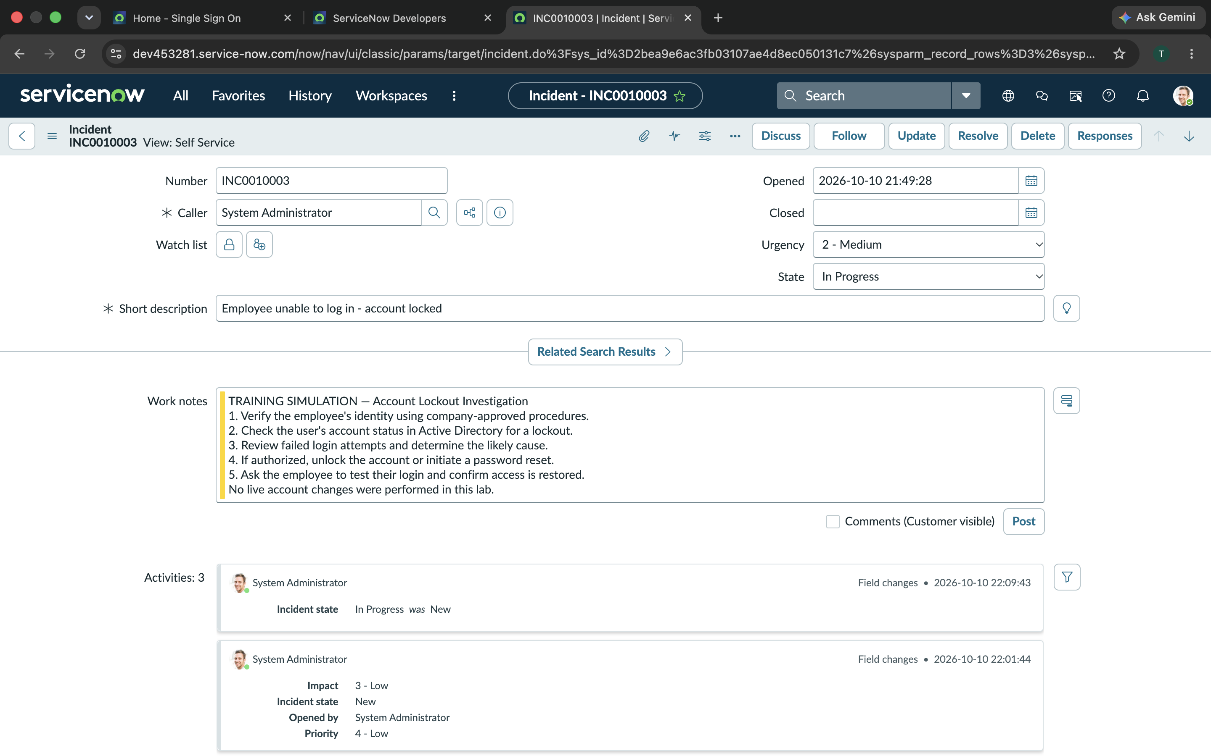
Figure 4. 04-Account-Lockout-Troubleshooting.png

5. Resolution documentation
Recorded a training-only resolution description and marked the simulated incident resolved; no live account was modified.
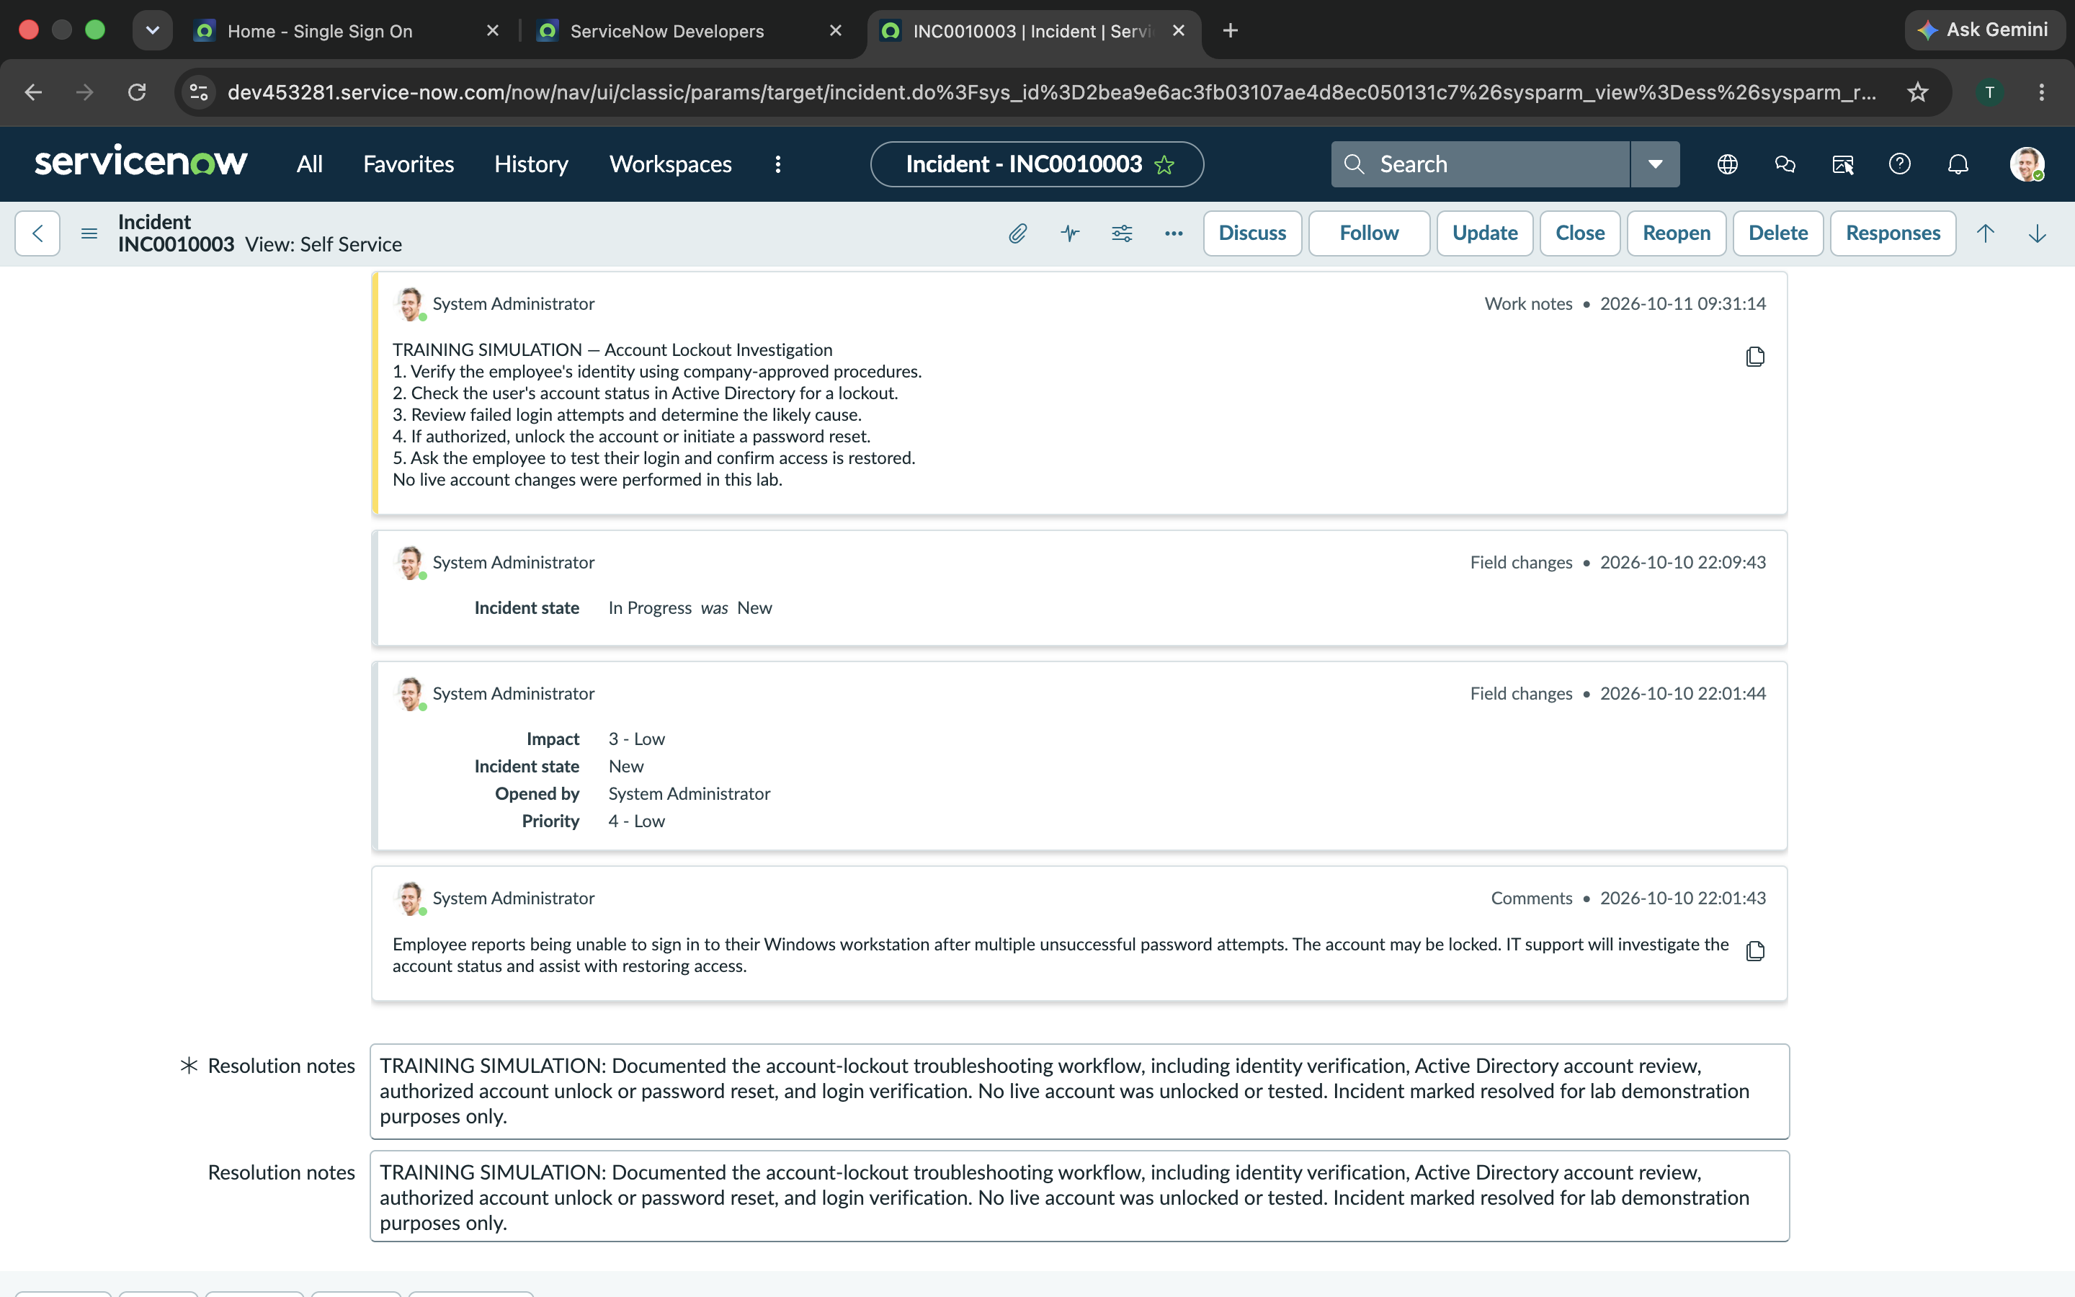
Figure 5. 05-Account-Lockout-Resolution.png

Skills demonstrated
Account status verification; identity verification; authorized credential recovery; clear ticket documentation.

Training and verification note
This is a simulated ServiceNow incident management exercise. Troubleshooting notes describe planned or hypothetical steps, not verified tests or repairs performed on real employee systems. For the outage scenario, escalation was documented as a plan rather than an actual production escalation.

