Exercise 1 | Performance Monitoring

Screenshot 1 of 4 — Task Manager — Processes
Reviewed running applications and overall resource usage. CPU utilization was approximately 5%, memory usage approximately 67%, and disk activity approximately 0%.
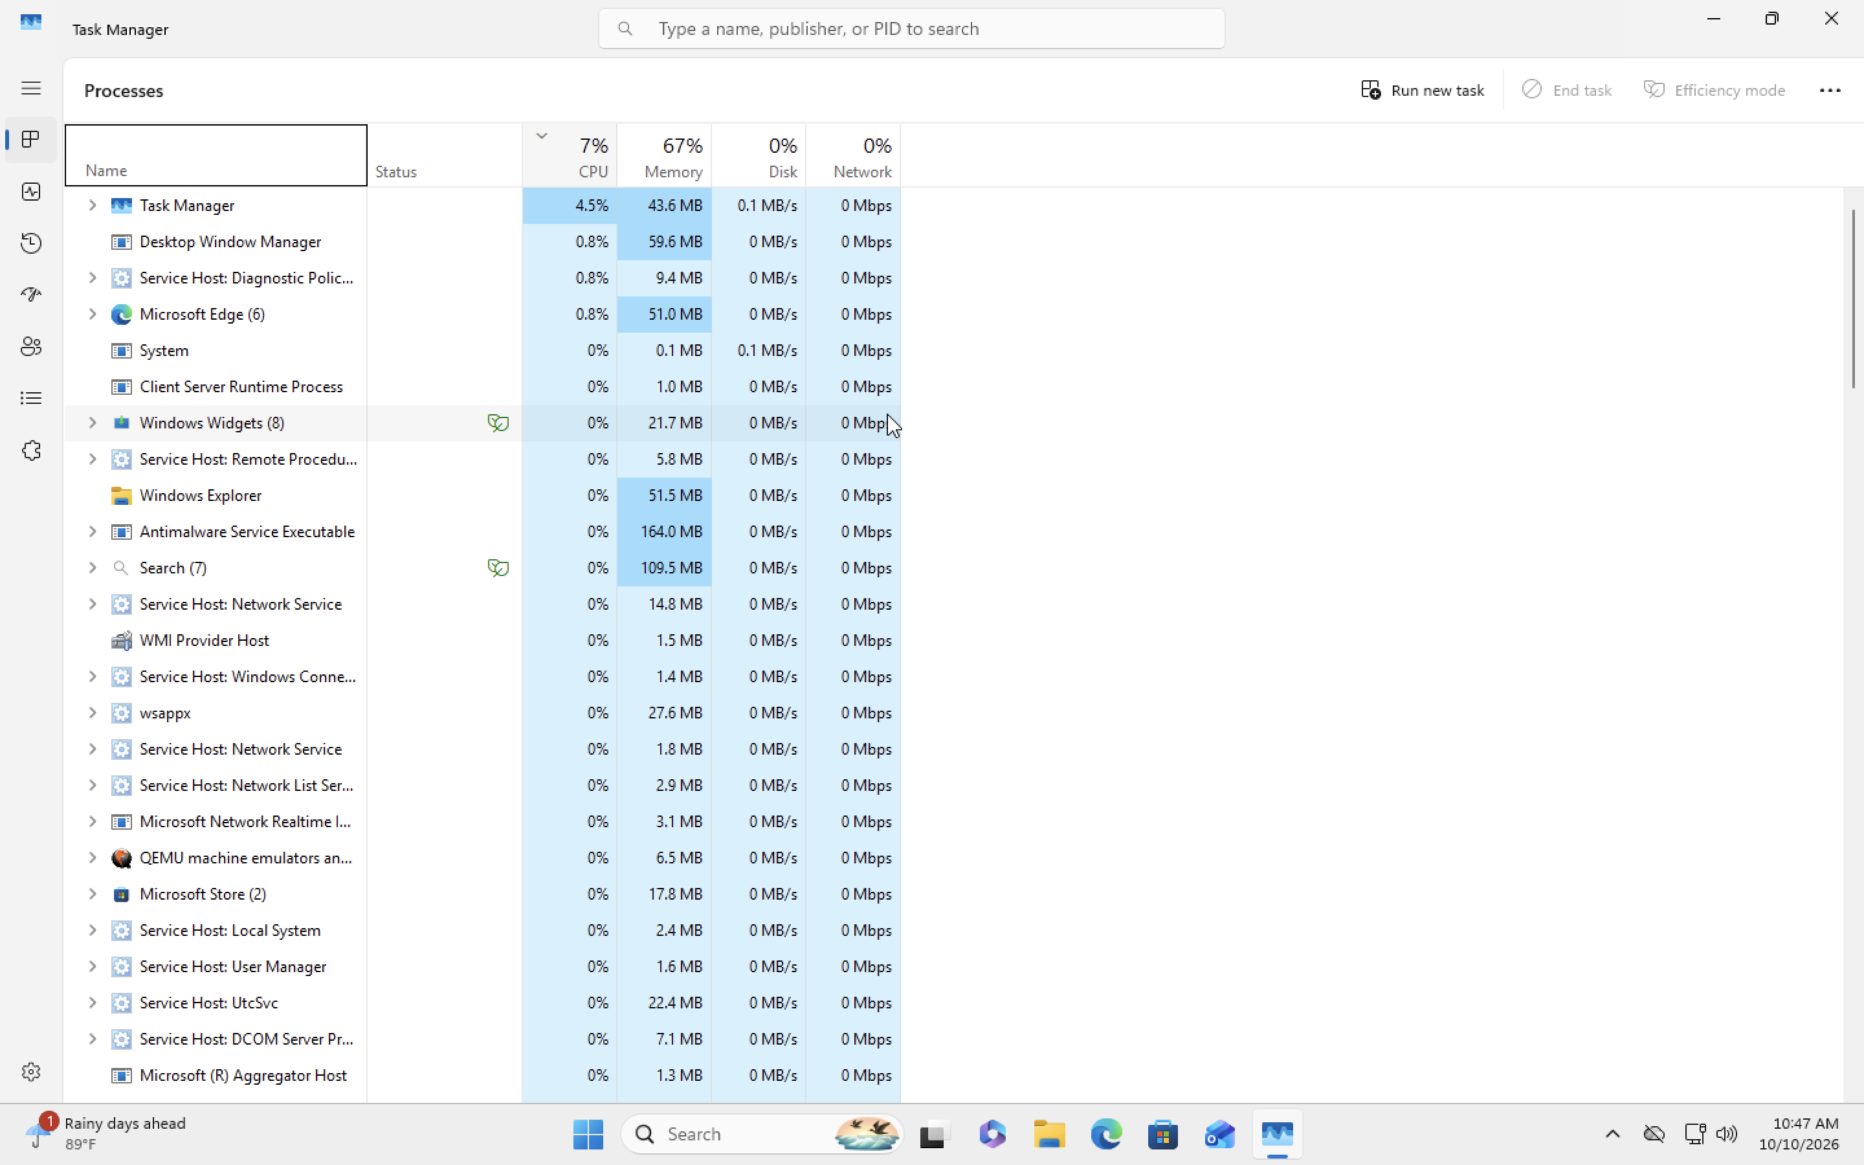
01-task-manager-processes.png

Exercise 1 | Performance Monitoring

Screenshot 2 of 4 — CPU Performance
Reviewed CPU performance in the Windows virtual machine, which was configured with two virtual processors. No sustained CPU saturation was observed.
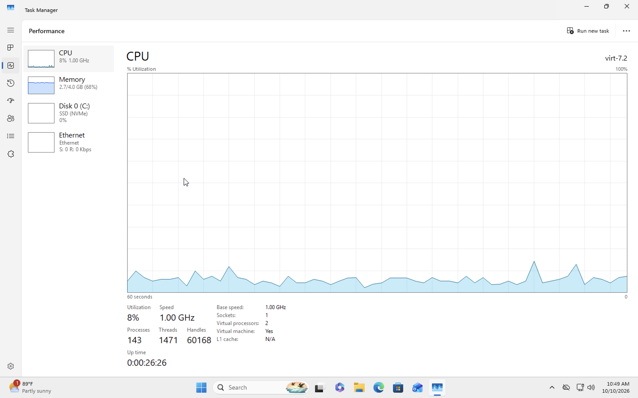
02-cpu-performance.png

Exercise 1 | Performance Monitoring

Screenshot 3 of 4 — Memory — Baseline
Recorded baseline memory usage of approximately 2.6 GB (65%), with approximately 1.4 GB available.
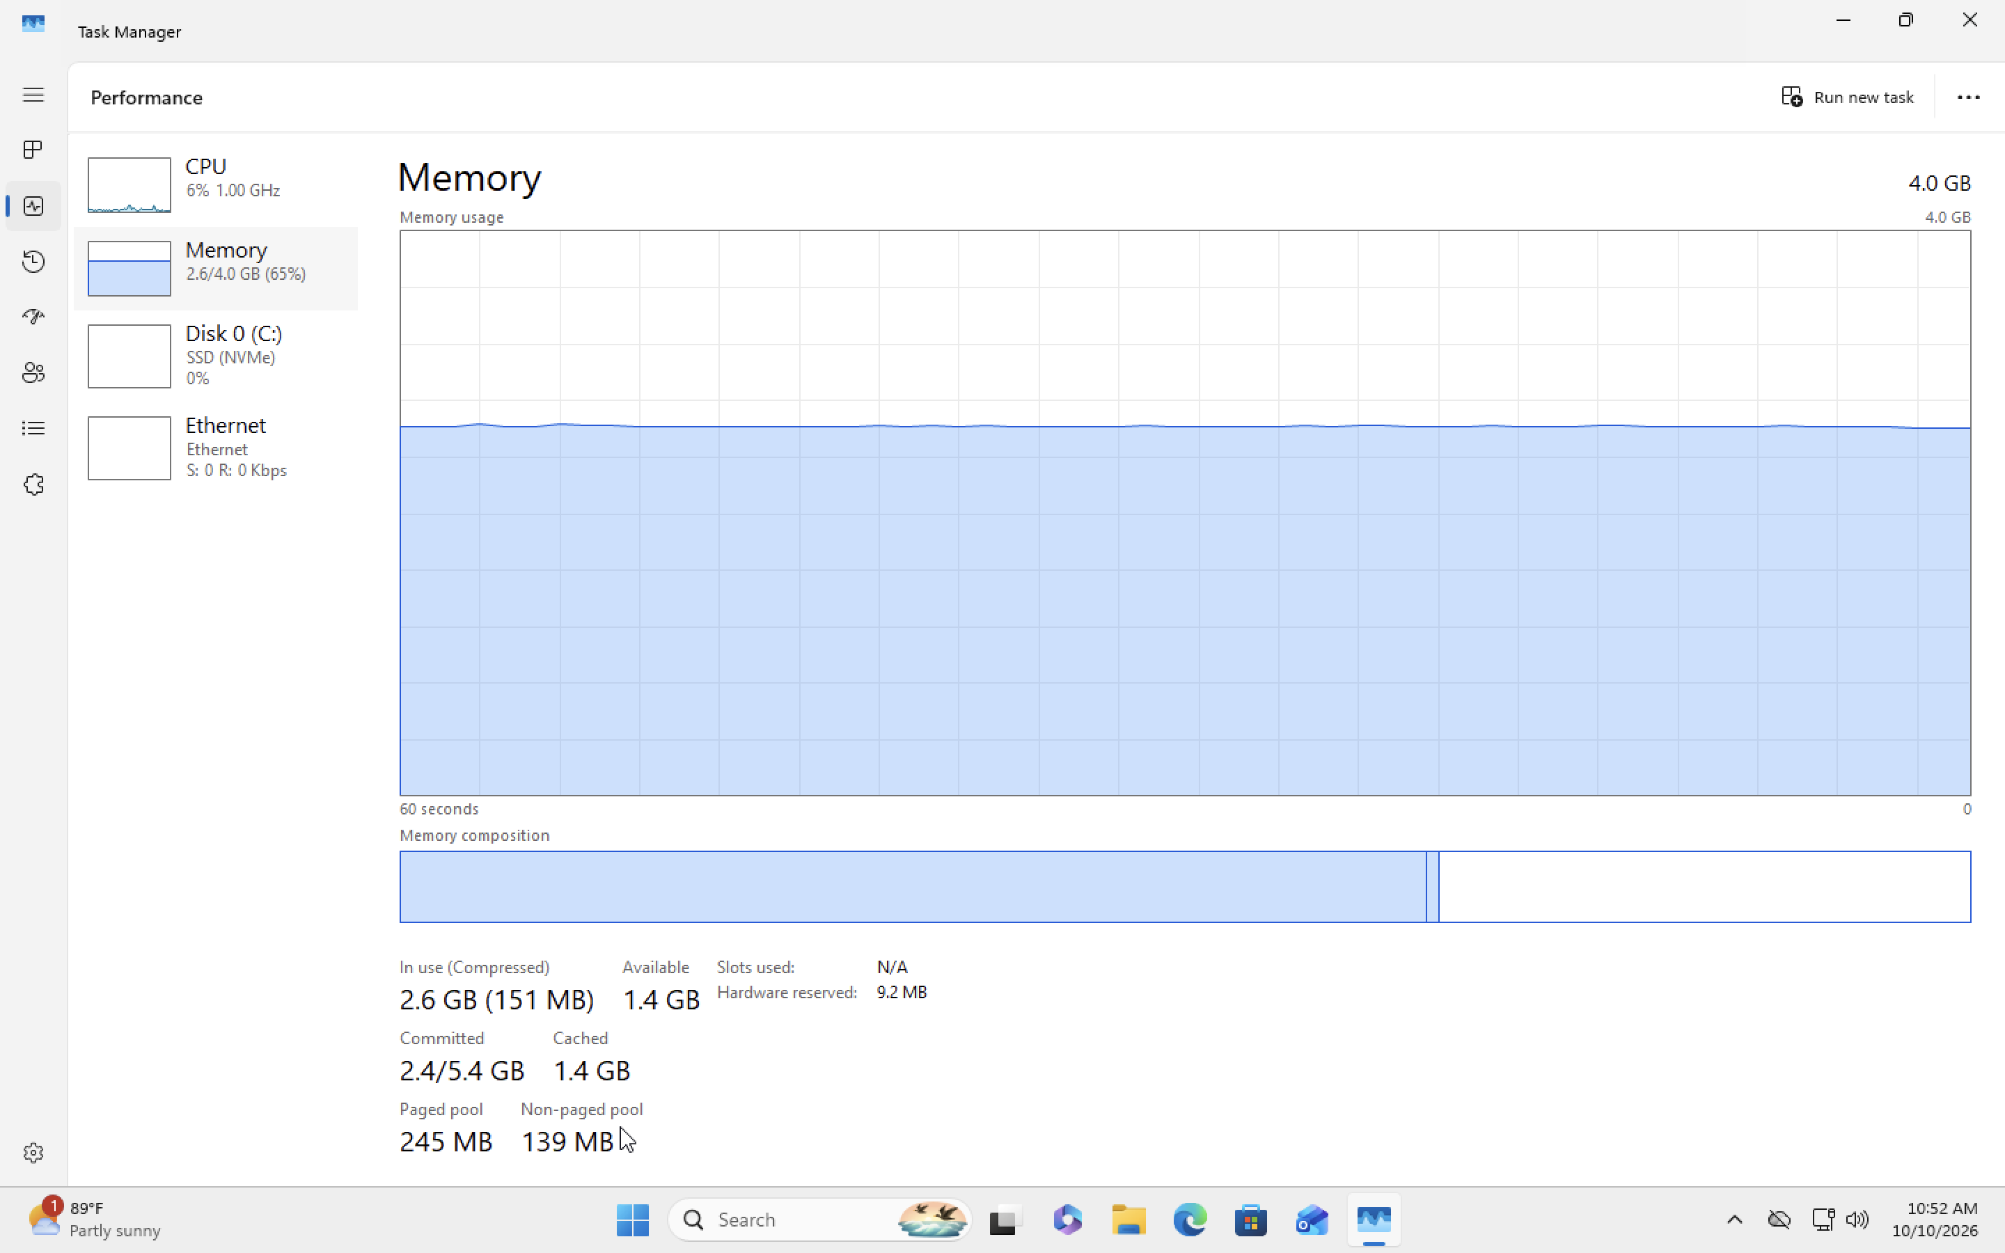
03-memory-baseline.png

Exercise 1 | Performance Monitoring

Screenshot 4 of 4 — Memory — Multitasking
Opened additional applications and compared utilization. Memory usage rose to approximately 3.3 GB (82%), leaving approximately 664 MB available.
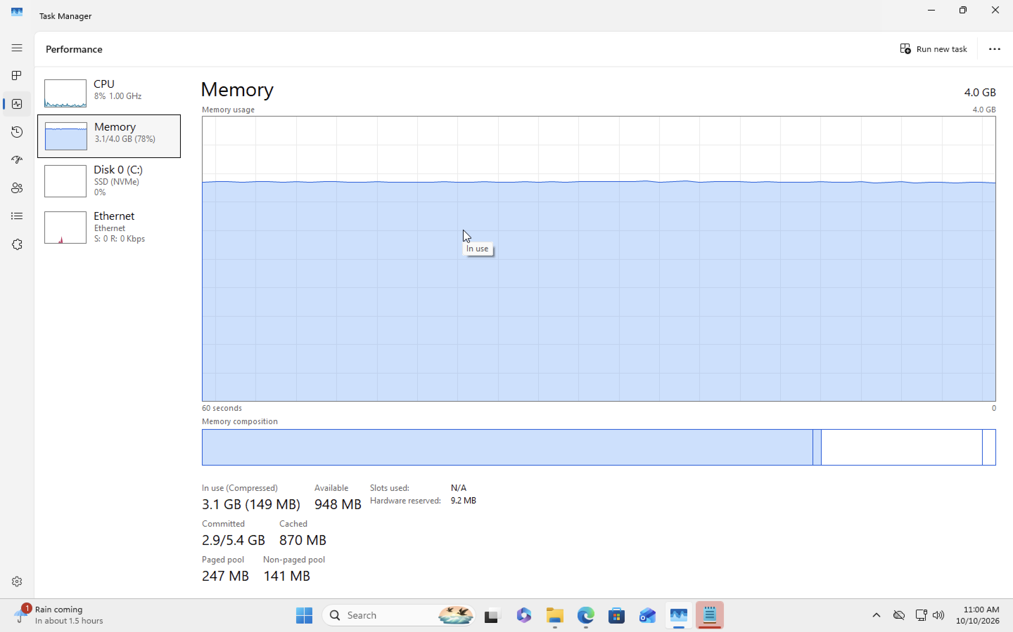
04-memory-multitasking.png
Conclusion: Memory usage increased under multitasking in the 4 GB VM. This exercise documents performance observation, not a confirmed hardware fault or repair.

