Windows Services — Print Spooler
  - Project 1 | Screenshot 1 of 1

Print Spooler Service Properties
Opened services.msc and inspected Print Spooler properties. Verified the service startup type was Automatic and service status was Running.
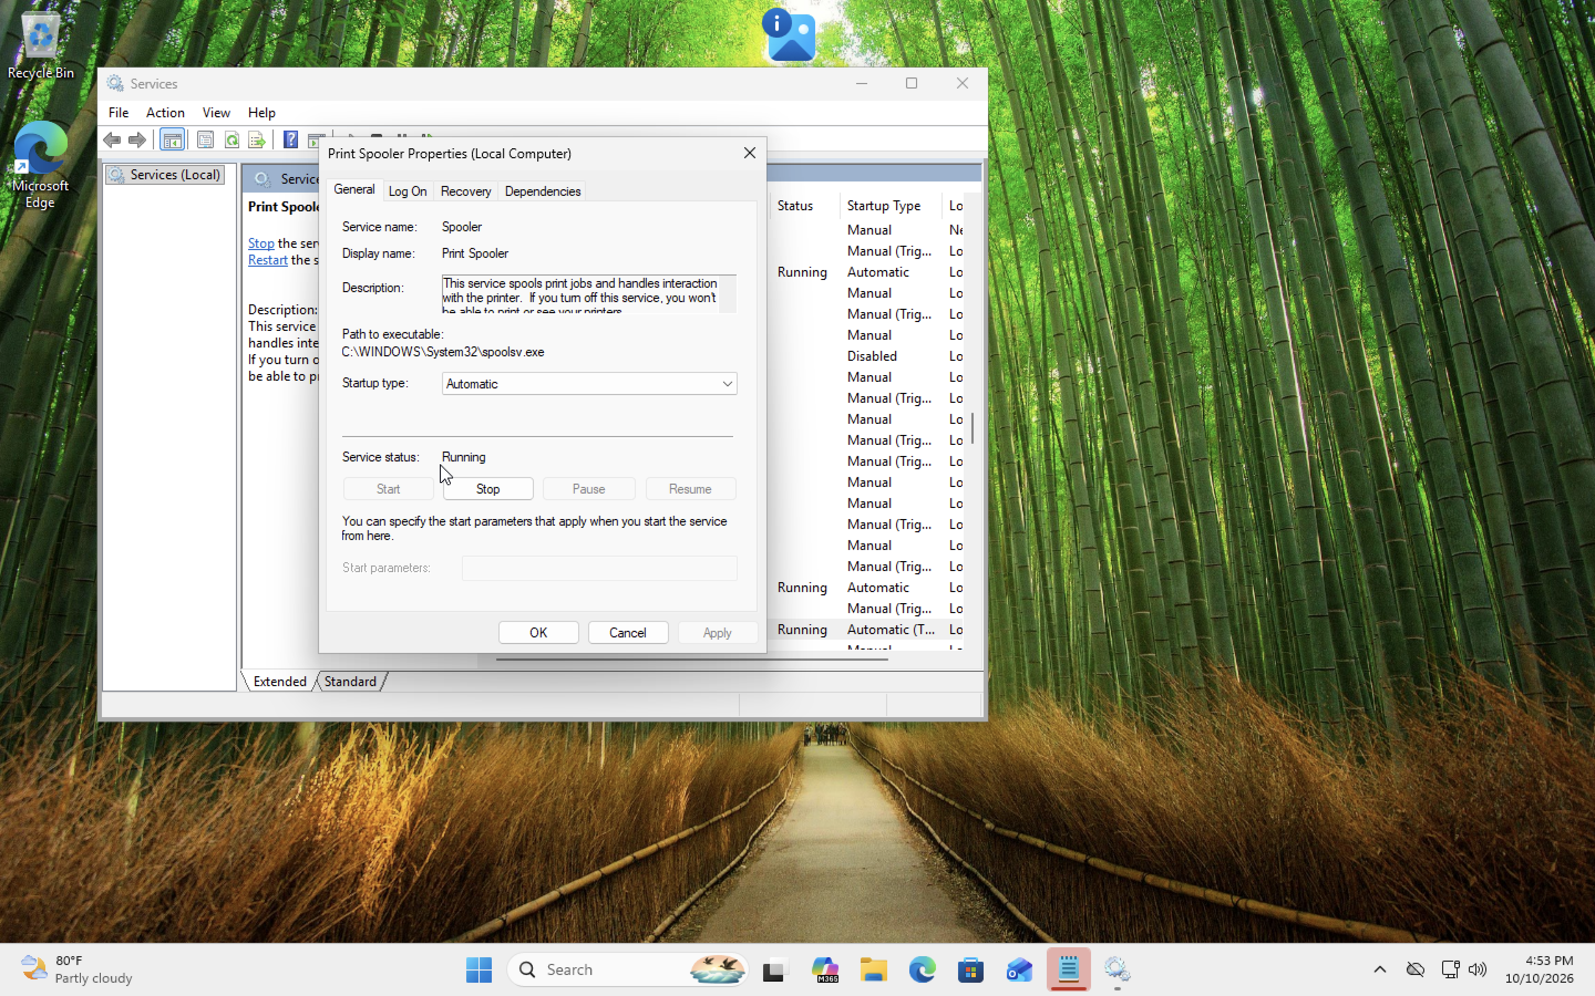
01-print-spooler-service.png

Findings
Outcome: Confirmed the Print Spooler service was running. No actual printer repair was performed or verified.

