PowerShell System Health Check
  - Project 1 | Screenshot 1 of 2

Computer, CPU and Disk Output
Ran the custom SystemHealthCheck.ps1 script to display computer information, CPU details and disk utilization. Resolved an initial script execution-policy restriction using a temporary process-scoped policy change.
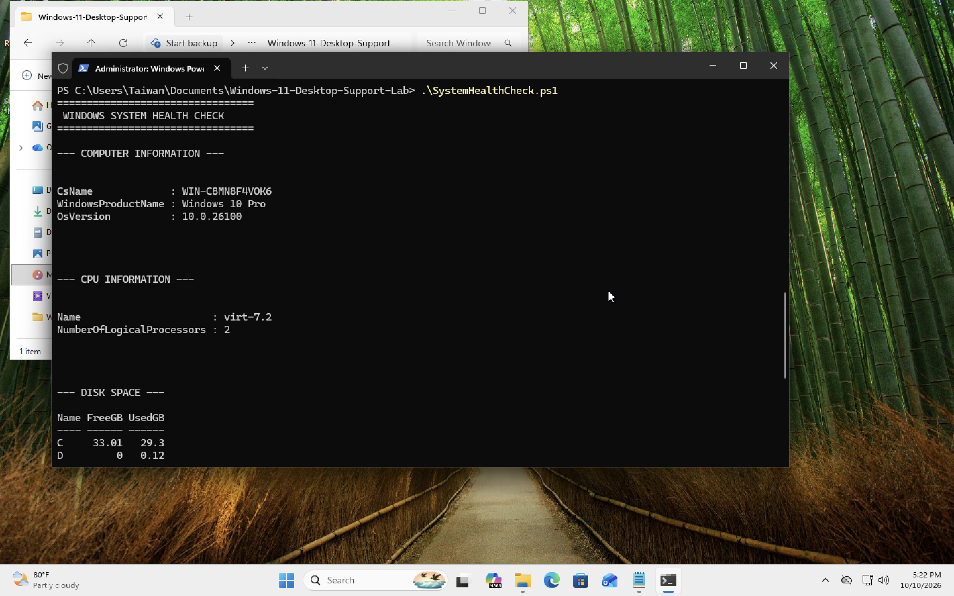
01-health-check-computer-cpu-disk.png

PowerShell System Health Check
  - Project 1 | Screenshot 2 of 2

Network and Print Spooler Output
Used the diagnostic script to display network configuration and Print Spooler status. Updated PowerShell formatting so multiple sections rendered correctly in the console.
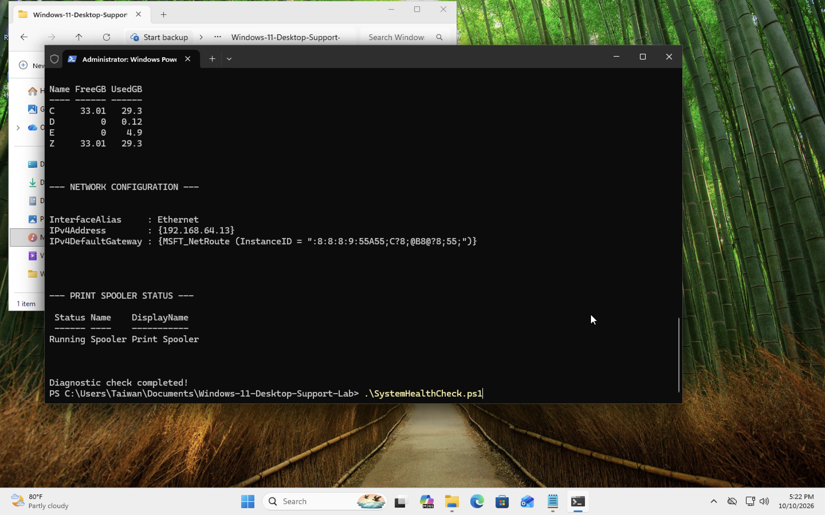
02-health-check-network-spooler-complete.png

Findings
Outcome: Created and tested a read-only PowerShell diagnostic script. The script source is also included separately in the GitHub repository.

