Event Viewer & TPM Investigation
  - Project 1 | Screenshot 1 of 2

System Event Log
Opened Event Viewer and reviewed the Windows System log. Filtered the log for critical, error, and warning events to identify entries for further investigation.
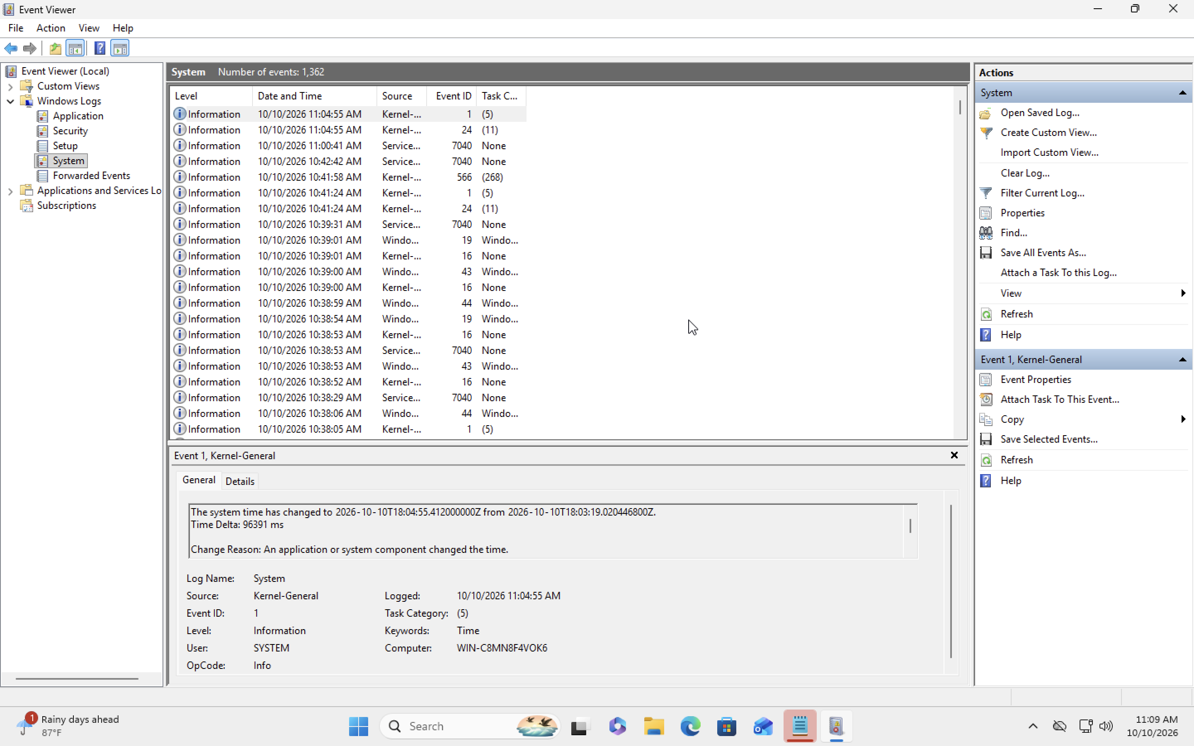
01-system-events.png

Event Viewer & TPM Investigation
  - Project 1 | Screenshot 2 of 2

TPM Error Investigation
Investigated recurring TPM-related Event ID 15 errors. TPM Management subsequently reported the TPM as ready for use. This evidence does not establish that the underlying issue was resolved.
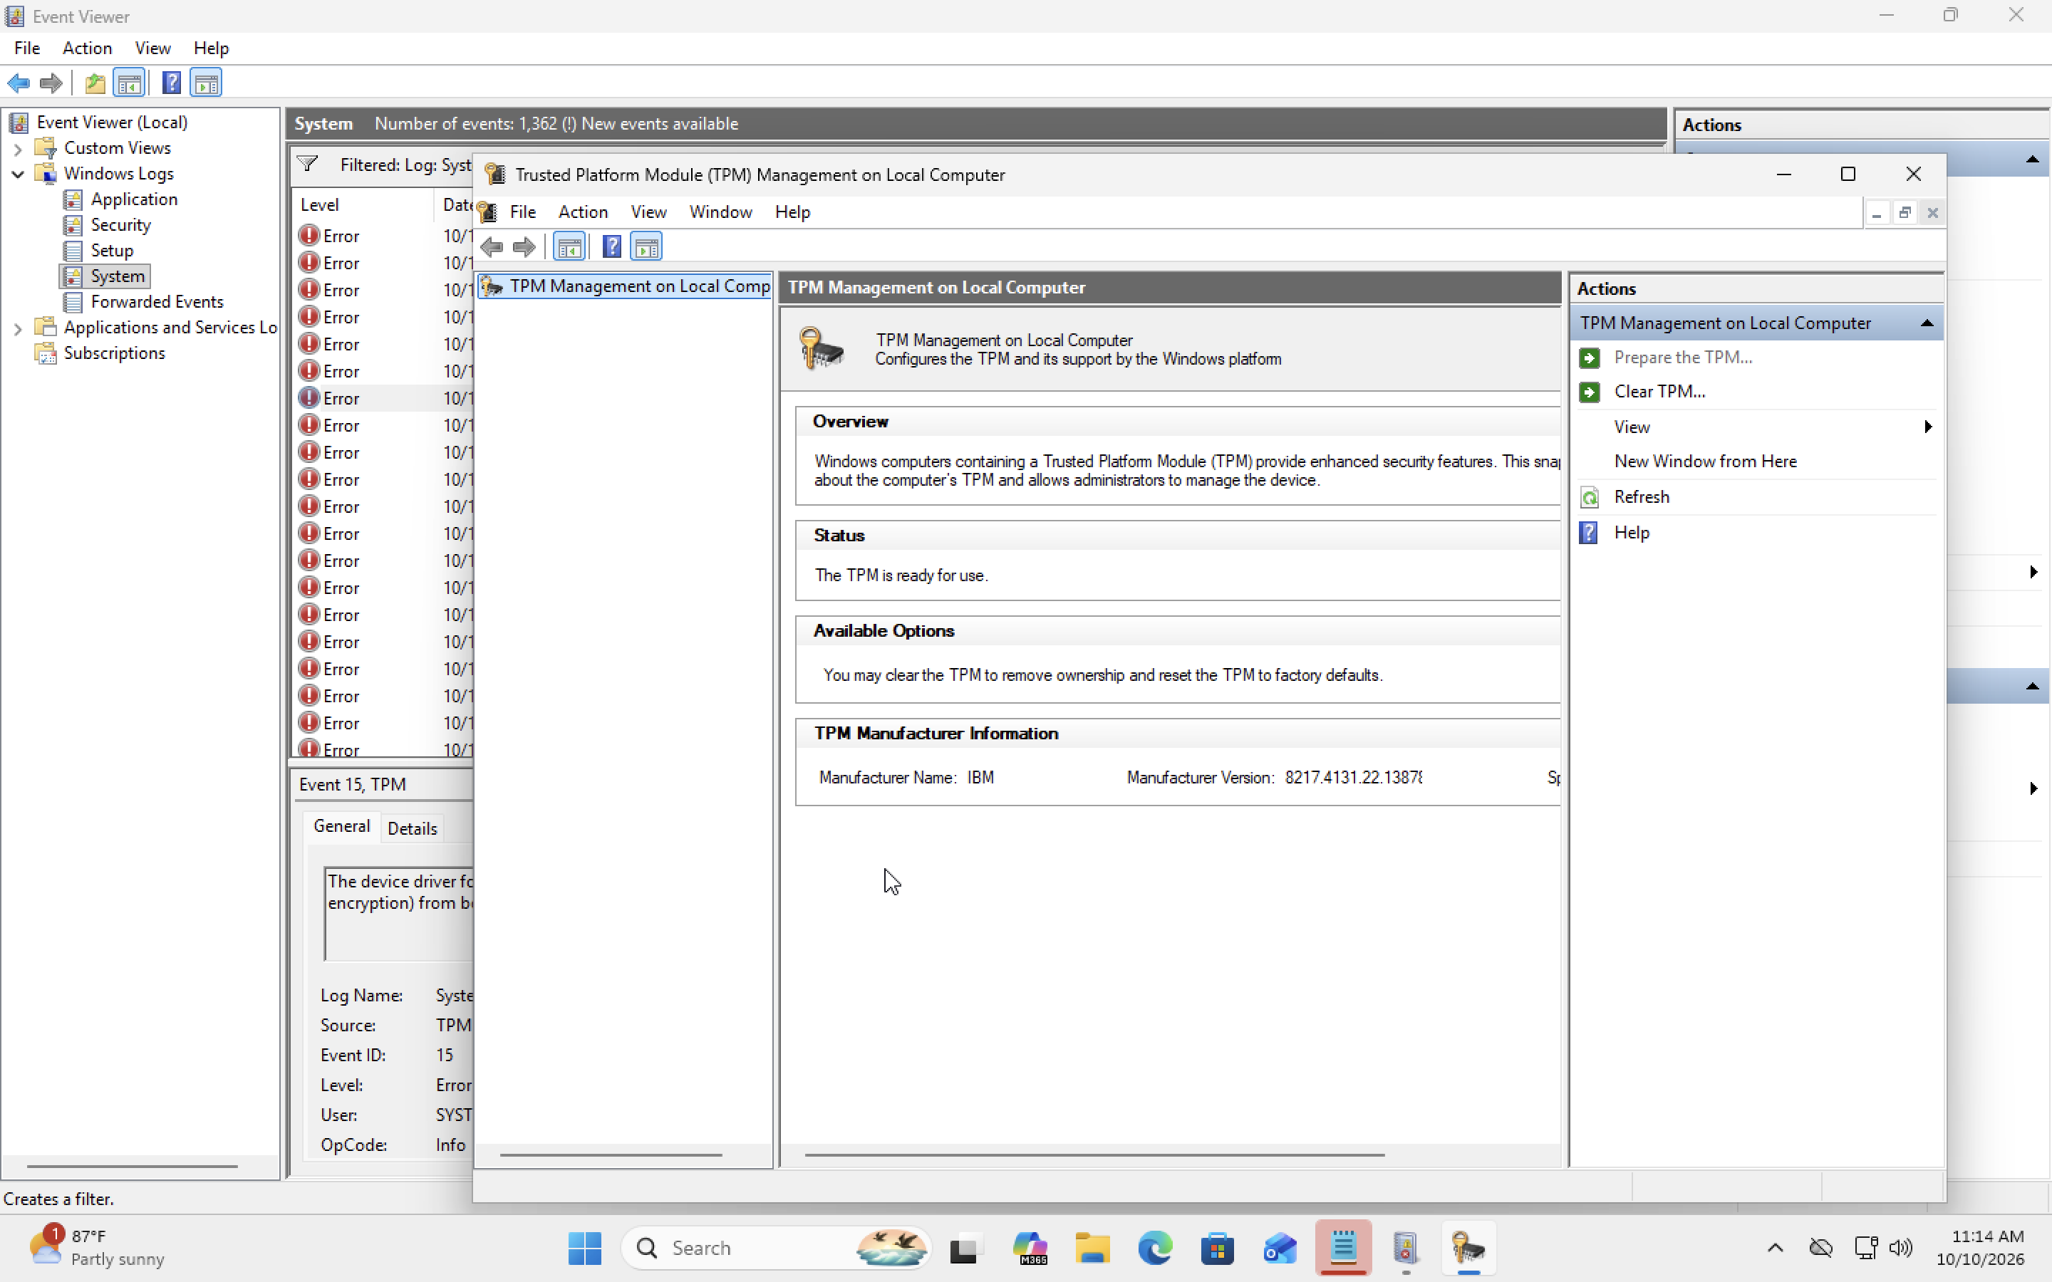
02-tpm-error-investigation.png

Findings
Outcome: Identified and documented TPM-related events; root cause and remediation were not verified.

