Network Connectivity & DNS Diagnostics
  - Project 1 | Screenshot 1 of 3

IP Configuration and Loopback
Used ipconfig /all to inspect the VM network configuration, including IPv4 address 192.168.64.13/24, default gateway 192.168.64.1 and DHCP settings. Tested the local TCP/IP stack using ping 127.0.0.1.
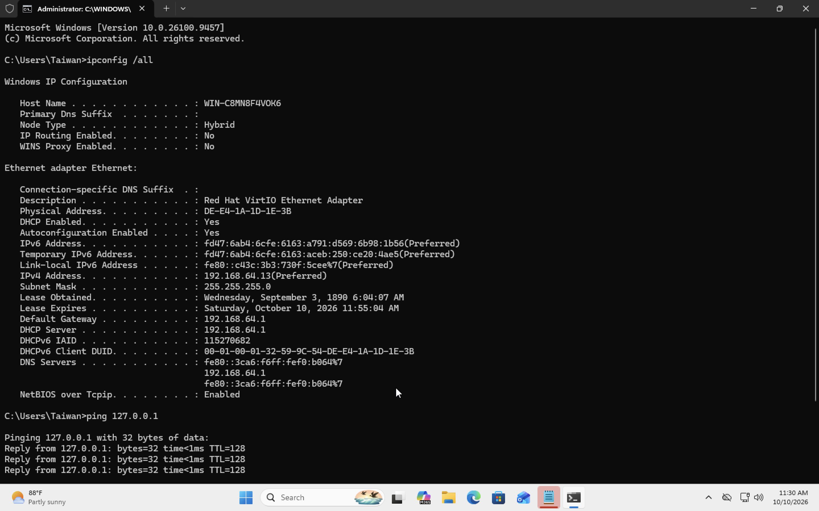
01-ip-configuration-and-loopback.png

Network Connectivity & DNS Diagnostics
  - Project 1 | Screenshot 2 of 3

Gateway and External Connectivity
Pinged the default gateway 192.168.64.1 and public address 8.8.8.8. The captured tests showed four replies each with no packet loss.
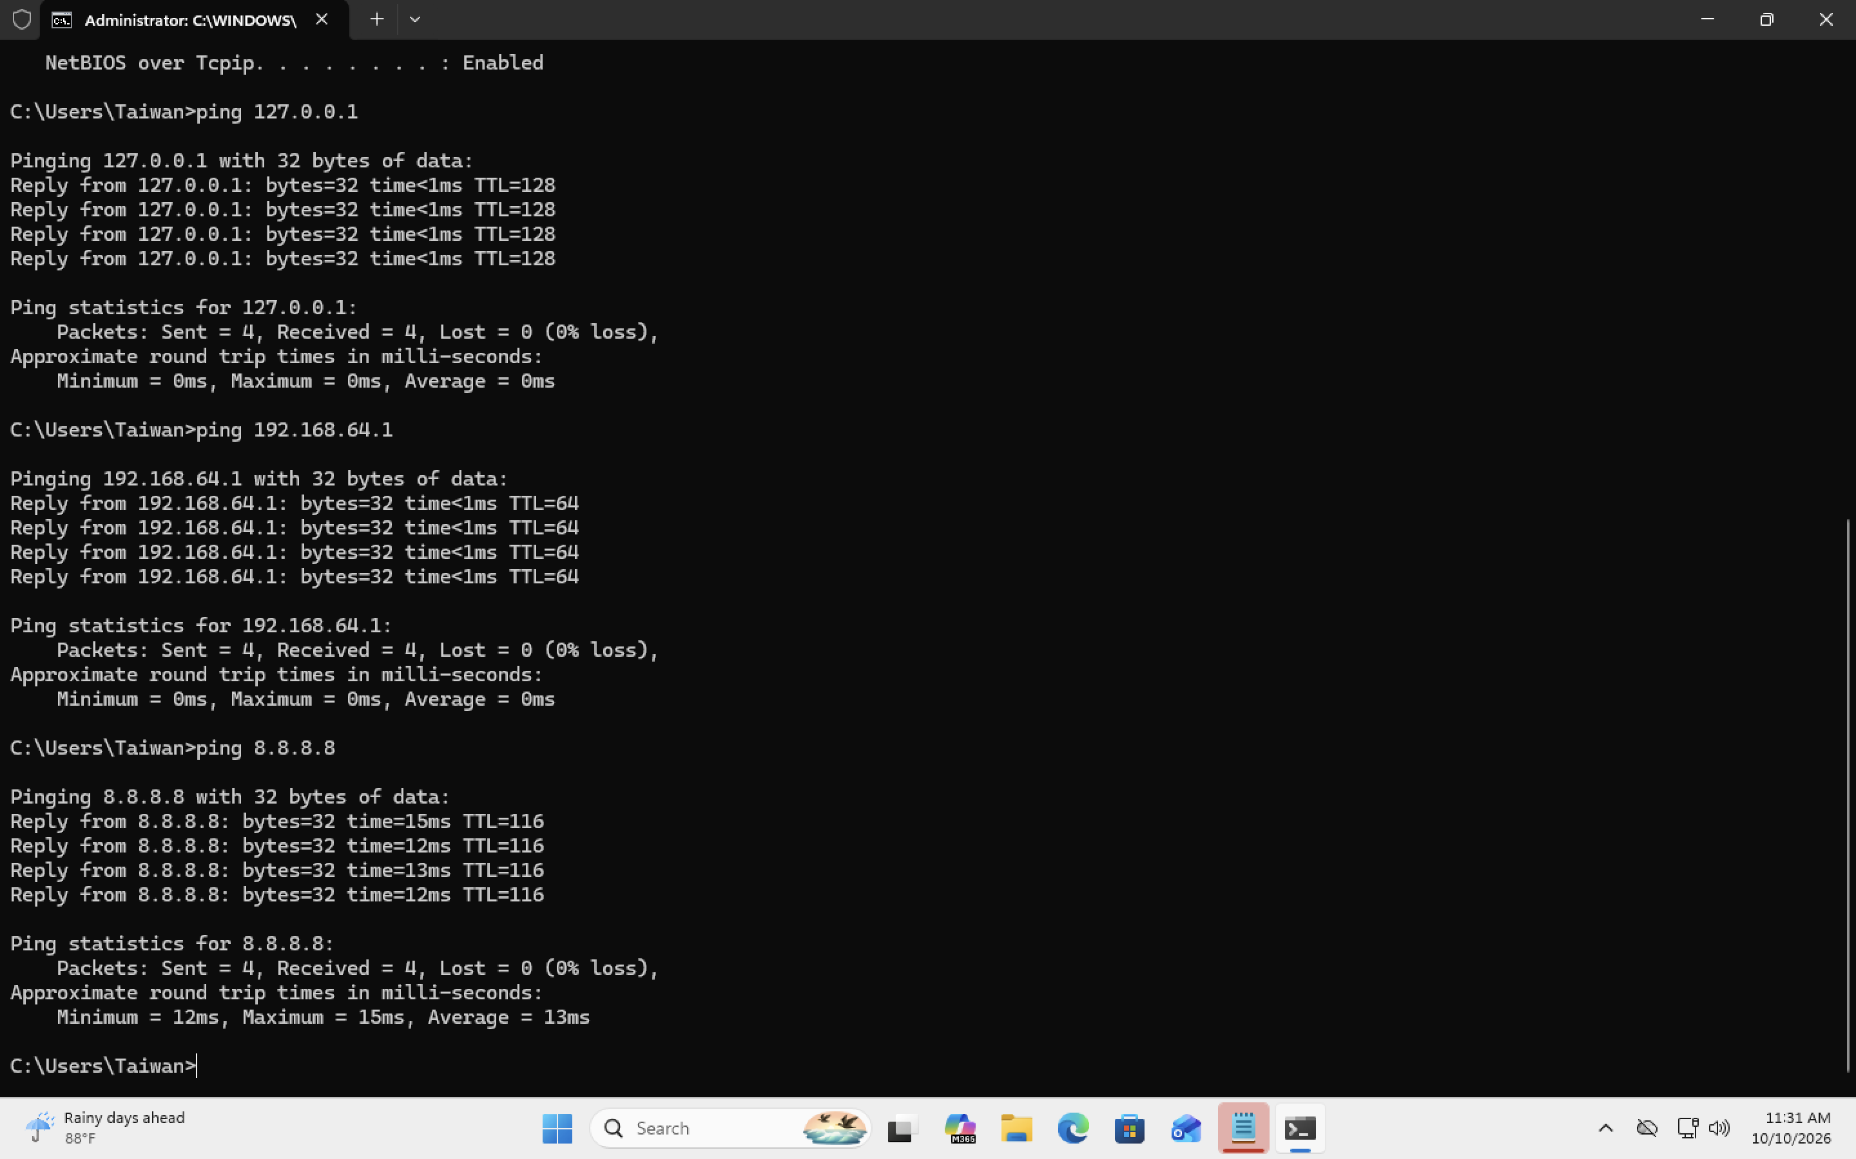
02-gateway-and-internet-ping.png

Network Connectivity & DNS Diagnostics
  - Project 1 | Screenshot 3 of 3

DNS Name Resolution
Used nslookup to query public domain names and test name resolution with the configured DNS server and 8.8.8.8. DNS resolution succeeded.
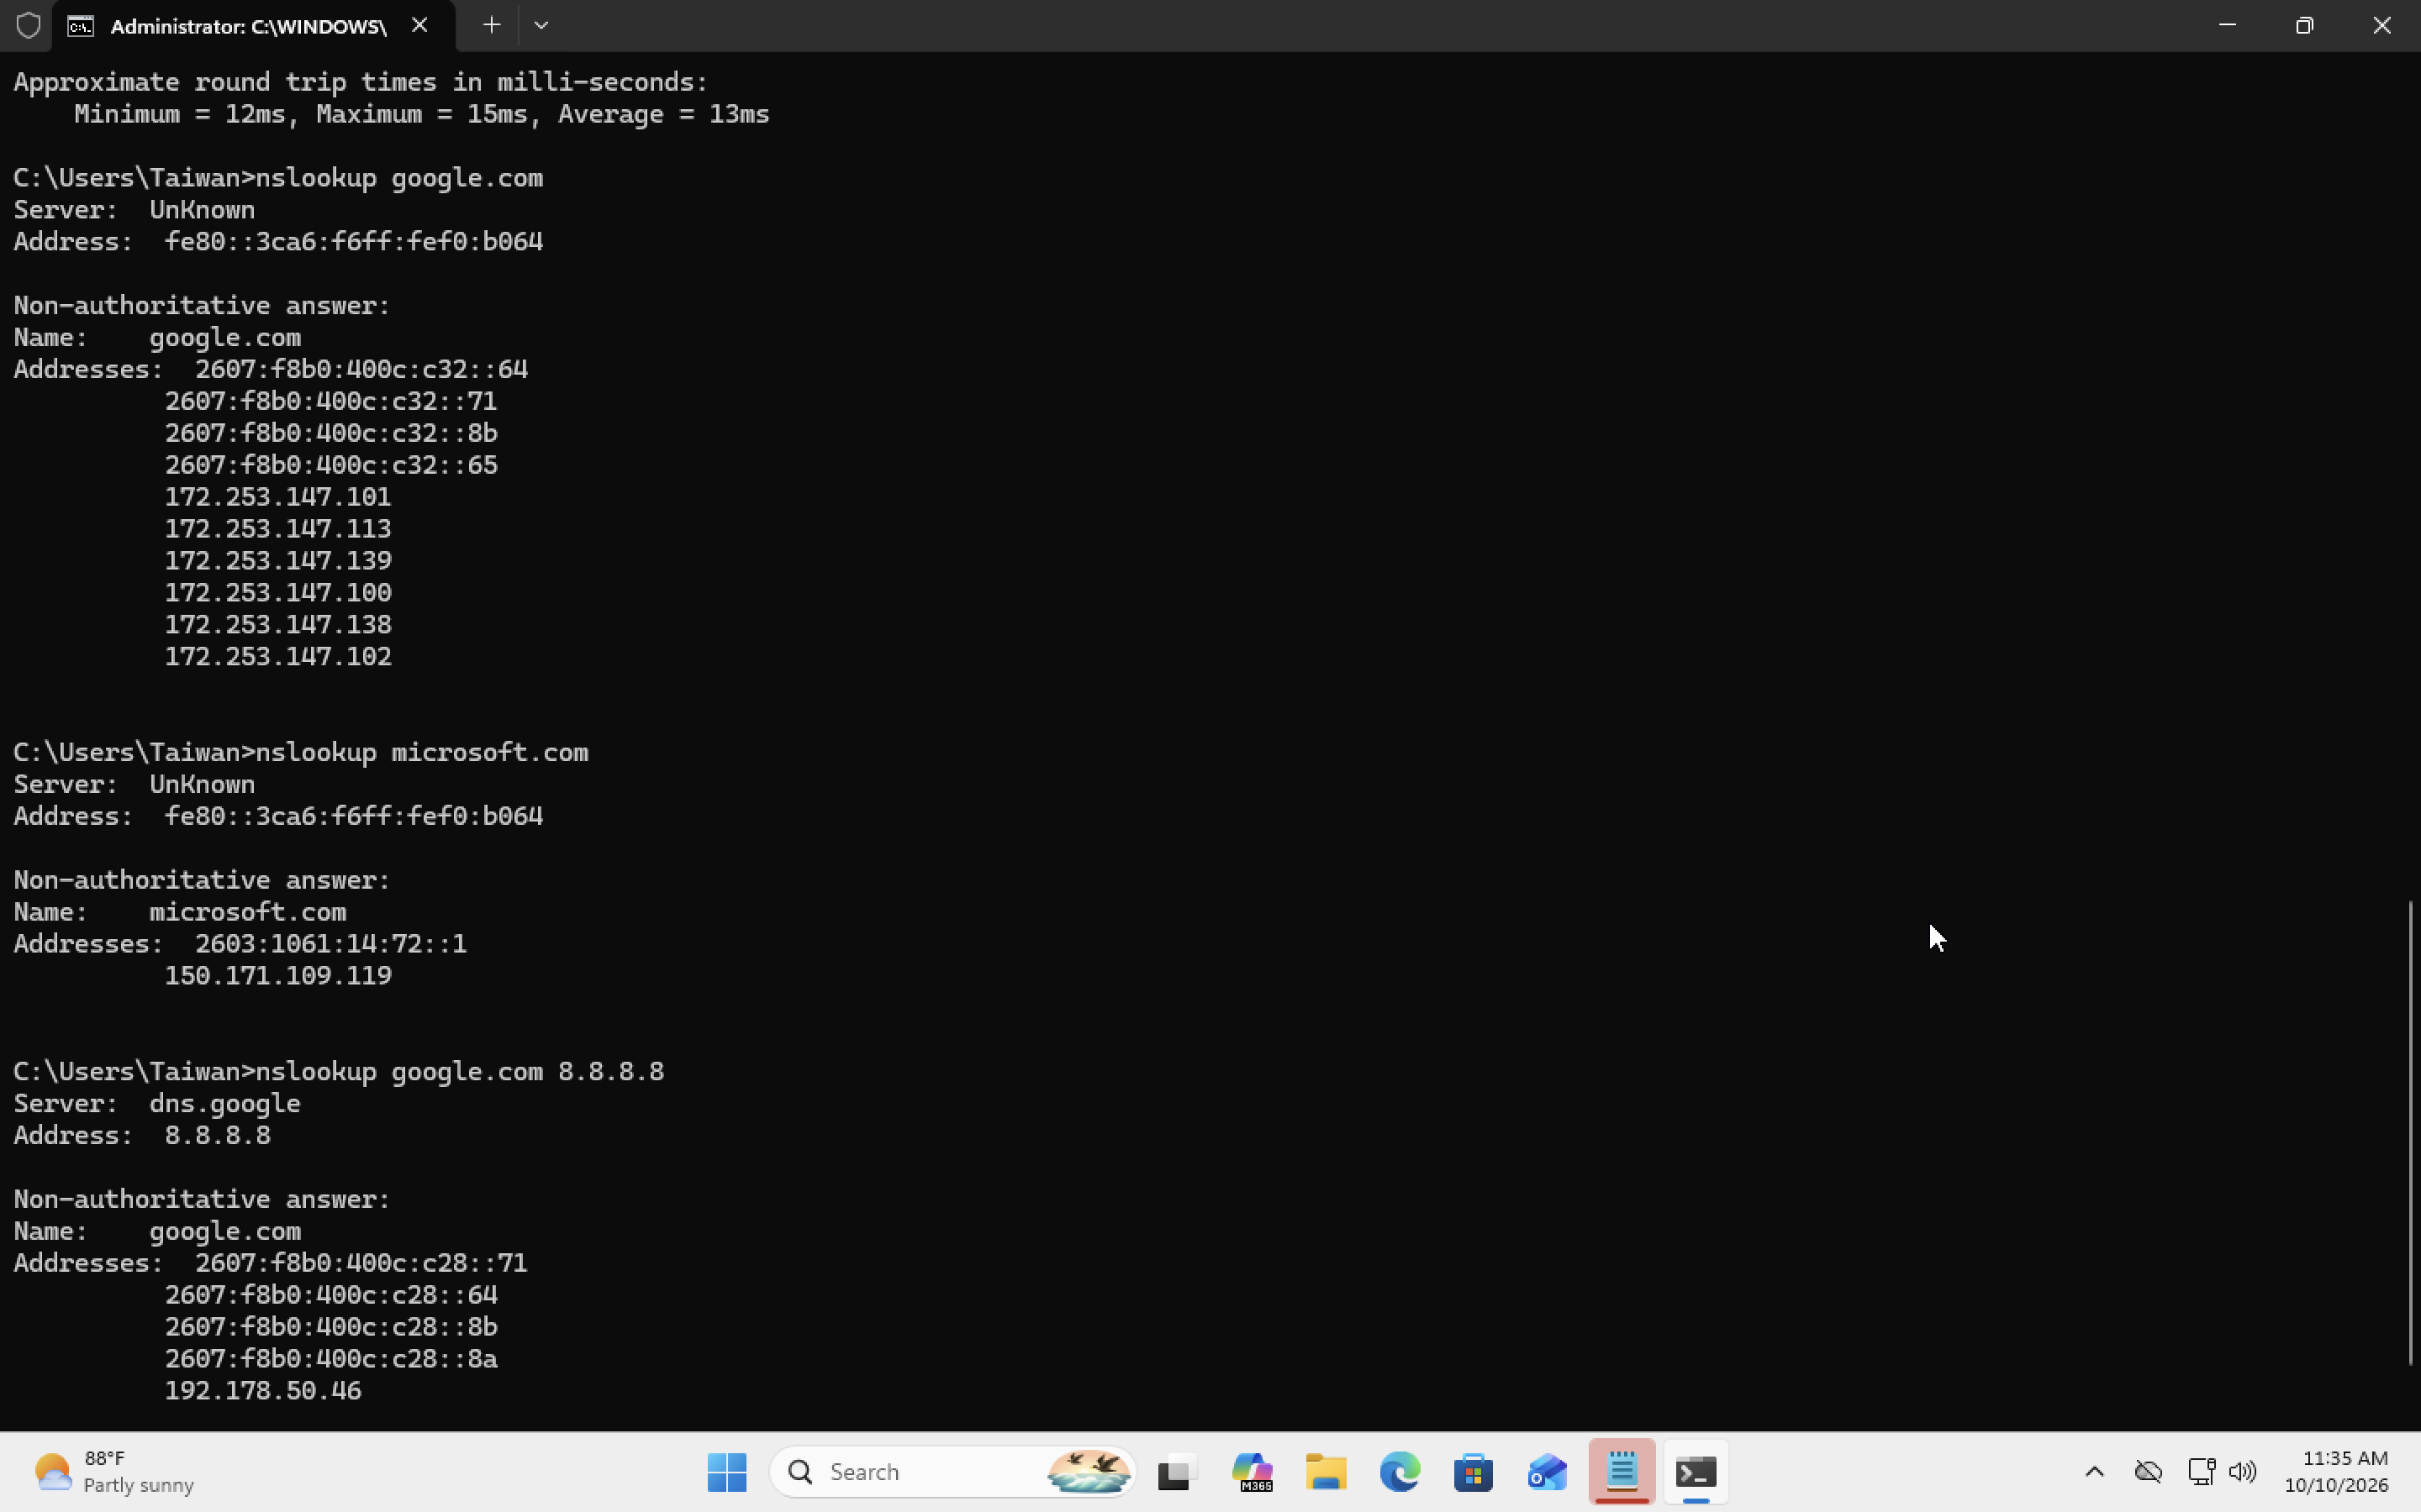
03-dns-nslookup.png

Findings
Outcome: Local networking, gateway reachability, external connectivity and DNS name resolution were validated; no active connectivity fault was reproduced.

