A Report on
Industrial Problems and Solutions: A Case Study at Knit Asia Ltd.

Course No: IPE 300
Course Name: Industrial Practice

Submitted to

Dr. Nikhil Ranjan Dhar
Professor, Department of IPE, BUET

Rashik Ahnaf
Lecturer, Department of IPE, BUET

Md. Tariqul Islam
DGM, HR, Knit Asia Ltd.

Submitted by

Student Name | Student ID
Abrar Hamim Masih | 1908021
Narayon Dey Noyon | 1908029
An-Nur Taiweb Rahman | 1908047
Muhammad Shadab Sakib | 1908050

Bangladesh University of Engineering and Technology
Department of Industrial and Production Engineering
Date: 21 September 2024

EXECUTIVE SUMMARY
The primary objective of our industrial attachment at Knit Asia Ltd. was to gain practical experience in an industrial setting, understand industry operations, and observe the role of industrial engineering in enhancing efficiency. We focused on the manufacturing process and identifying opportunities for applying our academic knowledge to improve operations.
Knit Asia Ltd. is a well-organized company committed to sustainability, using renewable energy sources such as solar power for over 50% of its operations. While employing modern equipment and automation, we identified several areas for improvement, including underutilization of helper workers, poor ventilation, sewing defects, unoptimized dyeing and washing layout, and ergonomic issues with chair design.
During our visit, we explored the manufacturing processes from yarn to the finished product, conducted time studies on the sewing line, collected data on defects, and surveyed workers to identify challenges. Our industrial supervisors, Md. Tariqul Islam and Shahin Ahmed, provided valuable support throughout our data collection.
Based on our findings, we recommended better manpower utilization through line balancing, improved ventilation, ergonomic chairs, and a new layout for the washing and dyeing shop. We also proposed strategies to reduce product defects.
Our experience at Knit Asia Ltd. offered valuable insights into applying academic knowledge to real-world challenges. The company's focus on continuous improvement through lean manufacturing, Six Sigma practices, and environmental sustainability made this attachment highly educational.

FORWARDING LETTER
21 September 2024
Dr. Nikhil Ranjan Dhar
Professor, IPE, BUET
Rashik Ahnaf
Lecturer, IPE, BUET
Md. Tariqul Islam
DGM, HR, Knit Asia Ltd.
Subject: Submission of the report on “A Report on Industrial Problems and Solutions: A case study at Knit Asia Ltd”
Dear Sir,
It is our pleasure to present to you the report entitled “A Report on some Industrial Problems and Solutions-A case study at Knit Asia Ltd”, which represents our experience and works that we have performed under your supervision. We delivered our observations, learnings, identified problems and proposed solutions with our theoretical background. We are hoping that our findings may add value to the industrial processes and help industry.
We would like to show our earnest gratitude for giving us the opportunity to work under your supervision in your company to enhance our knowledge. We have tried our best to abide by your suggestions and guidelines in every aspect on our report. We hope you will appreciate our genuine effort put forth hereby.
Sincerely yours,
Abrar Hamim Masih (1908021)
Narayon Dey Noyon (1908029)
An-Nur Taiweb Rahman (1908047)
Muhammad Shadab Sakib (1908050)
Level-4, Term-2
Department of Industrial and Production Engineering, BUET.

CERTIFICATE OF APPROVAL
The report titled “A Report on Industrial Problems and Solutions-A case study at Knit Asia Ltd” is submitted by Abrar Hamim Masih (1908021), Narayon Dey Noyon (1908029), An-Nur Taiweb Rahman (190847), Muhammad Shadab Sakib (1908050) has been accepted as satisfactory under the course “Industrial Practice” bearing course no. IPE-300.

Approved by:

Dr. Nikhil Ranjan Dhar
Professor, Department of IPE, BUET

Rashik Ahnaf
Lecturer, Department of IPE, BUET

Md. Tariqul Islam
DGM, HR, Knit Asia Ltd.

DECLARATION
We do hereby declare that this attachment report has been prepared by us and neither this report nor any part of it has been submitted elsewhere. We do not intend to profit from this report by utilizing it for business purposes.
The Authors:
Signature:

____________________
Name: Abrar Hamim Masih
Student ID: 1908021
Signature:

____________________
Name: Narayon Dey Noyon
Student ID: 1908029
Signature:

____________________
Name: An-Nur Taiweb Rahman
Student ID: 1908047
Signature:

____________________
Name: Muhammad Shadab Sakib
Student ID: 1908050

ACKNOWLEDGEMENT
We would like to express our gratitude, especially to the Department of Industrial and Production Engineering, BUET, for arranging this educative industrial attachment program. Besides, we would also like to thank the authority of Knit Asia Limited for helping us by giving us an opportunity to work with them.
A special word of thanks to Dr. Syed Mithun Ali (Professor and Head of the Department of IPE), our Academic Supervisors, Dr. Nikhil Ranjan Dhar (Professor, Department of IPE) and Rashik Ahnaf (Lecturer, Department of IPE) for their thoughtful suggestions and useful guidance.
We are also thankful and acknowledge our industrial supervisor, Md. Tariqul Islam (Deputy General Manager, Human Resource, Knit Asia Limited) for his untiring guidance, help, effort, and valuable suggestions. He tried his best to enlighten us about various prospects of the Textile and RMG Industry. Whenever we faced problems, he managed time to solve our problems. Without his direct help, suggestions, and assistance it would have been impossible for us to complete this report. We would also be very grateful to Shahin Ahmed (Manager, IE, Knit Asia Limited) for his constant support & making us acquainted with Knit Asia.
Special thank goes to all the personnel of the industry, who has provided all the information, suggestion, inspiration, and support for preparing this report. We sincerely owe the division and department heads for sharing valuable knowledge in their areas of expertise. We must mention the wonderful working environment and group commitment of this company that has enabled us to deal with a lot of things.
Finally, we would like to give sincere thanks to all those who either directly or indirectly helped us in any way to complete this report work.

TABLE OF CONTENTS
EXECUTIVE SUMMARY i
FORWARDING LETTER ii
CERTIFICATE OF APPROVAL iii
DECLARATION iv
ACKNOWLEDGEMENT v
Chapter 1: Overview of Knit Asia Limited 1
1.1 Introduction 1
1.2 Objectives 5
1.3 Methodology 6
Chapter 2: Problem Identification 8
2.1 Problem Statement 01: Improper Ventilation and Air Circulation on a Sewing Floor at Knit Asia Ltd 8
2.2 Solution of Problem 01: Calculating the ventilation capacities and requirements: 9
2.3 Problem Statement 02: Improper manpower utilization causing bottleneck in a sewing line 15
2.4 Solution of Problem 02: Proposed solution to utilize manpower and remove the bottleneck 19
2.5 Problem Statement 03: Inefficient Layout of the Washing and Dyeing Shop at Knit Asia Ltd. (Plant No. 1) 22
2.6 Solution of Problem 03: Proposed Layout of the Washing and Dyeing Shop at Knit Asia Ltd. (Plant No. 1) 24
2.7 Problem Statement 04: Identification and Analysis of Defects in Finished Products Leading to Quality Control Challenges 30
2.8 Solution of Problem 04: Identification and Analysis of top three “Vital few” Defects in Finished Products Leading to Quality Control Challenges using Fishbone Diagram 32
2.9 Problem Statement 05: Ergonomic Deficiencies in Existing Seating for the workers in Knit Asia Ltd. 41
2.10 Solution of problem 05: Ergonomic Considerations for Proposed Seat Design 42
Chapter 3: Discussion 44
Chapter 4: Conclusion 46
APPENDIX 47
Appendix A: Questionnaire for Survey and the response 47
References 50

Chapter 1: Overview of Knit Asia Limited

1.1 Introduction
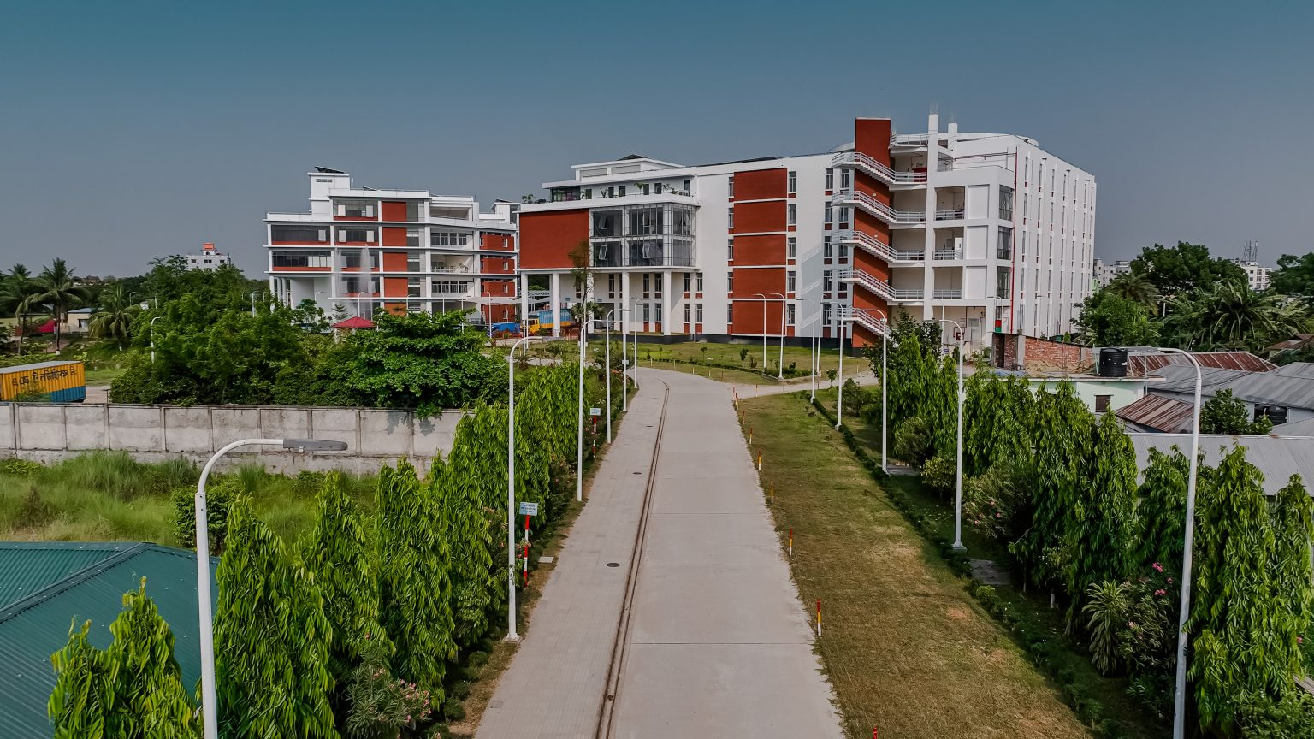
In an ever-evolving global market, the textile industry stands as a beacon of innovation and adaptability. Among the key players shaping this landscape, Knit Asia Ltd emerges as a trailblazer, marking its inception in 1999. From humble beginnings with a lone garment manufacturing unit in Ashulia, Shofipur, and Ratanpur, this company has grown to redefine the benchmarks of excellence in ready-made garment (RMG) production. Figure 1.1. shows the factory building of the company. With a commitment to versatility, innovation, and vertical integration, Knit Asia Ltd has established itself as a frontrunner in the industry, fostering a legacy of quality, reliability, and unwavering dedication to meeting the demands of global retail giants. This is the story of a company that has seamlessly woven together tradition and innovation, earning its place among the elite suppliers to some of the world’s most renowned retail brands. Notably, we have secured a prominent position as a primary supplier to some of the leading retail giants, including Kohl’s, Next, Zara, Decathlon, American Eagle, Eddie Bauer, and others in the high street market.

Figure 1.1: Knit Asia Limited Factory Building
Knit Asia Ltd is a LEED-Certified Green Garment Factory, demonstrating their commitment to sustainable and environmentally friendly practices. Additionally, they are affiliated with WRAP (Worldwide Responsible Accredited Production), BSCI (Business Social Compliance Initiative), CT PAT (Customs Trade Partnership Against Terrorism), GOTS (Global Organic Textile Standard), OEKO-TEX, and OCS (Organic Content Standard). The company holds the Wal-Mart Yellow Certification and the Environmental & Chemical Policy (ECP) certification from M&S (Marks & Spencer), further highlighting their dedication to ethical and environmentally conscious operations. Knit Asia Ltd is associated with ACCORD and ALLIANCE, organizations focused on improving workplace safety in the garment industry. Furthermore, they have received recognition for their efforts, including the Best Award on Wastewater Management from DECATHLON, affirming their excellence in sustainable practices and waste management within their operations.
Knit Asia Ltd operates across multiple locations, with its Fabric Production Unit located in Shafipur (Kaliakoir), Gazipur, Dhaka, Bangladesh. The facility has a fabric dyeing capacity of approximately 30 tons per day and a knitting production capacity of 25 tons per day, ensuring all products are AZO-free. The unit employs over 1,000 people. In addition, the company’s Ready-Made Garment (RMG) facilities are located in Ashulia (Savar), Shafipur (Gazipur), and Nischintapur (Gazipur), Bangladesh. The RMG unit produces a wide range of garments, including men's, women's, and children's wear, with a production capacity of 200,000 pieces per day, supported by a workforce of more than 6,000 employees.
1.1.1 Technology Used in Knit Asia Limited
Knit Asia Ltd leverages cutting-edge technologies such as Clo and Optitex for virtual design, along with Browzewear and V-stitcher for 3D sampling. Their operations incorporate virtual dummies, Lectra-Modaris, and Santoni seamless methods, enhancing efficiency and precision. They employ tools like CETME stretch ability checker, TECHNOPEA heat setter, and AUTOCLAVE steam heat setter, alongside FLAINOX Dyeing and drying facilities. The company boasts an accredited testing lab, an award-winning flow segregation biological ETP (Effluent Treatment Plant), and LECTRA Auto Cutter technology. Their adherence to CTPAT-approved practices, BNBC and NPFA fire safety protocols, and utilization of solar power generation showcase their commitment to sustainability and safety. Furthermore, Knit Asia Ltd invests in high-functional medical equipment for healthcare safety, GTR pattern and marker, Winda Pattern Cutter, Winda Marker, Ema Auto Cutter, conditioning laboratory, and functional seaming machines. Their operations are optimized through JIT (Just-In-Time) and LEAN manufacturing principles, supported by an efficient ERP system.
1.1.2 All the Departments of Knit Asia Limited
Administration
Our training covered the administrative processes that support the day-to-day operations of the company. This includes managing office logistics, coordinating between different departments, and ensuring that the organizational policies are implemented effectively. The administration team plays a pivotal role in maintaining a smooth workflow and providing necessary resources for efficient operations.
Human Resource and Compliance
The HR department is responsible for maintaining employee records, including personal files that contain essential information such as employment contracts, identification documents, and performance evaluations. These records are meticulously maintained in compliance with Bangladeshi labor laws, which mandate that personal files should be updated regularly to reflect any changes in employment status or personal information.
We learned about the compliance requirements specific to the garment industry in Bangladesh, which are governed by the Bangladesh Labor Act 2006 and the subsequent amendments. The compliance department ensures adherence to laws and regulations related to workplace safety, wage payments, working hours, and employee benefits. This includes regular audits and inspections to verify that the company meets all legal standards and provides a safe working environment.
Marketing and Merchandising
This department is the heart of the industry, significantly influencing other departments. Buyers communicate with the marketing team to understand the company profile, strengths, and compliance status. Before placing an order, buyers inquire about several aspects such as:
- Compliance of the industry
- Bank solvency
- Standardization of processes
- Certification of the company
- Previous clients and projects
If the buyer finds these aspects satisfactory, they request a sample test. The sample's quality is evaluated to see if the company can meet the buyer's requirements at a competitive price. After negotiations, the order is placed. The merchandising team quotes prices to the buyer by calculating processing costs and including profit margins. Both marketing and merchandising teams work together as a cohesive unit.
Processing Departments
Printing: Printing can be categorized into two types: all-over print and placement print. This department handles printing on specific fabric locations. The buyer provides the design in formats like Photoshop, Illustrator, JPG, or PNG. From these files, colors are separated, screens are prepared from films, and colors are mixed in the laboratory. Finally, the printing is done on the fabric using a press.
Embroidery: Semi-automated machines perform embroidery on the fabric. Workers place the fabric under the machine needle, and the embroidery is done automatically. The pattern being embroidered is displayed on a screen.
Dyeing and Washing: Fabric can be Ready for Dyeing (RFD) or Regular dyeing. Various washing processes include acid wash, garment wash, enzyme wash, bleach wash, heavy wash, and burnout wash. Dyeing processes include pigment dyeing, reactive dyeing, direct dyeing, tie dyeing, dip dyeing, and fluorescent dyeing. Machines used in these operations include dyeing machines, tumble dryers, hydro extractors, and acid washers. These processes generate special designs and effects on the fabric.
Fabric Dyeing: Fabric dyeing involves adding color to the fabric by immersing it in a dye bath. The dye molecules penetrate the fibers, bonding to achieve the desired hue. The dyed fabric is then rinsed, dried, and finished to ensure color uniformity. Colors are mixed in the laboratory.
Knitting: In the knitting operation, yarn is looped together to create fabric.
Sewing: Industrial engineering plays a significant role in the sewing section. The layout is U-shaped with 11 lines, each dedicated to sewing different products. Different types of sewing machines are used for various operations:
- Lockstitch Machine: Uses two threads to create a strong, secure stitch, interlocking the top and bottom threads.
- Overlock Machine: Trims fabric edges while stitching them together, providing a professional finish.
- Flatlock Machine: Produces a seam that lies flat against the fabric, ideal for sportswear and close-fitting garments.
- Kansai Machine: Creates cover stitch seams, common in knitwear and sportswear.
- Vertex Machine: Used for garments requiring strong, durable seams.
1.1.3 Production Process Flowchart
The overall production process flowchart of Knit Asia limited is shown in the Figure 1.2.
Textile Section
Garment Section

Figure 1.2 : Production Process Flow Chart

1.2 Objectives
The objectives of the report are as follows:
- To gain practical industrial experience by identifying and analysing operational challenges at Knit Asia Ltd.
- To evaluate and propose solutions for improving manpower utilization on the sewing floor through time studies and line balancing.
- To assess the adequacy of the factory’s ventilation system and recommend improvements for worker comfort and safety.
- To identify and analyse common defects in finished products, with the goal of improving quality control processes.
- To optimize the layout of the washing and dyeing shop to reduce material handling costs and increase operational efficiency.
- To eliminate the problem due to seating and propose an ergonomic seating for the workers

1.3 Methodology
The methodology employed in the report is as follows:
- Data Collection:
- Time studies were conducted on the sewing floor to evaluate manpower utilization and identify bottlenecks.
- Floor layouts and machine placements in the washing and dyeing shop were assessed.
- Data on defects in finished products were collected for analysis.
- Surveys were carried out with workers to identify whether they face any problems and from the outcome of the survey the ergonomic issue was identified
- Ventilation data was collected from the sewing floor
- Analysis:
- Time studies were analysed to find imbalances in the sewing line, identifying bottleneck processes and underutilized manpower.
- Ventilation systems were evaluated by calculating air changes per hour (ACH) and comparing it with recommended standards.
- Defect analysis was performed using Fishbone diagrams to determine the root causes of common quality control challenges.
- The existing layout of the washing and dyeing section was reviewed, and alternative layouts were proposed to reduce material handling costs and operational inefficiencies.
- The ergonomic facilities of the current chair were evaluated and its problems were identified.
- Proposed Solutions:
- Ventilation Issues on the Sewing Floor: Reposition ceiling fans and air coolers to eliminate dead spots and ensure uniform airflow, improving worker comfort and air quality.
- Improper Manpower Utilization and Bottleneck in Sewing Line: Redistribute tasks and allow workers to share workloads in the U-shaped layout to balance the line and remove bottlenecks.
- Inefficient Layout of the Washing and Dyeing Shop: Implement a linear process layout, separating washing and dyeing machines, to reduce material handling costs and improve operational efficiency.
- Defects in Finished Products: Use Fishbone diagrams to identify the root causes of major defects and enhance quality control processes to reduce errors and improve product quality.
- Ergonomic Deficiencies in Worker Seating: Design and implement ergonomic chairs to improve worker comfort, reduce fatigue, and enhance productivity on the sewing floor.

Chapter 2: Problem Identification

2.1 Problem Statement 01: Improper Ventilation and Air Circulation on a Sewing Floor at Knit Asia Ltd
The provision of a safe and comfortable work environment is critical in ensuring the productivity and well-being of employees in any industrial setting. At Knit Asia Ltd., one of the key aspects influencing the work environment on any production floor is the adequacy of the ventilation system. Proper ventilation is essential not only for maintaining optimal air quality but also for ensuring thermal comfort, reducing the presence of airborne contaminants, particulate matters (PM) and preventing heat stress among the workers and supervisors in the floor to provide a convenient and discomfort-free environment for working efficiently. However, we have noticed some issues with the air circulation, particularly, some dead spots and localized low air-flow regions on one of the sewing floors at Knit Asia Ltd.
2.1.1 Current Ventilation Setup
For ventilation, most of the production floors in Knit Asia Ltd. are equipped with a combination of ceiling fans, exhaust fans, and air coolers. While these systems are designed to provide sufficient airflow, we are concerned about the actual performance and efficiency of the ventilation throughout the production floor, which is also affected by the presence of equipment, workstations and other objects, as well as the arrangement of these items. Specifically, the following issues have been identified:
1. Airflow Capacity and Distribution:
- Although the total ventilation capacity, when calculated based on the specifications of the installed fans, appears to be sufficient, there is a need to verify this through observations.
- Potential dead spots and regions, or areas where air movement is minimal, could result in localized discomfort and inadequate air quality for workers in those zones. This has been observed in some regions of the packaging zones.
2. Thermal Comfort:
- The sewing floor experiences significant heat generation due to the density of sewing machines and the physical activity of workers. Effective ventilation is crucial to dissipate this heat and maintain a comfortable working temperature. Although the workers have been instructed to always wear masks during work (for protection from dust and particulate matters), we have learned through speaking with some of the workers that it often becomes very difficult for them to wear masks for hours, especially during noon, when the temperatures are usually higher. Some workers in the packaging zones also mentioned that their working area are often hotter than the sewing line regions.
3. Air Quality:
- Inadequate ventilation can also lead to the accumulation of dust, fibers, particulate matter (PM) and other airborne contaminants, which can cause respiratory issues and allergic reactions among workers.

2.2 Solution of Problem 01: Calculating the ventilation capacities and requirements:
We evaluate the ventilation sufficiency of one of the three similar sewing floors at Knit Asia Ltd. (Ratanpur/Unit-2). The steps are as follows:
- We assess the actual airflow provided by the existing ventilation system (ceiling fans, exhaust fans and air coolers) in comparison to the required airflow based on the number of people in the floor (sewing line workers, line supervisors, cleaning and other personnel) and their activity level (light, heavy or moderate work)
- Then we identify and analyse the presence of dead spots where air circulation is insufficient.
- Finally, we propose practical solutions to enhance the ventilation system, ensuring a uniform distribution of airflow and improved air quality.
2.2.1 Methodology
To achieve the aforementioned objectives, the following steps has been undertaken:

1. Data Collection:
- Ventilation Specifications:
- Number of Ceiling Fans: 168
- Number of Exhaust Fans: 14
- Number of Air Coolers: 6
- Capacity of each ceiling fan: 2,000 cubic feet per minute (CFM)
- Capacity of each exhaust fan: 3,000 CFM
- Capacity of each air cooler: 18,000 CFM
- Other necessary data:
- Floor Area: 55,000 sq. ft
- Ceiling Height: 16 ft
- Total number of people in the floor (sewing line workers, line supervisors, packaging workers, cleaning personnel, etc.): 1130
- Floor Layout: We mapped out an approximate floor layout shown in Figure: 2.1 of the sewing floors under consideration to understand the placement of fans, coolers and workstations, which can influence airflow patterns.

2. Analysis:
- Calculation of provided ventilation capacity:
168 fans × 1,500 CFM/fan = 252,000 CFM (Ceiling Fans)
14 fans × 2,500 CFM/fan = 35,000 CFM (Exhaust Fans)
6 coolers × 14,000 CFM/cooler = 84,000 CFM (Air Coolers)
Therefore, Total Ventilation Capacity:
252,000 CFM +35,000 CFM +84,000 CFM= 371,000 CFM

We evaluate the sufficiency by following two methods:
- Calculating the ACH (Air Changes per Hour): Air Changes per Hour (ACH) is a measure of how many times the air within a defined space (such as the sewing floor in this scenario) is replaced with fresh air in one hour (ASHRAE, 2017). It is given by:

$$ACH=\frac{Total CFM ×60}{Volume of the Sewing Floor (in cubic feet)}$$
Volume of the Sewing Floor = 55,000 sq. ft × 16 ft = 880, 000 cu. ft
Total CFM = 371,000 CFM
Therefore, ACH = 25.3
For an RMG factory floor, the recommended ACH range is 6-12 as per ASHRAE Standard 62.1. The calculated ACH is well above this range. This level of ventilation is high enough to provide a well-ventilated and comfortable working environment for the 1,130 people on the floor.

- Ventilation Required for the number of people on the floor: According to ASHRAE Standard 62.1, a sewing floor should typically require around 25 cubic feet per minute (cfm) per person.
Total CFM Required = 1,130 workers × 25 CFM/worker = 28,250 CFM
This value is well below the provided ventilation capacity of 371,000 CFM, which again goes on to show that the ventilation is sufficient.

Although the total ventilation capacity, when calculated based on the specifications of the installed fans and coolers, appears to be sufficient, there is a need to verify this through observations. The floor layout in the following page has been provided to show the approximate placement of the workstations (sewing lines), packaging platform, fans and cooler throughout the floor, which affect the airflow patterns.
Packaging Area (Many Dead Spots)
Exhaust Fans
Air Cooler
U-shaped Sewing Line
Ceiling Fans
Production (Sewing) Line Area (Usually well-ventilated and Controlled Temperature)
Packaging Platforms
Dead Spots

Figure 2.1: A Rough Layout Illustration of one of the Sewing Floors of Knit Asia Ltd. (Not to Scale)
(Note: All the sewing lines have ceiling fans arranged directly above them as shown)

Dead Spot Identification: Through visiting the sewing floor and observing various regions on the floor, we identified several dead spots and some hotter regions with lower airflow compared to the rest of the floor. Unfortunately, we were unable to take any numerical data regarding airflow in those regions of concern due to the unavailability of dedicated devices and equipment.
Some workers involved in packaging and product handling work on the packaging side of the floor added that they were not very comfortable standing and working in those regions and would often have to momentarily pause their work and move around a little to relieve themselves from the discomfort.
2.2.2 Recommendations
The following could be done in order to potentially remove dead spots and ensure more uniform air distribution:
- Fan Repositioning: Changing the locations of the ceiling fans in the packaging side to enhance airflow distribution.
- Air Cooler Repositioning: Position the coolers in such a way that there is a fraction of direct airflow from the coolers towards the packaging regions
- Additional Ventilation: Installing additional ceiling fans in appropriate locations, such as directly above where packing workers usually sit or stand for working.
- Exhaust Fan Optimization: Install higher capacity exhaust fans on the packaging side and increase the number of exhaust fans on that side.
- Regular Maintenance: Regular maintenance and cleaning of the air coolers and exhaust fans to ensure they are working correctly and providing the actual amount of ventilation they are rated for.
A potential improved arrangement of the fans and coolers has been shown in the following page, which could possibly solve the current airflow issues in the sewing floor.
Addressing the ventilation issues on the sewing floor at Knit Asia Ltd. is crucial for maintaining a healthy and productive work environment. Improving the work environment temperature and air quality can improve the performance of workers (and hence the productivity of the floor) by eliminating or reducing the need for relieving themselves from heat stress and exhaustion, as well as ensuring better health of all workers in the production floor.

Packaging Area
Exhaust Fans
Air Cooler
U-shaped Sewing Line
Ceiling Fans
Production (Sewing) Line Area (Usually well-ventilated and Controlled Temperature)
Packaging Platforms

Figure 2.2: An improved arrangement of the sewing floor ventilation system

2.3 Problem Statement 02: Improper manpower utilization causing bottleneck in a sewing line
The sewing process is organized in a U-shaped layout, with machines placed side by side. In this configuration, the machines face each other in two rows, forming the U shape. There is no centre table utilized in this setup. The layout is modular, allowing for easy reconfiguration as needed. Figure 2.3 shows the illustration of a U-shaped layout-
Workstation
Product flow
Product flow
In
Out

Figure 2.3: Schematic of a U-shaped layout

We performed time study to establish a benchmark for the time required to perform a task. The U-shaped sewing line is facing significant challenges. The workload among the workers is unevenly distributed, causing inefficiencies and making it difficult to meet the production goals. This imbalance not only affects the productivity but also prevents from utilizing the manpower effectively. We need a solution to balance the line with our current workforce. By doing so, we aim to fully utilize each worker's capacity and achieve the required production capacity, ultimately improving our overall efficiency. In the following page, we have shown the time study chart of a line (line-17), in Figure 2.4, where we did the study-

Knit Asia Limited(unit 2)
Buyer: |  | Decathlon |  |  | Office :117/A Tejgaon Industrial Area. Dhaka. |  |  |  |  |  |  |  | Line | : 17
Style : 350567 |  |  |  |  |  | Time Study Chart |  |  |  |  |  |  | SMV | : 23.20
Item : Jacket |  |  |  |  |  |  |  |  |  |  |  |  | OP/HP | : 38+4
Size | : L |  |  |  |  |  |  |  |  |  |  |  | Target | : 75
SL No | Workers Name |  | ID NO: | Process Name | M/C | Quantiy (pcs) | Total Time(Sec) | Avg. Time | Rating% | Normal Time | All: % | SSV | SMV | Capacity | TTL CPTY
1 | Lipi |  |  | Label make | LS | 10 | 315 | 31.5 | 100% | 31.5 | 18% | 37.17 | 0.62 | 97 | 97
2 | Rabbi |  |  | Chest panel join | OL | 7 | 306 | 43.7 | 100% | 43.7 | 18% | 51.58 | 0.86 | 70 | 70
3 | Munni |  |  | Side pocket zipper tack | LS | 7 | 233 | 33.3 | 100% | 33.3 | 18% | 39.28 | 0.65 | 92 | 92
4 | Sathi |  |  | side pocket zipper join | LS | 7 | 196 | 28.0 | 100% | 28.0 | 15% | 32.20 | 0.54 | 112 | 112
5 | Jesmin |  |  | Long zipper tack & facing tack | LS | 11 | 271 | 24.6 | 100% | 24.6 | 12% | 27.59 | 0.46 | 130 | 130
6 | Piya |  |  | Label make | LS | 10 | 315 | 31.5 | 100% | 31.5 | 18% | 37.17 | 0.62 | 97 | 97
7 | Afroja |  |  | Side pocket servicing& facing servicing | OL | 11 | 412 | 37.5 | 100% | 37.5 | 18% | 44.20 | 0.74 | 81 | 81
8 | Kali |  |  | Upper pocket mesh join | LS | 7 | 272 | 38.9 | 100% | 38.9 | 18% | 45.85 | 0.76 | 79 | 79
9 | Bithi |  |  | Side pocket zipper 1/16 top stitch | LS | 7 | 457 | 65.3 | 100% | 65.3 | 18% | 77.04 | 1.28 | 47 | 93
10 | Sharmin |  |  | Do | LS | 7 | 462 | 66.0 | 100% | 66.0 | 18% | 77.88 | 1.30 | 46 | 93
11 | Nur nahar |  |  | Lower pocket mesh join | LS | 11 | 356 | 32.4 | 100% | 32.4 | 18% | 38.19 | 0.64 | 94 | 94
12 | Rupali |  |  | Mesh inside security tack | LS | 7 | 273 | 39.0 | 100% | 39.0 | 18% | 46.02 | 0.77 | 78 | 78
13 | Sobi rani |  |  | Pocket bag servicing | OL | 11 | 282 | 25.6 | 100% | 25.6 | 15% | 29.48 | 0.49 | 122 | 122
14 | Romana |  |  | Riser Label join | LS | 9 | 124 | 13.8 | 100% | 13.8 | 15% | 15.84 | 0.26 | 227 | 227
15 | Rubina |  |  | Side panel join | LS | 9 | 453 | 50.3 | 100% | 50.3 | 18% | 59.39 | 0.99 | 61 | 61
16 | Aklima |  |  | Side panel join pin servicing | OL | 9 | 398 | 44.2 | 100% | 44.2 | 18% | 52.18 | 0.87 | 69 | 69
17 | Sultana |  |  | Bottom &side mesh folds tack | LS | 9 | 305 | 33.9 | 100% | 33.9 | 12% | 37.96 | 0.63 | 95 | 95
18 | Rashida |  |  | Side Pocket bar tack | BT | 9 | 301 | 33.4 | 100% | 33.4 | 18% | 39.46 | 0.66 | 91 | 91
19 | Mizanur |  |  | Bottom &side mesh servicing | OL | 5 | 191 | 38.2 | 100% | 38.2 | 18% | 45.08 | 0.75 | 80 | 80
20 | Asadul |  |  | Shoulder join | OL | 6 | 209 | 34.8 | 100% | 34.8 | 12% | 39.01 | 0.65 | 92 | 92
21 | Mala |  |  | Shoulder join pin top stitch | LS | 6 | 178 | 29.7 | 100% | 29.7 | 18% | 35.01 | 0.58 | 103 | 103
22 | Meher Ali |  |  | Collar join | OL | 6 | 182 | 30.3 | 100% | 30.3 | 18% | 35.79 | 0.60 | 101 | 101
23 | Shamima |  |  | Body & sleeve match | HP | 5 | 162 | 32.4 | 100% | 32.4 | 15% | 37.26 | 0.62 | 97 | 97
24 | Marjiya |  |  | Sleeve join | OL | 6 | 212 | 35.3 | 100% | 35.3 | 18% | 41.69 | 0.69 | 86 | 86
25 | Kohinur |  |  | Side seam | OL | 5 | 342 | 68.4 | 100% | 68.4 | 18% | 80.71 | 1.35 | 45 | 91
26 | Monisha |  |  | Side &Chest panel join(support) | OL | 11 | 726 | 66.0 | 100% | 66.0 | 18% | 77.88 | 1.30 | 46 | 91
27 | All Amin |  |  | Bottom Bunding | FL | 10 | 262 | 26.2 | 100% | 26.2 | 18% | 30.92 | 0.52 | 116 | 116
28 | Kaiyum |  |  | Front part zipper join pin servicing | LS | 10 | 312 | 31.2 | 100% | 31.2 | 15% | 35.88 | 0.60 | 100 | 100
29 | Bilkis |  |  | Facing 1/4 top stitch | LS | 6 | 179 | 29.8 | 100% | 29.8 | 15% | 34.31 | 0.57 | 105 | 105
30 | Shimu |  |  | Zipper join | LS | 5 | 354 | 70.8 | 100% | 70.8 | 18% | 83.54 | 1.39 | 43 | 87
31 | Rohima |  |  | Do | LS | 5 | 348 | 69.6 | 100% | 69.6 | 18% | 82.13 | 1.37 | 44 | 87
32 | Jui |  |  | Facing mouth close | LS | 5 | 171 | 34.2 | 100% | 34.2 | 15% | 39.33 | 0.66 | 92 | 92
33 | Kajoli |  |  | Facing join | LS | 5 | 179 | 35.8 | 100% | 35.8 | 12% | 40.10 | 0.67 | 90 | 90
34 | Rojina |  |  | Collar mouth close & Label | LS | 5 | 209 | 41.8 | 100% | 41.8 | 18% | 49.32 | 0.82 | 73 | 73
35 | Ruma |  |  | Zipper top stitch | LS | 5 | 178 | 35.6 | 100% | 35.6 | 12% | 39.87 | 0.66 | 90 | 90
36 | Julekha |  |  | Collar 1/4 top stitch | LS | 6 | 192 | 32.0 | 100% | 32.0 | 15% | 36.80 | 0.61 | 98 | 98
37 | Rani |  |  | Elastic measurement cut& ring tack | LS | 10 | 321 | 32.1 | 100% | 32.1 | 18% | 37.88 | 0.63 | 95 | 95
38 | Umme Hani |  |  | Ring tack at sly | LS | 5 | 201 | 40.2 | 100% | 40.2 | 13% | 45.43 | 0.76 | 79 | 79
39 | Jahanara |  |  | Sleeve close | LS | 5 | 302 | 60.4 | 100% | 60.4 | 18% | 71.27 | 1.19 | 51 | 99
40 | Renu |  |  | Do | LS | 5 | 312 | 62.4 | 100% | 62.4 | 18% | 73.63 | 1.23 | 49 | 99
41 | Laboni |  |  | Trimmings | HP | 5 | 332 | 66.4 | 100% | 66.4 | 13% | 75.03 | 1.25 | 48 | 97
42 | Mosleme |  |  | Do | HP | 5 | 328 | 65.6 | 100% | 65.6 | 13% | 74.13 | 1.24 | 49 | 97
43 | Ruma |  |  | Body Turnover | HP | 5 | 201 | 40.2 | 100% | 40.2 | 12% | 45.02 | 0.75 | 80 | 80
. |  |  |  |  |  |  |  |  |  |  |  |  | 34.59

Maximum capacity | 227
Minimum capacity | 61
Figure 2.4: Time study chart of unbalanced line

2.3.1 Sample calculation:
We will show the calculation of the above table for the 4th process which is side pocket zipper join.
Machine – Lock stich
Quantity processed = 7 pcs
Total time required = 196 sec
Average time $=\frac{Total time required}{Quantity processed}$ $=\frac{196}{7}$ $=28.0$ sec
Worker rating = 100%
Normal time $=Avg. time×worker rating$ $=28.0×100\%$ $=28.0$sec
Allowance = 15%
Standard second value (SSV) $=Normal time+Normal time ×Allowance$ (Niebel, 2009)
$=28.0+28.0×15\%$
$=32.20$ sec
Standard minute value (SMV) $=\frac{SSV}{60}$ $=\frac{32.20}{60}$ $=0.54$ min
Capacity $=\frac{3600}{SSV}$ $=\frac{3600}{0.54}$ $=112$ pcs/hr
The hourly production target is 75 pcs/hr.

2.3.2 Finding bottleneck processes:
A bottleneck is a point of congestion or obstruction in a system that slows down the overall process. In manufacturing or production, it is the stage where the flow of production is restricted or limited, causing delays and reducing the efficiency and capacity of the entire system. If the capacity of all the processes that are performed in a line are not same, there can occur bottleneck. By time study, we tried to find the processes which occurred bottleneck to the sewing line. The time study bar chart (Figure 2.5) shows the capacity of each workstation in the line-

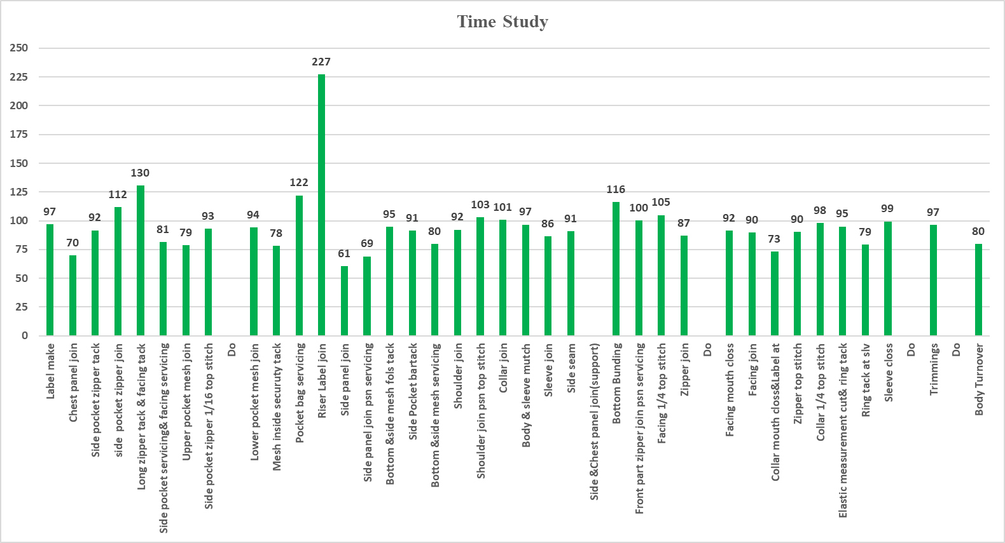

Figure 2.5: Time study bar chart of unbalanced line

The required hourly production target is 75pcs. So, from the above figure we can determine that 2, 14, 15, 33 are the process where bottleneck occurred because the capacity of these process is below 75.

2.4 Solution of Problem 02: Proposed solution to utilize manpower and remove the bottleneck
- Share tasks among workers so that those with extra capacity can help those who are overloaded.
- In the U-shaped sewing line, workers facing each other on the same machine can easily share work to meet the required capacity.
- Replace the worker in the bottleneck area with an expert worker to improve efficiency.
- Change the machine layout to optimize workflow and reduce bottlenecks.
- Assign an additional worker to the bottleneck area to help alleviate congestion.

Following the solution techniques, we tried to solve the bottleneck and improve the capacity (Calculations are shown in Figure 2.6) -
- Merging Processes for Improved Capacity: The chest panel join (Process-2) and pocket bag servicing (Process-12) can be merged to improve the capacity of Process-2. While this may slightly reduce the capacity of Process-1, the overall capacity will still remain above our target of 75 pcs/hr. Assuming that, in the U-shaped layout, these two processes will be positioned opposite each other.
- Combining Processes for Efficiency: The riser label join (Process-13) and side panel join (Process-14) can be combined to enhance the capacity of Process-14. Since Process-13 has a capacity of 227 pcs/hr, which is more than sufficient, the worker handling this process can share their workload with the worker performing the side panel join. This will help increasing the capacity of Process-14 to over 75 pieces per hour.
- Adding an Additional Worker: To achieve the desired target for Process-14, an additional worker has been assigned to the line. This will help to meet the production goals.
- Optimizing Worker Allocation: Process-33 currently has a capacity of 73 pieces per hour, slightly below the desired target. By replacing the current worker with an expert, we can achieve the target capacity. The current worker can then be reassigned to a different workstation where their skills can be better utilized.

Knit Asia Limited (unit2)
Buyer: |  | Decathlon |  |  | Office :117/A Tejgaon Industrial Area. Dhaka. |  |  |  |  |  |  |  | Line | : 17
Style : 350567 |  |  |  |  |  | Time Study Chart |  |  |  |  |  |  | SMV | : 23.20
Item : Jacket |  |  |  |  |  |  |  |  |  |  |  |  | OP/HP | : 38+4
Size | : L |  |  |  |  |  |  |  |  |  |  |  | Target | : 75
SL No | Workers Name |  | ID NO: | Process Name | M/C | Quantiy (pcs) | Total Time(Sec) | Avg. Time | Rating% | Normal Time | All: % | SSV | SMV | Capacity | TTL CPTY
1 | Lipi |  |  | Label make | LS | 10 | 315 | 31.5 | 100% | 31.5 | 18% | 37.17 | 0.62 | 97 | 97
2 | Rabbi |  |  | Chest panel join and pocket bag servicing | OL | 8 | 304 | 38.0 | 100% | 38.0 | 18% | 44.84 | 0.75 | 80 | 80
3 | Munni |  |  | Side pocket zipper tack | LS | 7 | 233 | 33.3 | 100% | 33.3 | 18% | 39.28 | 0.65 | 92 | 92
4 | Sathi |  |  | side pocket zipper join | LS | 7 | 196 | 28.0 | 100% | 28.0 | 15% | 32.20 | 0.54 | 112 | 112
5 | Jesmin |  |  | Long zipper tack & facing tack | LS | 11 | 271 | 24.6 | 100% | 24.6 | 12% | 27.59 | 0.46 | 130 | 130
6 | Afroja |  |  | Side pocket servicing& facing servicing | OL | 11 | 412 | 37.5 | 100% | 37.5 | 18% | 44.20 | 0.74 | 81 | 81
7 | Kali |  |  | Upper pocket mesh join | LS | 7 | 272 | 38.9 | 100% | 38.9 | 18% | 45.85 | 0.76 | 79 | 79
8 | Bithi |  |  | Side pocket zipper 1/16 top stitch | LS | 7 | 457 | 65.3 | 100% | 65.3 | 18% | 77.04 | 1.28 | 47 | 93
9 | Sharmin |  |  | Do | LS | 7 | 462 | 66.0 | 100% | 66.0 | 18% | 77.88 | 1.30 | 46 | 93
10 | Nur nahar |  |  | Lower pocket mesh join | LS | 11 | 356 | 32.4 | 100% | 32.4 | 18% | 38.19 | 0.64 | 94 | 94
11 | Rupali |  |  | Mesh inside security tack | LS | 7 | 273 | 39.0 | 100% | 39.0 | 18% | 46.02 | 0.77 | 78 | 78
12 | Sobi rani |  |  | Chest panel join and pocket bag servicing | OL | 9 | 285 | 31.7 | 100% | 31.7 | 15% | 36.42 | 0.61 | 99 | 99
13 | Romana |  |  | Riser Label join and side panel join | LS | 9 | 328 | 36.4 | 100% | 36.4 | 15% | 41.91 | 0.70 | 86 | 167
14 | Rubina |  |  | Riser Label join and side panel join | LS | 9 | 339 | 37.7 | 100% | 37.7 | 18% | 44.45 | 0.74 | 81 | 167
15 | X |  |  | Side panel join servicing | OL | 9 | 395 | 43.9 | 100% | 43.9 | 18% | 51.79 | 0.86 | 70 | 139
16 | Aklima |  |  | Side panel join servicing | OL | 9 | 398 | 44.2 | 100% | 44.2 | 18% | 52.18 | 0.87 | 69 | 139
17 | Sultana |  |  | Bottom &side mesh folds tack | LS | 9 | 305 | 33.9 | 100% | 33.9 | 12% | 37.96 | 0.63 | 95 | 95
18 | Rashida |  |  | Side Pocket bar tack | BT | 9 | 301 | 33.4 | 100% | 33.4 | 18% | 39.46 | 0.66 | 91 | 91
19 | Mizanur |  |  | Bottom &side mesh servicing | OL | 5 | 191 | 38.2 | 100% | 38.2 | 18% | 45.08 | 0.75 | 80 | 80
20 | Asadul |  |  | Shoulder join | OL | 6 | 209 | 34.8 | 100% | 34.8 | 12% | 39.01 | 0.65 | 92 | 92
21 | Mala |  |  | Shoulder join pin top stitch | LS | 6 | 178 | 29.7 | 100% | 29.7 | 18% | 35.01 | 0.58 | 103 | 103
22 | Meher Ali |  |  | Collar join | OL | 6 | 182 | 30.3 | 100% | 30.3 | 18% | 35.79 | 0.60 | 101 | 101
23 | Shamima |  |  | Body & sleeve match | HP | 5 | 162 | 32.4 | 100% | 32.4 | 15% | 37.26 | 0.62 | 97 | 97
24 | Marjiya |  |  | Sleeve join | OL | 6 | 212 | 35.3 | 100% | 35.3 | 18% | 41.69 | 0.69 | 86 | 86
25 | Kohinur |  |  | Side seam | OL | 5 | 342 | 68.4 | 100% | 68.4 | 18% | 80.71 | 1.35 | 45 | 91
26 | Monisha |  |  | Side &Chest panel join(support) | OL | 11 | 726 | 66.0 | 100% | 66.0 | 18% | 77.88 | 1.30 | 46 | 91
27 | All Amin |  |  | Bottom Bunding | FL | 10 | 262 | 26.2 | 100% | 26.2 | 18% | 30.92 | 0.52 | 116 | 116
28 | Kaiyum |  |  | Front part zipper join pin servicing | LS | 10 | 312 | 31.2 | 100% | 31.2 | 15% | 35.88 | 0.60 | 100 | 100
29 | Bilkis |  |  | Facing 1/4 top stitch | LS | 6 | 179 | 29.8 | 100% | 29.8 | 15% | 34.31 | 0.57 | 105 | 105
30 | Shimu |  |  | Zipper join | LS | 5 | 354 | 70.8 | 100% | 70.8 | 18% | 83.54 | 1.39 | 43 | 87
31 | Rohima |  |  | Do | LS | 5 | 348 | 69.6 | 100% | 69.6 | 18% | 82.13 | 1.37 | 44 | 87
32 | Jui |  |  | Facing mouth close | LS | 5 | 171 | 34.2 | 100% | 34.2 | 15% | 39.33 | 0.66 | 92 | 92
33 | Kajoli |  |  | Facing join | LS | 5 | 179 | 35.8 | 100% | 35.8 | 12% | 40.10 | 0.67 | 90 | 90
34 | Y |  |  | Collar mouth close & Label | LS | 5 | 195 | 39.0 | 100% | 39.0 | 18% | 46.02 | 0.77 | 78 | 78
35 | Ruma |  |  | Zipper top stitch | LS | 5 | 178 | 35.6 | 100% | 35.6 | 12% | 39.87 | 0.66 | 90 | 90
36 | Julekha |  |  | Collar 1/4 top stitch | LS | 6 | 192 | 32.0 | 100% | 32.0 | 15% | 36.80 | 0.61 | 98 | 98
37 | Rani |  |  | Elastic measurement cut& ring tack | LS | 10 | 321 | 32.1 | 100% | 32.1 | 18% | 37.88 | 0.63 | 95 | 95
38 | Umme Hani |  |  | Ring tack at sly | LS | 5 | 201 | 40.2 | 100% | 40.2 | 13% | 45.43 | 0.76 | 79 | 79
39 | Jahanara |  |  | Sleeve close | LS | 5 | 302 | 60.4 | 100% | 60.4 | 18% | 71.27 | 1.19 | 51 | 99
40 | Renu |  |  | Do | LS | 5 | 312 | 62.4 | 100% | 62.4 | 18% | 73.63 | 1.23 | 49 | 99
41 | Laboni |  |  | Trimmings | HP | 5 | 332 | 66.4 | 100% | 66.4 | 13% | 75.03 | 1.25 | 48 | 97
42 | Mosleme |  |  | Do | HP | 5 | 328 | 65.6 | 100% | 65.6 | 13% | 74.13 | 1.24 | 49 | 97
43 | Ruma |  |  | Body Turnover | HP | 5 | 201 | 40.2 | 100% | 40.2 | 12% | 45.02 | 0.75 | 80 | 80
. |  |  |  |  |  |  |  |  |  |  |  |  | 35.59

Maximum capacity | 167
Minimum capacity | 78
Figure 2.6: Time study chart of proposed line
Figure 2.7 shows the time study bar chart for balanced line-
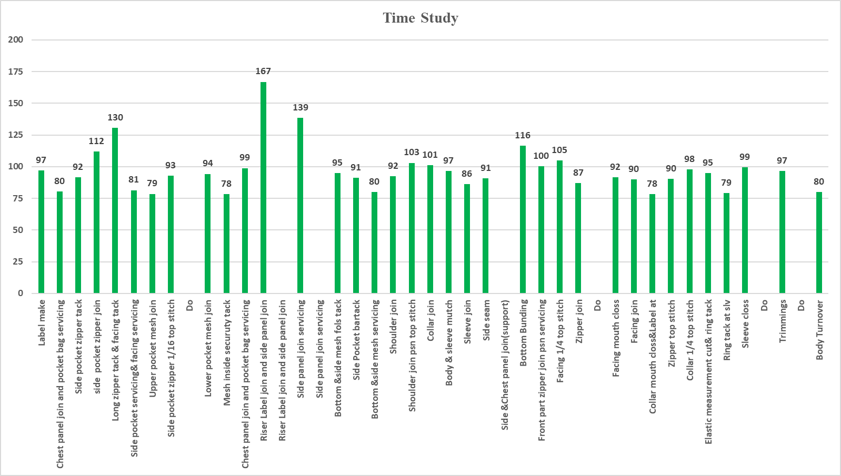

Figure 2.7: Updated time study bar chart for balanced line

From Figure 2.7, it's evident that there is no bottleneck, as every process can produce more than 75 pieces per hour. For simplicity, we have assumed specific values from the time study in the balanced line. By implementing the suggested methods, we can balance the line using the current workforce, thereby enhancing productivity.

2.5 Problem Statement 03: Inefficient Layout of the Washing and Dyeing Shop at Knit Asia Ltd. (Plant No. 1)
The washing and dyeing shop in Plant No. 1 of Knit Asia Ltd. has been identified as having layout inefficiencies that negatively impact productivity and increase operational costs. The shop is equipped with 14 washing machines, 5 deep dyeing machines, and 14 drying machines. The layout and arrangement of these machines present several critical issues, detailed below:
- Proximity of Deep Dyeing Machines to Washing Machines: The deep dyeing machines are placed near the washing machines. While this arrangement may maximize floor space, it creates significant operational challenges. The tight spacing leads to congestion, making it difficult for operators to move efficiently between machines, resulting in delays during the loading and unloading of materials. This constrained space also complicates maintenance and repair efforts, increasing downtime and reducing overall productivity. Furthermore, the proximity of the dyeing and washing machines raises a critical risk: chemicals from the dyeing process may inadvertently mix with those used in the washing machines. This cross-contamination could result in the staining of fabrics, leading to product defects and increased rework or rejection rates.
- High Material Handling Costs: The current layout results in large distances between the washing and drying areas. This configuration leads to inefficient material flow, as operators are required to transport materials over extended distances between processes. These long travel distances contribute to higher material handling costs, as more time, labor, and equipment are needed to move materials throughout the shop. For example, once fabrics are washed, they must be transported over a significant distance to the drying machines, adding to the overall lead time of each batch. The increased handling not only slows down production but also heightens the risk of fabric damage, which can further escalate costs. Additionally, this inefficient workflow creates bottlenecks, reducing the overall throughput of the shop.
These combined challenges—congestion due to close machine placement, the risk of chemical contamination, and high material handling costs—diminish the operational efficiency of the washing and dyeing shop. Addressing these issues is crucial to improving productivity, reducing costs, and ensuring the quality of the final product.
2.5.1 Current Layout: The current layout of the washing and dyeing shop is shown below in Figure 2.8.

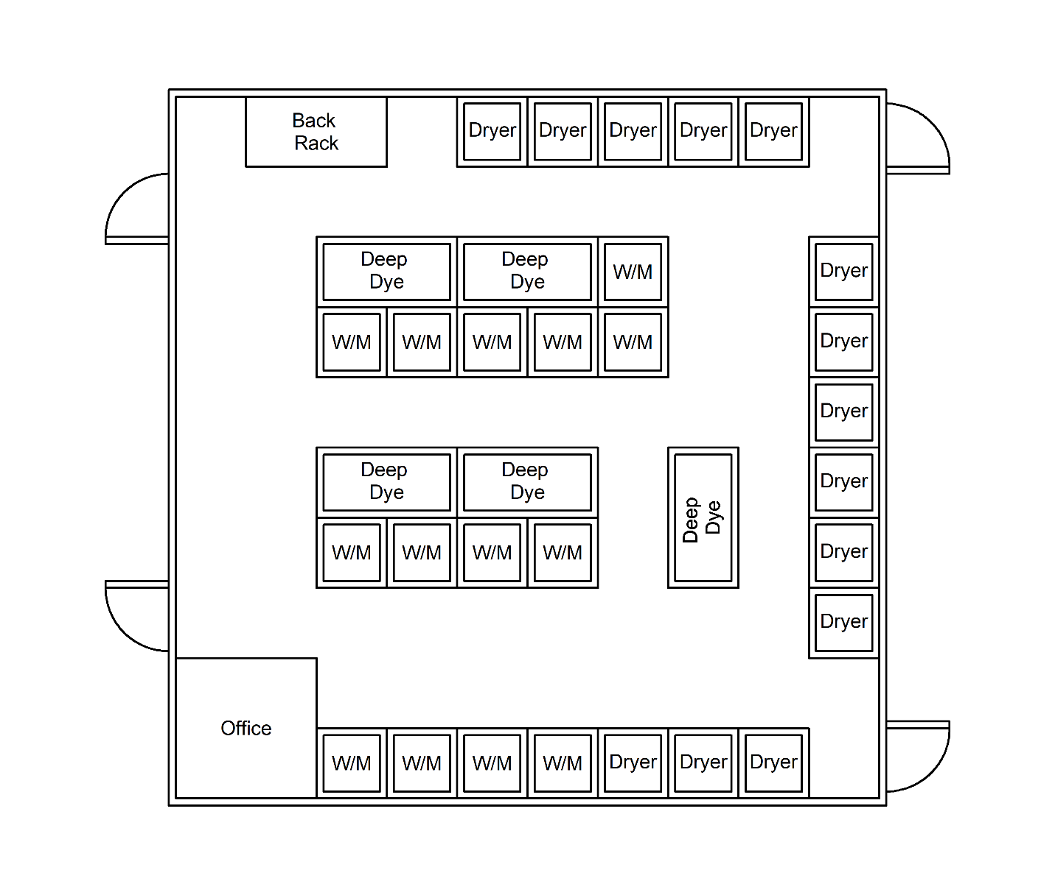Figure 2.8: Current Layout of the Washing and Dyeing Shop

Average distance from Deep Dyeing to Washing is found to be 36.42 meter, and the average distance from Washing to Drying is 61.24 meter.

2.5.2 Current Layout Challenges:
- Deep Dyeing Machine Proximity: In the current layout, the deep dyeing machines are positioned close to the washing machines. This proximity leads to several issues:
- Heat Transfer: The heat from the deep dyeing machines can affect the washing process, leading to inconsistent washing results.
- Space Congestion: The tight spacing between the machines limits movement and complicates maintenance, increasing downtime and reducing overall efficiency.
- Water Pollution: Chemicals from the dyeing machines may mix with those in the washing machines, leading to potential staining of the clothes.
- Material Handling: The overall material handling cost is high due to the large distances between the washing and drying areas.

2.6 Solution of Problem 03: Proposed Layout of the Washing and Dyeing Shop at Knit Asia Ltd. (Plant No. 1)
Proposed layout of the washing and dyeing shop in shown below in Figure 2.9 -
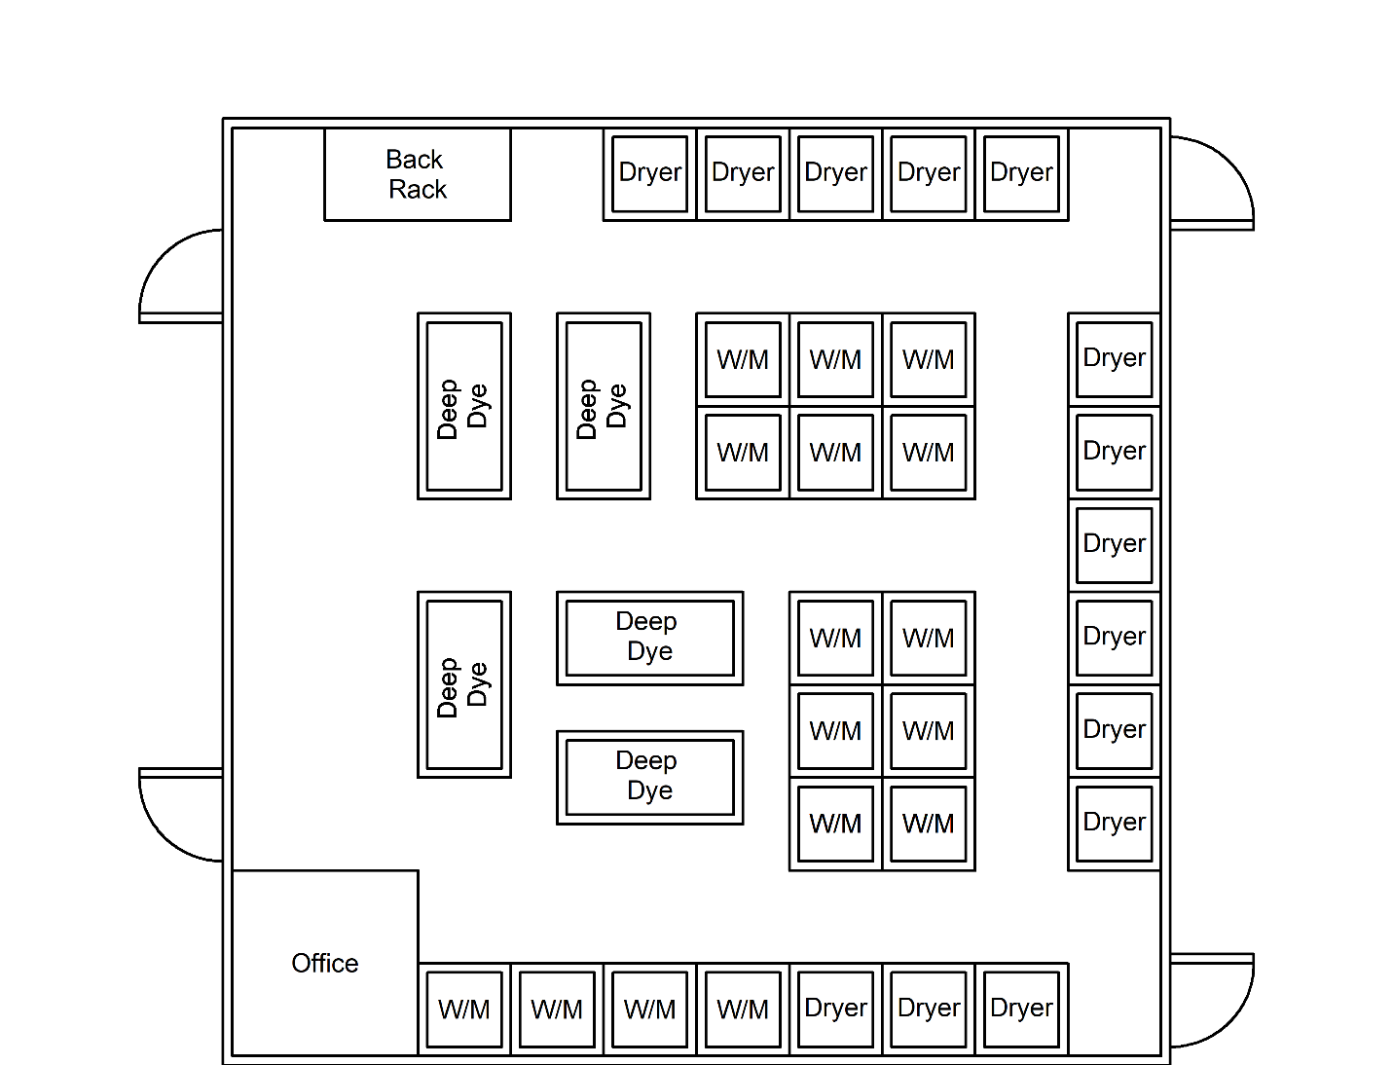
Figure 2.9: Proposed layout of the Washing and Dyeing Shop

In this proposed layout, the average distance from Deep Dyeing to Washing has now been determined to be 41.94 meter, and the average distance from Washing to Drying would be 51.29 meter.
2.6.1 Proposed Layout Features
- Improved Spacing: The proposed layout maintains a minimum distance of 0.5 meters between the deep dyeing and washing machines. This spacing reduces heat transfer issues, improves safety, and allows for easier maintenance.
- Line/Process Layout: The proposed layout follows a line or process layout, where:
- Most of the deep dyeing machines are positioned at the beginning of the production line.
  - Washing machines are centrally located in the middle.
  - Drying machines are placed at the end of the line.
- Flow Efficiency: This arrangement ensures a smoother and more logical flow of materials through the production process, reducing bottlenecks and improving overall efficiency.

2.6.2 Matlab Code
We have calculated the average distance from Deep Dyeing to Washing and average distance from Washing to Drying using Matlab. The codes are listed below.
- For Current Layout:
% Coordinates for each machine type
deep_dyeing = [30,25; 50,25; 30,55; 50,55; 75,60];
washing = [25,95; 35,95; 45,95; 55,95; 25,65; 35,65; 45,65; 55,65; ...
25,35; 35,35; 45,35; 55,35; 65,35; 65,25];
drying = [45,5; 55,5; 65,5; 75,5; 85,5; 95,25; 95,35; 95,45; 95,55; ...
95,65; 95,75];

% Calculate average distance from Deep Dyeing to Washing
total_dist_dyeing_to_washing = 0;
num_distances_dyeing_to_washing = 0;

for i = 1:size(deep_dyeing, 1)
for j = 1:size(washing, 1)
dist = sqrt((deep_dyeing(i, 1) - washing(j, 1))^2 + (deep_dyeing(i, 2) - washing(j, 2))^2);
total_dist_dyeing_to_washing = total_dist_dyeing_to_washing + dist;
num_distances_dyeing_to_washing = num_distances_dyeing_to_washing + 1;
end
end

avg_dist_dyeing_to_washing = total_dist_dyeing_to_washing / num_distances_dyeing_to_washing;

% Calculate average distance from Washing to Drying
total_dist_washing_to_drying = 0;
num_distances_washing_to_drying = 0;
for i = 1:size(washing, 1)
for j = 1:size(drying, 1)
dist = sqrt((washing(i, 1) - drying(j, 1))^2 + (washing(i, 2) - drying(j, 2))^2);
total_dist_washing_to_drying = total_dist_washing_to_drying + dist;
num_distances_washing_to_drying = num_distances_washing_to_drying + 1;
end
end

avg_dist_washing_to_drying = total_dist_washing_to_drying / num_distances_washing_to_drying;

% Display results
fprintf('Average distance from Deep Dyeing to Washing: %.2f units\n', avg_dist_dyeing_to_washing);
fprintf('Average distance from Washing to Drying: %.2f units\n', avg_dist_washing_to_drying);

- For Proposed Layout
% Coordinates for each machine type
deep_dyeing = [25,30; 25,60; 45,55; 45,65; 40,30];
washing = [55,25; 65,25; 75,25; 55,35; 65,35; 75,35; 25,95; 35,95; 45,95; ...
55,95; 65,55; 65,65; 65,75; 75,55; 75,65; 75,75];
drying = [45,5; 55,5; 65,5; 75,5; 85,5; 95,25; 95,35; 95,45; 95,55; ...
95,65; 95,75];

% Calculate average distance from Deep Dyeing to Washing
total_dist_dyeing_to_washing = 0;
num_distances_dyeing_to_washing = 0;

for i = 1:size(deep_dyeing, 1)
for j = 1:size(washing, 1)
dist = sqrt((deep_dyeing(i, 1) - washing(j, 1))^2 + (deep_dyeing(i, 2) - washing(j, 2))^2);
total_dist_dyeing_to_washing = total_dist_dyeing_to_washing + dist;
num_distances_dyeing_to_washing = num_distances_dyeing_to_washing + 1;
end
end
avg_dist_dyeing_to_washing = total_dist_dyeing_to_washing / num_distances_dyeing_to_washing;

% Calculate average distance from Washing to Drying
total_dist_washing_to_drying = 0;
num_distances_washing_to_drying = 0;
for i = 1:size(washing, 1)
for j = 1:size(drying, 1)
dist = sqrt((washing(i, 1) - drying(j, 1))^2 + (washing(i, 2) - drying(j, 2))^2);
total_dist_washing_to_drying = total_dist_washing_to_drying + dist;
num_distances_washing_to_drying = num_distances_washing_to_drying + 1;
end
end

avg_dist_washing_to_drying = total_dist_washing_to_drying / num_distances_washing_to_drying;
% Display results
fprintf('Average distance from Deep Dyeing to Washing: %.2f units\n', avg_dist_dyeing_to_washing);
fprintf('Average distance from Washing to Drying: %.2f units\n', avg_dist_washing_to_drying);

    - Data collection:
Information, calculations and findings regarding the layouts (Current and Improved) have been shown below:
- Processes & Flow:
- Process Flow: Deep Dyeing (optional) → Washing → Drying.
Distances Between Processes (Current):
Deep Dyeing to Washing: 36.42 meters.
Washing to Drying: 61.24 meters
- Material Handling & Costs (Current):
- Average Fabric batch weight: 200 kg
- Average Number of batches per day: 10
- Average Handling cost: $0.02 per kg per meter
- Number of Machines:
- 14 Washing Machines
- 5 Deep Dyeing Machines
- 14 Drying Machines
- Material Handling Cost (per batch - Current):
C_batch current = Σ (D_i × W_i × R_i) (Tompkins, 2010)
C_batch current = [(36.42 × 200 × 0.02) + (61.24 × 200 × 0.02)]
C_batch current = (145.68 + 244.96) = 390.64 dollars per batch
- Total Daily Material Handling Cost (Current):
- C_total current = C_batch current × number of batches = 3906.4 dollars per day

- Proposed Layout Optimization:
Distances Between Processes (Proposed):
Deep Dyeing to Washing: 41.94 meters.
Washing to Drying: 51.29 meters
New Material Handling Cost (per batch - Proposed):
- C_batch proposed = Σ (D_i × W_i × R_i) (Tompkins, 2010)
- C_batch proposed = [(41.94 × 200 × 0.02) + (51.29 × 200 × 0.02)]
- C_batch proposed = (167.76 + 205.16) = 372.92 dollars per batch
New Total Daily Material Handling Cost (Proposed):
- C_total proposed = C_batch proposed × number of batches = 3729.2 dollars per day
- Savings and Analysis:
Material Handling Cost Savings per Day:
3906.4 - 3729.2 = 177.2 dollars per day
Percentage Savings: (177.2/3906.4) ×100 = 4.54%
The proposed layout addresses key challenges of the current setup by maintaining appropriate distances between machines, reducing material handling costs, and workflow efficiency. The implementation of a line/process layout enhances the logical progression of the production process, which reduces bottlenecks and enhances overall productivity. The changes lead to a 4.54% reduction in material handling costs, contributing to operational savings while maintaining production efficiency.

2.7 Problem Statement 04: Identification and Analysis of Defects in Finished Products Leading to Quality Control Challenges
On the production floor, numerous defects occur daily, resulting in significant costs in both time and money for the organization. To improve output rates, it's crucial to analyze these defects and develop strategies to minimize them as much as possible. At first, we performed a Pareto analysis to classify these defects into the Vital Few and Trivial Many. The following data represents the defects frequency and their percentage value-

Table 2.1: Different types of defects and their frequencies
Defects type | No. of defects | Percentage | Cumulative Percentage
Skipped Stitches | 112 | 18% | 18%
Excess Threads | 95 | 15% | 32%
Loose Stitches | 79 | 12% | 45%
Incorrect Dimensions | 55 | 9% | 54%
Unravelled Stitches | 48 | 8% | 61%
Open Seams | 41 | 6% | 68%
Unfinished Hems | 39 | 6% | 74%
Stains or Spots | 34 | 5% | 79%
Puckering | 30 | 5% | 84%
Uneven Seams | 28 | 4% | 88%
Inconsistent Sizing | 22 | 3% | 92%
Shade Variation | 18 | 3% | 94%
Incorrect Label Placement | 13 | 2% | 96%
Fabric Snags | 9 | 1% | 98%
Colour Fading | 6 | 1% | 99%
Holes or Tears | 4 | 1% | 99%
Zipper Malfunctions | 2 | 0% | 100%
Misprints | 2 | 0% | 100%

Figure 2.10 represents the Pareto Chart for the defects-

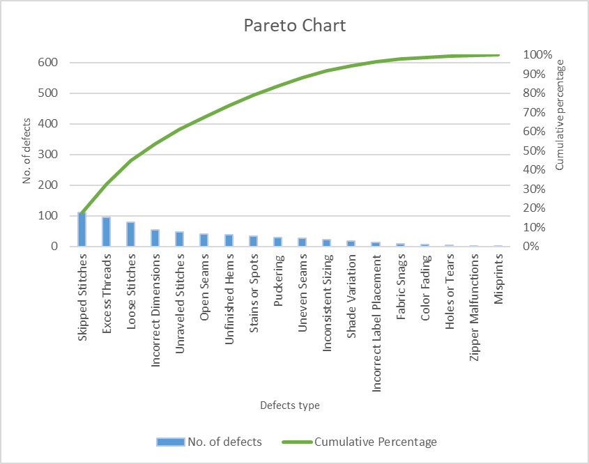
Figure 2.10: Pareto Chart for the defects

From the pareto chart, it is evident that the top three Vital Few sewing defects are as follows-
- Skipped Stitches
- Excess Threads
- Loose Stitches
To determine the root causes for the defects that we observed, we first used a fishbone diagram, also called an Ishikawa diagram. By using this tool, one is able to categorize potential causes of defects in terms of material, method, machine, man, and environment. By gathering input from the production team, we were able to brainstorm and map out all possible root causes for each type of defect observed. This visual representation helped us to not only pinpoint specific areas where improvements were needed but also to understand how different factors might be interrelated.

2.8 Solution of Problem 04: Identification and Analysis of top three “Vital few” Defects in Finished Products Leading to Quality Control Challenges using Fishbone Diagram

- Skipped Stitches: Figure 2.11 shows an example of skipped stitches-
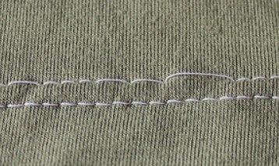

Figure 2.11: Skipped Stitches

A fishbone diagram in Figure 2.12 is shown to identify potential causes of the defect (skipped stitch)-
Skipped Stiches
Measurements
Material
Environment
Men
Machine
Method
Inadequate Training
Bent Needles
Lack of focus
Incorrect Fabric Alignment
Improper Threading
Wrong Machine Settings

Malfunction of sewing machine
Fabric Layer Misalignment
Skipping quality checks
Wrong Stitch type
Incompatibility
Incorrect fabric thickness
Poor Quality Thread
Uncomfortable working conditions
Noise or Vibration
Poor Lighting
Needle Positioning error
Figure 2.12: Fishbone Diagram for Skipped Stitches

Figure 1: Fishbone Diagram for Skipped Stitches
Men:
- Inadequate training leading to improper handling of the sewing machine.
- Operator fatigue or lack of focus during stitching.
- Failure to correctly align the fabric before sewing.
Machine:
- Worn-out or bent needles causing missed stitches.
- Poor maintenance of sewing machines leads to malfunction.
- Incorrect machine settings, such as stitch length and tension.
Method:
- Incorrect sewing techniques, like improper threading.
- Skipping quality checks during the stitching process.
- Using the wrong stitch type for the fabric being used.
Measurements:
- Misalignment of fabric layers leading to uneven stitches.
- Errors in setting needle positions or feed rates.
Material:
- Fabric too thick or too thin for the selected needle and stitch type.
- Incompatibility between fabric and thread type.
- Use of poor-quality thread that doesn’t work well with the machine.
Environment:
- Poor lighting causes difficulty in seeing stitches.
- Excessive vibration or noise in the environment leading to operator error.
- Uncomfortable working conditions leading to operator mistakes.

2.8.1 Probable Solution Approaches:
The following solution approaches were guided by the principles mentioned by (Ishikawa, 1986)-
- Implement regular training sessions to improve operator skills, focusing on proper machine handling, threading techniques, and attention to detail.
- Develop a regular maintenance schedule to inspect and repair machines, ensuring that all components (such as needles and tension settings) are functioning correctly.
- Provide clear guidelines and standard operating procedures (SOPs) for setting machine parameters, including stitch length, tension, and needle type, based on fabric types.
- Introduce jigs or guides to help operators align fabric layers accurately before sewing. Additionally, provide training on proper fabric placement techniques.
- Use high-quality threads that are suitable for the fabric type. Ensure threads are compatible with the sewing machine and the material being sewn to prevent skipped stitches.

- Excess Threads: Figure 2.13 shows an example of excess threads-

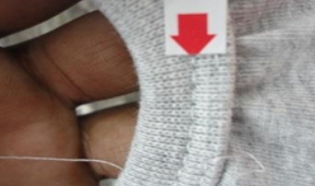
Figure 2.13: Excess Threads

A fishbone diagram in Figure 2.14 is shown to identify potential causes of the defect (excess threads)-
Figure 2.14: Fishbone Diagram for Excess Threads
Excess Threads
Measurements
Material
Environment
Men
Machine
Method
Inadequate Training
Faulty Thread Trimmer
Negligence in Trimming
Improper Inspection
Wrong Machine Settings

Worn-out Blades
Inaccurate Thread Length Estimation
Skipping trimming steps
Wrong Thread Securing Techniques
Fabric-Thread Mismatch
Incompatible Thread Material
Poor Quality Thread
Static Electricity
Poor Lighting
Misalignment During Trimming

Men:
- Lack of Proper Training: Operators may not be trained to handle excess threads effectively during sewing or finishing.
- Negligence in Trimming: Operators may neglect to trim threads properly after stitching due to haste or inattention.
- Improper Inspection: Workers fail to identify or address excess threads during quality checks.
Machine:
- Faulty Thread Trimmers: Automatic thread trimmers in the machine may be malfunctioning or improperly set, leading to excess threads.
- Incorrect Machine Settings: Machine settings such as thread tension or trimming length are incorrectly configured.
- Worn-Out Blades: The blades on the machine’s thread trimmer may be dull or damaged, failing to cut threads cleanly.
Method:
- Skipping Trimming Steps: Trimming steps are skipped due to poor process management or time constraints.
- Improper Thread Securing Techniques: Incorrect methods are used to secure thread ends, causing them to unravel and become excess.
Measurements:
- Inaccurate Thread Length Estimation: Misjudgment of the correct thread length required, leading to excessive leftover threads.
- Misalignment During Trimming: Threads may not be properly aligned for trimming, leading to uneven or excess threads left behind.

Material:
- Incompatible Thread Material: Using threads that are prone to fraying or are too thick for the fabric, resulting in excess.
- Poor Thread Quality: Low-quality threads may break or fray, leading to excess threads that need trimming.
- Fabric-Thread Mismatch: The fabric type may cause threads to shift or bunch up, leading to visible excess.
Environment:
- Static Electricity: High static conditions can cause threads to stick out or cling, creating the appearance of excess.
- Poor Lighting Conditions: Poor lighting may cause operators to overlook excess threads during the trimming and inspection process.

2.8.2 Probable Solution Approaches:
The following solution approaches were guided by the principles mentioned by (Ishikawa, 1986)-
- Provide training programs focused on thread management techniques, including correct trimming methods and securing thread ends effectively.
- Regularly inspect and maintain thread trimmers, replacing dull or damaged blades promptly to ensure efficient cutting of excess threads.
- Standardize the trimming process within the sewing workflow, ensuring it is consistently applied. Introduce checks to ensure threads are trimmed before moving to the next stage.
- Use thread length guides or measuring tools to help operators accurately estimate the correct thread length required for each stitch.
- Select threads that match the fabric type and use threads that are less prone to fraying or breakage. Conduct compatibility tests before bulk production.

- Loose Stitches: Figure 2.15 shows an example of excess threads-
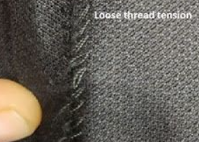
Figure2.15: Loose Stitches

A fishbone diagram in Figure 2.16 is shown to identify potential causes of the defect (skipped stitch)-
Figure 2.16: Fishbone Diagram for Loose Stitches
Loose Stitches
Measurements
Material
Environment
Men
Machine
Method
Lack of Training
Threading Issues
Inattentiveness
Fatigue
Incorrect Stitching Technique
Worn-Out Machine
Incorrect Machine Calibration
Inconsistent Measurement Tools
Inconsistent Stitch Length
Improper Machine Settings
Inappropriate Needle Size
Inconsistent Fabric Tension
Low-Quality Thread
Temperature and Humidity

Dust or Debris
Poor Lighting
Inaccurate Quality Checks
Men:
- Workers are not properly trained in handling the machines or techniques.
- Operator negligence or lack of focus during stitching.
- Operator tiredness leads to mistakes.
Machine:
- Old or poorly maintained sewing machines.
- Machines not calibrated correctly, leading to uneven stitching.
- Improper threading of the machine caused tension problems.
Method:
- Poor sewing techniques or not following standard operating procedures.
- Tension settings on the sewing machine were not adjusted properly.
- Uneven stitch length due to improper machine calibration.
Measurements:
- Lack of rigorous inspection processes.
- Use of faulty or inconsistent tools for measuring stitches.
Material:
- Weak or poor-quality thread that breaks easily.
- Fabric that has varying tension could lead to lose stitches.
- Using the wrong size needle for the fabric.
Environment:
- Inadequate lighting could result in errors.
- Accumulation of dust or lint affects machine performance.
- Extreme environmental conditions affecting the material or machine performance.

2.8.3 Probable Solution Approaches:
The following solution approaches were guided by the principles mentioned by (Ishikawa, 1986)-
- Regularly calibrate and adjust machine tension settings based on the type of thread and fabric being used. Provide training on recognizing and adjusting tension issues.
- Create clear visual guides and training materials for correct machine threading procedures. Ensure regular audits to check for proper threading.
- Use stabilizers or interfacing for stretchy or slippery fabrics. Adjust machine settings, such as using a walking foot, to handle difficult fabrics effectively.
- Maintain a controlled environment with optimal humidity levels in the sewing area to prevent thread from expanding or contracting, which can affect stitch quality.

2.9 Problem Statement 05: Ergonomic Deficiencies in Existing Seating for the workers in Knit Asia Ltd.
The comfort and safety of workers are essential for maintaining productivity. We did a survey to find out about workers’ safety and facilities, and from that survey we came to know that many workers in the sewing line experience back pain and other discomforts, which seem to be linked to sitting for long hours in the existing chairs. Workers spend extended hours on the sewing line, often using chairs that are not ergonomically designed. These chairs and sitting postures have long term effects of health issues and this can lead to less productivity and fatigue.
Here are several issues that the workers face due to the design of the chair:
- Chairs are not ergonomically perfect for prolonged siting. These chairs have hard seat cushions that lead to discomfort after prolonged usage. Poor cushioning can result in pressure points and pain in the lower back and buttocks.
- These Chairs do not conform to the natural curve of the spine, which can lead to musculoskeletal disorders such as lower back pain. Studies have shown that chairs lacking lumbar support contribute significantly to these problems by increasing spinal disc pressure and muscle fatigue, particularly in the lower back region.
- The chairs are fixed, which does not allow for varying statures of workers. As a result, the workers may have improper sitting posture, and this leads to strain on the neck and shoulders.
- The rigid structure of the chairs does not allow for easy movement or adjustment, so it can be restrictive and lead to discomfort.
- Static loading of the back muscles due to poor seat design is a cause of early onset fatigue, reduced circulation, and decreased oxygenation of muscle tissues. Over time, this leads to chronic pain and even permanent damage to the spine and related structures.
- This design of chair creates postural fixity to the workers for a long time, which promotes static loading of the back and shoulder muscles.
Therefore, to address these issues and ensure workers’ health, we must suggest a design of chair by providing better ergonomic support. Moreover, it is necessary to ensure that the chairs follow the general principles of seat design to provide for ergonomic support.

2.10 Solution of problem 05: Ergonomic Considerations for Proposed Seat Design
To minimize the issues concerning the workers’ health due to improper design of the chairs, we came up with a design of the chair which follows the general principles of seat design to ensure ergonomic support. Here is our proposed design shown in Figure 2.17:
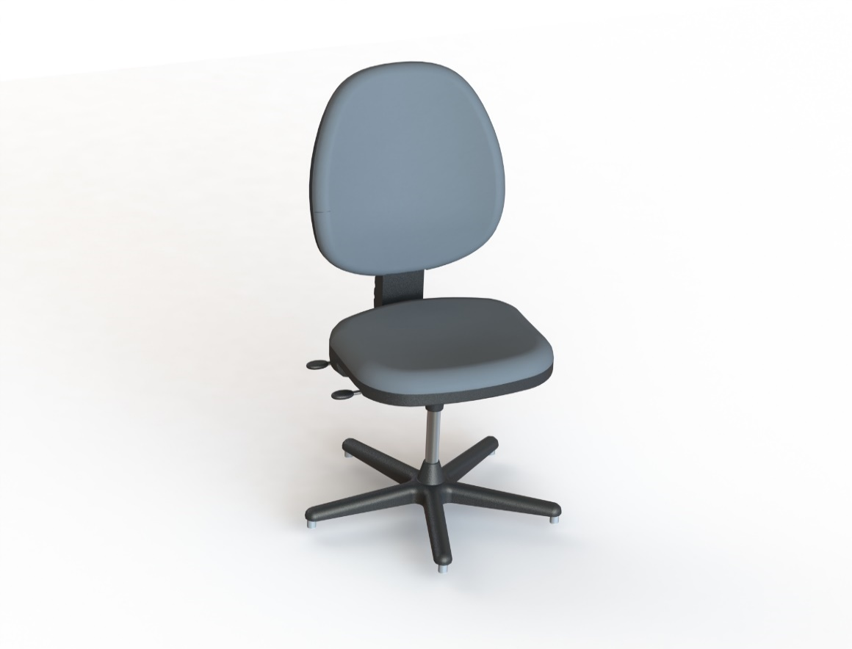

Figure 2.17: Proposed ergonomic design of chair for sewing line workers
We designed the chair using SolidWorks software and tried to ensure the design provides proper ergonomic value. Some features of our designed chair design that align with general principles of seat design (McCormick, 1993) is described below-
- Promote Lumbar Lordosis
- The backrest has been developed in a manner that adaptation to the curvature of the spine, especially the lower back. This helps to create natural lumbar lordosis which helps in preventing lower back pain and allows proper alignment of spine when a person sits for long time. Moreover, we can add additional lumber support with the backrest if needed.

- Minimize Disc Pressure
- The sitting surface part of the seat cushion has a purpose to evenly spread the body weight to reduce pressure exerted on the intervertebral discs. This helps in minimizing the effects of discomfort and other spinal complications which have occurred by long sitting.
- Minimize Static Loading of the Back Muscles
- The backrest provides adequate support to the back muscles, reducing the need for these muscles to work continuously to maintain posture. This minimizes static loading and fatigue in the back muscles, especially during long work hours.
- Reduce Postural Fixity
- The chair’s swivel base allow workers to move freely without having to leave their seat. This minimizes postural fixity because it would be easier to change the sitting positions.
- Provide for Easy Adjustability
- The chair can be easily adjusted in height, allowing each worker to customize the chair to their individual needs, ensuring proper posture and reducing strain.
By ensuring the above measures, we can hope to overcome the issues, and the workers will be benefitted. Though implementing this design needs investments, it will improve worker health and comfort, which will eventually enhance productivity and job satisfaction, ultimately benefiting the organization.

Chapter 3: Discussion
3.1 Improving Air Distribution and Ventilation:
- Reposition ceiling fans and air coolers to enhance airflow distribution, particularly towards packaging areas.
- Install additional ceiling fans in key locations to improve worker comfort.
- Optimize the number and capacity of exhaust fans and ensure regular maintenance of all ventilation equipment.
3.2 Addressing Bottlenecks in Production:
- Share tasks among workers to balance workloads and improve capacity.
- Reassign expert workers to bottleneck areas for higher efficiency.
- Adjust machine layouts to streamline workflow and alleviate congestion.
- Combine or merge processes where possible to improve capacity and efficiency.
- Add additional workers in critical areas to meet production targets.
3.3 Enhancing Operator Skills and Machine Maintenance:
- Implement regular training sessions focused on machine handling, threading techniques, and attention to detail.
- Schedule regular machine maintenance to ensure optimal performance.
- Provide clear SOPs for machine settings and introduce jigs or guides for accurate fabric alignment.
- Use high-quality threads compatible with fabric and sewing machines.
3.4 Improving Thread Management:
- Train workers on correct trimming methods and regularly inspect thread trimmers for efficiency.
- Standardize the trimming process across workflows and use thread guides for accuracy.
- Ensure threads are compatible with fabric types to minimize fraying and breakage.
3.5 Providing Adjustable Ergonomic Chairs:
- Introduce ergonomic chairs with features that promote lumbar support, helping reduce lower back pain and minimize disc pressure.
- Ensure that the chairs have adjustable height settings, allowing workers to customize their seating positions for proper posture and comfort during long hours.
- Equip chairs with swivel bases to enable easy movement, reducing postural fixity and static loading on back muscles.
3.6 Improved Spacing:
- A 0.5-meter gap between deep dyeing and washing machines reduces heat transfer, enhances safety, and allows easier maintenance.
3.7 Logical Machine Layout:
- Deep dyeing machines are placed at the start, washing machines in the middle, and drying machines at the end, ensuring a clear process flow.

Chapter 4: Conclusion
Our industrial attachment at Knit Asia Ltd., from June 2 to July 11, 2024, has been a transformative experience that provided us with a comprehensive understanding of the RMG sector and its operations. During these five weeks, we had the opportunity to explore various departments, gaining valuable insights into the entire production process, from raw material sourcing to finished goods. The hands-on exposure to industrial workflows, compliance, and production systems has significantly enhanced our knowledge of garment manufacturing.
A key takeaway from this experience was the emphasis on work culture, adaptability, and efficiency within the RMG sector. The proactive engagement of all personnel, including engineers, workers, and support staff, made it a highly cooperative environment. Through constant interaction, we developed essential skills in communication, teamwork, and leadership, which are crucial for transitioning from academic life to professional work.
Additionally, this attachment allowed us to apply our theoretical knowledge in real-world scenarios, particularly in areas like production efficiency, line balancing, work environment, compliance, and workforce management. We observed practical applications of lean manufacturing, quality control processes, and sustainable practices in the factory. This exposure has honed our analytical and problem-solving skills, enabling us to evaluate and optimize workflows effectively.
We are immensely grateful to the department of Industrial and Production Engineering, BUET, for facilitating this experience, and to Knit Asia Ltd. for their generosity and support throughout our entire time at their industry. This attachment has greatly enriched our understanding of the RMG sector, providing us with practical knowledge that will undoubtedly benefit us in our future careers. The experience has been invaluable in shaping our professional skills and preparing us for the dynamic challenges of industrial environments.

APPENDIX

Appendix A: Questionnaire for Survey and the response
Total Survey participants: 32
1. Do you know the emergency evacuation procedures?
- Yes
- No
- Not sure

2. Have you been trained to use safety equipment?

- Yes
- No

3. Does management address your safety concerns?

- Yes
- No
- Sometimes

4. Are machines and equipment well-maintained?
- Yes
- No
- Not sure

5. Are you aware of health hazards and protective measures?
- Yes
- No
- Partially

6. Is personal protective equipment provided and used?
- Yes
- No
- Sometimes

7. Are safety drills or training sessions held regularly?
- Yes
- No
- Not sure

8. Do you experience any health issues (for example-pain, fatigue) during or after the job?
- Yes
- No
- Sometimes

9. What safety improvements do you suggest?
- Better training
- Improved equipment
- More frequent safety checks

References
ASHRAE. (2017). Ventilation for Acceptable Indoor Air Quality (Standard 62.1). Atlanta : American Society of Heating, Refrigerating and Air-Conditioning Engineers (ASHRAE).
Ishikawa, K. (1986). Guide to Quality Control. Tokyo : Asian Productivity Organization.
McCormick, E. J. (1993). Applied Anthropometry, Work-Space Design, and Seating. New York: McGraw-Hill.
Niebel, B. W. (2009). Methods, Standards, and Work Design. New York: McGraw-Hill.
Tompkins, J. A. (2010). Facilities Planning. Hoboken : Wiley.

