| **修訂紀錄** | | | |
| --- | --- | --- | --- |
| **修訂日期** | **申請流水號** | **修訂內容摘要** | **版次** |
| 2014/4/7 |  | 初版 | V2014.01 |
|  |  |  |  |
|  |  |  |  |
|  |  |  |  |
|  |  |  |  |
|  |  |  |  |
|  |  |  |  |
|  |  |  |  |
|  |  |  |  |
|  |  |  |  |
|  |  |  |  |
|  |  |  |  |
| 核准 |  | | |

**目錄**

DEA網路架構及設備版本 3

1.1 **LTE網路架構** 3

1.2 **DEA設備元件及功能說明** 3

1.3 **設備版本** 4

Chapter 2 DEA漫遊參數(增加routing/peer)說明及設定 5

2.1 **漫遊參數說明** 5

2.2 **漫遊參數設定** 6

Chapter 3 告警檢查及設備查測 8

3.1 **告警檢查及系統查測** 8

3.2 **CPU/Memory/Disk and Main Processes Check** 9

Chapter 4 系統備份與Restore操作說明 14

4.1 **定期備份** 14

4.2 **備份之執行(手動方式)** 14

4.3 **設定還原** 14

DEA網路架構及設備版本

* 1. **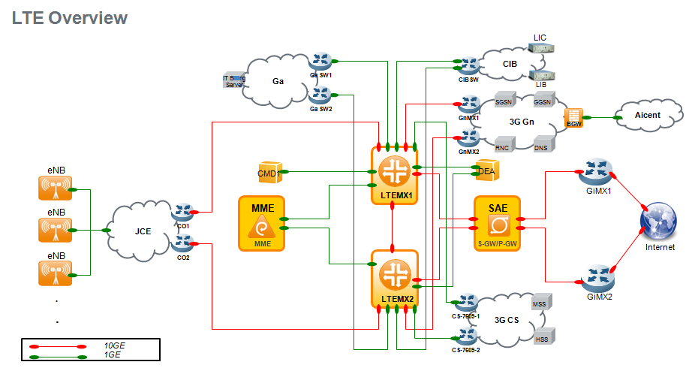****LTE網路架構**
  2. **DEA設備元件及功能說明**

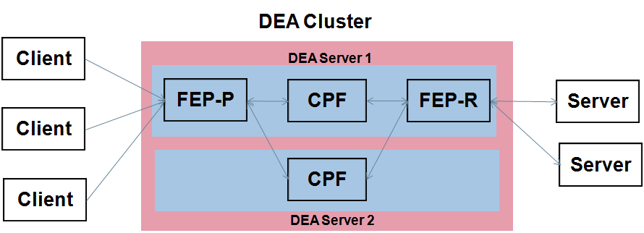

**CPF** ：provides session management, routing, LB

**FEP** ：provides network distribution point

**Configuration Manager** ：provides rules configuration management

**Web UI** ：provides web based access for configuration provision

* 1. **設備版本**

|  |  |  |  |
| --- | --- | --- | --- |
| Node | HW. | OS version | APP version |
| DEAX01 | HP DL380p Gen8 | Redhat 6.8 | SDC-4.4.21 |
| DEAX02 | HP DL380p Gen8 | Redhat 6.8 | SDC-4.4.21 |
| DEAW01 | HP DL380p Gen8 | Redhat 6.8 | SDC-4.4.21 |
| DEAW02 | HP DL380p Gen8 | Redhat 6.8 | SDC-4.4.21 |
| DEAEMSX01 | HP DL380p Gen8 | Redhat 6.8 | SDC-4.4.21 |
| DEAEMSX02 | HP DL380p Gen8 | Redhat 6.8 | SDC-4.4.21 |
| DEAEMSX03 | HP DL380p Gen8 | Redhat 6.8 | SDC-4.4.21 |

# DEA漫遊參數(增加routing/peer)說明及設定

* 1. **漫遊參數說明**

DEA定義的host以及realm如下

|  |  |
| --- | --- |
| Origin-Realm | epc.mnc097.mcc466.3gppnetwork.org |
| NEO DEA origin-Host | dra.deax01.epc.mnc097.mcc466.3gppnetwork.org |
| CHO DEA origin-Host | dra.deaw01.epc.mnc097.mcc466.3gppnetwork.org |

定義的host以及realm會設置在Topology->Peer Profile底下，以使用在DEA與其他設備建立Diameter連線。

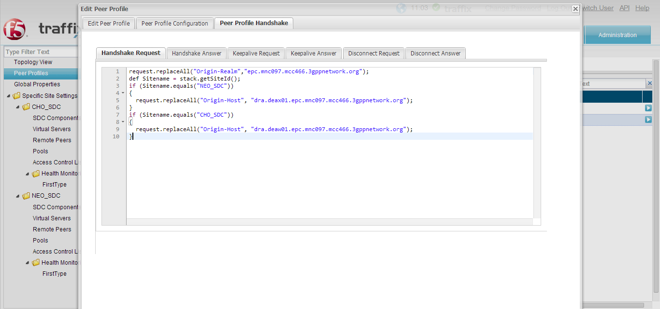

* 1. **漫遊參數設定**

**建立Peer：**

於Topology-><Site Name>->Remote Peers，可針對Peer做新增/建立/刪除等動作。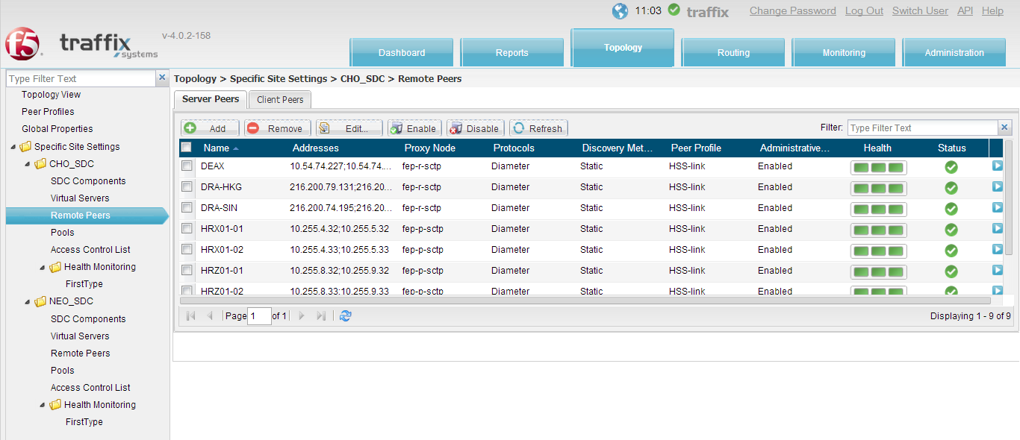

**建立Pool：**

於Topology-><Site Name>->Pool，可定義Pool放入已建立好的Peer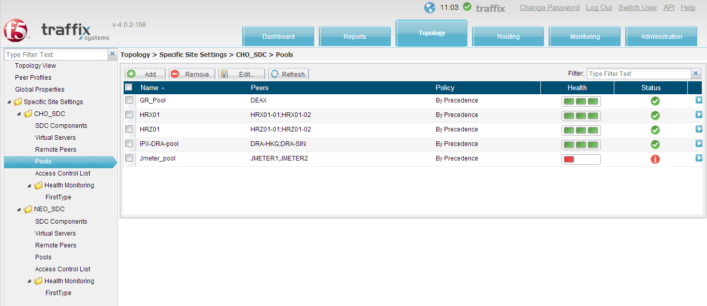

**建立Routing：**

於Routing->Routing頁面，可針對不同條件建立Routing，指定forward至不同的Destnation Pool

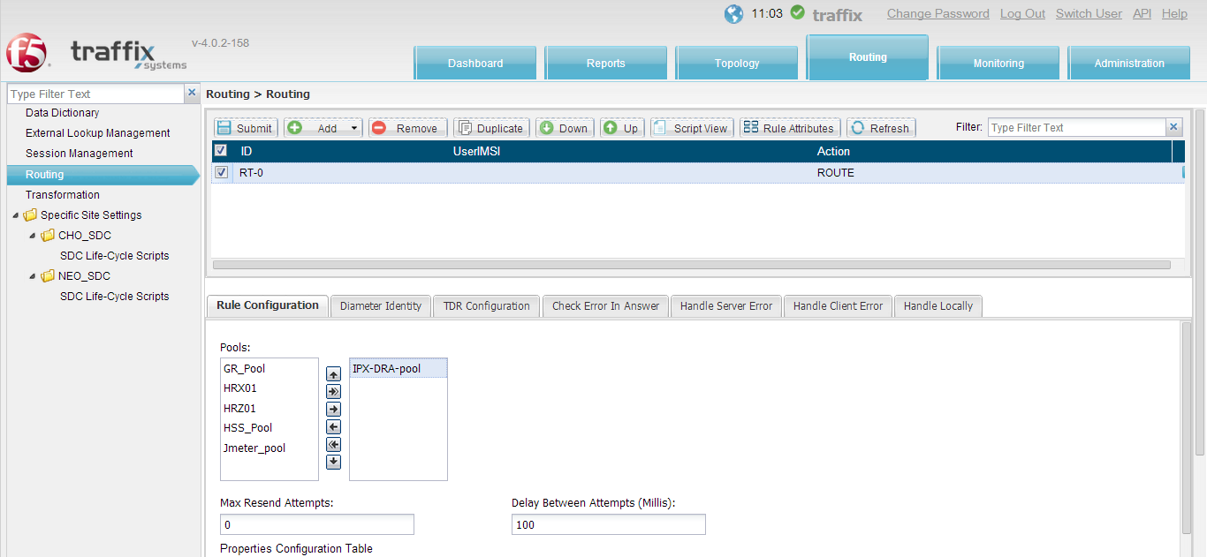

# 告警檢查及設備查測

* 1. **告警檢查及系統查測**
* EMS/DEA Site information

|  |  |  |
| --- | --- | --- |
| **Site** | **Node Name** | **OAM IP, SDC cluster – Webui IP** |
| NEO | DEAX01 | OAM -172.18.213.129  OAM -172.18.213.131  SDC WebUI - 172.18.213.133 |
| NEO | DEAX02 |
| NEO | DEAEMSX01 | OAM -172.18.8.122  OAM -172.18.8.124  EMS WebUI - 172.18.8.126 |
| NEO | DEAEMSX02 |
| NEO | DEAEMSX03 |
| CHO | DEAW01 | OAM -172.18.212.129  OAM -172.18.212.131  SDC WebUI - 172.18.212.133 |
| CHO | DEAW02 |

* 系統查測

於Monitoring->System View下確認Site Status、Host Status、Service Status是否皆UP正常

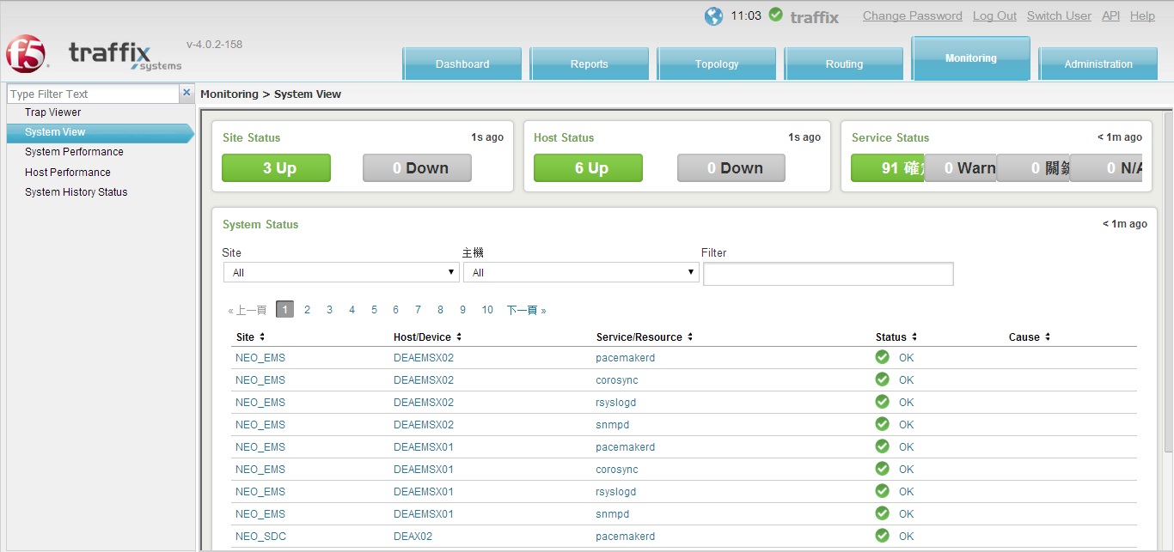

* 告警檢查

於Monitoring->Trap Viewer頁面確認是否有異常告警產生

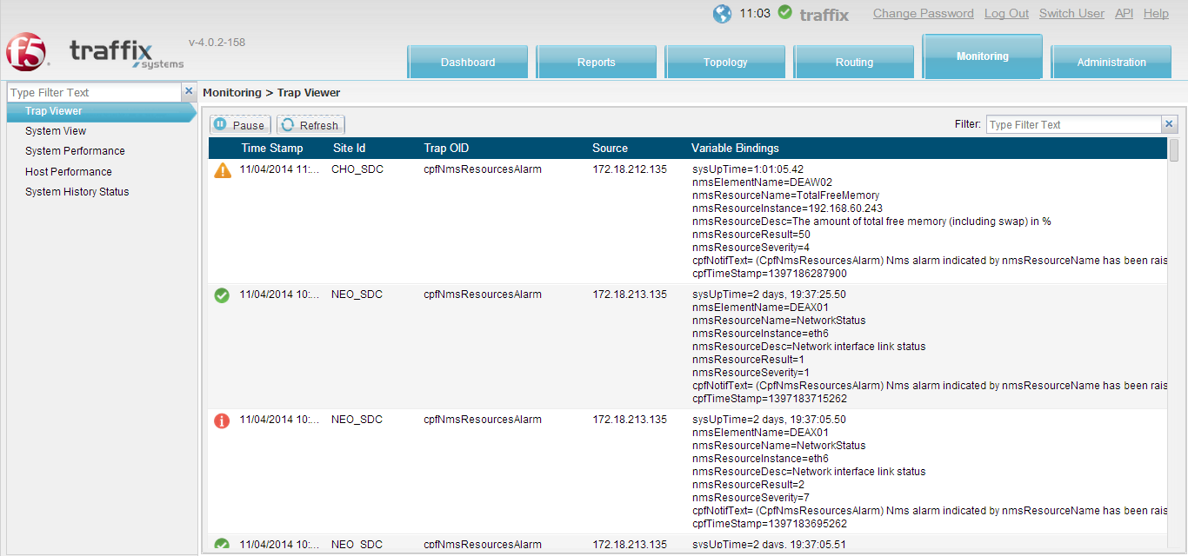

* 1. **CPU/Memory/Disk and Main Processes Check**
* 檢查DEA CPU、Memory、Disk是否有異常或overload及DEA系統主要process是否運作正常。

於Monitoring->System Performance確認各台系統CPU/Memory/Disk是否正常

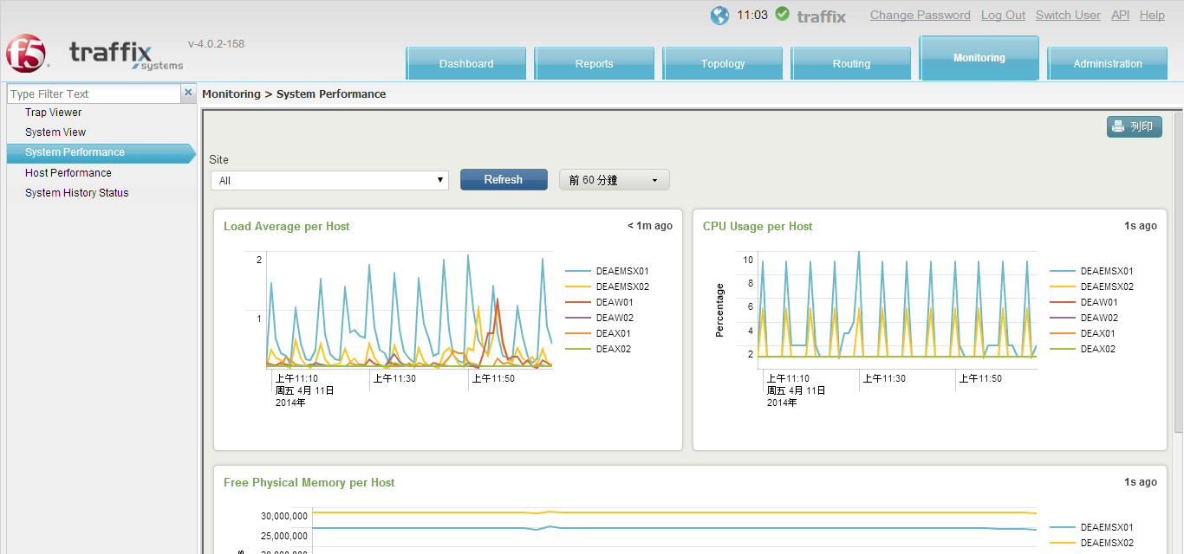

於Monitoring->System History Status確認系統process是否正常

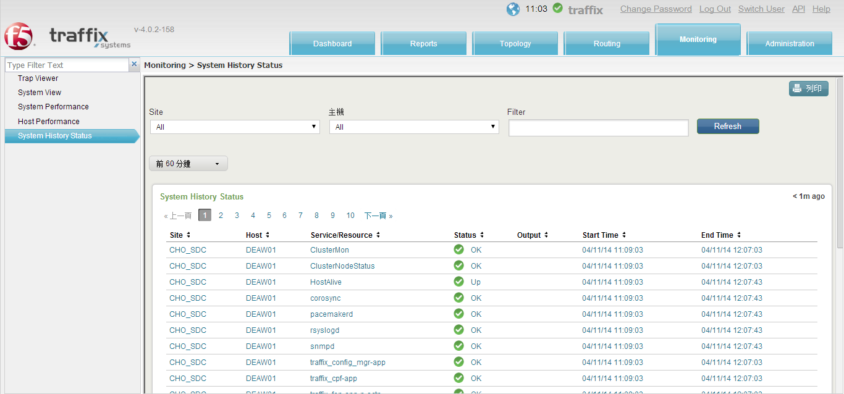

如系統有告警產生，可於Administration->Audit確認是否有進行作業更動設定所造成

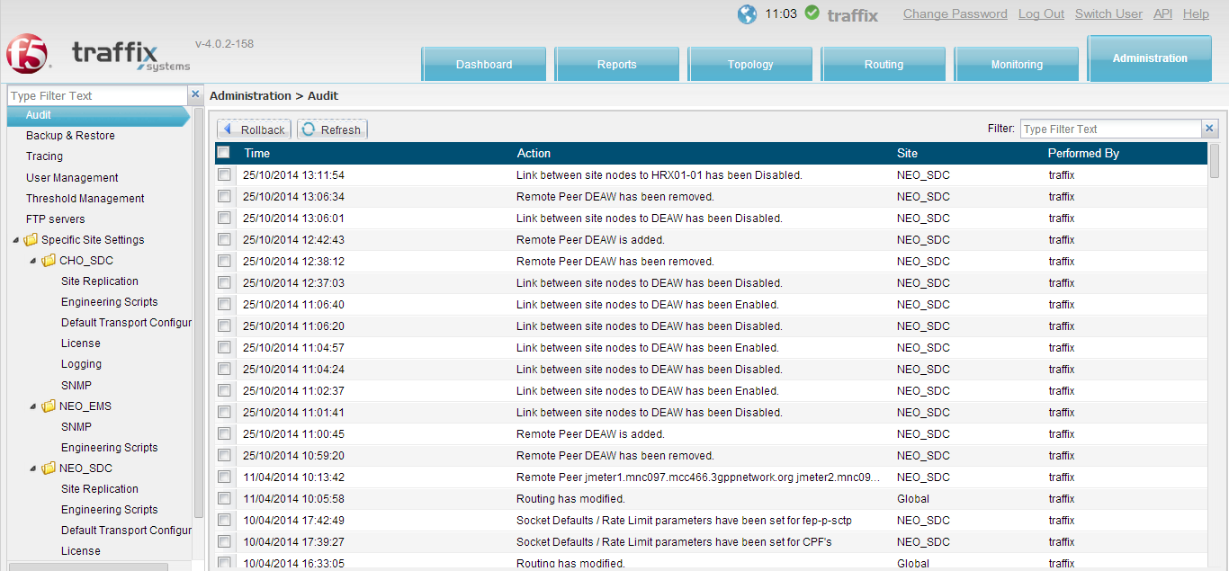

* 1. **障礙處理**
* Service process重啟/切換

如系統process發生異常或部分process切換至secondary node，需進行手動切換recovery，可透過ssh登入後，先確認目前cluster狀態，指令及example如下：

**[root@DEAW01 ~]# crm status**

**============**

**Last updated: Wed Jan 22 11:39:46 2014**

**Last change: Tue Jan 21 15:02:43 2014 via crm_attribute on DEAW02**

**Stack: openais**

**Current DC: DEAW02 - partition with quorum**

**Version: 1.1.7-6.el6-148fccfd5985c5590cc601123c6c16e966b85d14**

**2 Nodes configured, 2 expected votes**

**19 Resources configured.**

**============**

**Online: [ DEAW01 DEAW02 ]**

**ClusterMon (ocf::pacemaker:ClusterMon): Started DEAW01**

**Resource Group: traffix_fep-p-sctp-grp-grp**

**traffix_fep-vip-p-sctp-a-prim (ocf::heartbeat:IPaddr2): Started DEAW01**

**traffix_fep-vip-p-sctp-b-prim (ocf::heartbeat:IPaddr2): Started DEAW01**

**traffix_fep-app-p-sctp-prim (ocf::traffix:traffix-ra): Started DEAW01**

**Resource Group: traffix_fep-r-sctp-grp-grp**

**traffix_fep-vip-r-sctp-a-prim (ocf::heartbeat:IPaddr2): Started DEAW01**

**traffix_fep-vip-r-sctp-b-prim (ocf::heartbeat:IPaddr2): Started DEAW01**

**traffix_fep-app-r-sctp-prim (ocf::traffix:traffix-ra): Started DEAW01**

**Resource Group: traffix_nmsagent-grp**

**traffix_nmsagent-vip-prim (ocf::heartbeat:IPaddr2): Started DEAW01**

**traffix_nmsagent-app-prim (ocf::traffix:traffix-ra): Started DEAW01**

**Resource Group: traffix_splunk_forwarder-grp**

**traffix_forwarder_vip-prim (ocf::heartbeat:IPaddr2): Started DEAW01**

**traffix_forwarder_app-prim (ocf::traffix:traffix-ra): Started DEAW01**

**Resource Group: traffix_webui-grp**

**traffix_webui-vip-prim (ocf::heartbeat:IPaddr2): Started DEAW01**

**traffix_webui-app-prim (ocf::traffix:traffix-ra): Started DEAW01**

**Clone Set: traffix_config_mgr-app-clone [traffix_config_mgr-app-prim]**

**Started: [ DEAW01 DEAW02 ]**

**Clone Set: traffix_cpf-app-clone [traffix_cpf-app-prim]**

**Started: [ DEAW01 DEAW02 ]**

**Clone Set: traffix_tripo-clone [traffix_tripo-prim]**

**Started: [ DEAW01 DEAW02 ]**

確認異常process後，將其手動進行重啟，指令example如下：

# crm resource stop traffix_webui-grp

# crm resource start traffix_webui-grp

或可強制進行切換確認

# crm resource migrate traffix_webui-grp <DEA Node>

* Cluster node切換/服務重啟

1.如系統發生異常卻無正常Failover，需進行手動切換，可透過ssh登入後，先確認目前cluster狀態，指令及example如下：

**[root@DEAW01 ~]# crm status**

**============**

**Last updated: Wed Jan 22 11:39:46 2014**

**Last change: Tue Jan 21 15:02:43 2014 via crm_attribute on DEAW02**

**Stack: openais**

**Current DC: DEAW02 - partition with quorum**

**Version: 1.1.7-6.el6-148fccfd5985c5590cc601123c6c16e966b85d14**

**2 Nodes configured, 2 expected votes**

**19 Resources configured.**

**============**

**Online: [ DEAW01 DEAW02 ]**

**ClusterMon (ocf::pacemaker:ClusterMon): Started DEAW01**

**Resource Group: traffix_fep-p-sctp-grp-grp**

**traffix_fep-vip-p-sctp-a-prim (ocf::heartbeat:IPaddr2): Started DEAW01**

**traffix_fep-vip-p-sctp-b-prim (ocf::heartbeat:IPaddr2): Started DEAW01**

**traffix_fep-app-p-sctp-prim (ocf::traffix:traffix-ra): Started DEAW01**

**Resource Group: traffix_fep-r-sctp-grp-grp**

**traffix_fep-vip-r-sctp-a-prim (ocf::heartbeat:IPaddr2): Started DEAW01**

**traffix_fep-vip-r-sctp-b-prim (ocf::heartbeat:IPaddr2): Started DEAW01**

**traffix_fep-app-r-sctp-prim (ocf::traffix:traffix-ra): Started DEAW01**

**Resource Group: traffix_nmsagent-grp**

**traffix_nmsagent-vip-prim (ocf::heartbeat:IPaddr2): Started DEAW01**

**traffix_nmsagent-app-prim (ocf::traffix:traffix-ra): Started DEAW01**

**Resource Group: traffix_splunk_forwarder-grp**

**traffix_forwarder_vip-prim (ocf::heartbeat:IPaddr2): Started DEAW01**

**traffix_forwarder_app-prim (ocf::traffix:traffix-ra): Started DEAW01**

**Resource Group: traffix_webui-grp**

**traffix_webui-vip-prim (ocf::heartbeat:IPaddr2): Started DEAW01**

**traffix_webui-app-prim (ocf::traffix:traffix-ra): Started DEAW01**

**Clone Set: traffix_config_mgr-app-clone [traffix_config_mgr-app-prim]**

**Started: [ DEAW01 DEAW02 ]**

**Clone Set: traffix_cpf-app-clone [traffix_cpf-app-prim]**

**Started: [ DEAW01 DEAW02 ]**

**Clone Set: traffix_tripo-clone [traffix_tripo-prim]**

**Started: [ DEAW01 DEAW02 ]**

2.確認後將Cluster進行切換(Standby原來Active Node)

# crm node standby <DEA Node>

(以上為例：#crm node standby DEAW01)

3.切換後確認系統服務是否正常，後續確認是否需要reboot或replace原異常設備，如需重新online，指令如下：

# crm node online <DEA Node>

# 系統備份與Restore操作說明

* 1. **定期備份**

每台設備於每天01:00自動進行備份系統資料至本機硬碟及CM Server，本機設備保留最近三代之備份。

* 1. **備份之執行(手動方式)**

|  |  |
| --- | --- |
| **執行步驟** | **執行指令及說明** |
| 1 | 登入設備後，進入下列資料夾  cd /opt/traffix/sdc/utils/system/linux/backup_and_restore |
| 2 | 執行以下指令進行備份  ./backup_traffix_no_splunk.sh |
| 3 | 備份完成後，檢查log確認是否完成  grep SDC_backup /var/log/messages |

* 1. **設定還原**

若service crash且無法開機需重新安裝或需更換設備，可以依下列步驟還原

|  |  |
| --- | --- |
| Preparations | 1. Replace the faulty blade/server Hardware.  2. Prepare laptop loaded with installer running on vmware  player/vmware workstation    3. Prepare and setup the Installer environment as above  picture. |
| **Restore configuration and data from backup** | 1. To perform OS and SDC software installation on SDC and EMS in  TWM existing network environment, configure installer eth0  interface IP as below and update  /etc/hosts then restart tomcat service.  NEO SDC installer IP =172.18.213.200  NEO EMS installer IP = 172.18.8.130  CHO installer IP =172.18.212.200  2. Before starting installation, extract a file name topology.xml from  the backup media tar file and copy this into installer Topologies  folder:  **/var/lib/apache-tomcat-7.0.29/webapps/Installer/Topologies**  3. For OS installation, Select Perform Installation option  Select Load Site configuration File from the Installation server  option and use above topology.xml (as per specified in step 5)  On “Do you want to install the operating system during  Installation”, select Yes and proceed with OS installation.  4. After OS installation is completed, login into Server and assign OAM  IP address on eth0 accordingly to IP plan  5. Select Custom Installation and **unchecked** the following goals:  a. Reboot  b. Install SS7 component (if not needed)  c. Install fileserver (if not needed)  d. Run-SDC  e. Stop-SDC  f. Configure Corosync cluster  g. System hardening (if not needed)  6. Please connect to restored node and run the following commands;  a. # crm node standby <hostname1>  b. # crm node standby <hostname2>  c. Make sure that all nodes processes are down  # crm_mon -1n  7. Verify that the backup and restore directory files exist at:  ${TRAFFIX_DIR}/utils/system/linux/backup_and_restore/  ** If the above directory doesn’t exist, create it from the Traffix  directory ${TRAFFIX_DIR}  # mkdir -p utils/system/linux/backup_and_restore  **Then, copy the files (B&R kit) into it**  8. Change directory  # cd ${TRAFFIX_DIR}/utils/system/linux/backup_and_restore/  9. Run the script  # ./restore_traffix.sh  a. When asked;“Need to stop the cluster to restore the cluster  configuration type "Y" to stop the SDC service and restore the  cluster configuration? [Y/N]” answer Y  **The site will stop service and place the cluster into standby mode**  b. The site will stop service and place the cluster into standby mode  c. When asked:“Do you wish to restore the SDC data directory?  [Y/N]” answer N  d. When asked:“Do you wish to restore the NIC rules files? [Y/N]”  answer N    10. Verify the process completes without errors or warnings  ** In case of errors, please alert Traffix support team  11. The server will reboot and start with stopped cluster services |
| **Restore post reboot cluster activation** | During the restore process the cluster services were disabled  1. After the reboot of the recovered node, login to the node as root  user.  2. **Before continuing the procedure**, please run the following  command on each node to verify that the NTP service is up and all  nodes have the correct date, time and time zone:  a. # ntpstat  b. # date  c. In case the process is stopped, please start it:  # service ntpd start  d. # ntpq –p  e. # chkconfig ntpd on    3. Please connect to the old (**not the restored**) node and run the  following commands;  a. # crm node standby <hostname1>  b. # crm node standby <hostname2>  c. Check and ensure that all SDC processes are not running on both  nodes.  a. # crm_mon -1n  d. # /opt/traffix/sdc/bin/traffix_config_mgr_init start  e. Wait 1 minute!    4. Please connect to restored node and run the following commands;  a. # chkconfig --level 345 corosync on  b. # chkconfig --level 345 pacemaker on  c. # service corosync start  d. # service pacemaker start  e. # /opt/traffix/sdc/bin/traffix_config_mgr_init start  f. Wait 2 minutes!  5. Please check that data directory and the configuration files are  restored correctly and the two nodes are synced  6. For EMS node only, check and initial the splunk process  # cd /opt/traffix/sdc/bin/  #./traffix_splunk_init status  Do you agree with this license? [y/n]: y  # ./traffix_splunkmaster_init status  Do you agree with this license? [y/n]: y  # ./traffix_splunksearch_init status  Do you agree with this license? [y/n]: y    7. On both SDC and EMS, modify the /dev/mapper/vg1-lv_opt  partition size  # df -h  # lvdisplay  # lvextend -L +145G /dev/vg1/lv_opt  # resize2fs /dev/vg1/lv_opt  # df -h    8. Reboot all nodes  9. Make sure that all nodes processes are up  a. # crm_mon -1n  10. Bring up the site (back to service) – in case processes are down  a. # crm node online <hostname1>  b. # crm node online <hostname2>  11. For EMS node only, add splunk license ( Refer Annex A  splunk-licensing-steps.pdf)  To open EMS_SPLUNK_MASTER_VIP:8000 (search)  # vi /opt/splunksearch/splunk/share/splunk/search_mrsparkle/templates/account/login.html  find "login_direct = False", change False to True  To open EMS_SPLUNK_MASTER_VIP:8200 (indexer) webpage  # vi /opt/splunk/share/splunk/search_mrsparkle/templates/account/login.html  find "login_direct = False", change False to True |
| **Verification** | 1. Verify network interfaces.  ✓Signaling Link status verification  Server accessibility  2. Verify connectivity to networks.  ✓Ensure ssh service is OK  3. Verify cluster status.  Using “crm status” check Cluster status  4. Switch web UI to recovered server.  5. Login to the web UI and verify configuration. |