# Contents

Contents 1

Abstract 1

Introduction 2

Experimental dataset 3

Modeling of the data 5

Correlation Analysis 5

Relationship between Variables 5

Multivariate Regression Analysis 6

Discussion of results 6

Correlation Analysis 6

Relationship between Variables 7

Multivariate Regression Analysis 9

Conclusions 11

References 11

# Abstract

Concrete is widely employed in the construction sector for many different projects, including buildings, bridges, and roadways. Concrete's strength is essential for determining whether it can be used in construction, because insufficient strength can result in safety risks, higher costs, and project delays. For large-scale construction projects, waiting for 28 days to ascertain the compressive strength of concrete is frequently impracticable and time-consuming, necessitating the development of a more effective and precise procedure. By examining the variables that determine compressive strength of concrete, such as cement, blast furnace slag, fly ash, water, superplasticizer, and aggregate proportions, as well as the age of concrete, this research study seeks to construct a multiple regression model that can predict compressive strength. Buildings, bridges, and roads are just a few of the many various projects that use concrete extensively in the construction industry. Because insufficient strength can lead to safety issues, greater costs, and project delays, concrete's strength is crucial in deciding whether it can be utilized in construction. It is sometimes impractical and time-consuming to wait 28 days to determine the compressive strength of concrete for large-scale construction projects, necessitating the creation of a more exact and effective process. This study aims to develop a multiple regression model that can forecast compressive strength by looking at the factors that affect concrete's compressive strength, including cement, fly ash, water, superplasticizer, and aggregate proportions, as well as the age of the concrete. Regression analysis was carried out again after the inconsequential factors were eliminated, and the results revealed that all variables were significant predictors of compressive strength. Water had a negative impact on compressive strength, but cement, slag, ash, and age had beneficial impacts. Superplasticizer had a beneficial impact, but it was less significant.

# Introduction

With its broad use in structures including buildings, roads, bridges, and other infrastructure projects, concrete serves as the industry's backbone. One of the most important aspects that determines whether concrete is suitable for use in construction is its strength. Concrete's lack of strength can cause structural breakdowns, which can have serious repercussions in terms of safety, expense, and delays. Therefore, for quality control and assurance, forecasting the compressive strength of concrete is essential. Concrete's compressive strength is influenced by a number of variables, such as the mix proportions and curing circumstances. Additionally, the concrete's age has a significant impact on its compressive strength. As the chemical reactions between the components continue, concrete gets stronger over time. Usually, the first 28 days after pouring, the compressive strength of concrete increases quickly, and subsequently the rate of strength gain slows down. In order to determine if concrete is suitable for use in construction, it is important to assess its compressive strength after 28 days. Traditionally, cylindrical samples of concrete that have been curing for 28 days are tested to evaluate their compressive strength. The method used to determine the concrete's typical strength is commonly regarded as the gold standard. But the 28-day waiting period is frequently inconvenient and time-consuming, particularly for large-scale construction projects that call for urgent quality control measures. Additionally, waiting beyond 28 days may result in project delays and higher expenditures.

To address this challenge, this research project aims to develop a multiple regression model that can predict the compressive strength of concrete more efficiently and accurately. The study will analyze the parameters that significantly affect concrete strength, including the amounts of cement, blast furnace slag, fly ash, water, and superplasticizer in each concrete mixture, as well as the proportions of coarse and fine aggregate and the age of the concrete in days. By understanding the relationship between each parameter and the strength parameter, the proposed model will help the construction industry to predict the compressive strength of concrete more accurately and efficiently. The model will allow engineers and construction professionals to assess the strength of concrete samples in a shorter period, which will save time and reduce costs. Moreover, the model will improve the overall quality control and assurance process, ultimately leading to safer and more durable concrete structures. This research project is essential for the construction industry, which heavily relies on concrete as the primary building material. By developing a multiple regression model to predict the compressive strength of concrete, the research aims to improve the quality control and assurance process, reduce costs, and enhance the safety and durability of concrete structures.

# Experimental dataset

A carefully curated set of 1031 concrete samples from Kaggle served as the study's dataset. The dataset has 10 features (10 columns), and the compressive strength of concrete serves as the dataset's sole dependent variable. Cement, blast furnace slag, fly ash, water, superplasticizer, the proportions of coarse and fine aggregate, and the age of the concrete in days are all independent variables utilized in the dataset. These elements were chosen based on their importance in prior studies and are known to have an impact on concrete's compressive strength. The dataset's rows each represent a distinct concrete sample with a unique value for each of the independent variables. The compressive strength of concrete for each sample was measured in mega Pascals, making it the dependent variable for this study.

The summary statistics table displays the minimum, maximum, mean, and median values for each of the independent variables (cement, slag, ash, water, superplasticizer, coarse aggregate, fine aggregate, and age) and the dependent variable (compressive strength). The minimum and maximum values represent the lowest and highest values in the dataset, respectively. The mean value is the average of all the values in the dataset, while the median is the middle value in the dataset. The first quartile (Q1) represents the 25th percentile of the data, and the third quartile (Q3) represents the 75th percentile of the data. From the table, it can be observed that the mean compressive strength of the concrete is 35.25 MPa, with a minimum value of 2.332 MPa and a maximum value of 82.599 MPa. The mean amounts of cement, slag, ash, water, and superplasticizer in the concrete mixtures are 278.6 kg/m3, 72.04 kg/m3, 55.54 kg/m3, 182.1 kg/m3, and 6.032 kg/m3, respectively. The mean proportions of coarse and fine aggregates in the concrete mixtures are 974.4 kg/m3 and 772.7 kg/m3, respectively. Finally, the mean age of the concrete samples is 45.86 days.

|  |  |  |  |  |  |  |  |  |  |
| --- | --- | --- | --- | --- | --- | --- | --- | --- | --- |
|  | Cement | Slag | Ash | Water | Superplasticizer | Coarse Aggregate | Fine Aggregate | Age | Concrete compressive strength |
| Min. | 102 | 0 | 0 | 121.8 | 0 | 801 | 594 | 1 | 2.332 |
| 1st Qu. | 190.7 | 0 | 0 | 166.6 | 0 | 932 | 724.3 | 7 | 23.524 |
| Median | 265 | 20 | 0 | 185.7 | 6.1 | 968 | 780 | 28 | 33.798 |
| Mean | 278.6 | 72.04 | 55.54 | 182.1 | 6.032 | 974.4 | 772.7 | 45.86 | 35.25 |
| 3rd Qu. | 349 | 142.5 | 118.27 | 192.9 | 10 | 1031 | 822.2 | 56 | 44.868 |
| Max. | 540 | 359.4 | 200.1 | 247 | 32.2 | 1145 | 992.6 | 365 | 82.599 |

The spread or variability of the values that a variable can take on is referred to as the variable's distribution. The distribution of the variables is depicted in the figure in this context. According to the figure, the target variable seems to have a pretty normal distribution, with the majority of the data points clustered in the center of the range of values and a small number of outliers towards the higher end. This indicates that while most of the concrete samples in the dataset have compressive strengths that are within a range, a few samples have compressive strengths that are noticeably greater. On the other hand, none of the features appear to have a normal distribution, meaning that the values are not evenly distributed across the range of possible values. For example, the "Ash" feature has a large number of samples with very low values, and relatively few samples with high values. Similarly, the "Superplasticizer" feature appears to have a somewhat bimodal distribution, with two peaks in the frequency of values.

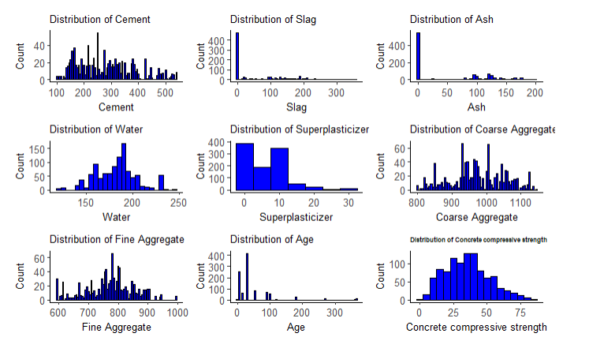

The dataset is ideal for building a multiple regression model to predict the compressive strength of concrete since it is extensive, varied, and has a big enough sample size. The model is reliable and accurate in estimating the concrete strength since it takes into account a number of independent variables. The dataset satisfies the criteria for a good dataset for predictive modelling and is trustworthy.

# Modeling of the data

A multiple regression model, a type of econometric modelling employed in this study, aids in determining the key variables that influence the compressive strength of concrete. The model can precisely predict the compressive strength of concrete by examining the link between each independent variable and the dependent variable. The following measures were taken by us in order to accomplish this.

## Correlation Analysis

Correlation is a statistical tool used to assess the relationship between two variables. It is frequently used to measure the magnitude and direction of the link between a feature and the target variable in the context of regression modelling. A feature and the target variable have a high correlation when there is a significant relationship between them. This implies that modifications to the feature's value will cause corresponding modifications to the target variable. On the other hand, a weak or nonexistent association between the trait and the target is indicated by a low correlation. It's crucial to find the features that are highly correlated with the target variable while developing a predictive model. These characteristics can be utilized to create a model that is more accurate because they are probably to have a bigger impact on the target variable [1].

This study conducted a correlation analysis to investigate the correlation coefficients between each feature and the target variable, which is the concrete compressive strength. Correlation coefficient measures the strength and direction of the relationship between two variables, where a value of 1 indicates a perfect positive correlation, 0 indicates no correlation, and -1 indicates a perfect negative correlation. The results are discussed in the subsequent section.

## Relationship between Variables

For visualizing the relationship between a feature and a target variable in regression issues, scatter plots are a crucial tool. They offer an efficient method for determining the correlation between two continuous variables. A pair of values, one from the feature variable and one from the target variable, are represented by each point in a scatter plot. The location of the point on the plot, with the feature variable on the x-axis and the target variable on the y-axis, represents the values of the two variables. The association between the feature and the target variable can be seen generally in the scatter plot as a trend or pattern. A trend line with an upward slope indicates a positive correlation, meaning that rising levels of the feature variable are correlated with rising levels of the target variable. A trend line that slopes downward indicates a negative correlation, meaning that an increase in the feature variable is linked to a reduction in the target variable. Scatter plots can aid in locating any outliers in the dataset, or points that deviate greatly from the trend line. Regression models' performance can be severely impacted by outliers since they skew the trend line and produce inaccurate predictions. We can pick whether to delete outliers from the dataset or change the data to lessen their impact by detecting them. In this research, a number of scatter plots between the target and the features to validate the relations established with the help of correlation [2].

To further investigate the relationship of the features and target that were established form the correlation analysis, this study computed scatter plots. The scatter plots between the variables that had significant correlation (both positive and negative) with the target variable (concrete strength) were plotted. The results are discussed in the subsequent section.

## Multivariate Regression Analysis

A statistical method for examining the relationship between several variables is multivariate analysis. Multivariate analysis can be used to determine which features, and to what extent, they have an impact on a target variable when examining the relationship between features and that variable. Linear regression is a popular method for multivariate analysis that entails building a model that estimates the target variable based on the values of the characteristics. Determine the relative significance of each factor in predicting the target variable using the regression model's coefficients [3].

In this study, the features that significantly affect the target variable were first shortlisted using simple linear regression. In a subsequent regression trial, the results were computed again by removing the insignificant variables, and the final equation was estimated

# Discussion of results

## Correlation Analysis

The table displays the correlation coefficients between each feature and the target variable, which is the concrete compressive strength. Correlation coefficient measures the strength and direction of the relationship between two variables, where a value of 1 indicates a perfect positive correlation, 0 indicates no correlation, and -1 indicates a perfect negative correlation. Based on the table, we can see that the feature 'Cement' has a moderate positive correlation of 0.49 with the target variable, indicating that as the amount of cement in the mix increases, the compressive strength of the concrete also increases. The feature 'Superplasticizer' also has a moderate positive correlation of 0.34, which means that higher levels of superplasticizer in the mix are associated with higher compressive strength. On the other hand, 'Water' has a moderate negative correlation of -0.27, indicating that as the amount of water in the mix increases, the compressive strength of the concrete decreases. Similarly, 'Fine Aggregate' and 'Coarse Aggregate' have weak negative correlations of -0.19 and -0.14, respectively, implying that an increase in these variables may result in a slight decrease in the compressive strength. The feature 'Slag' has a weak positive correlation of 0.10 with the target variable, suggesting that it has little effect on the compressive strength of the concrete. The feature 'Ash' has a weak negative correlation of -0.08, indicating that it may have a small effect on the compressive strength. Finally, the feature 'Age' has a moderate positive correlation of 0.34 with the target variable, implying that as the age of the concrete increases, its compressive strength also increases. This can be attributed to the fact that the chemical reaction between the cement and water continues over time, leading to the development of stronger bonds between the materials.

|  |  |  |
| --- | --- | --- |
| Cement | Concrete compressive strength | 0.49 |
| Slag | Concrete compressive strength | 0.1 |
| Ash | Concrete compressive strength | -0.08 |
| Water | Concrete compressive strength | -0.27 |
| Superplasticizer | Concrete compressive strength | 0.34 |
| Coarse Aggregate | Concrete compressive strength | -0.14 |
| Fine Aggregate | Concrete compressive strength | -0.19 |
| Age | Concrete compressive strength | 0.34 |
| Concrete compressive strength | Concrete compressive strength | 1 |

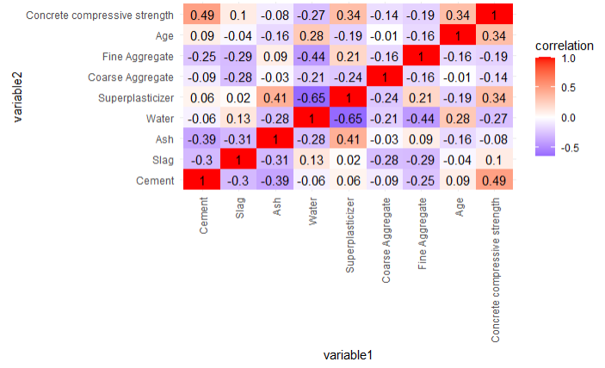

## Relationship between Variables

To further investigate the relationship of the features and target that were established form the correlation analysis, this study computed scatter plots. The scatter plots between the variables that had significant correlation (both positive and negative) with the target variable (concrete strength) were plotted. Cement, Age, and Superplasticizer had the highest positive correlation with concrete comprehensive strength while Water and Fine Aggregate has the highest negative correlation with the concrete comprehensive strength hence these feature were considered.

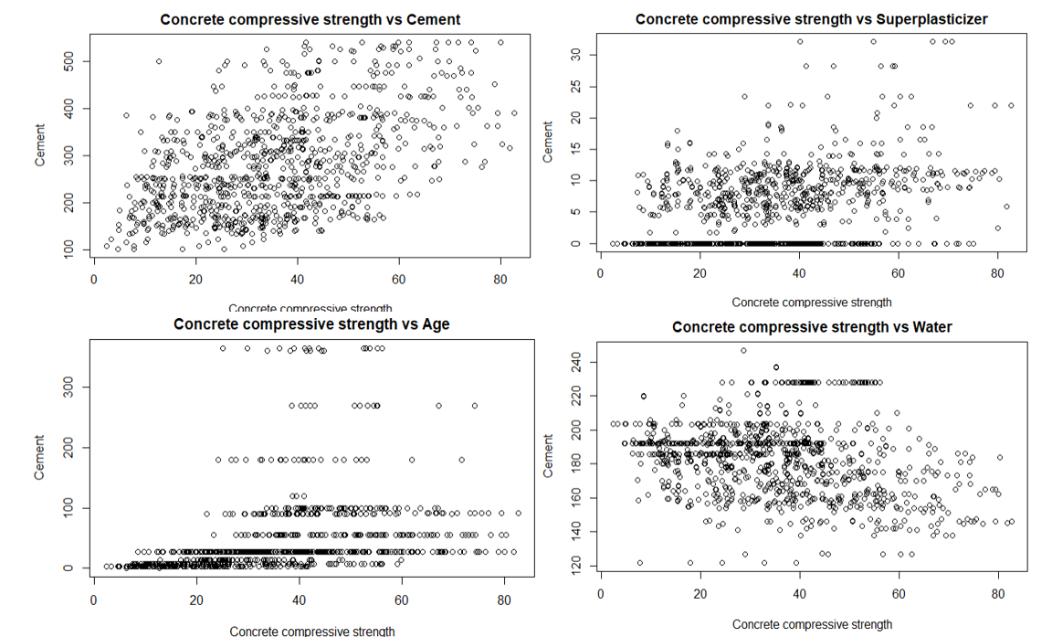

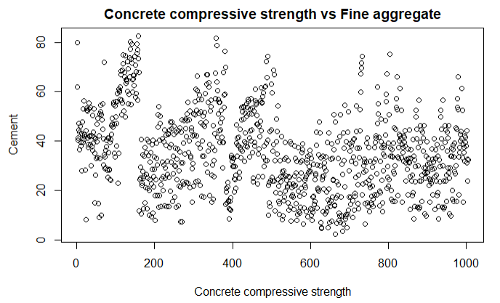

The scatter plots confirm that the feature 'Cement' has a moderate positive relation with the target variable, resulting in higher compressive strength of the concrete as the amount of cement in the mix increases. 'Superplasticizer' also has a moderate positive relation with the target variable, indicating that higher levels in the mix lead to higher compressive strength. Conversely, 'Water' has a moderate negative relation with the target variable, indicating that an increase in water in the mix leads to a decrease in compressive strength. 'Fine Aggregate' and 'Coarse Aggregate' have weak negative relations with the target variable, suggesting a slight decrease in compressive strength with an increase in these variables. 'Slag' has a weak positive relation, while 'Ash' has a weak negative relation with the target variable, indicating little effect on compressive strength. Finally, 'Age' has a moderate positive relation with the target variable, as the age of the concrete increases, its compressive strength also increases due to the continued chemical reaction between the cement and water, leading to stronger bonds between the materials.

## Multivariate Regression Analysis

Simple regression was used to shortlist the features that significantly affect the target. The table below summarizes the results of regression.

|  |  |  |  |  |
| --- | --- | --- | --- | --- |
| Variable | Estimate | Std. Error | t-value | p-value |
| (Intercept) | -17.748084 | 26.419314 | -0.672 | 0.501877 |
| Cement | 0.117221 | 0.008495 | 13.799 | < 2e-16 |
| Slag | 0.099445 | 0.010158 | 9.79 | < 2e-16 |
| Ash | 0.085632 | 0.012478 | 6.862 | 1.19E-11 |
| Water | -0.15263 | 0.039801 | -3.835 | 0.000134 |
| Superplasticizer | 0.28338 | 0.092929 | 3.049 | 0.002353 |
| Coarse Aggregate | 0.015621 | 0.009321 | 1.676 | 0.094092 |
| Fine Aggregate | 0.018291 | 0.010675 | 1.713 | 0.08694 |
| Age | 0.112181 | 0.005393 | 20.8 | < 2e-16 |

Based on the results of the linear regression analysis, the variables Cement, Slag, Ash, Water, Superplasticizer, and Age were found to be significant predictors of the compressive strength of concrete, with p-values less than 0.05. Cement had the largest positive effect on compressive strength, with an estimate of 0.117221 and a very low p-value of less than 2e-16, indicating that this variable has a highly significant effect on the outcome. Similarly, Slag and Ash were found to have significant positive effects on compressive strength, with estimates of 0.099445 and 0.085632 respectively, and p-values of less than 2e-16. Water, on the other hand, was found to have a significant negative effect on compressive strength, with an estimate of -0.15263 and a p-value of 0.000134. This indicates that increasing the amount of water in the concrete mixture will decrease its compressive strength. Superplasticizer and Age were also found to have significant positive effects on compressive strength, with estimates of 0.28338 and 0.112181 respectively, and p-values of 0.002353 and less than 2e-16 respectively.

On the other hand, Coarse Aggregate and Fine Aggregate were found to be non-significant predictors of compressive strength, with p-values of 0.094092 and 0.08694 respectively, and estimates of 0.015621 and 0.018291 respectively. These variables can be considered insignificant and removed from the final model.

After identification of insignificant variables, again regression analysis way conducted after the removal of insignificant variables i.e. Coarse Aggregate and Fine Aggregate. The table below summarizes the results of the regression analysis after removal of insignificant variables.

|  |  |  |  |  |
| --- | --- | --- | --- | --- |
| Variable | Estimate | Std. Error | t-value | p-value |
| (Intercept) | 28.504229 | 4.170758 | 6.834 | 1.43E-11 |
| Cement | 0.104254 | 0.004227 | 24.662 | < 2e-16 |
| Slag | 0.083801 | 0.00498 | 16.827 | < 2e-16 |
| Ash | 0.06841 | 0.007697 | 8.887 | < 2e-16 |
| Water | -0.21254 | 0.020953 | -10.144 | < 2e-16 |
| Superplasticizer | 0.240087 | 0.084439 | 2.843 | 0.00456 |
| Age | 0.111464 | 0.005369 | 20.759 | < 2e-16 |

The regression results suggest that the model has a significant overall fit. Looking at the individual variables, all of them are significant based on their p-values and t-values. The intercept is also significant, indicating that there is a significant difference between the average concrete compressive strength and zero.

The coefficient for "Cement" is 0.104254, with a standard error of 0.004227. This indicates that for every one unit increase in cement, there is a 0.104254 increase in concrete compressive strength, holding all other variables constant. The coefficient is positive, which suggests that cement has a positive effect on concrete compressive strength.

The coefficient for "Slag" is 0.083801, with a standard error of 0.00498. This suggests that for every one unit increase in slag, there is a 0.083801 increase in concrete compressive strength, holding all other variables constant. The coefficient is also positive, which suggests that slag has a positive effect on concrete compressive strength.

The coefficient for "Ash" is 0.06841, with a standard error of 0.007697. This suggests that for every one unit increase in ash, there is a 0.06841 increase in concrete compressive strength, holding all other variables constant. The coefficient is also positive, which suggests that ash has a positive effect on concrete compressive strength.

The coefficient for "Water" is -0.21254, with a standard error of 0.020953. This suggests that for every one unit increase in water, there is a -0.21254 decrease in concrete compressive strength, holding all other variables constant. The coefficient is negative, which suggests that water has a negative effect on concrete compressive strength.

The coefficient for "Superplasticizer" is 0.240087, with a standard error of 0.084439. This suggests that for every one unit increase in superplasticizer, there is a 0.240087 increase in concrete compressive strength, holding all other variables constant. The coefficient is positive, which suggests that superplasticizer has a positive effect on concrete compressive strength. However, this variable has a higher standard error than the other variables, which suggests that there is more uncertainty around this estimate.

The coefficient for "Age" is 0.111464, with a standard error of 0.005369. This suggests that for every one unit increase in age, there is a 0.111464 increase in concrete compressive strength, holding all other variables constant. The coefficient is positive, which suggests that age has a positive effect on concrete compressive strength.

The results suggest that cement, slag, ash, superplasticizer, and age have a positive effect on concrete compressive strength, while water has a negative effect. The final equation for this linear regression model is:

$$Concrete compressive strength = 28.504 + 0.104Cement + 0.084Slag + 0.068Ash - 0.213Water + 0.240Superplasticizer + 0.111Age$$

Where Cement, Slag, Ash, Water, Superplasticizer, and Age are the independent variables, and Concrete compressive strength is the dependent variable.

# Conclusions

Concrete is widely employed in the construction sector for many different projects, including buildings, bridges, and roadways. Concrete's strength is essential for determining whether it can be used in construction, because insufficient strength can result in safety risks, higher costs, and project delays. For large-scale construction projects, waiting for 28 days to ascertain the compressive strength of concrete is frequently impracticable and time-consuming, necessitating the development of a more effective and precise procedure. By examining the variables that determine compressive strength of concrete, such as cement, blast furnace slag, fly ash, water, superplasticizer, and aggregate proportions, as well as the age of concrete, this research study seeks to construct a multiple regression model that can predict compressive strength. Buildings, bridges, and roads are just a few of the many various projects that use concrete extensively in the construction industry. Because insufficient strength can lead to safety issues, greater costs, and project delays, concrete's strength is crucial in deciding whether it can be utilized in construction. It is sometimes impractical and time-consuming to wait 28 days to determine the compressive strength of concrete for large-scale construction projects, necessitating the creation of a more exact and effective process. This study aims to develop a multiple regression model that can forecast compressive strength by looking at the factors that affect concrete's compressive strength, including cement, fly ash, water, superplasticizer, and aggregate proportions, as well as the age of the concrete. Regression analysis was carried out again after the inconsequential factors were eliminated, and the results revealed that all variables were significant predictors of compressive strength. Water had a negative impact on compressive strength, but cement, slag, ash, and age had beneficial impacts. Superplasticizer had a beneficial impact, but it was less significant

# References

|  |  |
| --- | --- |
| [1] | Tabachnick, B.G. and L. Fidell, "Using multivariate statistics:," in *Pearson new international edition.*, Pearson Higher Ed., 2013. |
| [2] | A. Hadi and S. Chatterjee, "Regression analysis by example.," John Wiley & Sons., 2015. |
| [3] | J. Hair, W. Black, B. Babin, R. Anderson and R. Tatham, "Multivariate data analysis," 2006. |