# Jenkins Setup

Follow the steps outlined in Tejinder’s resource: <https://android.jlelse.eu/setting-up-jenkins-for-android-how-i-dealt-with-the-challenges-i-faced-1bbdb6580b8d>

*I skipped the step the publish to the Store*

Jenkins global configuration: Environment variables:

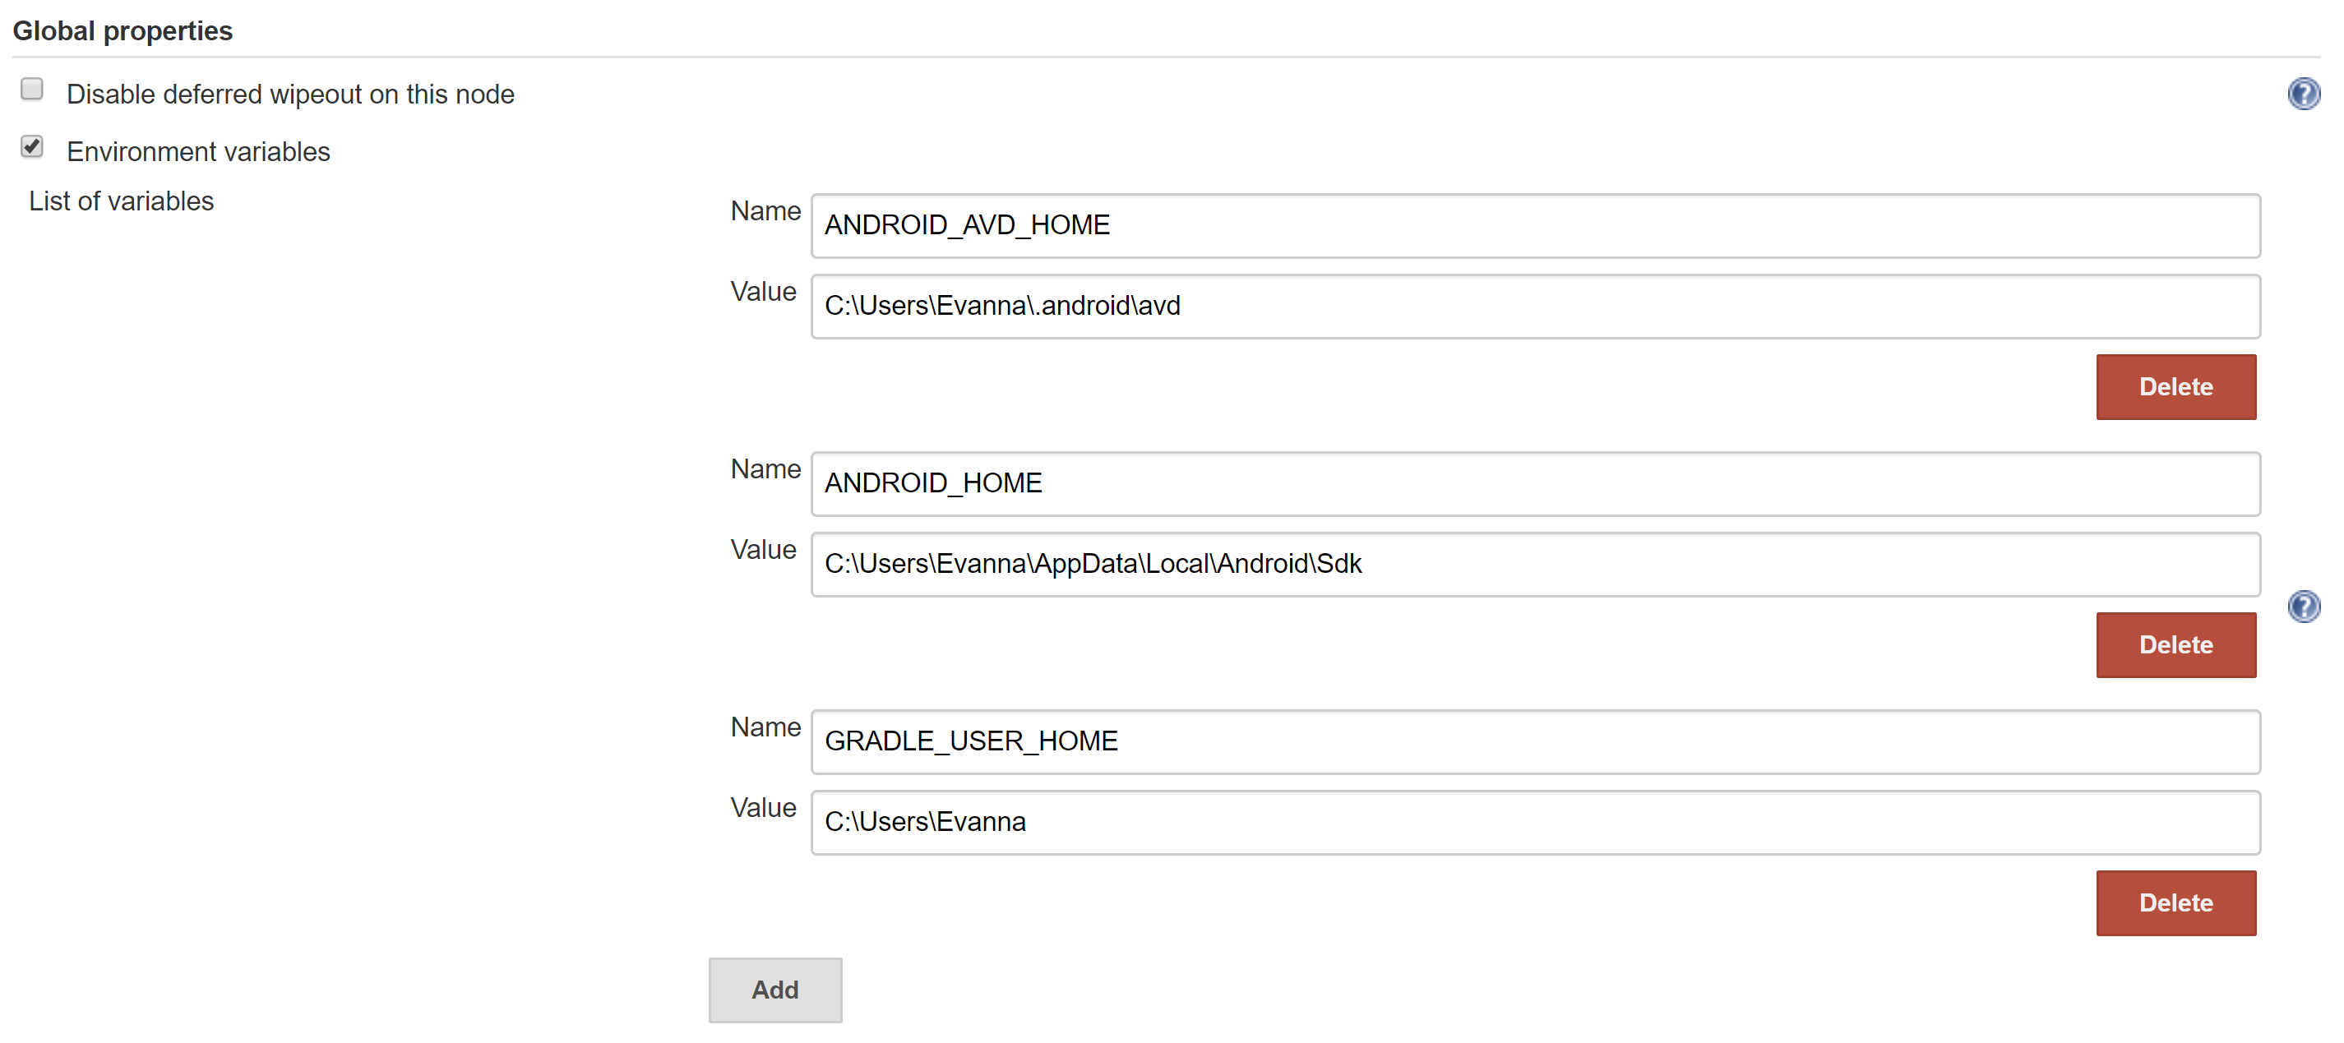

Jenkins global configuration: Grade version selected:

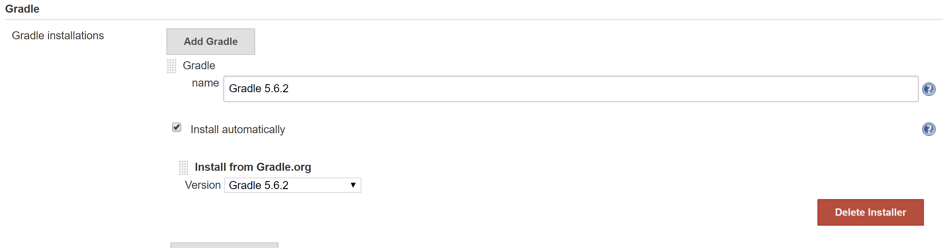

New Build Item: Espresso test branch setup:

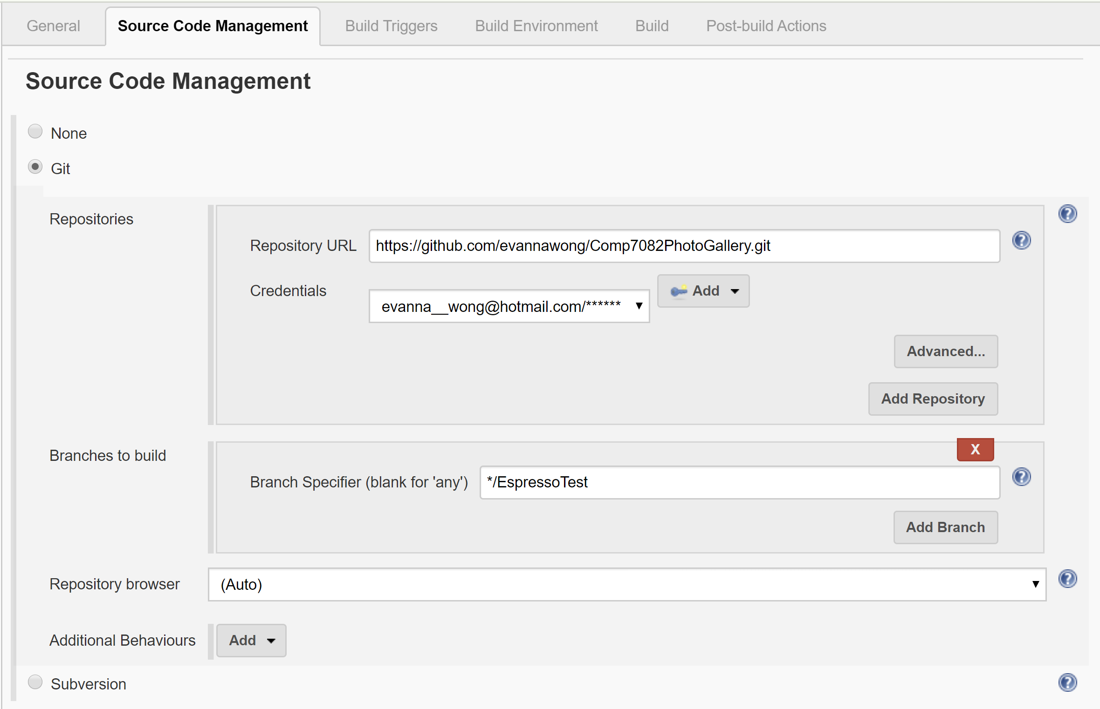

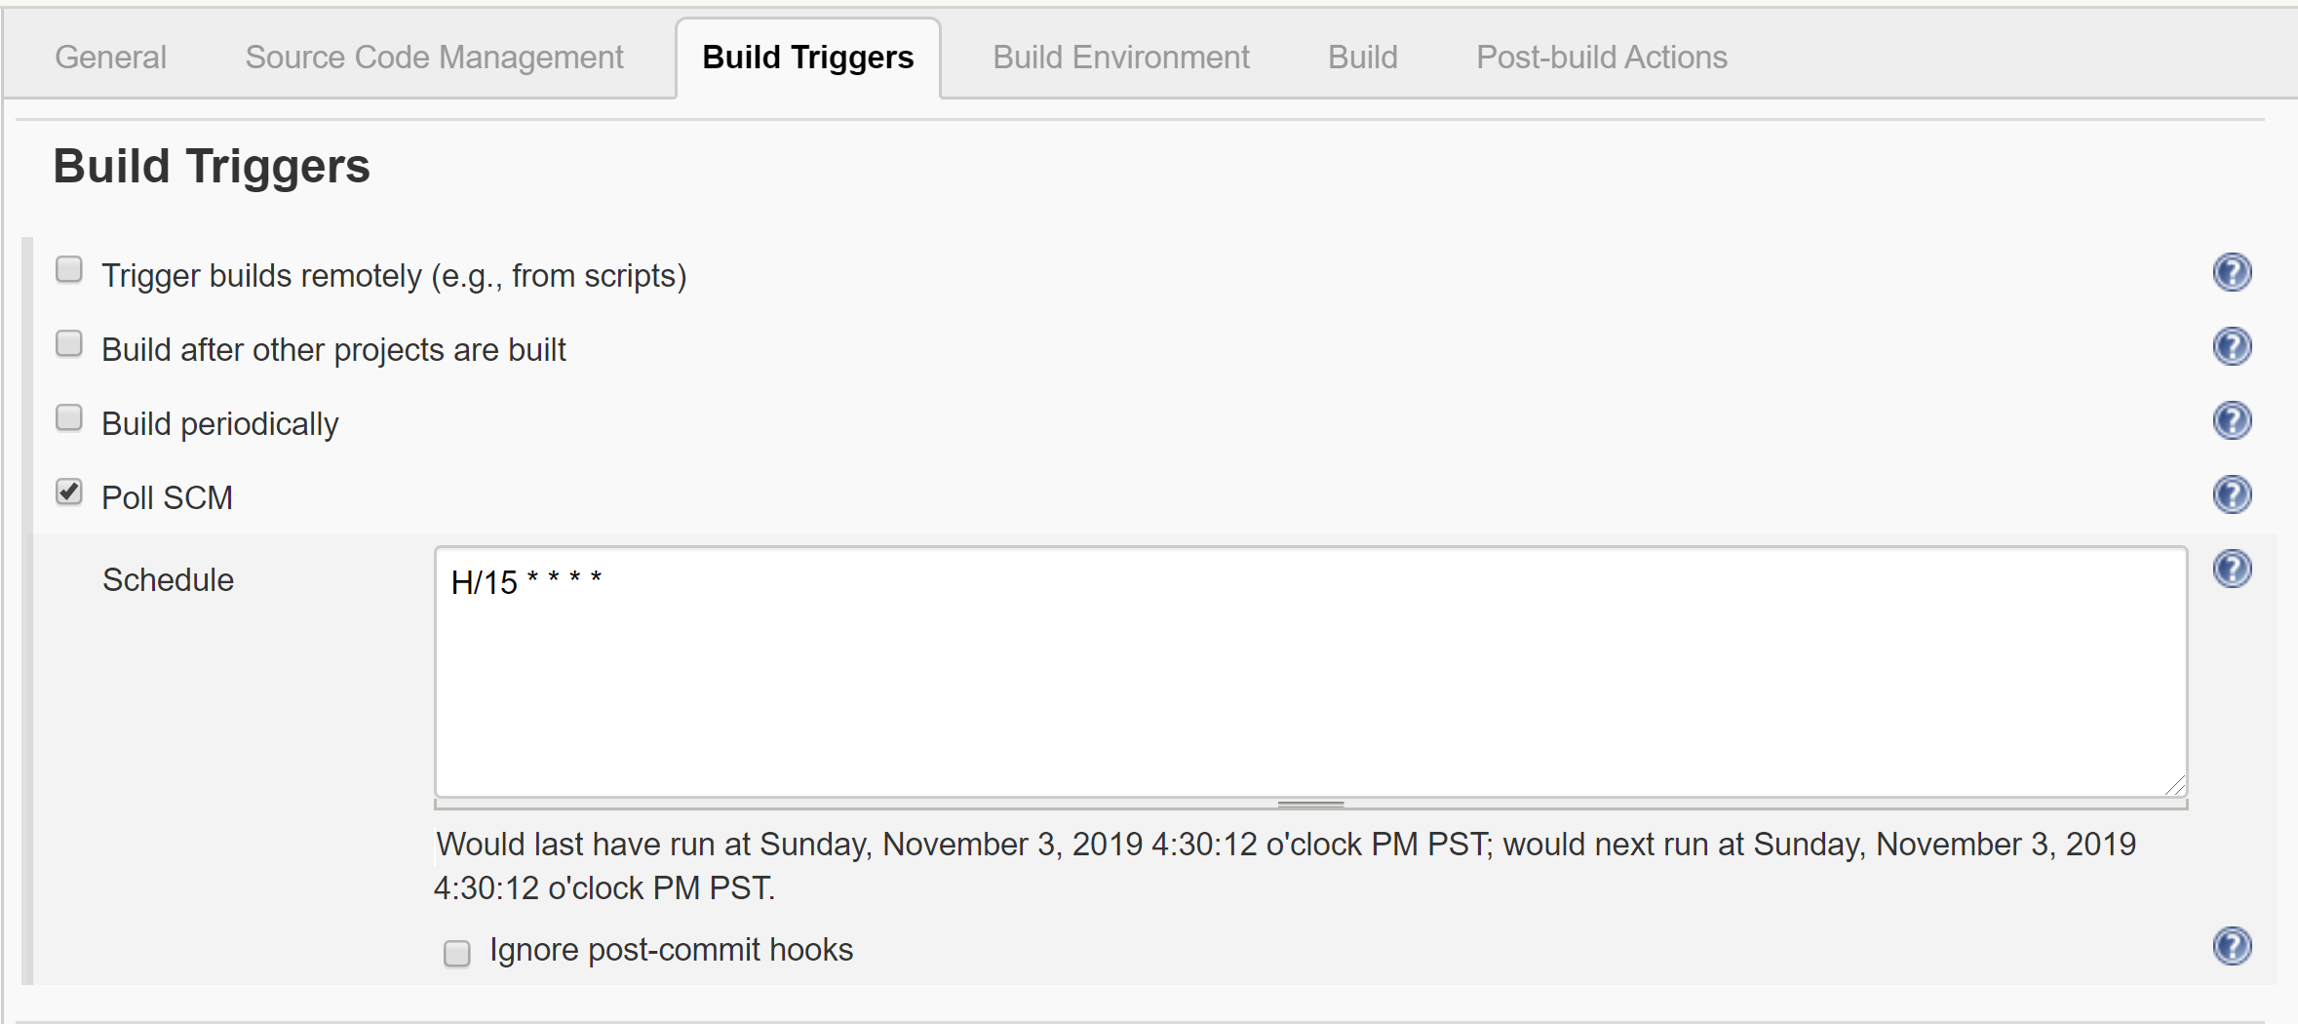

*These are the same specs as the emulator used in Android Studio. You could also just use an existing AVD. By selecting “Run existing emulator”. You need to setup the environment variable so Jenkins knows where to look for this existing AVD. I believe the environment variable is ANDROID_AVD_HOME.

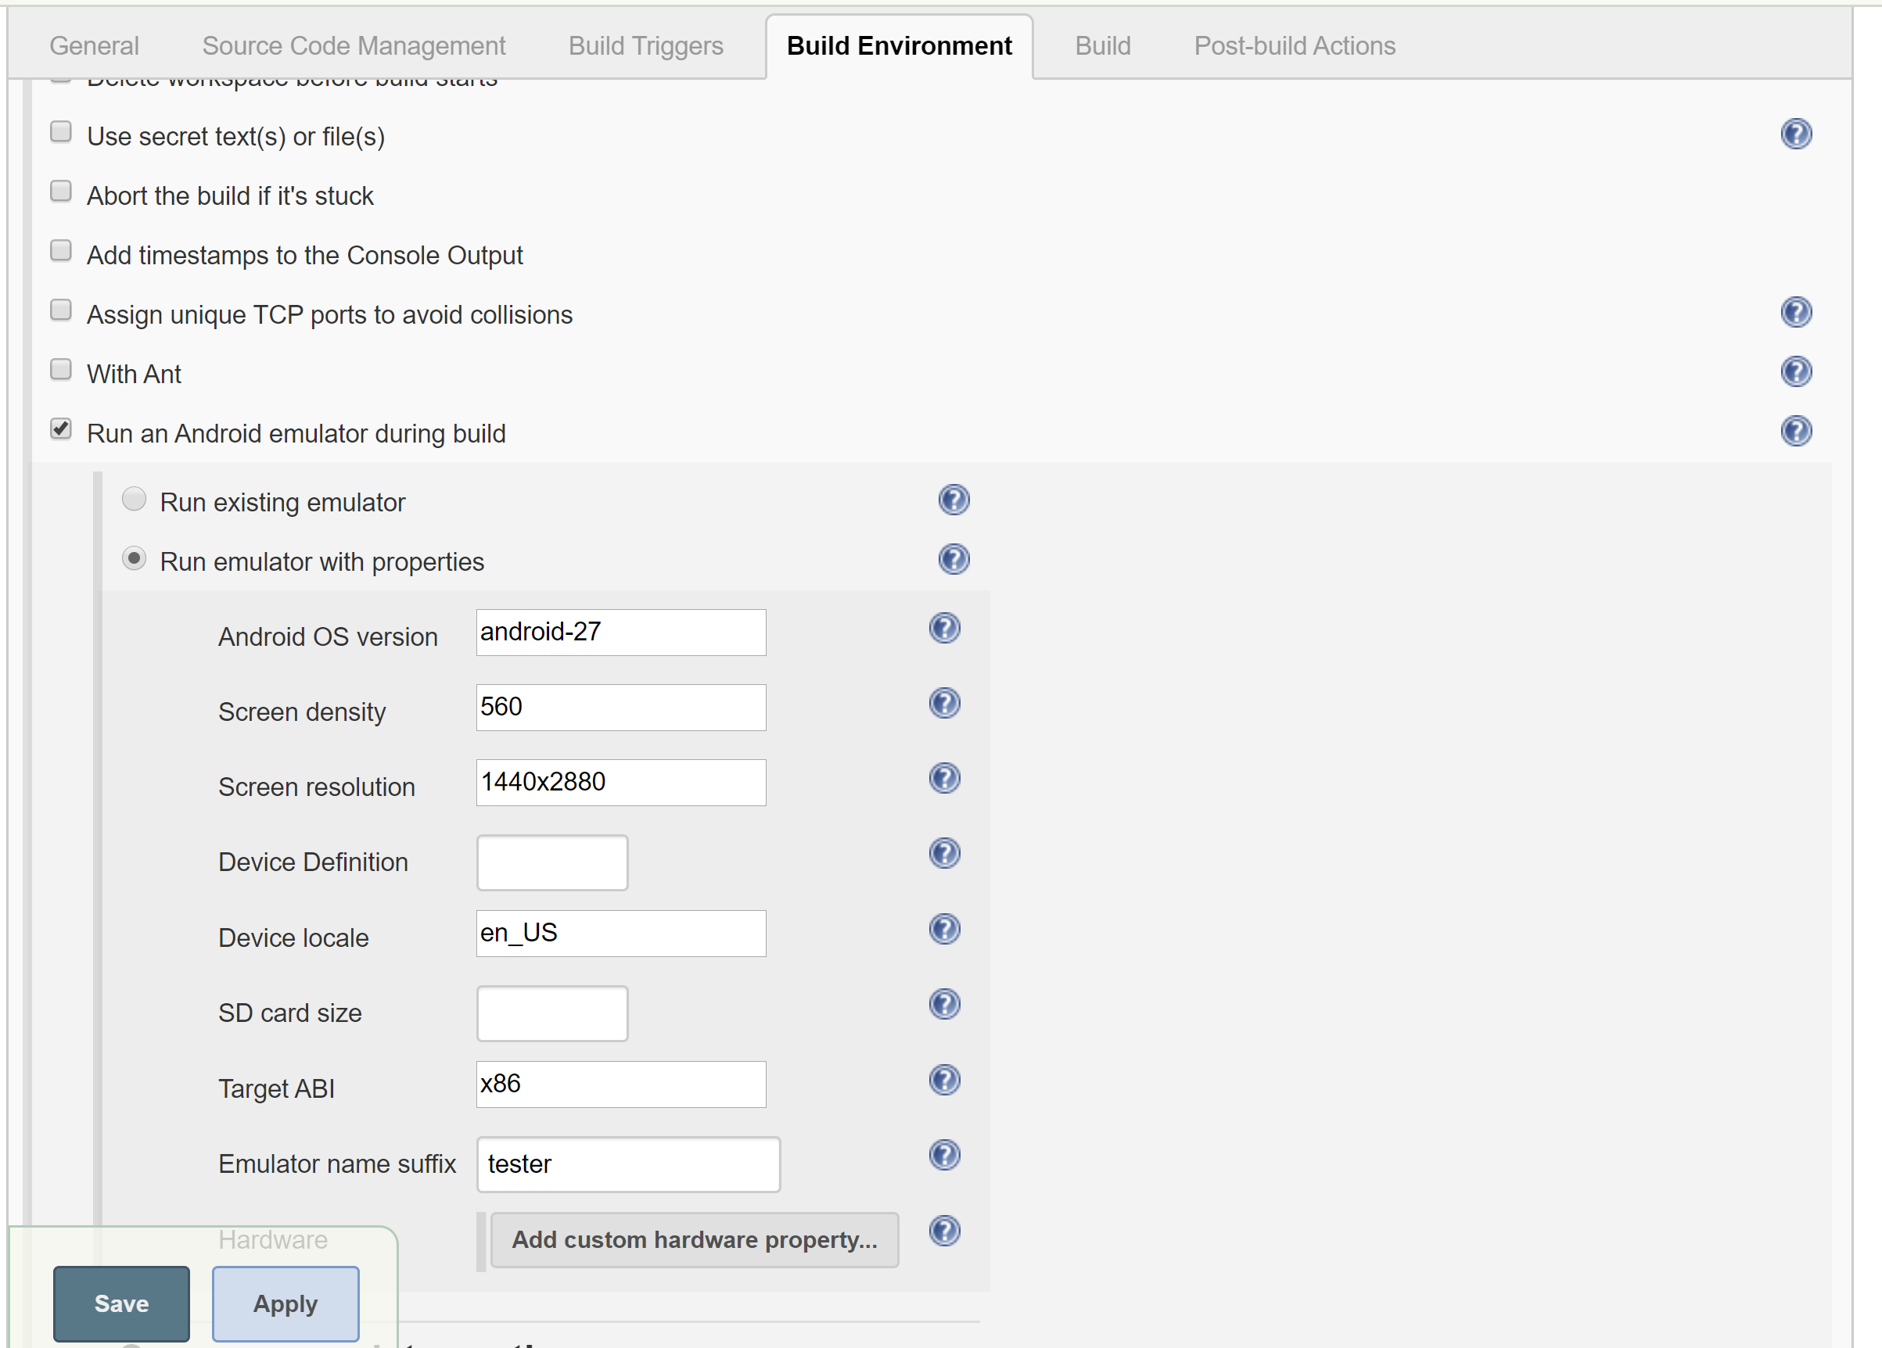

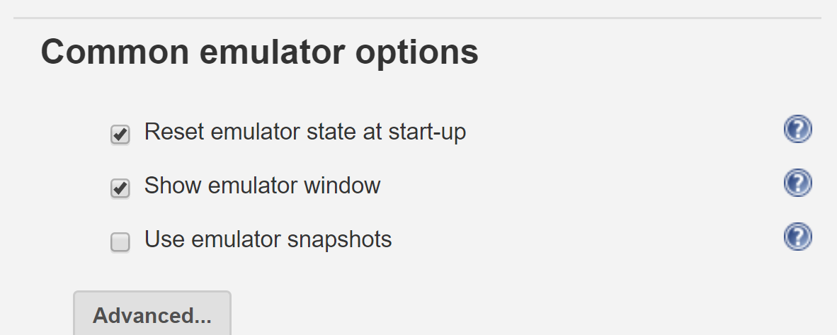

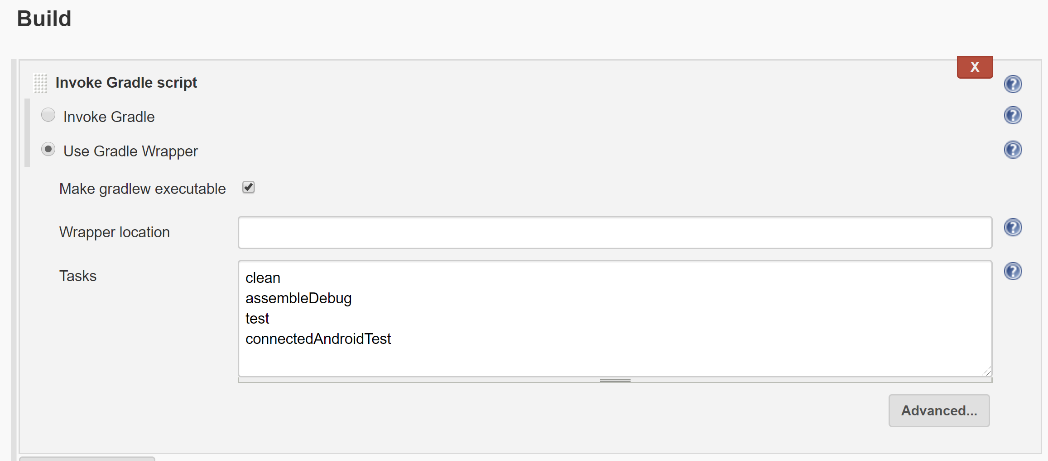

You can get the image of the test result from: C:\Program Files (x86)\Jenkins\workspace\Comp7031_EspressoTest\ . Mine was named “JenkinsEspressoTestResult.PNG”

## Issue with Jenkins permissions and running/creating the emulator

I had an issue with Jenkins not being able to create or access the AVD so I found this temporary fix online:

1. Opens Services
2. Right click Jenkins, select Properties
3. Go to the Log On tab
4. Select “This account”
5. Enter credentials for your admin account. In my case, it was the credentials I used to login to my laptop.