Sahej Bhatia, Evanna Wong, Chris Murray, Muntaj Kahlon

Abstract

Each team should submit the final set of user stories, acceptance criteria for each user story, and screen mockups /wire frames

Photo Gallery App

COMP 7082

* **User Story 1**

As a hobbyist photographer I would like to take a picture.

**Acceptance Criteria**

Lets say I want to take a picture

I open the photo gallery app

On the home page / landing page – press button named “Snap”

On clicking “snap” – the native android camera app comes up

Take a picture using this native camera app

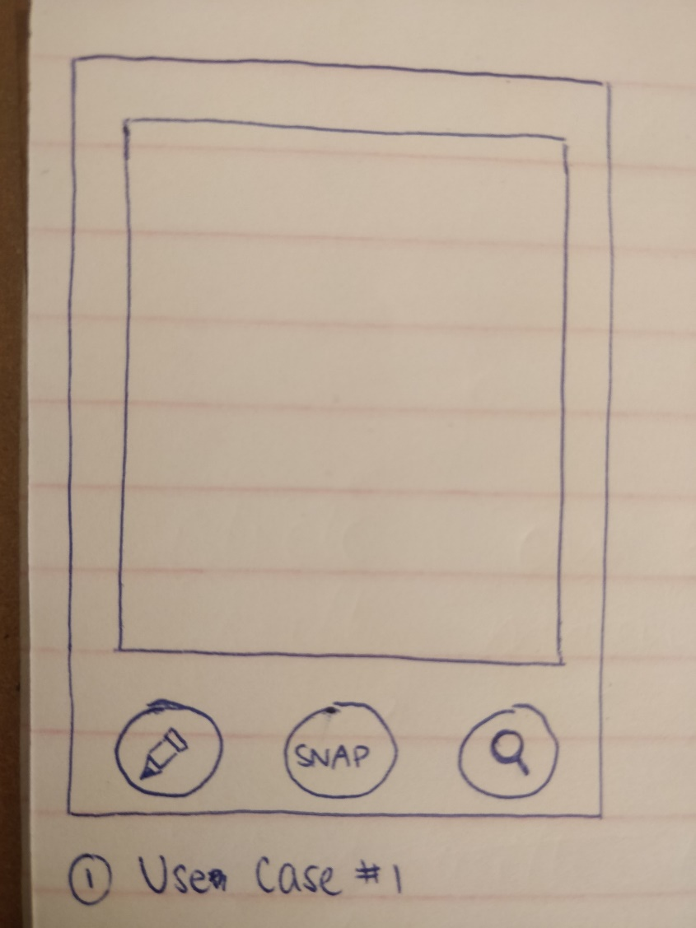

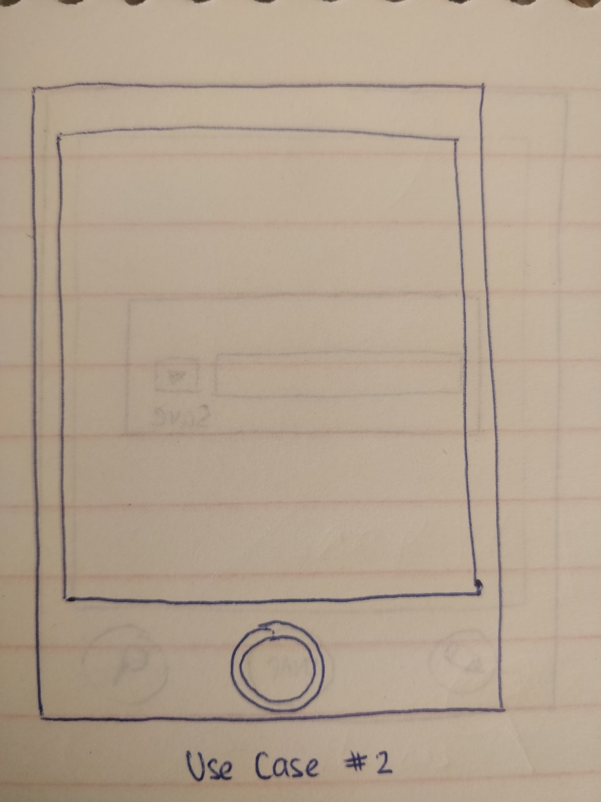

* **User Story 2**

As a hobbyist photographer I would like to preview the picture I just took

**Acceptance Criteria**

After I have just taken a picture ( see user story 1) by clicking on the button called “snap” – the picture should come up in preview mode.

I will have 2 options to discard the picture by clicking on the red X on the bottom left

OR to accept and save the image by clicking on the green check mark on the bottom right

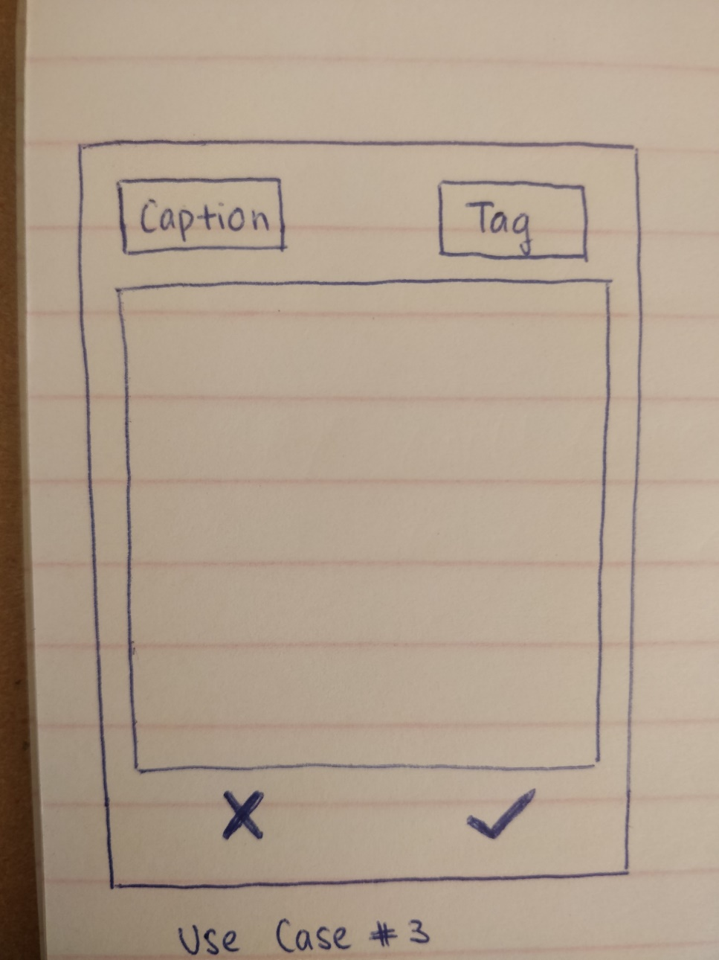

* **User Story 3**

As a hobbyist photographer I would like to categorize and caption the picture I just took

**Acceptance Criteria**

While you are previewing the image you just clicked, the same screen will also give you options to choose a caption and tag.

You will see two buttons to the top.

On clicking the button labelled “Caption” – a small text box will pop open allowing me to enter a caption.

On clicking the button tag – another window will open up where I can choose from a list of drop downs ( previously made tags) or have the option of creating new tags.



* **User Story 4**

As a hobbyist photographer, I would like to search or look up pictures by tag name

**Acceptance Criteria**

On the home page there is a button called search( with a magnifying glass icon).

On clicking search a small box pops open , allowing me to enter a search key work or choose a search tag key word from a drop down list

On clicking enter or ok, it will show me all images that are associated with the tag keyword I just searched with.

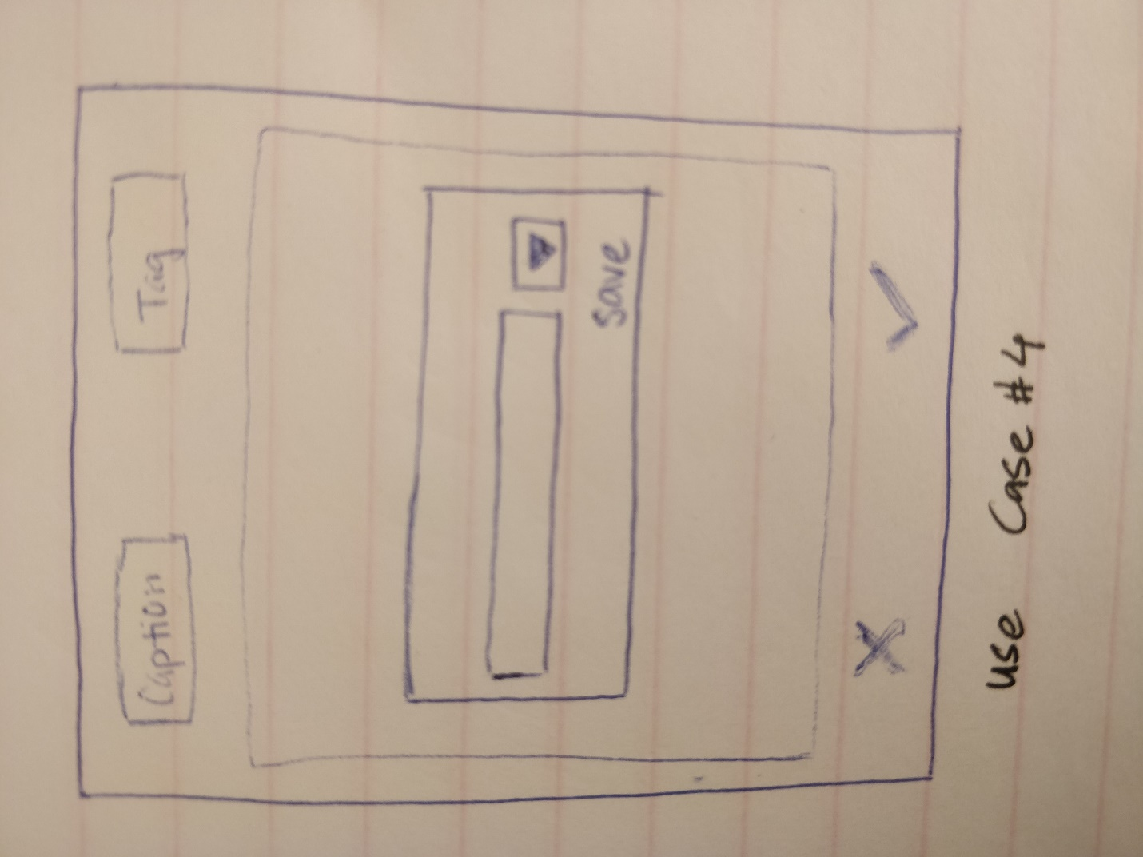

* **User Story 5**

As a hobbyist photographer I would like to add and edit tags on selected pictures

**Acceptance Criteria**

I should be able to select one image taken in the past by scrolling left or right on the home page

Once I have chosen which image I want to make the changes on, I can click a button called edit with a pencil icon.

This will allow me to edit caption and tag that was previously set.

