Mobile shop

Contents

Introduction 1

Web Technologies: 1

Accessibility 3

Website Documentation: 4

Deploy the Website: 7

Requirement Engineering: 8

Conclusion: 9

# Introduction

The selected project is the mobile Shop, I have collaborated with the local shop, I will develop the website and showcase the products over there. For the current project, the website has been developed using Html, CSS and jQuery. The developed website helps to increase the business, create awareness and ensure to open over the different devices with the user-friendly view. There re number of the website pages at the top of the Nav bar.

# Web Technologies:

The following technologies has been used to develop the website:

* HTML
* CSS
* jQuery

HTML is a markup language used to describe the general layout of a webpage. Standard Generalized Markup Language (SGML) has been enhanced by HTML (SGML). For the first time, Tim Berners-Lee created an HTML document from scratch. When it comes to computer network services, there is a distinct difference between the computers that store and access data. The same online page is accessed by millions of individuals using a variety of devices. Each computer must be able to display the web pages that the user is accessing. As a result, in order to show documents received from external systems, each system must be configured properly (Klein, 2003).

Style sheets defined in a markup language such as CSS describe how a document's appearance and formatting should look. In addition to HTML and XHTML, the language can be applied to any type of XML document, such as plain XML, SVG, and XUL, which are all examples of XML documents. When it comes to creating visually appealing webpages, web application interfaces, and mobile app interfaces, CSS is a go-to tool along with HTML and JavaScript. CSS comes in three flavors.

* Internal CSS
* External CSS
* To style a specific HTML element, use inline CSS. style attribute can be added to HTML tag to apply inline CSS.

Benefits: Using inline CSS makes it simple to apply CSS rules. Because of this, we don't need to create any more paperwork.

Secondarily, In order to use Internal CSS, we must add style elements to the html page's head section.

It is possible to apply CSS to any and all of the html components or tags in our file. HTML elements and tags are selected using the CSS selector, and then given styling as described in the above syntax.

A CSS document can be attached to an HTML document in one of three ways, and as a result, it can appear in several places. Designers can use any of the approaches to style a page, and it's up to their discretion. However, each has a distinct purpose. When we have a lot of pages and we want to use the same layout or design on all of them, external CSS is the best option. It's preferable to connect to a single CSS file instead of defining styles for each individual HTML page.

Websites, Hypertext Transfer Protocol (HTTP), Hypertext Markup Language (HTML), and Web browsers are some of the technologies that make up the World Wide Web (HTTP). A web browser is a piece of software used to access the internet (World Wide Web). It serves as a conduit for sending requests for online documents and services to the server.

A web server is a program that responds to network requests from users by delivering files that are used to build web pages across the internet. It's all being done using the Hypertext Transfer Protocol (HTTP) (HTTP).

A webpage is a digital document that can be accessed by anybody who has access to the internet and a web browser and is accessible via the World Wide Web.

Creating and managing websites is referred to as web development. It encompasses web design, web publishing, web programming, and database administration. Developing an application that can be used on a website is the goal (Jaimez-González, 2018).

# Accessibility

People with disabilities are entitled to equal access to technology, and web accessibility is a term that describes the design of websites, tools, and technologies that are made accessible and usable for those with disabilities.

For the following reasons, web accessibility is critical: -

* People with disabilities can access the site in the same way as those without.
* People with disabilities have an equal opportunity to participate in society since technology is made more user-friendly for them.
* It gives them easy access to data and the chance to communicate with people from all over the world.
* Using technology, it makes their lives easier by removing any obstacles that might stand in their way of interacting with any website on the internet at all.

It allows the user to read the information for a longer period of time by making all of the capabilities available on the keyboard. Not a single website seizure has been caused by it.

The following are the various aspects of web accessibility:

**Accessibility Aids**

Using Braille, people with disabilities can access the content on the website for a longer period of time and more effortlessly.

**The screen reader**

For those who are blind or visually challenged, a screen reader is a program that reads out the material on a computer screen for them. Deaf and dumb persons can utilize the website with ease because to the inclusion of sign language and subtitles.

**Speech-to-text technology**

This makes the web more accessible to those who are blind or visually impaired by allowing them to speak their input.

**Magnification of the display**

For those who are visually handicapped, this magnifies and audibly reads the material on the screen.

The newly developed website has been able to cap with the almost all available tools for the screen recording, speech to text etc. with the display magnification to endorse the numbers and screen.

# Website Documentation:

The website has 4 main pages:

* Home
* About Us
* Contact Us
* Mobile Phones List

The content slider has been used, the content has been moving from right to left side. It tells the browser that this is an HTML page, as well as that it is the document's root tag. The format of tags is simple: > for opening tags and /> for closing tags are used.

In the opening tag, it's made clear that the tag's beginning is here. A starting tag, such as html>, tells the browser that the HTML document has begun. the tag's main body Everything that follows the opening tag is referred to as the tag's child tag/value and forms the tag's body. When we're done utilizing the tag, we can simply close the tag to signal the browser that the tag is done. For example, the closing tag /html>

There are some tags that don't need closing tags because they don't have a body, thus they're written in a single tag. Img src="/path/to/image.png">, for example. Since closing the tag isn't necessary in this case, we've merely opened it, and the entire thing has been wrapped up in a single line. It's done this way to save us from having to create any more code.

The number of the CSS blocks and jQuery has been used to enhance the connectivity with the project, helps to make the background image catchier and gives the website a view. Tag values are the attributes of a tag. They function like HTML tag modifiers, adding more details about the tag they modify. 'nameOfAttribute="ValueOfAttribute"' is the most common definition. Img tags feature an attribute called "src" that tells browsers that an image tag has a source of an image to "/path/to/image.png" so it can load and display that image in an img tag, as shown above.

The style.css has been validated to ensure that there is no error in the css file.

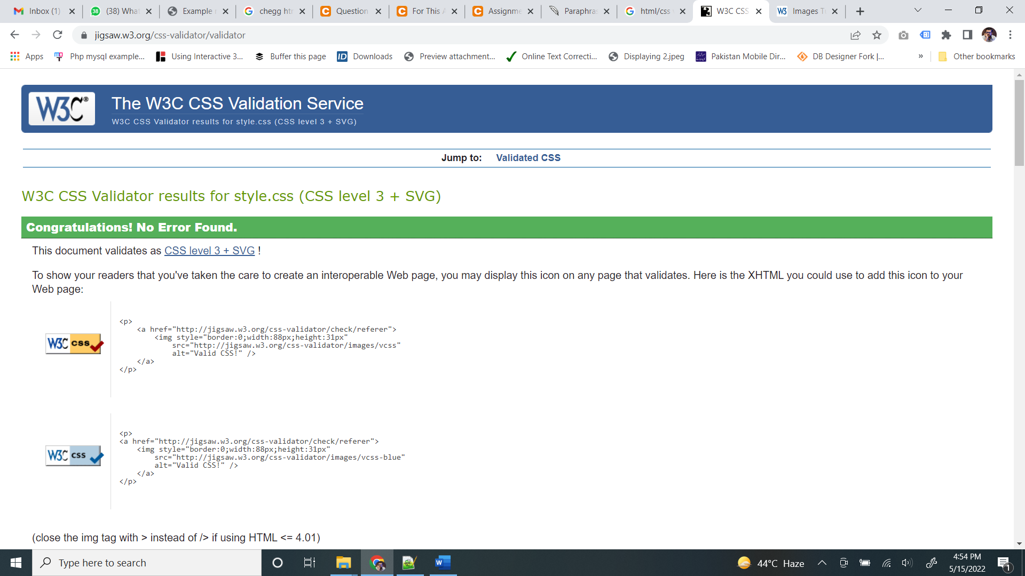

The HTML page has been validated to ensure the performance of the website:

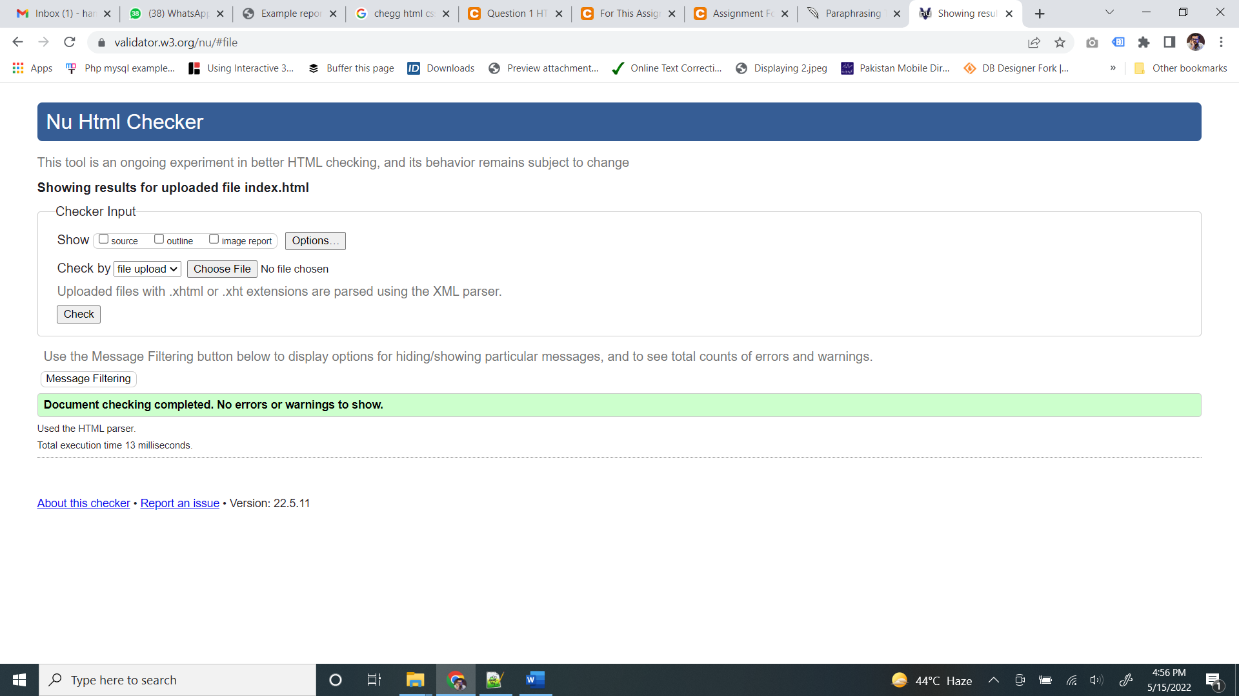

It was easier to understand JavaScript documentation due to the fact that it was organized according to its functionality and complexity and flowed from top to bottom and examples and visual representation were also provided (Arora et al., 2016). There were examples of how to call certain APIs in JavaScript’s miscellaneous section, along with explanations of some of the most important APIs. A jQuery event is about to occur when $(document) .ready(functon() Do something ") is called. Our magic begins when the HTML document itself is placed within the parentheses. jQuery's.ready(); function is a simple action, or function. It declares, "hey, I'm going to do something as soon as the HTML document is finished!"

Anything in parentheses around.ready() is the jQuery event that occurs when the HTML document is complete. There is a jQuery object called $(document). The $() function is disguised as a jQuery object; it transforms the document. One can think of ready() as a sort helper that runs the code inside its parenthesis when the HTML document is ready. The first thing. Ready() does after the HTML document has loaded is call a function() callback function. A placeholder called Do something is where these actions would be placed.

# Deploy the Website:

The most "conventional" method of distributing your code is also the simplest, according to many. Simply moving (or dragging and dropping) files from their local copy of their code to the server is all that is required. The modern method is to use the GitHub, GitHub repository helps to manage the code, upload commit, push and pull (Arora et al., 2016). The major steps involved in it is as follows:

Step 1: One of the first steps is to create a new GitHub repository

Once you've entered a name for your repository, click the "Create Repository" button to get started.

Step 2: Add the GitHub pages dependency.

If you haven't already, create a react app.

and then execute the command below

npm install gh-pages — save-developer

Step 3:

GitHub Repository through Remote GitHub

Step 4:

Commit the Changes

# Requirement Engineering:

Your project's foundation is built on functional and nonfunctional needs. They communicate your goals and expectations to your development team and outline the tasks they will be responsible for accomplishing (Arora et al., 2016).

Your website's functional requirements are its what. Getting a user to take action on your website is all about the features and basic operations of your e-store. Website's "how" can be found in its "non-functional requirements." They are known as a system's quality qualities, and they contribute to the overall user experience and implicitly indicate some broad, abstract product expectations.

E-commerce store's user experience is shaped by these needs, which represent the "how" of your website. They are implemented as a collection of web features that combine to fulfil the functional requirements. Users should be able to readily locate the products on the website, and they should be visually appealing to them (Shuvalova, 2021).

* Usability
* Security
* Maintainability.
* Performance
* Scalability.

The requirement engineering phase of the project is as follows:

* Showcase the products
* Showcase the About Us
* Showcase the Contact Us with all contact information’s

# Conclusion:

The website has been able to fight with the number of the challenges, it includes the development, alignment of content and much more with the jQuery. The other major challenge is to understand the concept of repository, GitHub and then path management as the major part of the project. The concept of push-pull and commit helps to understand how actually the GitHub works and what are their major related benefits. The project has been able to understand the alignment of the content, the series is the important to understand and manipulate.

# References

Arora, R., Goel, S., & Mittal, R. (2016). Supporting collaborative software development over GitHub. *Software: Practice And Experience*, *47*(10), 1393-1416. https://doi.org/10.1002/spe.2468

Jaimez-González, C. (2018). Portal web con recursos didácticos digitales para el aprendizaje de HTML y CSS / Web portal with HTML and CSS digital learning resources. *RIDE Revista Iberoamericana Para La Investigación Y El Desarrollo Educativo*, *8*(15), 833-860. https://doi.org/10.23913/ride.v8i15.323

Klein, J. (2003). Building Enhanced HTML Help with DHTML &amp; CSS [Book Review]. *IEEE Transactions On Professional Communication*, *46*(1), 68-69. https://doi.org/10.1109/tpc.2002.808344

Shuvalova, O. (2021). METHODS OF TEACHING HTML AND CSS STYLES IN THE DISCIPLINE OF INFORMATICS FOR STUDENTS OF PEDAGOGICAL INSTITUTES. *OPEN EDUCATIONAL E-ENVIRONMENT OF MODERN UNIVERSITY*, (10), 241-253. https://doi.org/10.28925/2414-0325.2021.1020