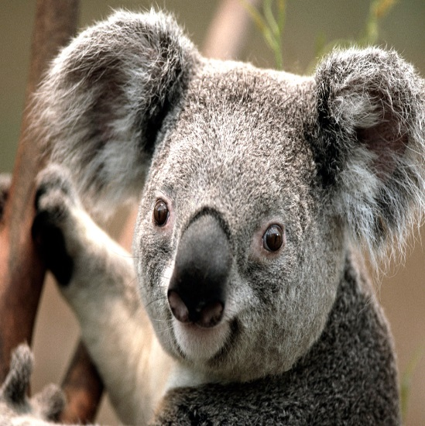

**Taka Morikawa**

**CONTACT**

 12

 takahiro.morikawa.tm@gmail.com

 12

12



 12

**EDUCATION**

4

1

Null - Null

1

1

Null - Null

1

1

Null - Null

**ABOUT ME**

My burning curiosity for coffee has brought me to Melbourne to know what the best coffee is. I would like to work as Barista at hospitality position, where I can utilize my coffee making skills with learning new techniques.

I would like to provide exceptional service to customers with improving communication skills.

**WORK EXPERIENCE**

* Interactive Data

Content Analyst

Oct 2015 - May 2017

* ICE Data Services

Fixed Income Analyst

Jun 2017 - Present

* A's Restaurant

Customer Service

Jan 2000 - Jan 2000

**SKILLS**

* s1a - l1a
* s1a - l1a
* s1a - l1a