Guide Start Project Mobile

Step 1: Get project file and start Server in BE

Step 2: Open Android studio

Step 3: Open Project

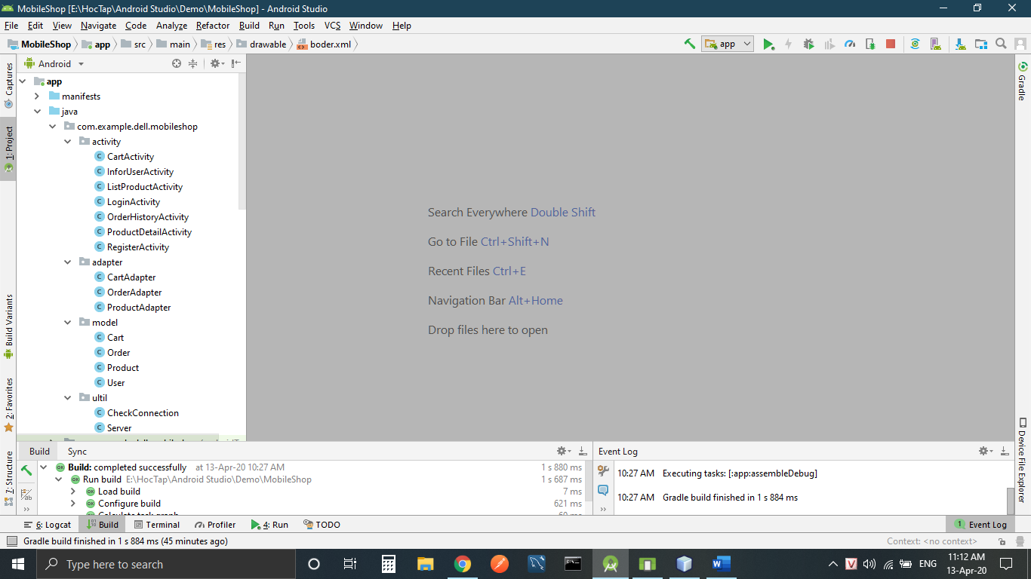

Step 4: Open Server.java in package Ultil

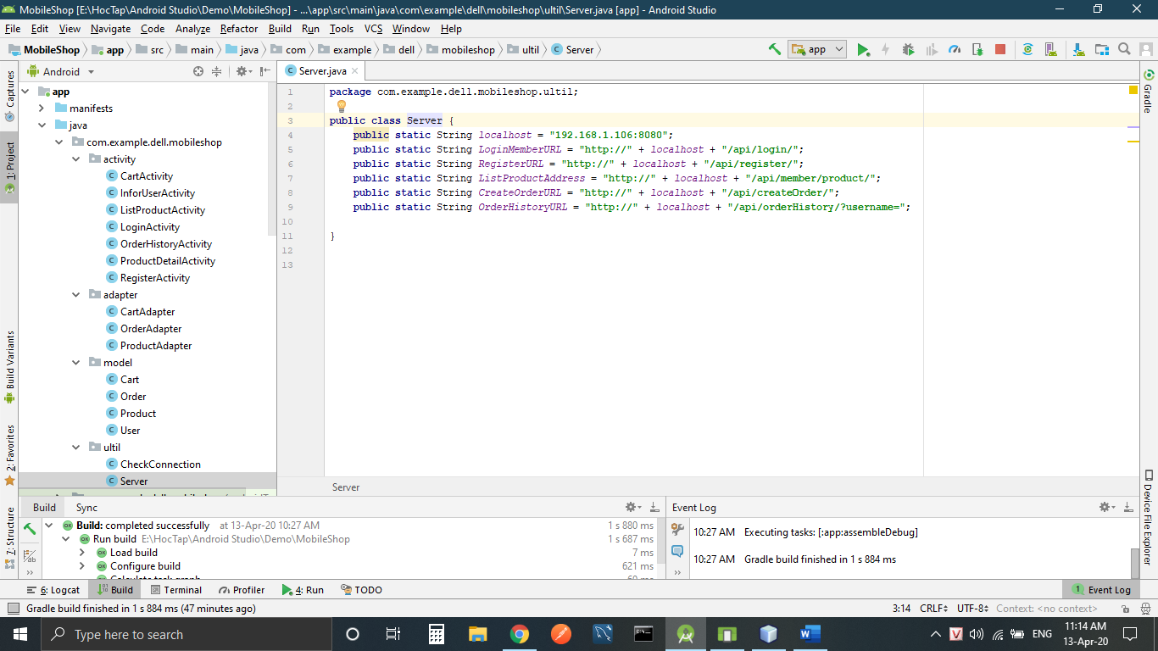

Step 5: Open cmd and type “ipconfig” to get your laptop IP address

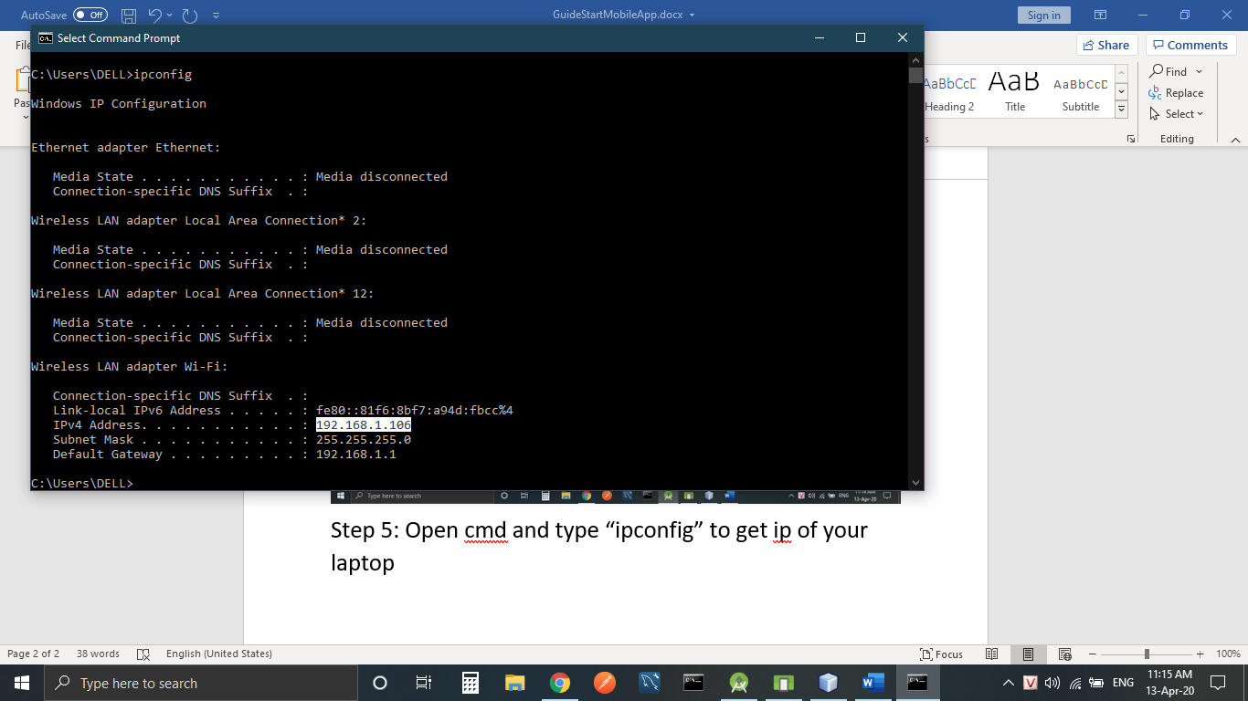

Step 6: Copy IP address to var localhost

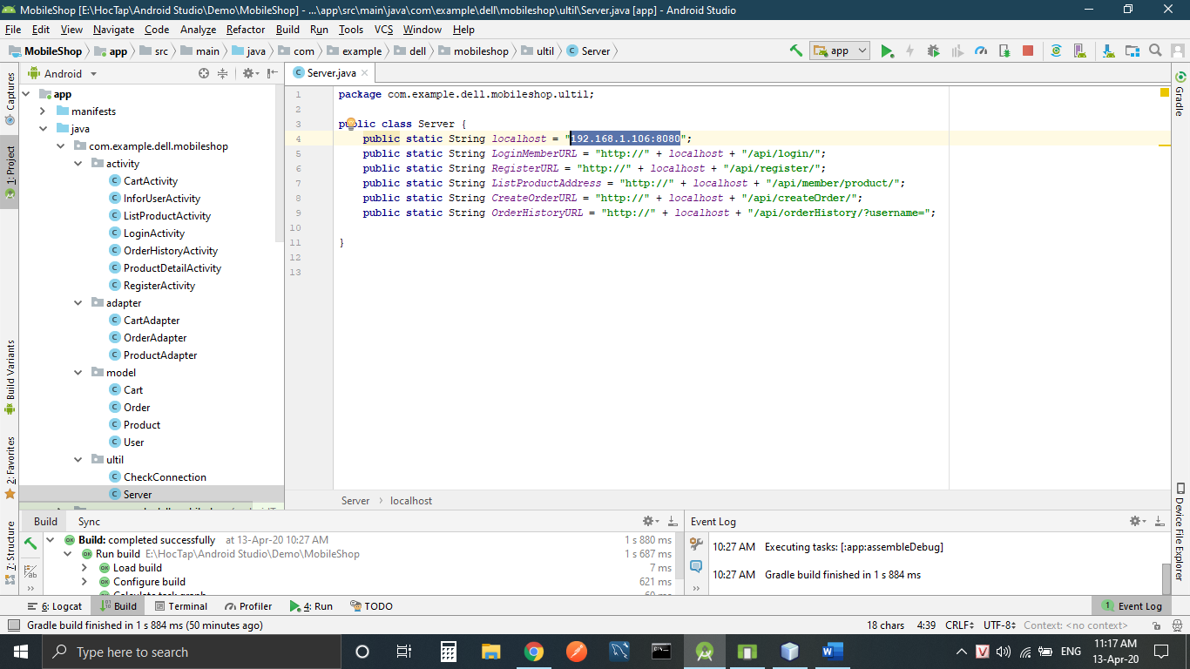

Step 7: Start project

