**Mobile Shop**

**Lê Hoàng Vũ – Lê Gia Bảo -Bùi Mạnh Tùng**

**User Guide**

1. **Admin**

**1.1 Go to Add new product page**

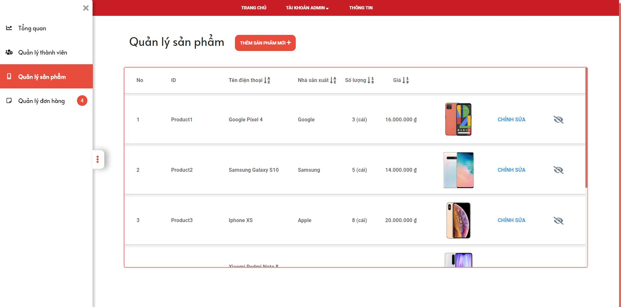

1

3

2

|  |  |
| --- | --- |
| **Step** | **Description** |
| Pre-condition | Login as role “Admin” |
| 1 | Click on “Quản lý Sản Phẩm” |
| 2 | Click on “Thêm mới Sản Phẩm” to go Add new Product Page |
| 3 | Click on “Chỉnh sửa” to go Update Product Page |

* + 1. **Add new Product**

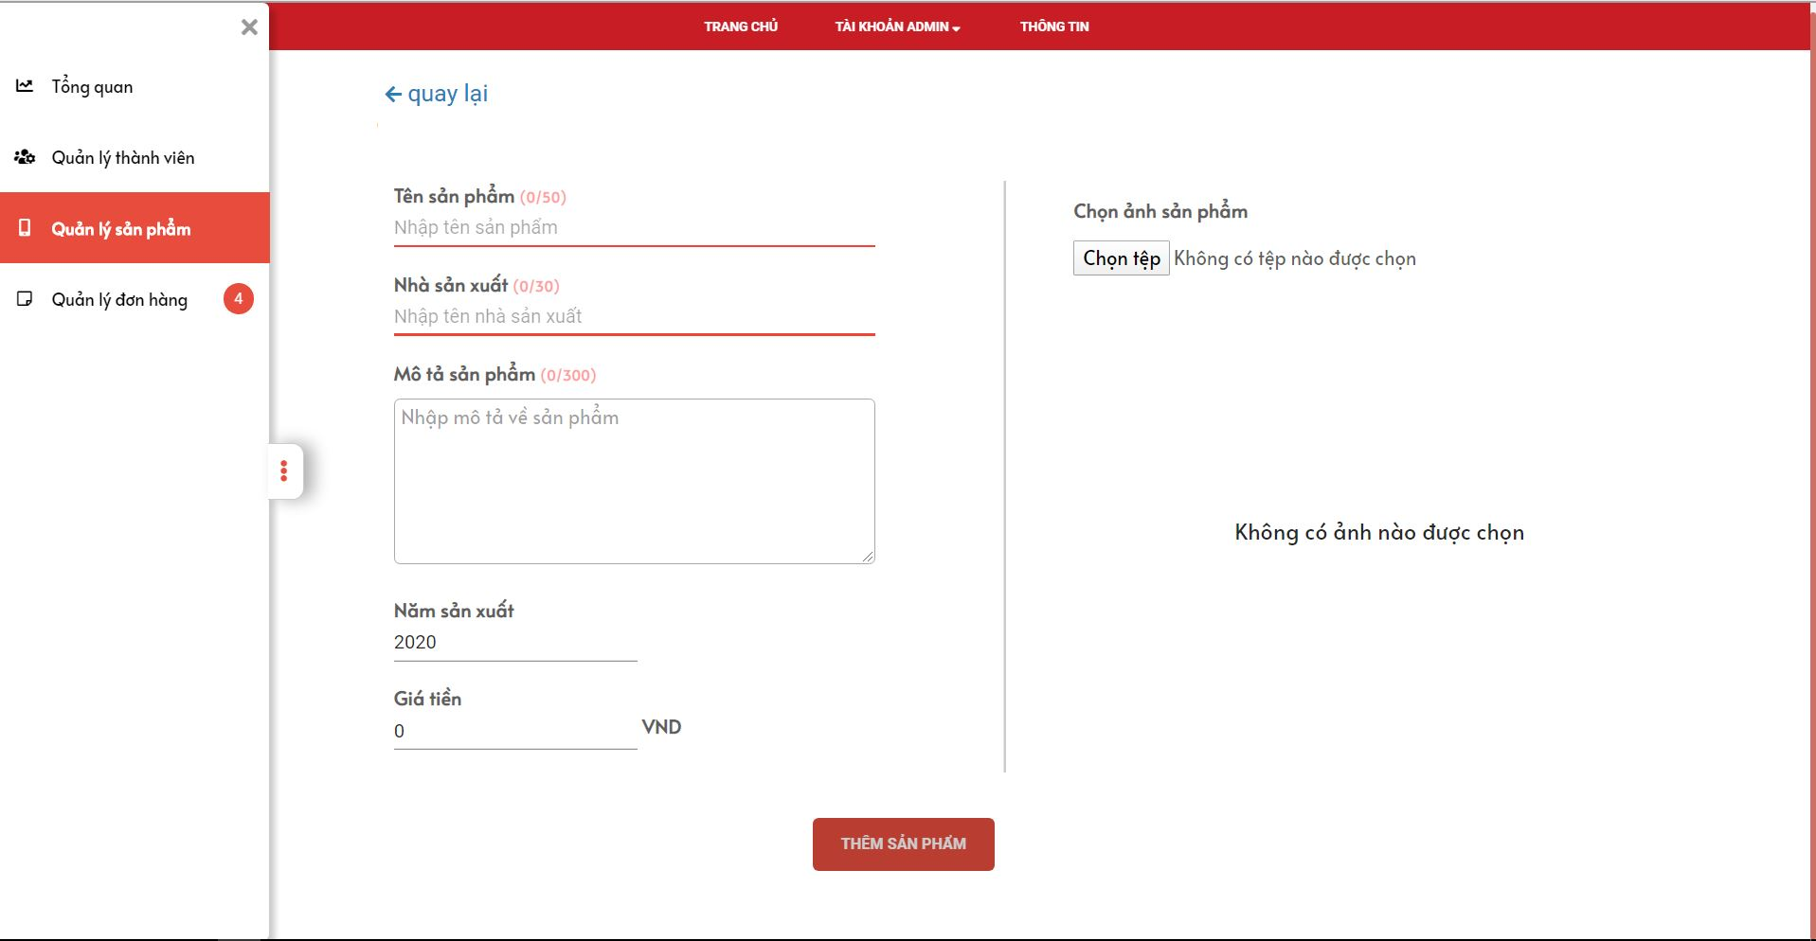

7

6

5

4

3

1

2

|  |  |
| --- | --- |
| **Step** | **Description** |
| Pre-condition | Login as role “Admin” |
| 1-5 | Fill in all fields ( Tên sản phẩm, Nhà sản xuất, Mô tả sản phẩm, Năm sản xuất, giá tiền ) |
| 6 | Click on “Chọn tệp” to Choose product image |
| 7 | After fill in all fields and choose image, click on “Thêm sản phẩm” button to add product |

* + 1. **Update the Product**

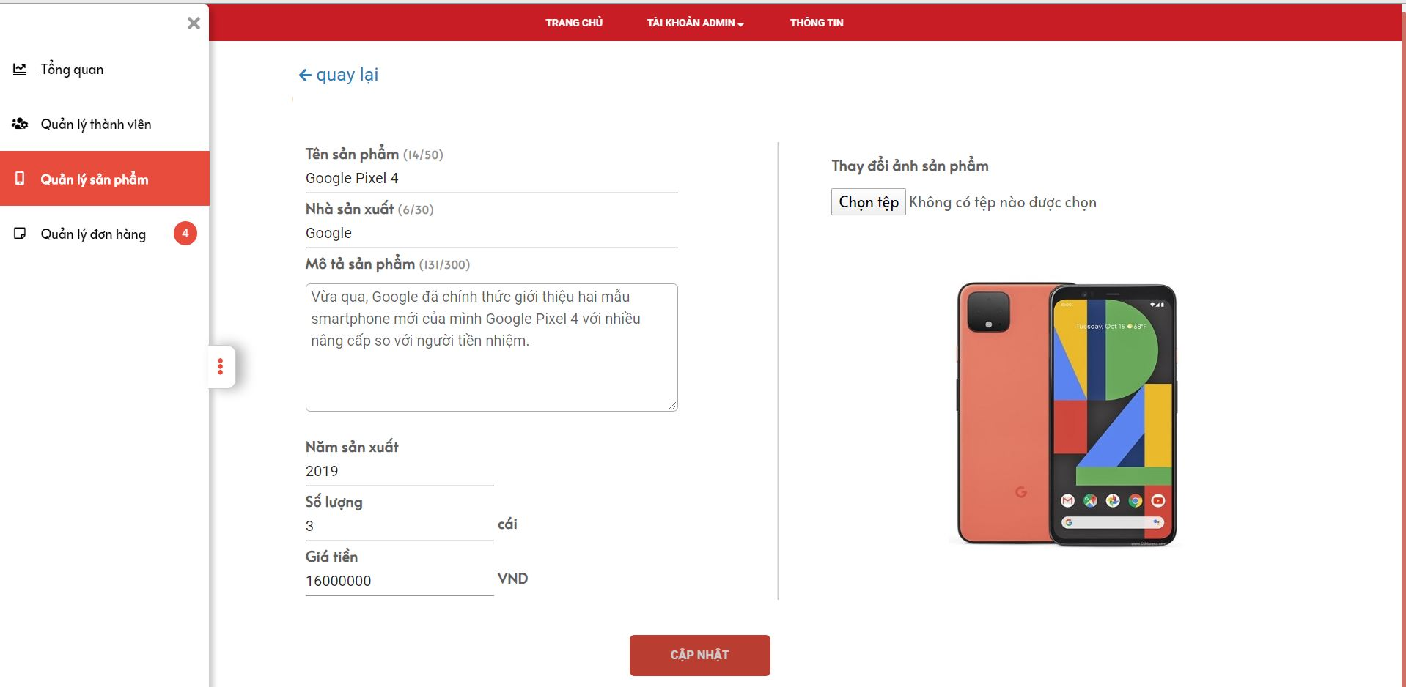

8

7

6

5

4

3

2

1

|  |  |
| --- | --- |
| **Step** | **Description** |
| Pre-condition | Login as role “Admin” |
| 1-6 | Change one/all fields ( Tên sản phẩm, Nhà sản xuất, Mô tả sản phẩm, Số lượng, Năm sản xuất, giá tiền ) |
| 7 | Click on “Chọn tệp” to Change product image |
| 8 | After change one/all fields and image, click on “Cập Nhật” button to update product |

**1.2 Manage Member**

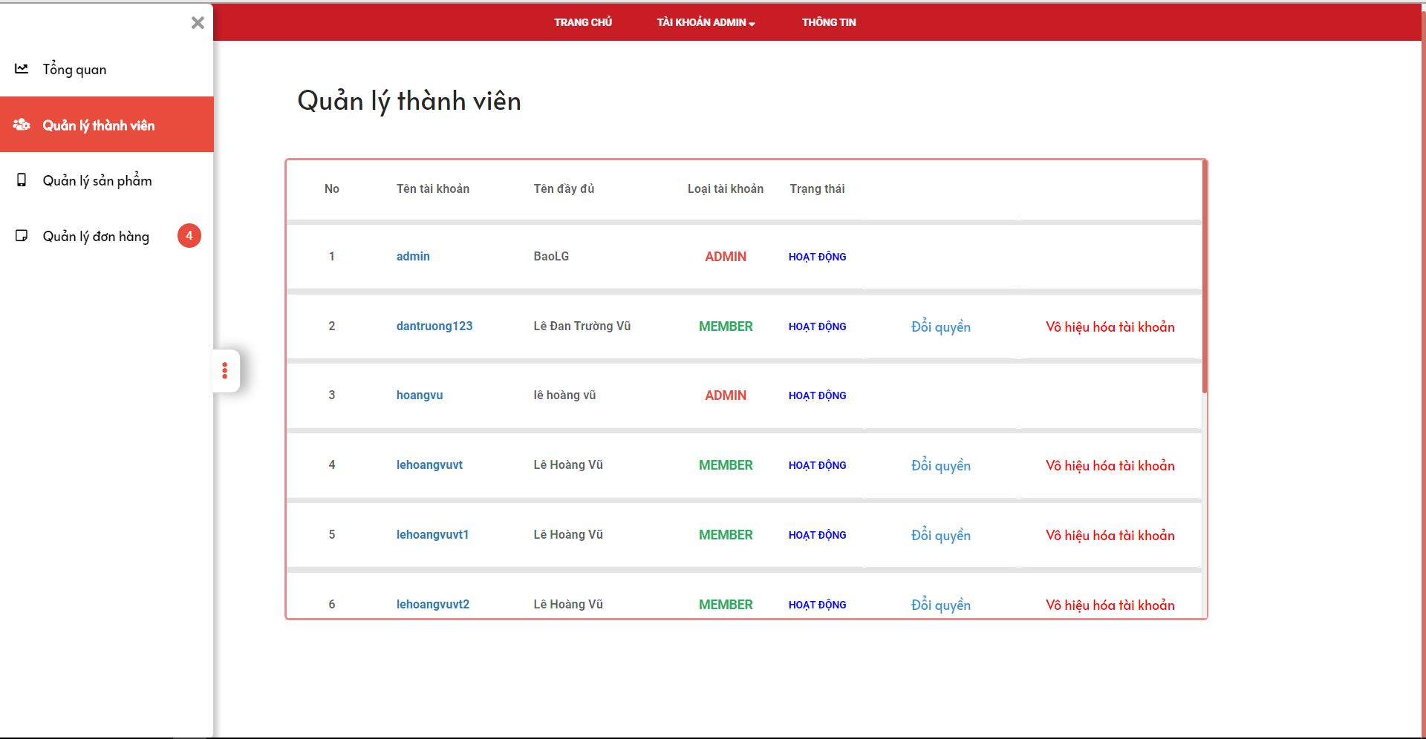

2

4

3

1

|  |  |
| --- | --- |
| **Step** | **Description** |
| Pre-condition | Login as role “Admin” |
| 1 | Click on “Quản lý thành viên” to see list members |
| 2 | Click on “Tên của mỗi tài khoản” to see member detail |
| 3 | Click on “Đổi quyền” to set role of member |
| 4 | Click on “Vô hiệu hóa tài khoản” block member |

* + 1. **Member detail**

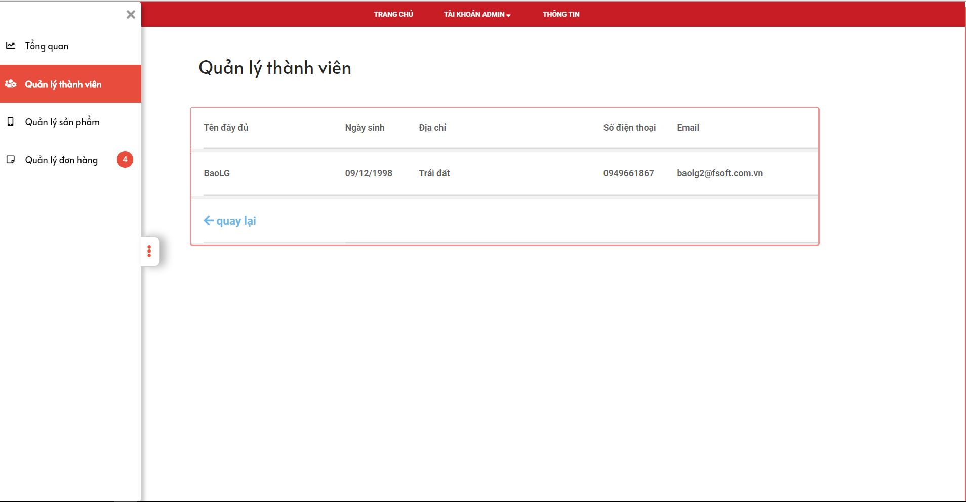

1

|  |  |
| --- | --- |
| **Step** | **Description** |
| Pre-condition | Login as role “Admin” |
| 1 | Click on “Quay lại” to back to List member page |

* 1. **Manage order**

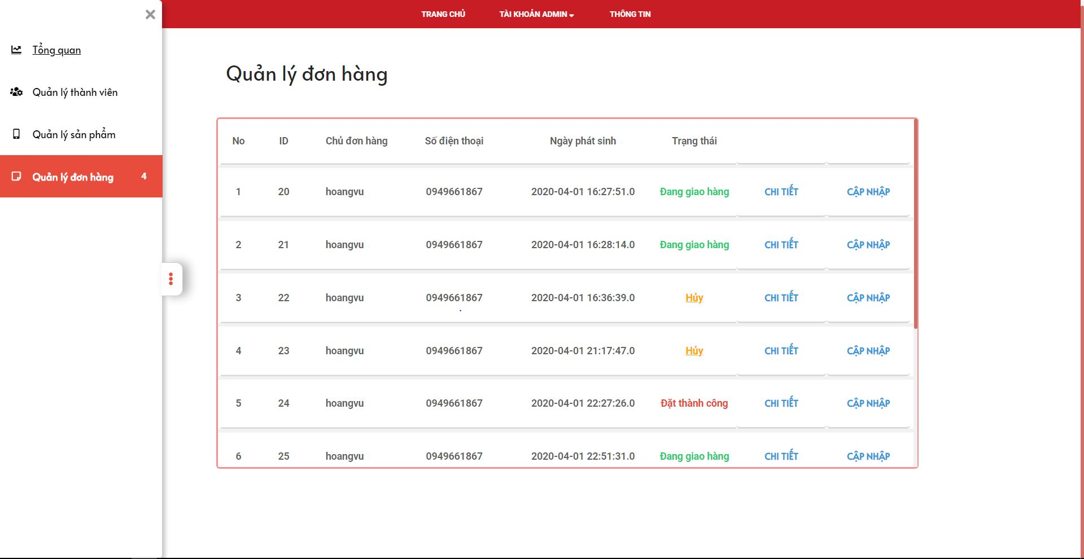

3

2

1

|  |  |
| --- | --- |
| **Step** | **Description** |
| Pre-condition | Login as role “Admin” |
| 1 | Click on “Quản lý đơn hàng” to show list orders |
| 2 | Click on “Chi Tiết” to show order detail |
| 3 | Click on “Cập nhật” to show update status of order |

* + 1. **Order Detail**

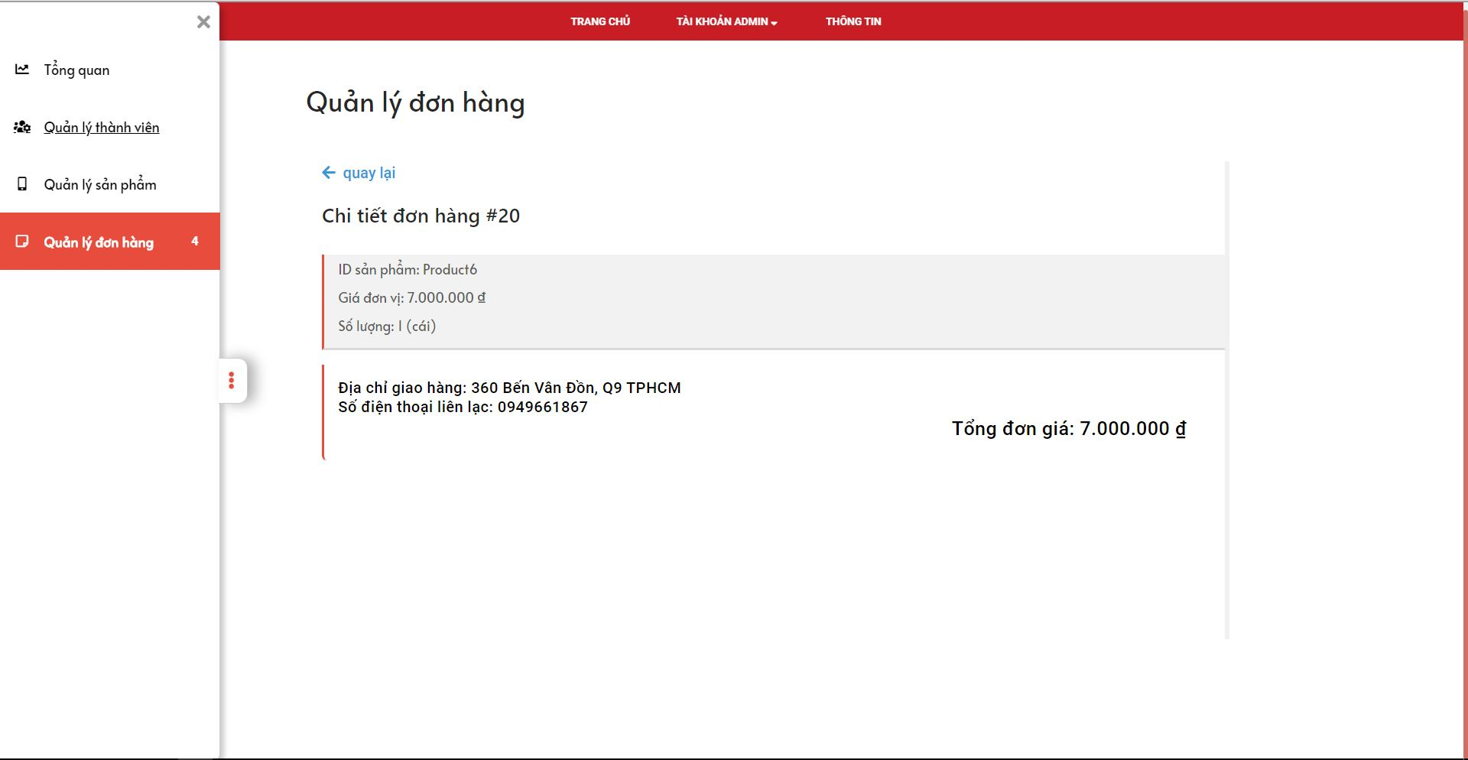

1

|  |  |
| --- | --- |
| **Step** | **Description** |
| Pre-condition | Login as role “Admin” |
| 1 | Click on “Quay lại” to back to List order page |

* + 1. **Update status order**

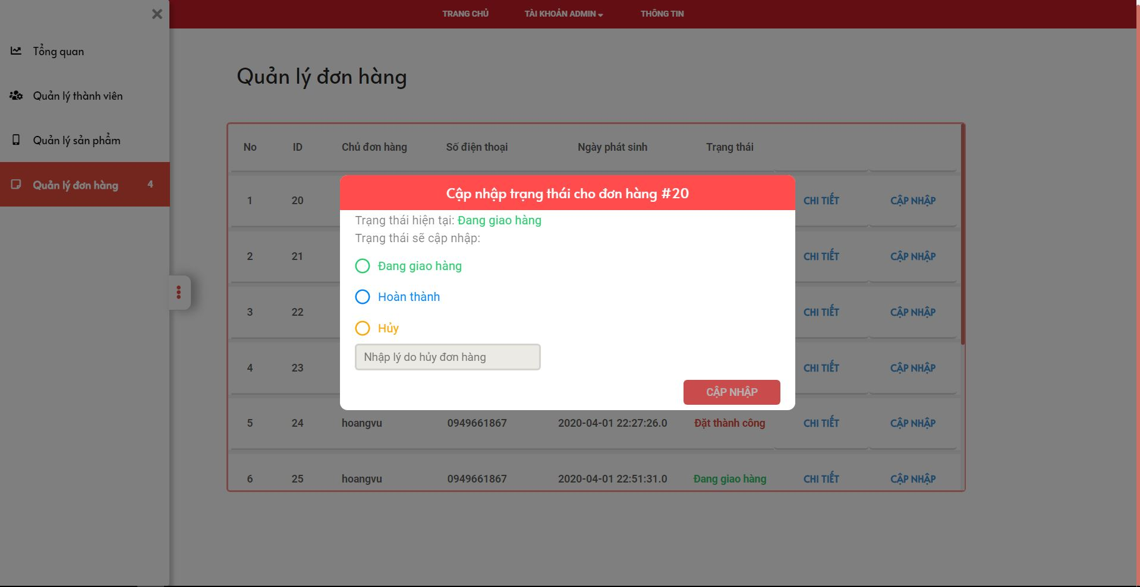

5

4

3

1

2

|  |  |
| --- | --- |
| **Step** | **Description** |
| Pre-condition | Login as role “Admin” |
| 1-3 | Choose one of radio button “Đang giao hàng” “Hoàn Thành” “Hủy” |
| 4 | If you choose 3, you must fill this field “Nhập lý do hủy đơn hàng” |
| 4 | After choice, you click on “Cập Nhật” to update status order |

1. **Member**
2. **Home page**

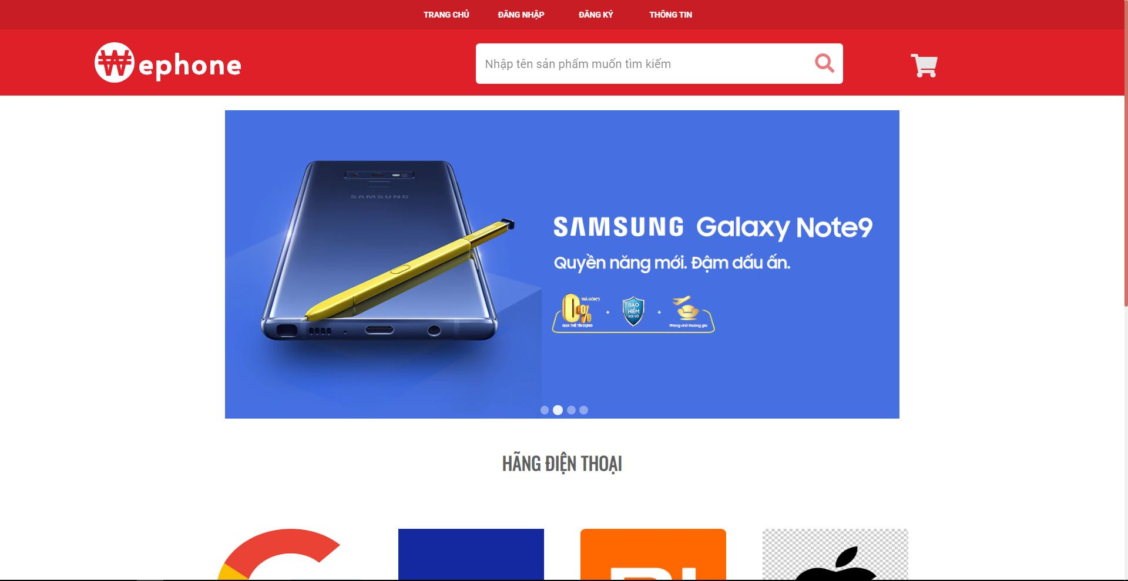

7

6

5

4

3

8

2

1

|  |  |
| --- | --- |
| **Step** | **Description** |
| 1 | Click on “Đăng nhập” to go login page |
| 2 | Click on “Đăng ký” to go register page |
| 3 | Fill this fill to Search product |
| 4-7 | Click on one of this logo to go list product of this company |
| 8 | Click icon “Cart” to go cart page |

* 1. **Login Page**

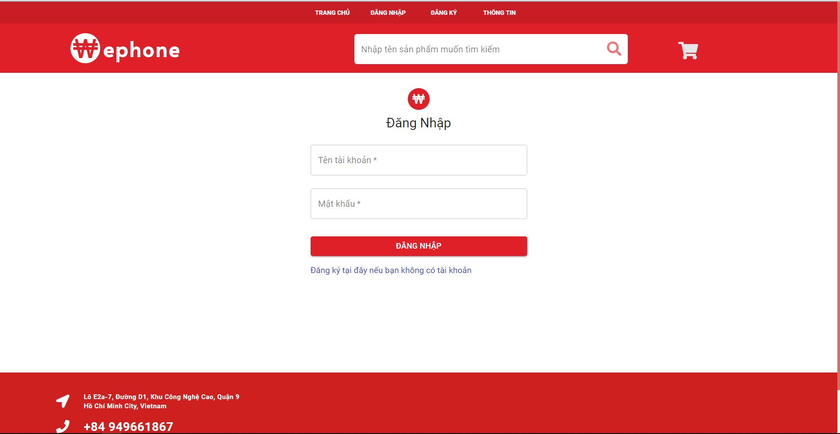

4

3

2

1

|  |  |
| --- | --- |
| **Step** | **Description** |
| 1-2 | Fill all field ( “Tên tài khoản” , “ Mật khẩu” ) |
| 3 | After fill all field, click on “Đăng nhập” to login |
| 4 | Click on “Tại đây” to go register page |

* 1. **Register Page**

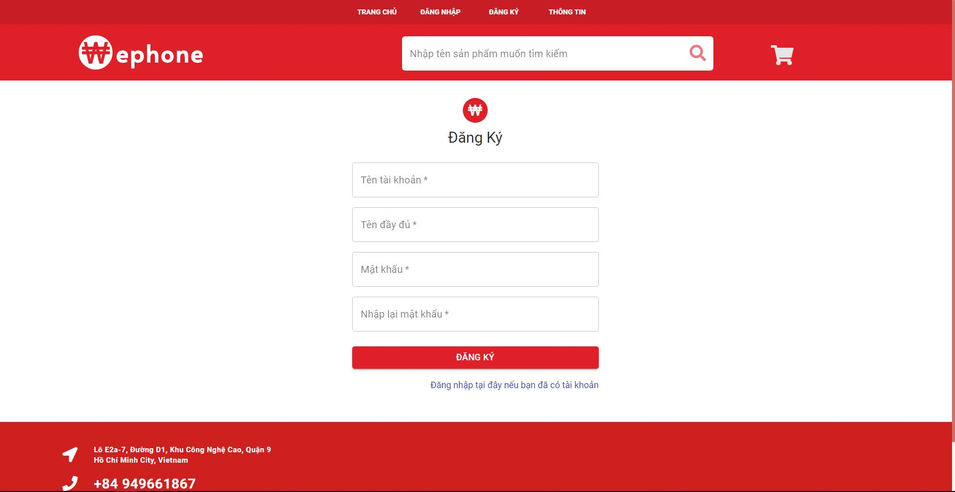

6

5

4

3

2

1

|  |  |
| --- | --- |
| **Step** | **Description** |
| 1-4 | Fill all field ( “Tên tài khoản” , “ Tên đầy đủ” , “Mật khẩu” , “Nhập lại mật khẩu” ) |
| 5 | After fill all field, click on “Đăng ký” to register |
| 6 | Click on “Tại đây” to go login page |

* 1. **Search Product**

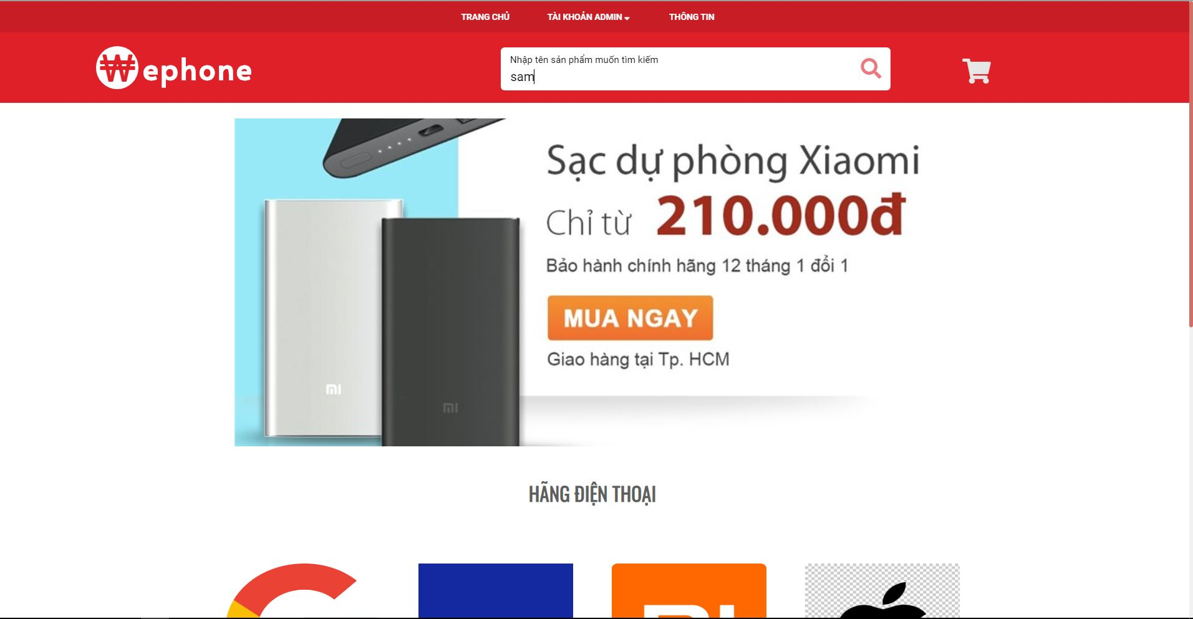

2

1

|  |  |
| --- | --- |
| **Step** | **Description** |
| 1 | Fill this field “Nhập tên sản phẩm muốn tìm kiếm” to search |
| 2 | Click icon to search product |

* + 1. **Search Result**

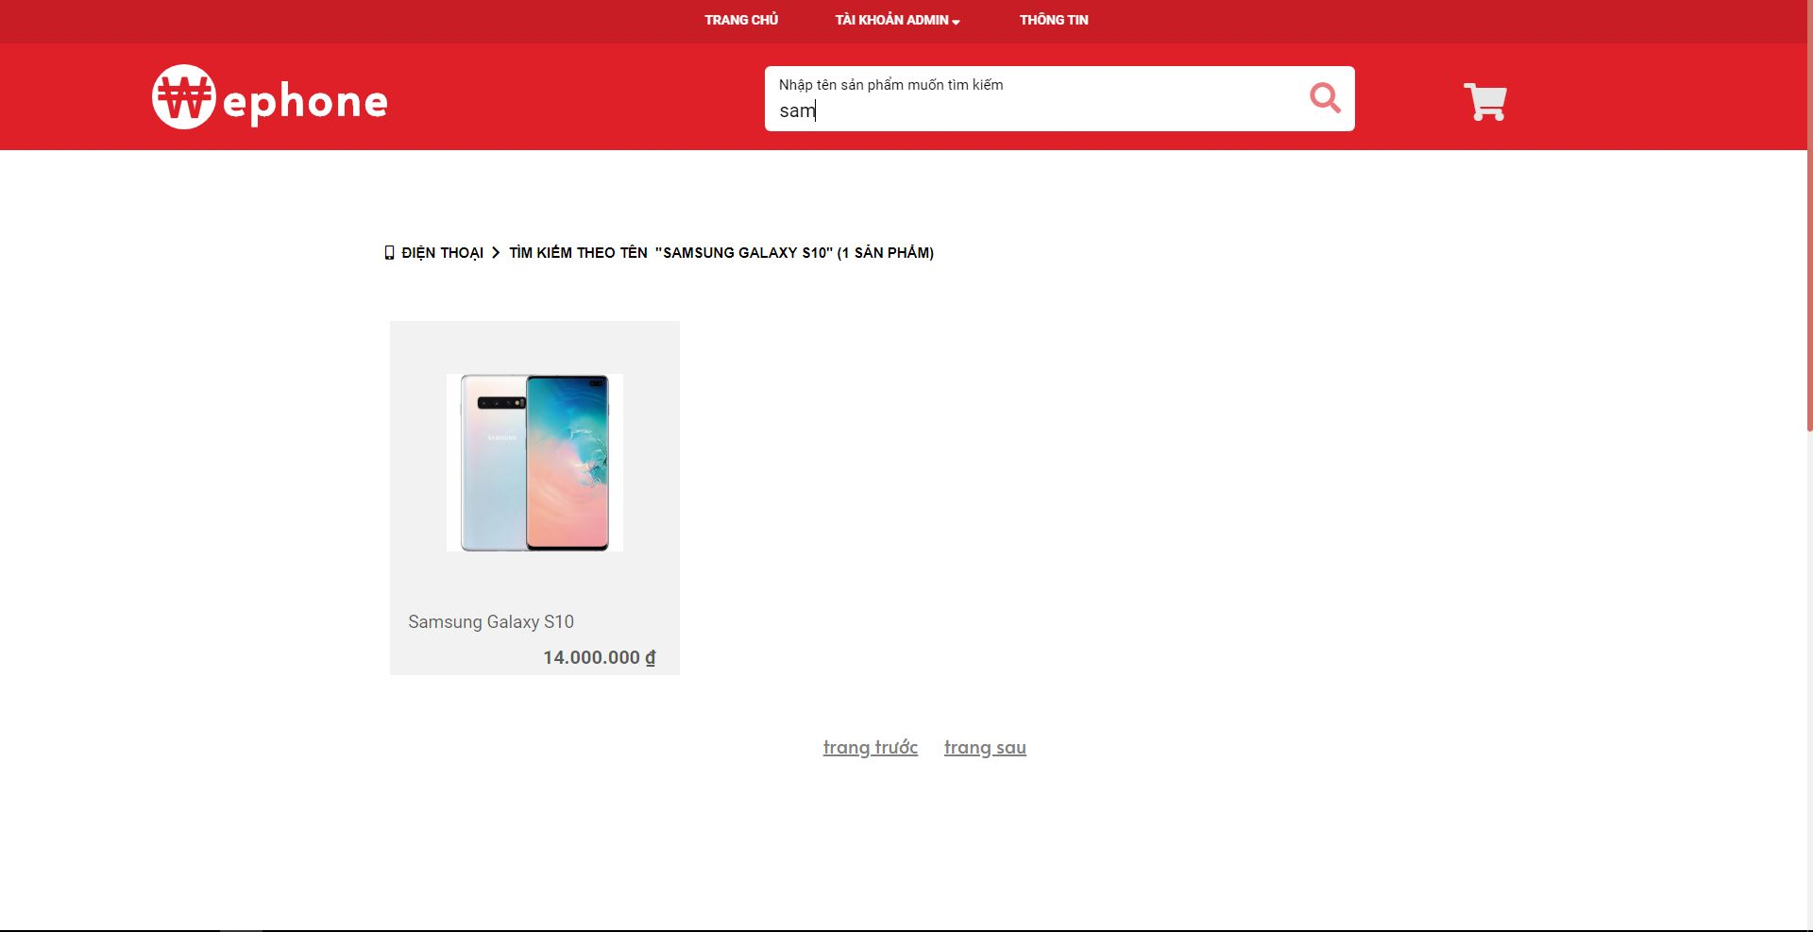

* 1. **Filter product by name company**

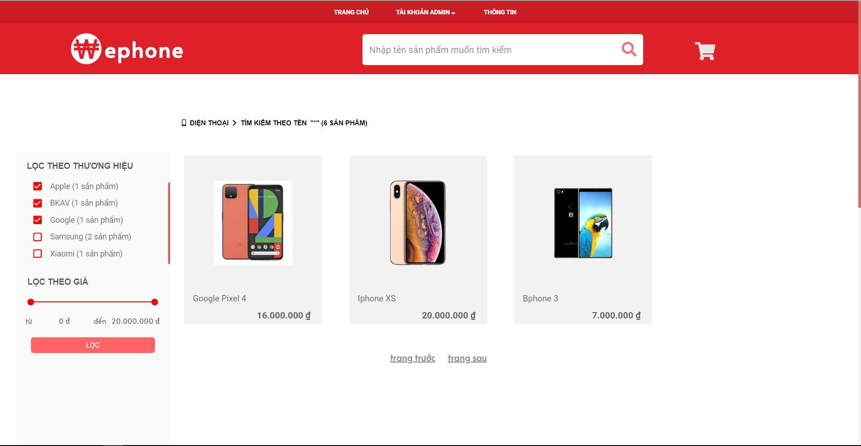

67

5

4

3

2

1

|  |  |
| --- | --- |
| **Step** | **Description** |
| 1-5 | Choose name company to search the product |
| 6 | Click on product to show product detail |

* 1. **Filter product by price**

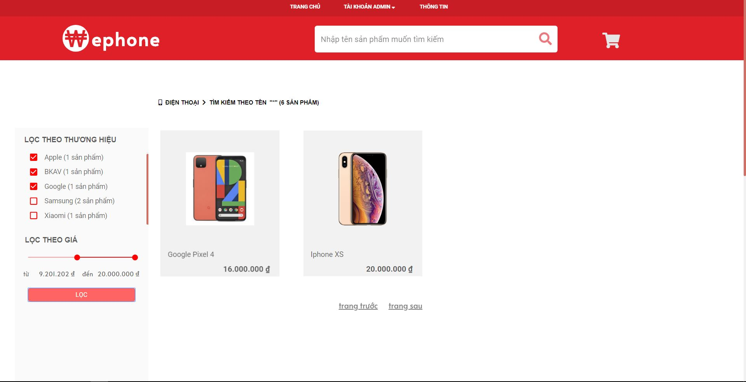

3

2

1

|  |  |
| --- | --- |
| **Step** | **Description** |
| 1 | Set range of price that you want to search |
| 2 | Click on “Lọc” to search by price |
| 3 | Click on product to show product detail |

* 1. **Product detail**

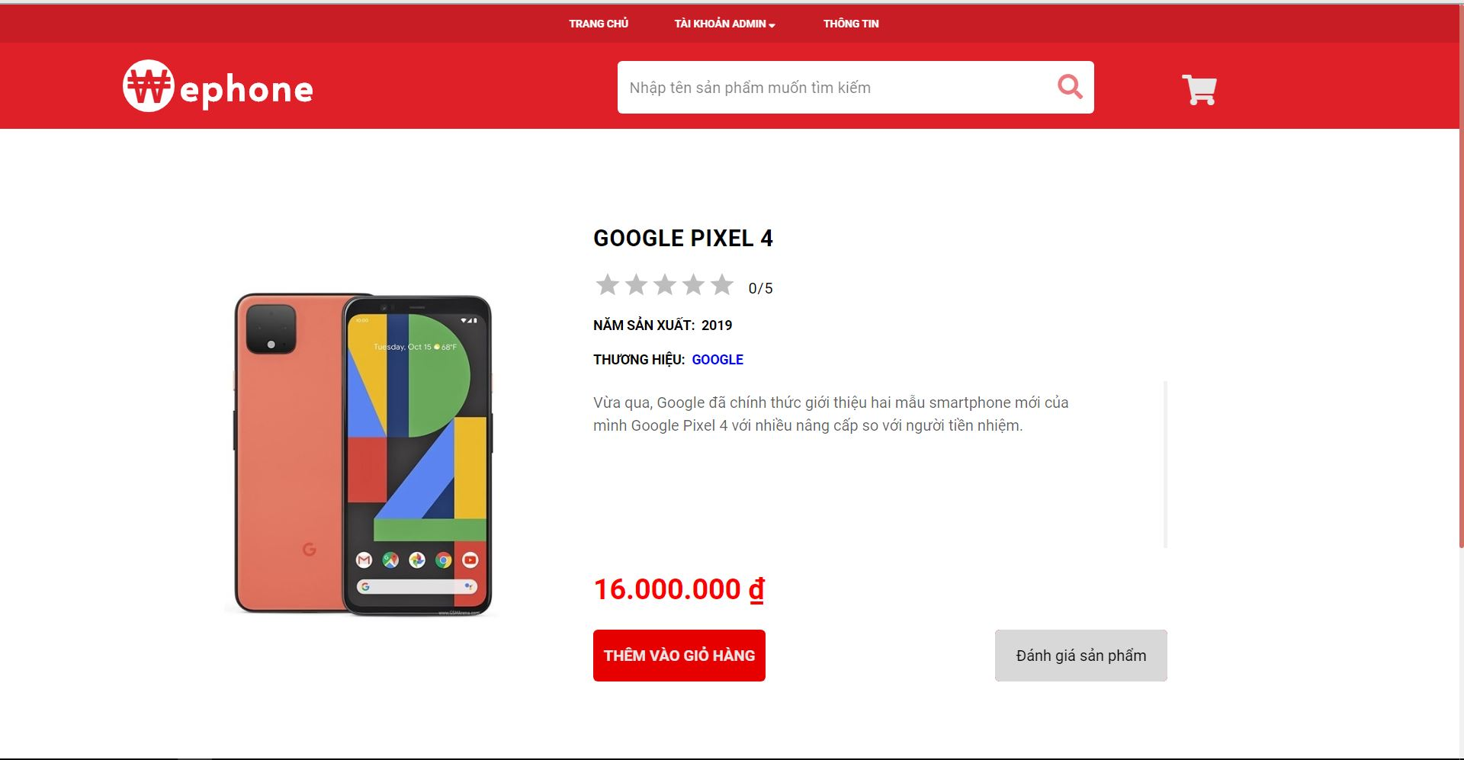

2

1

|  |  |
| --- | --- |
| **Step** | **Description** |
| 1 | Click on “Thêm vào giỏ hàng” to add product to cart |
| 2 | Click on “Đánh giá sản phẩm” to rate the product |

* + 1. **Rate Product**

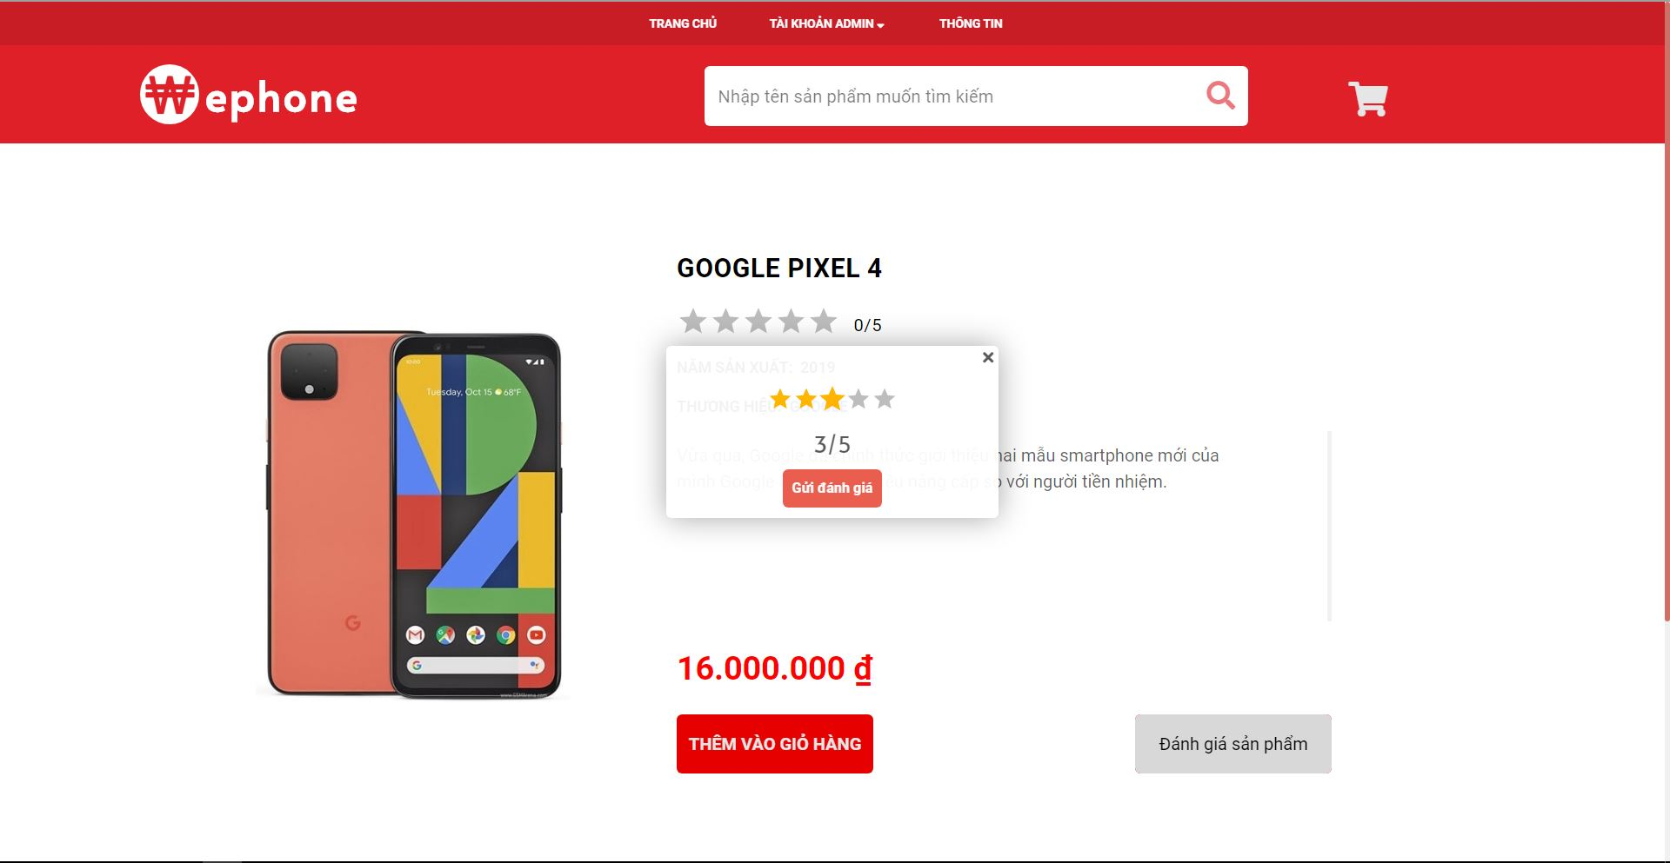

2

1

|  |  |
| --- | --- |
| **Step** | **Description** |
| Pre-condition | Login as role “Member/Admin” |
| 1 | Set star to rate product |
| 2 | Click on “Gửi đánh giá” to rate product |

* 1. **Cart products**

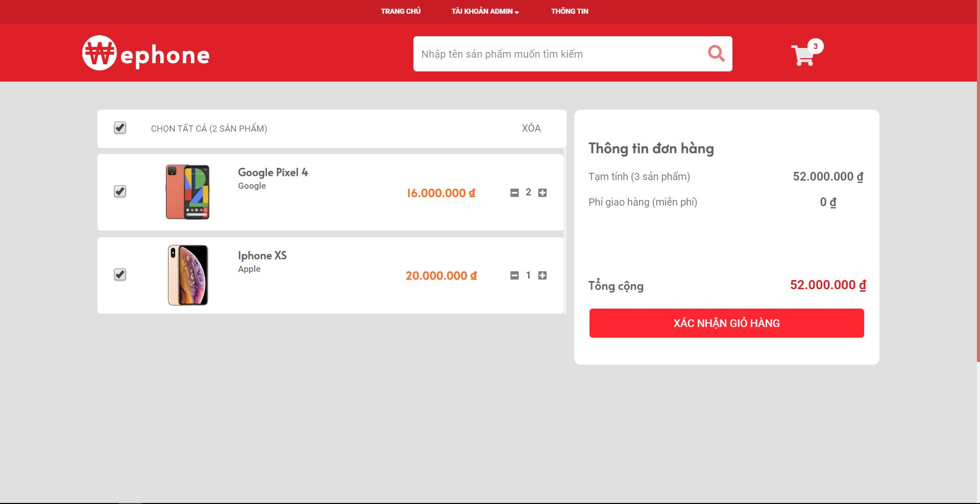

7

5

4

6

3

2

1

|  |  |
| --- | --- |
| **Step** | **Description** |
| 1-3 | Choose one or all product to payment or delete |
| 4-5 | “+/-“ to set quantity of product that you want to buy |
| 6 | Click on “Xóa” to delete product from cart |
| 7 | Click on “Xác nhận giỏ hàng” to payment |

* 1. **Step by step to order product**
     1. **Step 1**

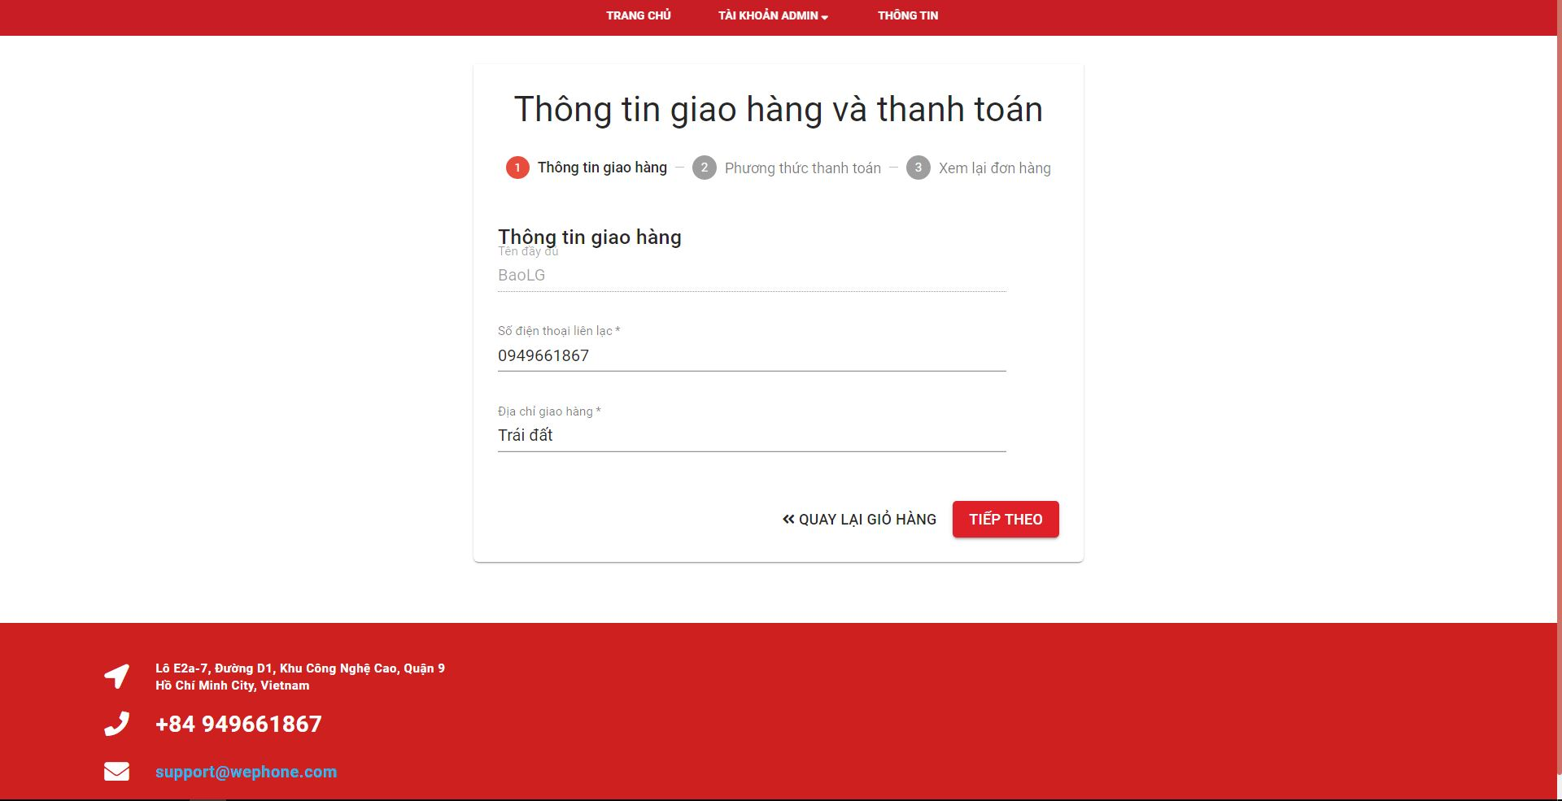

4

3

2

1

|  |  |
| --- | --- |
| **Step** | **Description** |
| Pre-condition | Login as role “Member/Admin” |
| 1-2 | Fill all of this field to order |
| 3 | Click on “Tiếp theo” to go to next step |
| 4 | Click on “Quay lại giỏ hàng” to go to cart page |

* + 1. **Step 2**

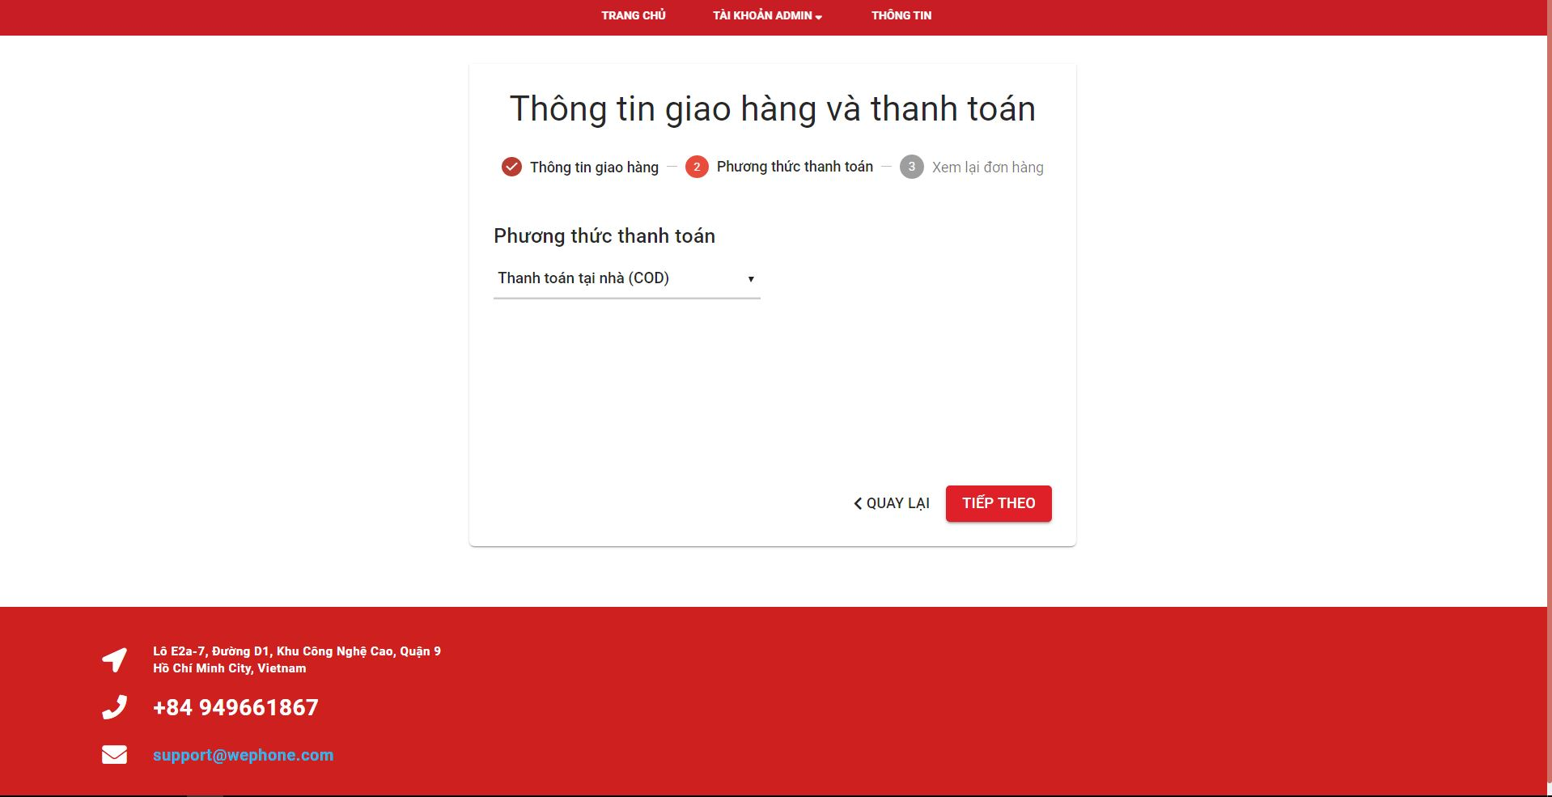

3

2

1

|  |  |
| --- | --- |
| **Step** | **Description** |
| Pre-condition | Login as role “Member/Admin” |
| 1 | Choose the style to payment |
| 2 | Click on “Tiếp theo” to go to next step |
| 3 | Click on “Quay lại” to back step 1 |

* + 1. **Step 3**

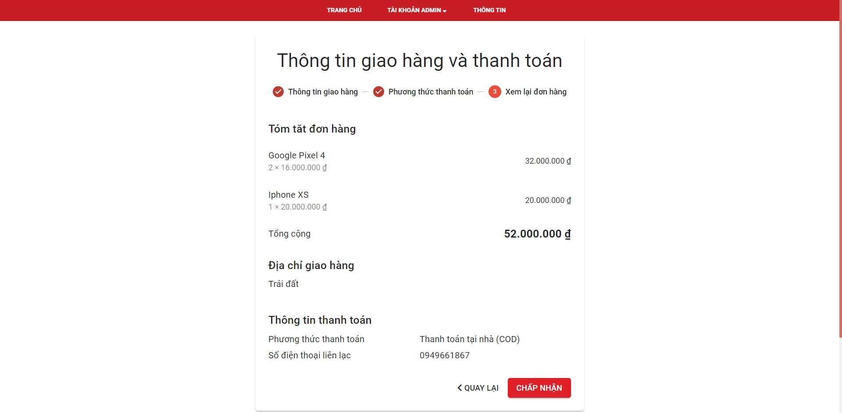

2

1

|  |  |
| --- | --- |
| **Step** | **Description** |
| Pre-condition | Login as role “Member/Admin” |
| 1 | Click on “Chấp nhận” to finish order |
| 2 | Click on “Quay lại” to back step 2 |

* + 1. **Step 4**

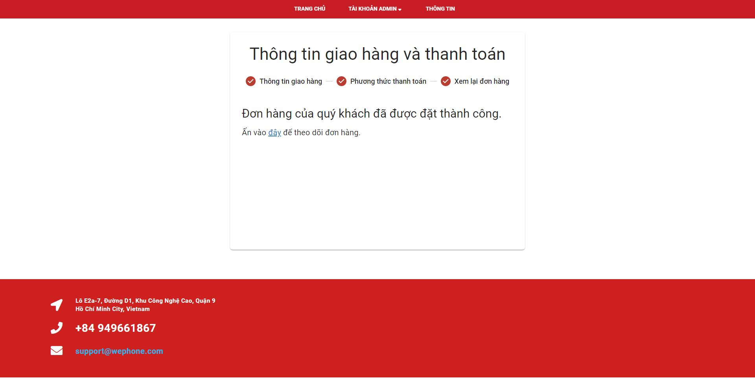

1

|  |  |
| --- | --- |
| **Step** | **Description** |
| Pre-condition | Login as role “Member/Admin” |
| 1 | Click on “Đây” to go to order page |

**1.9 Update profile user**

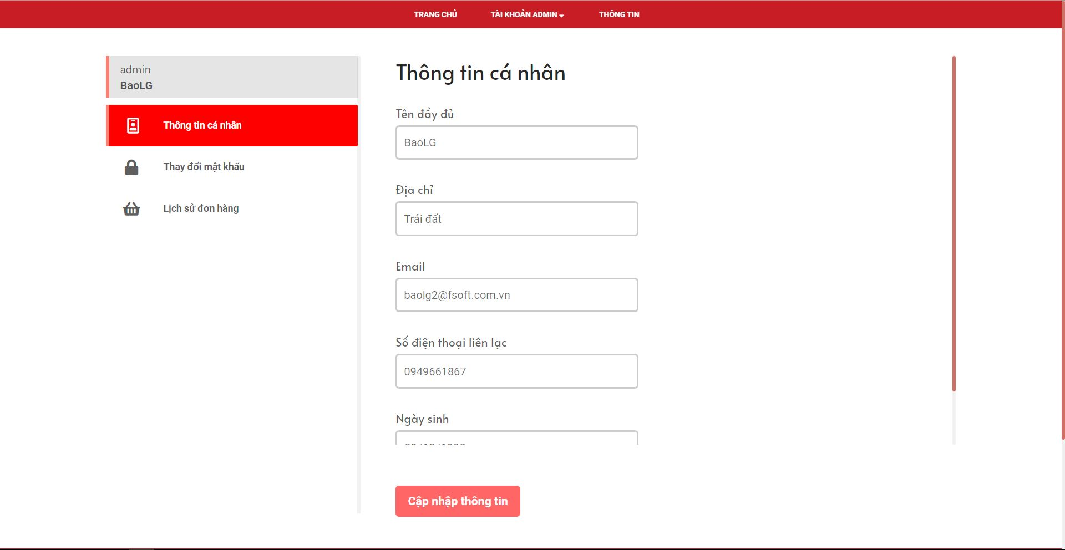

5

4

3

2

1

6

|  |  |
| --- | --- |
| **Step** | **Description** |
| Pre-condition | Login as role “Member/Admin” |
| 1-5 | Fill to chane the profile |
| 6 | Click on “Cập nhật thông tin” to change profile |

* 1. **Change password**

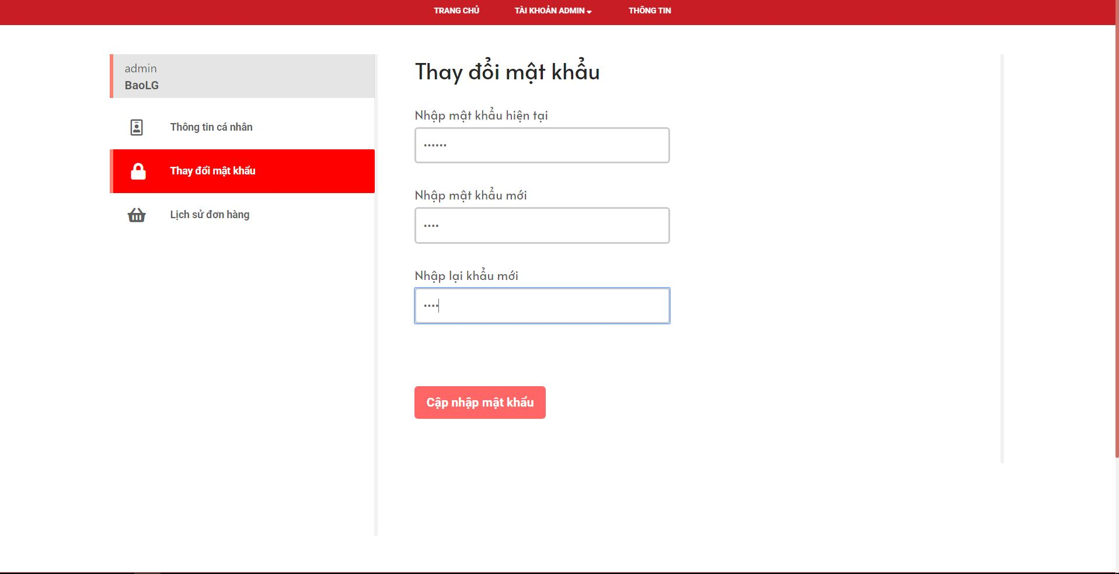

4

3

2

1

|  |  |
| --- | --- |
| **Step** | **Description** |
| Pre-condition | Login as role “Member/Admin” |
| 1 | Fill to current password |
| 2 | Fill to new password |
| 3 | Fill to confirm new password |
| 4 | Click on “Cập nhật mật khẩu” to change password |

* 1. **History order**

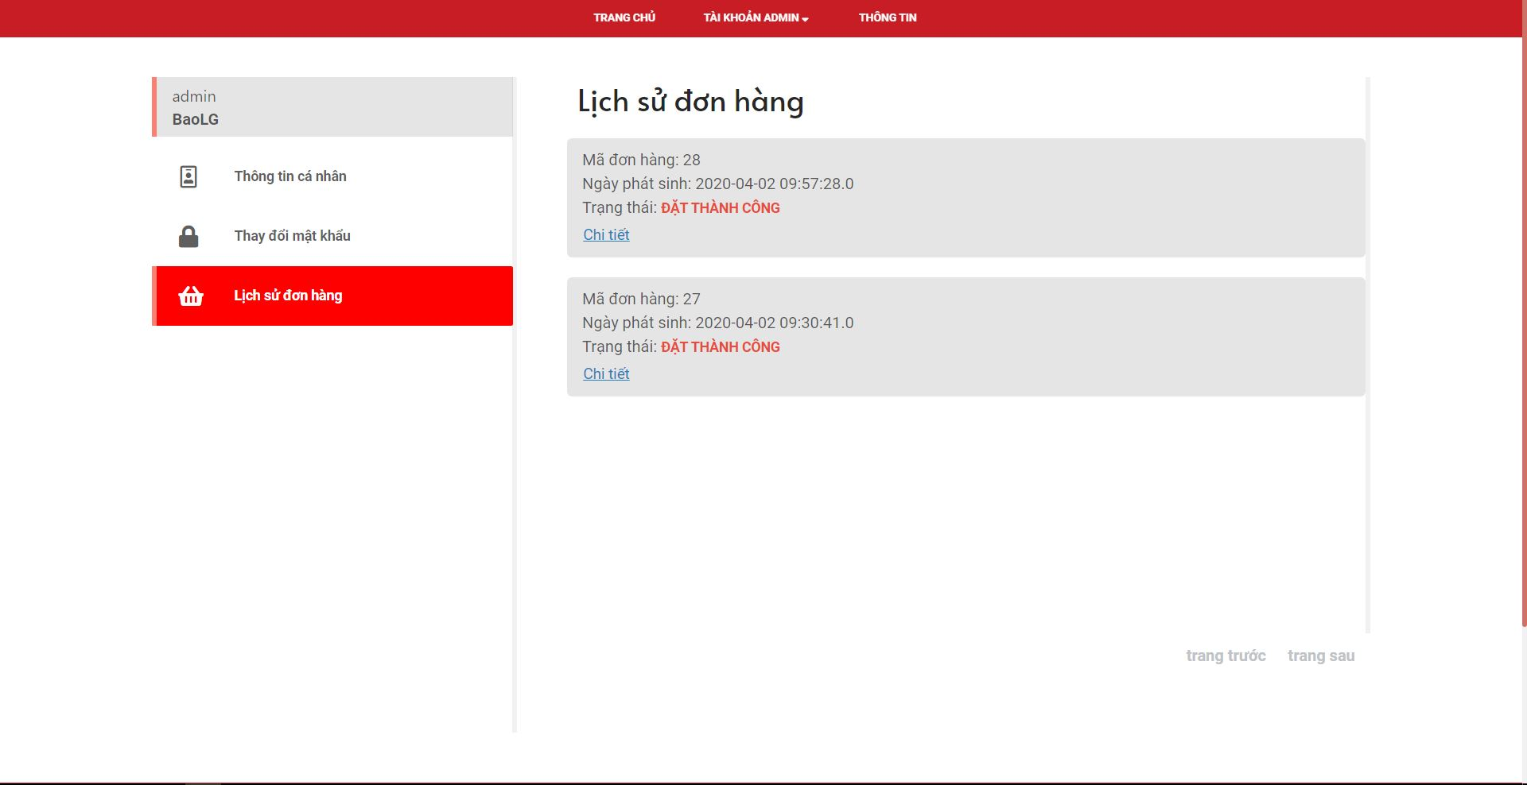

2

1

|  |  |
| --- | --- |
| **Step** | **Description** |
| Pre-condition | Login as role “Member/Admin” |
| 1-2 | Click on “Chi tiết” to show order detail |