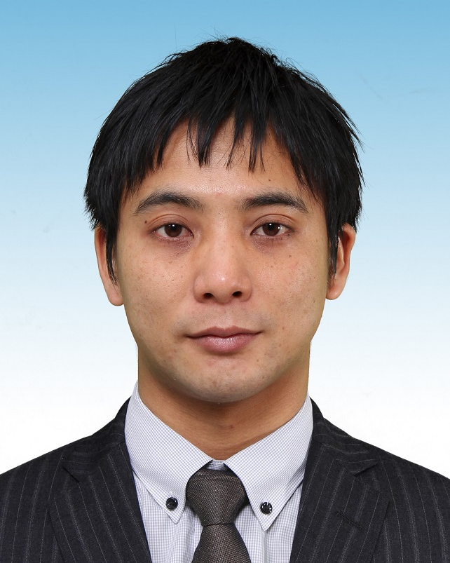 | Takashi Ijiri  Associate Professor,  Interactive Graphics Lab (PI),  Shibaura Institute of Technology.  Ph.D  Information Science and Technology | Oct. 2019

Contact information
E-mail1 : takashi.ijiri80 AT gmail.com
E-mail2 : ijiri AT shibaura-it.ac.jp
Address : 3-7-5 Toyosu, Koto-ku, Tokyo, Japan, 135-8548.

Education
4 / 2006 – 3 / 2009 Ph.D in Information Science and Technology, the University of Tokyo.
4 / 2004 – 3 / 2006 MS in Information Science and Technology, the University of Tokyo.
4 / 2000 – 3 / 2004 BS in Information Science, Tokyo Institute of Technology.

Research Interests
I am interested in computer graphics, image processing, and user interface in general, especially in interactive 3D modeling and interactive image segmentation. My current subject is easy-to-use interactive techniques for modeling 3D biological objects such as plants, cells, or organs.

Work Experience
4 / 2017 – present Associate Professor, Shibaura Institute of Technology
4 / 2017 – present Visiting Researcher, Keio University, SFC
9 / 2016 – present Visiting Researcher, National Cerebral and Cardiovascular Center.
4 / 2015 – present Visiting Researcher, RIKEN
4 / 2015 – 3 / 2017 Full time lecturer, Ritsumeikan University
9 / 2014 – 3 / 2016 Visiting Researcher, National Cerebral and Cardiovascular Center.
4 / 2013 – 3 / 2016 Visiting Associate Professor, Hokkaido University
4 / 2012 – 3 / 2015 Special Postdoctoral Researcher, RIKEN
4 / 2009 – 3 / 2012 Researcher, RIKEN
5 / 2007 – 8 / 2007 Student intern, Adobe Systems Incorporated

Programming Experiences
Computer languages: C/C++, OpenGL, Python, Java, Java 3D, and Scheme.
Plat forms: Windows and UNIX.

Language Skills
Japanese (native) and English (10 years of study).

Publications
Journals
Y. Dobashi, K. Iwasaki, M. Okabe, T. Ijiri, H. Todo. Inverse Appearance Modeling of Interwoven Cloth. The Visual Computer, Vol. 35, Issue 2, pp. 175–190, February 2019.
T. Ijiri, H. Todo, A. Hirabayashi, K. Kohiyama, Y. Dobashi. Digitization of natural objects with micro CT and photographs. PLoS ONE 13(4): e0195852, April 2018. [online journal]
R. Kawami，A. Hirabayashi，N. Tanaka，T. Ijiri，S. Shimamura，H. Kikuchi，G. Kim，T. Ushio. Simple Compression Technique for Phased Array Weather Radar and 2-Dimensional High-Quality Reconstruction. IEEJ Transactions on Electronics, Information and Systems, Vol. 137, No. 7, pp. 864-870, July 2017.
N. Nogami, A. Hirabayashi, T. Ijiri, J. White. Toward large-pixel number high-speed imaging exploiting time and space sparsity. IEICE Transactions on Fundamentals of Electronics, Communications and Computer Sciences, Vol. E100-A, No. 6, pp. 1279-1285, June 2017.
T. Ijiri, A. Nakamura, A. Hirabayashi, W. Sakai, T. Miyazaki, R. Himeno. Automatic spin measurements for pitched Baseballs via consumer-grade high-speed cameras. Springer, Signal Image and Video Processing, Vol. 11, Issue 7, pp 1197–1204, 22 February 2017.
M. Morita, T. Tawara, M. Nishimura, S. Yoshizawa, B. Chou, I. Kuroki, T. Ijiri, Y. Tsujimura, R. Himeno, and H. Yokota, Communication Platform for Image Analysis and Sharing in Biology. International Journal of Networking and Computing, 4(2), 369-391, 2014.
D. Ueno, K. Makiyama, H. Yamanaka, T. Ijiri, H. Yokota and Y. Kubota: Prediction of open urinary tract in laparoscopic partial nephrectomy by virtual resection plane visualization. BMC Urology, 14(47), 2014.
T. Ijiri, S. Yoshizawa, H. Yokota, T. Igarashi. Flower Modeling via X-ray Computed Tomography, ACM Transactions on Graphics, 33(4), 2014. (SIGGRAPH 2014).
T. Ijiri, S. Yoshizawa, Y. Sato, M. Ito, H. Yokota. Bilateral Hermite Radial Basis Functions for Contour-based Volume Segmentation. Computer Graphics Forum, 32(2), 123-132, 2013. (EUROGRAPHICS 2013)
T. Ijiri, T. T. Ashihara, N. Umetani, T. Igarashi, R. Haraguchi, H. Yokota, K. Nakazawa. A Kinematic Approach for Efficient and Robust Simulation of the Cardiac Beating Motion. PLoS ONE 7(5), 2012.
T. Ijiri, H. Yokota. Contour-based Interface for Refining Volume Segmentation. Computer Graphics Forum, 29(7), 2153-2160, 2010. (Pacific Graphics 2010).
T. Ijiri, K. Takayama, H. Yokota, T. Igarashi. ProcDef: Local-to-global Deformation for Skeleton-free Character Animation. Computer Graphics Forum, 28(7), 1821-1828, 2009. (Pacific Graphics 2009).
T. Ijiri, R. Měch, G. Miller, T. Igarashi. An Example-based Procedural System for Element Arrangement. Computer Graphics Forum, 27(2), 429-436, 2008. (EUROGRAPHICS 2008)
T. Ijiri, T. Ashihara, T. Yamaguchi, K. Takayama, T. Igarashi, T. Shimada, T. Namba, R. Haraguchi, K. Nakazawa. A procedural method for modeling the Purkinje fibers of the heart. The Journal of Physiological Science, 58(7), 481-486, 2008.
K. Takayama, T. Ashihara, T. Ijiri, T. Igarashi, R. Haraguchi, K. Nakazawa, A Sketch-Based Interface for Modeling Myocardial Fiber Orientation that Considers the Layered Structure of the Ventricles. The Journal of Physiological Sciences, 58(7), 487-492, 2008.
K. Takayama, M. Okabe, T. Ijiri, T. Igarashi. Lapped solid textures: filling a model with anisotropic textures. ACM Transactions on Graphics, 27(3), 2008. (ACM SIGGRAPH 2008)
T. Ijiri, S. Owada, T. Igarashi. Seamless Integration of Initial Sketching and Subsequent Detail Editing in Flower Modeling. Computer Graphics Forum, 25(3), 617-624, 2006. (EUROGRAPHICD 2006)
T. Ijiri, S. Owada, M. Okabe, T. Igarashi, Floral diagrams and inflorescences: Interactive flower modeling using botanical structural constraints. ACM Transactions on Graphics, 24(3), 720-726, 2005. (ACM SIGGRAPH 2005)

Refereed full papers (more than 3 pages)
R. Kawami, H. Kataoka, D. Kitahara, A. Hirabayashi, T. Ijiri, S. Shimamura, H. Kikuchi, T. Ushio. Fast high-quality three-dimensional reconstruction from compressive observation of phased array weather radar. In Proceedings of Asia-Pacific Signal and Information Processing Association Annual Summit and Conference (APSIPA ASC) 2017, pp. 44-49, Kuala Lumpur, Malaysia, December 2017.
R. Kawami, A. Hirabayashi, T. Ijiri, S. Shimamura, H. Kikuchi, T. Ushio. 3-dimensional compressive sensing and high-quality recovery for phased array weather radar. In Proceedings of 2017 International Conference on Sampling Theory and Applications (SampTA), pp. 658-661, Tallin, Estonia, July 2017.
C. Tang, N. Inamuro, T. Ijiri, and A. Hirabayashi. Compressed sensing MRI using double sparsity with additional training images. In Proceedings of the International Conference on Acoustics, Speech, and Signal Processing (ICASSP) 2017, New Orleans, LA, March 2017.
Y. Dobashi, T. Ijiri, H. Todo. Estimating Surface Roughness for Realistic Rendering of Fruits. IEVC 2017, Da Nang, Vietnam, 28 Feb - 3 Mar 2017
H. Kataoka, T. Ijiri; J. White; A. Hirabayashi, Acoustic Probing to Estimate Freshness of Tomato, Asia-Pacific Signal and Information Processing Association (APSIPA) 2016, Jeju Korea, 13-16 Dec 2016.
R. Kawami; A. Hirabayashi; N. Tanaka; M. Shibata; T. Ijiri, 2-Dimensional High-Quality Reconstruction of Compressive Measurements of Phased Array Weather Radar, Asia-Pacific Signal and Information Processing Association (APSIPA) 2016, Jeju Korea, 13-16 Dec 2016.
M. Shibata, N. Inamuro, T. Ijiri, and A. Hirabayashi, High accuracy reconstruction algorithm for CS-MRI using SDMM, Asia-Pacific Signal and Information Processing Association (APSIPA) 2016, Jeju Korea, 13-16 Dec 2016.
A, Hirabayashi, N. Nogami, T. Ijiri, L. Condat, Sequential image completion for high-speed large-pixel number sensing, EUSIPCO 2016, Posters, Budapest, Hungary, 29 Aug - 2 Sep 2016.
T. Kojima, T. Ijiri, H. Kataoka, J. White, A. Hirabayashi. CogKnife: Food Recognition From Their Cutting Sounds, Proc. CEA2016: 8th Workshop on Multimedia for Cooking and Eating Activities (ICME 2016), Seattle WA, 15 Jul, 2016.
K. Nakashima, Y. Koyama, T. Igarashi, T. Ijiri, S. Inada, K. Nakazawa., Interactive Deformation of Structurally Complex Heart Models Constructed from Medical Images, Eurographics 2016, Short Papers, Lisbon, Portugal, 09-13 May, 2016.
M. Morita, T. Tawara, M. Nishimura, S. Yoshizawa, B. Chou, I. Kuroki, T. Ijiri, Y. Tsujimura, R. Himeno, and H. Yokota. Biomedical Image Communication Platform, In Proc. of International Symposium on Computing and Networking, 281-287, Matsuyama, Japan, 2013.
T. Ijiri, M. Yokoo, S. Kawabata, T. Igarashi. Surface-based Growth Simulation for Opening Flowers. In Proc. Graphics Interface 2008, 227-234. 2008. Michael A. J. Sweeney Award (best student paper award).
T. Ijiri, S. Owada, T. Igarashi. Sketch L-System: Global Control of Tree Modeling Using Free-form Stroke. In Proc of the 6th International Symposium of SmartGraphics, 138-146, 2006.

Other presentations
Daisuke Inagaki, Yucheng Qiu, Raku Egawa, Takashi Ijiri. Pop-up digital tabletop: seamless integration of 2D and 3D visualizations in a tabletop environment. SIGGRAPH ASIA 2019, posters, Brisbane Australia 17 November 2019. (refereed poster, 2 page short paper)
Yucheng Qiu, Daisuke Inagaki, Kenji Kohiyama, Hiroya Tanaka, Takashi Ijiri. Focus stacking by multi-viewpoint focus bracketing. SIGGRAPH ASIA 2019, posters, Brisbane Australia 17 November 2019. (refereed poster, 2 page short paper)
Takashi Ijiri. 3D modeling of flowers and insects by using X-ray CT and photographs. MEIS 2018, Tokyo Japan, 8-9 Dec 2018. (non refereed, invited talk, 1 page abstract)
Wataru Ono, Hikaru Shionozaki, Takashi Ijiri, Kenji Kohiyama, Hiroya Tanaka. Shape and texture reconstruction for insects by using X-ray CT and focus stack imaging. SIGGRAPH ASIA 2018, posters, article no. 36, Tokyo Japan, December 2018. (Refereed poster, 2 page short paper)
Hiroki Sakai, Daisuke Niino, and Takashi Ijiri. Japanese Kanji Font Style Transfer based on GAN with Unpaired Training. Pacific Graphics 2018 posters, Hong Kong, China, 8-11 October, 2018. (Refereed poster, 2 page short paper)
Sakiho Kato, Tomofumi Narita, Chika Tomiyama, Takashi Ijiri, Hiroya Tanaka. 4D computed tomography measurement for growing plant animation, SIGGRAPH Asia 2017 Posters, Bangkok, Thailand, 27-30 November, 2017. (Refereed poster, 2 page short paper)
S. Pirk, B. Benes, O. Deussen, R. Mech, B. Chen. and T. Ijiri.: Modeling Plant Life in Computer Graphics, SIGGRAPH 2016 courses, Anaheim, USA, 24-28 July, 2016. (Refereed tutorial)
Y. Dobashi, T. Ijiri, H. Todo, K. Iwasaki, M. Okabe, S. Nishimura., Measuring Microstructures Using Confocal Laser-Scanning Microscopy for Estimating Surface Roughness. SIGGRAPH 2016 Posters, Anaheim, USA, 24-28 July, 2016.
Y. Sato, K. Akita, T. Ijiri, Y. Tsukada, M. Ito, H. Yokota, N. Saito. The diversity of pelvic floor by MRI image analysis and histologic reevaluation of its anatomy. Asian Association of Clinical Anatomists, Busan, Korea, November 3-4, 2012.
T. Ijiri, T. Ashihara, N. Umetani, T. Igarashi, R. Haraguchi, H. Yokota, K. Nakazawa, An Efficient, Robust Framework For Simulating the Beating Heart, 23rd Conference of the Society for Medical Innovation and Technology, Tel Aviv, Israel, September 2011.
Y. Sato, T. Ijiri, T. Kobayashi, H. Yokota, M. Ito, Semi-automatic Segmentation Tool for Anal Sphincter Muscles, 23rd Conference of the Society for Medical Innovation and Technology, Tel Aviv, Israel, Sep, 2011.
M. Okabe, K. Takayama, T. Ijiri, T. Igarashi, Light shower: a poor man's light stage built with an off-the-shelf umbrella and projector, ACM SIGGRAPH 2007 sketches, San Diego, CA, USA, Aug, 2007.
T. Ijiri, K. Takayama, T. Igarashi, T. Ashihara, T. Namba, T. Yamaguchi, T. Shimada, R. Haraguchi, K. Nakazawa, The use of L-system for modeling Purkinje fibers. The 2nd MEI International Symposium: The Worldwide Challenge to Physiome and Systems Biology, 07-09 Dec, 2007.
T. Ijiri, T. Igarashi, S. Takahashi, E. Shibayama. Sketch interface for 3D modeling of flowers, SIGGRAPH 2004 Sketches and Applications, Los Angeles, CA, USA, Aug, 2004.

(and others in Japanese)

