

**[An Analysis of Ecommerce’s Performance in the Competitive Strategies to Produce BaiBao Online Ecommerce Website with using DSDM Method, MySQL, PHP]**

**Min Mya Thi [ID: 001121700]**

**Supervisor: Dr. Win Zaw**

**Initial Contextual Report**

**COMP1682 Final Year Project**

**Programme Title, e.g. BSc Computer Science or BSc Computing**

**Due date: Nov/25/2020**

**Word count:**

**Abstract**

As selling products online are becoming more popular, e-commerce is yet becoming a trend in the small to large company in business world. Thus, young Baibao company is wanted to require online ecommerce system for expending its productivity and fame. This project will provide online ecommerce website for a start-up company named Baibao and produce the development report which will aims to analyze, examine and plan for the implementation with methodology and techniques which will be compared to find out the most suitable for this project. The researches will be gathered and justified to focus on building proper ecommerce webpages which contain the functional actions for both staffs and clients. As for those, DSDM framework and UML are chosen to build this project. Additionally, MySQL database and PHP language are used to develop the web system. Moreover, as for timeframe, MoSCoW and Timebox are applied. The gathered facts from this project’s analyses will be utilized to develop and deliver a successful product by this report. After completion, my knowledge and experience could be enhanced in the field of business information system.

**Acknowledgement**

Table of Contents

1 Chapter 1 – Introduction 1

1.1 Introduction 1

1.2 Background 1

1.3 Current Business Introduction 1

1.3.1 Current Business History & Future Plan 1

1.3.2 Current Business Process 2

1.3.3 Current Business Issues 2

1.4 Scope of Project 3

1.5 Aim & Objectives 4

1.5.1 Aims 4

1.5.2 Objectives 4

2 Chapter 2 - Literature Review 9

2.1 Approach to literature searching 9

2.1.1 The Struggle of Competing on Price and Shipping 9

2.1.2 Incorporation Problem 10

2.1.3 Fraud and Transaction 10

2.1.4 An Absence of Online Identity Verification 10

2.2 Legal, Social, Ethical and Professional Issues and Considerations 11

2.3 Methodology 12

2.3.1 SSADM (Structured Systems Analysis & Design Method) 12

2.3.2 DSDM (Dynamic System Development Method) 13

2.3.3 Justification of the suitability of a Methodology or a Framework followed. 13

2.4 Languages 14

2.4.1 ASP.NET (Active Server Pages) 14

2.4.2 PHP (Personal Home Page or Hypertext Preprocessor) 15

2.4.3 Justification of the Suitable Language for this Project 15

2.5 Database 16

2.5.1 MySQL 16

2.5.2 Microsoft SQL Server (MS SQL) 17

2.5.3 Justification of the Suitable Database for this Project 17

2.6 Literature Self-Evaluation Summary 18

3 Chapter 3 – Product Research 18

3.1 Research on Similar Ecommerce Websites 18

3.2 Review/ Comparison 20

4 Chapter 4 – Requirements 20

4.1 High Level Requirements 20

4.2 Functional Requirements Prioritizing with MoSCoW 22

4.3 Non-Functional Requirements 25

4.4 Use Case Diagram 27

5 Chapter 5 – Design 27

5.1 Analyzing and Normalizing Structure 27

5.1.1 Third Normalized Form (3NF) for the Ecommerce System 28

5.2 Entity Relationship Diagram (ERD) 31

5.2.1 Initial Diagram 31

5.2.2 Detail Diagram 32

5.2.3 Data Dictionary 32

5.3 Prototype 38

# Chapter 1 – Introduction

## Introduction

As technologies are becoming much advanced, most e-commerce businesses are struggling to compete with one another so that they will be able to grip their consumers and gain their profits and be successful. Fulfilling such businesses’ needs are extremely challenging for those companies which have not yet started to experiencing ecommerce system and it is undoubtedly truth that every data in their system is extremely sensitive to both staffs and clients. To earn and secure success, e-commerce businesses’ information is also needed to be precise and concrete for the business in exchanging of data over electronic means; such as the Internet or any other computer networks.

## Background

The outcome of this project will be the online e-commerce website, for a start-up company named Baibao, that will sell and buy the products via computerized transaction. Concerning those trading of several goods or services will be electronic devices, clothes and accessories. The whole website will contain the most fundamental and important actions for both clients such as registration, receipt, transits receipt, delivery appointments and facilitating the financing & payment features of business transaction. Moreover, the main functionalities where the e-commerce webpages are successfully being facilitated will also be included like supply chain management, online marketing, transaction processing, inventory management systems, automated data collection systems and electronic data interchange (EDI).

## Current Business Introduction

### Current Business History & Future Plan

Baibao company, which is located at Mandalay, is newly established products store which is started from a small shop. As internet is becoming more popular, the business wants to further request for the online shopping system that will provide the customers to buy various kinds of international products cheaply and easily. Currently, there are 5 staff members working all together including admin.

The Baibao company initially sell the shirts, cosmetics and electronics which are from their partner’s suppliers. As wide range of customers are coming under this company due to its business bloom, it is a big chance for the company to have an online ecommerce system as there are many products sold and staff members who are having workloads because of using with the offline selling method, especially with Excel, in this company at present. As to promote its business, Baibao company wants to further sell different products with more suppliers to expend its business and productivity.

### Current Business Process

Every new staff members and customers information are written on the sheet of paper and then manually inserted onto Excel files with computer. Additionally, if the main subject information is to change, any changes of the user’s information are also edited on the Excel files with computer. Concerning with the data storing, all of the user’s information are then stored in the Hard Disk.

When customers want to buy or order products, they are required to come to the store to buy or call phone to the store manager to make order. Moreover, all the customer orders are noted and dictated from the phone to the paper. Then, those information are filled on the Excel file and prepare for the delivery. The receipts are written on the paper and given to the customer.

Store manager mainly start to purchase product from the suppliers through the phone line and the receipts are transferred with hardcopy.

When there is a discount for the product, the staff member calculates the product price from the Excel and announce it on the pamphlet.

All product orders, reviewed with the Excel paper, from the customers are notified to the deliveryman and procced to the customer font door with given customer’s name, phone, address. The order receipts are then collected in cash during the final delivery.

### Current Business Issues

Concerning with the issues, Baibao uses a manual paper-based system currently. Every information is are written from the paper to Excel file which are stored in the computer. From this, human errors could actually made while collecting information from the paper and typing onto the Excel. So, when such information is sent to headquarter, there will be several conflicts and occurring data inconsistency which is always a big case.

While notifying the latest and trendy products in accordance with time, marketing in the Baibao is negatively affected due to its latency of the information entry with manual. On selling hours, a bunch of customers call with phone to make order. As phone line is limited to each pre call, Baibao could not provide excellent customer service and build a strong relationship with them.

When registering members, many of its information sheet papers are manually typed on the Excel files which is very time consuming and requires several data entry clerks to finish the work done day by day.

During large number of customers order at the same time, staffs couldn’t actually catch up the information fully in detail while they are dictating from the phone. It also gives many customers a dissatisfaction while their calls are in busy. Thus, there is a limitation to the customer’s attraction.

As store manager purchase the product from the supplier, both of them also have to telecommunicate during buying and selling which consume times for writing physical copy of the receipts and lacks visual confirmation from the purchases.

## Scope of Project

In order to produce a successful business plan, scope of project is needed to be defined. In today’s age of online ecommerce, many clients are told to sign in with their account before ordering products rather than immediately enabling purchase as a guest. This kind of system will keep all client’s details of order’s history to avoid major threats such as anonymous purchasing. Moreover, by using with this sign-in system, it enables clients to manage their account, purchase their orders, preorder their products, become a third-party seller and review all of the orders they placed.

As for the main goal of this project, it must to produce the facility for the clients to shop and sell around in this company’s online ecommerce system conveniently. In this fact, there must contain optimizations for user like navigating the product’s list, searching with category, selecting the product for purchase, adding products to the chart, removing products from the current order, giving delivery address, order-type and payment methods. When information such as client’s order is sent to the database with proper information successfully, clients should get the order’s confirmation through their account. If clients are not satisfied with the products, they could complaint or enquiry to the company.

As for the server-side system, it must include the features of recording or modifying the information about suppliers, purchases, orders, clients, staffs, sales, feedbacks and deliveries. As to promote with business’s marketing area, enabling promotional or discount deals on the products to the clients is recommended as an additional feature. Moreover, there should be a feature for exporting reports about sales in the Excel format automatically.

## Aim & Objectives

### Aims

The main aim for this project is to build up a proper ecommerce website for a business to reach a larger customer base and increase profits.

### Objectives

The timeframe is [Weeks, Days].

#### Researches Report [0.6]

##### Research Report for the Ecommerce Project. [0.2]

###### Research the background information of ecommerce nowadays. [0.1]

###### Research the aim and objectives for the company Baibao. [0.1]

##### Research about Ecommerce’s Issues [0.4]

###### Research the struggles of competing on price and shipping in ecommerce. [0.1]

###### Research incorporation issue in ecommerce. [0.1]

###### Research ecommerce’s transaction on oversea problem. [0.1]

###### Research Legal, Social, Ethical and Professional issues. [0.1]

Deliverables:

* Chapter Introduction [Word count: 800~1200 words]
* Chapter Literature Review [Word count: 1000~1700 words]

#### Analysis and Justification [3.0]

##### Justify the Methodology for the Project. [0.1]

##### Similar Products Comparison for Usability (Jakob Nelson’s 10 Heuristics) [0.5]

##### Produce the Product’s Requirements for the Project. [1.3]

###### Produce the Functional requirements. [0.6]

###### Produce the MoSCoW prioritization on the Functional requirements. [0.4]

###### Produce the Non-Functional requirements with Global. [0.4]

##### Analyse the Risk and Project’s Success Factors. [0.6]

###### Analyse the risk management. [0.3]

###### Analyse the risk matrix. [0.3]

###### Analyse the critical success factors. [0.3]

Deliverables:

* Chapter Requirements [Word count: 800~1000 words]
* Chapter Design [Word count: 1000~1300 words]

#### Planning and Design [6.6]

##### Plan the Requirement Catalogue. [0.5]

##### Design low-fidelity prototyping of UI. [1.3]

##### Design UML’s Structure Diagrams. [1.5]

###### Design a conceptual ER Diagram (Initial Class Diagram). [0.5]

###### Design a physical ER Diagram (Detail Class Diagram). [1.1]

###### Design Deployment Diagram. [0.4]

##### Design UML’s Behavioural Diagrams. [2.4]

###### Design Use-Case Diagram. [1.2]

###### Design Sequence Diagram. [1.2]

##### Plan the Time Box. [0.3]

Deliverables:

* Chapter Design [Word count: 1000~1500 words]
* Chapter Prototype [Word count: 900~1400 words]

#### Implementation [13.5]

##### Create Database. [3.0]

###### Create database, relating to time boxings, with MySQL. [2.0]

###### Examine and visualize the database. [1.0]

##### Create UI for the Webpages. [4.0]

###### Create server-side UI. [2.0]

###### Create client-side UI. [2.0]

##### Create Actions and Features for the Website. [6.0]

###### Create server-side actions and features. [3.0]

###### Create client-side actions and features. [3.0]

##### Examine and iterate any final visualization’s thought. [1.5]

Deliverables:

* Chapter Implementation [Word count: 1400~2000 words]

#### Testing [1.2]

##### Produce Documentation on Black and White box Testing. [1.2]

###### Test Database of MySQL. [0.3]

###### Test Webpages’ interfaces and their actions. [0.3]

###### Test Excel Export feature. [0.3]

Deliverables:

* Chapter Testing [Word count: 1000~1500 words]

#### Evaluation and Reflection [1.2]

##### Document the evaluation and conclusion for the project. [1.2]

###### Evaluate on aim and objectives. [0.2]

###### Evaluate against similar system. [0.2]

###### Evaluate against justification made. [0.2]

###### Evaluate to myself. [0.1]

###### Document future amendment for the project. [0.2]

Deliverables:

* Chapter Evaluation [Word count: 1800~2000 words]

# Chapter 2 - Literature Review

## Approach to literature searching

To approach this research, some information is thoroughly researched from the articles. It is very important to focus on the issues and the solution in current ecommerce topic. Moreover, the definition and purpose of the ecommerce in the other’s opinions are investigated. Related to these topics will emphasis on the ecommerce website and what issues is currently facing.

### The Struggle of Competing on Price and Shipping

Every online shopper likes free and fast shipping and items at low cost. Thus, all online merchants are frequently competing on such prices. It is typically challenging when sellers list the same products on their sites, but the prices are changed. As those mid-sized and large competitors are vying to grow their market share by selling the product, small e-commerce businesses are particularly effected when it comes to price competition and free shipping as such competitors can often offer products for less. How can this be solved? Almost all of the online ecommerce businesses such as Amazon and Walmart are basically shipping from the closest facility or warehouses across the country. It seems that approximately 60% of the orders that are made by the customers are shipped from the same area that the customers are. Since order’s products are shipped from the nearby warehouse, the ecommerce businesses satisfy two criteria or needs simultaneously, the cost of shipping and the shipping time decreased. To survive in such competitive market as start-up ecommerce companies, they will need to find products that are hot and rare in market, distribute their inventory for warehouses and be a very supplied shippers to lessen this problem (Vishnoi, 2019).

### Incorporation Problem

When ecommerce operated merely through a website, not being incorporated with consumers is a vital problem. Any purchase and selling activity associated to products may be considered illegal in case of any fraud and corruption. Without incorporation, company can’t claim any business’s right (Eurologo, 2019).

### Fraud and Transaction

Over the past few years, payments fraud, or card-not-present (CNP) fraud, has become a widespread online security issues and it is expected to be grow by 14 percent annually up to 2023 (Goldstein, 2019). There are also some fraudsters who will contact to owner of the credit card and demand delicate data in a tricky way. Those kinds of ways include stealing sensitive data by giving an attachment file or a link through the webpage, an email or SMS which is known as phishing (Securionpay, 2019).

In Australia, the Australian Consumer Law (ACL) governs all e-commerce transactions in its own country. The company will be penalized by the ACL expecting when e-commerce fails to provide clear and complete description of the product, cost and purchase details, information about delivery and other related exchanging and refunding. Hence, when shipping to Australia without adhering its rules, company can get into serious law violation problems (Eurologo, 2019).

### An Absence of Online Identity Verification

When clients browse into an ecommerce website and sign up, the information that used to register their account are not verified whether those are genuine or not. In the situation alike information hold fake addresses or phone number, Cash-On-Delivery (COD) purchases can suffer massive revenue losses. In order to minimize this kind of problem, a system to watch any suspicious activities must be implemented such as sending a verification link or token and texting messages via email when a customer signs up in order to check whether the information is genuine. This could be like checking email addresses, zip codes if the state/city matched, and phone numbers (Vishnoi, 2019).

## Legal, Social, Ethical and Professional Issues and Considerations

*Copyright Protection Issue (Copyright Act of 1998)*

During publishing content for e-commerce website, using any other company’s content can be a severe legal problem (Eurologo, 2019). This might mark an end to the e-business even when it is unintentionally used copyrighted content because the other party can easily sue to this project.

*General Data Protection Regulation (GDPR)*

Privacy comes the top priority issue when concerning to online businesses because it can create corruption to both business and customers. Most web-based business platforms often collect some of the customer data through contact, registration and payment. By just one minor mistake and leakage of valuable information of a customer, the result of this project will not only lose its potential data but its reputation (Eurologo, 2019). How to solve it?

To ensure that this project compliant with data protection rules, the data protection policy will have to be carefully regulated in order to prevent any hijacking of the information. To consider this law, any data protection and security tools or conditions are needed to ensure that every data and information must only be accessed, modified or deleted by authorized users.

*The Computer Misuse Act 1990*

One of the most nightmare scenarios is security issues. Till now, fraudsters are infecting the websites with the ransomware by uploading spam, attacking and accessing the main web host server where confidential data such as credit card details and clients’ information are kept (Eurologo, 2019). How to solve it?

To consider such law in this project, any software that has the ability to backup, encrypt and secure the data will have to be used. One of such software is the Online Acronis true image (ATI) which prevent any virus intrusion. Even when the ransomware is start injecting into the server, ATI instantly stop that process and kill ransomware, notify to the victim, and recover corrupted data from the backup.

## Methodology

### SSADM (Structured Systems Analysis & Design Method)

One of the most common and oldest models in SSADM methodology is Waterfall Model which is utilized for the system development. It contains phases where the processes are in series and logical, in another word linear sequence. To simply illustrate how this works, the following phase can only be started only if previous phase is finished. The Waterfall phases are Requirements, Design, Implementation, Testing, Deployment & Maintenance. This method is suitable to be used when the systems requirements are known. However, it is not for the project which has to work in changing environments such as requirements.

Strengths

* Very simple and easy to understand.
* More effective in the smaller projects with clear requirements.
* Useful for the beginner or novice developer.
* Each stage has specific individual review process.
* Easy to test by referencing the earlier functional specification.

Weaknesses

* Need precise requirements.
* When the stage has begun, it is not possible to go back and make changes to the earlier stage.
* Risky when single problem pops up and could double the duration of the project.
* Not suitable for long and ongoing projects.

(TatvaSoft, 2015)

### DSDM (Dynamic System Development Method)

The DSDM methodology is one of the agile methods which originally based on the RAD (Rapid Application Development). The latest DSDM contains 8 principles that is used to make the project successful within limited resources and small period of time. This will be used in order to superb the flexibility in the project. It also allows to deliver projects on time and budget while simultaneously accommodating changes on the requirements, simply in other word iterative. This will also focus on producing the product with different techniques: MoSCoW prioritization, Timeboxing, and Prototyping. Using those techniques determine to ensure that the project finishes in short period and together producing the reusable products.

Strengths

* Active user participation throughout the project.
* Iterative nature of development improves quality of the product.
* Development approach projects delivered on time and within a specific budget.
* Enable to access by developers to end-users.

Weaknesses

* Costly to implement.
* Requires users and developers both to be trained to utilize it.
* Not recommended for small organizations or one-time projects.
* Not common and easy to understand due to its new model.

(TatvaSoft, 2015)

### Justification of the suitability of a Methodology or a Framework followed.

There are numbers of software development frameworks and methodologies that will help resolving some of the issues depending on the project. In my opinion, alleviating the project with the DSDM method is the best choose. It is due to its advantages of the adaptive approach which simply flexible enough to emphasis on continuous incremental and iterative. Using DSDM methodology in this project will not only allow help to proceed with limited requirements in a few months but also gains benefits that will identify the possibilities solution. As the project duration is about six months, DSDM is the definite choice for this project because it will help produce the essential components needed to deliver on-time.

Therefore, this methodology is suitable for this project approach. It can offer new idea or gain new possibilities of the system and ensure that the project will encounter less problems. The techniques such as MoSCoW prioritization, Timeboxing and prototype will also help to improve the overall product in the end overall.

## Languages

### ASP.NET (Active Server Pages)

According to Guru99, ASP.NET is an object-oriented programming language uses server-side technology to simplify the developments with library and efficient IDE. It is a proprietary software developed by Microsoft which needs to purchase its license as well as compatible IIS web server and database. However, it cannot be run on multiple platforms concerning with the OSs and servers but the security of this language is becoming better.

Strengths

* Suitable for the developer who knows International languages like Javas or C script.
* Uses the Professional Programming Software, Microsoft Visual Studio.
* Able to use in multiplatform.
* It is very modern, fast and have tons of libraries.
* Its technology is advancing and evolving.

Weaknesses

* Expensive as there are expenses like SQL Server licenses, Visual Studio licenses, Windows server licenses.
* Needs further more plugins from GitHub when moving to the different version of the ASP.NET or the project data files might not work.
* May have issues when moving to the different version of the application.
* Needs Internet Information Service (IIS) because most web hosting servers may not support ASP.NET.

### PHP (Personal Home Page or Hypertext Preprocessor)

PHP is an open source programming language for server-side scripting. It is widely-used due to its fast response time, freeware services and ease of use on developing the websites. Moreover, it supports numerous databases, languages and multi OS platforms with most security. This server-side language can also be written with the HyperText Markup Language (HTML), for building contents or building-blocks of web pages, and Cascading Style Sheets (CSS), for creating stylish user interface web design. (Guru99, n.d.)

Strengths

* Great documentation and a lot of learning resources.
* Short learning curve compares with other web languages.
* Most web hosting servers support PHP by default.
* Is consider as the secured web developing language until now.

Weaknesses

* Cannot write for the website with just only PHP.
* Most PHP frameworks come with robust feature and tools to accelerate during developing large or complex websites. These additional features may often impact the speed and performance of websites poorly.
* May need to learn PHP as an additional programming language.
* Not designed for large application creations.

(Guru99, n.d.)

### Justification of the Suitable Language for this Project

Unlike ASP.NET, PHP is cost free and more secure when building up the projects. Concerning with the performance and time, writing with PHP is recommended in this project for producing a fast response time. As it is an open source software, finding solutions for the error will be much easier than the ASP.NET through community groups. Moreover, PHP can be run on different OS platforms, like Linux and Windows, and is secure than the IIS web server which makes PHP more convenient to the developers. Due to these reasons, I prefer to choose PHP to fit into this project that is purposed to build quicker and high-quality website independently.

## Database

### MySQL

MySQL, which is under proprietary products of Oracle Corporation, is an open source and multi-user relational database management system (RDBMS) based on Structured Query Language. It is the most flexible and runs on many other cross-platforms: LAMP in Linux and Apache in Windows. Typically, it is made to handle databases quickly and enable to send them to multiple sites, allowing users to access with different MySQL client interfaces. Even though it is the open source, there are 3 types of Community Edition: Standard Edition, Enterprise Edition and Cluster Carrier Grade Edition. Those also provide for the large enterprise with high performance database but may have to purchase for the specific requirements for the business. (Lehmann, 2010)

Strengths

* Many solutions of the problems can be collected from the large and thriving community of developers.
* Easy to set up the database.
* Only hardware cost is needed.
* Compatible with virtually every operating system.

Weaknesses

* Could not handles when forcing to deal with too many operations at a given time.
* Often added some other addons or plugins for other immediate functionality.
* Maybe difficult to debug and maintain stored procedures.

(Lehmann, 2010)

### Microsoft SQL Server (MS SQL)

Microsoft SQL Server is a license required software which promote to handle the large numbers of users, transactions and data. A variety of functions such as preventing the concurrent changes on the transaction by locking it are provided to the users to facilitate with high level controls on the database. (Lehmann, 2010)

Strengths

* Allows developers to manage the database with limitless volume of data and functions.
* Has number of features that promote data restoration and recovery.
* Includes administration features such as restricting the access of a table or data.
* Allows to retrieve large amounts of records from a database quickly and efficiently.
* Enable to joins two or more tables and show it as one object to user.
* More secure from the unauthorized access and threats

Weaknesses

* Limited compatibility.
* Interfacing the database maybe complex.
* May find it difficult to learn and understanding.
* Older version of SQL Server may need to install on older hardware equipment while newer releases require more advanced technologies to support the resources needed by the database.

(QuickStart, 2018)

### Justification of the Suitable Database for this Project

Even though MS SQL has more functionalities than the MySQL, it will be too complex for the start-up company like Baibao to utilize for the first time. As for the fact that the customer who is beginning to be familiar with the database usage, MySQL will be used for the best because there will be some unnecessariness for them to provide the most end-features and tools which can leads to either poor quality data or upraise the problem. Although MS SQL is more capable to advance functions than MySQL, MySQL still can support nearly most of the functionalities from the MS SQL and is more compatible with PHP. Moreover, unlike MS SQL, MySQL can run on multiple platforms. Because of these reasons, MySQL is chosen for Baibao project.

## Literature Self-Evaluation Summary

After researching some of the articles from the internet, I have gained a lot of good understanding into why the ecommerce website is being challenging. Moreover, in my opinion, it is also a good chance to start creating an ecommerce website with its suitable methods, programming languages, and database due to its critical decision on business and information system. All of these researches on these topic’s issues are still occurring nowadays. That’s is why understanding the trend of the ecommerce and tools can collect most of the patterns to be successful in project.

# Chapter 3 – Product Research

This chapter will contain about how this project can make preparation for the user requirements on the Baibao by capturing and researching on similar Ecommerce websites. This will be carried out to understand the fundamental and standard features that an ecommerce should have by analyzing two of such type of websites.

## Research on Similar Ecommerce Websites

***Walmart Online Shop***

Walmart is one of the most famous ecommerce throughout the country. It mainly provides its services through their mobile applications or website where users all around the world can find the trendiest fashions, brands and varieties of products for clothing, bags & accessories available in one place. Walmart has over 200 departments in China and USA and shipped its products over more than 90 countries. According to my analysis on Walmart’s website, there are many services that are offered to customers and it is influenced by the western product delivery services and the system.

Walmart Online Shop Link: https://www.walmart.com/

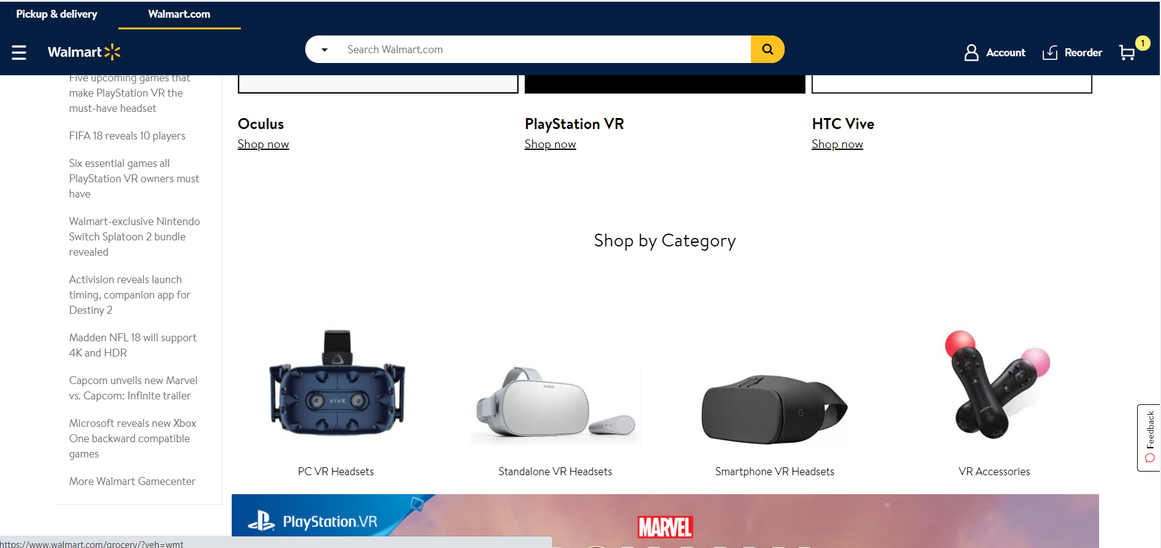

***Myanmarkt Online Shop***

Myanmarkt is one of the online shopping sites for the sellers and was established and aim to compete with the online shopping services in Yangon. It offers wide range of electronics and gadgets, real estate and more and allows users to shop conveniently for it with reasonable prices as registered members. It also offers sellers to sell their products with both auctions and fixed price where they can grow their own shop over this website.

Myanmarkt Online Shop Link: https://myanmarkt.com/

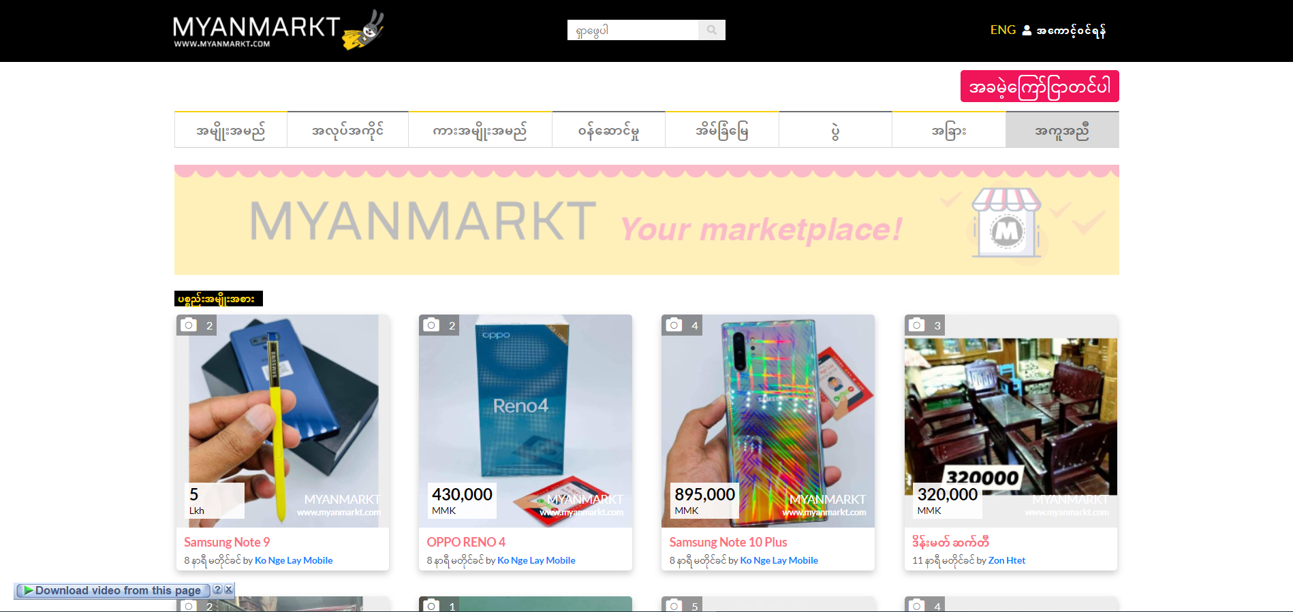

***Shop.mm Online Shop***

Shop.mm, founded in 2012 and owned by Alibaba Group Holding Limited, is one of most famous South Asia’s online shopping sites in Pakistan, Bangladesh, Sri Lanka, Myanmar and Nepal. It supported varies range ecommerce and has more than 2 million products available, 30,000 sellers and 500 brands, serving 5 million consumers. This shop.mm is aimed to provide best excellent customer experience offering numerous categories and product’s type like groceries, sports equipment and beauty and more. It also offers multiple payment methods like in cash delivery and product returns.

Shop.mm Online Shop Link: https://www.shop.com.mm/

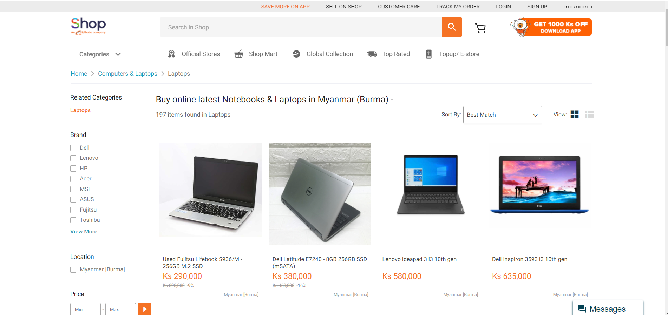

## Review/ Comparison

|  |  |  |  |
| --- | --- | --- | --- |
|  | ***Walmart*** | ***Myanmarkt*** | ***Shop.mm*** |
| Profile Editor | ✔ | ✔ | ✔ |
| Search Filter | ✔ | ✖ | ✔ |
| Discounts Display | ✔ | ✖ | ✔ |
| User Friendly UI Layouts | ✔ | ✖ | ✔ |
| Great Design | ✔ | ✖ | ✔ |
| Linking with Social media | ✔ | ✔ | ✔ |
| Can make Order as Guest | ✖ | ✖ | ✖ |
| Responsive Design | ✔ | ✔ | ✖ |
| Reviews/ Ratings | ✔ | ✖ | ✔ |
| Feedbacks/ Comments on Items | ✔ | ✖ | ✔ |
| Product Return | ✔ | ✖ | ✔ |
| Available on Mobile Platform | ✔ | ✖ | ✔ |
| Track Order | ✔ | ✖ | ✖ |

# Chapter 4 – Requirements

This section will describe which system requirements will be presented in both functional and non-functional requirements to reach the objectives of this project.

## Requirements elicitation

To precept for the requirement’s needs, a survey method will be done because the main purpose for this project is to produce the website that will provide the essential for the customers. Also, because of its ability to reach the user’s preceptive easily. This can be like an observational study from the survey results which is from the users. This will help the project to obtain the requirements smoothly and note the target customers faster.

As for the analyzing the requirements, the survey will be gathered through the Google Form with various types of setup questions which will be relating to the project for Baibao online system. The results from this survey will help this project to progress more and will address the concerns of the potential needs and actions for the system.

### Findings

#### Questionnaire

The questionnaire, written in English, have 9 questions which provide to get the clear feedback from the people and the questionnaire are as follow:

The below survey shows that 66 respondents know about the e-commerce and they online shopping and only 19.7% do not know about it. This shows that large numbers of respondents who are within the 80.3% understand and visited the e-shopping sites. The below chart clarifies the result.

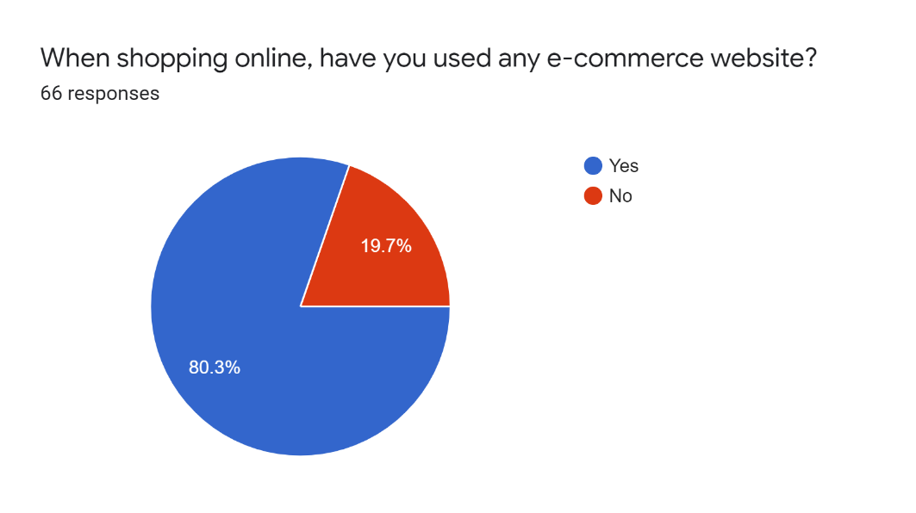

The survey shows that majority of respondents say that they have been using the e-commerce website at least more than one year or 3 years. On the other hand, only 7.5% says that they are using the e-commerce website for less than a year. The result is illustrated in the next chart.

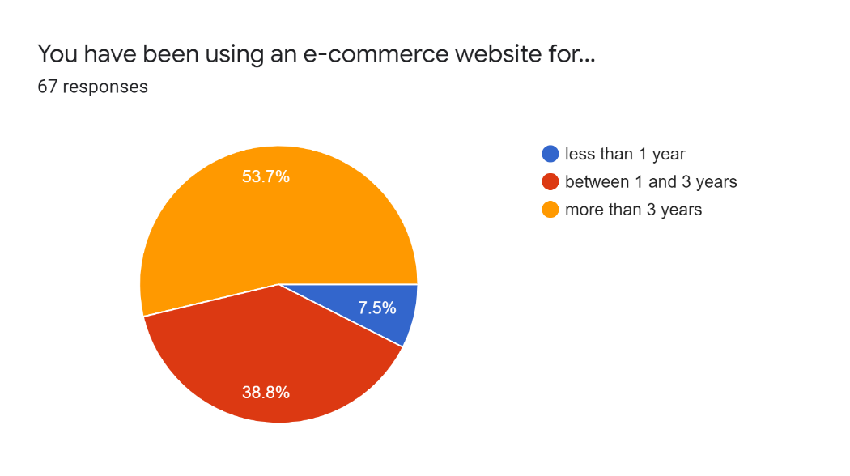

The questionnaire shows that the vast majority of the respondents are using the e-commerce website for personal use when comparing to the usage for work which is only 12.1%. However, 54.5% of the respondents said that they are using it for both personal and work use purpose.

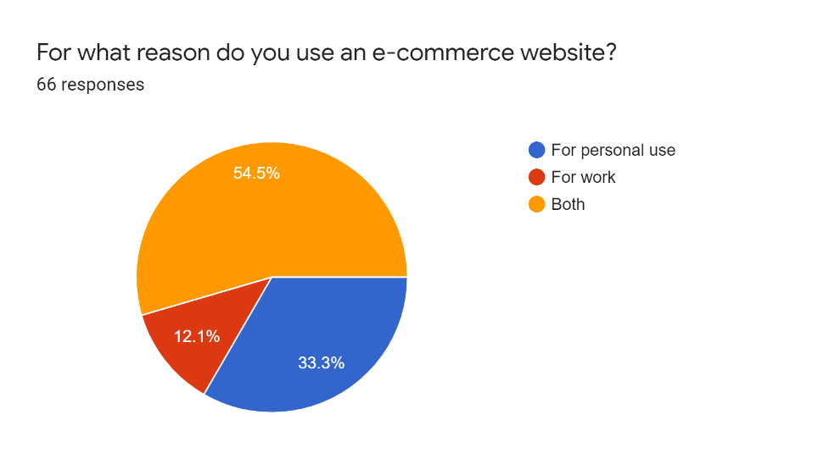

When letting the respondents to think about advantages over the commercial methods, the highest percentage of the vote said that they strongly agree to the part that commercials on an e-commerce website can make advantages over the traditional commercial methods which is 35.9%.

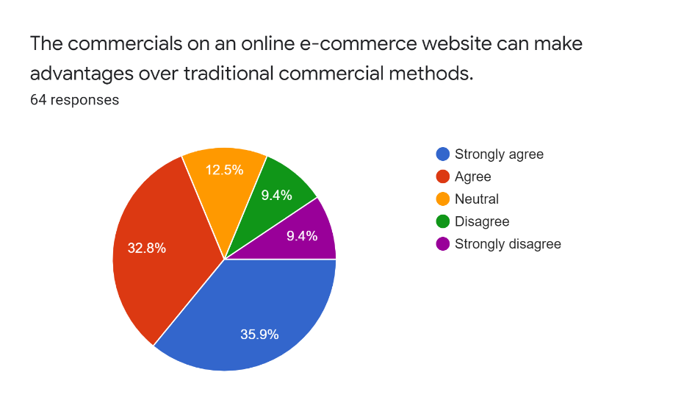

When asked the respondents about whether the e-commerce can provide a different new way of marketing, 66.1% of the respondents said that they do agree to the point. 14.5% of the respondents said no and the rest said that they maybe.

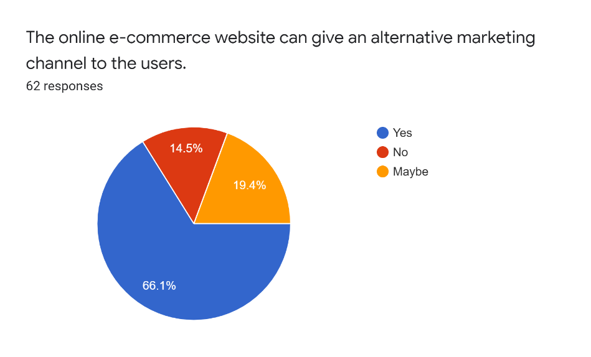

When letting the respondent to ask about what are the challenges in using e-commerce, 65 respondents said that because of the problem of data security there are some challenges using e-commerce 61 respondents said that due to the lack of flexibility. In addition, 49 respondents choose concerning with the slow internet and performance and 41 respondents choose due to the nurturing the ideal prospects. Only 17 respondents said that it is because of the abandonment of consumer’s level.

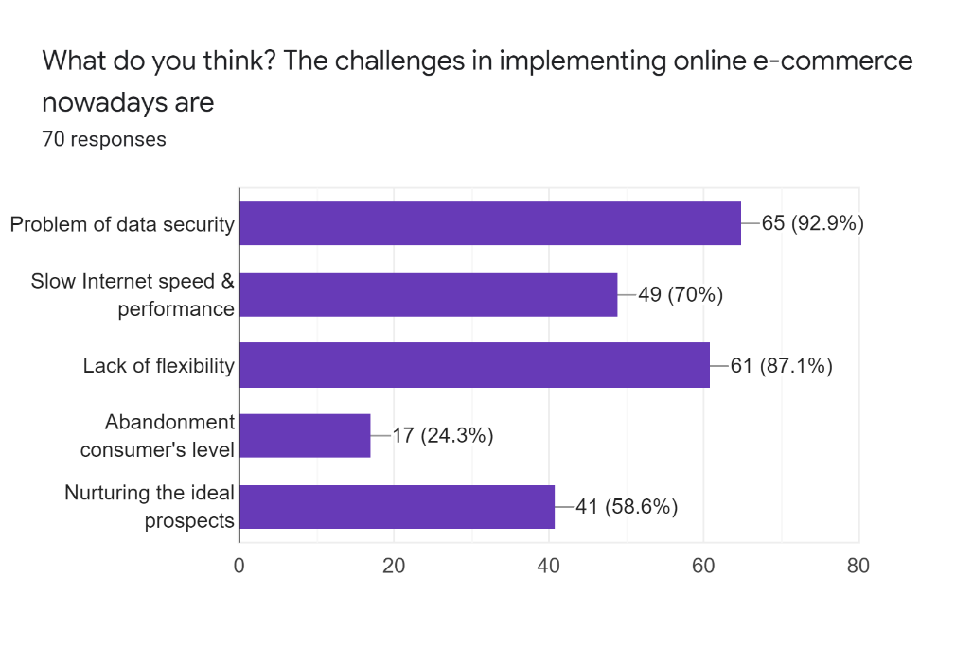

The survey shows that how people thought about the Baibao company and most of the vast majority think that its future is excellent and good. On the other hand, 9.8% think that the future is poor and 11.5% think that the future is fair enough.

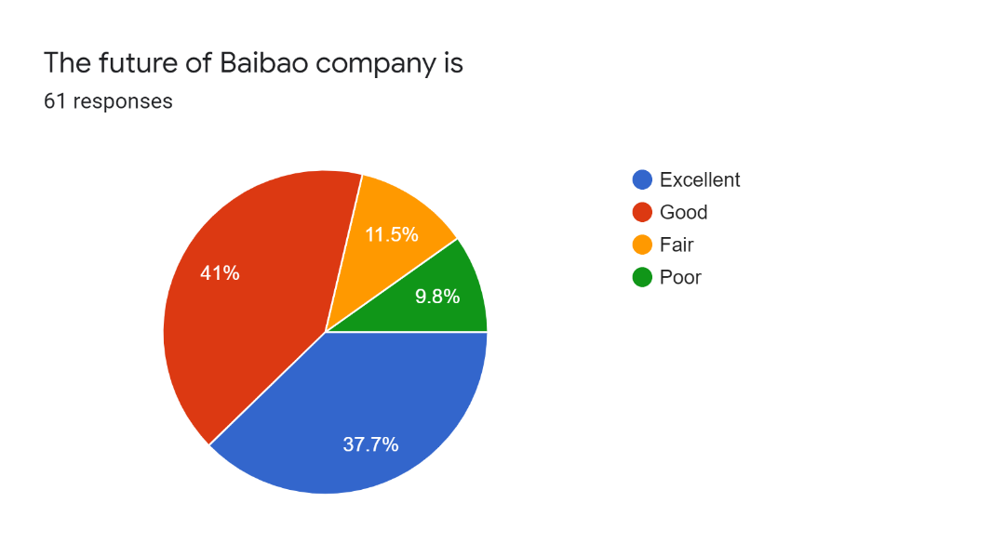

When asking about the payment method on survey, 55.9% respondents said that they like to use any available payment methods on the e-commerce website and 22% of the respondents said that they wanted to pay with the mobile. Also, 13.6% said that they like to use with the credit card payment and 8.5% requested that they want to make cash on delivery. The below chart mentioned the results.

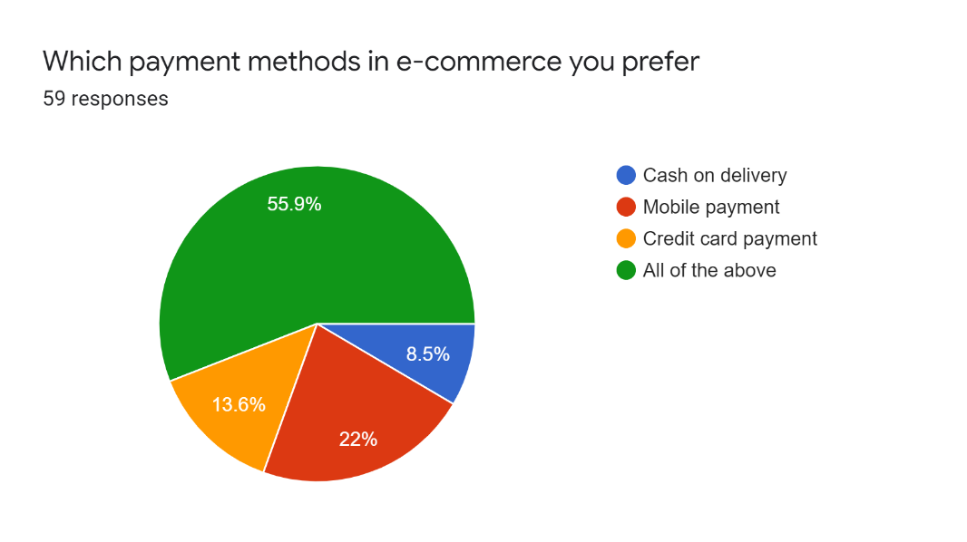

#### Interview

According to interviews with Mr. Moe Kyaw (Senior Consultant of e-commerce) and Ms. Khin Su Su Han (Managing Director of Baibao Company), the results will be presented in the following context,

When asking Mr. Moe Kyaw about how he sees the e-commerce in Myanmar he thinks that using of e-commerce system in Myanmar is extremely low and that maybe due to the culture. However, he expects that the situation will soon be changed in the future and there will be chances to growth the rate of e-commerce usage. On top of that, both Mr. Moe Kyaw and Ms. Khin Su Su Han agree that people can buy and sell through the internet. And when Mr. Moe Kyaw asked about the means usage of buying and selling through online, he said that most people in Myanmar used social media such as Facebook and Messengers even though the order process may take some time. When things get available for people to allows them to buy and sell in such social media, Mr. Moe Kyaw wonder if e-commerce website will get popular by users. And also, he strongly suggests that regarding the structures that must be provided on the website, try out some requirements which will be very user-friendly and provide new different classification of the products for the customer. Mr. Moe Kyaw also agree Ms. Khine Su Su Han about the acceptance of the credit card and invoice on the webpage. In conclusion, asked for the advice from the Senior Consultant of e-commerce where Mr. Moe Kyaw said “You must have to try something that might excite the users when shopping online and come up with more ease-to-use actions and user-friendly features”

### Summary Findings

From the Findings, the points are extracted as its follow:

* Make people to increase the mobility on the e-commerce website.
* Be aware of the challenges on the e-commerce implementation.
* Provide something which will make people more excited.
* Be easy to use and must user-friendly.
* Follow the necessity standards of the functional and non-functional web requirements.

## High Level Requirements

In this part, the high-level requirements are described and these will be about what system should provide or do for the users and it is as follow:

* User Roles and Profile
* **Administrator**: This is the most authoritative user to all roles that are within management where they can control and manage all the users and system.
* **Manager**: This is the user who have an authority to approve the new seller and product. This user can control and manage overall website data such as:
  + Manage website data: Add product information, shipment status and manage order.
  + Control web users: approve the seller and product of the data and activate and deactivate customer’s account.
* **Seller**: This is the supplier, company or user that owns the business and they have the role to add new products within its jurisdiction from the manager. These users can register their account on the website and can update the personal profile and add the Commercial Registration Certificate so the admin and manager can check it and make approval and after that, the account will be active to register products. The available powers to this user are adding, editing and checking list of the products.
* **Shipper**: This user is specialized in the transportation and shipments of the products who has the power to make the shipping orders on the shipping route.
* **Customer**: This is the user who browses the products throughout the website and make orders will be the important user who will serve the business to the Baibao. This user has the power to register account, edit profile, and complete the shopping process: selecting products, adding to cart, selecting payment method, and checking out the order.
* General Requirements:
* **Registration**: Allows user to open a new account on the website where any 3 types of users can register: customer, seller, and shipper.
* **Login**: Allows the registered user to access and surf the website with further privileges by user type.
* **Logout**: Allows the registered user to log out from the website.
* Admin Requirements:
* Have the **most** authoritative controls and modifications of the users and website system.
* Manager Requirements:
* **Approve user**: Allows this user to give approval to the seller and shipper users.
* **Approve product**: Allows this user to give approval for the new product before they are displayed on the webpages to offer to the customers.
* **Statistics Reports**: Allows this user to get the sales or business report statistics from the website.
* Customer Requirements:
* **Cart**: Allows this user to put favored products into the cart during the shopping process.
* **Checkout**: When this user finished the cart process, it allows the registered customer to checkout their order.
* **Choose Payment**: During the checkout, this user must select their payment method to complete the ordering process.
* **Return items**: Allows this user to return the purchased items when he/she did not satisfy with the product.
* **Give ratings & feedbacks**: Allows this user to make feedbacks and rate the product.
* Seller Requirements:
* **Add product**: Allows this user to register the new items on the website from the admin and manger’s acceptance.
* **View orders**: Allows this user to follow up and verify the customer requests.
* Shipper Requirements:
* **View order’s requests**: Allows this user to track the address of the shipping orders and determine the delivery price.
* **Update the delivery status**: Allows this user to update the status of the delivery list where the products are finished the delivery.

## Functional Requirements Prioritizing with MoSCoW

With the help of listing requirements, high level requirements are effectively captured and the details of functional requirements are clarified. These will be the same as the business requirements which will be expected from Baibao. These functionalities will be reorganized in accordance by prioritizing using with the MoSCoW strategy.

|  |  |  |  |  |  |
| --- | --- | --- | --- | --- | --- |
| **High Level Requirement** | **Priority** | | | | **Reason** |
| **M** | **S** | **C** | **W** |
| Approve Items | ✔ |  |  |  | The seller must make a request from the admin or manager to publish their products. Without this functional requirement, any user will be publishing bad product and drop down the Baibao’s reputation. |
| Manage Orders | ✔ |  |  |  | In order to make a business from this website, the orders from the customer who purchased the products must be provided to the admin, manager or shipper to deliver the products. |
| Manage Products | ✔ |  |  |  | Without products in the database, nothing can be done as an online ecommerce system. |
| Manage Users | ✔ |  |  |  | Every user must be registered member in order to do actions within their work field. It is also highly necessary requirement for the admin and manager to control the information. If not, security privilege can be happened like unauthorized access. Therefore, it is a must-have requirement. |
| Manage Shipments |  | ✔ |  |  | The website should have a functional requirement for the shipper to put prices and shipping plan for the delivery and track the list of the customer’s order. |
| Statistics Reports |  | ✔ |  |  | In order to capture the business profit, reviews of statistics report such as sales should be included so that further business plan can be work on. |
| Return Items |  |  | ✔ |  | As to give more customer satisfaction, return items system could be provided online but it is not a highly required function for the Baibao as most customer will simply make a voice call. |
| Give Ratings & Feedbacks |  |  |  | ✔ | As this project is needed to contain the necessary features, this function is not required for current business operation. |

## Non-Functional Requirements

The non-functional requirement will be defined on how the system works in usability, performance, reliability, and supportability and it’s as follow:

|  |  |  |
| --- | --- | --- |
| **Name** | **Description** | **Category** |
| Attractive interface design | Baibao web system must provide customer and users with user friendly interface and ease of use features. This must also handle the simple design and actions for the users to access all easily. | Usability |
| Product option | Customer can choose the item’s option such as size or color. |
| Preorder | Customer can easily preorder by choosing with the calendar view and set time. |
| Order with google map | Customer can set the shipment destination simply by pinning on the google map or using with the GPS. |
| Reorder | Customer can easily make the same order again from his/her history order list in the account. |
| Promotion | Customers can get the points and have discounts from buying from the website or become premium customer. |
| Web hosting time | Baibao web system must available at all times and indicate to the users with maintenance page if there is a period of maintenance of this website. | Availability |
| Protection from sensitive data | Baibao web system must have a secure system to promote the customer assurance. For that, this website will only allow the authorized users to access and browse the web data in specific type of user’s perspective site. Moreover, this project will use encodes and decodes method on some features to secure the data. | Security |
| Fast website system | Baibao web system must have a high performance with fast response time and no latency. There must also have the messages to alert for any systemic failure when user done a wrong process in action. | Performance |
| Flexible upgrade | Baibao web system must have flexible and enable to open on any updates in future change. | Flexibility |

## Use Case Diagram

[FILL_THIS_PART] Use case diagram

# Chapter 5 – Design

The section is about designing a database for the young Baibao ecommerce business in order to provide the opportunity to utilize the ease-of-use online shop system. This database will be related to the ordering system for the franchise according to the relevant requirements and normalized to achieve the Entity Relationship Diagram (ERD). The data dictionary will also be made from the collected attributes, gathered from the normalization, so as to design towards the physical model for the database with the MySQL program.

The prototype of this database will then be specific on their certain premise: able to track which staff member took the orders, which product is in approval and orders taken, whether the customer paid by cash or credit card.

## Analyzing and Normalizing Structure

With the intention of normalizing to the 3NF, one of the existing receipts is analyzed and then data are gathered base on the relevant information. The following image shows the receipt.

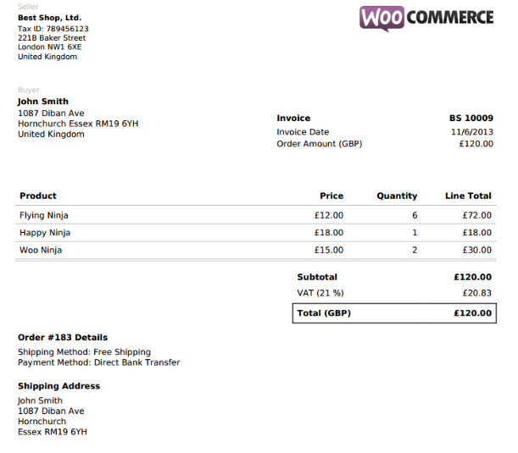

Figure 3.1 WOO Commerce Sample Receipt

### Third Normalized Form (3NF) for the Ecommerce System

|  |  |  |
| --- | --- | --- |
| **categories** | **subcategories** | **products** |
| Category_id (PK) | Subcategory_id (PK) | Product_id (PK) |
| Category_image | Subcategory_image | Product_image |
| Category_name | Subcategory_name | Product_brand |
| created_at | Category_id (FK) | Product_name |
| updated_at | created_at | Product_price |
|  | updated_at | Product_discounted_price |
|  |  | Product_weight |
|  |  | Product_description |
|  |  | Status_approve |
|  |  | Status_changed_by |
|  |  | Subcategory_id (FK) |
|  |  | Seller_id (FK) |
|  |  | created_at |
|  |  | updated_at |

|  |  |  |
| --- | --- | --- |
| **variants** | **variant options** | **orderdetails** |
| Variant_id (PK) | Variant_option_id (PK) | Order_id (FK) |
| Variant_name | Variant_option_name | Sub_quantity_amount |
| Variant_description | Variant_option_description | Product_id (FK) |
| Product_id (FK) | Variant_option_additional_price | Product_variant_option |
| created_at | Variant_id (FK) | Product_vop |
| updated_at | created_at | Product_per_weight |
|  | updated_at |  |

|  |  |  |
| --- | --- | --- |
| **users** | **orders** | **shippings** |
| User_id (PK) | Order_id (PK) | Shipping_id (PK) |
| Role | Order_date | Shipping_name |
| Photo | Order_total_price_amount | Per_order_price |
| Fullname | Order_total_discount_amount | Per_item_price |
| Username | Order_total_weight_amount | Per_weight_price |
| Email | Order_total_quantity_amount | Shipping_provider_id (FK) |
| Password | O_address | Status_approve |
| Dob | O_phone_number | Status_changed_by |
| Phone_number | Notes | created_at |
| Address | Payment_type | updated_at |
| User_approval | Payment_status |  |
| CR_detail | Credit_card_number |  |
| Company | Shipment_status |  |
| isEmailConfirmed | Order_cancel_status |  |
| token | User_id (FK) |  |
| Status_changed_by | Shipping_id (FK) |  |
| created_at | Status_changed_by |  |
| updated_at | created_at |  |
|  | updated_at |  |

## Entity Relationship Diagram (ERD)

### Initial Diagram



### Detail Diagram



### Data Dictionary

|  |  |  |  |  |  |  |  |
| --- | --- | --- | --- | --- | --- | --- | --- |
| **categories** | This entity is used to save product’s category such as: clothing, electronics and more. | | | | | | |
| **Attribute Name** | **Description** | **Type** | **Size** | **PK** | **FK** | **Null** | **Unique?** |
| Category_id |  | varchar | 50 | ✔ |  |  |  |
| Category_image |  | text |  |  |  |  |  |
| Category_name |  | varchar | 255 |  |  |  |  |
| created_at |  | timestamp |  |  |  |  |  |
| updated_at |  | timestamp |  |  |  |  |  |

|  |  |  |  |  |  |  |  |
| --- | --- | --- | --- | --- | --- | --- | --- |
| **subcategories** | This entity is used to save product’s subcategory such as: laptops, shirts for men and more. | | | | | | |
| **Attribute Name** | **Description** | **Type** | **Size** | **PK** | **FK** | **Null** | **Unique?** |
| Subcategory_id |  | varchar | 50 | ✔ |  |  |  |
| Subcategory_image |  | text |  |  |  |  |  |
| Subcategory_name |  | varchar | 255 |  |  |  |  |
| Category_id |  | varchar | 50 |  | ✔ |  |  |
| created_at |  | timestamp |  |  |  |  |  |
| updated_at |  | timestamp |  |  |  |  |  |

|  |  |  |  |  |  |  |  |
| --- | --- | --- | --- | --- | --- | --- | --- |
| **variants** | This entity is used to save product’s variants such as: RAMs, sizes and more. | | | | | | |
| **Attribute Name** | **Description** | **Type** | **Size** | **PK** | **FK** | **Null** | **Unique?** |
| Variant_id |  | varchar | 50 | ✔ |  |  |  |
| Variant_name |  | varchar | 255 |  |  |  |  |
| Variant_description |  | text |  |  |  |  |  |
| Product_id |  | varchar | 50 |  | ✔ |  |  |
| created_at |  | timestamp |  |  |  |  |  |
| updated_at |  | timestamp |  |  |  |  |  |

|  |  |  |  |  |  |  |  |
| --- | --- | --- | --- | --- | --- | --- | --- |
| **variant_options** | This entity is used to save product’s variant option such as: 16 GB, large and more. | | | | | | |
| **Attribute Name** | **Description** | **Type** | **Size** | **PK** | **FK** | **Null** | **Unique?** |
| Variant_option_id |  | varchar | 50 | ✔ |  |  |  |
| Variant_option_name |  | varchar | 255 |  |  |  |  |
| Variant_option_description |  | text |  |  |  |  |  |
| Variant_option_additional_price |  | decimal | (19,2) |  |  |  |  |
| Variant_id |  | varchar | 50 |  | ✔ |  |  |
| created_at |  | timestamp |  |  |  |  |  |
| updated_at |  | timestamp |  |  |  |  |  |

|  |  |  |  |  |  |  |  |
| --- | --- | --- | --- | --- | --- | --- | --- |
| **products** | This entity is used to save product information. | | | | | | |
| **Attribute Name** | **Description** | **Type** | **Size** | **PK** | **FK** | **Null** | **Unique?** |
| Product_id |  | varchar | 50 | ✔ |  |  |  |
| Product_image |  | text |  |  |  |  |  |
| Product_brand |  | varchar | 255 |  |  |  |  |
| Product_name |  | varchar | 255 |  |  |  |  |
| Product_price |  | decimal | (19,2) |  |  |  |  |
| Product_discounted_price |  | decimal | (19,2) |  |  |  |  |
| Product_weight |  | decimal | (19,2) |  |  |  |  |
| Product_description |  | text |  |  |  |  |  |
| Status_approve | Done by admin or manager | boolean |  |  |  |  |  |
| Status_changed_by | Get admin or manager id | varchar | 50 |  |  |  |  |
| Subcategory_id |  | varchar | 50 |  | ✔ |  |  |
| Seller_id | User_id of Seller role | varchar | 50 |  | ✔ |  |  |
| created_at |  | timestamp |  |  |  |  |  |
| updated_at |  | timestamp |  |  |  |  |  |

|  |  |  |  |  |  |  |  |
| --- | --- | --- | --- | --- | --- | --- | --- |
| **users** | This entity is used to save users information. | | | | | | |
| **Attribute Name** | **Description** | **Type** | **Size** | **PK** | **FK** | **Null** | **Unique?** |
| User_id |  | varchar | 50 | ✔ |  |  |  |
| Role |  | varchar | 50 |  |  |  |  |
| Photo |  | text |  |  |  |  |  |
| Fullname |  | varchar | 255 |  |  |  |  |
| Username |  | varchar | 255 |  |  |  |  |
| Email |  | varchar | 255 |  |  |  |  |
| Password |  | text |  |  |  |  |  |
| Dob | Date of Birth | date |  |  |  |  |  |
| Phone_number |  | varchar | 15 |  |  |  |  |
| Address |  | text |  |  |  |  |  |
| User_approval |  | boolean |  |  |  |  |  |
| CR_detail | Commercial Certificate | text |  |  |  |  |  |
| Company |  | varchar | 255 |  |  |  |  |
| isEmailConfirmed |  | boolean |  |  |  |  |  |
| token | For email registration token | text |  |  |  |  |  |
| Status_changed_by | Get admin or manager id | varchar | 255 |  |  |  |  |
| created_at |  | timestamp |  |  |  |  |  |
| updated_at |  | timestamp |  |  |  |  |  |

|  |  |  |  |  |  |  |  |
| --- | --- | --- | --- | --- | --- | --- | --- |
| **orders** | This entity is used to save orders information. | | | | | | |
| **Attribute Name** | **Description** | **Type** | **Size** | **PK** | **FK** | **Null** | **Unique?** |
| Order_id |  | varchar | 50 | ✔ |  |  |  |
| Order_date |  | date |  |  |  |  |  |
| Order_total_price_amount |  | decimal | (19,2) |  |  |  |  |
| Order_total_discount_amount |  | decimal | (19,2) |  |  |  |  |
| Order_total_weight_amount |  | decimal | (19,2) |  |  |  |  |
| Order_total_quantity_amount |  | Int | 11 |  |  |  |  |
| O_address | Order address | text |  |  |  |  |  |
| O_phone_number | Order phone number | varchar | 15 |  |  |  |  |
| Notes |  | text |  |  |  |  |  |
| Payment_type |  | varchar | 255 |  |  |  |  |
| Payment_status | Done by admin and manager | boolean |  |  |  |  |  |
| Credit_card_number |  | varchar | 16 |  |  |  |  |
| Shipment_status | Done by admin, manager, shipper | boolean |  |  |  |  |  |
| Order_cancel_status | Done by admin and manager | boolean |  |  |  |  |  |
| User_id | The one who is buyer | varchar | 50 | ✔ |  |  |  |
| Shipping_id | Shipping plan type | varchar | 50 | ✔ |  |  |  |
| Status_changed_by | Get admin, manager or shipper id | varchar | 50 |  |  |  |  |
| created_at |  | timestamp |  |  |  |  |  |
| updated_at |  | timestamp |  |  |  |  |  |

|  |  |  |  |  |  |  |  |
| --- | --- | --- | --- | --- | --- | --- | --- |
| **orderdetails** | This entity is used to make a dummy table between products and orders. | | | | | | |
| **Attribute Name** | **Description** | **Type** | **Size** | **PK** | **FK** | **Null** | **Unique?** |
| Order_id |  | varchar | 50 | ✔ | ✔ |  |  |
| Sub_quantity_amount |  | int | 11 |  |  |  |  |
| Product_id |  | varchar | 50 | ✔ | ✔ |  |  |
| Product_variant_option | Set of product variant option chosen | text |  |  |  |  |  |
| Product_vop | Product variant option price | decimal | (19,2) |  |  |  |  |
| Product_per_weight |  | decimal | (19,2) |  |  |  |  |

|  |  |  |  |  |  |  |  |
| --- | --- | --- | --- | --- | --- | --- | --- |
| **shippings** | This entity is used to save shipping plans and prices information. | | | | | | |
| **Attribute Name** | **Description** | **Type** | **Size** | **PK** | **FK** | **Null** | **Unique?** |
| Shipping_id |  | varchar | 50 | ✔ |  |  |  |
| Shipping_name |  | varchar | 255 |  |  |  |  |
| Per_order_price |  | decimal | (19,2) |  |  |  |  |
| Per_item_price |  | decimal | (19,2) |  |  |  |  |
| Per_weight_price |  | decimal | (19,2) |  |  |  |  |
| Shipping_provider_id | User id of shipper role | varchar | 255 | ✔ |  |  |  |
| Status_approve | Done by admin or manager | boolean |  |  |  |  |  |
| Status_changed_by | Get admin, manager id | varchar | 50 |  |  |  |  |
| created_at |  | timestamp |  |  |  |  |  |
| updated_at |  | timestamp |  |  |  |  |  |

## Prototype