RELEASE READINESS BRIEF
Project Atlas v2.4.0
Go / No-Go review for the production deployment window
Decision owner | Platform Engineering / Release Manager
Review date | 2026-08-21 15:00 JST
Change window | 2026-08-26 22:00–23:30 JST
Release candidate | v2.4.0-rc.3 / commit 6e8a4c1
Current decision | DOCX RELEASE DECISION: CONDITIONAL GO

1. Executive summary
Recommendation. Proceed with the canary deployment after closing the two documentation actions below. Automated rollback remains mandatory until the 30-minute hypercare window ends.
- CI, dependency license audit, and package-integrity suites are green.
- Database migration was rehearsed against the staging snapshot in 7m 42s.
- PPTX speaker-note edits remain a protected boundary and must be documented in the release notes.

2. Release gates
Gate | Owner | Status | Evidence
A · Preservation | Format Team | PASS | Unknown parts and raw slices retained
B · Integrity | Core Team | PASS | Markers, graph, map, and hashes verified
C · Security | AppSec | PASS | DTD, external rels, and risky formula policies
E · Quality | QA | REVIEW | 76 automated tests; 2 documentation actions

3. Control-room evidence
Figure 1 shows the release candidate status at the review cut-off. The screenshot is embedded as immutable evidence; the source workbook and package indexes remain in the RTMD workspace.
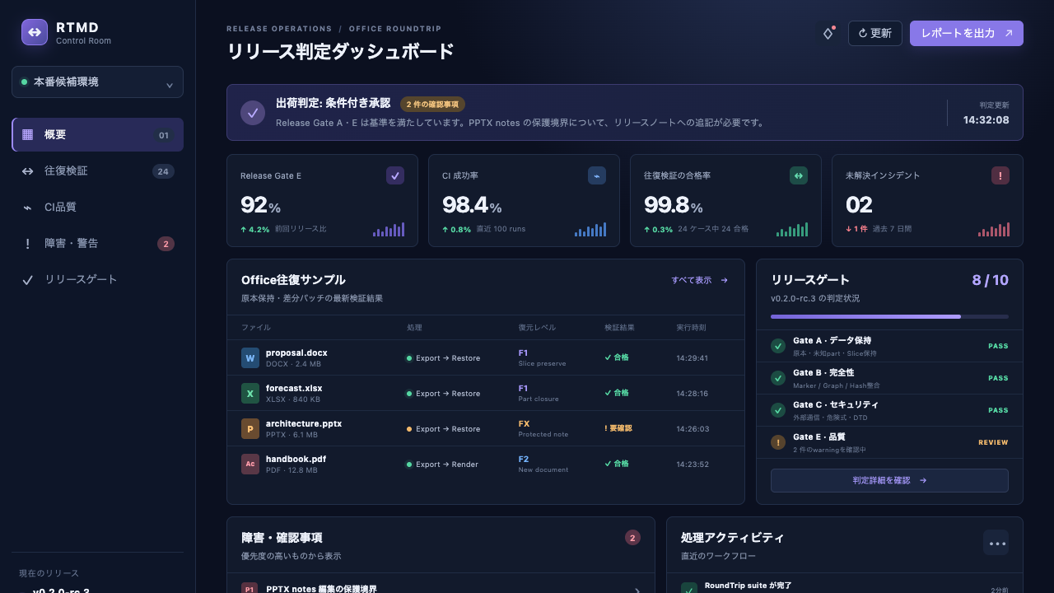
Figure 1 — Release control-room dashboard at 2026-08-21 14:32 JST

Observed exceptions
- P1 — Speaker Notes changes are rejected explicitly; existing notes are preserved.
- P2 — Low-confidence OCR is surfaced as annotation-only evidence and never mutates original content.

4. Deployment and rollback flow
The rollout is intentionally gated. Promotion to the next stage requires a stored evidence record and an affirmative owner decision.
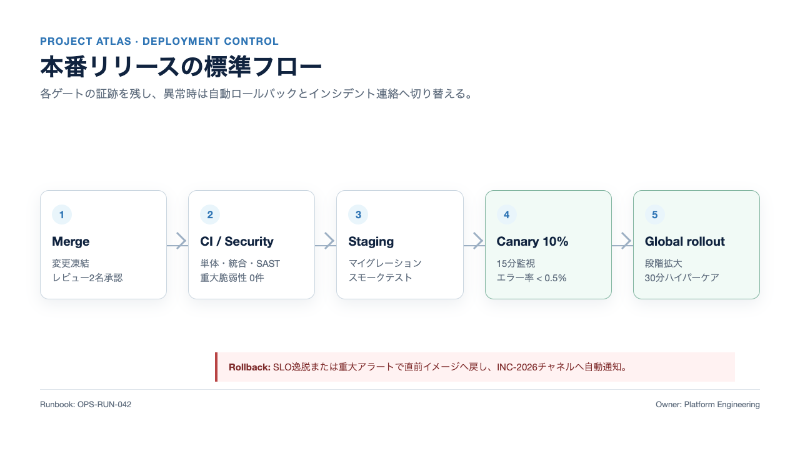
Figure 2 — Production deployment flow and automatic rollback path

Operator sequence
- Freeze the release branch and capture the approved commit SHA.
- Run CI, SAST, dependency license audit, and package-integrity verification.
- Deploy to staging; execute migration and smoke checks against the runbook.
- Promote 10% canary traffic and observe error rate, latency, and saturation for 15 minutes.
- Expand globally only if all SLOs remain within threshold; otherwise roll back immediately.

5. Handoff
Preservation sentinel: DOCX-PRESERVE-OPS-2026
Release Manager records the final decision in the change ticket; Platform Engineering owns deployment, rollback, and the 30-minute hypercare bridge.

