Digital Logic Gates
2023/10/05
B113040045 許育菖
實驗內容
Exercise1
Derive (x ↓ y) ↓ z = (x + y)z', z ↓ (y ↓ x) = z' (y + x) and
x ↓ (y ↓ z) = x' (y + z) (applying DeMorgan's theorem)
- Verify (x ↓ y) ↓ z = z ↓ (y ↓ x) (using Structural level modeling)
- Verify (x ↓ y) ↓ z ≠ x ↓ (y ↓ z) (using Structural level modeling)
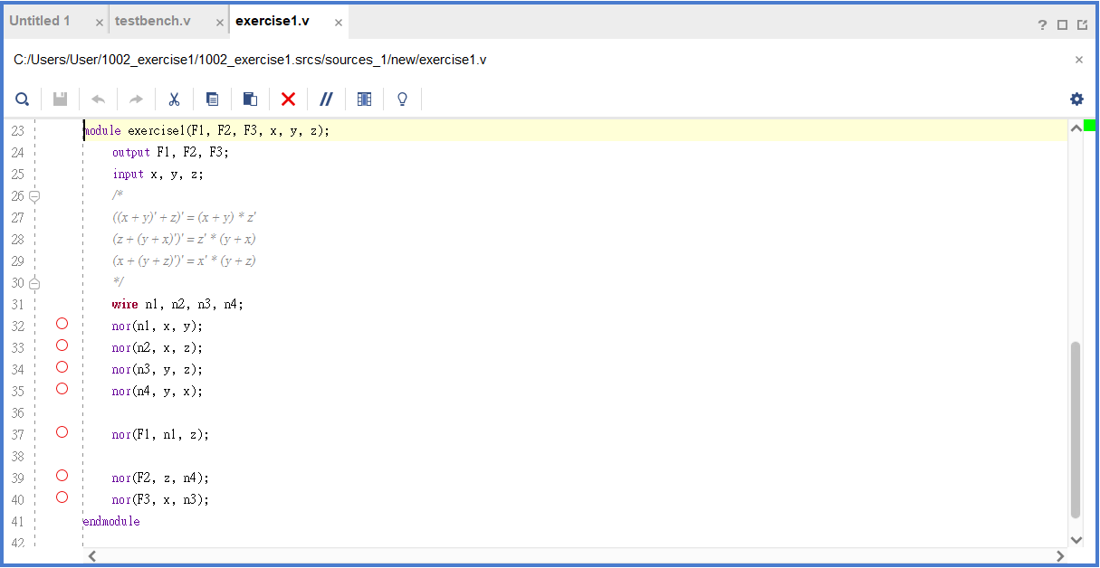
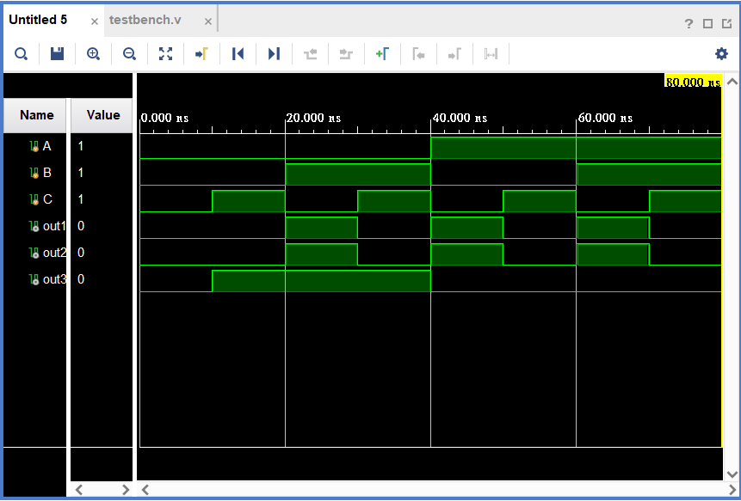

跟據題目， (x ↓ y) ↓ z = (x + y)z'
z ↓ (y ↓ x) = z' (y + x)
x ↓ (y ↓ z) = x' (y + z)。
第一步要驗證 (x + y)z' 是否等於 z' (y + x) ，由實驗結果的波形圖可以證明等式 (x + y)z' = z' (y + x) 成立。
我們也可以從布林代數的定理進行二次驗證：
Postulate 4a, (x + y)z' = xz' + yz', z' (y + x) = z'y + z'x
Postulate 3b, z'y + z'x = yz' + xz'
Postulate 3a, yz' + xz' = xz' + yz'
$⟹$ (x + y)z' = xz' + yz' = xz' + yz' = z' (y + x)
第二步則是要驗證 (x + y)z' 是否不等於 x' (y + z)，實驗結果的波形圖可以發現該等式式不成立的。
我們也試著從布林代數的定理進行推算看看：
Postulate 4a, (x + y)z' = xz' + yz', x' (y + z) = x'y + x'z
Postulate 3a, x'y + x'z = x'z + x'y
$⟹$ (x + y)z' = xz' + yz' ≠ x'z + x'y = x' (y + z)
推導 (x ↓ y) ↓ z = (x + y)z' ↓：nor gate
x ↓ y = (x + y)' = x' y', by Thm 5a (DeMorgan Thm)
$⟹$ (x ↓ y) ↓ z = [(x + y)' + z]'
= [x' y' + z]' = (x' y')' z'
= (x + y) z', by Thm 5b (DeMorgan Thm)
∴ (x ↓ y) ↓ z = (x + y) z'
Exercise2
Derive [(ABC)' × (DE)' ]' = ABC + DE (applying DeMorgan's theorem)
Use Structural level modeling to verify that [(ABC)' × (DE)' ]' = ABC + DE
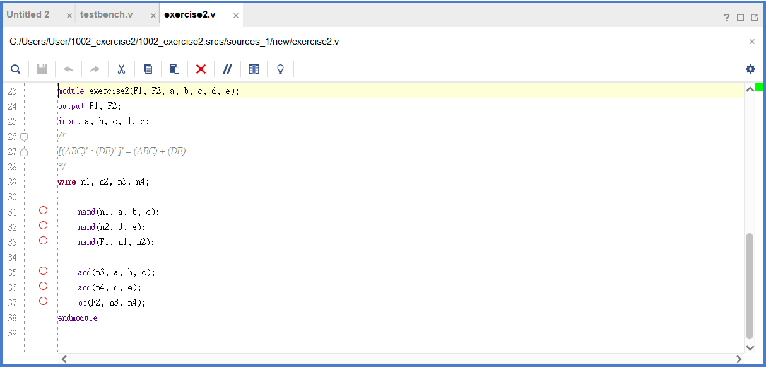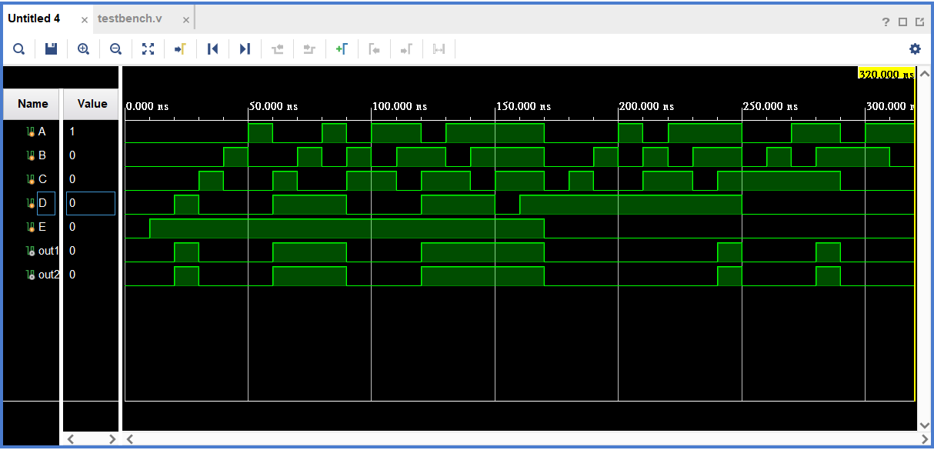
由實驗結果可以驗證 [ (ABC)' × (DE)' ]' = ABC + DE。
以布林代數定理驗證過程如下：
(ABC)' = A' + B' + C', (DE)' = D' + E', by DeMorgan's theorem
[ (ABC)' × (DE)' ]' = [ (A' + B' + C')(D' + E') ]'
= (A' + B' + C')' + (D' + E')'
= ABC + DE, by DeMorgan's theorem
Exercise3
XOR is an odd function.
Complete the truth table of four-variable XOR function:
- F(w, x, y, z)
- F1 = (w ⊕ x) ⊕ (y ⊕ z)
- F2 = w ⊕ (x ⊕ (y ⊕ z))
- F3 = w ⊕ x ⊕ y ⊕ z
Verify F1 = F2 = F3 (using Structural level modeling)
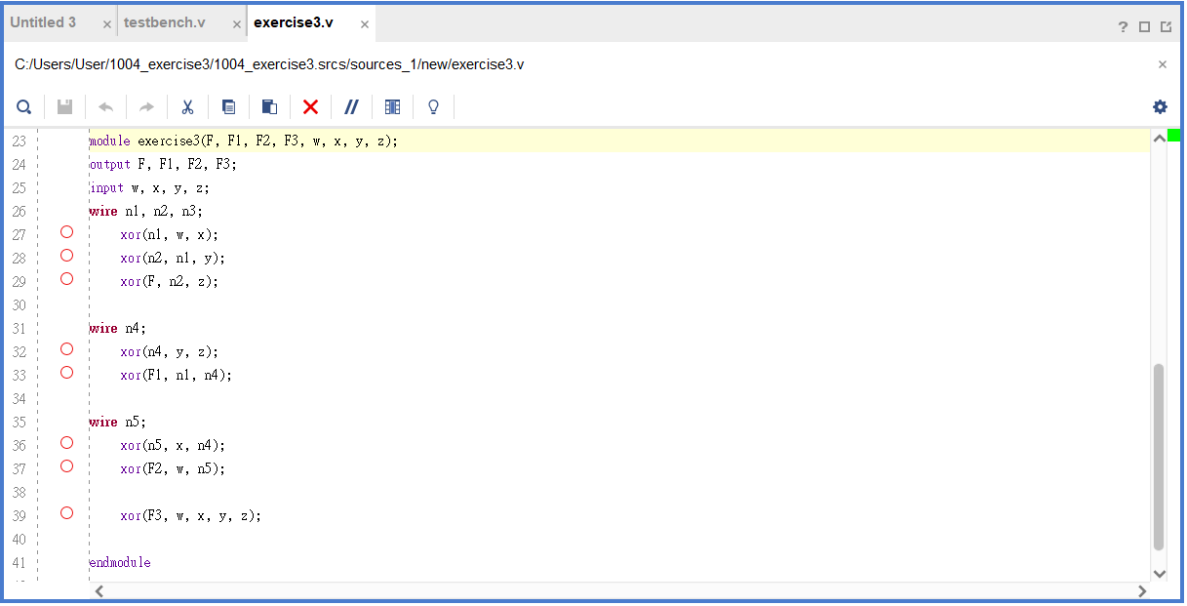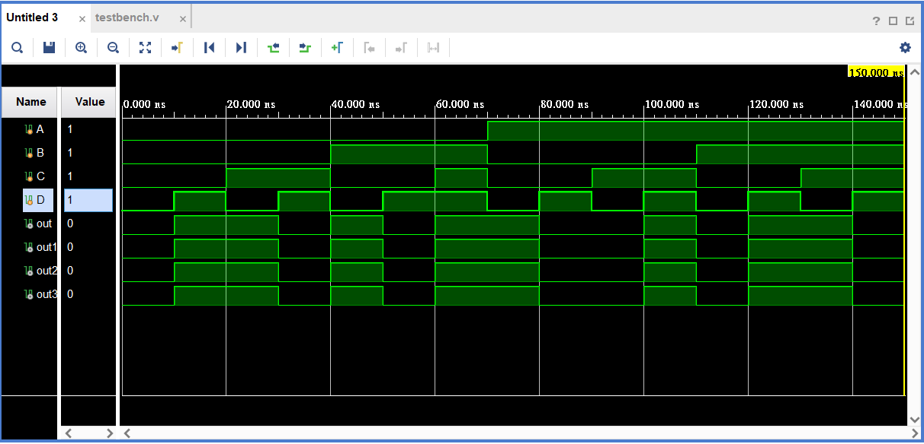
由實驗結果可以驗證 F1 = F2 = F3。
使用布林代數定理驗證過程如下：
w ⊕ x = wx' + w'x
$⟹$ F1 = (w ⊕ x) ⊕ (y ⊕ z) = (wx' + w'x) ⊕ (yz' + y'z)
= (wx' + w'x) (yz' + y'z)' + (wx' + w'x)' (yz' + y'z)
= (wx' + w'x) (yz')'(y'z)' + (wx')'(w'x)' (yz' + y'z)
= (wx' + w'x) (yz + y'z') + (wx + w'x') (yz' + y'z)
= wx'yz + w'xyz + wx'y'z' + w'xy'z' + wxyz' + w'x'yz' + wxy'z + w'x'y'z
F2 = w ⊕ (x ⊕ (y ⊕ z)) = w ⊕ (x ⊕ (yz' + y'z))
= w ⊕ ( x'(yz' + y'z) + x(yz' + y'z)' )
= w ⊕ ( x'yz' + x'y'z + x(yz')'(y'z)' )
= w ⊕ ( x'yz' + x'y'z + x(y' + z)(y + z') )
= w ⊕ ( x'yz' + x'y'z + x(y'y + yz + y'z' + zz')
= w ⊕ ( x'yz' + x'y'z + xyz + xy'z')
= w'( x'yz' + x'y'z + xyz + xy'z') + w( x'yz' + x'y'z + xyz + xy'z')'
= ……(用筆算，超麻煩)
= w'x'yz' + w'x'y'z + w'xyz + w'xy'z' + wx'yz + wxy'z + wxyz' + wx'y'z'
F3 = w ⊕ x ⊕ y ⊕ z = (w'x + wx') ⊕ y ⊕ z
= [ (w'x + wx')'y + (w'x + wx')y' ] ⊕ z
= ( w'x'y + wxy + w'x y' + wx'y' ) ⊕ z
= ( w'x'y + wxy + w'x y' + wx'y' )'z + ( w'x'y + wxy + w'x y' + wx'y' )z'
實驗心得
這次實驗總體而言進行得比上次順利很多，也是我從開學以來第一次提早 完成，小有成就感。 此次實驗首次使用到邏輯閘：XOR，原本以為這個特殊的 gate 會比較難 使用，但實驗時發現撰寫 verilog 的 XOR gate 並沒有想像中的那麼困 難；反倒是在寫實驗心得時，用布林代數去驗證 XOR gate 的等式非常的 麻煩，計算過程一大堆。而且此次實驗才使用到 4 個 XOR 閘而已，如果 以後用到更多個時，我無法想像那驗證過程的計算量……。

