Karnaugh Map
2023/10/16
B113040045 許育菖
實驗內容
Eercise1
Let F(w, x, y, z) = w'yz' + w'xy + wxz + xyz + wx'y'.
Draw the Karnaugh map and find all the simplest sum-of-products of F.
If the simplest sum-of-products of F are F1, F2 and F3, verify F1
= F2 = F3 by using Verilog Dataflow modeling.
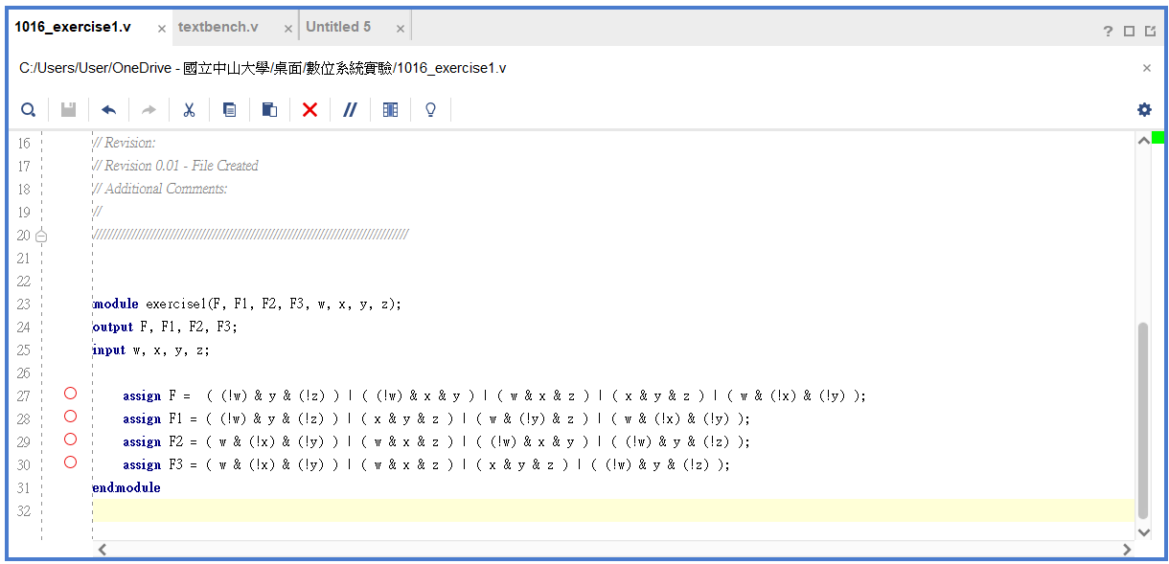
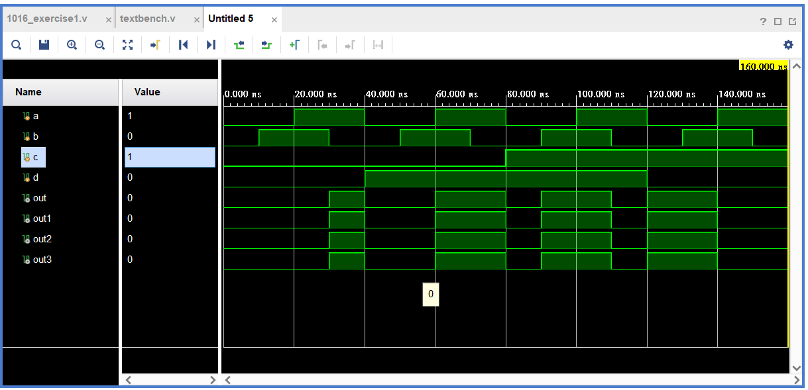

根據題目，可以得到以下的Karnaugh Map：
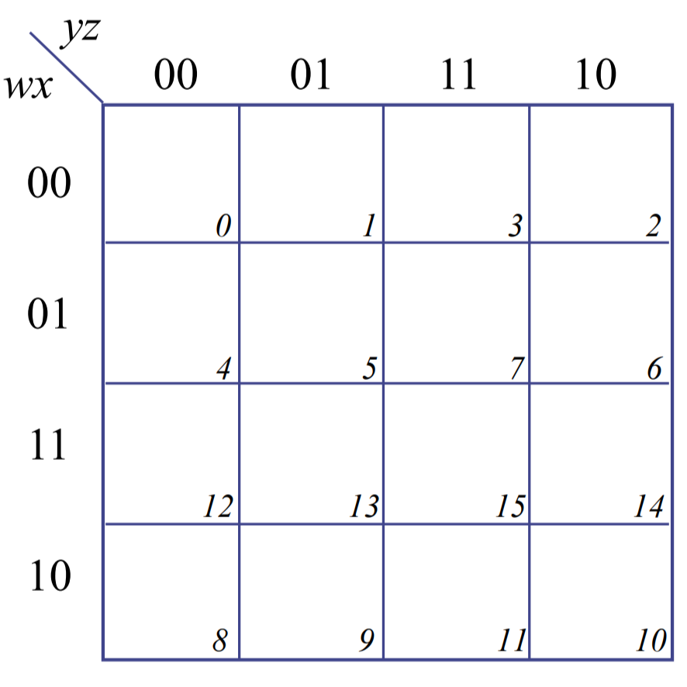
1
1
1
1
1
1
1
可以發現需要兩格兩格一組來得出sum-of-products。
Let F1 = w'yz' + xyz + wy'z + wx'y'

1
1
1
1
1
1
1
F2 = wx'y' + wxz + w'xy + w'yz'

1
1
1
1
1
1
1
F3 = wx'y' + wxz + xyz + w'yz'

1
1
1
1
1
1
1
由實驗結果可以發現：F(w, x, y, z) = F1 = F2 = F3
Exercise2
Draw the Karnaugh map of F1(v, w, x, y, z) = $\sum{(}$ 1, 2, 3, 6, 7, 9, 10, 11, 14, 15, 17, 18, 19, 22, 25, 26, 27, 30 ), and find the simplest sum-of-products of this Boolean function.
If the simplest sum-of-products of F1 is F2, verify F1 = F2 by using Verilog Structural level modeling.
Verilog code：
`timescale 1ns / 1ps
module exercise2(v, w, x, y, z, F1, F2);
output F1, F2;
input v, w, x, y, z ;

wire and1, and2, and3, and4, and5, and6, and7, and8, and9, and10;
and(and1, !v, !w, !x, !y, z);
and(and2, !v, !w, !x, y, z);
and(and3, !v, !w, !x, y, !z);

and(and4, !v, !w, x, y, z);
and(and5, !v, !w, x, y, !z);

and(and6, !v, w, x, y, z);
and(and7, !v, w, x, y, !z);

and(and8, !v, w, !x, !y, z);
and(and9, !v, w, !x, y, z);
and(and10, !v, w, !x, y, !z);

wire and11, and12, and13, and14, and15, and16, and17, and18;
and(and11, v, !w, !x, !y, z);
and(and12, v, !w, !x, y, z);
and(and13, v, !w, !x, y, !z);

and(and14, v, !w, x, y, !z);

and(and15, v, w, x, y, !z);

and(and16, v, w, !x, !y, z);
and(and17, v, w, !x, y, z);
and(and18, v, w, !x, y, !z);

or(F1, and1, and2, and3, and4, and5, and6, and7, and8, and9, and10, and11, and12, and13, and14, and15, and16, and17, and18);

wire n1, n2, n3;
and(n1, !x, z);
and(n2, !v, y);
and(n3, y, !z);
or(F2, n1, n2, n3);
endmodule
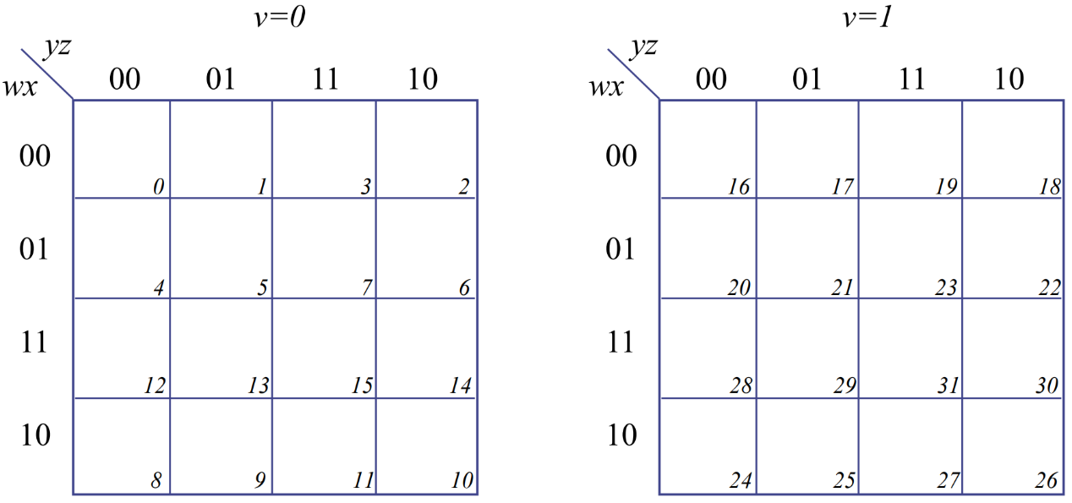
1
1
1
1
1
1
1
1
1
1
1
1
1
1
1
1
1
1
Let F1 = 所有值為true的格子加起來
將Karnaugh map中值為true的格子八個八個一組可得到F1的sum-of-product，把得到的方程式定義為F2
$⟹$ F2 = x'z + v'y + yz'
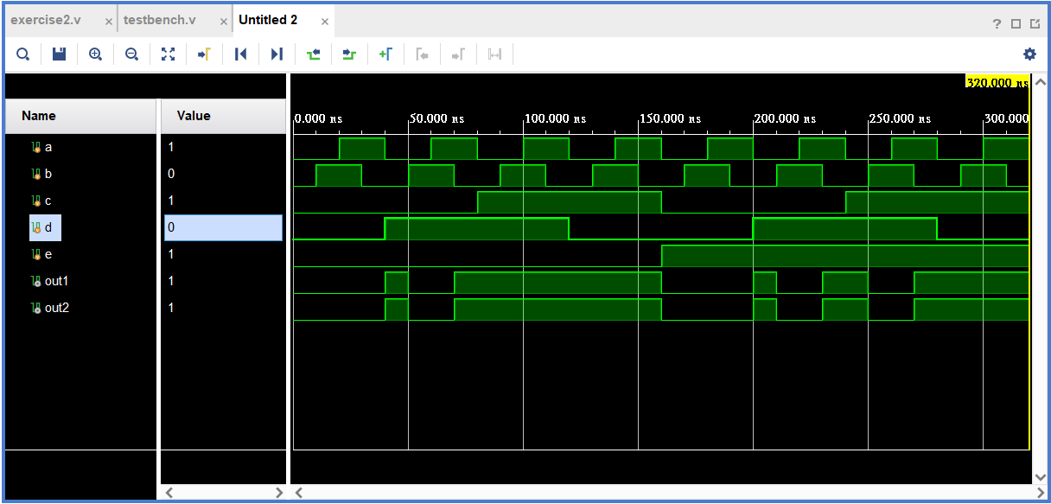
由實驗結果可發現 F1 = F2
Exercise3
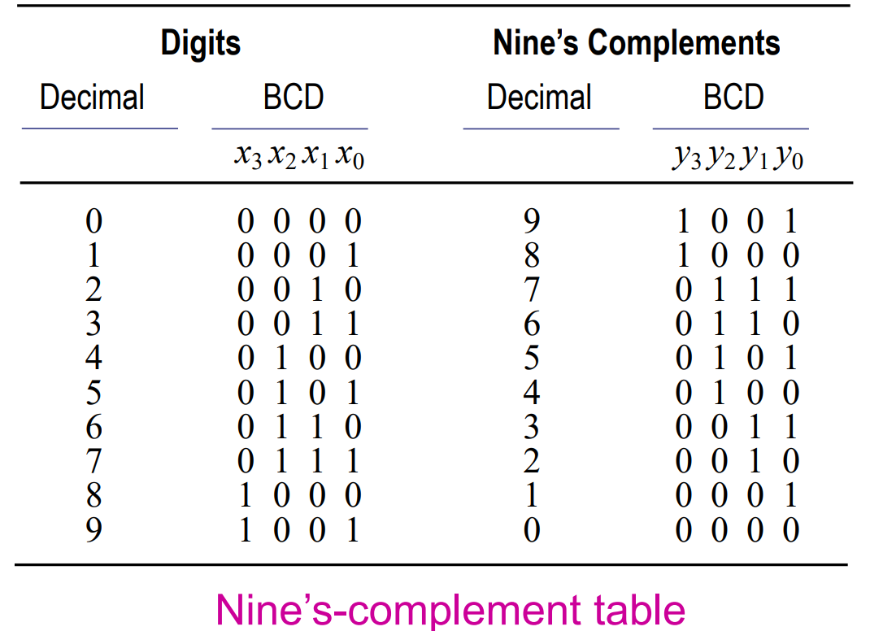
Design the nine's complement converter using Karnaugh maps
and don't-care conditions.
Draw the logic diagram of the nine's complement converter and verify the circuit by using Verilog Structural level modeling.

Verilog code：
`timescale 1ns / 1ps
module exercise3(x0, x1, x2, x3, y0, y1, y2, y3);
output y0, y1, y2, y3;
input x0, x1, x2, x3;
// y0
not(y0, x0);

// y1
and(y1, 1, x1);

// y2
wire and1, and2, xor1, xor2;
and(and1, x1, y1);
and(xor1, !x2, and1);

and(and2, !x1, !y1);
and(xor2, x2, and2);
or(y2, xor1, xor2);

// y3
and(y3, !x3, !x2, !x1);

endmodule
題目要求輸入一個變數，然後輸出它的9補數，意即該數與它的9補數相加起來會等於9，以2進制表示為1 0 0 1。
從y₀往y₃做處理，並觀察Nine’s-complement table中的規律
我們可以發現：
y₀ = (x₀)'
y₁ = x₁
而y₂比較不好直接觀察出它的規律，但經過計算後可以得到：
當 x₁ = y₁ = 1 and x₂ = 0
或是
x₁ = y₁ = 0 and x₂ = 1時，y₂ = 1。
其餘情況y₂ = 0。
最後y₃則是當x₂, x₁, x₀ = 0時，y₃ = 1，否則y₃ = 0。
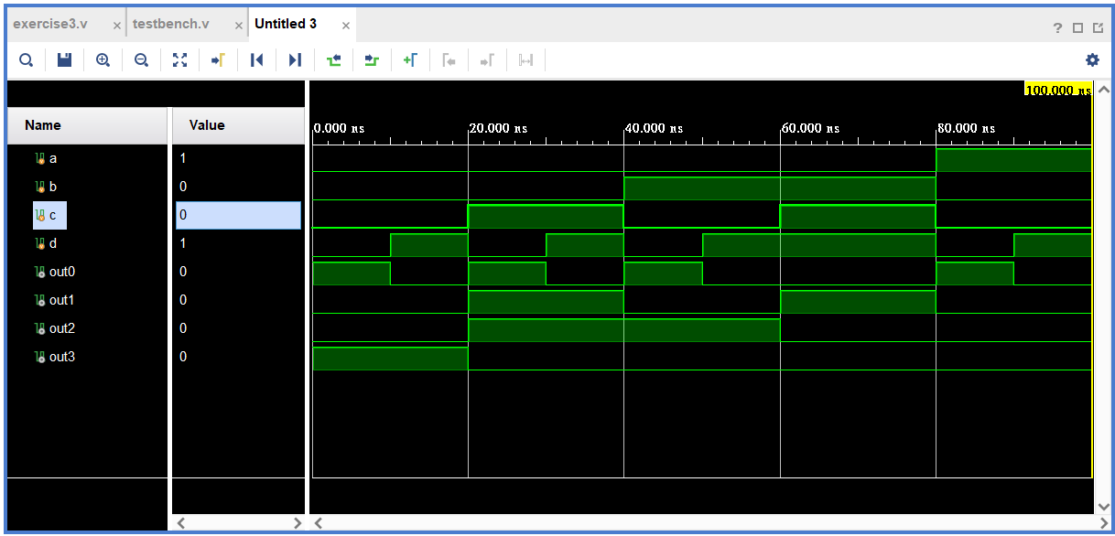
實驗心得
這次實驗室我們第一次接觸Karnaugh Map，老實說一開始完全不知道如何下手，還去重翻了之前上課的PPT，才總算有點頭緒。在實驗過程中，我對Karnaugh Map有點改觀，原本我以為它是一個麻煩的東西，沒想到使用它來找出sum-of-product還滿方便的，尤其是在知道原本的解的時候。不過這次的第二題好麻煩喔，看完題目發現至少要寫18個node，當下真的還滿心累的。

