Karnaugh Map
2023/10/23
B113040045 許育菖
實驗內容
Exercise1
Let F = (AB' +A'B)(C+ D')
- Implement F with AND-OR gates (denoted as F1)
- Implement F with multi-level NAND gate circuit (denoted as F2)
- Implement F with multi-level NOR gate circuit (denoted as F3)
Verify F1 = F2 = F3 (using Verilog Structural level modeling)
使用DeMorgan’s theorem反運算:
F1 = AB'C + A'BC + AB'D + A'BD
$⇒$ F2 = [ (AB'C)' (A'BC)' (AB'D)' (A'BD)' ]' (SOP)
F3 = (A' + B') (C + D) (A + B) (SOP)
= [ (A' + B')' + (C + D)' + (A + B)' ]' (POS)
Verilog code:
`timescale 1ns / 1ps

module exercise1(A, B, C, D, F1, F2, F3);
output F1, F2, F3;
input A, B, C, D;
// F1
wire and1, and2, and3, and4;
and(and1, A, !B, C);
and(and2, !A, B, C);
and(and3, A, !B, !D);
and(and4, !A, B, !D);
or(F1, and1, and2, and3, and4);

// F2
wire and5;
and(and5, !and1, !and2, !and3, !and4);
not(F2, and5);

// F3
wire or1, or2, or3, or4;
or(or1, !A, !B);
or(or2, A, B);
or(or3, C, !D);

or(or4, !or1, !or2, !or3);
not(F3, or4);
endmodule
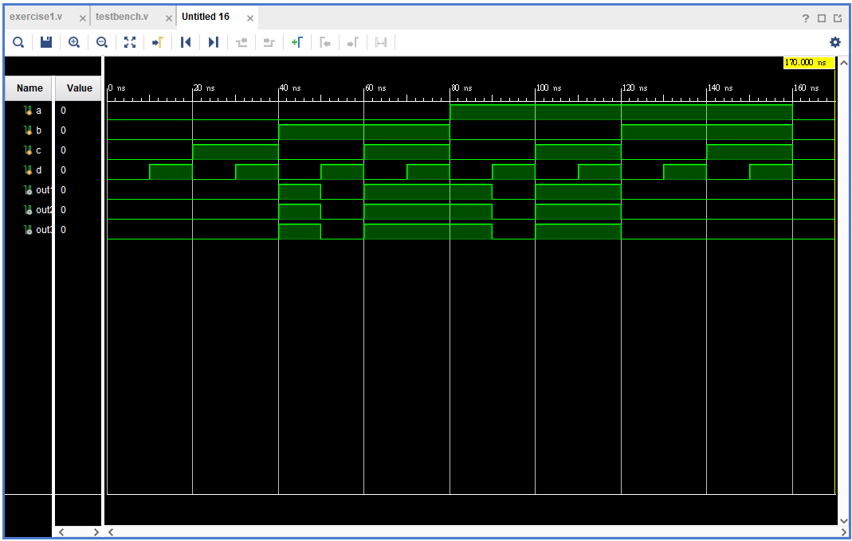
從實驗結果可發現: F = F1 = F2 = F3
Exercise2
- Simplify the following Boolean function using Karnaugh maps: F(x, y, z) = S (1, 2, 3, 4, 5, 7).
- Find the simplest sum of products (F4) and draw its logic diagram (two-level implementation).
- Implement F4 with two-level NAND gate circuit (denoted as F5).
- F6 = (F4')' , implement F6 with two-level OR-NAND (OAI) circuit.
- Verify F4 = F5 = F6 (using Verilog Structural level modeling)
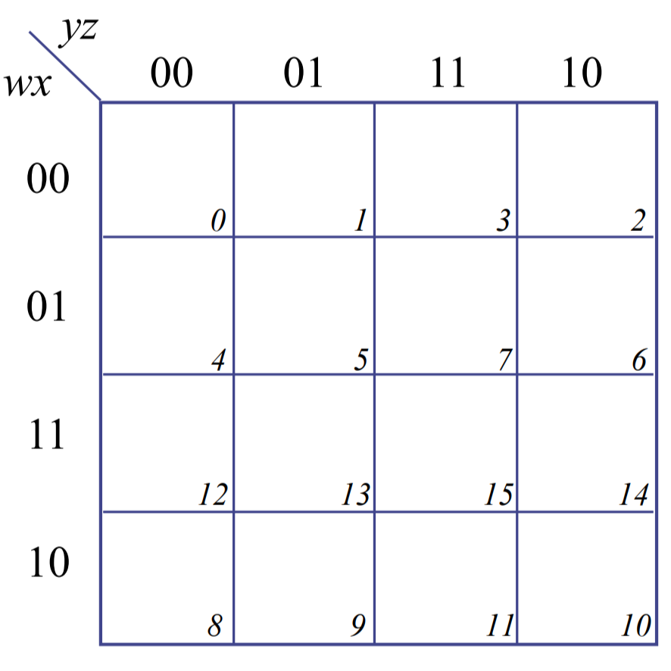
（w沒用到）
1
1
1
1
1
1
F4 = z + x'y + xy'
F5 = [ z' (x'y)' (xy')' ]'
F6 = [ z' (x + y') (x' + y) ]'
Verilog code
`timescale 1ns / 1ps

module exercise2(x, y, z, F4, F5, F6);
output F4, F5, F6;
input x, y, z;

// F4
wire and1, and2;
and(and1, x, !y);
and(and2, !x, y);

or(F4, and1, and2, z);

// F5
wire and4;
and(and4, !and1, !and2, !z);
not(F5, and4);

// F6
wire or1, or2, and5;
or(or1, !x, !y, z);
or(or2, x, y, z);
nand(and5, or1, or2);
not(F6, and5);
// not(F6, and5);
endmodule
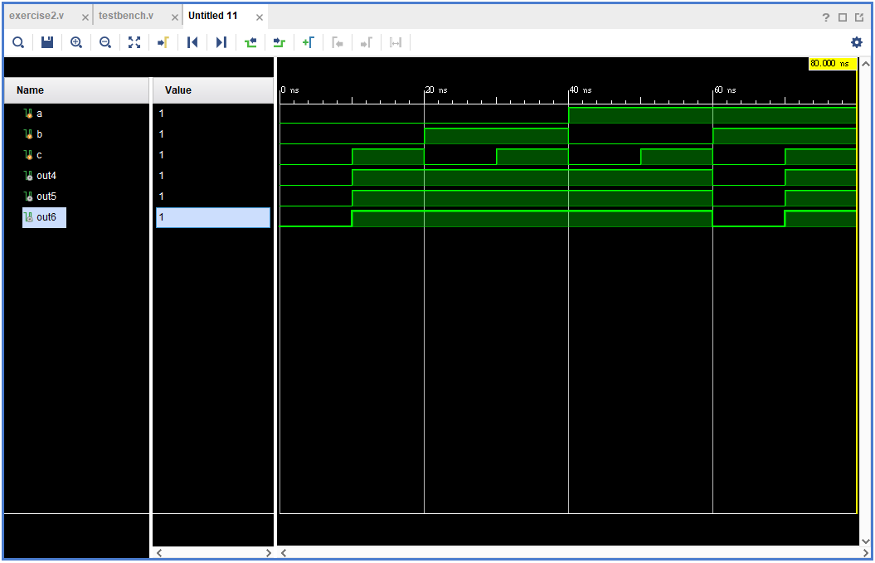
從實驗結果可以發現，F4 = F5 = F6。
Exercise3
- Simplify the following Boolean function using Karnaugh maps: F(x, y, z) = S (1, 2, 3, 4, 5, 7)
- Find the simplest product of sums (F7) and draw its logic diagram (two-level implementation)
- Implement F7 with two-level NOR gate circuit (denoted as F8)
- Implement F7 with two-level AND-NOR (AOI) circuit (denoted as F9)
- Verify F7 = F8 = F9 (using Verilog Structural level modeling)

（w沒用到）
1
1
1
1
1
1
F7 = (x + y + z)(x' + y' + z)
$⇒$ F8 = [ (x + y + z)' + (x' + y' + z)' ]'
F9 = [ (x'y'z') + (xyz') ]'
Verilog code
`timescale 1ns / 1ps

module exercise3(x, y, z, F7, F8, F9);
output F7, F8, F9;
input x, y, z;

// F7
wire or1, or2;
or(or1, x, y, z);
or(or2, !x, !y, z);
and(F7, or1, or2);

// F8
wire nor1, nor2;
nor(nor1, x, y, z);
nor(nor2, !x, !y, z);
nor(F8, nor1, nor2);

// F9
wire and1, and2;
and(and1, !x, !y, !z);
and(and2, x, y, !z);
nor(F9, and1, and2);

endmodule
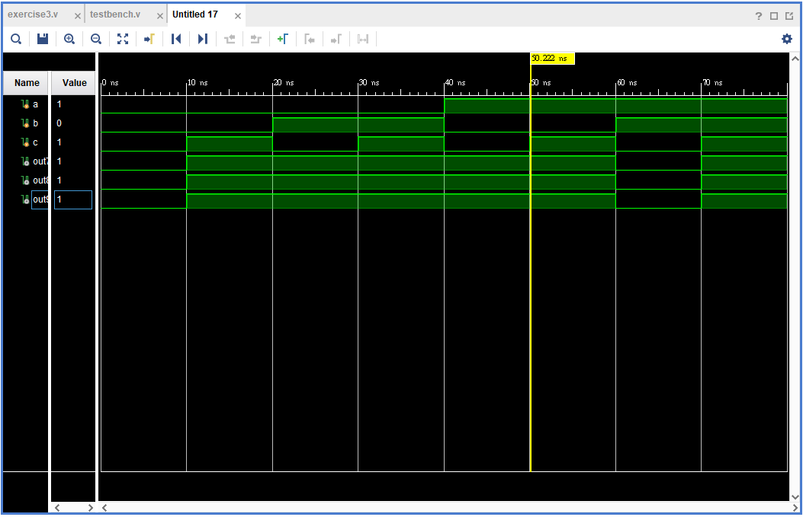
從實驗結果可以證明：F7 = F8 = F9
實驗心得
還滿感謝教授讓我們進行這次的練習，因為在這次實作之前，我對於POS和SOP之間的差別一直很不清楚，我一直以為POS和SOP都一樣是尋找Kar-naugh Map中值為true的格子，只是其中SOP是先乘再加，而POS是先加再乘而以。這次實作後才搞清楚，原來SOP是尋找值為true的格子，POS則是尋找值為false的格子，然這兩個表示法對於變數的呈現方式也是相反的。總之，雖然這次在寫verilog的時候因為觀念錯誤而重新撰寫了幾次，但至少不是錯在隔一天的期中考中。

