Adder
2023/11/03
B113040045 許育菖
實驗內容
Exercise1
題目說明
Design and verify the 8-bit ripple-carry adder composed of eight
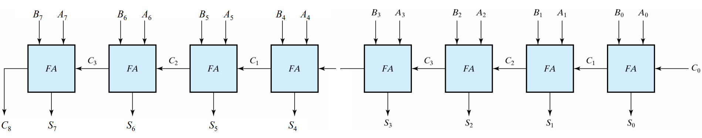
full-adders by using Verilog Structural level modeling.

推導
Half-Adder:
`timescale 1ns / 1ps

module halfAdder(output S, C, input x, y);
xor(S, x, y);
and(C, x, y);
endmodule
Full-Adder:
`timescale 1ns / 1ps

module fullAdder(output S, C, input x, y, z);
wire S1, C1, C2;
halfAdder HA1 (S1, C1, x, y);
halfAdder HA2 (S, C2, S1, z);

or(C, C2, C1);
endmodule
Verilog code:
`timescale 1ns / 1ps
module exercise1(output[7:0] Sum, output C8, input [7:0] A, B, input C0);
wire C1, C2, C3, C4, C5, C6, C7;
fullAdder FA0 (Sum[0], C1, A[0], B[0], C0),
FA1 (Sum[1], C2, A[1], B[1], C1),
FA2 (Sum[2], C3, A[2], B[2], C2),
FA3 (Sum[3], C4, A[3], B[3], C3),
FA4 (Sum[4], C5, A[4], B[4], C4),
FA5 (Sum[5], C6, A[5], B[5], C5),
FA6 (Sum[6], C7, A[6], B[6], C6),
FA7 (Sum[7], C8, A[7], B[7], C7);

endmodule
Half-Adder: S = x ⊕ y
C = xy
Full-Adder: S_{i} = (x ⊕ y) ⊕ C_{i-1}
C_{i} = (x ⊕ y)z + xy
8-bit ripple-carry = 8個Full-Adder連接起來
S_{i} = (x ⊕ y) ⊕ C_{i-1}
C_{i} = (x ⊕ y)z + xy
i$∈$N, 0 < i < 8
結論
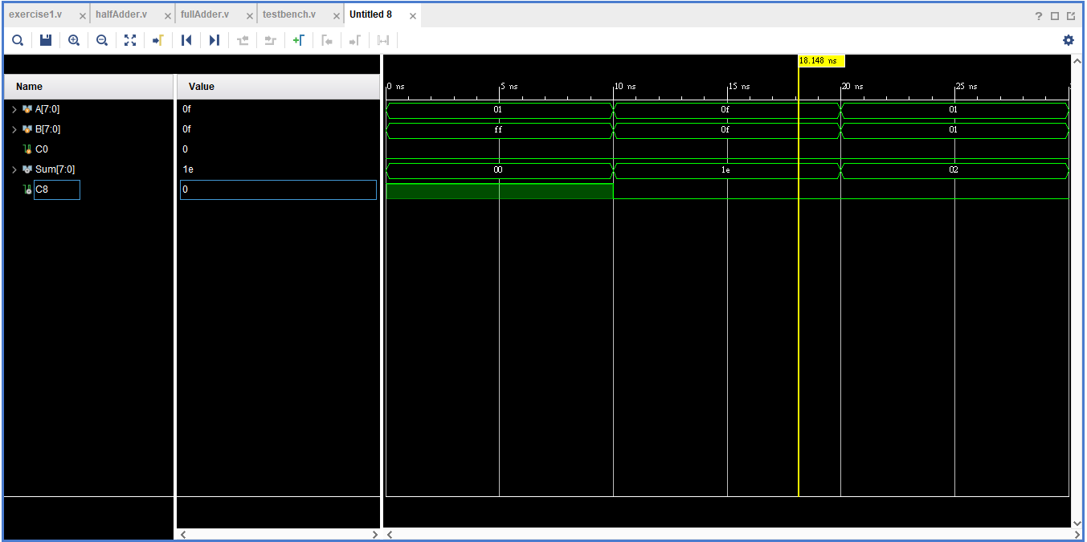
Exercise2
題目說明
Design and verify the 4-bit carry-look ahead adder by using
Verilog Structural level modeling.
- carry propagate: P_{i} = A_{i} ⊕ B_{i}, carry generate: Gi = A_{i}B_{i}
- sum: S_{i} = P_{i} ⊕ C_{i}, carry: C_{i+1} = G_{i} + P_{i}C_{i}
- C₁ = G₀+P₀C₀
- C₂ = G₁+P₁C₁ = G₁+P₁(G₀+P₀C₀) = G₁+P₁G₀+P₁P₀C₀
- C₃ = G₂+P₂C₂ = G₂+P₂G₁+P₂P₁G₀+ P₂P₁P₀C₀
- C₄ = G₃+P₃C₃ = …
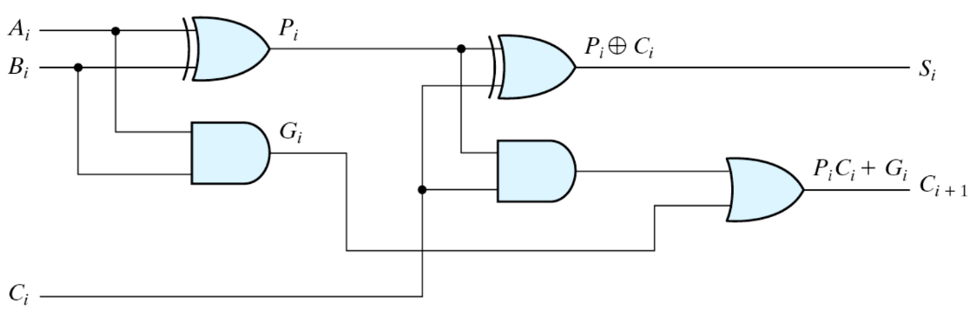
推導
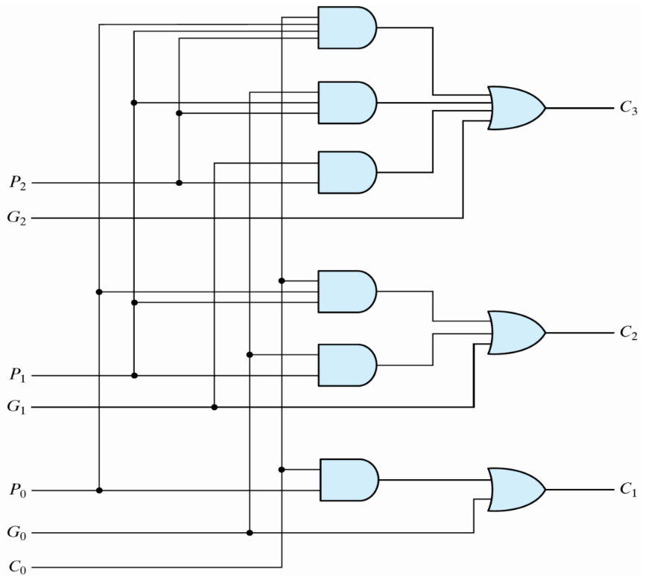
Since C₃ = G₂ + P₂G₁ + P₂P₁G₀ + P₂P₁P₀C₀
$⇒$ C₄ = G₃ + P₃G₂ + P₃P₂G₁ + P₃P₂P₁G₀ + P₃P₂P₁P₀C₀

Verilog code:
timescale 1ns / 1ps

module exercise2(output [3:0] Sum, input [3:0] A, B, output C4, input C0);
wire G0, G1, G2, G3;
and(G0, A[0], B[0]);
and(G1, A[1], B[1]);
and(G2, A[2], B[2]);
and(G3, A[3], B[3]);

wire P0, P1, P2, P3;
xor(P0, A[0], B[0]);
xor(P1, A[1], B[1]);
xor(P2, A[2], B[2]);
xor(P3, A[3], B[3]);

wire C1, C2, C3;
wire and0;
and(and0, P0, C0);
or(C1, G0, and0);

wire and1, and2;
and(and1, P1, G0);
and(and2, P1, P0, C0);
or(C2, G1, and1, and2);

wire and3, and4, and5;
and(and3, P2, G1);
and(and4, P2, P1, G0);
and(and5, P2, P1, P0, C0);
or(C3, G2, and3, and4, and5);

wire and6, and7, and8, and9;
and(and6, P3, G2);
and(and7, P3, P2, G1);
and(and8, P3, P2, P1, G0);
and(and9, P3, P2, P1, P0, C0);
or(C4, G3, and6, and7, and8, and9);

/*
wire and10, and11, and12, and13, and14;
and(and10, P4, G3);
and(and11, P4, P3, G2);
and(and12, P4, P3, P2, G1);
and(and13, P4, P3, P2, P1, G0);
and(and14, P4, P3, P2, P1, P0, C0);
or(C4, G4, and10, and11, and12, and13, and14);
*/

xor(Sum[0], P0, C0);
xor(Sum[1], P1, C1);
xor(Sum[2], P2, C2);
xor(Sum[3], P3, C3);

endmodule
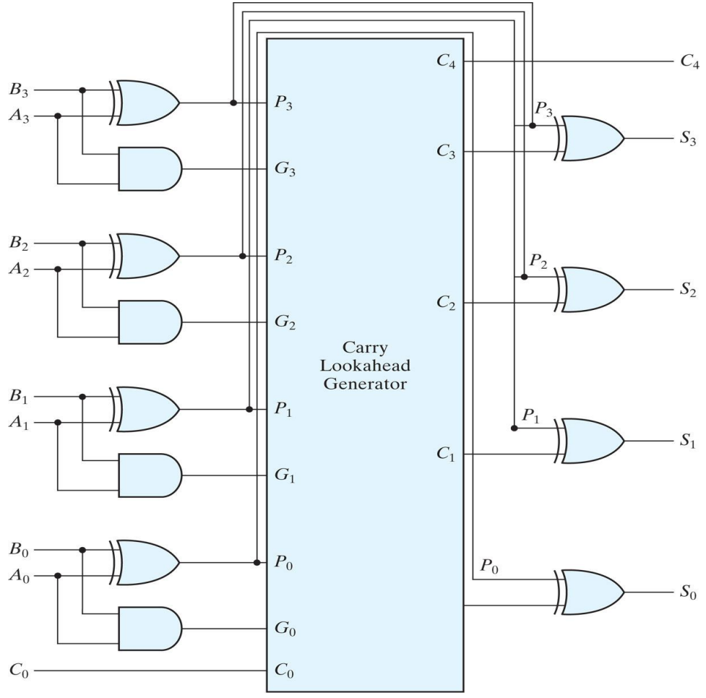
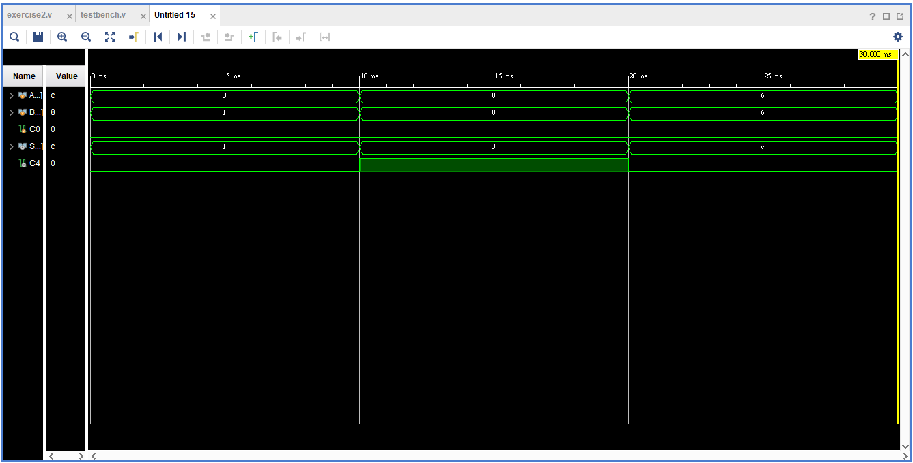
結論

實驗心得
本週的實驗內容為製作加法器。加法器主要分為兩種，一種是ripple-carry adder，另一種則是carry-look ahead adder，兩種的差別在於：ripple adder在進行多位數的加法時，會比look ahead adder花費更多的時間，因為look ahead adder是直接從傳入值得出每個位數加起來的結果，而ripple adder在計算當前位數時，需要先求出前一個位數的值，並將前一位數相加後的結果帶入運算。
雖然說look ahead adder在運算時可以比較節省時間，但在撰寫它的程式邏輯時好麻煩喔，程式碼要寫一大串，果然這世界上沒有甚麼事情是兩全其美的。

