Magnitude Comparator,
Decoder and Multiplexer
2023/11/06
B113040045 許育菖
實驗內容
Exercise1
- Design and verify the 4-bit magnitude comparator by using Verilog Structural level modeling.
- Algorithm -> logic
A = A₃A₂A₁A₀; B = B₃B₂B₁B₀
A = B if A₃=B₃, A₂=B₂, A₁=B₁ and A₁=B₁
equality: x_{i}= A_{i}B_{i}+A_{i}'B_{i}'
(A=B) = x₃x₂x₁x₀
(A>B) = A₃B₃' + x₃A₂B₂' + x₃x₂A₁B₁' + x₃x₂x₁A₀B₀'
(A<B) = A₃'B₃ + x₃A₂'B₂ + x₃x₂A₁'B₁ + x₃x₂x₁A₀'B₀
- Implementation
xi = (AiBi' +Ai'Bi)'

Algorithm -> logic
A = A₃A₂A₁A₀
B = B₃B₂B₁B₀
A=B: if E = 1 1010, 1010
A>B: if G = 1 1101, 1011 and 0111, 0101
A<B: if L = 1 0111, 1000 and 1001, 1101
Verilog code
`timescale 1ns / 1ps

module exercise1(
output L, G, E,
input [3:0] A, [3:0] B
);

// =
wire n0, n1, n2, n3;
or(n0, (A[0] & B[0]), ( (!A[0]) & (!B[0]) ) );
or(n1, (A[1] & B[1]), ( (!A[1]) & (!B[1]) ) );
or(n2, (A[2] & B[2]), ( (!A[2]) & (!B[2]) ) );
or(n3, (A[3] & B[3]), ( (!A[3]) & (!B[3]) ) );

and(E, n0, n1, n2, n3);

// >
wire n4, n5, n6, n7;
and(n4, A[3], (!B[3]));
and(n5, A[2], (!B[2]), n3);
and(n6, A[1], (!B[1]), n3, n2);
and(n7, A[0], (!B[0]), n3, n2, n1);

or(G, n4, n5, n6, n7);

// <
wire n8, n9, n10, n11;
and(n8, (!A[3]), B[3]);
and(n9, (!A[2]), B[2], n3);
and(n10, (!A[1]), B[1], n3, n2);
and(n11, (!A[0]), B[0], n3, n2, n1);

or(L, n8, n9, n10, n11);

endmodule
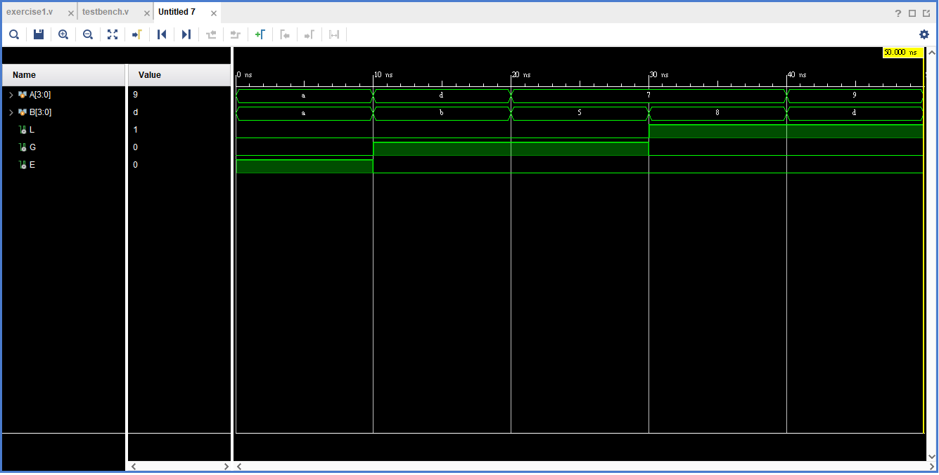
Exercise2
Design and verify a 3-to-8 decoder composed of two 2-to-4 de-coders.
  - Dataflow modeling
  - Structural level (Gate-level) modeling
Verilog code
`timescale 1ns / 1ps

module exercise2(
output D0, D1, D2, D3, D4, D5, D6, D7,
input x, y, z
);

decoder A(D0, D1, D2, D3, x, y, (!z));

decoder B(D4, D5, D6, D7, x, y, z);

endmodule
The Decoder
`timescale 1ns / 1ps

module decoder(D0, D1, D2, D3, A, B, E);
output D0, D1, D2, D3;
input A, B, E;

and(D0, (!A), (!B), E);
and(D1, (!A), B, E);
and(D2, A, (!B), E);
and(D3, A, B, E);

endmodule

先建立兩個2-to-4 decoder，接著再把兩個2-to-4 decoder合併形成3-to-8 decoder。
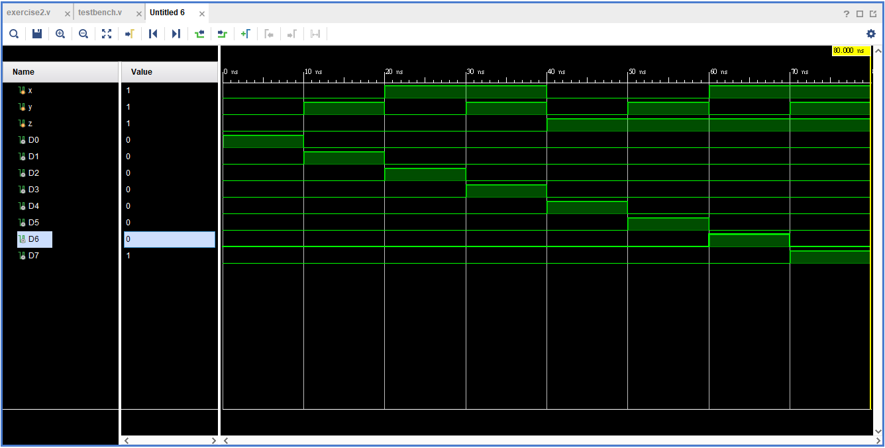
Exercise3
Design and verify the 8-to-1 multiplexer using Verilog HDL
  - Behavioral level modeling
  - Dataflow modeling
  - Structural level (Gate-level) modeling
Verilog code
`timescale 1ns / 1ps

module exercise3(
output reg [2:0] Y,
input [2:0]I0, I1, I2, I3, I4, I5, I6, I7,
input [2:0] S
);
always @ (I0, I1, I2, I3, I4, I5, I6, I7, S)
case (S)
3'b000: Y = I0;
3'b001: Y = I1;
3'b010: Y = I2;
3'b011: Y = I3;
3'b100: Y = I4;
3'b101: Y = I5;
3'b110: Y = I6;
3'b111: Y = I7;
endcase
endmodule
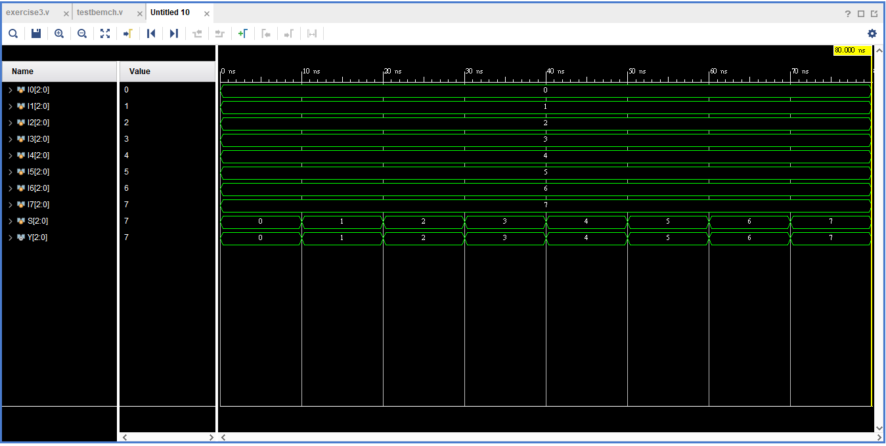

實驗心得
此次實驗是我們首次使用Behavioral level modeling來撰寫verilog，我原本以為新的modeling會不太好寫，為此還特地從第三題開始進行實驗，沒想到比想像中的還簡單，三題總共只花費一個多小時就完成了，讓我難得地提早交卷。
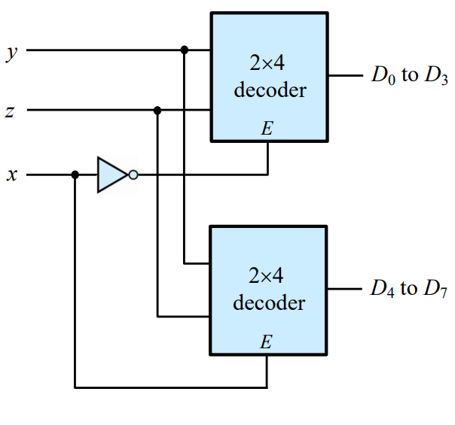
這次實驗我在撰寫第二題的時候發生了一個小插曲，題目圖片上的x, y, z沒有按照順序排，我以為是出題者不小心打錯了所有就把x, y, z按順序輸入，沒想到輸出出來的圖形雖然是正確的，但排序完全錯誤，看來我錯怪出題者了，sorry。

