XML Assignment Two
1) A valid XML document is located at assignment1.xml With respect to this document, answer the following questions.

- Draw the document “tree” for this document. The order of elements in the tree should go from left to right corresponding with the order of elements in the xml document.
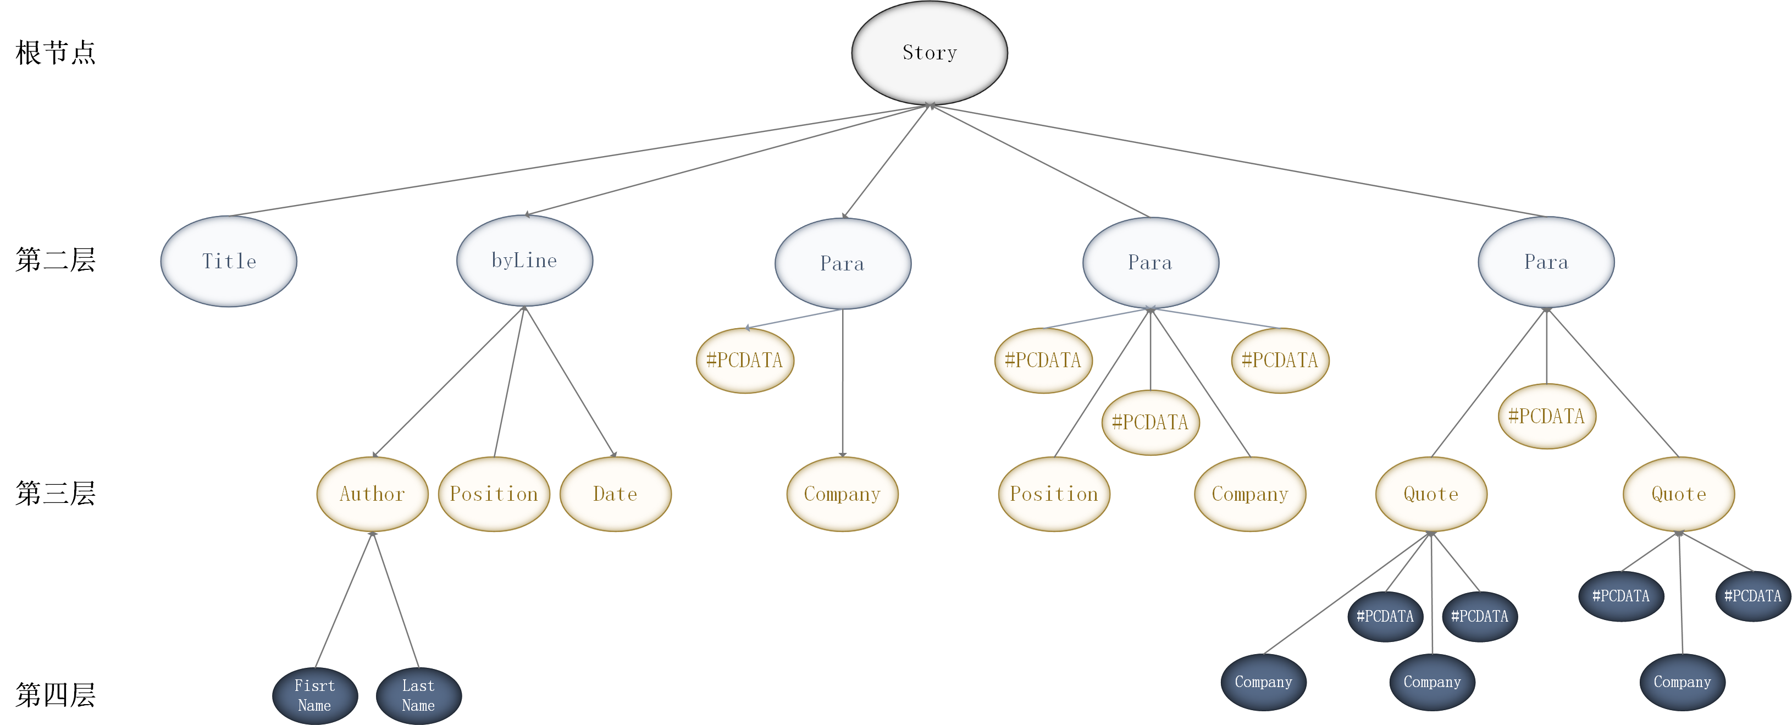

2. Write DTD file for assignment1.xml, Make sure that your final product is well-formed XML by examining it in an XML compatible web-browser like IE 5.5 above.
<?xml version="1.0" encoding="UTF-8"?>
<!--***************标签******************-->
<!--根节点标签-->
<!ELEMENT story (title,byline,para*)>

<!--第二层标签-->
<!ELEMENT title (#PCDATA)>
<!ELEMENT byline (author,position,date)>
<!ELEMENT para (#PCDATA | position | company | quote)*>

<!--第三层标签-->
<!ELEMENT author (firstname, lastname)+>
<!ELEMENT position (#PCDATA)>
<!ELEMENT date (#PCDATA)>
<!ELEMENT company (#PCDATA)>
<!ELEMENT quote (#PCDATA | company)*>

<!--第四层标签-->
<!ELEMENT firstname (#PCDATA)>
<!ELEMENT lastname (#PCDATA)>

<!--***************标签属性******************-->
<!ATTLIST para lead (yes | no) #REQUIRED>

2) From follow tree, Creating DTD file and XML file
Person
Person
Person
Name
Address
Tel
Fax
Emailn
People
<?xml version="1.0" encoding="UTF-8"?>
<!--根标签-->
<!ELEMENT People (Person+)>

<!--第一层标签-->
<!ELEMENT Person (Name,Address,Tel,Fax,Email)*>

<!--第二层标签-->
<!ELEMENT Name (#PCDATA)>
<!ELEMENT Address (#PCDATA)>
<!ELEMENT Tel (#PCDATA)>
<!ELEMENT Fax (#PCDATA)>
<!ELEMENT Email (#PCDATA)>

<!--people.dtd文件-->

<?xml version="1.0" encoding="UTF-8"?>
<!DOCTYPE People SYSTEM "people.dtd">

<People>
<Person></Person>

<Person>
<Name>Jayce</Name>
<Address>Piltover</Address>
<Tel>10086</Tel>
<Fax>None</Fax>
<Email>10010@gmail.com</Email>
</Person>

<Person></Person>
</People>

<!--people.xml文件-->

