北京邮电大学软件学院
2017-2018学年第一学期实验报告

课程名称： XML & Web Service

项目名称： 实验一：DOM、SAX解析XML

项目完成人：
姓名： 刘浩博 学号： 2015212086

指导教师：___________吴国仕___________

日 期： 2018年 1月 13日
- 实验目的
通过实验，通过使用DOM以及SAX进行解析、分割等操作，来熟悉DOM及SAX的用法。
- 实验内容
In the directory, there IPO.XML, IBM_COMP.XML and ABC_COMP.XML, please do followings:

1)Using the DOM model in ECLIPSE environment, divide IPO.XML file into two XML files,(IBM_COMP.XML and ABC_COMP.XML) based on the attribute value of “comp_name” .
Coding the project.

2)Using the SAX model to retrieve all the attribute information from IPO.XML and display them in the console.

3）After finishing your development, write a word document to describe DOM and SAX the different features with your development Experience.( Can use Chinese or English).
- 实验环境
Intellij IDEA 2017.2.5
- 实验步骤
- DOM
分割后的文件如下：
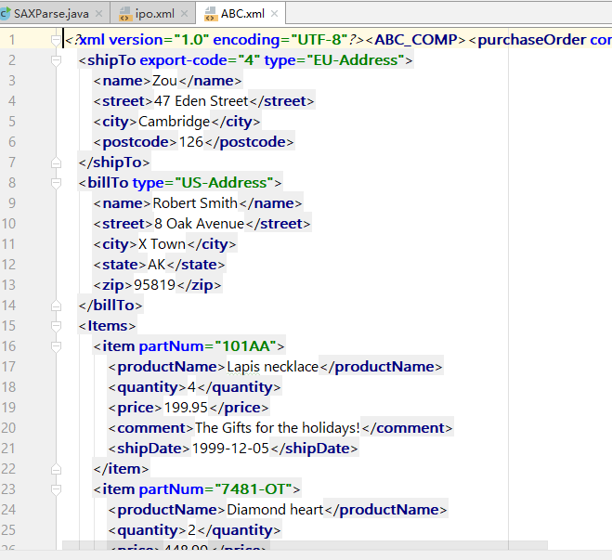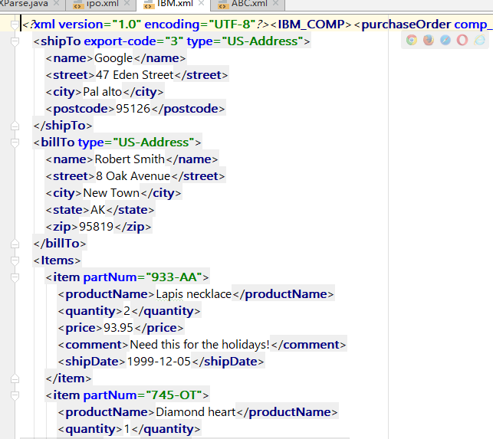
- SAX
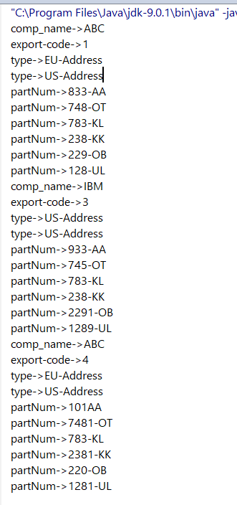
- 附录
- DOM
PurchaseOrder.java:
package DOM;
//该对象是一个实体bean，其字段信息对应xml文件中的元素字段
public class PurchaseOrder {
private String comp_name;
@Override
public String toString() {
return "comp_name="+comp_name;
}
public String getComp_name() {
return comp_name;
}
public void setComp_name(String comp_name) {
this.comp_name = comp_name;
}
}

Segmentation.java:
package DOM;
import org.w3c.dom.Document;
import org.w3c.dom.Element;
import org.w3c.dom.Node;
import org.w3c.dom.NodeList;
import javax.xml.parsers.DocumentBuilder;
import javax.xml.parsers.DocumentBuilderFactory;
import javax.xml.transform.Transformer;
import javax.xml.transform.TransformerConfigurationException;
import javax.xml.transform.TransformerFactory;
import javax.xml.transform.dom.DOMSource;
import javax.xml.transform.stream.StreamResult;
import java.io.File;
import java.io.FileOutputStream;
import java.util.Objects;
public class Segmentation {
public static void main(String[] args) throws TransformerConfigurationException {
File file = new File("./src/DOM/ipo.xml");
segmentation(file);
}
public static void segmentation(File file) {
try {
DocumentBuilderFactory dbFactory = DocumentBuilderFactory.newInstance();
DocumentBuilder dBuilder = dbFactory.newDocumentBuilder();
Document doc = dBuilder.parse(file);
NodeList purchaseOrderList = doc.getElementsByTagName("purchaseOrder"); //get order list
Element nodeABC = doc.createElement("ABC_COMP");
Element nodeIBM = doc.createElement("IBM_COMP");
FileOutputStream fileABC = new FileOutputStream("./src/DOM/ABC.xml");
FileOutputStream fileIBM = new FileOutputStream("./src/DOM/IBM.xml");
StreamResult resultABC = new StreamResult(fileABC);
StreamResult resultIBM = new StreamResult(fileIBM);
TransformerFactory tFactory = TransformerFactory.newInstance();
Transformer transformer = tFactory.newTransformer();
for (int i = purchaseOrderList.getLength()-1; i >= 0; i--) {
Node purchaseOrderNode = purchaseOrderList.item(i);
if (purchaseOrderNode.getNodeType() == Node.ELEMENT_NODE) {
Element purchaseOrderElement = (Element) purchaseOrderNode;
PurchaseOrder purchaseOrder = new PurchaseOrder();
purchaseOrder.setComp_name(purchaseOrderElement.getAttribute("comp_name"));
//Seperate
if (Objects.equals(purchaseOrder.getComp_name(), "ABC")) {
nodeABC.appendChild(purchaseOrderNode);
} else if (Objects.equals(purchaseOrder.getComp_name(), "IBM")) {
nodeIBM.appendChild(purchaseOrderNode);
}
}
}
DOMSource sourceABC = new DOMSource(nodeABC);
DOMSource sourceIBM = new DOMSource(nodeIBM);
//Output file
transformer.transform(sourceABC, resultABC);
transformer.transform(sourceIBM, resultIBM);
} catch (Exception e) {
e.printStackTrace();
}
}
}

- SAX
SAXParse.java:
package SAX;
import org.xml.sax.*;
import org.xml.sax.helpers.*;
import javax.xml.parsers.*;
public class SAXParse {
public static class myParser extends DefaultHandler{
@Override
public void startElement(String uri, String localName, String qName, Attributes attributes) throws SAXException {
int len=attributes.getLength();
for(int i=0;i<len;i++){
System.out.println(attributes.getLocalName(i)+"->"+attributes.getValue(i));
}
}
}
public static void main(String[] args) throws Exception {
SAXParserFactory factory=SAXParserFactory.newInstance();
SAXParser saxParser=factory.newSAXParser();
saxParser.parse("./src/SAX/ipo.xml",new myParser());
}
}

