Bengaluru, Karnataka, India



AN INTERNSHIP REPORT ON

“Full Stack Web Development”

## BACHELOR OF ENGINEERING

In

#### COMPUTER SCIENCE AND ENGINEERING

##### Submitted by: Nitish Chandrashekar(1MV18CS064)



SSir M. Visvesvaraya Institute of Technology

(Affiliated to Visvesvaraya Technological University and Approved by AICTE, New Delhi)Accredited By NAAC with ‘B++’ Grade

ISO 9001-2015 and 14001-2015 certified Institute

**Bengaluru, Karnataka 562157**

##### 2020-2021

**ABOUT THE COMPANY**

CST is a digital service provider that aims to provide software, designing and marketing solutions to individuals and businesses. At CST , we believe that service and quality is the key to success

We provide all kinds of technological and designing solutions from Billing Software to Web Designs or any custom demand that you may have. Experience the service like none other!

Some of our services include:

* Development - We develop responsive, functional and super-fast websites.
* We keep User Experience in mind while creating websites. A website should load quickly and shouldbe accessible even on a small view-port and slow internet connection.
* Mobile Application - We offer a wide range of professional Android, iOS& Hybrid app development services for our global clients, from a start up to a large enterprise.
* Design - We offer professional Graphic design, Brochure design & Logo design. We are expertsin crafting visual content to convey the right message to the customers.
* Consultancy - We are here to provide you with expert advice on your design and development requirement.
* Videos - We create a polished professional video that impresses your audience.

# Table of Contents

#### Contents Page No.

**Table of Contents I**

Overview of the project 1

About 2

Tools used 3

Implementation 4-34

Snapshots 35-38

Biblography 39

### OVERVIEW OF THE PROJECT

**Project Name**: VTU SGPA/CGPA Calculator

**Team Members:**

Nitish Chandrashekar (1MS18CS064)

This project is based on Web Development and its Applications. The main objective of this project is to learn the implementation of HTML, CSS and JavaScript at frontend and PHP, MySQL database at backend, The webpage of this project is created using HTML and styling of the webpage is done using CSS.

It is a web application that simplifies the task of storing a users results . The system is flexible to be used and reduces the need of frequently searching and accessing an individuals marks. The system is developed to provide an easy means for storing semester wise results. Individuals have to login and enter their marks in a form.They can then access the result and print it in a PDF format.

1. **USER MODULE**

This module is mainly dedicated to the candidates who are looking to store their result. They can log in into the system, via the credentials provided to them & once they are in, they have to enter their data by filling an online form . They can download the result from the same module, in PDF file format.

1. **ADMIN MODULE**

This module is maintained by the admin and only he/she can manage and have access to every account. Admin can add or delete the users as well. They can modify the functionalities of the system, too. Admin can also add users on the fly to the application to make the application full of new functionalities.

**SGPA/CGPA Calculator**

CGPA refers to the cumulative grade point average which literally translates to the sum total of all your credit points. This system helps in assessing the overall academic performance of a student. Although the evaluation criteria may vary from one country to another, the CGPA system is among the most common evaluation way in most professional/technical courses.

SGPA, which stands for Semester Grade Point Average is an evaluation method that highlights the semester wise performance of the student. It can be calculated by simply adding all the credit points awarded for the subjects and then dividing it by the total credits allotted to that semester.

Now let’s look at how to calculate SGPA and CGPA respectively by taking an example

In a total of 3 subjects, you scored the following grade points:

Subject1:8

Subject2:6

Subject 3: 7

The total credit for each subject is 10.

1. Now, first we will multiply, the grade point with the total credit point for each subject:

Subject 1: 8*10 = 80

Subject 2: 6*10 = 60

Subject 3: 7*10 = 70

2. To calculate SGPA here, you need to add all these grade points and then divide it by the total credits, i.e.

Total grade points: 210

Total credits: 30

To get SGPA, divide grade points by total credits, =210/30 =7 SGPA

To find CGPA from SGPA, you need to follow this formula:

CGPA= (SGPAs of All semesters in an academic year)/ Number of semesters

Thus, by adding up all the SGPAs you have got in an academic year by the total number of semesters, you will find CGPA from SGPA.

For example,

Suppose that you scored 7 SGPA and 9 SGPA in your two semesters.

1. First you need to add both these SGPAs.

2. Then, divide the total SGPA with the number of semesters, i.e.

3. Your CGPA would be: CGPA = SGPA of all semesters in a year/Number of semesters = (7+9)/2 = 8 CGPA

### TOOLS USED

**Software Requirements**

* + Visual Studio Code 2019.
  + Google Chrome or Microsoft Edge of latest version.
  + Front End: HTML, CSS, JS
  + Backend : Php, MySQL, Xampp
  + Linux 7.1 or Windows XP/7/8/10 OS or Mac OS

**Hardware Requirements**

* + Pentium 200-MHz computer with a minimum of 64 MB of RAM (128 MB of RAM recommended).
  + Monitor with a refresh rate of at least 40Hz for a smooth GUI experience (optional).

# IMPLEMENTATION

# This Code section contains the important code snippets as the whole file is quite large, the whole code can be found in the following GitHub repository: https://github.com/crimsonlotus/Dec2021FullStackWebDevelopment/tree/nitish-064

# App.js

# import "./App.css";

# import Home from "./pages/Home.js";

# import Sem from "./pages/Sem";

# import FirstSemPhy from "./pages/sems/FirstSemPhy.js";

# import FirstSemchem from "./pages/sems/FirstSemchem";

# import ThirdSem from "./pages/sems/ThirdSem";

# import FourthSem from "./pages/sems/FourthSem";

# import FifthSem from "./pages/sems/FifthSem";

# import SixthSem from "./pages/sems/SixthSem";

# import Branch7 from "./pages/sems/7thSem/Branch7";

# import CSE from "./pages/sems/7thSem/CSE";

# import EighthSem from "./pages/sems/EighthSem";

# import EC from "./pages/sems/7thSem/EC";

# import CGPACalc from "./pages/CGPACalc";

# import { BrowserRouter as Router, Routes, Route } from "react-router-dom";

# function App() {

# return (

# <Router>

# <Routes>

# <Route exact path="/" element={<Home/>} />

# <Route exact path="/sem" element={<Sem/>} />

# <Route exact path="/fistsemphy" element={<FirstSemPhy/>} />

# <Route exact path="/fistsemchem" element={<FirstSemchem/>} />

# <Route exact path="/thirdsem" element={<ThirdSem/>} />

# <Route exact path="/fourthsem" element={<FourthSem/>} />

# <Route exact path="/fifthsem" element={<FifthSem/>} />

# <Route exact path="/sixthsem" element={<SixthSem/>} />

# <Route exact path="/branch7" element={<Branch7/>} />

# <Route exact path="/cse7" element={<CSE/>} />

# <Route exact path="/ec7" element={<EC/>} />

# <Route exact path="/eightsem" element={<EighthSem/>} />

# <Route exact path="/cgpacalc" element={<CGPACalc/>} />

# </Routes>

# </Router>

# );

# }

# export default App;

# GradePointCalc.js

# function GradePointCalc(sub) {

# if (sub >= 90) {

# return 10;

# } else if (sub < 90 && sub >= 80) {

# return 9;

# } else if (sub < 80 && sub >= 70) {

# return 8;

# } else if (sub < 70 && sub >= 60) {

# return 7;

# } else if (sub < 60 && sub >= 50) {

# return 6;

# } else if (sub < 50 && sub >= 45) {

# return 5;

# } else if (sub < 45 && sub >= 40) {

# return 4;

# } else {

# return 0;

# }

# }

# export function calculateSgpa(

# sub1,

# cred1,

# sub2,

# cred2,

# sub3,

# cred3,

# sub4,

# cred4,

# sub5,

# cred5,

# sub6,

# cred6,

# sub7,

# cred7,

# sub8,

# cred8

# ) {

# const sum =

# (GradePointCalc(sub1) * cred1) +

# (GradePointCalc(sub2) * cred2) +

# (GradePointCalc(sub3) * cred3) +

# (GradePointCalc(sub4) * cred4) +

# (GradePointCalc(sub5) * cred5) +

# (GradePointCalc(sub6) * cred6) +

# (GradePointCalc(sub7) * cred7) +

# (GradePointCalc(sub8) * cred8);

# const totalCredit = cred1+cred2+cred3+cred4+cred5+cred6+cred7+cred8;

# return sum/totalCredit;

# }

# export function calculateSgpa9(

# sub1,

# cred1,

# sub2,

# cred2,

# sub3,

# cred3,

# sub4,

# cred4,

# sub5,

# cred5,

# sub6,

# cred6,

# sub7,

# cred7,

# sub8,

# cred8,

# sub9,

# cred9

# ) {

# const sum =

# (GradePointCalc(sub1) * cred1) +

# (GradePointCalc(sub2) * cred2) +

# (GradePointCalc(sub3) * cred3) +

# (GradePointCalc(sub4) * cred4) +

# (GradePointCalc(sub5) * cred5) +

# (GradePointCalc(sub6) * cred6) +

# (GradePointCalc(sub7) * cred7) +

# (GradePointCalc(sub8) * cred8) +

# (GradePointCalc(sub9) * cred9);

# const totalCredit = cred1+cred2+cred3+cred4+cred5+cred6+cred7+cred8+cred9;

# return sum/totalCredit;

# }

# export function cgpacalc(res){

# 

# var sum = 0;

# var count = 0;

# for(let i=0;i<res.length;i++){

# if(res[i]!=="0") count++;

# sum+=Number(res[i]);

# }

# console.log(count);

# return sum/count;

# }

# Index.js

# import React from 'react';

# import ReactDOM from 'react-dom';

# import './index.css';

# import App from './App';

# import reportWebVitals from './reportWebVitals';

# ReactDOM.render(

# <React.StrictMode>

# <App />

# </React.StrictMode>,

# document.getElementById('root')

# );

# CGPACalc.js

# import React, { useRef } from "react";

# // import html2canvas from "html2canvas";

# import "./sems/sems.css";

# import {cgpacalc} from "../GradePointCalc";

# import TextField from "@mui/material/TextField";

# // import { jsPDF } from "jspdf";

# function CGPACalc() {

# const [sub1, setSub1] = React.useState();

# const [sub2, setSub2] = React.useState();

# const [sub3, setSub3] = React.useState();

# const [sub4, setSub4] = React.useState();

# const [sub5, setSub5] = React.useState();

# const [sub6, setSub6] = React.useState();

# const [sub7, setSub7] = React.useState();

# const [sub8, setSub8] = React.useState();

# const [ans, setAns] = React.useState();

# const calc = () => {

# //Array.from([sub1,sub2,sub3,sub4,sub5,sub6,sub7,sub8]);

# const res = Array.from([sub1,sub2,sub3,sub4,sub5,sub6,sub7,sub8])

# setAns(cgpacalc(res));

# };

# const inputRef = useRef(null);

# // const printDocument = () => {

# // html2canvas(inputRef.current).then((canvas) => {

# // const imgData = canvas.toDataURL("image/png");

# // const pdf = new jsPDF({

# // orientation: "landscape",

# // unit: "px",

# // format: [1080, 1920],

# // });

# // pdf.addImage(imgData, "JPEG", 1, 1);

# // pdf.save("Results.pdf");

# // });

# // };

# return (

# <div ref={inputRef} className="cnt2 ">

# <h1>CGPA Calculator</h1>

# <h2 id="note">*Enter 0 for the sems which are not completed</h2>

# <div className="txtFld">

# 

# <TextField

# id="outlined-basic"

# label="1st Semister SGPA"

# variant="outlined"

# value={sub1}

# onChange={(e) => setSub1(e.target.value)}

# />

# <TextField

# id="outlined-basic"

# label="2nd Semister SGPA"

# variant="outlined"

# value={sub2}

# onChange={(e) => setSub2(e.target.value)}

# />

# <TextField

# id="outlined-basic"

# label="3rd Semister SGPA"

# variant="outlined"

# value={sub3}

# onChange={(e) => setSub3(e.target.value)}

# />

# <TextField

# id="outlined-basic"

# label="4th Semister SGPA"

# variant="outlined"

# value={sub4}

# onChange={(e) => setSub4(e.target.value)}

# />

# <TextField

# id="outlined-basic"

# label="5th Semister SGPA"

# variant="outlined"

# value={sub5}

# onChange={(e) => setSub5(e.target.value)}

# />

# <TextField

# id="outlined-basic"

# label="6th Semister SGPA"

# variant="outlined"

# value={sub6}

# onChange={(e) => setSub6(e.target.value)}

# />

# <TextField

# id="outlined-basic"

# label="7th Semister SGPA"

# variant="outlined"

# value={sub7}

# onChange={(e) => setSub7(e.target.value)}

# />

# <TextField

# id="outlined-basic"

# label="8th Semister SGPA"

# variant="outlined"

# value={sub8}

# onChange={(e) => setSub8(e.target.value)}

# />

# <button onClick={calc} className="css-button-rounded--rose">

# Calculate CGPA

# </button>

# {/* <button onClick={printDocument} className="css-button-rounded--rose">

# Download results

# </button> */}

# </div>

# {ans ? (

# <div className="result">

# <h2>CGPA:&nbsp;&nbsp;{ans.toFixed(2)}</h2>

# <h2>Percentage:&nbsp;&nbsp;{ans ? ((ans - 0.75) * 10).toFixed(2) : 0}%</h2>

# </div>

# ) : (

# <div className="result"></div>

# )}

# </div>

# );

# }

# export default CGPACalc

# Sem.js

# import React from "react";

# import "./Sem.css";

# import { Link } from "react-router-dom";

# function Sem() {

# return (

# <div className="sem-wrapper">

# <h1 className="heading">CHOOSE YOUR SEMESTER</h1>

# <div className="container">

# <Link id="lk" to="/fistsemphy">

# <div className="card">

# <h1>1st & 2nd SEM</h1>

# <h1 id="sub">PHYSICS</h1>

# </div>

# </Link>

# <Link id="lk" to="/fistsemchem">

# <div className="card">

# <h1>1st & 2nd SEM</h1>

# <h1 id="sub">CHEMISTRY</h1>

# </div>

# </Link>

# <Link id="lk" to="/thirdsem">

# <div className="card">

# <h1>3rd SEM</h1>

# <h1 id="sub">All Branch</h1>

# </div>

# </Link>

# <Link id="lk" to="/fourthsem">

# <div className="card">

# <h1>4th SEM</h1>

# <h1 id="sub">All Branch</h1>

# </div>

# </Link>

# <Link id="lk" to="/fifthsem">

# <div className="card">

# <h1>5th SEM</h1>

# <h1 id="sub">All Branch</h1>

# </div>

# </Link>

# <Link id="lk" to="/sixthsem">

# <div className="card">

# <h1>6th SEM</h1>

# <h1 id="sub">All Branch</h1>

# </div>

# </Link>

# <Link id="lk" to="/branch7">

# <div className="card">

# <h1>7th SEM</h1>

# <h1 id="sub">(CS,IS,EC,EE,CV)</h1>

# </div>

# </Link>

# <Link id="lk" to="/eightsem">

# <div className="card">

# <h1>8th SEM</h1>

# <h1 id="sub">All Branch</h1>

# </div>

# </Link>

# </div>

# </div>

# );

# }

# export default Sem;

# Home.js

# import React from "react";

# import "./Home.css";

# import heroImage from "../images/Saly-16.png";

# import { Link } from "react-router-dom";

# function Home() {

# return (

# <div className="wrapper">

# <div className="text">

# <h1>VTU SGPA & CGPA CALCULATOR</h1>

# <div className="btns">

# <Link to="/sem">

# <button className="css-button-rounded--rose">Calculate SGPA</button>

# </Link>

# <Link to="/cgpacalc">

# <button className="css-button-rounded--rose">Calculate CGPA</button>

# </Link>

# </div>

# </div>

# <div className="pic">

# <img className="heroImg" src={heroImage} alt="heroImage" />

# </div>

# </div>

# );

# }

# export default Home;

# CSE.js

# import React, { useRef } from "react";

# // import html2canvas from "html2canvas";

# import "../sems.css";

# import {calculateSgpa} from "../../../GradePointCalc";

# import TextField from "@mui/material/TextField";

# // import { jsPDF } from "jspdf";

# function CSE() {

# const [sub1, setSub1] = React.useState();

# const [sub2, setSub2] = React.useState();

# const [sub3, setSub3] = React.useState();

# const [sub4, setSub4] = React.useState();

# const [sub5, setSub5] = React.useState();

# const [sub6, setSub6] = React.useState();

# const [sub7, setSub7] = React.useState();

# 

# const [ans, setAns] = React.useState();

# const calc = () => {

# setAns(

# calculateSgpa(

# sub1,

# 4,

# sub2,

# 4,

# sub3,

# 3,

# sub4,

# 3,

# sub5,

# 3,

# sub6,

# 2,

# sub7,

# 1,

# 0,

# 0

# )

# );

# };

# const inputRef = useRef(null);

# // const printDocument = () => {

# // html2canvas(inputRef.current).then((canvas) => {

# // const imgData = canvas.toDataURL("image/png");

# // const pdf = new jsPDF({

# // orientation: "landscape",

# // unit: "px",

# // format: [1080, 1920],

# // });

# // pdf.addImage(imgData, "JPEG", 1, 1);

# // pdf.save("Results.pdf");

# // });

# // };

# return (

# <div ref={inputRef} className="cnt2 ">

# <h1>7th Semister SGPA</h1>

# <div className="txtFld">

# <TextField

# id="outlined-basic"

# label="18CS71"

# variant="outlined"

# value={sub1}

# onChange={(e) => setSub1(e.target.value)}

# />

# <TextField

# id="outlined-basic"

# label="18CS72"

# variant="outlined"

# value={sub2}

# onChange={(e) => setSub2(e.target.value)}

# />

# <TextField

# id="outlined-basic"

# label="18CS73X"

# variant="outlined"

# value={sub3}

# onChange={(e) => setSub3(e.target.value)}

# />

# <TextField

# id="outlined-basic"

# label="18CS74X"

# variant="outlined"

# value={sub4}

# onChange={(e) => setSub4(e.target.value)}

# />

# <TextField

# id="outlined-basic"

# label="18CS75X"

# variant="outlined"

# value={sub5}

# onChange={(e) => setSub5(e.target.value)}

# />

# <TextField

# id="outlined-basic"

# label="18CSL76"

# variant="outlined"

# value={sub6}

# onChange={(e) => setSub6(e.target.value)}

# />

# <TextField

# id="outlined-basic"

# label="18CSP77"

# variant="outlined"

# value={sub7}

# onChange={(e) => setSub7(e.target.value)}

# />

# 

# 

# </div>

# <div className="bt" >

# <button onClick={calc} className="css-button-rounded--rose">

# Calculate SGPA

# </button>

# {/* <button onClick={printDocument} className="css-button-rounded--rose">

# Download results

# </button> */}

# </div>

# {ans ? (

# <div className="result">

# <h2>SGPA:&nbsp;&nbsp;{ans.toFixed(2)}</h2>

# <h2>Percentage:&nbsp;&nbsp;{ans ? ((ans - 0.75) * 10).toFixed(2) : 0}%</h2>

# </div>

# ) : (

# <div className="result"></div>

# )}

# </div>

# );

# }

# export default CSE

# EC.js

# import React, { useRef } from "react";

# // import html2canvas from "html2canvas";

# import "../sems.css";

# import {calculateSgpa} from "../../../GradePointCalc";

# import TextField from "@mui/material/TextField";

# // import { jsPDF } from "jspdf";

# function EC() {

# const [sub1, setSub1] = React.useState();

# const [sub2, setSub2] = React.useState();

# const [sub3, setSub3] = React.useState();

# const [sub4, setSub4] = React.useState();

# const [sub5, setSub5] = React.useState();

# const [sub6, setSub6] = React.useState();

# const [sub7, setSub7] = React.useState();

# const [sub8, setSub8] = React.useState();

# const [ans, setAns] = React.useState();

# const calc = () => {

# setAns(

# calculateSgpa(

# sub1,

# 3,

# sub2,

# 3,

# sub3,

# 3,

# sub4,

# 3,

# sub5,

# 3,

# sub6,

# 3,

# sub7,

# 2,

# sub8,

# 2

# )

# );

# };

# const inputRef = useRef(null);

# // const printDocument = () => {

# // html2canvas(inputRef.current).then((canvas) => {

# // const imgData = canvas.toDataURL("image/png");

# // const pdf = new jsPDF({

# // orientation: "landscape",

# // unit: "px",

# // format: [1080, 1920],

# // });

# // pdf.addImage(imgData, "JPEG", 1, 1);

# // pdf.save("Results.pdf");

# // });

# // };

# return (

# <div ref={inputRef} className="cnt2 ">

# <h1>7th Semister SGPA</h1>

# <div className="txtFld">

# <TextField

# id="outlined-basic"

# label="18XX71"

# variant="outlined"

# value={sub1}

# onChange={(e) => setSub1(e.target.value)}

# />

# <TextField

# id="outlined-basic"

# label="18XX72"

# variant="outlined"

# value={sub2}

# onChange={(e) => setSub2(e.target.value)}

# />

# <TextField

# id="outlined-basic"

# label="18XX73X"

# variant="outlined"

# value={sub3}

# onChange={(e) => setSub3(e.target.value)}

# />

# <TextField

# id="outlined-basic"

# label="18XX74X"

# variant="outlined"

# value={sub4}

# onChange={(e) => setSub4(e.target.value)}

# />

# <TextField

# id="outlined-basic"

# label="18XX75X"

# variant="outlined"

# value={sub5}

# onChange={(e) => setSub5(e.target.value)}

# />

# <TextField

# id="outlined-basic"

# label="18XXL76"

# variant="outlined"

# value={sub6}

# onChange={(e) => setSub6(e.target.value)}

# />

# <TextField

# id="outlined-basic"

# label="18XXL77"

# variant="outlined"

# value={sub7}

# onChange={(e) => setSub7(e.target.value)}

# />

# <TextField

# id="outlined-basic"

# label="18XXP78"

# variant="outlined"

# value={sub8}

# onChange={(e) => setSub8(e.target.value)}

# />

# 

# 

# </div>

# <div className="bt" >

# <button onClick={calc} className="css-button-rounded--rose">

# Calculate SGPA

# </button>

# {/* <button onClick={printDocument} className="css-button-rounded--rose">

# Download results

# </button> */}

# </div>

# {ans ? (

# <div className="result">

# <h2>SGPA:&nbsp;&nbsp;{ans.toFixed(2)}</h2>

# <h2>Percentage:&nbsp;&nbsp;{ans ? ((ans - 0.75) * 10).toFixed(2) : 0}%</h2>

# </div>

# ) : (

# <div className="result"></div>

# )}

# </div>

# );

# }

# export default EC

# FirstSemChem.js

# import React, { useRef } from "react";

# // import html2canvas from "html2canvas";

# import "./sems.css";

# import {calculateSgpa} from "../../GradePointCalc";

# import TextField from "@mui/material/TextField";

# // import { jsPDF } from "jspdf";

# function FirstSemchem() {

# const [sub1, setSub1] = React.useState();

# const [sub2, setSub2] = React.useState();

# const [sub3, setSub3] = React.useState();

# const [sub4, setSub4] = React.useState();

# const [sub5, setSub5] = React.useState();

# const [sub6, setSub6] = React.useState();

# const [sub7, setSub7] = React.useState();

# const [sub8, setSub8] = React.useState();

# const [ans, setAns] = React.useState();

# const calc = () => {

# setAns(

# calculateSgpa(

# sub1,

# 4,

# sub2,

# 4,

# sub3,

# 3,

# sub4,

# 3,

# sub5,

# 3,

# sub6,

# 1,

# sub7,

# 1,

# sub8,

# 1

# )

# );

# };

# const inputRef = useRef(null);

# // const printDocument = () => {

# // html2canvas(inputRef.current).then((canvas) => {

# // const imgData = canvas.toDataURL("image/png");

# // const pdf = new jsPDF({

# // orientation: "landscape",

# // unit: "px",

# // format: [1080, 1920],

# // });

# // pdf.addImage(imgData, "JPEG", 1, 1);

# // pdf.save("Results.pdf");

# // });

# // };

# return (

# <div ref={inputRef} className="cnt2 ">

# <h1>1st & 2nd Semister Chemistry Cycle</h1>

# <div className="txtFld">

# <TextField

# id="outlined-basic"

# label="18MAT11/21"

# variant="outlined"

# value={sub1}

# onChange={(e) => setSub1(e.target.value)}

# />

# <TextField

# id="outlined-basic"

# label="18CHE12/22"

# variant="outlined"

# value={sub2}

# onChange={(e) => setSub2(e.target.value)}

# />

# <TextField

# id="outlined-basic"

# label="18CPS13/23"

# variant="outlined"

# value={sub3}

# onChange={(e) => setSub3(e.target.value)}

# />

# <TextField

# id="outlined-basic"

# label="18ELN14/24"

# variant="outlined"

# value={sub4}

# onChange={(e) => setSub4(e.target.value)}

# />

# <TextField

# id="outlined-basic"

# label="18ME15/25"

# variant="outlined"

# value={sub5}

# onChange={(e) => setSub5(e.target.value)}

# />

# <TextField

# id="outlined-basic"

# label="18CHEL16/26"

# variant="outlined"

# value={sub6}

# onChange={(e) => setSub6(e.target.value)}

# />

# <TextField

# id="outlined-basic"

# label="18CPL17/27"

# variant="outlined"

# value={sub7}

# onChange={(e) => setSub7(e.target.value)}

# />

# <TextField

# id="outlined-basic"

# label="18EGH18/28(ENGLISH)"

# variant="outlined"

# value={sub8}

# onChange={(e) => setSub8(e.target.value)}

# />

# <button onClick={calc} className="css-button-rounded--rose">

# Calculate SGPA

# </button>

# {/* <button onClick={printDocument} className="css-button-rounded--rose">

# Download results

# </button> */}

# </div>

# {ans ? (

# <div className="result">

# <h2>SGPA:&nbsp;&nbsp;{ans.toFixed(2)}</h2>

# <h2>Percentage:&nbsp;&nbsp;{ans ? ((ans - 0.75) * 10).toFixed(2) : 0}%</h2>

# </div>

# ) : (

# <div className="result"></div>

# )}

# </div>

# );

# }

# export default FirstSemchem

# FirstSemPhy.js

# import React, { useRef } from "react";

# // import html2canvas from "html2canvas";

# import "./sems.css";

# import {calculateSgpa} from "../../GradePointCalc";

# import TextField from "@mui/material/TextField";

# // import { jsPDF } from "jspdf";

# function FirstSemPhy() {

# const [sub1, setSub1] = React.useState();

# const [sub2, setSub2] = React.useState();

# const [sub3, setSub3] = React.useState();

# const [sub4, setSub4] = React.useState();

# const [sub5, setSub5] = React.useState();

# const [sub6, setSub6] = React.useState();

# const [sub7, setSub7] = React.useState();

# const [sub8, setSub8] = React.useState();

# const [ans, setAns] = React.useState();

# const calc = () => {

# setAns(

# calculateSgpa(

# sub1,

# 4,

# sub2,

# 4,

# sub3,

# 3,

# sub4,

# 3,

# sub5,

# 3,

# sub6,

# 1,

# sub7,

# 1,

# sub8,

# 1

# )

# );

# };

# const inputRef = useRef(null);

# // const printDocument = () => {

# // html2canvas(inputRef.current).then((canvas) => {

# // const imgData = canvas.toDataURL("image/png");

# // const pdf = new jsPDF({

# // orientation: "landscape",

# // unit: "px",

# // format: [1080, 1920],

# // });

# // pdf.addImage(imgData, "JPEG", 1, 1);

# // pdf.save("Results.pdf");

# // });

# // };

# return (

# <div ref={inputRef} className="cnt2 ">

# <h1>1st & 2nd Semister Physics Cycle</h1>

# <div className="txtFld">

# <TextField

# id="outlined-basic"

# label="18MAT11/21"

# variant="outlined"

# value={sub1}

# onChange={(e) => setSub1(e.target.value)}

# />

# <TextField

# id="outlined-basic"

# label="18PHY12/22"

# variant="outlined"

# value={sub2}

# onChange={(e) => setSub2(e.target.value)}

# />

# <TextField

# id="outlined-basic"

# label="18ELE13/23"

# variant="outlined"

# value={sub3}

# onChange={(e) => setSub3(e.target.value)}

# />

# <TextField

# id="outlined-basic"

# label="18CIV14/24"

# variant="outlined"

# value={sub4}

# onChange={(e) => setSub4(e.target.value)}

# />

# <TextField

# id="outlined-basic"

# label="18EGDL15/25"

# variant="outlined"

# value={sub5}

# onChange={(e) => setSub5(e.target.value)}

# />

# <TextField

# id="outlined-basic"

# label="18PHYL16/26"

# variant="outlined"

# value={sub6}

# onChange={(e) => setSub6(e.target.value)}

# />

# <TextField

# id="outlined-basic"

# label="18ELEL17/27"

# variant="outlined"

# value={sub7}

# onChange={(e) => setSub7(e.target.value)}

# />

# <TextField

# id="outlined-basic"

# label="18EGH18/28(ENGLISH)"

# variant="outlined"

# value={sub8}

# onChange={(e) => setSub8(e.target.value)}

# />

# <button onClick={calc} className="css-button-rounded--rose">

# Calculate SGPA

# </button>

# {/* <button onClick={printDocument} className="css-button-rounded--rose">

# Download results

# </button> */}

# </div>

# {ans ? (

# <div className="result">

# <h2>SGPA:&nbsp;&nbsp;{ans.toFixed(2)}</h2>

# <h2>Percentage:&nbsp;&nbsp;{ans ? ((ans - 0.75) * 10).toFixed(2) : 0}%</h2>

# </div>

# ) : (

# <div className="result"></div>

# )}

# </div>

# );

# }

# export default FirstSemPhy;

# ThirdSem.js

# import React, { useRef } from "react";

# // import html2canvas from "html2canvas";

# import "./sems.css";

# import {calculateSgpa9} from "../../GradePointCalc";

# import TextField from "@mui/material/TextField";

# // import { jsPDF } from "jspdf";

# function ThirdSem() {

# const [sub1, setSub1] = React.useState();

# const [sub2, setSub2] = React.useState();

# const [sub3, setSub3] = React.useState();

# const [sub4, setSub4] = React.useState();

# const [sub5, setSub5] = React.useState();

# const [sub6, setSub6] = React.useState();

# const [sub7, setSub7] = React.useState();

# const [sub8, setSub8] = React.useState();

# const [sub9, setSub9] = React.useState();

# const [ans, setAns] = React.useState();

# const calc = () => {

# setAns(

# calculateSgpa9(

# sub1,

# 3,

# sub2,

# 4,

# sub3,

# 3,

# sub4,

# 3,

# sub5,

# 3,

# sub6,

# 3,

# sub7,

# 2,

# sub8,

# 2,

# sub9,

# 1

# )

# );

# };

# const inputRef = useRef(null);

# // const printDocument = () => {

# // html2canvas(inputRef.current).then((canvas) => {

# // const imgData = canvas.toDataURL("image/png");

# // const pdf = new jsPDF({

# // orientation: "landscape",

# // unit: "px",

# // format: [1080, 1920],

# // });

# // pdf.addImage(imgData, "JPEG", 1, 1);

# // pdf.save("Results.pdf");

# // });

# // };

# return (

# <div ref={inputRef} className="cnt2 ">

# <h1>Third Semister SGPA</h1>

# <div className="txtFld">

# <TextField

# id="outlined-basic"

# label="18MAT31"

# variant="outlined"

# value={sub1}

# onChange={(e) => setSub1(e.target.value)}

# />

# <TextField

# id="outlined-basic"

# label="18**32"

# variant="outlined"

# value={sub2}

# onChange={(e) => setSub2(e.target.value)}

# />

# <TextField

# id="outlined-basic"

# label="18**33"

# variant="outlined"

# value={sub3}

# onChange={(e) => setSub3(e.target.value)}

# />

# <TextField

# id="outlined-basic"

# label="18**34"

# variant="outlined"

# value={sub4}

# onChange={(e) => setSub4(e.target.value)}

# />

# <TextField

# id="outlined-basic"

# label="18**35"

# variant="outlined"

# value={sub5}

# onChange={(e) => setSub5(e.target.value)}

# />

# <TextField

# id="outlined-basic"

# label="18**36"

# variant="outlined"

# value={sub6}

# onChange={(e) => setSub6(e.target.value)}

# />

# <TextField

# id="outlined-basic"

# label="18**L37"

# variant="outlined"

# value={sub7}

# onChange={(e) => setSub7(e.target.value)}

# />

# <TextField

# id="outlined-basic"

# label="18**L38"

# variant="outlined"

# value={sub8}

# onChange={(e) => setSub8(e.target.value)}

# />

# <TextField

# id="outlined-basic"

# label="18CPC39/49 or Kannada"

# variant="outlined"

# value={sub9}

# onChange={(e) => setSub9(e.target.value)}

# />

# 

# </div>

# <div className="bt" >

# <button onClick={calc} className="css-button-rounded--rose">

# Calculate SGPA

# </button>

# {/* <button onClick={printDocument} className="css-button-rounded--rose">

# Download results

# </button> */}

# </div>

# {ans ? (

# <div className="result">

# <h2>SGPA:&nbsp;&nbsp;{ans.toFixed(2)}</h2>

# <h2>Percentage:&nbsp;&nbsp;{ans ? ((ans - 0.75) * 10).toFixed(2) : 0}%</h2>

# </div>

# ) : (

# <div className="result"></div>

# )}

# </div>

# );

# }

# export default ThirdSem

# FourthSem.js

# import React, { useRef } from "react";

# // import html2canvas from "html2canvas";

# import "./sems.css";

# import {calculateSgpa9} from "../../GradePointCalc";

# import TextField from "@mui/material/TextField";

# // import { jsPDF } from "jspdf";

# function FourthSem() {

# const [sub1, setSub1] = React.useState();

# const [sub2, setSub2] = React.useState();

# const [sub3, setSub3] = React.useState();

# const [sub4, setSub4] = React.useState();

# const [sub5, setSub5] = React.useState();

# const [sub6, setSub6] = React.useState();

# const [sub7, setSub7] = React.useState();

# const [sub8, setSub8] = React.useState();

# const [sub9, setSub9] = React.useState();

# const [ans, setAns] = React.useState();

# const calc = () => {

# setAns(

# calculateSgpa9(

# sub1,

# 3,

# sub2,

# 4,

# sub3,

# 3,

# sub4,

# 3,

# sub5,

# 3,

# sub6,

# 3,

# sub7,

# 2,

# sub8,

# 2,

# sub9,

# 1

# )

# );

# };

# const inputRef = useRef(null);

# // const printDocument = () => {

# // html2canvas(inputRef.current).then((canvas) => {

# // const imgData = canvas.toDataURL("image/png");

# // const pdf = new jsPDF({

# // orientation: "landscape",

# // unit: "px",

# // format: [1080, 1920],

# // });

# // pdf.addImage(imgData, "JPEG", 1, 1);

# // pdf.save("Results.pdf");

# // });

# // };

# return (

# <div ref={inputRef} className="cnt2 ">

# <h1>Fourth Semister SGPA</h1>

# <div className="txtFld">

# <TextField

# id="outlined-basic"

# label="18MAT41"

# variant="outlined"

# value={sub1}

# onChange={(e) => setSub1(e.target.value)}

# />

# <TextField

# id="outlined-basic"

# label="18**42"

# variant="outlined"

# value={sub2}

# onChange={(e) => setSub2(e.target.value)}

# />

# <TextField

# id="outlined-basic"

# label="18**43"

# variant="outlined"

# value={sub3}

# onChange={(e) => setSub3(e.target.value)}

# />

# <TextField

# id="outlined-basic"

# label="18**44"

# variant="outlined"

# value={sub4}

# onChange={(e) => setSub4(e.target.value)}

# />

# <TextField

# id="outlined-basic"

# label="18**45"

# variant="outlined"

# value={sub5}

# onChange={(e) => setSub5(e.target.value)}

# />

# <TextField

# id="outlined-basic"

# label="18**46"

# variant="outlined"

# value={sub6}

# onChange={(e) => setSub6(e.target.value)}

# />

# <TextField

# id="outlined-basic"

# label="18**L47"

# variant="outlined"

# value={sub7}

# onChange={(e) => setSub7(e.target.value)}

# />

# <TextField

# id="outlined-basic"

# label="18**L48"

# variant="outlined"

# value={sub8}

# onChange={(e) => setSub8(e.target.value)}

# />

# <TextField

# id="outlined-basic"

# label="18CPC39/49 or Kannada"

# variant="outlined"

# value={sub9}

# onChange={(e) => setSub9(e.target.value)}

# />

# 

# </div>

# <div className="bt" >

# <button onClick={calc} className="css-button-rounded--rose">

# Calculate SGPA

# </button>

# {/* <button onClick={printDocument} className="css-button-rounded--rose">

# Download results

# </button> */}

# </div>

# {ans ? (

# <div className="result">

# <h2>SGPA:&nbsp;&nbsp;{ans.toFixed(2)}</h2>

# <h2>Percentage:&nbsp;&nbsp;{ans ? ((ans - 0.75) * 10).toFixed(2) : 0}%</h2>

# </div>

# ) : (

# <div className="result"></div>

# )}

# </div>

# );

# }

# export default FourthSem

# FifthSem.js

# import React, { useRef } from "react";

# // import html2canvas from "html2canvas";

# import "./sems.css";

# import {calculateSgpa9} from "../../GradePointCalc";

# import TextField from "@mui/material/TextField";

# // import { jsPDF } from "jspdf";

# function FifthSem() {

# const [sub1, setSub1] = React.useState();

# const [sub2, setSub2] = React.useState();

# const [sub3, setSub3] = React.useState();

# const [sub4, setSub4] = React.useState();

# const [sub5, setSub5] = React.useState();

# const [sub6, setSub6] = React.useState();

# const [sub7, setSub7] = React.useState();

# const [sub8, setSub8] = React.useState();

# const [sub9, setSub9] = React.useState();

# const [ans, setAns] = React.useState();

# const calc = () => {

# setAns(

# calculateSgpa9(

# sub1,

# 3,

# sub2,

# 4,

# sub3,

# 4,

# sub4,

# 3,

# sub5,

# 3,

# sub6,

# 3,

# sub7,

# 2,

# sub8,

# 2,

# sub9,

# 1

# )

# );

# };

# const inputRef = useRef(null);

# // const printDocument = () => {

# // html2canvas(inputRef.current).then((canvas) => {

# // const imgData = canvas.toDataURL("image/png");

# // const pdf = new jsPDF({

# // orientation: "landscape",

# // unit: "px",

# // format: [1080, 1920],

# // });

# // pdf.addImage(imgData, "JPEG", 1, 1);

# // pdf.save("Results.pdf");

# // });

# // };

# return (

# <div ref={inputRef} className="cnt2 ">

# <h1>Fifth Semister SGPA</h1>

# <div className="txtFld">

# <TextField

# id="outlined-basic"

# label="18**51"

# variant="outlined"

# value={sub1}

# onChange={(e) => setSub1(e.target.value)}

# />

# <TextField

# id="outlined-basic"

# label="18**52"

# variant="outlined"

# value={sub2}

# onChange={(e) => setSub2(e.target.value)}

# />

# <TextField

# id="outlined-basic"

# label="18**53"

# variant="outlined"

# value={sub3}

# onChange={(e) => setSub3(e.target.value)}

# />

# <TextField

# id="outlined-basic"

# label="18**54"

# variant="outlined"

# value={sub4}

# onChange={(e) => setSub4(e.target.value)}

# />

# <TextField

# id="outlined-basic"

# label="18**55"

# variant="outlined"

# value={sub5}

# onChange={(e) => setSub5(e.target.value)}

# />

# <TextField

# id="outlined-basic"

# label="18**56"

# variant="outlined"

# value={sub6}

# onChange={(e) => setSub6(e.target.value)}

# />

# <TextField

# id="outlined-basic"

# label="18**L57"

# variant="outlined"

# value={sub7}

# onChange={(e) => setSub7(e.target.value)}

# />

# <TextField

# id="outlined-basic"

# label="18**L58"

# variant="outlined"

# value={sub8}

# onChange={(e) => setSub8(e.target.value)}

# />

# <TextField

# id="outlined-basic"

# label="Environmental Studies"

# variant="outlined"

# value={sub9}

# onChange={(e) => setSub9(e.target.value)}

# />

# 

# </div>

# <div className="bt" >

# <button onClick={calc} className="css-button-rounded--rose">

# Calculate SGPA

# </button>

# {/* <button onClick={printDocument} className="css-button-rounded--rose">

# Download results

# </button> */}

# </div>

# {ans ? (

# <div className="result">

# <h2>SGPA:&nbsp;&nbsp;{ans.toFixed(2)}</h2>

# <h2>Percentage:&nbsp;&nbsp;{ans ? ((ans - 0.75) * 10).toFixed(2) : 0}%</h2>

# </div>

# ) : (

# <div className="result"></div>

# )}

# </div>

# );

# }

# export default FifthSem

# SixthSem.js

# import React, { useRef } from "react";

# // import html2canvas from "html2canvas";

# import "./sems.css";

# import {calculateSgpa} from "../../GradePointCalc";

# import TextField from "@mui/material/TextField";

# // import { jsPDF } from "jspdf";

# function SixthSem() {

# const [sub1, setSub1] = React.useState();

# const [sub2, setSub2] = React.useState();

# const [sub3, setSub3] = React.useState();

# const [sub4, setSub4] = React.useState();

# const [sub5, setSub5] = React.useState();

# const [sub6, setSub6] = React.useState();

# const [sub7, setSub7] = React.useState();

# const [sub8, setSub8] = React.useState();

# const [ans, setAns] = React.useState();

# const calc = () => {

# setAns(

# calculateSgpa(

# sub1,

# 4,

# sub2,

# 4,

# sub3,

# 4,

# sub4,

# 3,

# sub5,

# 3,

# sub6,

# 2,

# sub7,

# 2,

# sub8,

# 2,

# )

# );

# };

# const inputRef = useRef(null);

# // const printDocument = () => {

# // html2canvas(inputRef.current).then((canvas) => {

# // const imgData = canvas.toDataURL("image/png");

# // const pdf = new jsPDF({

# // orientation: "landscape",

# // unit: "px",

# // format: [1080, 1920],

# // });

# // pdf.addImage(imgData, "JPEG", 1, 1);

# // pdf.save("Results.pdf");

# // });

# // };

# return (

# <div ref={inputRef} className="cnt2 ">

# <h1>6th Semister SGPA</h1>

# <div className="txtFld">

# <TextField

# id="outlined-basic"

# label="18**61"

# variant="outlined"

# value={sub1}

# onChange={(e) => setSub1(e.target.value)}

# />

# <TextField

# id="outlined-basic"

# label="18**62"

# variant="outlined"

# value={sub2}

# onChange={(e) => setSub2(e.target.value)}

# />

# <TextField

# id="outlined-basic"

# label="18**63"

# variant="outlined"

# value={sub3}

# onChange={(e) => setSub3(e.target.value)}

# />

# <TextField

# id="outlined-basic"

# label="18**64*"

# variant="outlined"

# value={sub4}

# onChange={(e) => setSub4(e.target.value)}

# />

# <TextField

# id="outlined-basic"

# label="18**65*"

# variant="outlined"

# value={sub5}

# onChange={(e) => setSub5(e.target.value)}

# />

# <TextField

# id="outlined-basic"

# label="18**L66 Lab"

# variant="outlined"

# value={sub6}

# onChange={(e) => setSub6(e.target.value)}

# />

# <TextField

# id="outlined-basic"

# label="18**L67 Lab"

# variant="outlined"

# value={sub7}

# onChange={(e) => setSub7(e.target.value)}

# />

# <TextField

# id="outlined-basic"

# label="18**MP68 Mini-Project"

# variant="outlined"

# value={sub8}

# onChange={(e) => setSub8(e.target.value)}

# />

# 

# 

# </div>

# <div className="bt" >

# <button onClick={calc} className="css-button-rounded--rose">

# Calculate SGPA

# </button>

# {/* <button onClick={printDocument} className="css-button-rounded--rose">

# Download results

# </button> */}

# </div>

# {ans ? (

# <div className="result">

# <h2>SGPA:&nbsp;&nbsp;{ans.toFixed(2)}</h2>

# <h2>Percentage:&nbsp;&nbsp;{ans ? ((ans - 0.75) * 10).toFixed(2) : 0}%</h2>

# </div>

# ) : (

# <div className="result"></div>

# )}

# </div>

# );

# }

# export default SixthSem

# EigthSem.js

# import React, { useRef } from "react";

# // import html2canvas from "html2canvas";

# import "./sems.css";

# import {calculateSgpa} from "../../GradePointCalc";

# import TextField from "@mui/material/TextField";

# // import { jsPDF } from "jspdf";

# function EighthSem() {

# const [sub1, setSub1] = React.useState();

# const [sub2, setSub2] = React.useState();

# const [sub3, setSub3] = React.useState();

# const [sub4, setSub4] = React.useState();

# const [sub5, setSub5] = React.useState();

# const [ans, setAns] = React.useState();

# const calc = () => {

# setAns(

# calculateSgpa(

# sub1,

# 3,

# sub2,

# 3,

# sub3,

# 8,

# sub4,

# 1,

# sub5,

# 3,

# 0,

# 0,

# 0,

# 0,

# 0,

# 0

# )

# );

# };

# const inputRef = useRef(null);

# // const printDocument = () => {

# // html2canvas(inputRef.current).then((canvas) => {

# // const imgData = canvas.toDataURL("image/png");

# // const pdf = new jsPDF({

# // orientation: "landscape",

# // unit: "px",

# // format: [1080, 1920],

# // });

# // pdf.addImage(imgData, "JPEG", 1, 1);

# // pdf.save("Results.pdf");

# // });

# // };

# return (

# <div ref={inputRef} className="cnt2 ">

# <h1>8th Semister SGPA</h1>

# <div className="txtFld">

# <TextField

# id="outlined-basic"

# label="18XX81"

# variant="outlined"

# value={sub1}

# onChange={(e) => setSub1(e.target.value)}

# />

# <TextField

# id="outlined-basic"

# label="18XX82X"

# variant="outlined"

# value={sub2}

# onChange={(e) => setSub2(e.target.value)}

# />

# <TextField

# id="outlined-basic"

# label="18XXP83"

# variant="outlined"

# value={sub3}

# onChange={(e) => setSub3(e.target.value)}

# />

# <TextField

# id="outlined-basic"

# label="18XXS84"

# variant="outlined"

# value={sub4}

# onChange={(e) => setSub4(e.target.value)}

# />

# <TextField

# id="outlined-basic"

# label="18XX185(Internship)"

# variant="outlined"

# value={sub5}

# onChange={(e) => setSub5(e.target.value)}

# />

# 

# 

# </div>

# <div className="bt" >

# <button onClick={calc} className="css-button-rounded--rose">

# Calculate SGPA

# </button>

# {/* <button onClick={printDocument} className="css-button-rounded--rose">

# Download results

# </button> */}

# </div>

# {ans ? (

# <div className="result">

# <h2>SGPA:&nbsp;&nbsp;{ans.toFixed(2)}</h2>

# <h2>Percentage:&nbsp;&nbsp;{ans ? ((ans - 0.75) * 10).toFixed(2) : 0}%</h2>

# </div>

# ) : (

# <div className="result"></div>

# )}

# </div>

# );

# }

# export default EighthSem

### 

### SNAPSHOTS

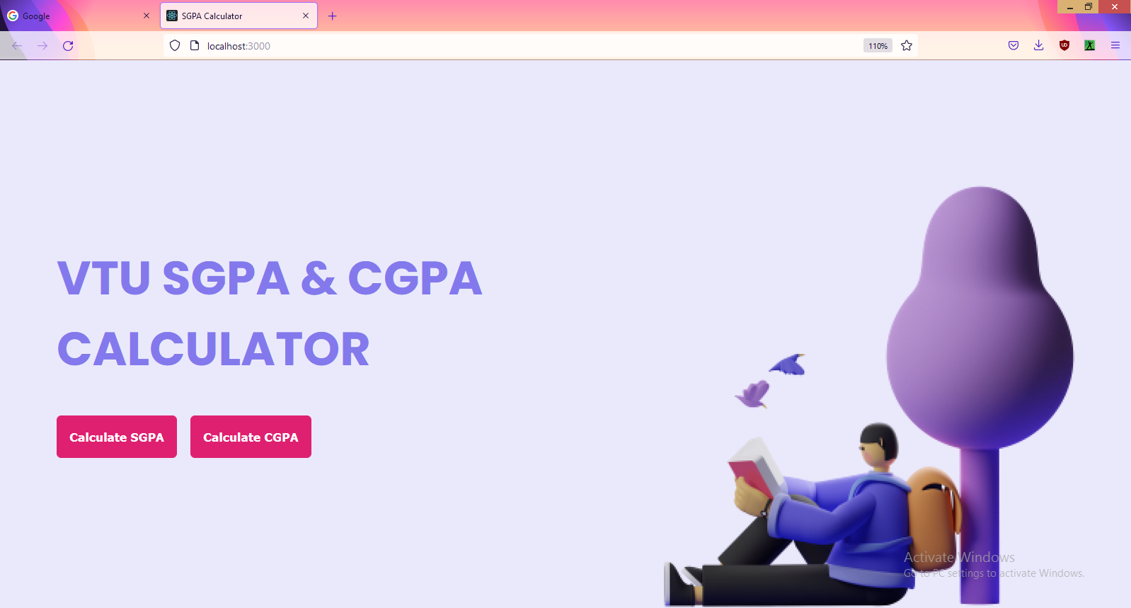

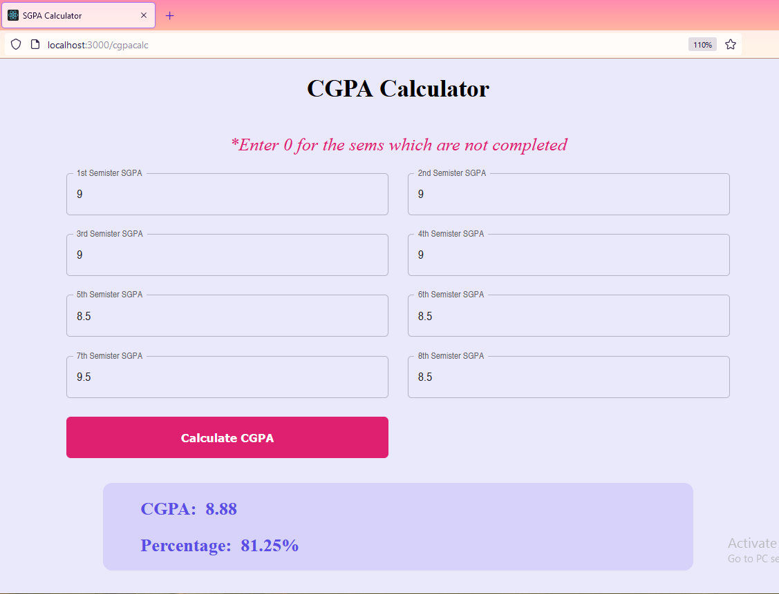

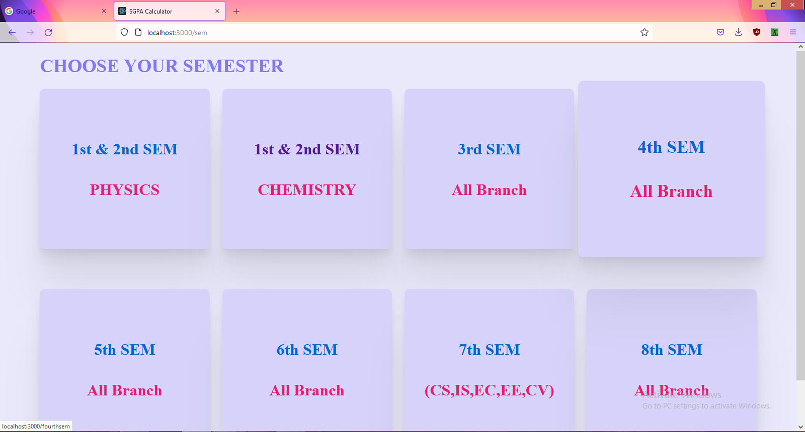

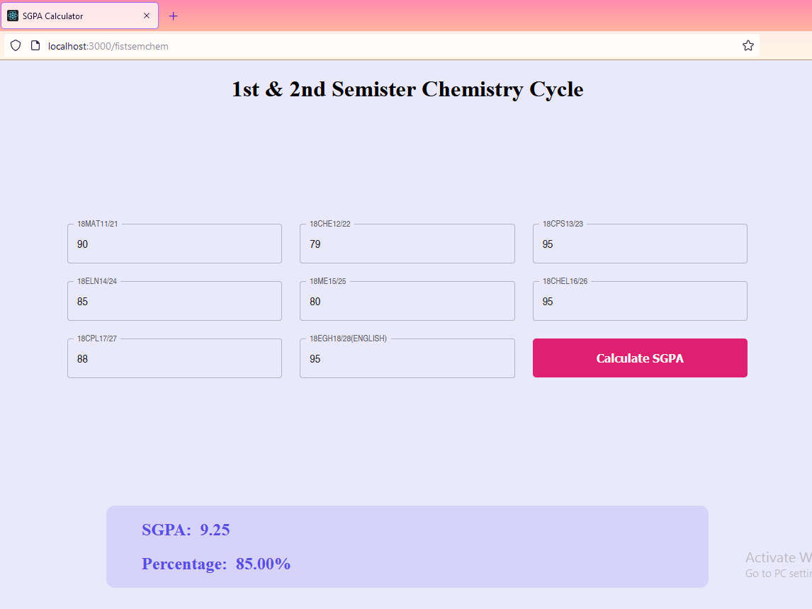

### BIBLIOGRAPHY

* https://[www.w3schools.com](http://www.w3schools.com/)
* https://www.geeksforgeeks org
* https://freefrontend.com
* <https://css-tricks.com/>
* https://www.takeiteasyengineers.com
* https://dev.to/mychi_darko/php-tips-and-tricks-4kpn