TakeTopDSH Team
User Guide

## Table of Contents
- 1. Overview
- 2. Platform Login
- 3. Administration Page
- 4. DSH Workbench
- 5. Other Member Operations
- 6. DSH Operations

This guide is for users. It explains: Install → Login → Open the Workbench → File Management / My Tasks → Admin task assignment, instance management, language switching → member DSH usage!

1. Installation
TakeTopDSH Team is a no-install, copy-and-run software. Follow these steps: copy the `TakeTopDshTeam` folder to the target machine → on Windows double-click `start.bat`, on macOS/Linux run `./start.sh` → open `http://127.0.0.1:46001` in the browser → click **"Open DSH"** to start using it. Detailed instructions below:
1-1. Windows
1-1-1. Copy the entire `TakeTopDshTeam` folder to the target computer.
1-1-2. Double-click **`start.bat`** (or right-click → Run as administrator, if the port is occupied).
1-1-3. The browser automatically opens the login page `http://127.0.0.1:46001`.

1-2. macOS (Apple Silicon, arm64)
1-2-1. Copy the entire `TakeTopDshTeam` folder to the target Mac.
1-2-2. Open Terminal and go to the folder:
bash cd /path/to/TakeTopDshTeam chmod +x start.sh ./start.sh

1-2-3. On first run it automatically unpacks Node and installs `@deepseek-ai/dsh` (**requires internet once**).
1-2-4. The browser automatically opens the login page `http://127.0.0.1:46001`.

1-3. Linux (x64 / arm64)
1-3-1. Copy the entire `TakeTopDshTeam` folder to the target machine.
1-3-2. Open a terminal and go to the folder:
bash cd /path/to/TakeTopDshTeam chmod +x start.sh ./start.sh
1-3-3. On first run it automatically unpacks Node (**already bundled, no download needed**); only `@deepseek-ai/dsh`'s native dependencies need **internet once**, after which it works offline.
1-3-4. The browser automatically opens the login page `http://127.0.0.1:46001`.

2. Platform Login
After each reboot, open the TakeTopDshTeam folder. You will see the two files below. Run the appropriate one for your system to open the login page:
> - Windows: double-click **`start.bat`**
> - macOS / Linux: run **`./start.sh`**
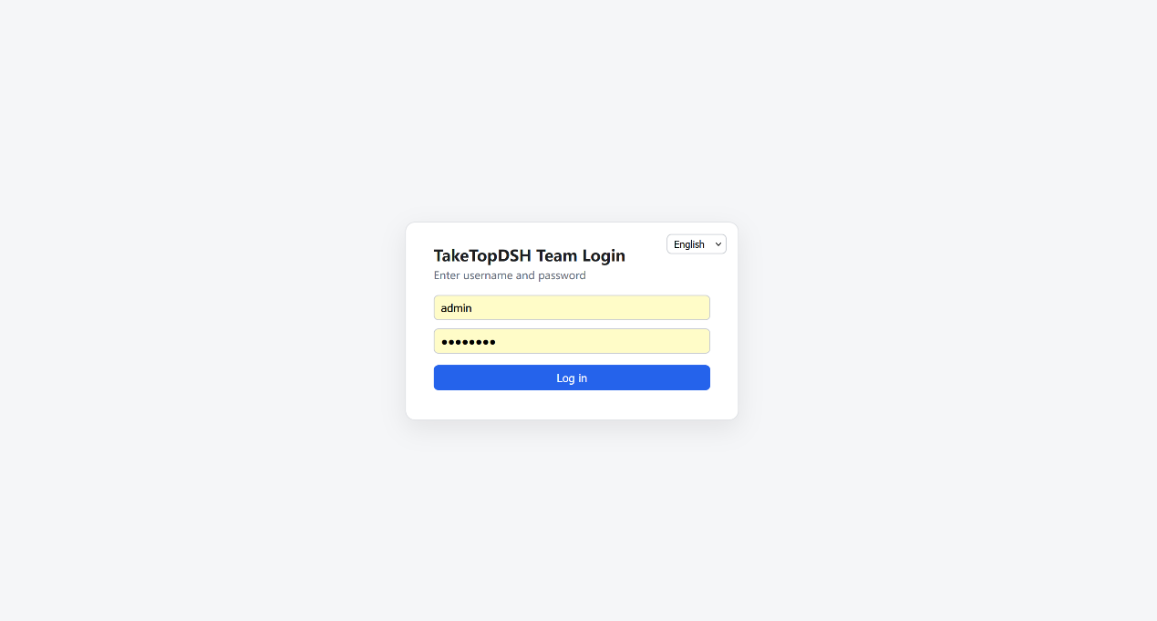
Enter username `admin` and password `12345678` to log in. After the first login, the TakeTopDSH Team background service TakeTopDSHLauncher keeps running in the background. As long as you have not rebooted, just open `http://127.0.0.1:46001` in the browser to return to the login page. If the launcher has been closed (e.g., after a reboot), you need to run the start program above again. http://127.0.0.1:46001

3. Administration Page
After the admin user logs in, you will see the page below. This is the admin user's administration page.
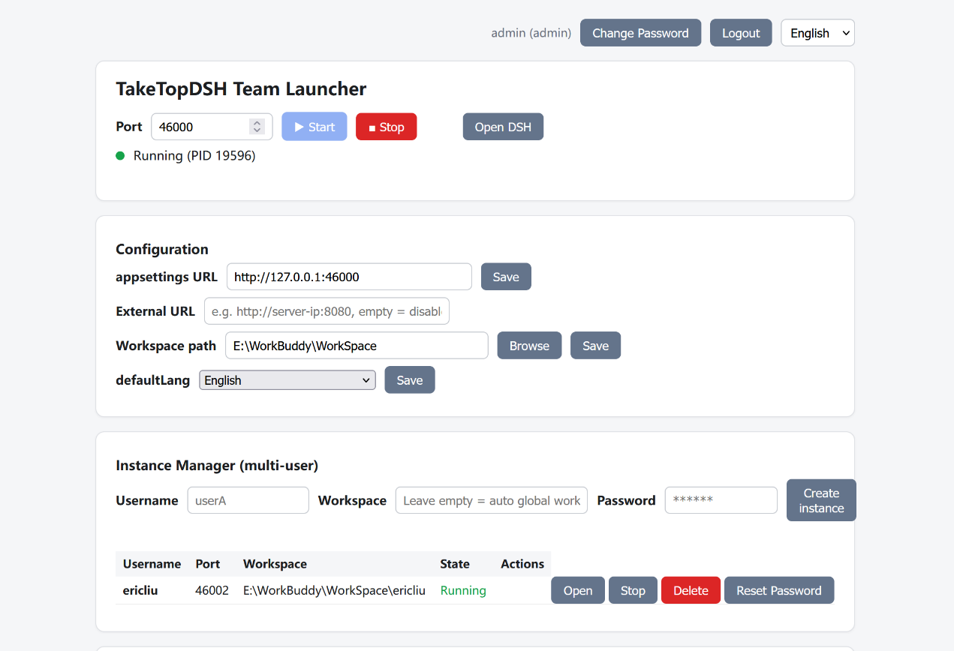
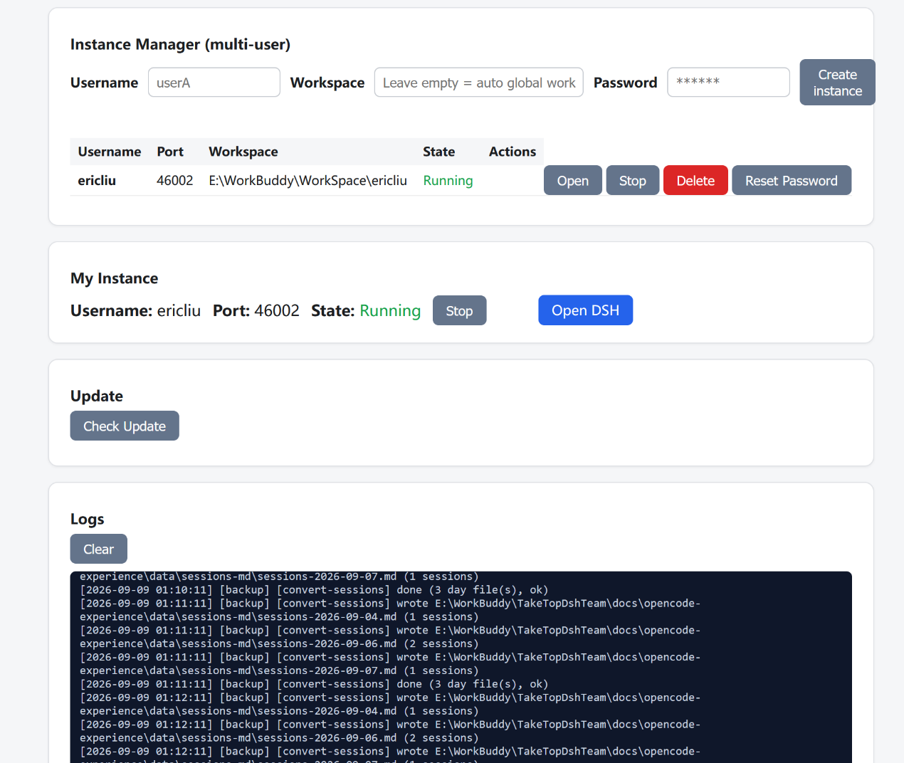
You can: Start/Stop, Open DSH, Configure, Manage Instances, Change Password. The key parts are described below; the rest is self-explanatory.
  - Configuration
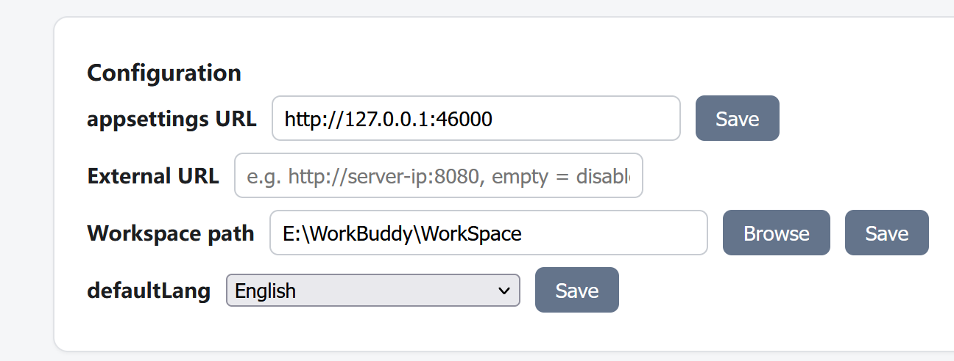
3-1-1. Set the Workspace path
Setting the Workspace path defines the platform's workspace directory. Note that this directory can be on any drive on the computer, but plan it well and ensure it has enough capacity, because all data you enter and all files you upload in TakeTopDSH Team are stored under this directory.

3-1-2. Set the External URL
The External URL applies if you also want to use the platform from outside the network. Give the server a public IP, then enter it here. For example, if the public IP is 188.88.88.88, you can set it as http://188.88.88.88:46000. If you are unsure, ask your network administrator to make sure it is configured correctly.http://188.88.88.88:46000

  - Add Member Users
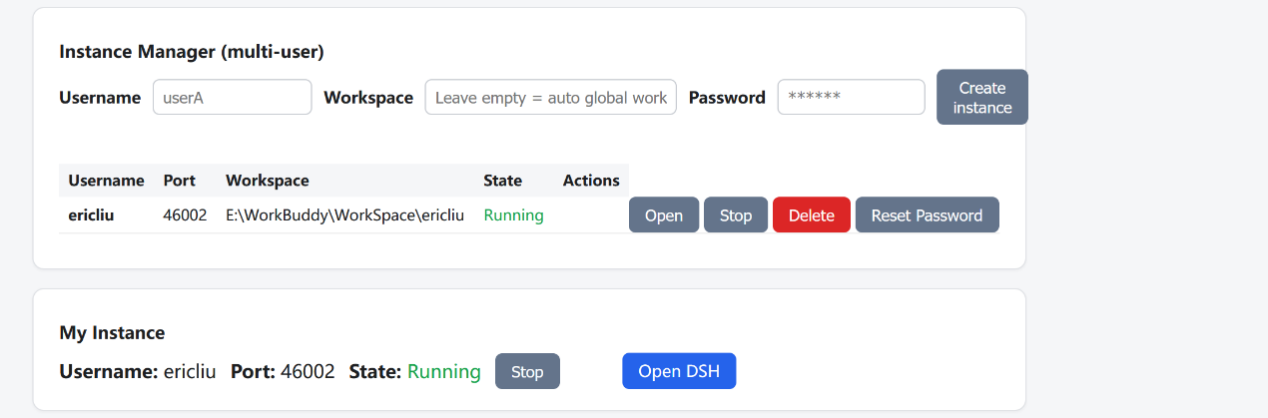
You can add member users here. Note that usernames should use English letters, not Chinese. Remember the password you set for a user, for example set it to `12345678`. After a member user logs in, they can change it themselves. You do not need to set this member's workspace directory — it is generated automatically from the main workspace directory + username.

  - Platform Update
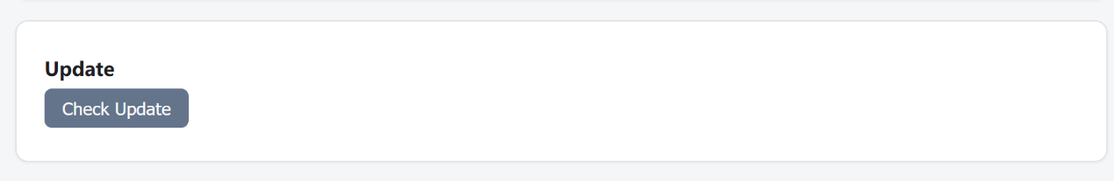
Because TakeTopDSH Team is an AI collaboration platform built on DeepSeek Harness, after DeepSeek Harness releases a new version, you can click this button to upgrade and ensure you are using the latest DeepSeek Harness features.

4. DSH Workbench
After completing the settings on the administration page, click the **Open DSH** button in the TakeTopDSH Team Launcher section to open the workbench page.
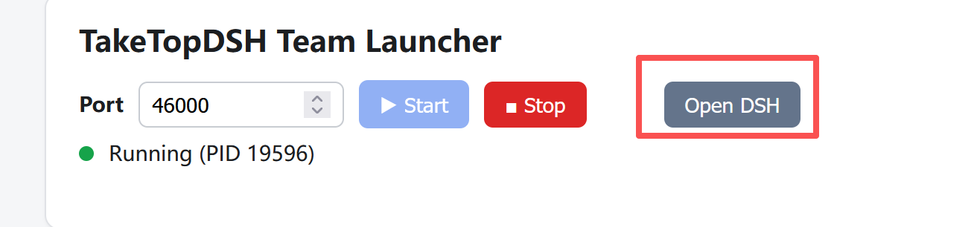

The workbench page is shown below, split left and right: the file manager / my tasks on the left, and the DSH chat interface on the right.
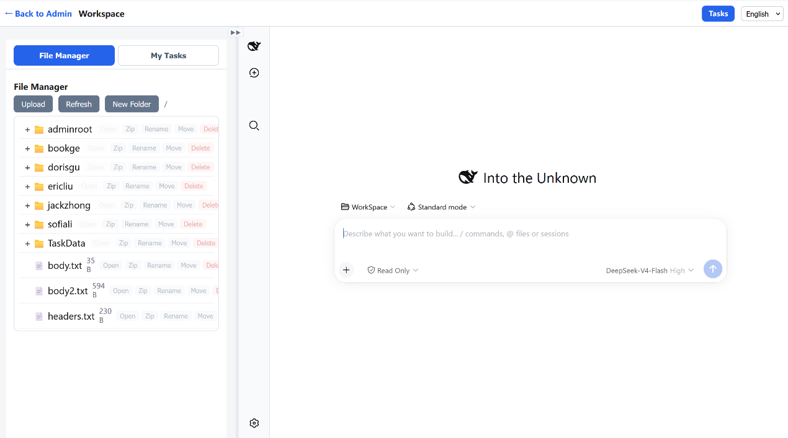
4-1. Configure the AI LLM API Key
Although TakeTopDSH Team is built on DeepSeek Harness, you can also connect other LLMs, such as OpenAI, Kimi, Claude, Qwen, etc., and even local models.
First, click the settings icon in the top-left of the right sidebar to open the settings page, as shown below.
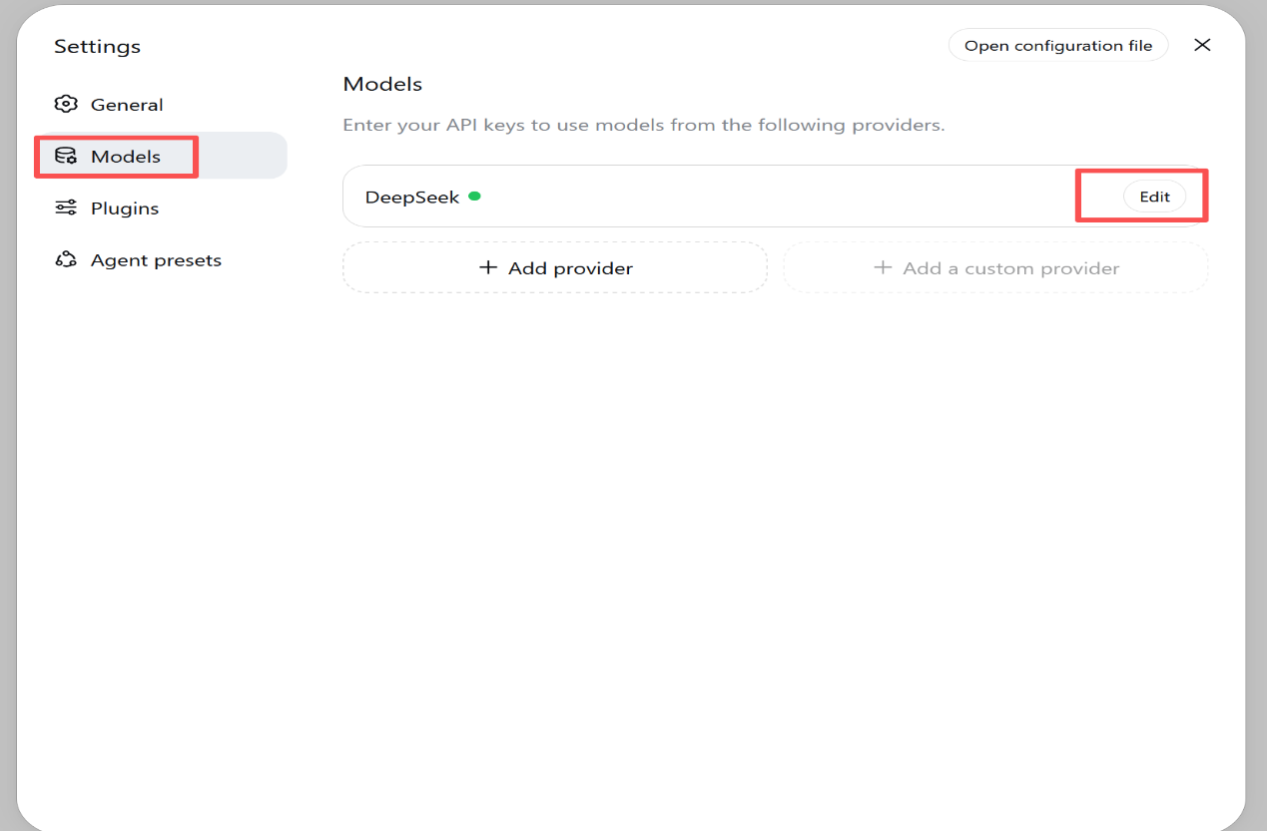
Click the Edit button, as shown below. You can choose from the listed models, or click Add model to add one. After selecting, enter the API Key you obtained. You can learn how to set it up on the website of the LLM you plan to connect.
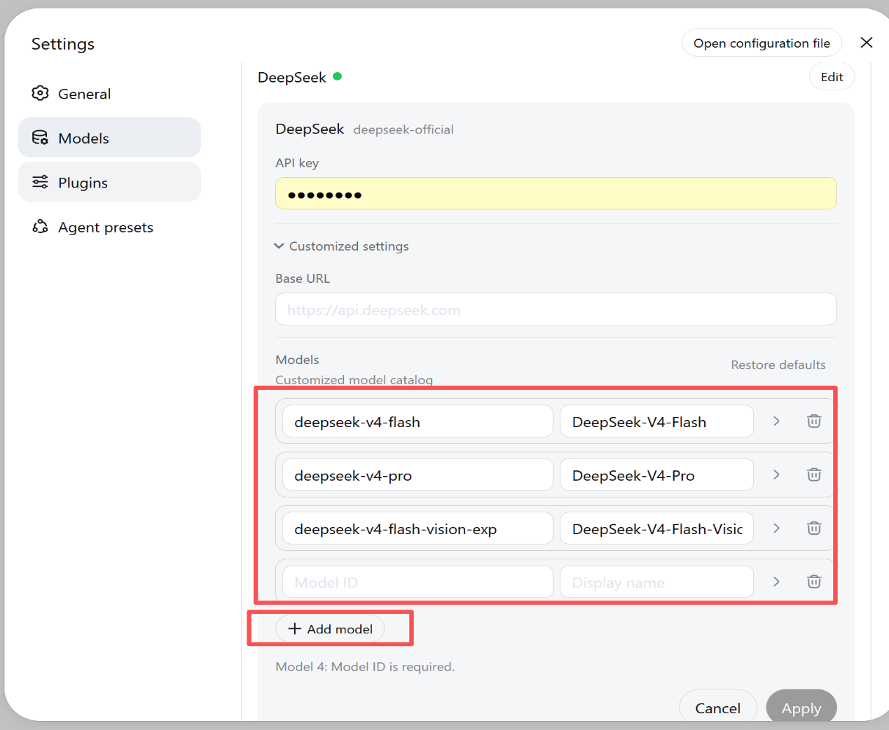
Once you have set the LLM's API Key, you can use DSH for AI conversations, as shown below.
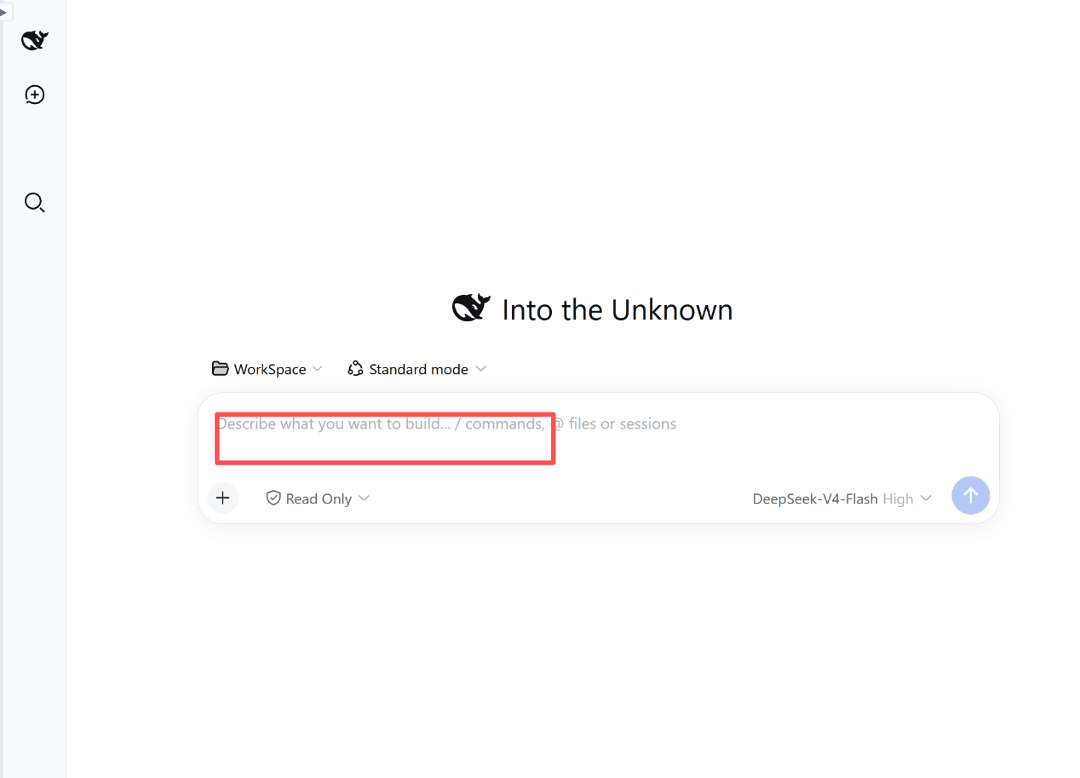
4-2. File Manager
The first tab in the left sidebar of the workbench is your file manager, as shown below. It shows the files under your workspace directory. You can only operate on files in this workspace directory. You can upload files you want to work on into this directory (multiple files allowed), and you can open, download, move, rename, delete, etc. You can also drag the file name of a selected file into the DSH input box on the right.
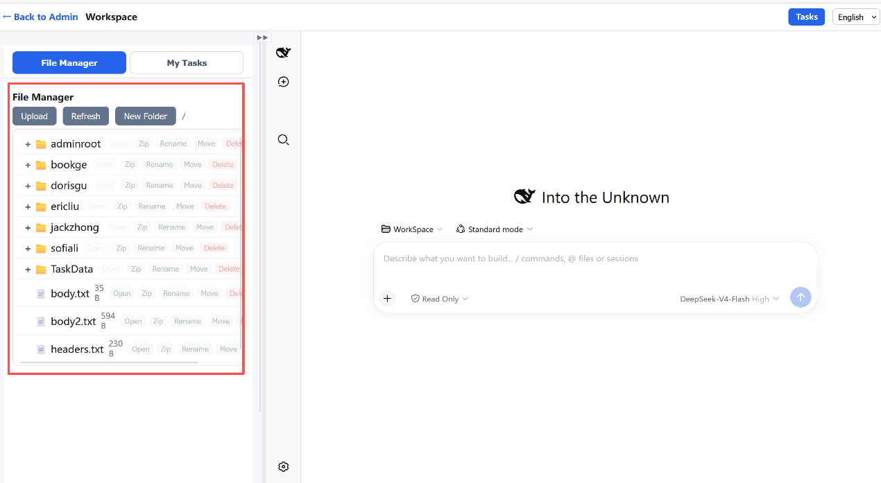
4-3. Task Management. Click the task management tab, as shown below. It shows the list of tasks assigned to you by other members. You can click a task name to preview its details, or click the Feedback button to give feedback on how you handled the task. You can also drag the task name directly into the DSH input box on the right.
``` k 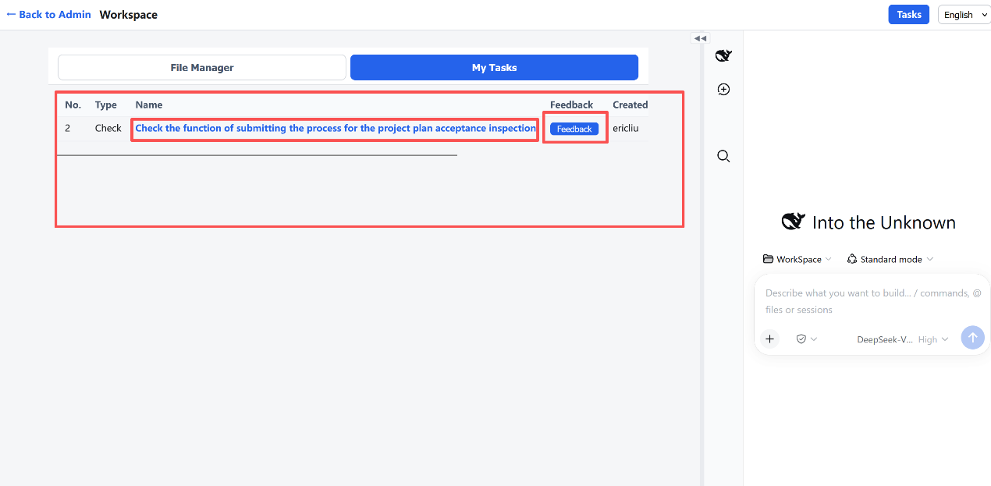
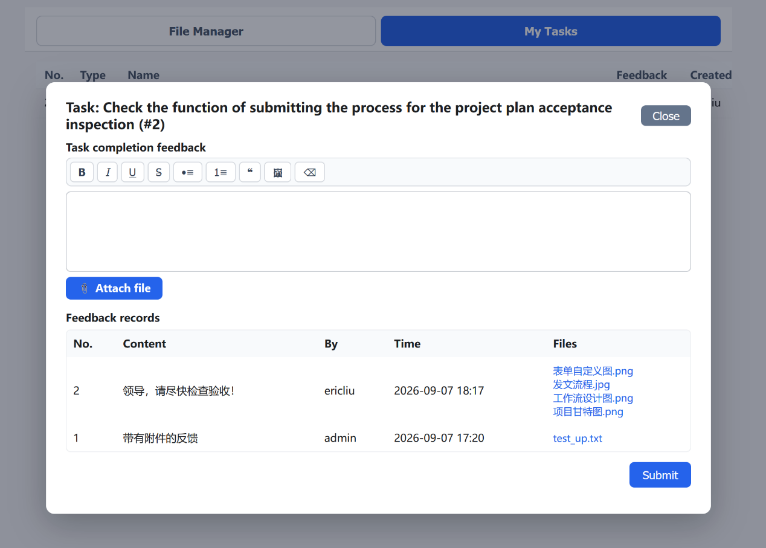
The input box above accepts text and pasted images. Click the Attach file button below to upload attachments.
4-4. Task Assignment. Click the "Task Assignment" button at the top-right of the page to open the task assignment page, as shown below.
It shows all the tasks you have created. Select the member you want to assign a task to in the member list on the left, then click the Add Task button to assign the task to that member.
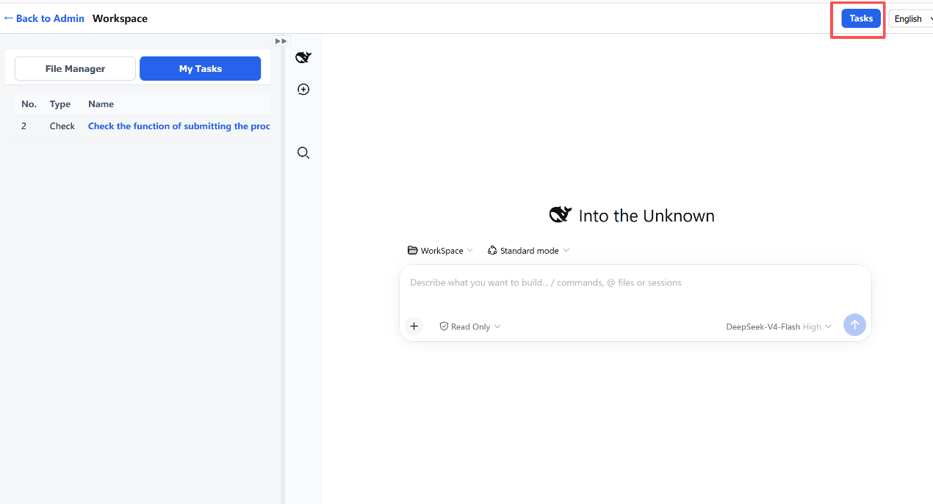
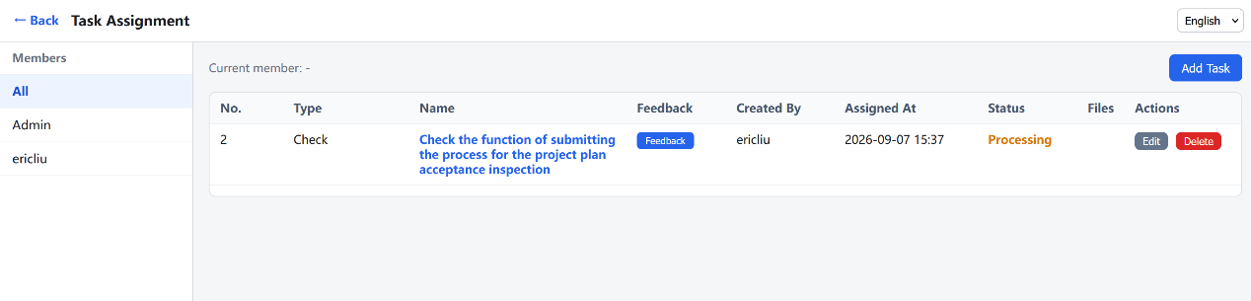
You can also click the Feedback button in the task list to evaluate how that member completed the task, entering your requirements and comments, as shown below. The operation is the same as above.
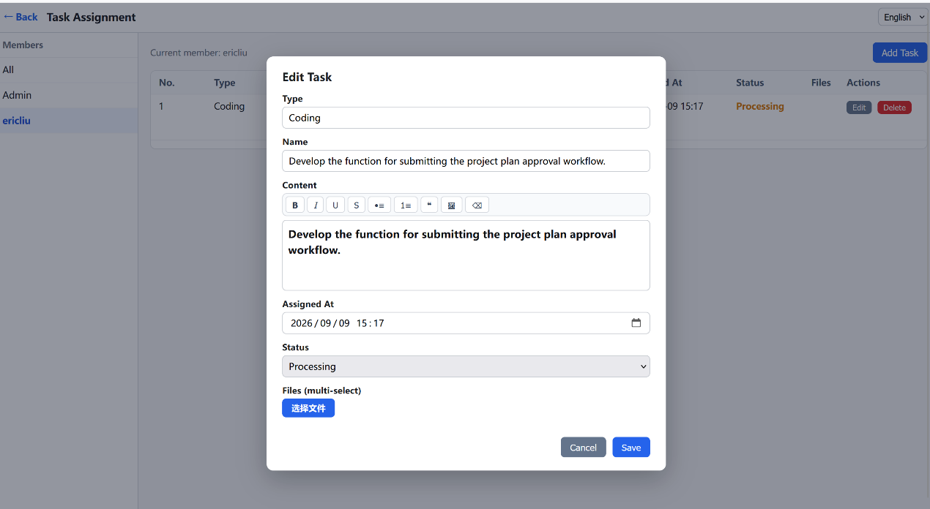
5. Other Member Operations
A member added by the admin on the administration page, for example the ericliu added earlier, can also log in from the login page and enter the member's administration page, as shown below. It is simpler than the admin (admin user)'s page.
On this page, you can click the Start button to start the DSH service. The first start may be slower; after it starts, you can open the member's DSH page, as shown below. The operation is the same as the admin's, but note that the member can only work in their own file workspace and cannot see the files of other workspaces.
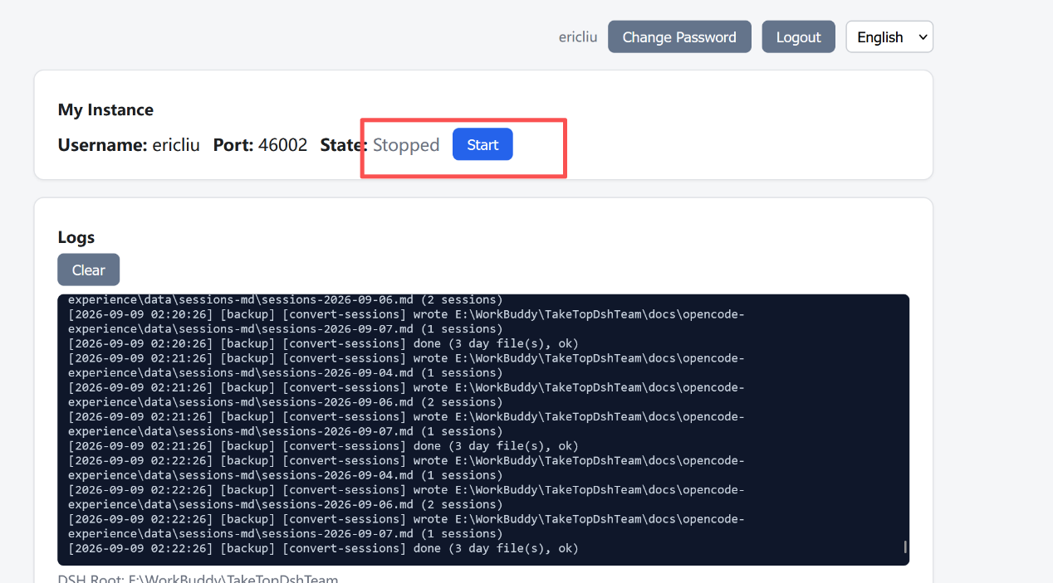
6. DSH Operations
After you are familiar with the functions on the pages above, you can use this AI Harness for work. For example, to modify a code file in the workspace directory, you can directly enter the modification instruction you want in the Harness input box, as shown below, then click the submit arrow button; it will call the connected LLM to do the work.
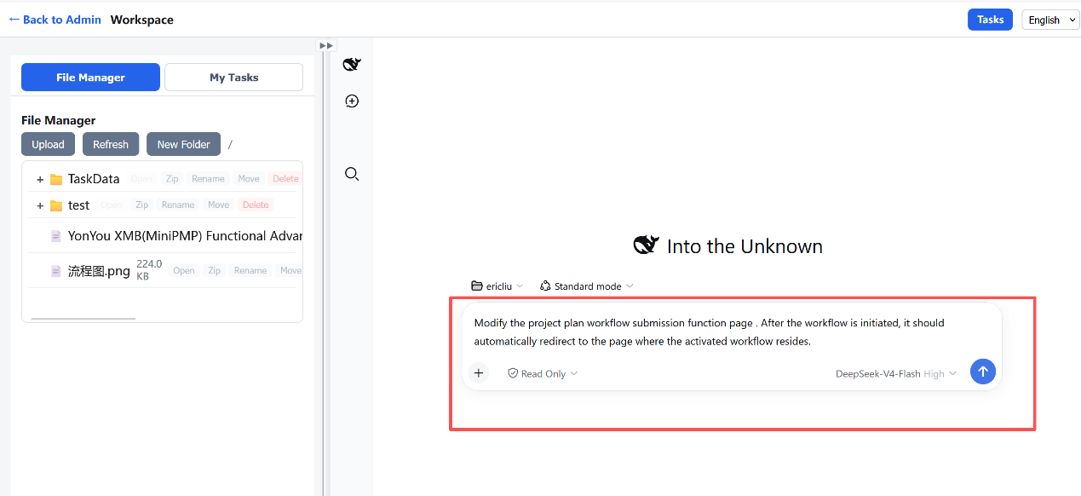
Of course, besides software development, you can also do other work, such as modifying a PPT file, creating a contract file, etc., and you can also complete tasks assigned to you by others here.

