TakeTopDSH Team
User Guide

## Table of Contents
- 1. Overview
- 2. Platform Login
- 3. Admin Page
- 4. DSH Workbench
- 5. Other Member Operations
- 6. Language
- 7. Platform Support
- 8. Advanced Edition (paid)
This guide covers: Installation → Login → Admin Settings → Open Workbench → File Manager / My Tasks → Task Assignment → Member DSH Usage!

- Installation
Download the installer: visit https://github.com/TakeTopITS/TakeTopDSHTeam, click the download button as shown below, then extract the archive. https://github.com/TakeTopITS/TakeTopDSHTeam
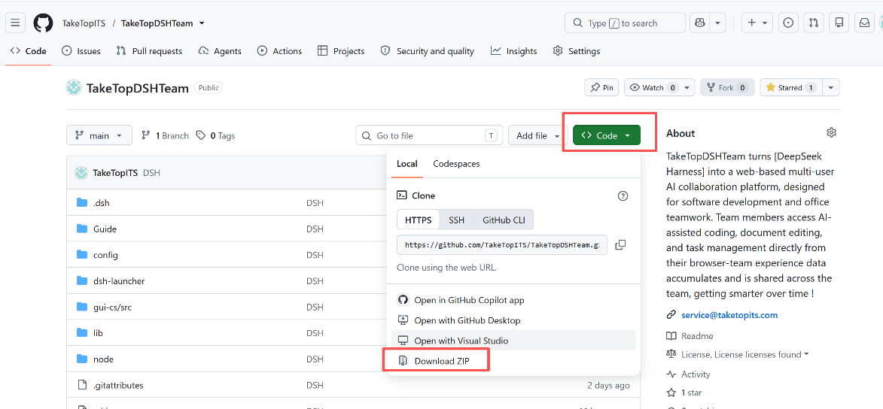
TakeTopDSH Team is a portable, copy-and-run application. Steps: copy the `TakeTopDshTeam` folder to the target machine → double-click `start.bat` on Windows, or run `bash start.sh` on macOS/Linux → open `http://127.0.0.1:46001` in your browser → click **"Open DSH"** to start. See details below:
1-1. Windows
1-1-1. Copy the entire `TakeTopDshTeam` folder to the target computer.
1-1-2. Double-click **`start.bat`** (if the port is occupied, right-click → Run as administrator).
1-1-3. The browser will automatically open the login page at `http://127.0.0.1:46001`.

1-2. macOS (Apple Silicon, arm64)
1-2-1. Copy the entire `TakeTopDshTeam` folder to the target Mac.
1-2-2. Open a terminal and navigate to the folder:
bash cd /path/to/TakeTopDshTeam bash start.sh

1-2-3. On first run, the built-in Node.js and `@deepseek-ai/dsh` dependencies are automatically extracted — **fully offline**, no additional download or compilation required.
1-2-4. The browser will automatically open the login page at `http://127.0.0.1:46001`.

1-3. Linux (x64 / arm64)
1-3-1. Copy the entire `TakeTopDshTeam` folder to the target machine.
1-3-2. Open a terminal and navigate to the folder:
bash cd /path/to/TakeTopDshTeam bash start.sh
1-3-3. On first run, the built-in Node.js and `@deepseek-ai/dsh` dependencies are automatically extracted — **fully offline**, no additional download or compilation required.
1-3-4. The browser will automatically open the login page at `http://127.0.0.1:46001`.

2. Platform Login
Each time you restart, open the TakeTopDshTeam folder and you will see the files below. Run the appropriate file for your system to open the login page:
> - Windows: double-click **`start.bat`**
> - macOS / Linux: run **`bash start.sh`**
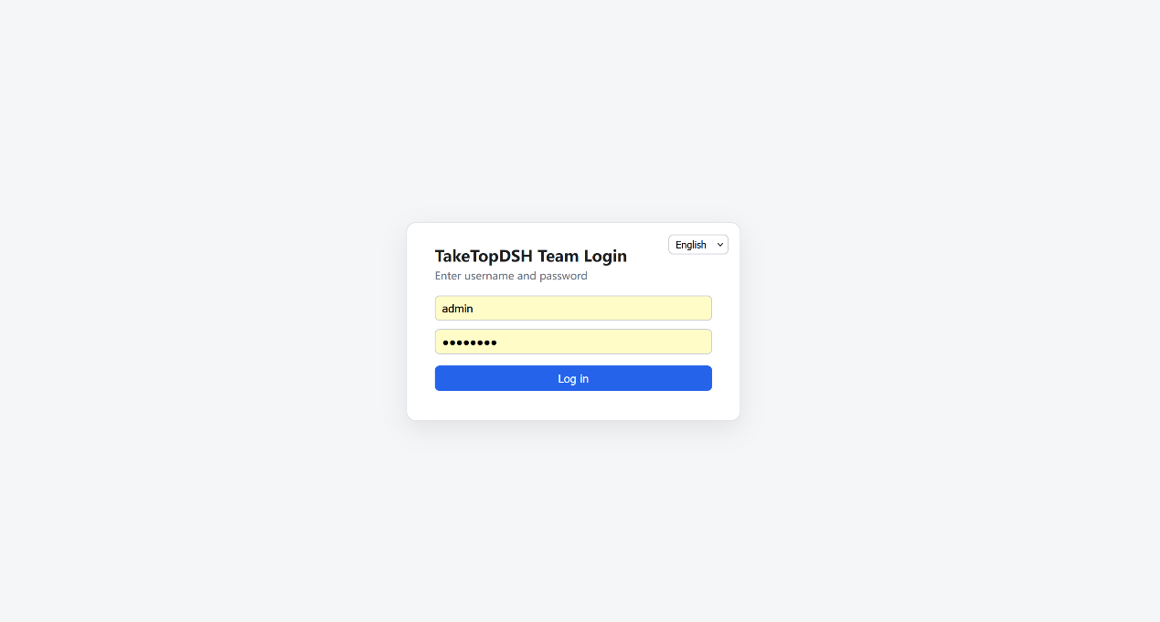
Enter username `admin` and password `12345678` to log in. After the first login, the TakeTopDSH Team background service (TakeTopDSHLauncher) will keep running in the background. As long as you have not restarted the computer, simply open `http://127.0.0.1:46001` in your browser to return to the login page. If the launcher has been closed (e.g., after a restart), re-run the startup program above. http://127.0.0.1:46001

3. Admin Page
After logging in as an administrator, you will see the page below. This is the admin management page.
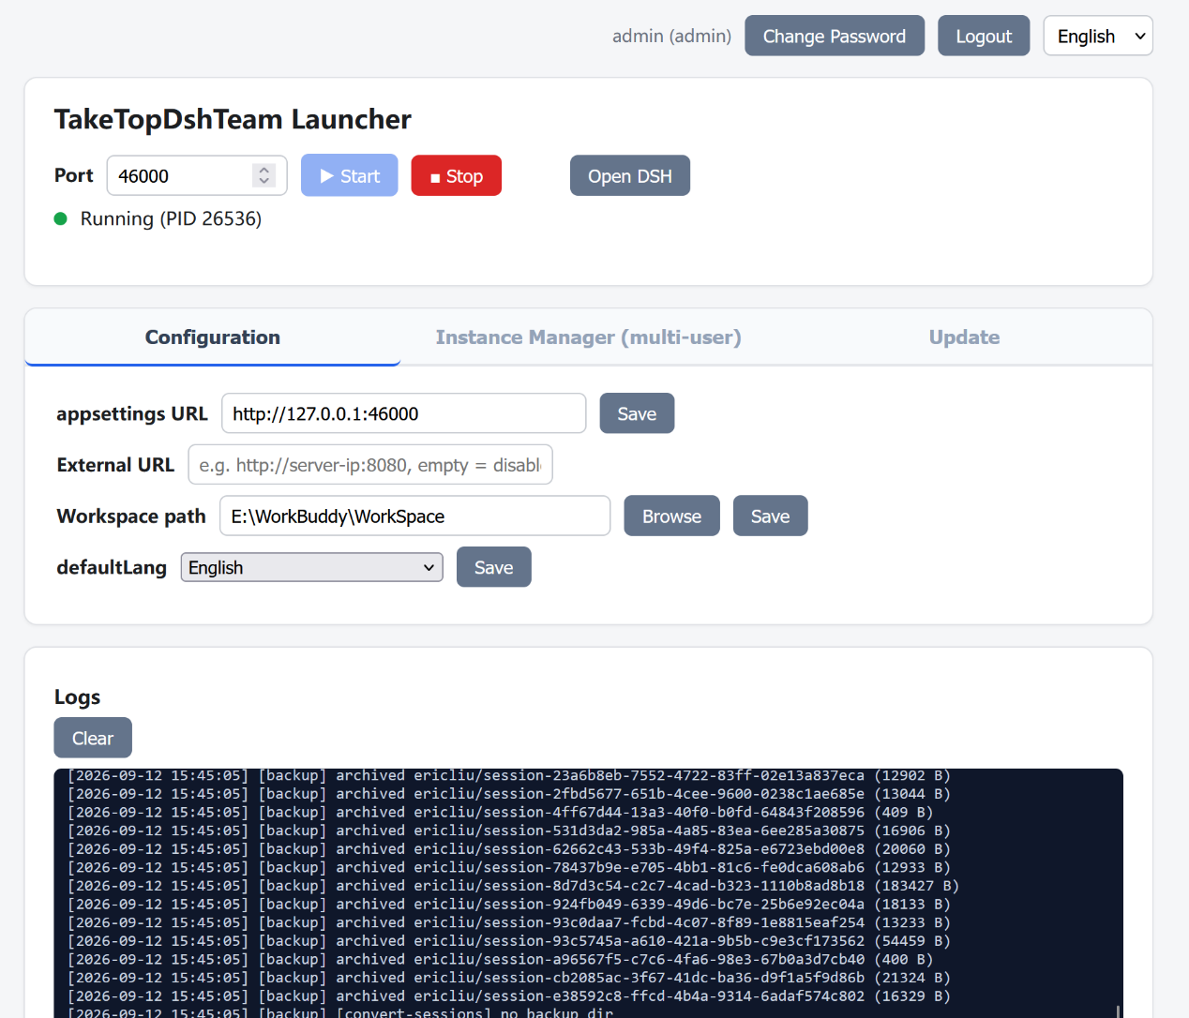
You can: start/stop, open DSH, configure, manage instances, and change passwords. Key sections are described below; the rest is self-explanatory.
  - Configuration
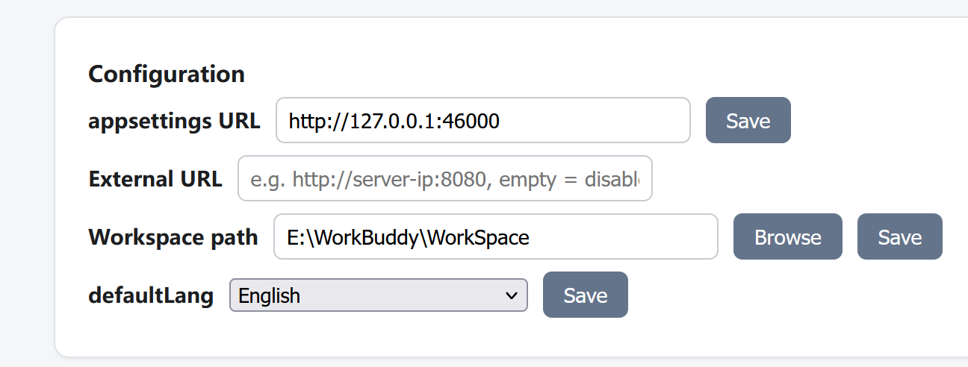
3-1-1. Set Workspace Path
Setting the workspace path defines the platform's working directory. This directory can be located on any drive, but plan carefully and ensure sufficient capacity, as all data entered and files uploaded in TakeTopDSH Team are stored in this directory.

3-1-2. Set External URL
If you want to access the platform from an external network, you need to set the external URL. Assign a public IP to the server, then enter it here. For example, if the public IP is 188.88.88.88, set it to http://188.88.88.88:46000. If unsure, consult your network administrator to ensure correct configuration. http://188.88.88.88:46000

  - Add Member Users
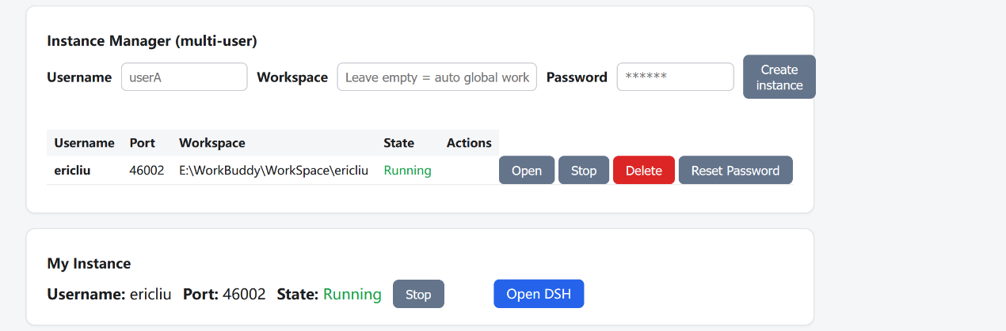
You can add member users here. Note that usernames should use English letters, not Chinese characters. Remember the password you set for each user, for example `12345678`. Members can change their own password after logging in. Member workspace directories do not need to be configured — they are automatically generated based on "main workspace directory + username".

  - Platform Update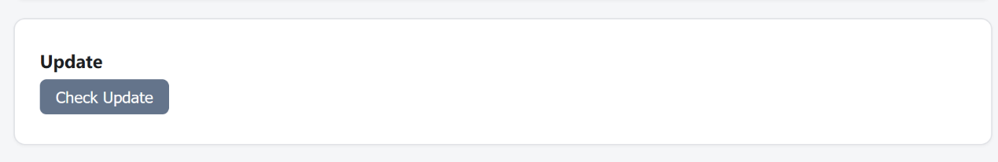
Since TakeTopDSH Team is built on DeepSeek Harness, when DeepSeek Harness releases a new version, you can click this button to upgrade and ensure you are using the latest DeepSeek Harness features.

4. DSH Workbench
After completing the admin page settings, click the **Open DSH** button in the TakeTopDSH Team launcher area to open the workbench page.
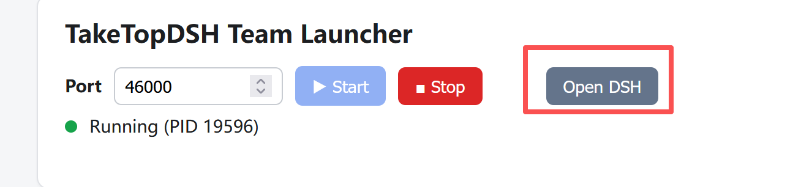
The workbench page is shown below, with a split view: the left side is the File Manager / My Tasks, and the right side is the DSH chat interface.
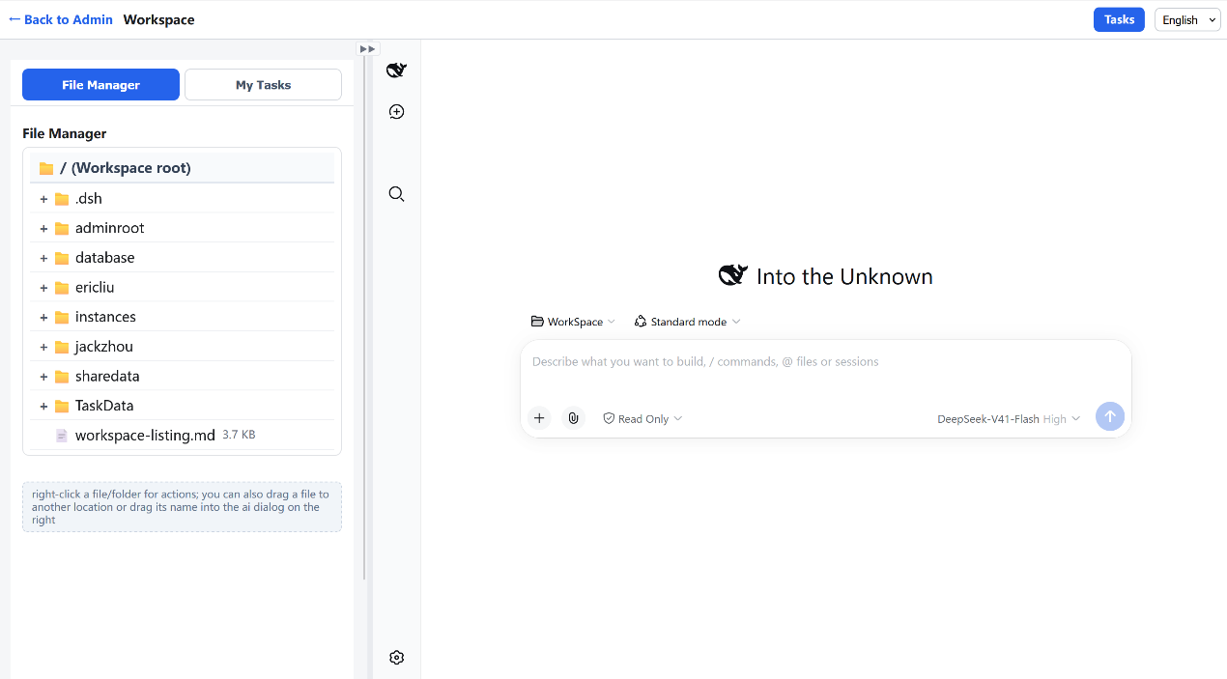
4-1. Configure AI LLM API Key
Although TakeTopDSH Team is built on DeepSeek Harness, you can also connect to other LLMs such as OpenAI, Kimi, Claude, Qwen, and even local models.
First, click the settings icon in the lower-left corner of the right sidebar to open the settings page, as shown below.
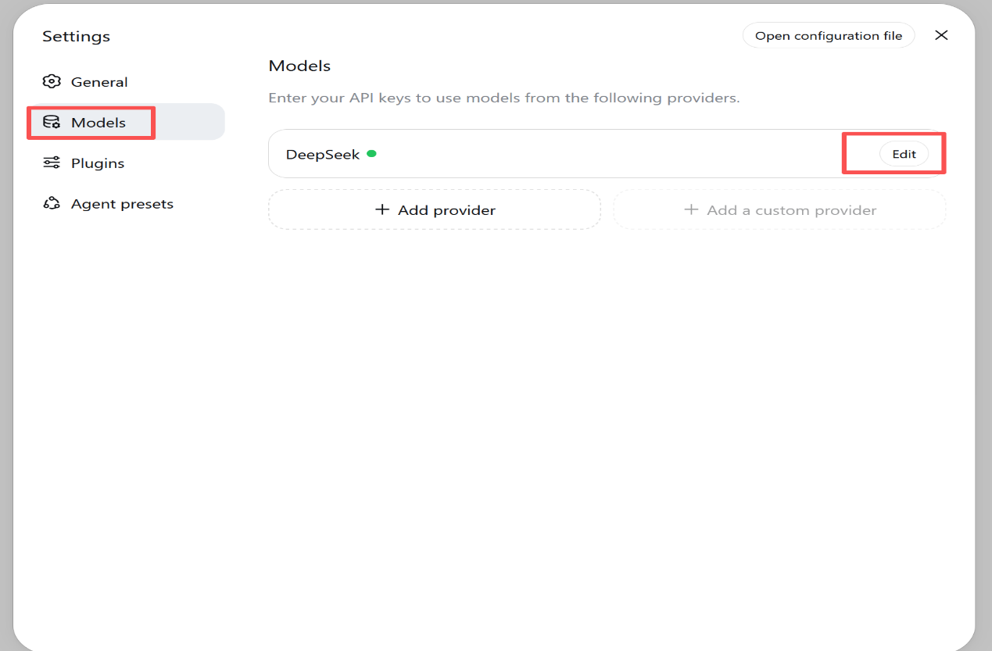
Click the Edit button, as shown below. You can select from the listed models, or click Add model to add a new one. After selection, enter your API Key. For detailed setup instructions, refer to the official website of the LLM you want to connect.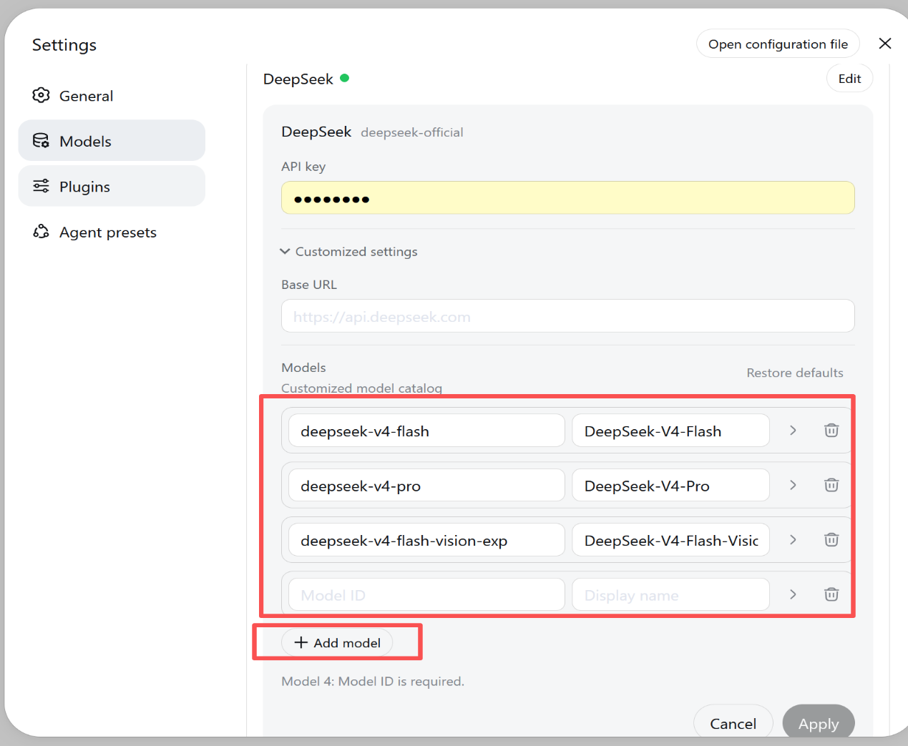
After configuring the LLM API Key, you can use DSH for AI conversations, as shown below.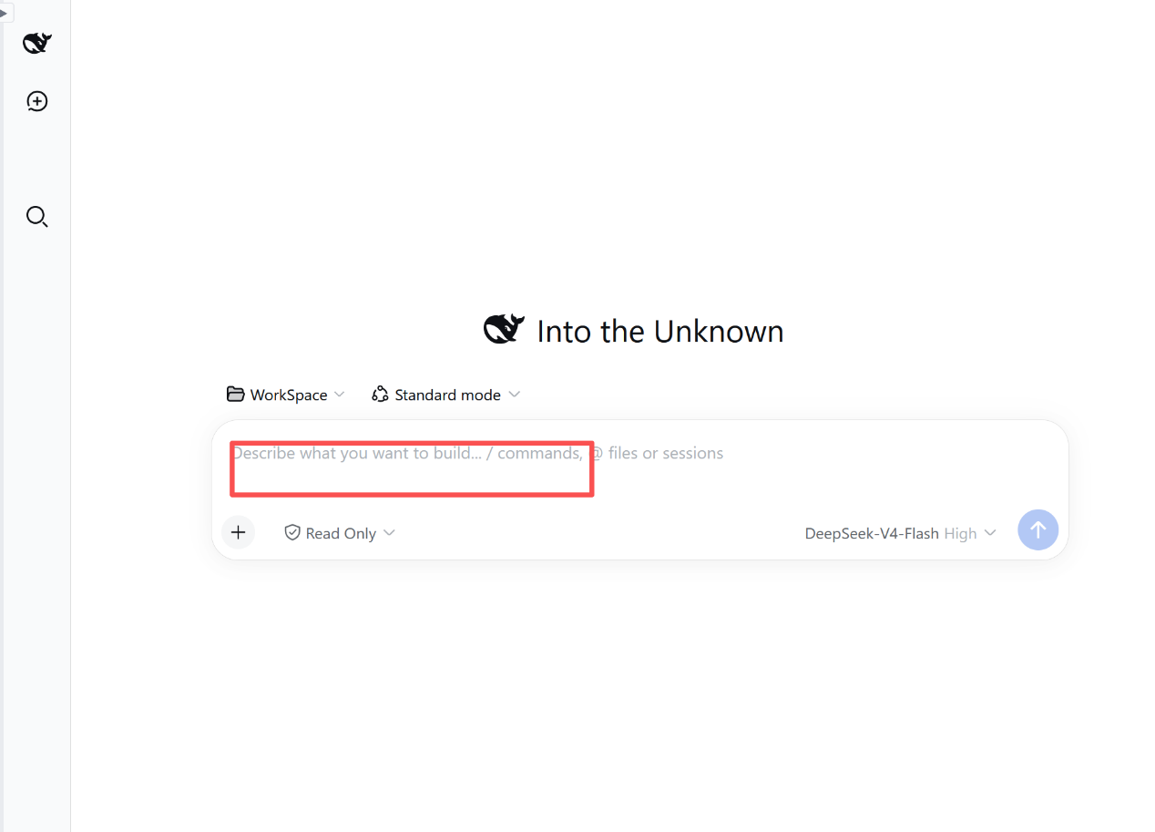
4-2. File Manager
The first tab in the workbench left sidebar is the File Manager, shown below. It displays files in your workspace directory. You can only operate on files within this workspace directory. You can upload files to this directory (supports multi-select), and perform operations such as open, download, move, rename, delete, compress, and decompress. You can also drag selected file names to the DSH input box on the right for AI to process. Leaders can upload project documents to each member's workspace directory for members to view and process!
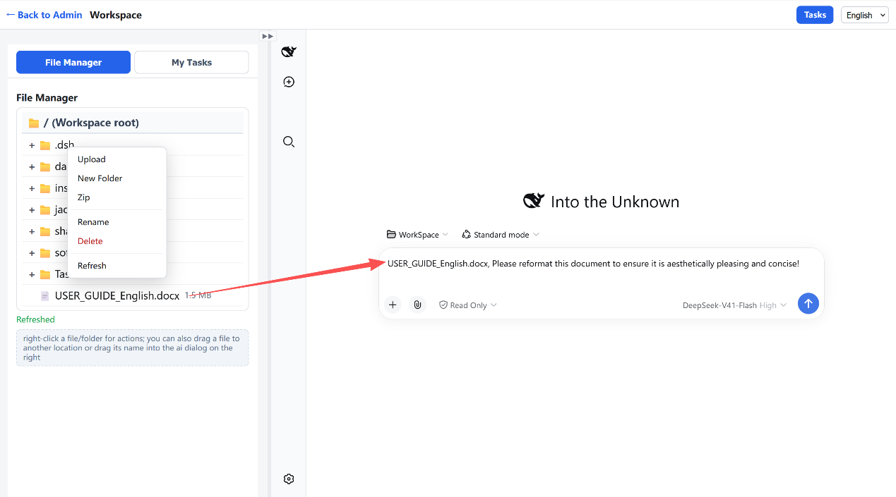
4-3. Task Assignment
Click the "Task Assignment" button in the top right corner of the page to open the task assignment page, as shown below.
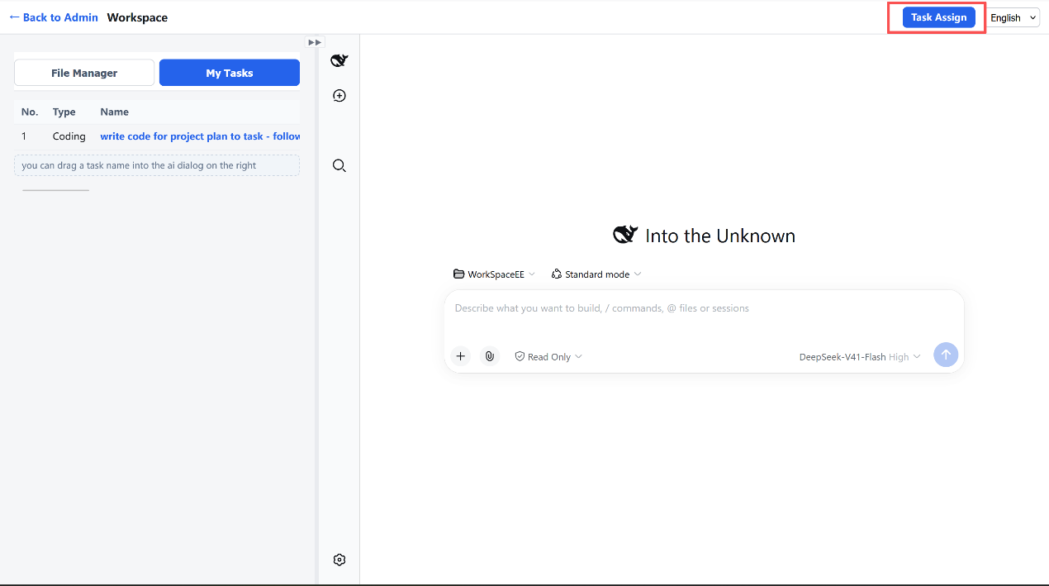
It displays all tasks you have created. The member list on the left is optional (for filtering). Click the "Add Task" button to open the dialog, and select an assignee from the "Assignee" dropdown. The "Type" field contains a text box, a dropdown, and a + button: you can select an existing type, or enter a new type and click + to add (types are remembered). You can also change the assignee when editing a task; after saving, the task moves to the new assignee's task list. Each task row has a + column to inline-expand its subtasks; each subtask stores its parent task's unique ID (UID), and the "No." column displays the hierarchical number (1, 1-1, 1-2-1...). Tasks without subtasks do not show a +.
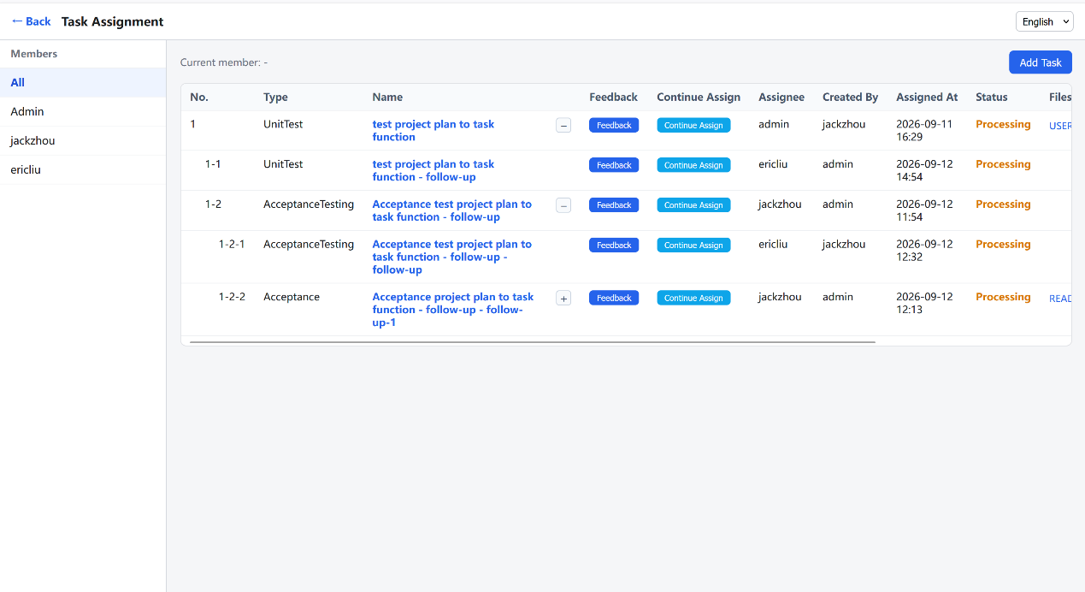
Task Assignment — use the "+" column to inline-expand task subtasks.
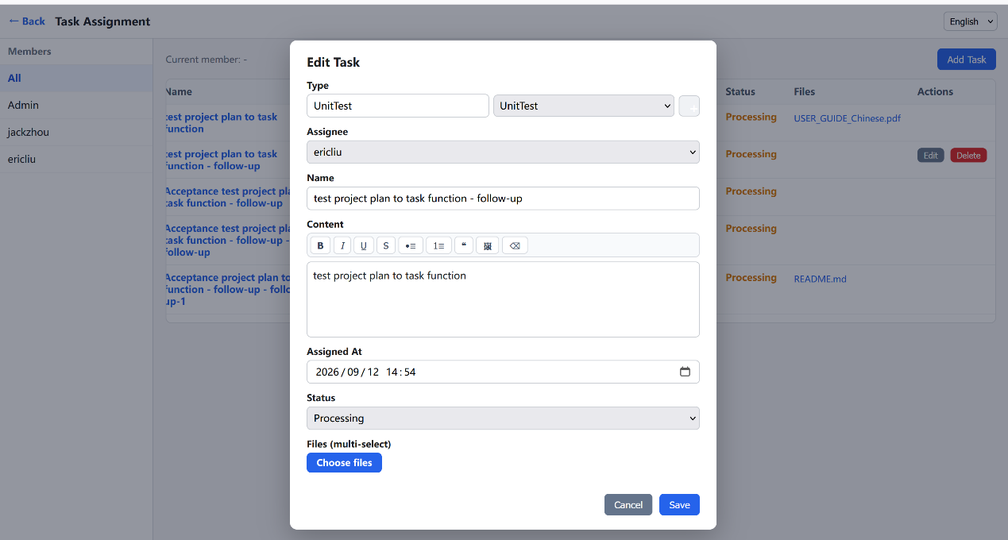
You can also click the "Feedback" button in the task list to evaluate how the member completed the task, filling in your requirements and comments, as shown below. The operation is the same as above.
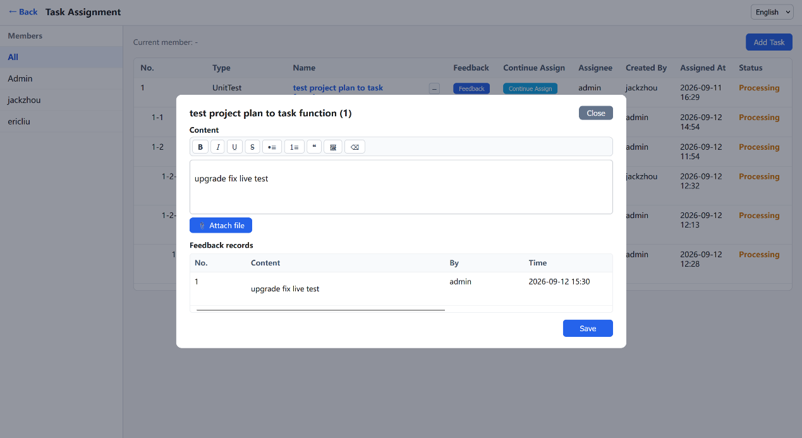

4-4. My Tasks
Click the "My Tasks" tab, as shown below. It displays the list of tasks assigned to you. Opening this page automatically widens the left pane to 70% for easier reading. The "No." column shows the task's hierarchical number (1, 1-1, 1-2-1...). Here you can: click a task name to preview the task; drag the task name or its attachments into the AI chat box for AI to process; click "Continue Assignment" to create follow-up (sub) tasks for other members (subtasks are added to that member's task list, and the parent task auto-expands after saving); click the + in the subtask column to inline-expand the task's subtask tree (multi-level; no + if no subtasks); and use Edit / Delete (available only if you created the task and it has no subtasks). You can also click "Feedback" to fill in feedback, paste images, or use "Attach File" to add attachments. Leaders can assign tasks to members, and members can also assign tasks to each other!
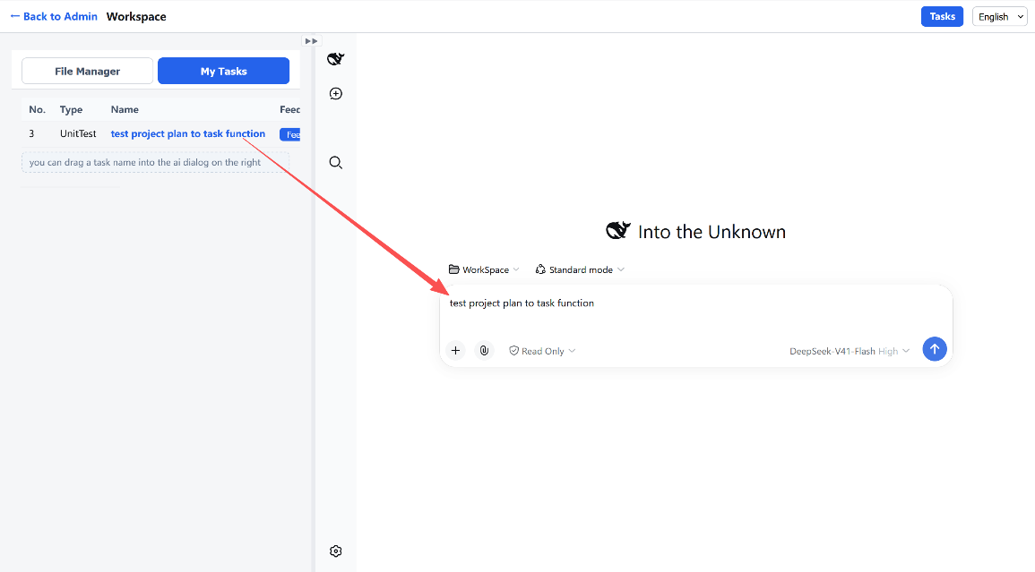
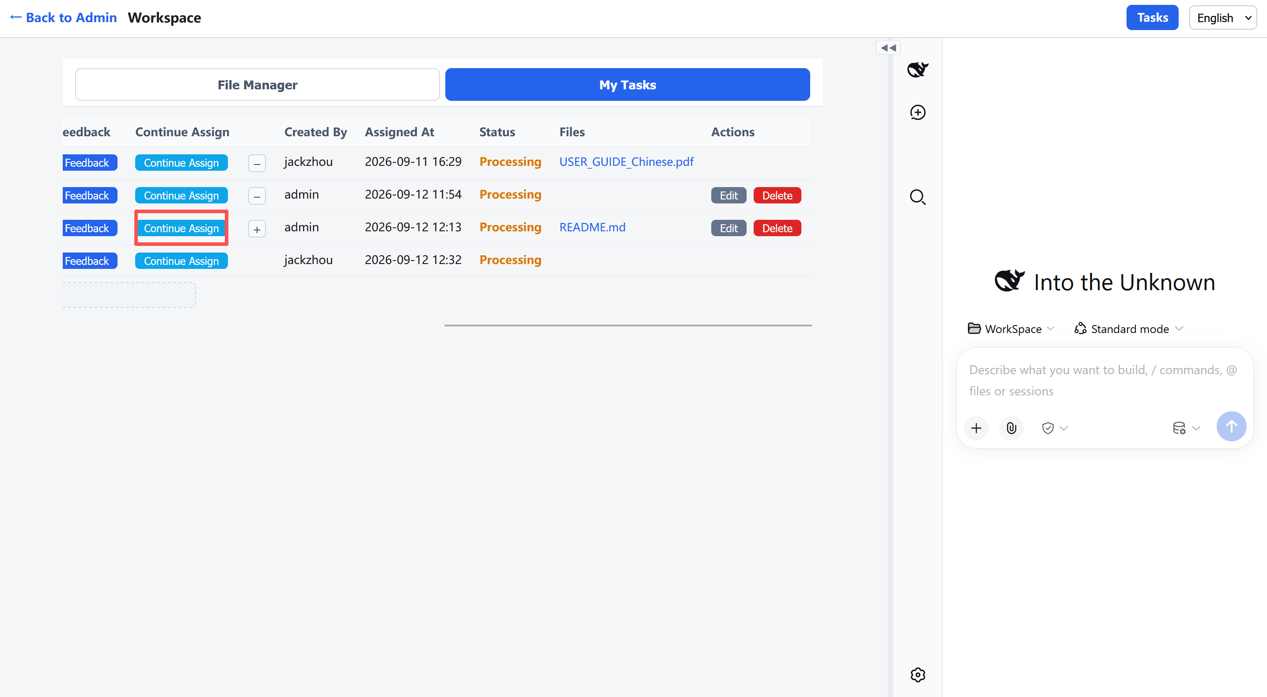
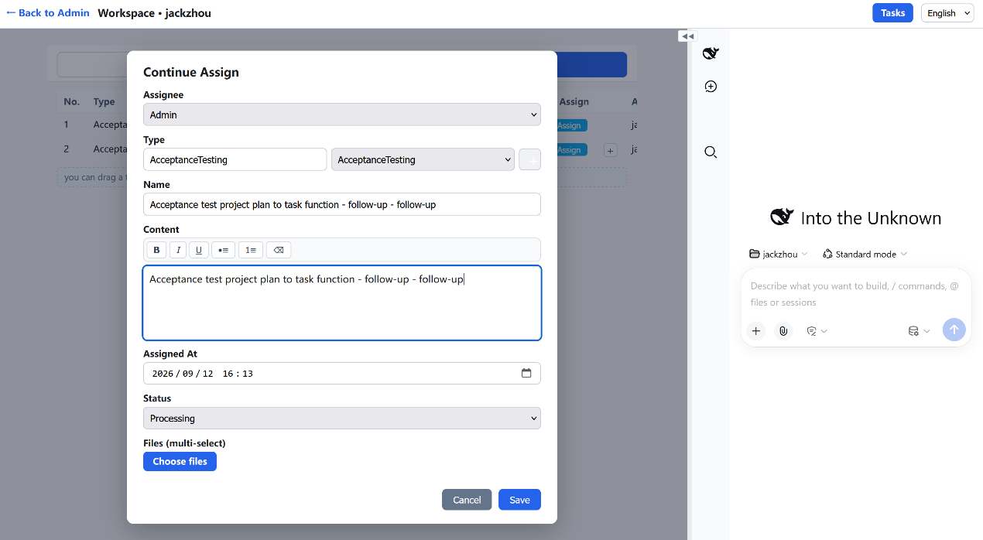
My Tasks — continue assignment, subtask tree, and edit / delete.

Task Feedback: the input box above supports text and pasted images. Click the "Attach File" button below to upload attachments. You can also drag the feedback description and related documents into the DSH chat box on the right for AI to process.！
Of course, beyond software development tasks, you can do other work too, such as editing PPT files, drafting contracts, media processing, engineering design, etc. You can also complete tasks assigned to you by others here.
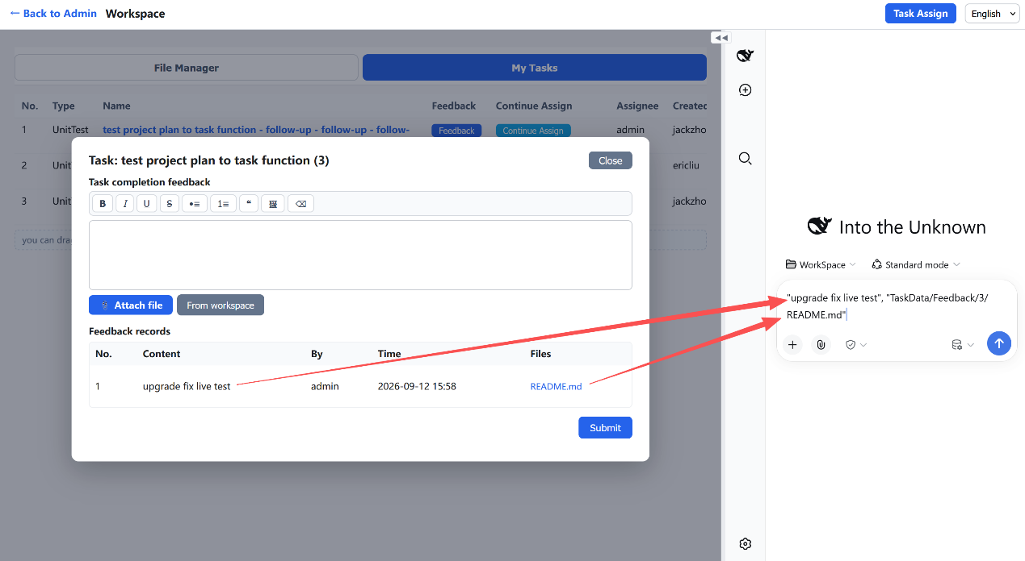
5. Other Member Operations
Members added by the administrator on the admin page (e.g., ericliu added earlier) can also log in from the login page and access that member's admin page, as shown below. This admin page is simpler than the admin's page.
On this page, you can click the "Start" button to start the DSH service. The first startup may be slow; once started, you can open that member's DSH page, as shown below. Operations are the same as the administrator, but note: members can only operate within their own file workspace and cannot see files in other workspaces.
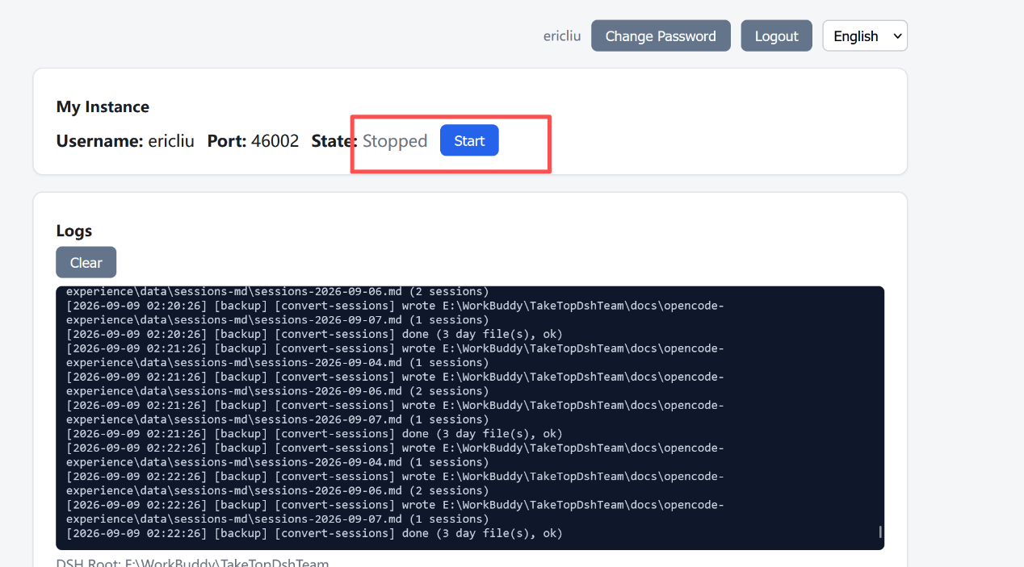

6. Language
The console, workbench, file manager, task assignment, and task forms all support full English / Chinese switching. The login page uses the configured default language and can be switched at any time.
7. Platform Support
TakeTopDSHTeam is cross-platform: a single installer covers Windows, macOS, and Linux, with fully offline installation — no compilation required, no additional downloads on the target machine.

8. Advanced Edition (paid)
The content above describes the features and how to use them of the Standard edition, which is MIT-licensed and free. For teams that need stronger governance we offer a paid Advanced edition that adds:
🧮 Per-member token control — see and control each member's token usage.
🏛️ Hierarchical (pyramid) member management — a normal member can create and manage sub-members' work; each sub-member can, in turn, create further sub-members and manage their work, forming a pyramid-style management structure.
📱 Mobile APP pages — built-in touch-optimized mobile interface; access the workbench and get all kinds of work done anytime, anywhere from a phone or other mobile device.
📚 Shared team knowledge base — a built-in team library (documents, reference books and curated session notes) that every member can browse, search and learn from, so team know-how keeps accumulating and new members grow fast.
💬 Instant chat — 1:1 and group chat, fully connected with the file manager, task manager and AI chat — communication without limits!
🛠️ Support — during the paid period we provide uninterrupted service and quickly help resolve any usage issues.

